**Worker Table**:

CREATE DATABASE ASSIGNMENT1;

CREATE TABLE assignment1.WORKER(

WORKER_ID INT primary key ,

FIRST_NAME varchar(15) NOT NULL,

LAST_NAME varchar(15) NOT NULL,

SALARY INT NOT NULL,

JOINING_DATE datetime default current_timestamp

);

select * FROM assignment1.title;

ALTER TABLE assignment1.worker add column DEPARTMENT_ID int NOT NULL;

insert into assignment1.worker(WORKER_ID, FIRST_NAME, LAST_NAME, SALARY, DEPARTMENT_ID) values

(2, 'Niharika', 'Verma', 80000, 2),

(3, 'Vishal', 'Singhal', 300000, 1),

(4, 'Amitabh', 'Singh', 500000, 2),

(5, 'Vivek', 'Bhati', 500000, 2),

(6, 'Vipul', 'Diwan', 200000, 3),

(7, 'Satish', 'Kumar', 75000, 3),

(8, 'Geetika', 'Chauhan', 90000, 2);

select * from assignment1.worker;

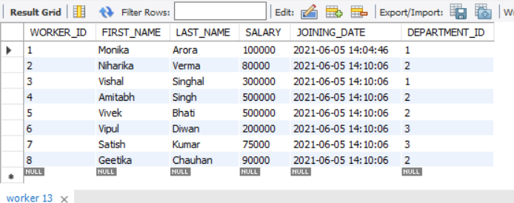

**Department Table**:

create table ASSIGNMENT1.DEPARTMENT(DEPARTMENT_ID INT PRIMARY KEY, DEPARTMENT_NAME VARCHAR(15) NOT NULL);

INSERT INTO ASSIGNMENT1.DEPARTMENT (DEPARTMENT_ID, DEPARTMENT_NAME) values

(1, 'HR'),

(2, 'ADMIN'),

(3, 'ACCOUNT');

ALTER TABLE assignment1.WORKER ADD foreign key(DEPARTMENT_ID) references assignment1.department(DEPARTMENT_ID);

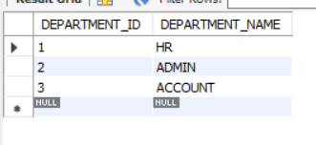

**Bonus Table**:

CREATE TABLE ASSIGNMENT1.BONUS(WORKER_REF_ID INT NOT NULL, BONUS_DATE datetime, BONUS_AMOUNT VARCHAR(15) NOT NULL);

INSERT INTO assignment1.BONUS (WORKER_REF_ID, BONUS_DATE, BONUS_AMOUNT) VALUES

(1, '2016-02-20 00:00', 5000),

(2, '2016-06-11 00:00', 3000),

(3, '2016-02-20 00:00', 4000),

(1, '2016-02-20 00:00', 4500),

(2, '2016-06-11 00:00', 3500);

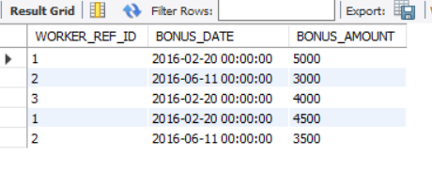

**Title Table**:

create table ASSIGNMENT1.TITLE (WORKER_REF_ID INT NOT NULL, WORKER_TITLE varchar(15) NOT NULL, AFFECTED_FROM datetime default current_timestamp);

INSERT INTO assignment1.TITLE (WORKER_REF_ID, WORKER_TITLE, AFFECTED_FROM) VALUES

(1, 'Manager', '2016-02-20 00:00'),

(2, 'Executive', '2016-06-11 00:00'),

(8, 'Executive', '2016-06-11 00:00'),

(5, 'Manager', '2016-06-11 00:00'),

(4, 'Asst. Manager', '2016-06-11 00:00'),

(7, 'Executive', '2016-06-11 00:00'),

(6, 'Lead', '2016-06-11 00:00'),

(3, 'Lead', '2016-02-20 00:00');

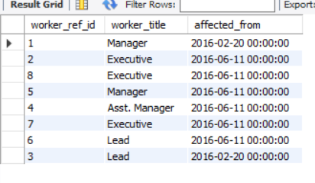

**Update salary to increase by 20000 of satish kumar and geetika chauhan**:

UPDATE assignment1.worker SET SALARY = (SALARY + 20000) WHERE FIRST_NAME = 'Satish' and LAST_NAME ='Kumar';

UPDATE assignment1.worker SET SALARY = (SALARY + 20000) WHERE FIRST_NAME = 'Geetika' and LAST_NAME ='Chauhan';

