Laboratoire 2 : Commande de transistors – Groupe B18

- Transistor du bas
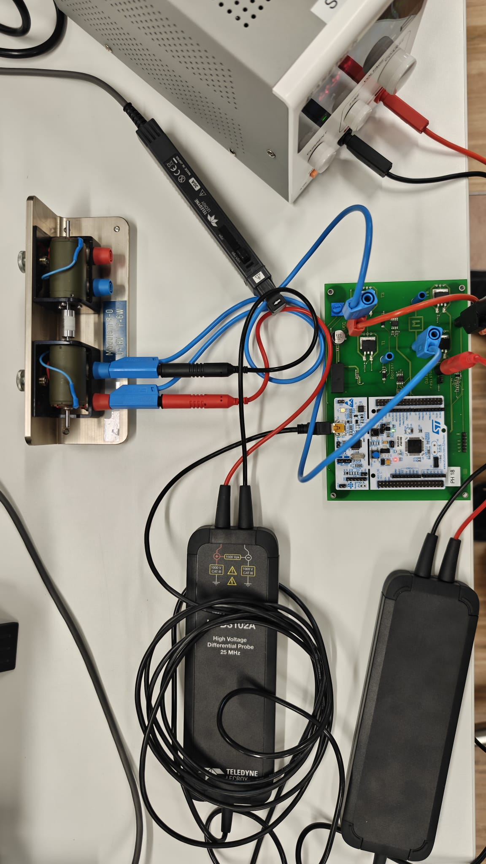Figure 1: Initial Setup for Transistor du bas

Gate Potential High connected to Transistor du bas

In this initial setup we are asked to analyse the current across the motor, voltage across its terminals and voltage across the transistor’s gate. Data was gathered focusing on a singular period, wherein we can observe all stages involved in the opening of a gate. We obtained the following results,

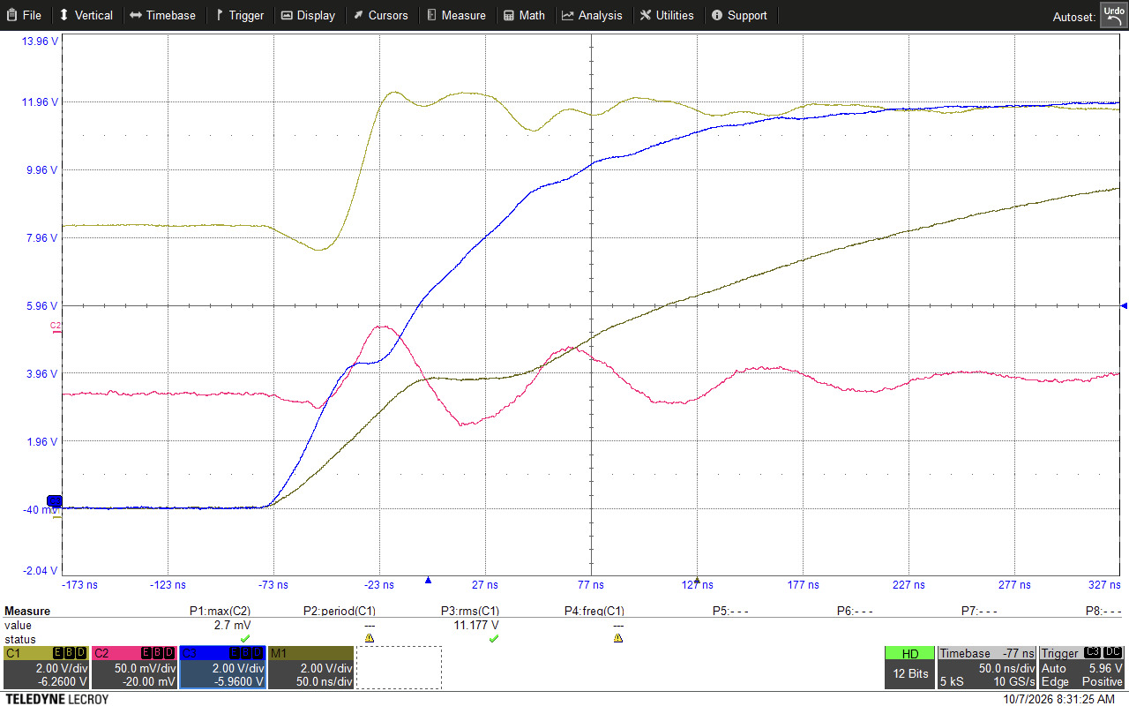Figure 2: Transistor Gate Opening with 10Ω Resistance

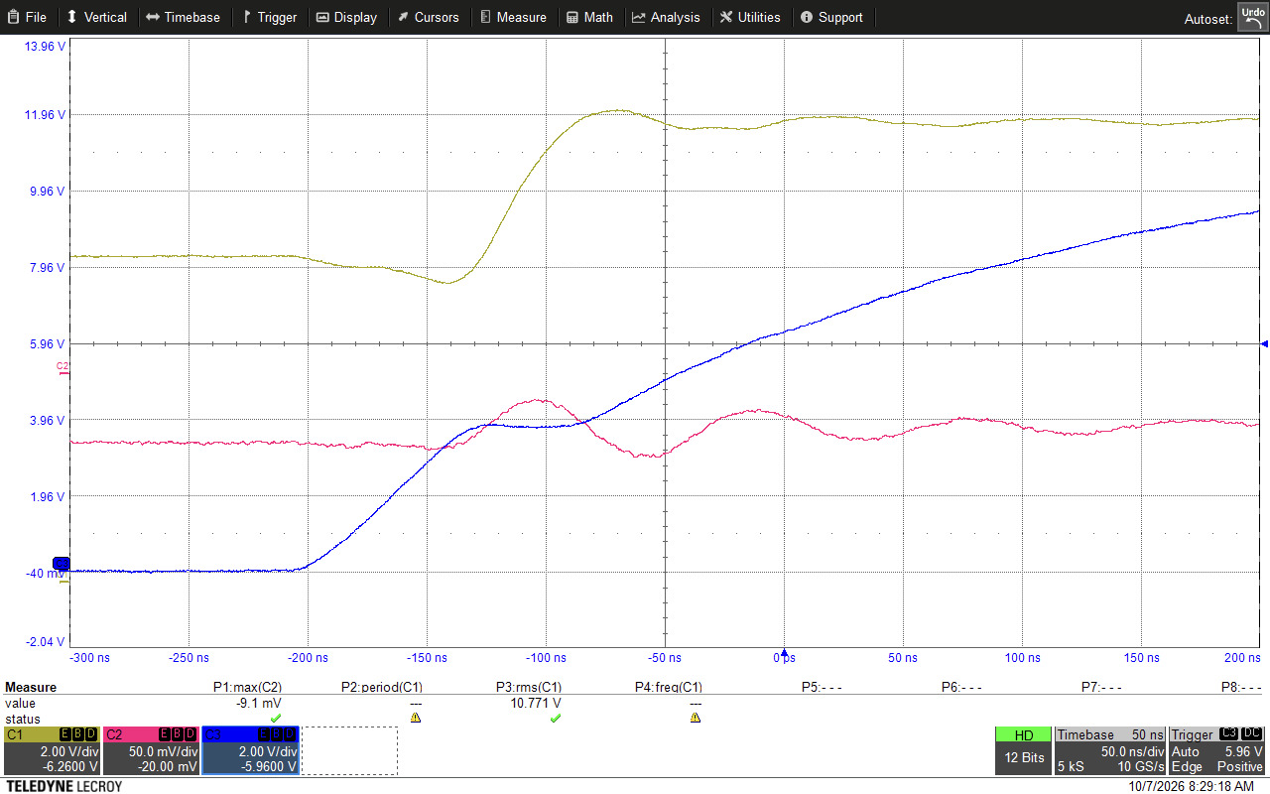Figure 3: Transistor Gate Opening with 110Ω Resistance

Taking the case of Figure 3, we can observe a few different phenomena within the lifecycle of a transistor gate opening. Initially we see the voltage across the terminals of the transistor increase from t0 to t1, during this period the voltage is not enough to pull open the pins of the transistor. When the voltage is reached (3.3V) that the gates begin to open we experience a large flux, wherein the Voltage across the Gate is rising but the Voltage across the Drain-Source wants to drop.
Here we experience a large dV/dt, which in turn results in a large requirement of current across a capacitor, by I = C*dV/dt. This draws all the current being supplied by the Gate driver and as such we observe a plateau between t1 and t2, also known as the “Miller Effect”. Only when the capacitance gets saturated, does the voltage across the gate begin climbing and reach a point of stabilisation where the gate is fully open.

Comparing the difference between Figure 2 and Figure 3, we can see the impact that adding a resistor has on the system. Indeed a smaller resistance leads to faster overcoming of the “Miller Effect”, however we observe that the current also oscillates more violently and with greater magnitude. This can be problematic and can damage the circuit, making it necessary to establish and find a “sweet-spot” wherein we are not spending too much time in the linear plateau region, where we are dissipating all energy as heat and loss, versus on the flip side potentially damaging the circuit through electromagnetic interference.

- Transistor du haut
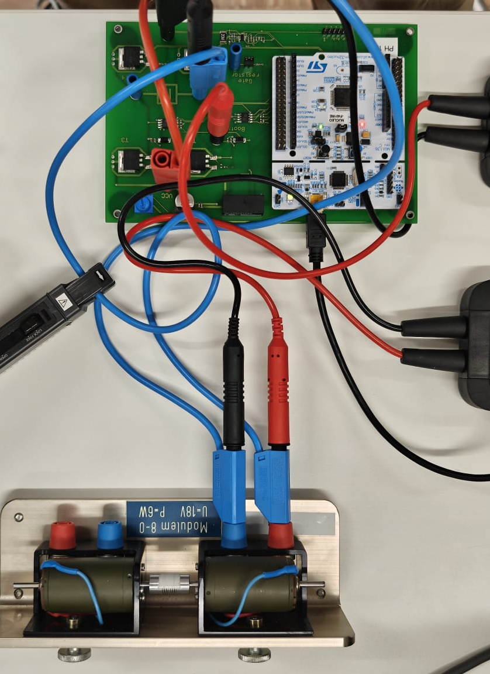

Transistor High connected to Capacitance Bootstrap.

In a scenario as such where we have a N-MOS Transistor, we need a floating voltage. This is because to open its gates we need to have a gate voltage applied too it, meaning it must have a net potential drop across its gates. For the bottom transistors, this is doable because we have the Drain-Source Voltage and the Ground, but in the context of the top transistor it is not connected to the ground it is connected directly to the motor phase. If the top transistor was told to open, and current would flow, it would go to both the Drain and Source around the Top Transistor which would instantly settle at the same voltage, making it impossible to open this gate. Having a floating voltage act as a secondary battery allows the system to artificially pump more voltage that the main power supply temporarily to create the required potential difference and open the gate.

This floating voltage is what we gain through our bootstrap capacitor, which gets charged during the down cycle, when the bottom transistor is open. During this period the power-source is forced to be pulled from the sources connected to a forward diode, which on its path to ground charges a capacitor.

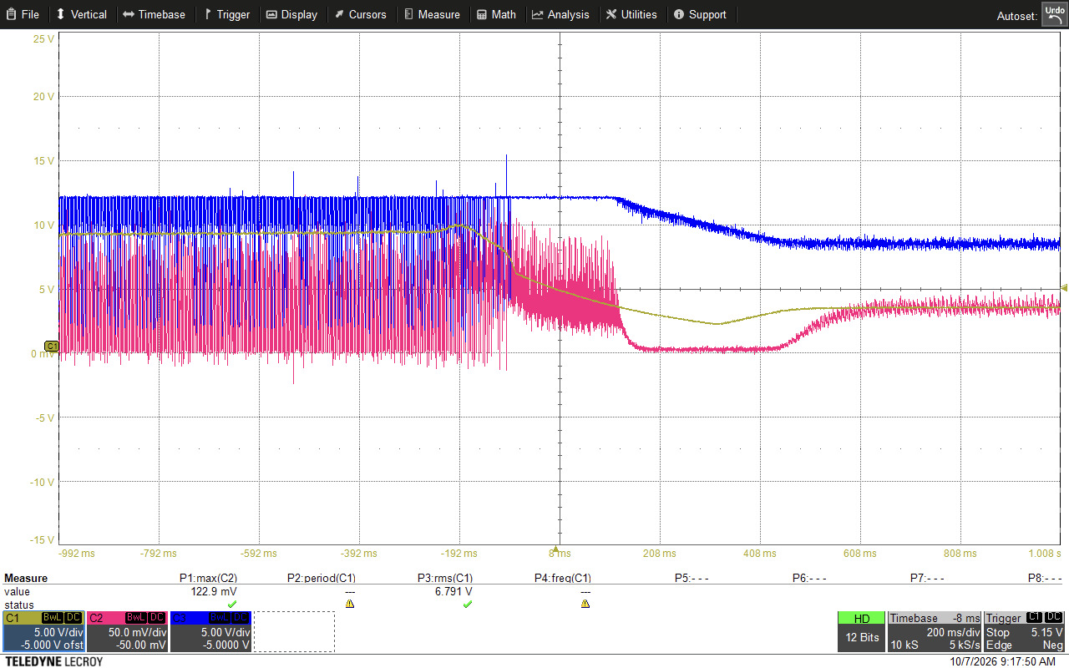Figure 4: Bootstrap Capacitance Discharge

This bootstrap capacitance can be seen in Figure 5, wherein (….)

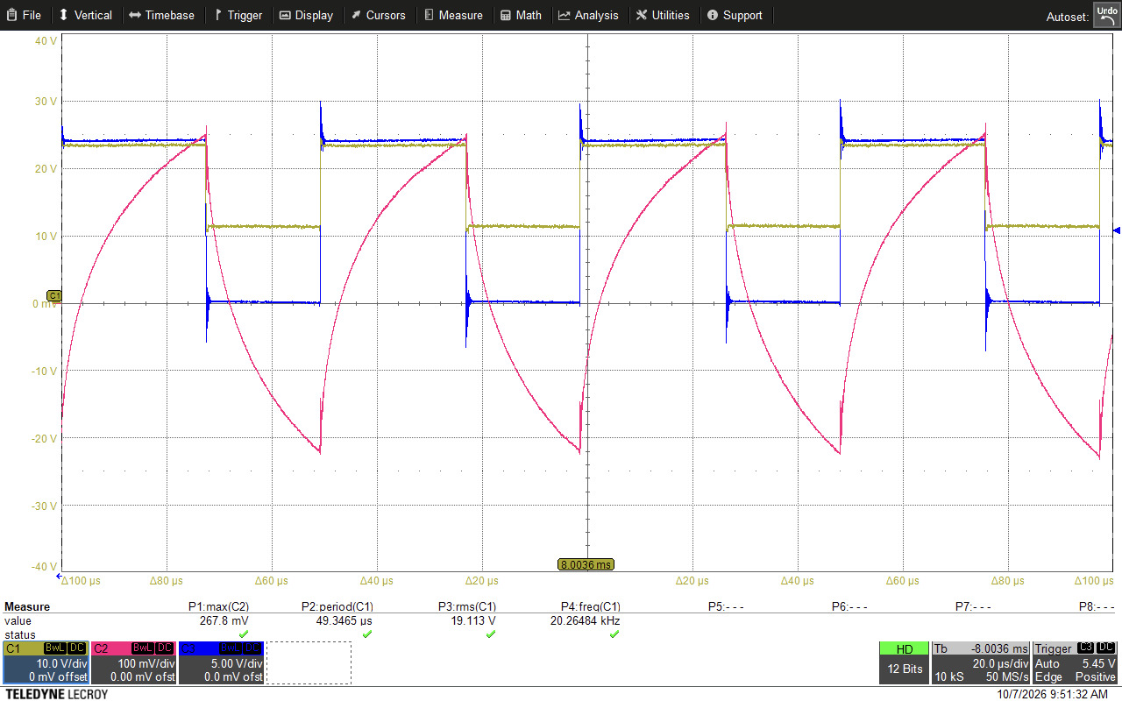Figure 5: Bootstrap Capacitance in action, Artificially Pumping Voltage

(…...)

- Redressement synchrone (les deux transistors commutent)

(No clue, gl champ)

- Further Reflection (first 2 questions answered in the Transistor du haut section, so I don’t think we need to repeat it here)
  - Qu’en est-il de cette charge dans le cas d’un pont en H ?
  - Comment freiner le moteur?

