

Rizvi College of Engineering

Department of Computer Engineering
Software Requirement Specification
For
CodeConnect- The Ultimate Social Platform for Coders

Document ID | SOFTWARE REQUIREMENT SPECIFICATION-v0.1
Version Number | 0.1
Issue Date | August 29, 2023
Team Members | - SOHAM SHRIKANT MANJREKAR  - SHAIKH MUDASSER ALI GULAM MUSTAFA ABBAS  - SAYED MOHAMMAD BAQUIR ANWAR ABBAS  - SIDDIQUI ADAAB HUSAIN AJAZ HUSAIN
Guide | PROF. SHIBURAJ PAPPU

Revision History

Date | Version | Description | Author (s)
29/08/2023 | 0.1 | Draft Version | Soham Manjrekar

Prepared By | Prepared By
Name: SOHAM SHRIKANT MANJREKAR | Name: SHAIKH MUDASSER ALI GULAM MUSTAFA ABBAS
Date: 29 / 08 / 2023 | Date: 29 / 08 / 2023

Prepared By | Prepared By
Name: SAYED MOHAMMAD BAQUIR ANWAR ABBAS | Name: SIDDIQUI ADAAB HUSAIN AJAZ HUSAIN
Date: 29 / 08 / 2023 | Date: 29 / 08 / 2023

TABLE OF CONTENTS
- Introduction
  - Purpose
  - Scope
  - Definitions, Acronyms, and Abbreviations
  - References
  - Overview of the SRS
  - literature survey
- Description
  - Product Perspective
  - Product Features and Functions
  - User Classes and Characteristics
  - Operating Environment
  - Design and Implementation Constraints
  - User Documentation
  - Assumptions and Dependencies
- Specific Requirements
  - External Interface Requirements
3.1.1 User Interfaces
3.1.2 Third-Party Services
3.2. Functional Requirements
3.2.1 User Registration and Authentication
3.2.2 Developer Profiles and Portfolios
3.2.3 Tech Stack Badges and Endorsements
3.2.4 Code Collaboration and Projects Showcase
3.2.5 Coding Communities and Groups
3.2.6 Code Learning Center
3.2.7 AI-Powered Job Recommendations
3.2.8 Virtual Tech Events and Webinars
3.2.9 Code Challenges and Hackathons
3.2.10 Developer Blogging Platform
3.3 Non-Functional Requirements
3.3.1 Performance Requirements
3.3.2 Security Requirements
3.3.3 Reliability Requirements
3.3.4 Scalability Requirements
3.3.5 Usability and User Experience Requirements
- System Design Constraints
4.1. Technology Stack and Architecture
4.2 Platform Compatibility and Responsiveness
- Database Design
5.1 Database Schema
5.2 Data Storage and Retrieval Requirements
- System Quality Attributes
6.1 Maintainability
6.2 Portability
6.3 Testability
- External Dependencies
7.1 Third-Party APIs and Services
7.2 Integration with Other Platforms
- Appendices
8.1 Use Case Diagrams
8.2 Entity-Relationship Diagram (ERD)
8.3 Mockups and Wireframes
1. INTRODUCTION
1.1 Purpose
The purpose of this document is to provide a comprehensive and detailed overview of the requirements, features, and functionalities of CodeConnect. It aims to serve as a foundation for the development team, ensuring a clear understanding of the project's scope and objectives.
1.2 Scope
CodeConnect envisions creating a dynamic online platform tailored for coders, developers, and tech enthusiasts. This platform will go beyond traditional professional networking by focusing on technical achievements, coding expertise, and fostering a strong sense of community.
1.3 Definitions, Acronyms, and Abbreviations
- SRS: Software Requirements Specification - A document outlining the functional and non-functional requirements of the software.
- AI: Artificial Intelligence - The simulation of human intelligence processes by machines.
- MVC: Model-View-Controller - A software architectural pattern that separates the application into three interconnected components.
1.4 References
The following references provide foundational concepts and technologies for the development of CodeConnect:
- LinkedIn: Inspiration for professional networking aspects.
- Django: Backend framework for robust web application development.
- Next.js: Frontend framework for creating dynamic web interfaces.
- Tailwind CSS: Styling framework for designing responsive and visually appealing user interfaces.

1.5 Overview of the SRS
This SRS document outlines the complete framework of CodeConnect. It offers a comprehensive understanding of the project's goals, user requirements, functionalities, and technical implementation.

1.6 Literature Survey
The foundation of the "CodeConnect" project is rooted in a comprehensive understanding of the existing landscape of coding-related social platforms, professional networks, and the nuanced challenges faced by developers in their quest for networking, collaboration, and skill enhancement. This literature survey endeavors to delve deep into the plethora of studies, platforms, and trends that collectively shape and inform the design, development, and vision of "CodeConnect."
1. Professional Networking Platforms: Laying the Groundwork
1.1 LinkedIn: Pioneer of Professional Networking
LinkedIn, established in 2002, stands as the archetypal platform for professional networking across diverse industries. Its core features, including user profiles, connections, endorsements, and job listings, have paved the way for online professional interactions. However, while LinkedIn provides a generic space for professionals, "CodeConnect" aspires to carve its own niche by catering exclusively to the coding community, a sector with unique networking needs.
1.2 Stack Overflow: A Haven for Technical Q&A
For developers, Stack Overflow is an invaluable resource for asking and answering technical questions. While it predominantly serves as a knowledge-sharing platform, it underlines the demand for coding-related interaction spaces. "CodeConnect" aims to integrate a robust Q&A mechanism, elevating the platform beyond a mere professional network.
2. Coding-Centric Communities: Fostering Collaboration
2.1 GitHub: Collaboration and Open Source Culture
GitHub has transformed the collaborative landscape for software developers. It enables version control, code collaboration, and the open-source movement. "CodeConnect" acknowledges the significance of collaborative coding and endeavors to imbue this ethos into its fabric. The platform's focus on project collaboration, team formation, and showcasing collaborative efforts aligns with GitHub's spirit.
2.2 DeviantArt for Coders: Showcasing Creative Coding
Platforms like DeviantArt provide artists with a canvas to showcase their work. Similarly, "CodeConnect" embraces the concept of showcasing. Developers can exhibit their coding prowess through portfolios, highlighting projects, coding languages, and achievements. This approach elevates the user experience, allowing users to visually communicate their technical expertise.

3. Challenges in Existing Platforms: Opportunities for Innovation
3.1 Privacy Concerns and Data Security
Privacy concerns and data breaches have tarnished the reputation of several social platforms. "CodeConnect" acknowledges these issues and strives to in still a sense of security among users. With granular privacy controls and robust data encryption, the platform intends to foster trust and confidence in its user base.
3.2 The Void of Coding-Centric Features
While platforms like LinkedIn and GitHub offer valuable features, they lack coding-specific elements tailored to developers. "CodeConnect" identifies this gap and positions itself as a platform that addresses these unique requirements. Tech stack badges, coding challenges, and AI-powered job recommendations tailored to coding skills offer a new dimension to professional networking.
4. Emerging Trends and Opportunities: Pioneering Innovation
4.1 AI-Driven Personalization and Recommendations
The infusion of artificial intelligence in networking platforms is an emerging trend. "CodeConnect" capitalizes on AI-driven algorithms to provide users with personalized job recommendations based on their profiles and coding expertise. This not only streamlines job searching but also enhances user engagement.
4.2 Learning as a Social Experience
The rise of online learning platforms signifies the importance of continuous skill development. "CodeConnect" envisions the integration of a Code Learning Center, offering coding tutorials, courses, and resources. By fostering a culture of lifelong learning within a social context, the platform seeks to enrich users' skillsets.
5. Conclusion: Vision for CodeConnect
In conclusion, the literature survey has elucidated the multifaceted landscape of professional networking, coding communities, and emerging trends. "CodeConnect" draws inspiration from established platforms while addressing their limitations. By amalgamating the essence of professional networking with the unique needs of developers, the project aims to create a dynamic and cohesive ecosystem that resonates with coders, fosters synergistic collaborations, and nurtures a vibrant global coding community.

2. OVERALL DESCRIPTION
2.1 Product Perspective
CodeConnect represents an independent web application designed to address the unique needs of coders and developers. While inspired by LinkedIn's professional networking, CodeConnect is distinct in its coding-centric approach and emphasis on fostering technical connections.
2.2 Product Features and Functions
CodeConnect is equipped with a suite of features designed to cater to the diverse needs of its user base:
- Developer Profiles: Users can create comprehensive profiles showcasing their coding skills, work experiences, and technical achievements.
- Tech Stack Badges: Recognize users' expertise in specific technologies through badges endorsed by peers.
- Code Collaboration: Facilitate collaborative coding projects by enabling users to form teams and showcase their joint efforts.
- Learning Center: Offer a dedicated space for users to access coding tutorials, online courses, and industry insights.
- Job Recommendations: Utilize AI algorithms to match users with job opportunities that align with their skills and preferences.
- Tech Events: Host virtual tech events, webinars, and coding challenges to enhance learning and engagement.
- Community Interaction: Foster coding communities and groups where users can engage in discussions and knowledge sharing.
2.3 User Classes and Characteristics
CodeConnect is designed to accommodate two main user classes:
- Developers: These individuals possess coding expertise and are seeking professional networking and collaboration opportunities.
- Tech Enthusiasts: Although not necessarily coders, these users have a keen interest in the tech industry and seek to engage in discussions and learn from experts.
2.4 Operating Environment
CodeConnect is accessible as a web-based application, accessible through modern web browsers across multiple devices, including desktops, tablets, and mobile phones.
2.5 Design and Implementation Constraints
To maintain a consistent and efficient user experience:
- Backend Framework: Django will be used to handle user authentication, data storage, and core functionalities.
- Frontend Framework: Next.js will facilitate dynamic and interactive frontend rendering.
- Styling: Tailwind CSS will be employed to create responsive and visually appealing designs.
- Responsive Design: The platform will prioritize responsive design to ensure optimal user experiences across various screen sizes.
2.6 User Documentation
CodeConnect will provide comprehensive user documentation, including user guides, tutorials, and FAQs. This documentation will aid users in navigating the platform's features and maximizing their engagement.
2.7 Assumptions and Dependencies
To ensure successful development and operation of CodeConnect:
- User Familiarity: Users are assumed to have basic familiarity with web browsing and navigation.
- Third-Party Services: CodeConnect relies on reliable third-party APIs and services, such as job recommendation algorithms, for certain features.

3. SPECIFIC REQUIREMENTS
3.1 External Interface Requirements
3.1.1 User Interfaces
CodeConnect's user interfaces will be designed with a focus on intuitiveness, user-friendliness, and accessibility. The platform's layout will be designed to guide users effectively through their interactions.
3.1.2 Third-Party Services
Integration with third-party services will enhance the user experience:
- Authentication Services: Users can authenticate through platforms like GitHub or Google, streamlining the registration process.
- Job Recommendations: AI-powered job recommendations will be offered through the integration of third-party algorithms.
3.2 Functional Requirements
3.2.1 User Registration and Authentication
- Registration Options: Users can register using their email addresses or third-party accounts, promoting a seamless onboarding experience.
- Two-Factor Authentication (2FA): To enhance security, 2FA will be implemented, requiring an additional verification step during login.
3.2.2 Developer Profiles and Portfolios
- Comprehensive Profiles: Users can create detailed profiles showcasing personal information, coding skills, work experiences, and technical accomplishments.
- Project Showcase: The platform will provide an avenue for users to highlight their projects, certifications, and achievements.
3.2.3 Tech Stack Badges and Endorsements
- Tech Stack Expertise: Users can earn "Tech Stack Badges" that represent their proficiency in specific coding languages, frameworks, or technologies.
- Peer Endorsements: Other users can endorse these badges, validating the authenticity of their connections' skills.
3.2.4 Code Collaboration and Projects Showcase
- Collaborative Coding: CodeConnect will enable developers to collaborate on coding projects, fostering teamwork and shared achievements.
- Project Showcase: Users can feature collaborative projects on their profiles, providing insights into project goals, contributions, and outcomes.
3.2.5 Coding Communities and Groups
- Diverse Communities: Users can join coding communities and groups tailored to specific programming languages, technologies, or interests.
- Knowledge Sharing: Groups offer platforms for engaging discussions, knowledge sharing, and networking opportunities.
3.2.6 Code Learning Center
- Diverse Learning Resources: The Code Learning Center will house a variety of coding tutorials, online courses, and resources contributed by industry experts.
- Continuous Skill Development: Users can engage in ongoing learning to enhance their coding abilities and stay updated with the latest trends.
3.2.7 AI-Powered Job Recommendations
- Personalized Job Matches: The platform will employ AI algorithms to analyze user profiles, skills, and preferences, providing personalized job recommendations.
- Enhanced Job Opportunities: Users can explore job listings aligned with their coding expertise, opening doors to exciting career prospects.
3.2.8 Virtual Tech Events and Webinars
- Educational Tech Events: CodeConnect will host virtual tech events, webinars, and tech talks featuring industry experts and developers who share their insights and knowledge.
- Networking Opportunities: Users can participate in these events to expand their network, learn from experts, and stay updated with industry trends.
3.2.9 Code Challenges and Hackathons
- Skill Testing: Regular coding challenges and hackathons will be organized on CodeConnect, allowing users to test and showcase their coding skills.
- Friendly Competitions: Users can compete in these events, fostering a spirit of healthy competition and skill enhancement.
3.2.10 Developer Blogging Platform
- User Contributions: CodeConnect offers a blogging platform for users to publish coding-related articles, tutorials, and insights.
- Knowledge Sharing: The blogging section encourages community-driven knowledge sharing and facilitates discussions around coding practices.
3.3 Non-Functional Requirements
3.3.1 Performance Requirements
- Responsive User Experience: CodeConnect should deliver fast response times and smooth content loading to ensure an enjoyable user experience.
- Concurrent Users: The platform should efficiently handle a substantial number of simultaneous users without compromising performance.
3.3.2 Security Requirements
- User Data Security: User data will be securely stored using encryption and proper access controls.
- Password Management: Passwords will be hashed and salted to ensure secure storage.
- Privacy Controls: Users will have control over the visibility of their profile information and connections.
3.3.3 Reliability Requirements
- Platform Uptime: CodeConnect should minimize downtime to ensure users have consistent access.
- Data Backup: Regular backups of user data and content will be performed to prevent data loss.
3.3.4 Scalability Requirements
- Scalable Infrastructure: CodeConnect will be designed to accommodate potential growth in user base and data volume.
- Load Handling: The platform's architecture should be scalable to handle increased load while maintaining performance.
3.3.5 Usability and User Experience Requirements
- Intuitive Navigation: The user interface will be designed for intuitive navigation, allowing users to find and use features effortlessly.
- Consistent Design: The design and layout of CodeConnect will provide a consistent experience across devices and screen sizes.
4. SYSTEM DESIGN CONSTRAINTS
4.1 Technology Stack and Architecture
- Backend Framework: Django will be used as the backend framework to handle user authentication, data storage, and business logic.
- Frontend Framework: Next.js will be utilized for frontend rendering, ensuring dynamic and interactive user interfaces.
- Styling Framework: Tailwind CSS will be employed for designing responsive and visually appealing user interfaces.
- Architecture: The MVC (Model-View-Controller) pattern will guide the development structure, separating concerns for maintainability.
4.2 Platform Compatibility and Responsiveness
- Cross-Platform Compatibility: CodeConnect will be designed for compatibility with a wide range of web browsers and devices.
- Responsive Design: Responsive design principles will ensure that the platform provides an optimal experience on various screen sizes and orientations.
5. DATABASE DESIGN
5.1 Database Schema
- User Profiles: The database will store comprehensive user profiles containing personal information, coding skills, endorsements, and achievements.
- Projects: Project details, team members, and project outcomes will be maintained in the database.
- Groups: Information about coding communities and groups will be stored to facilitate interactions.
5.2 Data Storage and Retrieval Requirements
- Efficient Storage: User data, project details, and community interactions should be stored efficiently for fast retrieval.
- Database Optimization: Database queries and operations will be optimized to prevent performance bottlenecks during data retrieval.

6. SYSTEM QUALITY ATTRIBUTES
6.1 Maintainability
- Code Standards: CodeConnect's codebase will adhere to industry best practices and coding standards to ensure readability and maintainability.
- Code Reviews: Regular code reviews will be conducted to maintain code quality and consistency.
6.2 Portability
- Cross-Platform Compatibility: CodeConnect will be designed to work seamlessly across different platforms, including desktops, tablets, and mobile devices.
- Responsive Design: The user interface will adapt fluidly to various screen sizes and orientations, promoting a consistent experience.
6.3 Testability
- Comprehensive Testing: CodeConnect will undergo rigorous testing, including unit tests, integration tests, and user acceptance testing.
- Automation: Automated testing and continuous integration practices will contribute to the platform's reliability and stability

7. External Dependencies
7.1 Third-Party APIs and Services
- Authentication Integration: Integration with third-party authentication services (e.g., GitHub, Google) will streamline the registration process.
- Job Recommendation APIs: Third-party APIs will be integrated to provide AI-powered job recommendations tailored to users' profiles.
7.2 Integration with Other Platforms
- Interplatform Integration: CodeConnect may explore integration options with other coding platforms, enabling seamless sharing of coding projects and achievements across platforms

8. APPENDICES
8.1 Use Case Diagrams
- Use case diagrams will visually depict the various interactions between users and the system, highlighting the functionalities and processes within CodeConnect.
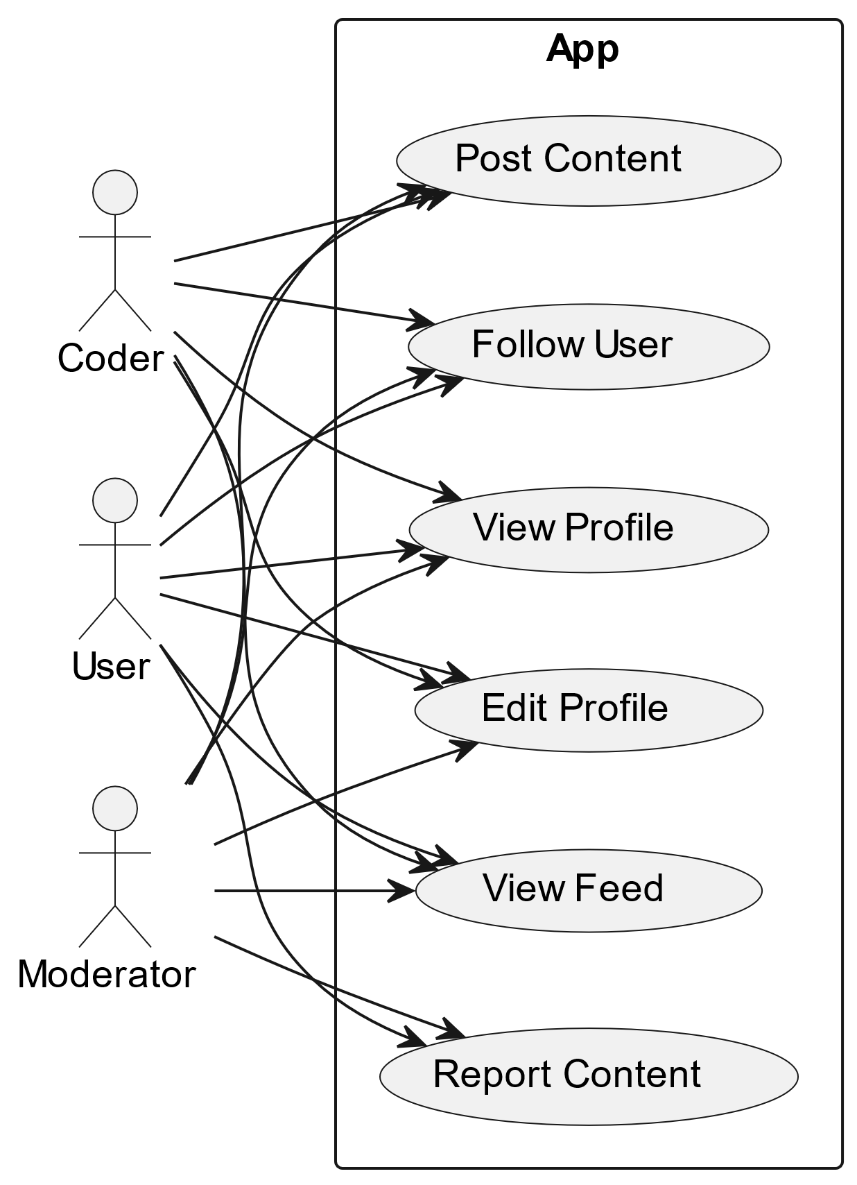
9.2 Entity-Relationship Diagram (ERD)
- An Entity-Relationship Diagram (ERD) will illustrate the relationships between different data entities in the database, helping to visualize the data structure.
9.3 Mockups and Wireframes
- Mockups and wireframes of key platform pages will be included to provide a visual representation of the user interface design. These visuals will showcase the layout, components, and interactions.

