CodeConnect: Where AI Meets Coders - Empowering Social Coding with Social Media
¹Reshma Lohar  Assistant Professor  1st line of address  2nd line of address  reshmalohar@eng.rizvi.edu.in | ²Soham Manjrekar  Student  1st line of address  2nd line of address  sohammanjrekar@eng.rizvi.edu.in | ³Shaikh Mudasser Ali  Student  1st line of address  2nd line of address  mudasser12@eng.rizvi.edu.in
⁴Mohammed Baquir Sayed  Student  1st line of address  2nd line of address  baquirsayed@eng.rizvi.edu.in |  | ⁵Siddiqui Adaab Husain  Student  1st line of address  2nd line of address  siddiquiadab@eng.rizvi.edu.in

ABSTRACT
In a successful collaborative software development environment, the nature of teamwork is enhanced by focusing on working together on collaborative projects. This feature works as a focal point by creating an environment that not only encourages collaboration but also fosters a sense of community among developers.CodeConnect At the heart of the collaborative approach is a learning center designed as a hub for knowledge sharing. In this space, developers have access to a variety of tutorials and resources created by industry experts. What makes it different is its AIpowered business proposition, which connects developers with opportunities as well as connects potential customers with their skills and ambitions. This partnership reflects CodeConnect's commitment to supporting lifelong learning and professional development beyond the realm of official websites.CodeConnect stands out by going beyond traditional communication capabilities. The platform offers a unique training program that adds another layer to productivity. Professionals act as mentors, providing guidance and support to people in the early stages of their careers. The training aims to go beyond skills development to address overall career development.In conclusion, CodeConnect is more than a collaboration platform; He strives to be cooperative. It is an ecosystem that thrives on collaboration, continuous learning and education. CodeConnect embodies the collaborative spirit at the heart of great software development by providing a dedicated coworking space, a rich learning environment, and tailored training.
General Terms
CodeConnect, Professional Networking, Coding Community, Technical Proficiency, Collaboration, Learning Resources, Community Building, Collaboration Hub, Career Development, Recognition, Tech Stack Badges

Keywords
CodeConnect, Professional Networking, Coding Community, Technical Proficiency, Collaboration, Learning Resources, Community Building, Collaboration Hub, Career Development, Recognition, Tech Stack Badges

INTRODUCTION

In the world of professional programming and development, CodeConnect is a purpose-built solution to dynamic community challenges. Today's social media is no exception for creators to connect, collaborate, and showcase great information. CodeConnect fills this gap by creating a space for coding professionals to collaborate, explore resources, collaborate on projects, and grow professionally. CodeConnect's resources go beyond professional networking and focus on the complex processes of its users. The platform covers the full spectrum of the developer journey, from in-depth developer information to specific coding challenges, and includes courses, collaborative coding and AI-powered study recommendations. This platform has many purposes. CodeConnect is designed to build a positive community of developers and foster meaningful connections. It also works collaboratively, facilitating the integration of projects and reporting the success of the collaboration. At the heart of this is the Code Learning Center, a rich library of coding tutorials, articles and resources from industry experts that foster lifelong learning in the community. In addition to networking, CodeConnect also integrates an optional AI-powered business recommendation for business development. The platform introduces the use of technology to recognize and reward professionals, thus promoting a culture of social recognition. In our prediction model, we can use an approach that initially trains each logistics model. We can use previous designs for prediction and continue improving them for future purposes. We can also use JWT authentication to access the secure platform.

2. RESEARCH METHODOLOGY

2.1 Surveying Existing System

Paper 1 - In their paper "Social Media for Program Building," disseminated in November 2010, Andrew Begel, Robert DeLine, and Thomas Zimmermann explore the transformative potential of social media in computer program change. They envision social media stages engaging novel ways of forming and collaborating interior program bunches, developing grassroots enhancement communities. The paper highlights the capacity for individuals and small companies to utilize social media all through the thing enhancement lifecycle, conceivably driving to productive and advantageous thing lines. The makers thrust the portion of investigators in making procedures that protect security and reputation in these progressing program progression shapes. Drawing parallels with set up joining models, the paper underscores the importance of engineers finding like-minded collaborators.

Paper 2 - In their 2012 paper titled "Programming in a Socially Organized World: the Headway of the Social Computer program build," Christoph Treude, Fernando Figueira Filho, Brendan Cleary, and Margaret-Anne Story conversation approximately the noteworthy influence of social media on program originators. They emphasize the portion of stages like Stack Surge in reshaping the program headway scene by making colossal records of information. The paper explores the openings and challenges gone up against by engineers depending on crowd-curated web substance, envisioning a future where architects both advantage from and contribute to a collective body of data kept up through social media.

Paper 3 - In their 2009 paper "Codebook: Social Organizing over Code," Andrew Begel and Robert DeLine show the concept of Codebook, a social organizing web advantage for program engineers. Not at all like standard social organizing, Codebook builds up affiliations not because it were between people but in addition with the work artifacts they share. The makers depict Codebook as a gadget laid out to help program engineers encourage and track works out, applying social organizing guidelines to work artifacts and works out, promising to advance coordination and collaboration interior computer program advancement groups

2.2. Objective
The core objective of the CodeConnect roam is to set up a powerful community organize tailor-made to the terms of coders. The aim of the organize is to:
1. Establish a vigorous & comprehensive community of engineers to foster great relations and collaborations. CodeConnect aims to spur energetic participation and knowledge-sharing among its individuals through features like discussion forums, chat windows and Strategy meetings.
2. Enable a wide range of resources revolving around coding challenges, instructive courses for teachers and a huge content of edicts works out and articles compiled by experts, to foster education & build capable engineers. The support to curate quality content plus advertising intellectuals learning experiences aims at empowering architects to develop their skills & keep abreast with industry trends.
3. Allow steady collaboration on roam, where productive development & shared accomplishments are encouraged. CodeConnect wandered organization devices, shape control systems and team collaborative coding circumstances allow bunches to collaborate in projects and streamline workflows to pass on top-quality results.
4. Use AI-generated work suggestions to validate gradable openings and drive their career mobility. From providing meaningful and recent calculations for each worker, to suggesting the next career moves with personalized work-path coordination capability, CodeConnect in-depth searching and end-to-end work-suggestions connect designers to unused career-openings that match their skills, interface, and career goals.
5. Establish a culture of appreciation inside the community, celebrating and rewarding mastery and commitments. Identifications, underwriting and appreciation programmers of CodeConnect showcase the achievements and competence of its members, generating the feeling of belonging and pride inside the community.
6. Realize strong security conventions, consisting JWT established protocols, to establish the integrity and privacy of the stage for all users.

3. PROPOSED SYSTEM
CodeConnect attempts to optimize client-side integration through unique fields. The organization has been carefully designed to include key elements such as Dashboard, Design Process, Technology Stack Differentiation Evidence Scope, Code Collaboration Centre, Learning Centre, Business Advice, Virtual Events, Coding Challenges, Creative Blog Organization, and Mentoring Program. CodeConnect participates in business arrangements with third parties to update its work. These include AI-powered job recommendations, collaborative planning of virtual incentives, and connections to external APIs to enable learning processes. CodeConnect prioritizes customer access and security by enabling registration and approval. Customers can sign up with a unique username, email address, and password or choose to use two-factor opt-in (2FA) for added security. Create profiles around a central organization that allows customers to showcase their coding skills, interests, certifications, and careers. The program emphasizes collaboration, allowing users to form teams, share their coding journeys, and share collaboration directly on their profiles. Purpose of the assistant

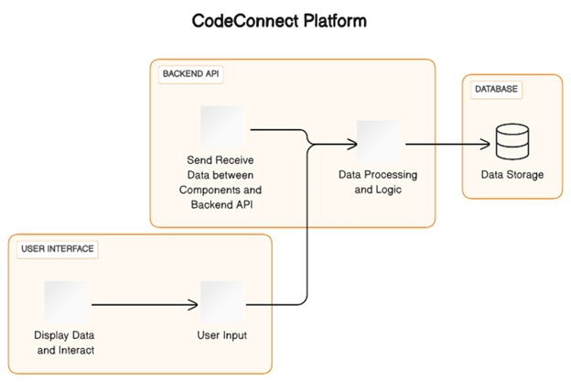
Fig 1:Component Diagram - Represents high-level components in system and their interaction

1. Client interface: Set a user-friendly and normal interface.
2. Community Building: Create a prosperous and cohesive community.
3. Coordination center: Providing a unified and stable place for coding companies.
4. Learning environment: Prepare exercises, products, and lessons focused on general instruction.
5. Career development: Provide advice on personal career development.
6. Credentials and fundamentals: Showcasing different technology products with proven and creative credentials is critical to customer approval.
Proof-of-concept technology serves as an undeniable guarantee that the customer's needs will be met based on their capabilities in a particular technology category. Warranty companies help other customers improve the user's reputation. To improve community engagement, collaboration and walking allow customers to join the community, share the journey, and share their successes to enhance collaboration and knowledge sharing. Code Learning Center offers specially prepared coding programs that underline the platform's commitment to sharing. Clients contribute to empowering, reinforcing and adaptive learning. An intelligence-driven business creation strategy that evaluates customer data, capabilities and preferences to deliver personalized business and facilitate business reviews in stages. Technology events, webinars, career challenges, and hackathons provide engaging learning, organization, and interest-building opportunities. The design blog organization enables customers to share their experiences, while the mentoring program fosters important connections in the community.
CodeConnect provides strong security, hybrid guidelines, and proven metrics for securing business coding to ensure enterprise security and collaborative environments. Meet processing and security needs with configuration and data encryption services. Additionally, AI computing leads to better customer relationships, transformative engagement, and satisfaction. We suggested a way to start planning after all the needs were realized in our forecast. Plan to use existing models for numbers and try to improve them for future purposes. It also supports customer engagement by providing AI-driven personalization, recommendations and content based on personal preferences and behaviours.

Modules in the Project
- User Registration and Authentication
- Developer Profiles and Portfolios
- Tech Stack Badges and Endorsements
- Code Collaboration and Projects Showcase
- Coding Communities and Groups
- Code Learning Center
- AI-Powered Job Recommendations
- Virtual Tech Events and Webinars
- Code Challenges and Hackathons
- Developer Blogging Platform
- CodeConnect Mentorship Program
- Secure Networking and Collaboration

METHODOLOGY
The strategy utilized in making CodeConnect takes after an iterative and collaborative handle, combining components of spry and incremental progress to guarantee responsiveness to client needs and advancing industry plans. The movement cycle starts with a comprehensive examination organize, where the prerequisites and focuses of intrigued are accumulated through wide assistant dialogs, client considers almost, and industry inquire around. This organizes joins characterizing the center highlights, functionalities, and client classes that diagram the spine of the arrangement. Taking after the examination, the improvement accumulate gets a dexterous strategy, breaking down the meander into sprints, each crossing a set time period. This iterative approach awards for nonstop input circles, locks in the bunch to put through input and address rising challenges instantly. Standard sprint audits consolidate assistants, guaranteeing course of activity with the imagined objectives and obliging any advancing prerequisites.
The advancement stack, checking Django for the backend, Next.js for the frontend, and related systems, is carefully chosen to modify execution, adaptability, and reasonability. The choice of MySQL and MongoDB as databases caters to both organized and unstructured data prerequisites, optimizing

Fig 2 : Component diagram for Frontend (Next.js)

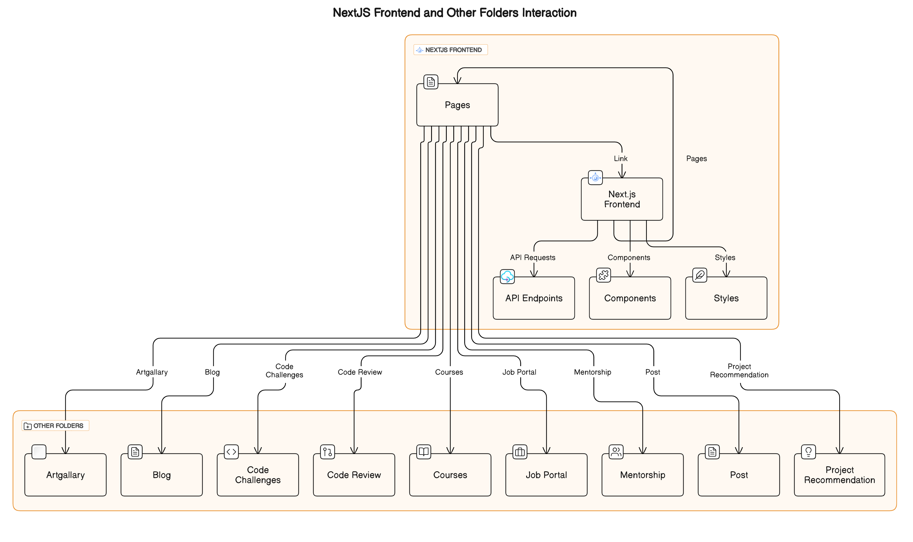
information organization. Client incorporation might be point all through the movement get prepared.

The frontend is made utilizing Next.js to guarantee a responsive and impulses interface. Standard ease of utilize testing and input components are orchestrates to refine the client interface, making it naturally and accessible. Security contemplations are basic. The framework cements lively encryption conventions for client information, utilizes JWT for secure affirmation, and experiences standard security reviews to recognize and calm potential vulnerabilities. In our assess outline, able to actualize an approach where after each strategy of thinking show up begins arranging. For wants, able to utilize as of presently made models and energetically refine them for future purposes. As well, AI-driven personalization overhauls the client incorporation, giving custom fitted suggestions and substance based on person inclines and behavior. Insides the method, NLP and ML procedures are utilized to personalize bolsters, bringing catchphrases for each client from differing user-generated substance, guaranteeing everything is personalized based on their slants and behavior. The headway handle isn't idle; it modifies to making plans and client input. Decided integration and shape control utilizing Git enable steady collaboration among planners. This strategy guarantees that CodeConnect impels really, remaining adjusted to the eager scene of the coding and progress community.
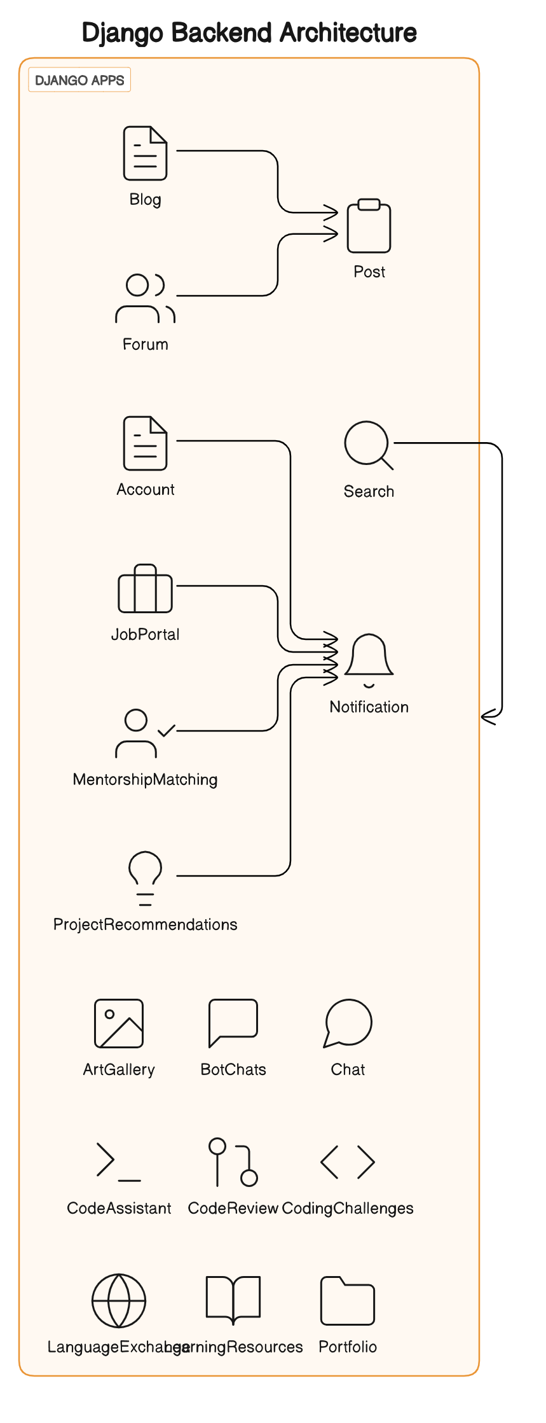
Fig 3: Component diagram for backend (Django)

- MACHINE LEARNING ALGORITHM
1. TF-IDF (Term Frequency-Inverse Document Frequency):
  - Theory: TF-IDF is a numerical statistic used to reflect the importance of a word in a document relative to a collection of documents. It is commonly used in information retrieval and text mining.
  - Formula:
      - TF (t, d) = (Number of times term t appears in document d) / (Total number of terms in document d)
      - IDF (t, D) = log (Total number of documents in the corpus |D| / Number of documents containing term t)
      - TF-IDF Formula: TF-IDF(t, d, D) = TF(t, d) × IDF(t, D)

- Cosine Similarity:
  - Theory: Cosine similarity is a measure of similarity between two non-zero vectors of an inner product space that measures the cosine of the angle between them. It is often used in information retrieval to compute the similarity of documents or text.
  - Formula: similarity(A, B) = (A ⋅ B) / (||A|| ||B||)
- Approach in the Code:
- TF-IDF Vectorization:
  - Preprocess job descriptions and user information.
  - Create a TF-IDF vectorizer to convert text data into numerical form.
  - Compute TF-IDF matrices for job descriptions and user information.
- Content-Based Filtering:
  - Calculate cosine similarities between user preferences and job descriptions using TF-IDF vectors.
  - Rank job postings based on the computed similarity scores.
- Collaborative Filtering:
  - Fetch user interactions with job postings (e.g., applying, viewing).
  - Construct a user-item interaction matrix based on these interactions.
  - Calculate cosine similarities between user interactions and job postings.
- Hybrid Recommendation:
  - Combine recommendations from content-based and collaborative filtering approaches.
  - Use a weighted average of scores from both approaches.
- Model Persistence:
  - Save the latest TF-IDF vectorizer model after each prediction to ensure the updated model is retained for future use.
This approach integrates content-based and collaborative filtering methods to provide job recommendations to users. It leverages TF-IDF for text representation and cosine similarity for measuring similarity between user preferences and job postings. Additionally, it combines collaborative filtering based on user interactions with hybrid recommendation techniques to enhance recommendation accuracy. Finally, it ensures the latest model is saved for continued improvement in recommendation quality.
CONCLUSION
In conclusion, CodeConnect stands as a confirmation to the energetic and ever-evolving scene of the coding and advancement community. With a clear understanding of the special challenges confronted by experts in this field, CodeConnect has been fastidiously created to address these challenges whereas cultivating a dynamic and locked in community. The platform's essential objective is to go past the non-specific offerings of conventional social media stages, giving a committed space where designers can really interface, collaborate successfully, and grandstand their specialized ability. By centering on the specialized complexities of its clients, from point-by-point designer profiles to specialized coding challenges, CodeConnect ranges the complete range of a developer's proficient travel. The multifaceted objectives of CodeConnect are planned to make a all-encompassing environment. From developing a dynamic community and serving as a collaborative center for ventures to giving nonstop learning openings through the Code Learning Center, the stage points to be a catalyst for person and collective advance inside the coding community. The presentation of imaginative highlights such as the Tech Stack Identifications and the AI-powered work proposal framework includes layers of profundity to the CodeConnect involvement.

These highlights not as it were recognized and remunerate ability but to improve career advancement by interfacing designers with openings adjusted with their aptitudes and yearnings. Besides, the CodeConnect Mentorship Program and the accentuation on secure organizing and collaboration underline the platform's commitment to the individual and proficient development of its clients. The secure and natural client interface, coupled with a carefully chosen innovation stack, guarantees a consistent and improving encounter over gadgets. As CodeConnect sets out on its travel, it envisions not fair being a organizing stage but a catalyst for transformative encounters, collaborative advancement, and persistent learning inside the coding and improvement circle. By remaining genuine to its destinations and adjusting to the advancing needs of its clients, CodeConnect is balanced to create a noteworthy effect on how experts in this industry interface, learn, and thrive.

ACKNOWLEDGMENTS

We are profoundly grateful to Prof. RESHMA LOHAR for her expert guidance and continuous encouragement throughout to see that this project rights its target. At last, we must express our sincere heartfelt gratitude to all the staff members of Computer Engineering Department who helped us directly or indirectly during this course of work.

REFERENCES
- Begel, A., DeLine, R., & Zimmermann, T. (2010). Social Media for Software Engineering. Conference Paper, November 2010. DOI: 10.1145/1882362.1882370
- Treude, C., Figueira Filho, F., Cleary, B., & Storey, M.-A. (2012). Programming in a Socially Networked World: the Evolution of the Social Programmer. Conference Paper, January 2012.
- Begel, A., & DeLine, R. (2009). Codebook: Social Networking over Code. Conference Paper, January 2009. DOI: 10.1109/ICSE-COMPANION.2009.5070997
- Nasir, J. A., Khatoon, A., & Bharadwaj, S. (2018).Social Media users in India: A Futuristic Approach.IJRAR- International Journal of Research and Analytical Reviews, Volume 5, Issue 4, October–December 2018.E ISSN: 2348 – 1269, Print ISSN: 2349-5138.Received: September 11, 2018; Accepted: October 22, 2018.
- M. Cataldo, D. Damian, P. Devanbu, S. Easterbrook, J. Herbsleb, and A. Mockus. 2nd international workshop on socio-technical congruence, May 2009.
- D. Cubranic, J. Singer, and K. S. Booth. Hipikat: A project memory for software development. IEEE Trans. Softw. Eng., 31(6):446–465, 2005. Member-Gail C. Murphy.
- G. Fitzpatrick, P. Marshall, and A. Phillips. Cvs integration with notification and chat: lightweight software team collaboration. In Proceedings of CSCW, pages 49–58, Banff, Alberta, Canada, 2006. ACM Press.
- S. Harrison and P. Dourish. Re-place-ing space: the roles of place and space in collaborative systems. In CSCW ’96: Proceedings of the 1996 ACM conference on Computer supported cooperative work, pages 67–76, New York, NY, USA, 1996. ACM..

