Analysis of the Program

We must identify the threshold voltage for the semiconductor device, from its I-V characteristics, where know that $V_{th}$ is the intersection point of the lines which the two branches of the line can be approximated to.

In our program, we choose to iterate $V_{th}$ from about 0 to 6, where it may lie. For each value of $V_{th}$ we calculate the best possible pair of lines by first calculating the best possible $m_{1}$ independently and then calculating the best $m_{2}$ using the $y$-coordinate generated by $m_{1}$ for $V_{th}$ as follows:

Error for $m_{1}=\left(y-m_{1}x\right)$ as first line is known to pass through the origin.

∑ Error2 fromto $V_{th}$ will thus be

$$∑{\left(y-m_{1}x\right)}^{2}=∑\left(y^{2}+m_{1}^{2}x^{2}-2m_{1}xy\right)={∑(y}^{2})+m_{1}^{2}∑(x^{2})-2m_{1}∑(xy)$$

Best $m_{1}$ gives us minimum error, so we take derivative of this w.r.t. $m_{1}$ and equate to 0.

$$\frac{d\left(Error\right)}{dm_{1}}=0+{2m}_{1}∑\left(x^{2}\right)-2∑\left(xy\right)=0$$

$$m_{1}=\frac{∑\left(xy\right)}{∑\left(x^{2}\right)}$$

Where summation is from $x=0$ to $x=V_{th}$

Let the current value ($y$-coordinate) corresponding to $V_{th}$ be $I_{th}$. Then,

$$I_{th}=m_{1}V_{th}$$

Now we must find best $m_{2}$ for $V_{th}$ onwards will be found by the same method if we shift our origin to the point $\left(V_{th},I_{th}\right),$ so we follow the same above procedure with a minor modification:

$$\frac{d\left(Error\right)}{dm_{2}}=0+{2m}_{1}∑\left({\left(x-V_{th}\right)}^{2}\right)-2∑\left(\left(x-V_{th}\right)\left(y-I_{th}\right)\right)=0$$

$$m_{2}=\frac{∑\left(\left(x-V_{th}\right)\left(y-I_{th}\right)\right)}{∑\left({\left(x-V_{th}\right)}^{2}\right)}$$

Where the summation is from $x=V_{th}$ to $x=15$

As we have both the straight lines, it is now trivial to calculate the mean square error for our pair of straight lines with loops, and store the guesses in an array.

We then use binary search algorithm to find the index of the minimum value of the error, and that pair of straight lines and $V_{th}$ is our answer for that dataset.

We do this for all 11 $V_{g}$ given to us.

In the following pages, you can find the 11 Current vs $V_{d}$ graphs corresponding to each $V_{g},$ with our pair of line estimations $,$ along with the $V_{th}$ vs $V_{g}$ graph at the end.

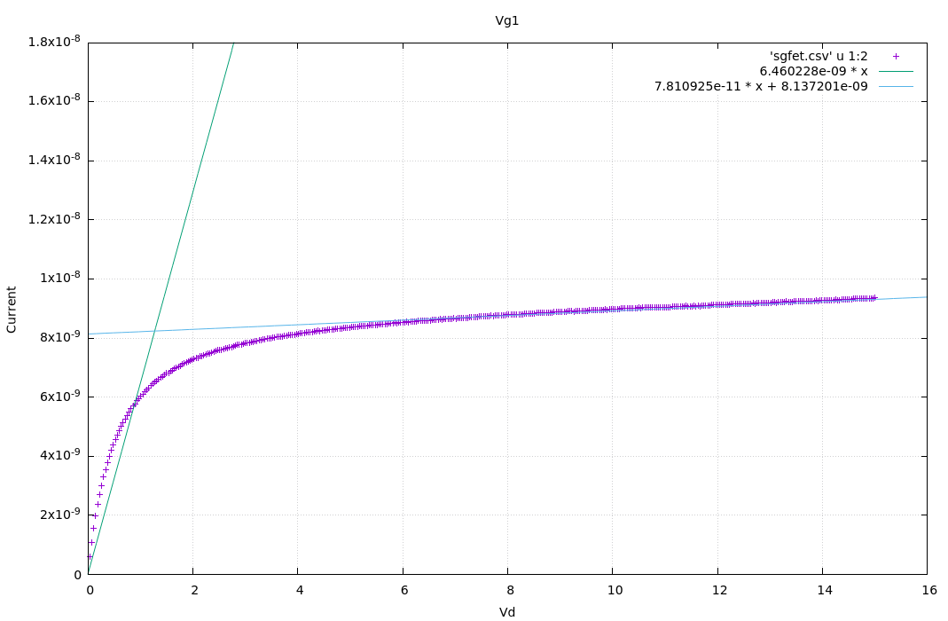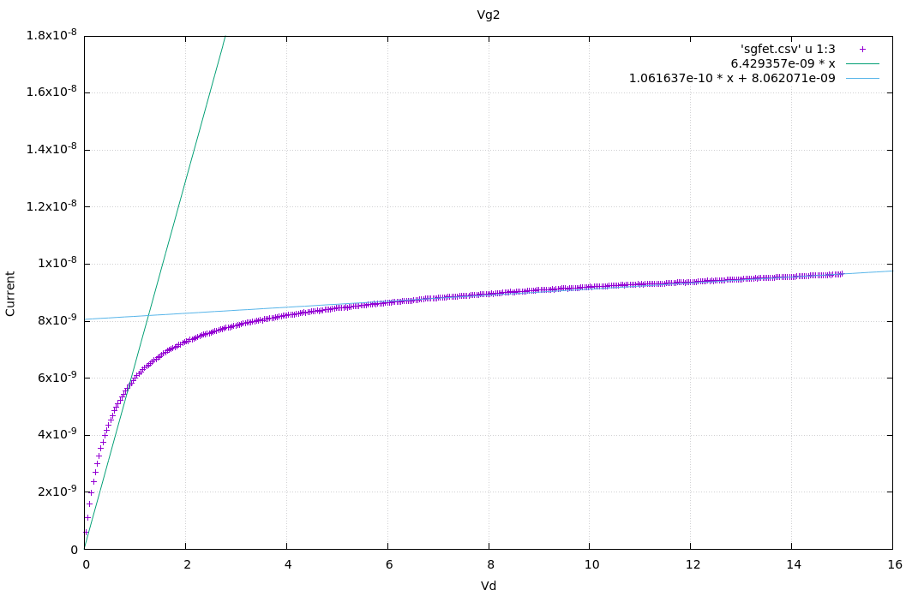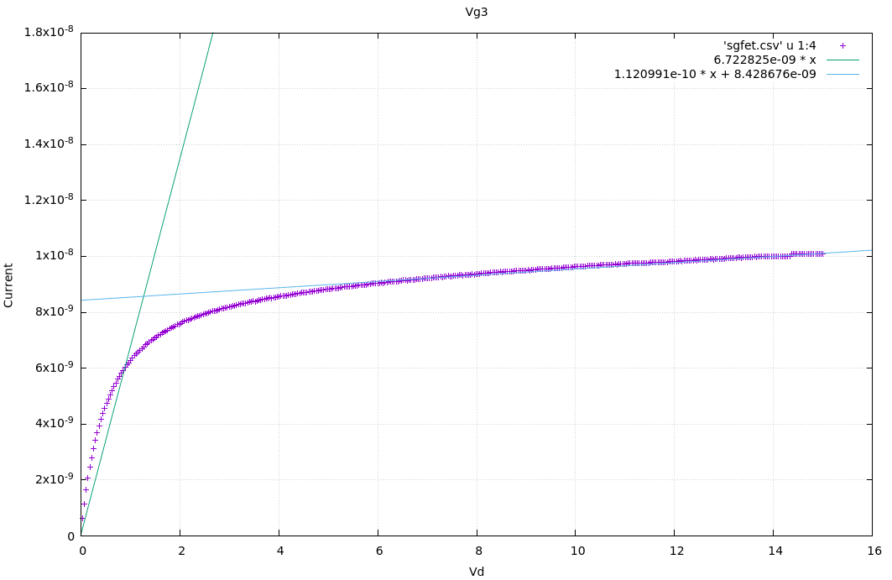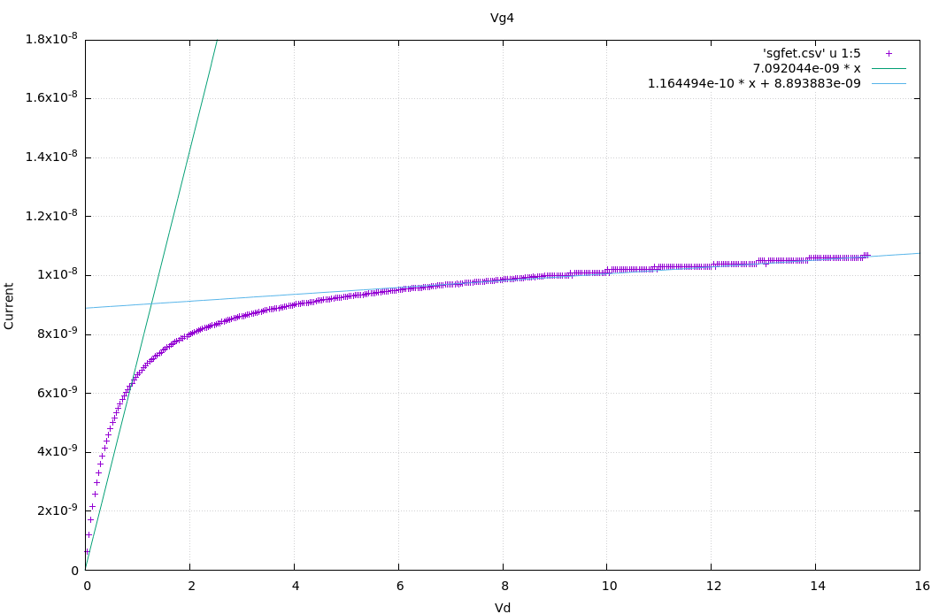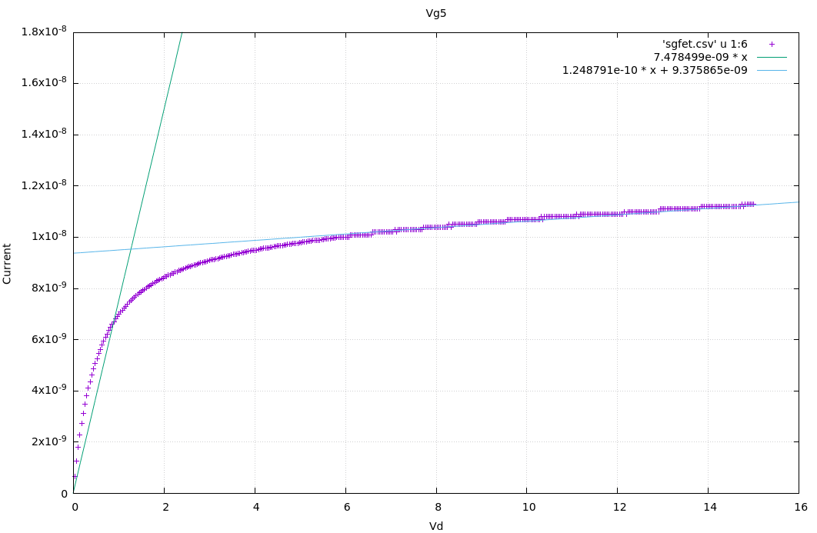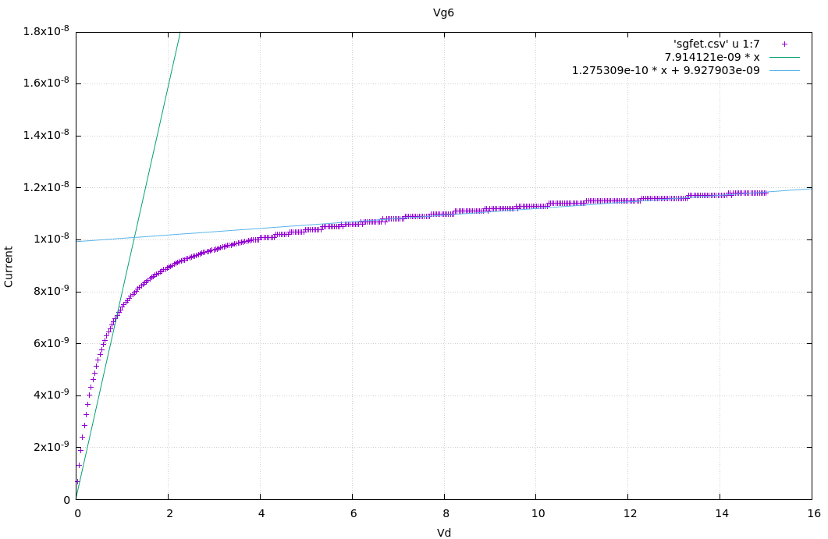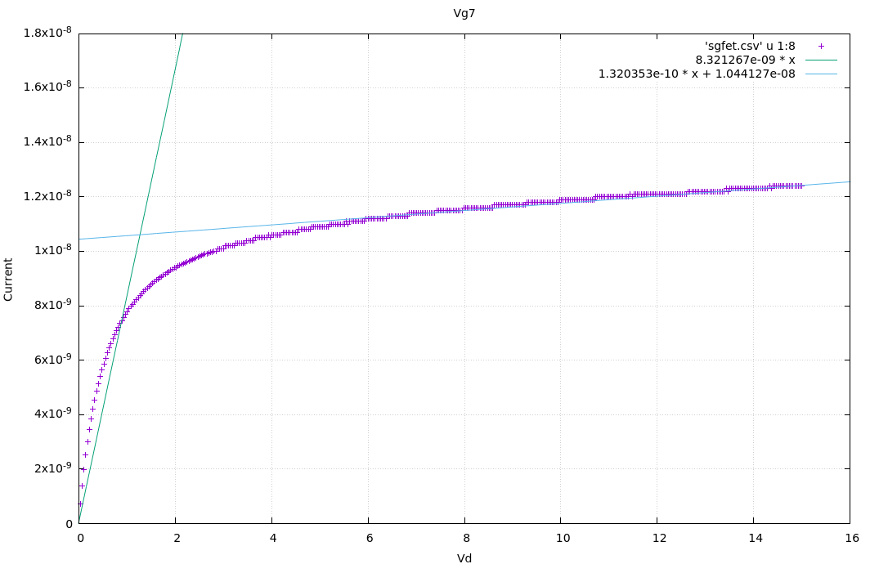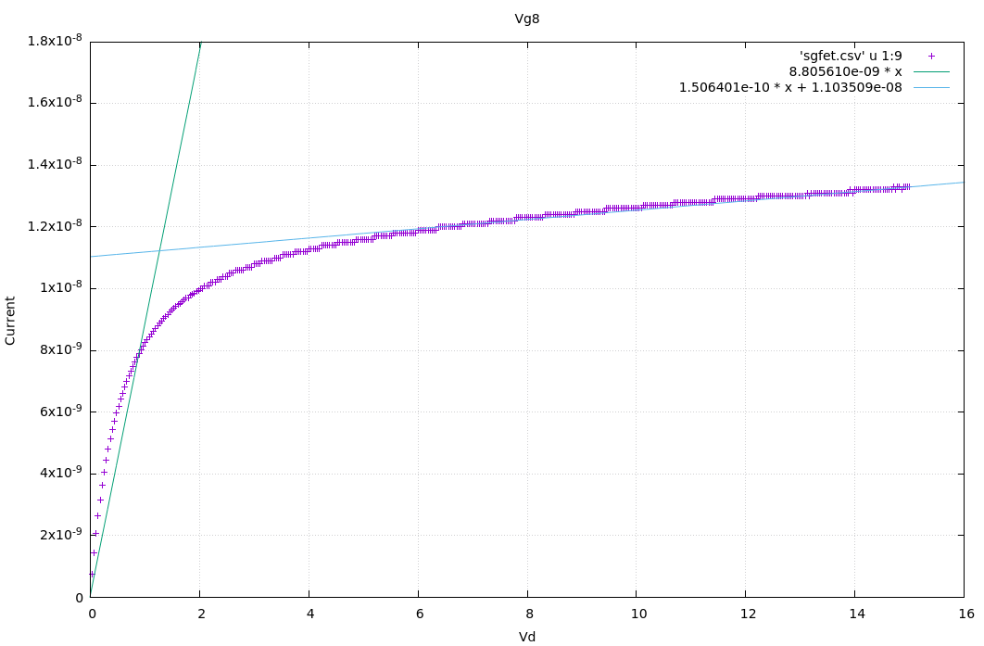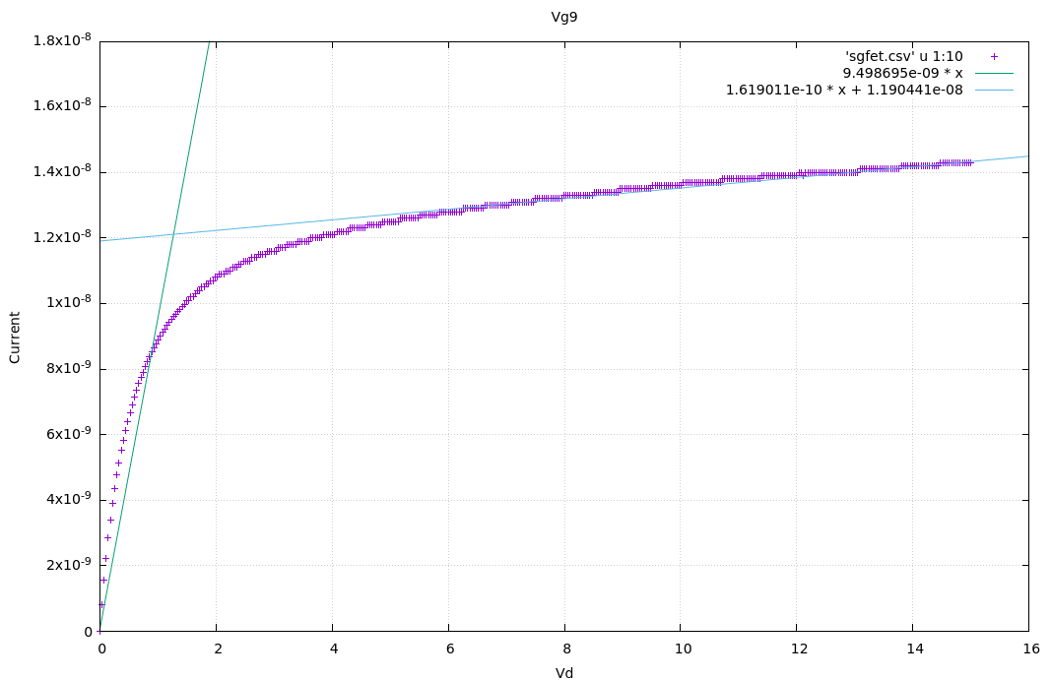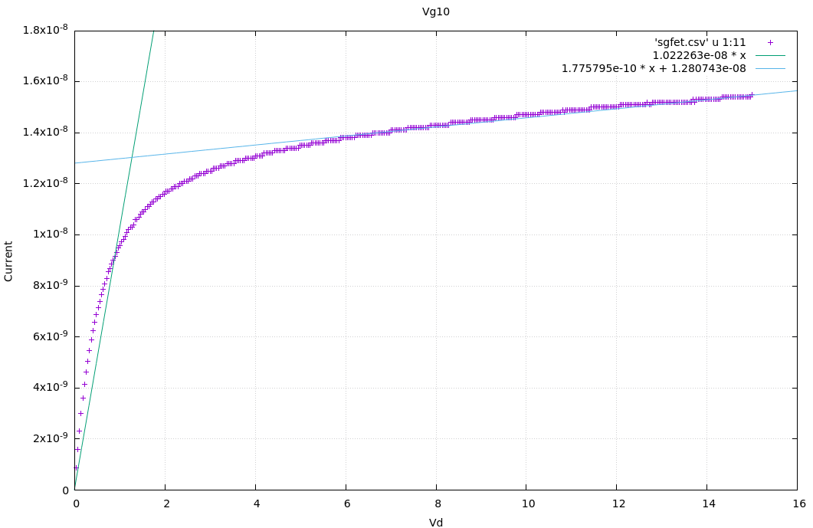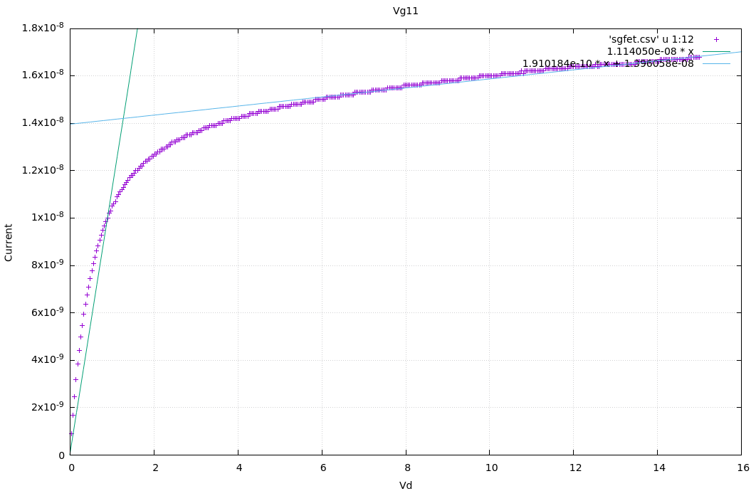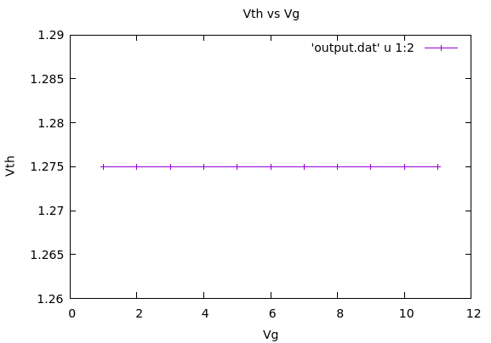

We see that the value of $V_{th}$ is constant for all $V_{g},$ which is expected as all the 11 Current vs $V_{g}$ graphs only differ by some factor along the $y$-axis, i.e. they seem to be merely stretched vertically. As $V_{th}$ is the $x$-coordinate of the intersection point, it will remain unchanged after any purely vertical stretching of the graph.

This is in accordance with the physical significance of $V_{th}$ for semiconductor devices.