*Display Student's Grade using shell*

A MINI- PROJECT REPORT ON

Submitted in partial fulfilment of the requirements

For the degree of

Bachelor of Engineering

In

Information Technology

By

**Soham Subhash Salkar 18IT1050**

**Riteshkumar Shivkumar Singh 18IT1068**

**Rahul Rajesh Modi 18IT2028**

Supervisor

Nilima Dongre



Department of Information Technology

Dr. D. Y. Patil Group’s

# **Ramrao Adik Institute of Technology**

Dr. D. Y. Patil Vidyanagar, Sector 7, Nerul, Navi Mumbai 400706. (Affiliated to University of Mumbai)

(2020)



# Ramrao Adik Institute of Technology

(Affiliated to the University of Mumbai)

Dr. D. Y. Patil Vidyanagar, Sector 7, Nerul, Navi Mumbai 400706.

CERTIFICATE

This is to certify that, Mini Project entitled

“*Display Student’s Grade using shell*”

is a bona fide work done by

**Soham Subhash Salkar 18IT1050**

**Riteshkumar Shivkumar Singh 18IT1068**

**Rahul Rajesh Modi 18IT2028**

And is submitted in the partial fulfilment of the requirement for the degree of

Bachelor of Engineering in

Information Technology to the University of Mumbai

Supervisor

Prof.Nilima M.Dongre

Project Guide Head of department

Nilima Dongre Dr. Ashish Jadhav

# Certificate of Approval by Examiners

This Mini Project report entitled “Display Student’s Grade using shell” is a bona fide work done by Student Names under the supervision of Prof.Nilima Dongre approved for the award of Bachelor Degree in Information Technology, University of Mumbai.

Examiners:

1. . . . . . . . . . . . . . . . . . . . . . . . . . . . . . .
2. . . . . . . . . . . . . . . . . . . . . . . . . . . . . . .

Supervisors:

1. . . . . . . . . . . . . . . . . . . . . . . . . . . . . . .
2. . . . . . . . . . . . . . . . . . . . . . . . . . . . . . .

Principal:

. . . . . . . . . . . . . . . . . . . . . . . . . . . . . .

Date:

Place:

# **TABLE OF CONTENTS**

**Declaration …………….…….………………………………………… I**

**Acknowledgement ……...……………………………………………… II**

**Preface …………….…………………………………………………… III**

**Abstract……...………………… VI**

## DECLARATION

We declare that this written submission represents our ideas in our own words and where others' ideas or words have been included, we have adequately cited and referenced the original sources. We also declare that we have adhered to all principles of academic honesty and integrity and have not misrepresented or fabricated or falsified any idea/data/fact/source in our submission. We understand that any violation of the above will be cause for disciplinary action by the Institute and can also evoke penal action from the sources which have thus not been properly cited or from whom proper permission has not been taken when needed.

**Name and Roll No. of Students Signature**

1. **Soham Subhash Salkar 18IT1050**
2. **Riteshkumar Shivkumar Singh 18IT1068**
3. **Rahul Rajesh Modi 18IT2028**

Date: 26-03-2020

Place: RAIT

## ACKNOWLEDGEMENT

The project “**Display Student’s Grade using shell**” is creative work of many minds. A proper synchronization between individual is must for any project to be completed successfully. One cannot imagine the power of the force that guides us all and neither can we succeed without acknowledging it.

We take this opportunity to express my profound gratitude and deep regards to our Guide **Nilima Dongre**, Department of the Information Technology Engineering for her or her exemplary guidance, monitoring and constant encouragement throughout the completion of this mini project.

We would like to express our gratitude to **Dr. Ashish Jadhav,** Head of the department, Information Technology Engineering for encouraging and inspiring us to carry out the project in the department lab. We take this privilege to express my sincere thanksare thankful to **Dr. Mukesh D. Patil, Principal RAIT,** for his constant support and motivation.

We also would like to thank all the staff members Department of the Information Technology

Engineering for providing us with the required facilities and support towards the completion of the project.

Last but not the least we are thankful to our parents and friends for their constant Inspiration, encouragement and well wishes by which we have made a challenging project.

STUDENT-NAME (ROLLNO) Signature

**Soham Subhash Salkar 18IT1050**

**Riteshkumar Shivkumar Singh 18IT1068**

**Rahul Rajesh Modi 18IT2028**

## PREFACE

We take great opportunity to present this Mini Project report on “**Display Student’s Grade using shell”** and put before readers some useful information regarding our project.

We have made sincere attempts and taken every care to present this matter in precise and compact form, the language being as simple as possible. We are sure that the information contained in this volume certainly prove useful for better insight in the scope and dimension of this project in it true perspective.

The task of the completion of the project though being difficult was made quite simple, interesting and successful due to deep involvement and complete dedication of our group members.

## ABSTRACT

This is a classic “taking the information from user and displaying it” program.

A student’s grades can be assessed by using this program.

Using the for loop, information for no.of students can be input in the program.

Using an if-else loop, a marking system is established.

Using the pre-calculated marking system, Distinction, first class, second class can be assigned to the data of the student .If student fails in the above criteria, he will assigned ‘fail’ value.

The following out comes for each student are saved and displayed on the screen in tabular format.

**SHELLCODE**

clear

echo -----------------------------------

echo '\tStudent Mark List'

echo -----------------------------------

echo Enter the Student name

read name

echo Enter the Roll number

read rno

echo Enter the Mark 1

read m1

echo Enter the Mark 2

read m2

echo Enter the Mark 3

read m3

echo Enter the Mark 4

read m4

echo Enter the Mark 5

read m5

tot=$(expr $m1 + $m2 + $m3 + $m4 + $m5)

avg=$(expr $tot / 5)

echo -----------------------------------

echo '\tStudent Mark List'

echo -----------------------------------

echo "Student Name :$name"

echo "Register Number:$rno"

echo "Mark1 :$m1"

echo "Mark2 :$m2"

echo "Mark3 :$m3"

echo "Mark4 :$m4"

echo "Mark5 :$m5"

echo "Total :$tot"

echo "Average :$avg"

if [ $m1 -ge 35 ] && [ $m2 -ge 35 ] && [ $m3 -ge 35 ] && [ $m4 -ge 35 ] && [ $m5 -ge 35 ]

then

echo "Result :Pass"

if [ $avg -ge 90 ]

then

echo "Grade :S"

elif [ $avg -ge 80 ]

then

echo "Grade :A"

elif [ $avg -ge 70 ]

then

echo "Grade :B"

elif [ $avg -ge 60 ]

then

echo "Grade :C"

elif [ $avg -ge 50 ]

then

echo "Grade :D"

elif [ $avg -ge 35 ]

then

echo "Grade :E"

fi

else

echo "Result :Fail"

fi

echo ---------------------------------

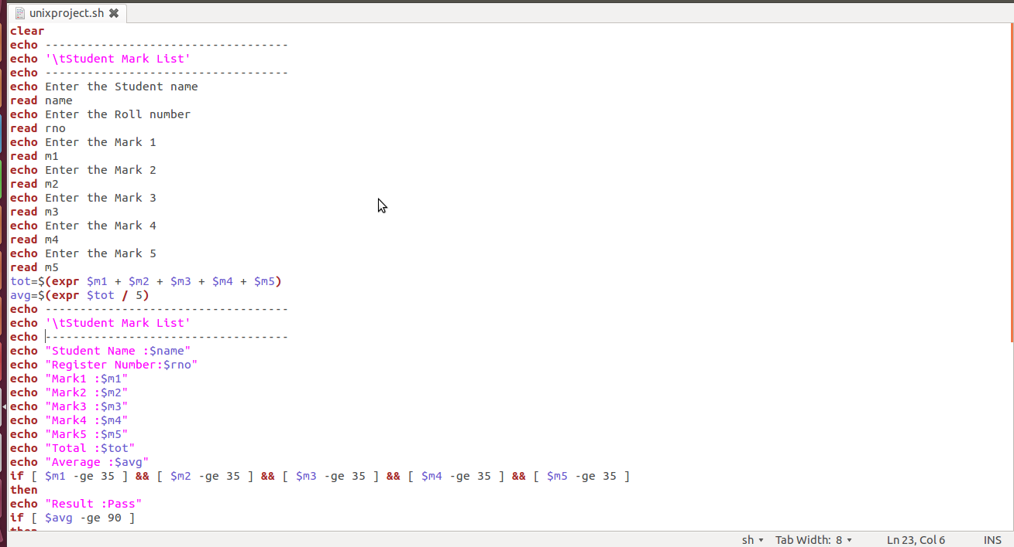

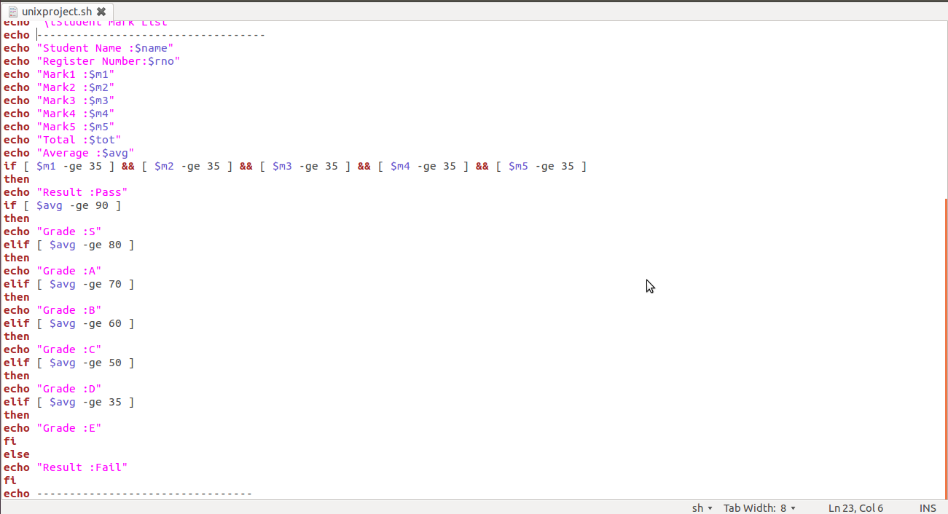

RESULT

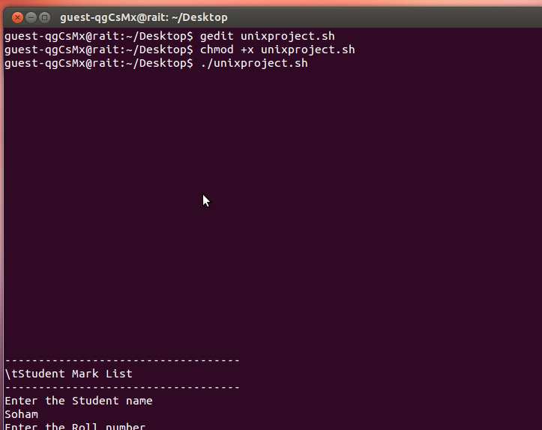

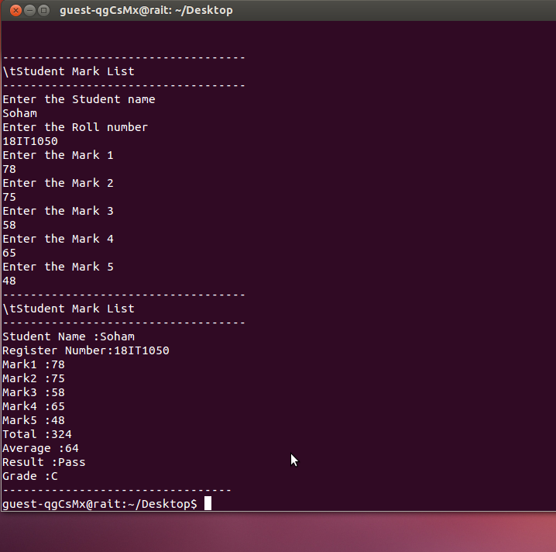

## Conclusion

From a proper analysis of positive points and constraints on the component , it can be safely concluded that the product is an efficient shell script based component. This application is working properly . This component can be easily plugged in many other systems.