

Bachelor of Computer Applications
Semester – V
Business Analytics
Experiment No: 2
Creating Power BI Visualizations for Sales Performance Analysis

Submitted By:
Name: Soham Sen
Reg. No.: 2411021240008
Date: 30/08/2026

Submitted To:
Faculty Name: Mr. Aman Kumar Sharma

Department of Computer Application
Alliance University
Chandapura - Anekal Main Road, Anekal
Bengaluru – 562106

Experiment No: 2
Creating Power BI Visualizations for Sales Performance Analysis
Problem Statement
You are a Data Analyst in a retail company. Management wants to quickly understand sales performance across different products, categories, and regions. Using the provided Sample Superstore dataset, create appropriate Power BI visualizations to identify key business patterns and support data-driven decision-making.
Methodology / Steps Followed
Step 1: Data Collection
- Obtained the Sample Superstore dataset in CSV format.
- The dataset contains retail transaction information such as:
  - Row ID
  - Order ID
  - Order Date
  - Ship Date
  - Customer ID
  - Segment
  - Country
  - City
  - State
  - Region
  - Product ID
  - Category
  - Sub-Category
  - Product Name
  - Sales
  - Quantity
  - Discount
  - Profit
Step 2: Data Import
A. Importing the CSV file:
1. Open Power BI Desktop.
2. Select Home → Get Data.
3. Select Text/CSV.
4. Select the Sample_ Superstore.csv file.
5. Preview the dataset.
6. Select Transform Data to open Power Query.

Step 3: Data Cleaning and Transportation
The imported dataset is checked and prepared using Power Query.
1. Check the column names.
2. Check for duplicate records.
3. Check for missing values.
4. Verify the data types.
5. Change incorrect data types where necessary.

Column | Data Type
Row ID | Whole Number
Order ID | Text
Order Date | Date
Ship Date | Date
Customer ID | Text
Segment | Text
Country | Text
City | Text
State | Text
Region | Text
Product ID | Text
Category | Text
Sub-Category | Text
Product Name | Text
Sales | Decimal Number
Quantity | Whole Number
Discount | Decimal Number
Profit | Decimal Number

6. Rename columns where necessary so that they are easy to understand.
7. Verify that numerical fields such as Sales, Quantity, Discount, and Profit have the appropriate numerical data types.
8. Select Close & Apply after completing the transformations.

Step 4: Data Modelling
- Go to Model View.
- Verify that the Sample Superstore table has loaded correctly.
- Confirm that the fields required for visualization are available:-
  - Sales
  - Profit
  - Quantity
  - Category
  - Sub-Category
  - Product Name
  - Region
  - Order Date

Step 5: Creating Sales Performance Visualizations
A. Total Sales KPI
Create a Card visual.
Fields:
Data:
- Sales
Power BI should automatically calculate:
Sum of Sales
Title
Total Sales

B. Total Profit KPI
Create another Card visual.
Fields:
Data:
- Profit
Title
Total Profit

C. Total Quantity KPI
Create another Card visual.
Fields:
Data:
- Quantity
Title
Total Quantity Sold
This shows the total number of units sold.

Step 6: Product-wise Sales Analysis
Create a Clustered Column Chart.
Fields
X-axis:
- Product Name
Y-axis:
- Sales
In the Filters pane:
1. Select Product Name.
2. Choose Top N.
3. Enter 10.
4. Under By value, select Sales.
5. Click Apply filter.
Sort the chart by:
Sales → Descending
Title
Top 10 Products by Sales

Step 7: Category-wise Sales Analysis
Create a Clustered Column Chart.
Fields
X-axis:
- Category
Y-axis:
- Sales
Turn on:
Format → Data labels → On
Title
Sales by Category

Step 8: Regional Sales Analysis
Create a Clustered Bar Chart.
Fields
Y-axis:
- Region
X-axis:
- Sales
Sort:
Sales → Descending
Turn on Data labels.
Title
Sales by Region

Step 9: Sub-Category Sales Analysis
Create another Bar Chart.
Fields
Y-axis:
- Sub-Category
X-axis:
- Sales
Sort by:
Sales → Descending
Title
Sales by Sub-Category

Step 10: Add Interactive Filters
Create three slicers:
Slicer 1 — Region
1. Select Slicer.
2. Add Region.
Slicer 2 — Category
1. Select Slicer.
2. Add Category.

Slicer 3 — Year
1. Select Slicer.
2. Add Order Date.
3. Select the Year level from the date hierarchy.

Final Dashboard Layout
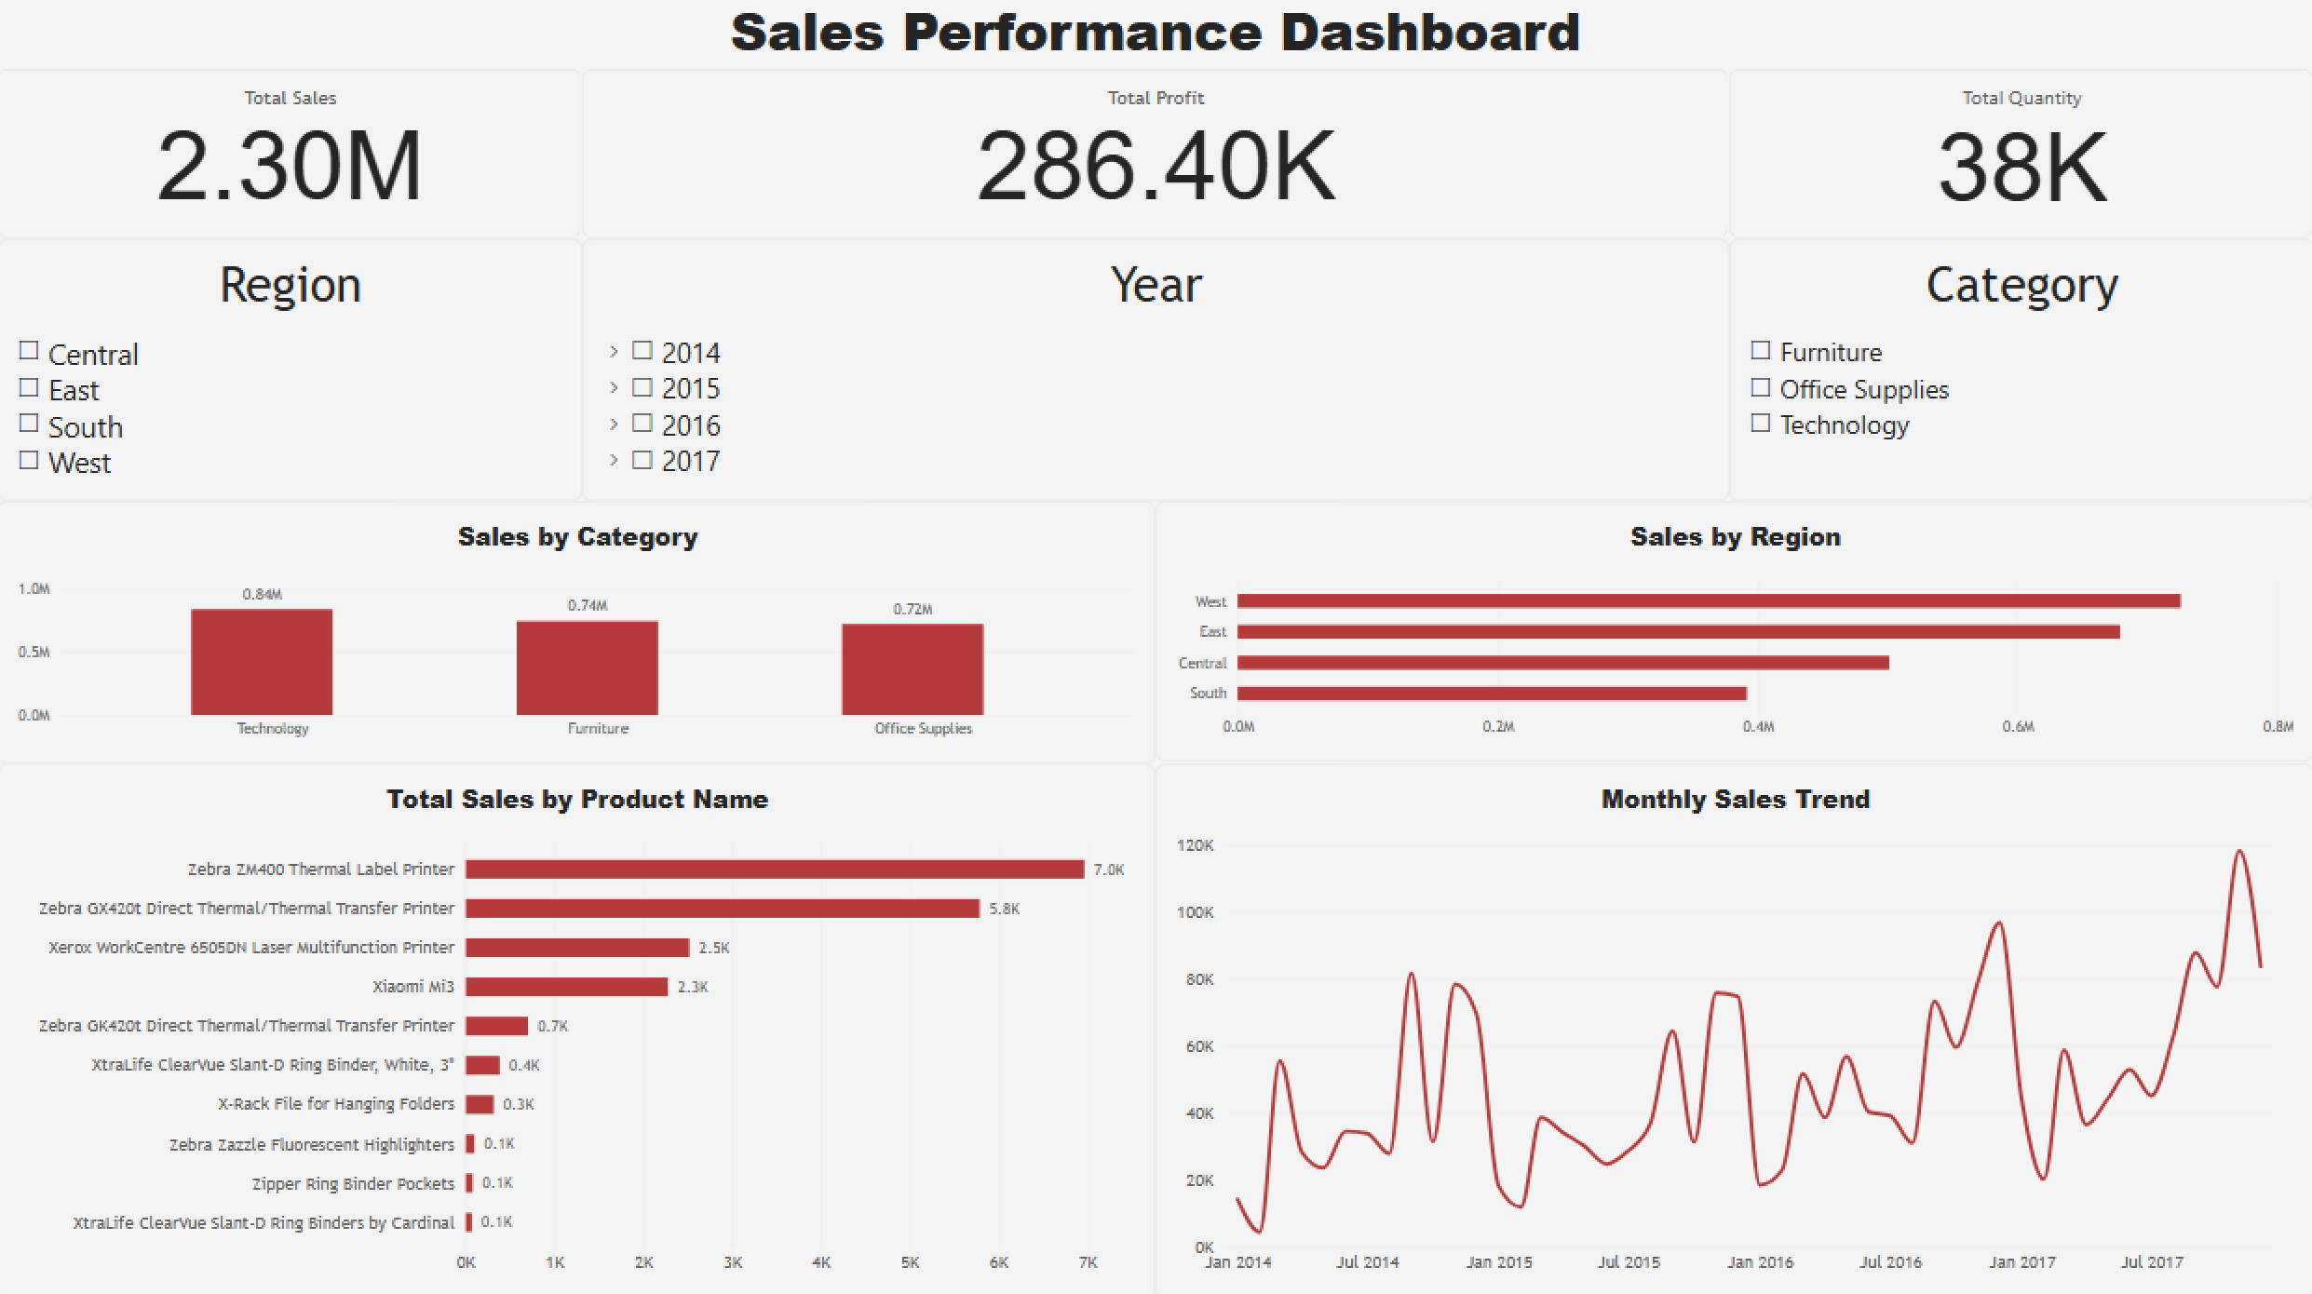

Output
The final Power BI dashboard provides:
- Total Sales Performance – Displays the overall sales generated from the retail transactions.
- Total Profit Analysis – Displays the overall profit generated from sales.
- Quantity Sold Analysis – Shows the total quantity of products sold.
- Product-wise Sales Analysis – Compares sales across the top-performing products.
- Category-wise Sales Analysis – Compares sales across different product categories.
- Sub-Category Sales Analysis – Provides a detailed comparison of sales across product sub-categories.
- Regional Sales Performance – Compares total sales across different regions.
- Interactive Data Visualization – Allows users to filter the dashboard using Region, Category, and Year slicers.
Conclusion
This project successfully uses Power BI to analyze retail sales performance using the Sample Superstore dataset. The data was imported from a CSV file, checked and prepared using Power Query, and used to create interactive business visualizations.
The resulting Power BI dashboard provides a centralized view of sales performance across products, categories, sub-categories, and regions. KPI cards provide an overview of total sales, profit, and quantity sold, while charts allow users to compare different areas of business performance.
The interactive slicers further allow users to analyze sales based on region, category, and year. This enables management to identify important business patterns and support data-driven decision-making.
Learning Outcomes
Through this project, I learned:
- How to import CSV datasets into Power BI.
- How to use Power Query for data cleaning and transformation.
- How to check and modify data types.
- How to create KPI cards for business analysis.
- How to create product-wise sales visualizations.
- How to analyze sales across different categories and sub-categories.
- How to analyze regional sales performance.
- How to create interactive slicers and filters.
- How to design an interactive Power BI business dashboard.
- How to identify meaningful business patterns from retail sales data.

