

Bachelor of Computer Applications
Semester – V
Business Analytics
Experiment No.: 1
Title: Importing business datasets from flat files & MySQL and
connecting with any other sources into Power BI

Submitted By:
Name: Soham Sen
Reg. No.: 2411021240008
Date: 20/08/2026

Submitted To:
Faculty Name: Mr. Aman Kumar Sharma

Department of Computer Application
Alliance University
Chandapura - Anekal Main Road, Anekal
Bengaluru – 562106

Experiment No.: 1
Importing Business Datasets from Excel/CSV & MySQL and Connecting with Other Sources into Power BI

Problem Statement
You are a Data Analyst in a retail company. Sales data is stored in Excel files, customer data in CSV files, and product information in another source. Management wants a centralized reporting system. Import data from multiple sources into Power BI, establish the required connections, and prepare the data for business reporting.

Methodology / Steps Followed

Step 1: Data Collection
- Obtained the retail sales dataset in CSV format from Kaggle.
- The CSV file contains retail transaction information such as:
  - Customer ID
  - Customer Name
  - Product ID
  - Product Name
  - Date
  - Quantity
  - Sales
  - Profit
  - Region
  - State
  - Outlet Type
  - Other retail-related fields
- Created a Customers table in MySQL containing customer information.
- The MySQL table contains:
  - Customer ID
  - Customer Name
  - Last Name
  - Date of Birth
  - Segment
- Used Customer ID as the common field between the CSV and MySQL data.

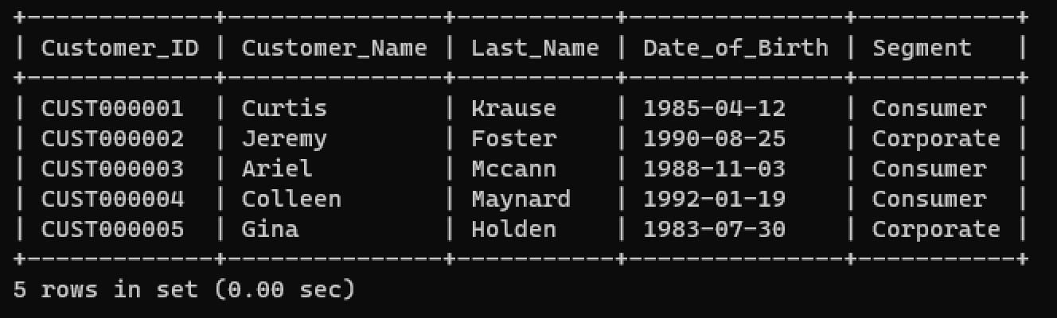
Step 2: Data Import
A. Importing the CSV file
- Open Power BI Desktop.
- Select Home → Get Data.
- Select Text/CSV.
- Select the store_sales_data (2).csv file.
- Preview the dataset.
- Select Transform Data to open Power Query.
B. Importing the MySQL data
- Select Home → Get Data → More.
- Search for MySQL database.
- Select the MySQL connector.
- Enter the MySQL server details.
- Enter the database name:
- retail_db
- Select Import as the storage mode.
- Enter the MySQL username and password.
- Select the Customers table.
- Select Transform Data.
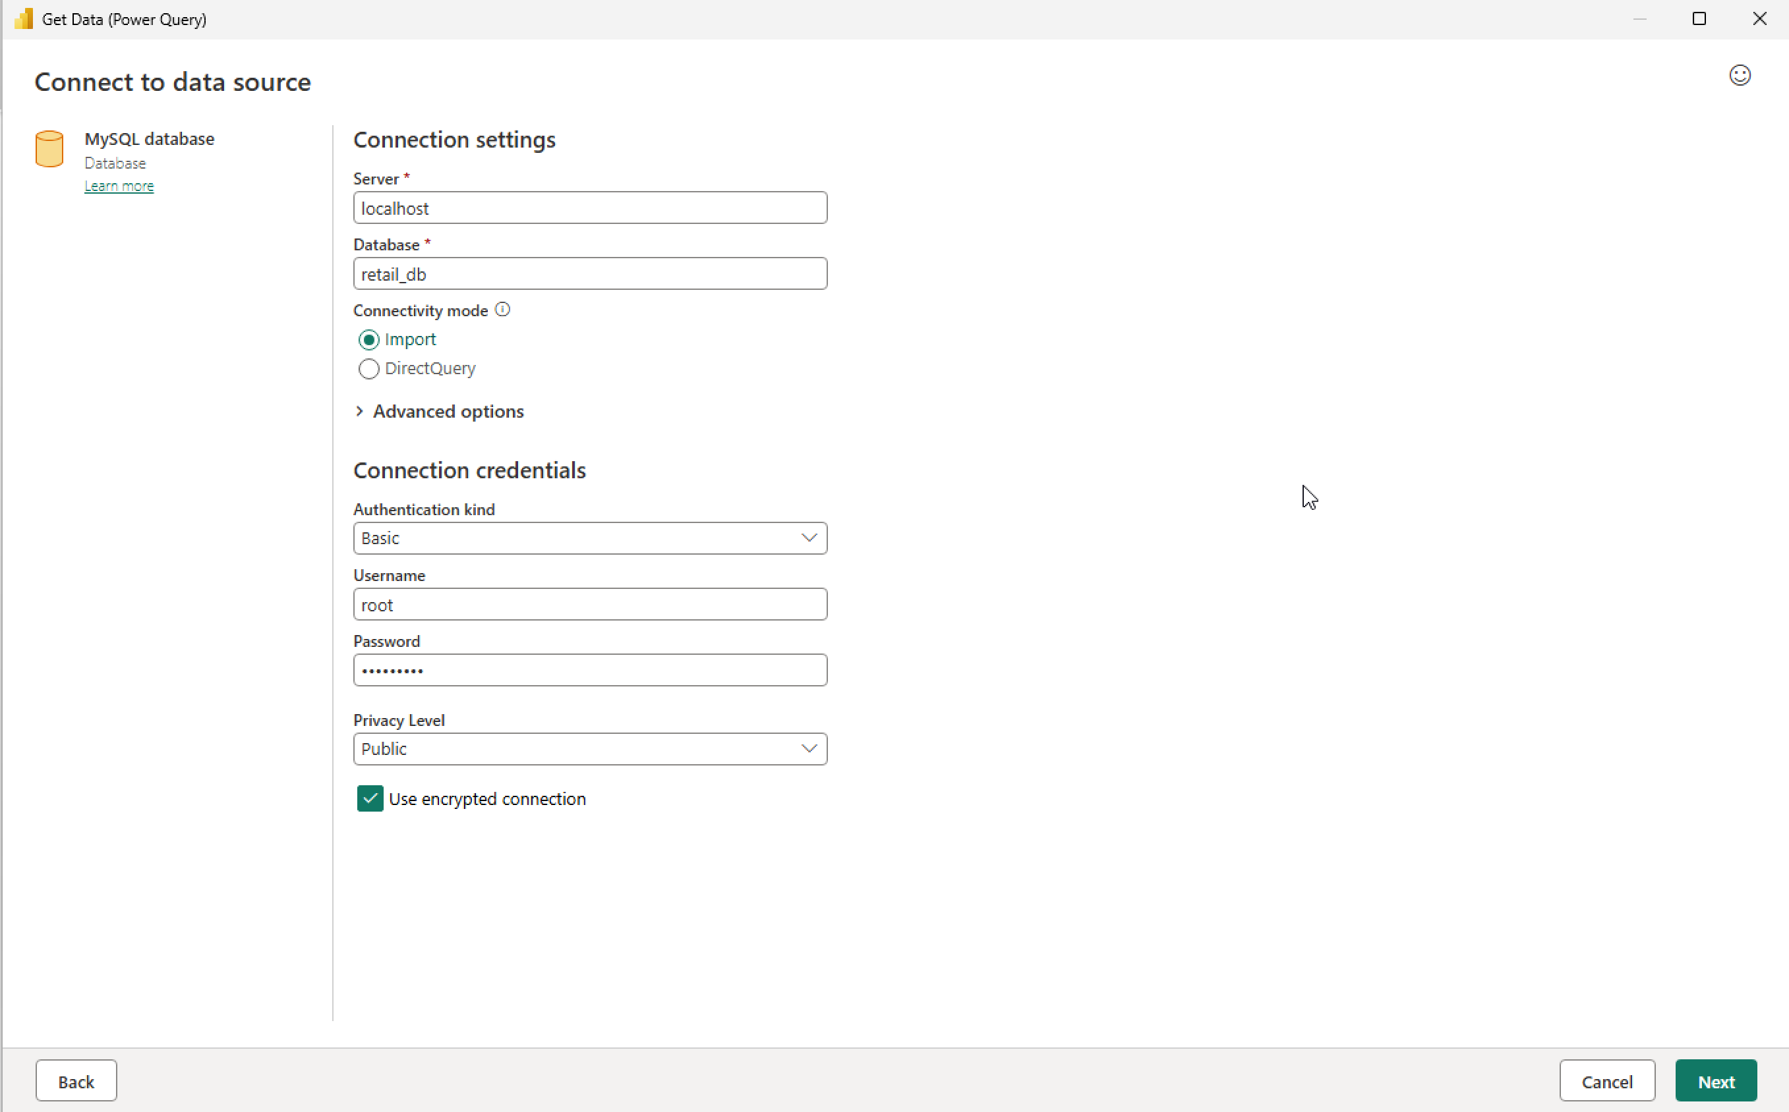
Step 3: Data Cleaning and Transformation
The imported data is checked and prepared using Power Query.
CSV dataset
- Check the column names.
- Check for duplicate records.
- Check for missing values.
- Verify the data types.
- Change incorrect data types where necessary.
Column | Data Type
Customer ID | Text
Customer Name | Text
Product ID | Text
Product Name | Text
Date | Date
Quantity | Whole Number
Sales | Decimal Number
Profit | Decimal Number
Region | Text
State | Text
Outlet Type | Text
MySQL Customers table
Column | Data Type
Customer_ID | Text
Customer_Name | Text
Last_Name | Text
Date_of_Birth | Date
Segment | Text

- Rename columns where necessary so that they are easy to understand.
- Verify that Customer ID and Customer_ID are both stored as Text.
- Select Close & Apply after completing the transformations.

Step 4: Data Modeling
After loading both datasets, open Model View in Power BI.
The two tables should be:
store_sales_data
│
│ Customer ID
│
▼
Customers
Create the relationship:
Customers[Customer_ID] → store_sales_data[Customer ID]
Set:
- Cardinality: One-to-many (1:*)
- Cross-filter direction: Single
- Active: Yes
The relationship should look approximately like:
┌──────────────────────┐
│ Customers │
├──────────────────────┤
│ Customer_ID 1 │
│ Customer_Name │
│ Last_Name │
│ Date_of_Birth │
│ Segment │
└──────────┬───────────┘
│
│ Customer ID
│
│ *
▼

┌─────────────────────┐
│ Store Sales Data │
├─────────────────────┤
│ Customer ID │
│ Product ID │
│ Product Name │
│ Date │
│ Quantity │
│ Sales │
│ Profit │
│ Region │
│ State │
│ Outlet Type │
└──────────────────── ┘
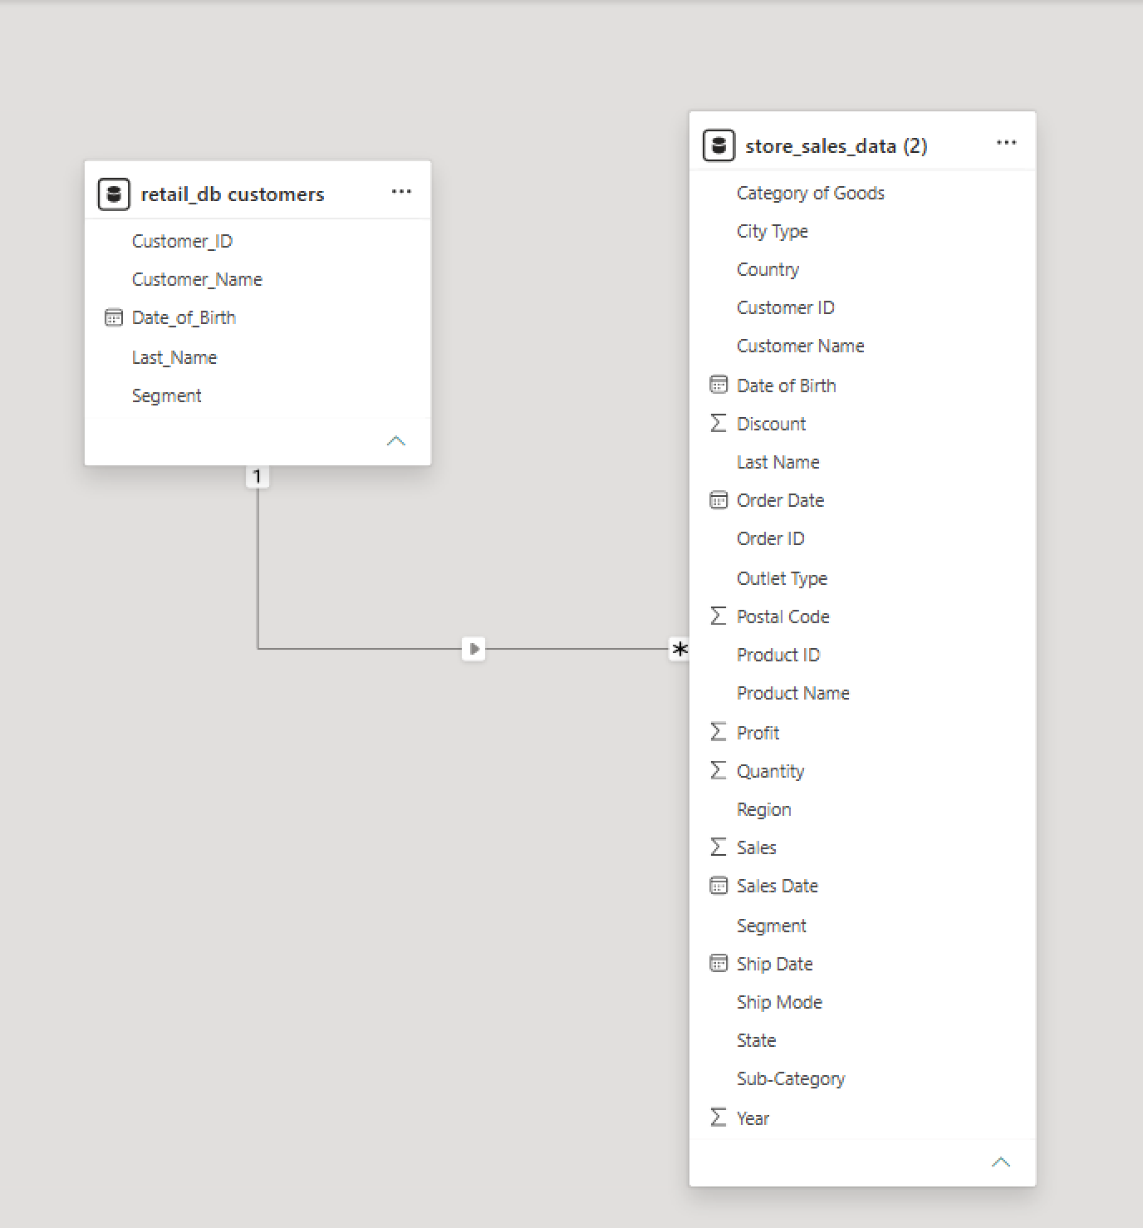
Output:
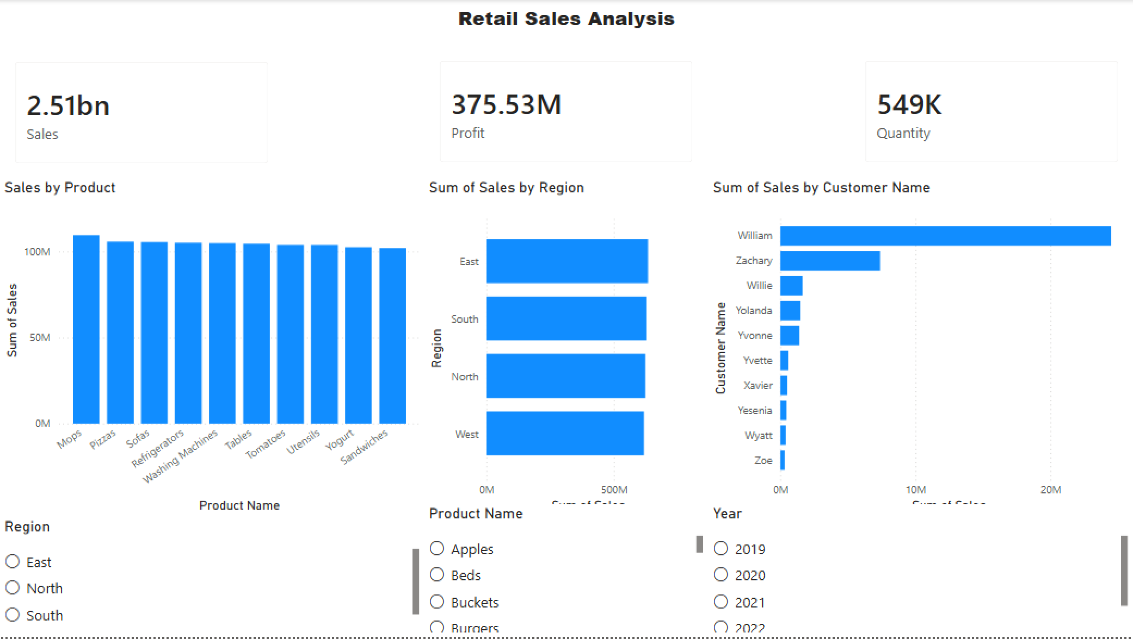
The final Power BI dashboard provides:
- Total Sales Performance – Total sales of 2.51 billion.
- Total Profit Analysis – Total profit of 375.53 million.
- Quantity Sold Analysis – Total quantity of 549K units.
- Product-wise Sales Analysis – Comparison of sales across different products such as Mobiles, Pizzas, Sofas, Refrigerators, Washing Machines, Tables, Tomatoes, Utensils, Yogurt, and Sandwiches.
- Regional Sales Performance – Comparison of total sales across the East, South, North, and West regions.
- Customer-wise Sales Analysis – Comparison of sales generated by individual customers.
- Interactive Data Visualization – The charts provide a visual overview of product, regional, and customer sales performance.
The dashboard provides a centralized view of the company's sales, profit, quantity, product performance, regional performance, and customer performance, helping users compare different aspects of retail business performance.
Conclusion
This project successfully integrates retail sales data from a CSV file and customer information from a MySQL database into Power BI. The data was cleaned and transformed using Power Query, and a relationship was established between the two datasets using Customer ID.
The resulting Power BI dashboard provides an interactive view of sales, profit, quantity, customers, products, locations, and time-based trends. This enables business users to analyze retail performance and support data-driven decision-making.
Learning Outcomes
Through this project, I learned:
- How to import CSV files into Power BI.
- How to connect Power BI Desktop to a MySQL database.
- How to use Power Query for data cleaning and transformation.
- How to check and modify data types.
- How to create relationships between tables from different data sources.
- How to use Customer ID as a common relationship key.
- How to create KPI cards and business charts.
- How to analyze sales by product, customer, location, and time.
- How to create interactive slicers and filters.
- How to design an interactive Power BI business dashboard.
- How to generate meaningful business insights from retail data.

