A
Project Report
on

(IoT-Based Smart Solar Energy Optimization System)

BTech IT, Sem II

Prepared By:
Priyanshi Patel
Gopi Vamja
Smit Varsada
Sohamsinh Sindhav
Guided By:
Prof. Kunal J. Sahitya
Dept. of Information Technology


Department of Information Technology
Faculty of Technology,
Dharmsinh Desai University
College Road, Nadiad - 387001

April, 2026

CANDIDATE'S DECLARATION
We declare that the 2th semester report entitled "Solar Tracker System" is our own work conducted under the supervision of our guide.

We further declare that to the best of our knowledge the report for B.Tech. II semester does not contain part of the work which has been submitted either in this or any other university without proper citation.

Candidate's Signature: ___________________

Candidate's Name: PRIYANSHI PATEL
Candidate's Signature: ___________________

Candidate's Name: GOPI VAMJA

Candidate's Signature: ___________________

Candidate's Name: SMIT VARSADA

Candidate’s Signature: ___________________

Candidate’s Name: SOHAMSINH SINDHAV
DHARMSINH DESAI UNIVERSITY
NADIAD-387001, GUJARAT

CERTIFICATE
This is to certify that the project carried out in the subject of Hardware Workshop, entitled "Solar Tracker Project" and recorded in this report is a bonafide report of the work of:

1) Priyanshi Patel Roll No.: IT150 ID No.: 25ITUOS150
2) Gopi Vamja Roll No.: IT141 ID No.: 25ITUOS141
3) Smit Varsada Roll No.: IT142 ID No.: 25ITUOS142
4) Sohamsinh Sindhav Roll No.: IT128 ID No.: 25ITUOZ128

of the Department of Information Technology, semester II. They were involved in project work during the academic year 2025-2026.

Prof. Kunal J. Sahitya
(Project Guide),
Department of Information Technology,
Faculty of Technology,
Dharmsinh Desai University, Nadiad
Date:
Prof. (Dr.) V. K. Dabhi
Head, Department of Information Technology,
Faculty of Technology,
Dharmsinh Desai University, Nadiad
Date:

ACKNOWLEDGEMENT
We extend our heartfelt gratitude to the Department of Information Technology, Dharmsinh Desai University, for providing us with the necessary resources, support, and an encouraging environment to undertake our project journey.

We sincerely thank our project mentor, Prof. Kunal J. Sahitya, for their unwavering support, insightful feedback, and invaluable guidance throughout the development of our project, "Solar Tracker Project”. Their mentorship played a crucial role in shaping our understanding and successfully bringing this project to fruition.

We also express our deep appreciation to our Head of Department for fostering a culture of innovation and continuous learning, and for their constant encouragement and support.

We would like to thank the medical professionals and hospital staff who provided valuable insights into the real-world challenges of IV monitoring and patient safety, helping us design a more practical and effective solution.

Lastly, we are grateful to all the faculty members and staff of the Information Technology Department for their guidance, as well as to our peers and classmates, whose feedback and motivation were instrumental throughout this journey.

Priyanshi Patel
Gooi Vamja
Smit Varsada
Sohamsinh Sindhav
B. Tech Semester II
Department of Information Technology
Dharmsinh Desai University

TABLE OF CONTENTS

ABSTRACT .............................................................................................................. Vii
TABLES ................................................................................................................... viii
1.List of Figures ............................................................................................. viii
2. List of Tables .............................................................................................. viii

1. Introduction ....................................................................................................... 01
1.1 Project Overview …………………………………………………………….. 01
1.2 Project Objectives ………………………………………………..………….. 02
1.3 Problem Statement ……………………………………………..…..……….. 02

Abstract

The Solar Tracker System is an IoT-based project designed to improve the efficiency of solar panels by continuously adjusting their position to follow the sun. Unlike fixed solar panels, this system ensures maximum sunlight exposure throughout the day, resulting in higher energy output.

The system uses Light Dependent Resistors (LDRs), a microcontroller (Arduino/ESP32), and a motor mechanism to detect sunlight intensity and move the solar panel accordingly. This project demonstrates the practical application of renewable energy systems, embedded systems, and automation.

Chapter 1: Introduction

1.1 Project Overview
The Solar Tracker System is designed to automatically track the sun’s movement and adjust the solar panel position to maximize energy absorption. It plays an important role in improving the efficiency of solar energy systems.

1.2 Key Features
• Automatic sunlight tracking
• Increased solar efficiency
• Eco-friendly system
• Low-cost and simple design
• Suitable for IoT integration

1.3 Project Objectives
• To design a solar tracking mechanism
• To increase efficiency of solar panels
• To demonstrate renewable energy usage
• To develop a cost-effective model

Chapter 2: Components Used

2.1 Solar Panel
Converts sunlight into electrical energy.

2.2 LDR Sensors
Detect light intensity and help determine direction of sunlight.

2.3 Microcontroller
Processes sensor data and controls motor movement.

2.4 Servo Motor/ DC Motor
Moves the solar panel towards the sunlight.

2.5 Battery
Stores electrical energy for system operation.

2.6 Connecting Wires
Used for circuit connections.

Chapter 3: Circuit Diagra

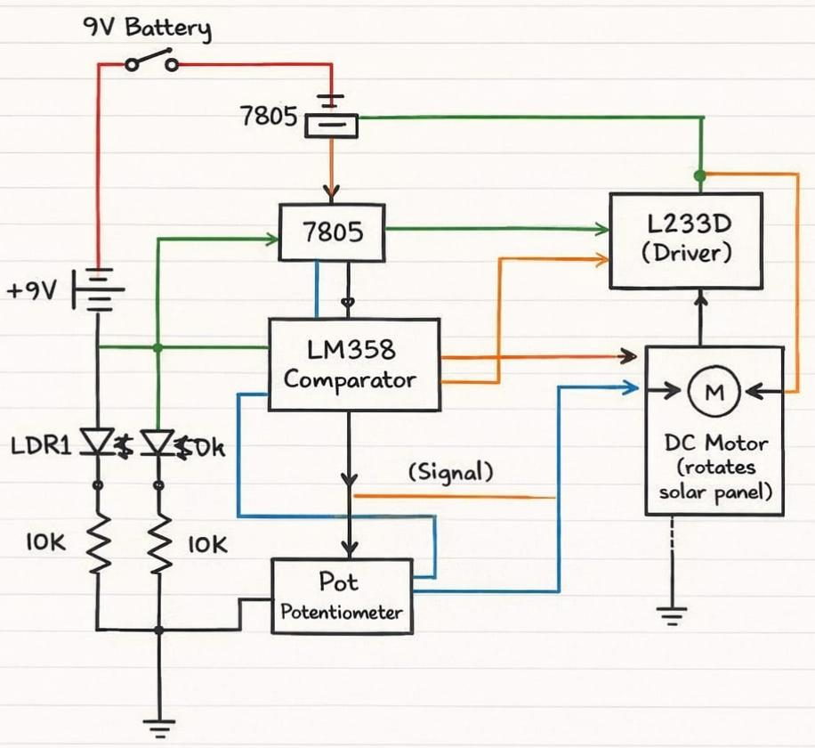
3.1 Circuit Description
• LDR sensors are connected to analog input pins
• Microcontroller processes signals
• Motor driver controls motor
• Motor adjusts solar panel direction

Chapter 4: Working Principle

4.1 Sunlight Detection
LDR sensors detect intensity of sunlight from different directions.

4.2 Signal Processing
Microcontroller compares LDR values and determines direction.

4.3 Panel Movement
Motor rotates panel toward higher light intensity.

4.4 Continuous Tracking
System continuously adjusts position throughout the day.

Chapter 5: Advantages

5.1 Efficiency Improvement
• Increases energy output by 30–40%

5.2 Environmental Benefits
• Renewable energy usage
• Reduces carbon footprint

5.3 Educational Value
• Demonstrates IoT and embedded systems
• Practical understanding of solar technology

Chapter 6: Estimated Cost

The following table provides an approximate cost breakdown for constructing the Solar Tracker. Actual prices may vary depending on the brand and quality of components purchased.

ITEM | PRICE
Solar Panel | ₹80 - ₹150
9V Battery | ₹40 - ₹50
LDR Sensors (×2) | ₹10 - ₹20
Gear Motor | ₹80 - ₹120
Custom PCB | ₹100 - ₹250
Control ICs | ₹40 - ₹70
Other Electronics | ₹30 - ₹50
Structure | ₹20- ₹40

Note: Total estimated cost is ₹400 – ₹750 depending on quality and brand of components. Cost-effective alternatives are available in local electronics markets.

Chapter 7: Limitations and Future Enhancements

8.1 Limitations
• Depends on weather conditions
• Limited battery storage
• Manual calibration may be required

8.2 Future Enhancements

• IoT monitoring via mobile app
• GPS-based solar tracking
• Dual-axis tracking system
• Improved battery storage

Chapter 8: Conclusion

The Solar Tracker System successfully demonstrates how solar energy efficiency can be improved using automation and embedded systems. It is an eco-friendly and cost-effective solution that highlights the importance of renewable energy.
This project provides valuable practical knowledge and can be further enhanced with IoT integration and advanced tracking systems

References

1.Solar Engineering of Thermal Processes
2.National Renewable Energy Laboratory (NREL) – www.nrel.gov⁠�
3.IEEE research papers on solar tracking systems
4.Datasheets of LM358 and L293D
5.Basic electronics resources and online tutorials on solar tracker circuits

