COL215 Mini Project
Final Report

Soham Gaikwad, 2018CS10394
Pushpendra Rana, 2018CS10371

Title: Bus/metro route display

Aim:
1. Display bus/metro routes on the computer screen using VGA interface.
2. Find the shortest path between any two given stations and display it on Screen.

Design:
- Generate raw input file (.txt/ .list etc.) of the route display image using python/matlab. The input file will contain pixel information for each of the 480*640 pixels in 1 byte. First 3 bits will correspond to Red, next 3 bits for Green and remaining two bits for blue.
- Store the input in memory using a memory unit which will store the pixel array.
- Clk generation unit: Generate 25 Mhz pixel clock
- VGA Controller Unit: used to generate VS and HS signal
VGA controller circuit generates the HS and VS timings signals and coordinate the delivery of data based on the pixel clock. The pixel clock defines the time available to display one pixel of information. The VS signal defines the "refresh" frequency of the display, or the frequency at which all information on the display is redrawn.The number of lines to be displayed at a given refresh frequency defines the horizontal "retrace" frequency. For a 640-pixel by 480-row display using a 25 MHz pixel clock and 60 +/-1Hz refresh.
The VGA controller circuit decodes the output of a horizontal-sync counter driven by the pixel clock to generate HS signal timings. We will use this counter to locate any pixel location on a given row. Likewise, the output of a vertical-sync counter that increments with each HS pulse can be used to generate VS signal timings, and we will use this counter to locate any given row.
- Helper component: acts as an interface between VGA controller and image stored in memory for the final output of the rgb given to the VGA port

Implementations:
- Completed Clk generation unit: Generate 25 Mhz pixel clock
- Completed VGA Controller Unit: used to generate VS and HS signal
- Memory Unit: Used IP core catalog in Vivado to create a block RAM and initialized it using coe file generated
- Image generation unit : added functions to draw line on monitor given two points (x1, y1) and (x2, y2) and tested it on monitor.
- Made VHDL compatible algorithm for finding shortest path between source and destination.
- Implemented dijkstra’s algorithm

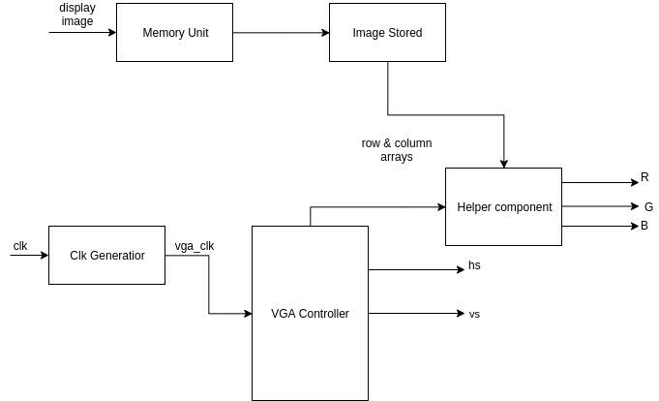
Block diagram

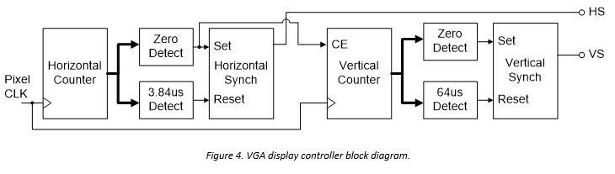

Route Map display:
256*256 px map
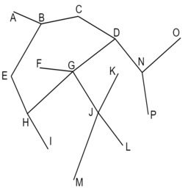

State Diagram for finding shortest path using dijkstra’s algorithm:

STATES -
1. idle : idle state, waiting for start signal
2. s0 : initialize curr_min with source row and def min with max value
3. s1 : find the minimum of curr_min not in not definitely maximum, i.e. not in def_min
4. s2 : assign def min at min_col to the new minimum
5. s3 : go to s1 if def_min not full, else done
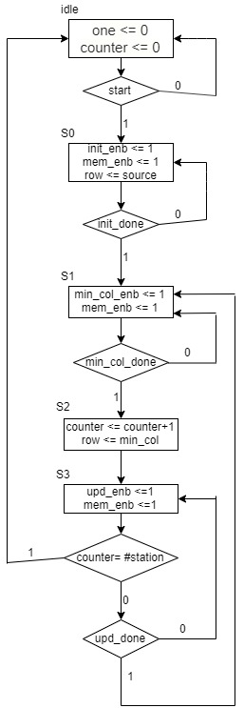

ASM chart for dijkstra algo on fpga

Testing
1. hysnc and vsync signals
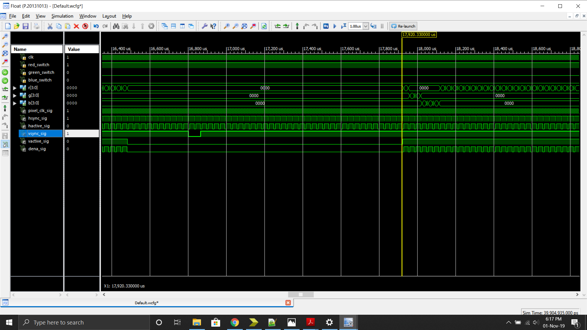

2. dijkstra algo
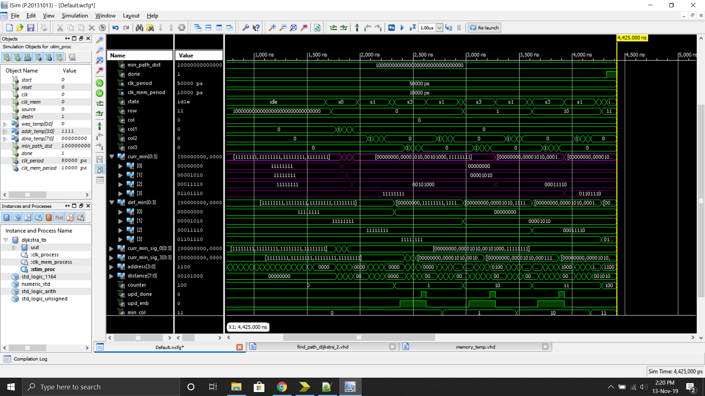
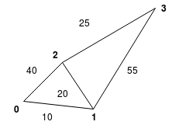
Tested case 1:

Correctly found and stores shortest path between various stations.

Learnings
We learned how to develop and implement complex algorithms on fpga board. We also learned various new concepts in vhdl like generate statements, functions etc.
Overall a good learning experience.

