COL334/672: Assignment 4

- We have the following topology: a sender communicating to a receiver via a series of two routers. Packets are of size s, the transit links have a transmission rate of r, while the access link operates at half the rate of the transit links. The round trip propagation delay is 4s/r, hence within an RTT of 8s/r the access link can just about support a window size of 4 packets. Ignore acknowledgement sizes.

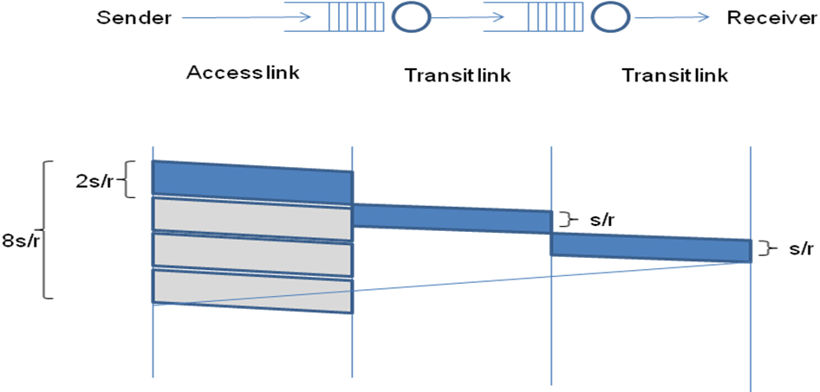

Consider the following packet trace at the sender using a transport protocol similar to TCP. The y-axis indicates sequence numbers in bytes – long vertical rectangles are packets and each packet is 100 bytes long, thus the first packet contains data from sequence number 0 to 99, the second packet from sequence number 100 to 199, etc. The x-axis indicates time in units of s/r. The small stubs are acknowledgement numbers – thus, the stub at time 9 (after one RTT) is the cumulative acknowledgement for the first packet with sequence number 0 to 99, the stub at time unit 11 is the cumulative acknowledgement for the second packet, etc.

The congestion window indicates the maximum number of unacked packets that can be sent. Assume this window size to be fixed and much greater than 4 packets – this implies that the sender will try to push out a packet every 2 time units, which is the maximum transmission rate its access link allows.

Also assume for simplicity that no acknowledgements are lost and no reordering occurs.

Fast retransmission is triggered upon getting triple duplicate acks, taking into account the very first ack as well.

Now explain the packet trace below.

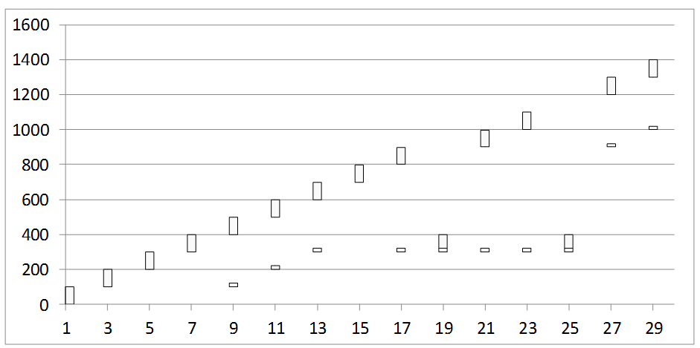

    - Packet 300-399 seems to have been lost. What triggers the retransmission of the lost packet?
Fast retransmission is triggered by the three duplicate 300 acks received at time 13, 17 and 19.

    - The acknowledgement received at time 21 was generated at the receipt of which packet at the receiver?
The packet sent at time 13.

    - Why is the acknowledgement at time 21 still referring to the lost packet even though it has been retransmitted?
Because the lost packet (300-399) is sent at time 19 and is yet to reach the destination at the time the ack (for packet sent at time 13) was sent.

    - Why is the lost packet again retransmitted at time 25?
Because of fast retransmission triggered by three duplicate 300 acks received at time 21, 23 and 25.

    - Why is there a sudden jump in the acknowledgement number at time 27? The acknowledgement was generated at the receipt of which packet?
The ack was generated at the receipt of packet sent at time 19 which contained the lost 300-399 packet. So, with this all 0-899 packets were received (which were buffered at receiver’s end) and now the 900 ack is sent.

- In another variant, the initial congestion window size is started at 4 packets, and the window is incremented fractionally by (1 / int(current window size)) upon receiving an acknowledgement. Thus, a window size of 4 will increment to 5 after having received 4 acknowledgements (4.25 after the first ack, 4.5 after the second ack, 4.75 after the third, and 5 after the fourth ack). Note that packets are dispatched only if they can be accommodated fully within the window, ie. even with a window of 4.75 only four outstanding packets will be allowed.

The window size also reduces to half upon receiving triple duplicate acknowledgements which is seen as an evidence of packet loss. Note that receipt of the third dup ack will not increment the window, ie. if the window is 5 when the third dup ack arrives, it will just be reduced to 2.5, and not add another 1 / int(2.5) increment for this ack as is done for other acks. Also note that the event of a triple dup ack is also interpreted as a loss, and hence the number of outstanding packets will be assumed to be one less than what was it estimated to be earlier. This is almost identical to TCP operations in the congestion avoidance phase.

Answer the following questions. Hint: Maintain two variables for congestion window and the outstanding data to understand what is happening.

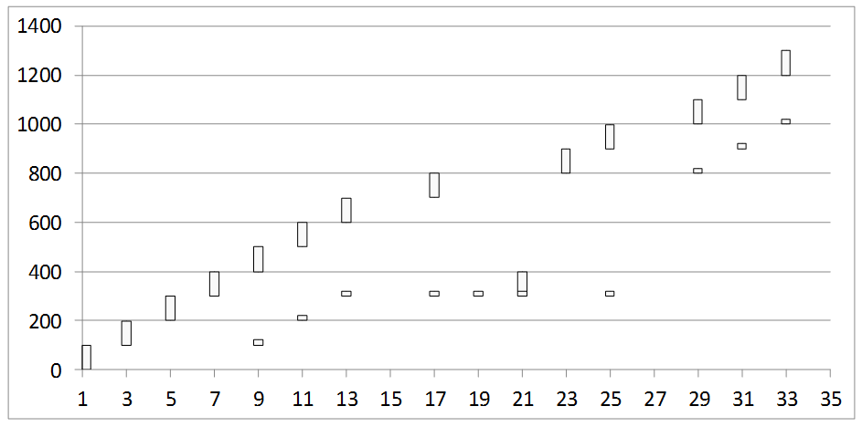

    - What is the window size at time 17?
5

    - What is the window size at time 19? Why is no packet pushed out at time 19?
Window size at time 19 is 2.5 which is half of earlier window of 5 due to the triple duplicate 300 acks. The number of outstanding packets at time 17 was 4 and after receiving an ack at time 19 it becomes 3, but as this is a triple dup ack, the number of outstanding packets at time 17 is one less i.e. 2. Hence no packet is pushed at time 19 as otherwise there would be 3 packets which cannot be accommodated in window size of 2.5.

    - What is the window size at time 21? What is the outstanding data estimated by the sender at time 21?
Window size at time 21 = 2.5 + 1/(int(2.5)) = 2.5 + 0.5 = 3. The number of outstanding packets at time 19 was 2 and after receiving an ack at time 21, it becomes 1 which can be accommodated in window of 3. So, another packet is sent at time 21 and number of outstanding packets become 2.

    - Why is a packet pushed out at time 23 even though no ack is received at that time?
Window size at time 23 is 3 as no ack is received. The number of outstanding packets at time 21 was 2 (as explained in previous question) and since 3 packets can be accommodated in window of 3, one more packet is sent even though no ack is received. After pushing out a packet at time 23, the number of outstanding packets become 3.

    - What is the window size at time 31?
4

- Now consider a different scenario where the access link is very fast but the next link is slower.
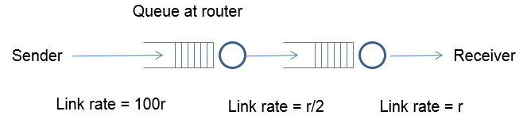
Assume an initial window size of 8 this time. As in the previous question, the window size is reduced to half upon receiving triple duplicate acknowledgements, and it is incremented by 1 / int(congestion window) upon receiving an acknowledgment. A timeout occurs if the last unacked packet goes unacknowledged for more than 25 time units. The buffer size at the first router is limited, and it follows a drop-tail policy. Assume that all packet losses happen due to buffer overflow at the first router. Answer the following questions:

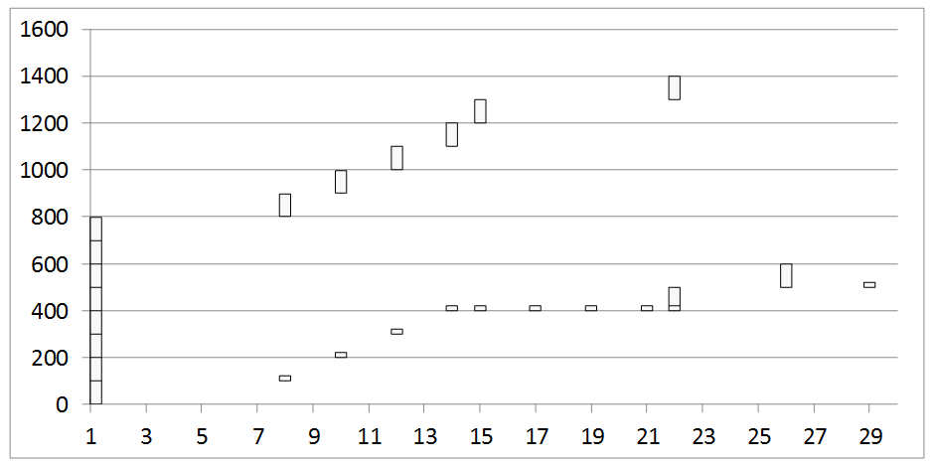

    - What is the RTT in this case?
Round trip propagation delay = s/100r + 2s/r + s/r = 301s/100r. So RTT is 301s/50r or 6.02s/r.
For first packet (with no buffer): 7 units
For second packet: 8 units…

    - Can you infer the buffer size at the first router? How?
Three dup acks are observed for the 400 packet which means that 5th packet was lost. So buffer size at first router must be of the size of 4 packets i.e. 400 bytes.

    - Why is there no retransmission at time 17 despite a triple dup ack? Why does this retransmission happen later at time 22? Why do two packets get fired off at time 22?
5 acks were received till time 15, so window size was increased by 1/8 five times at time 15. So window size at time 15 is 8 + 5/8 = 8.625 with 8 outstanding packets. At time 17, triple dup acks is encountered and window size is halved; it becomes 4.3125. Also after receiving an ack at time 17, the number of outstanding packets become 7, but since there was a loss (triple dup ack), the number of outstanding packets at time 17 is one less i.e. 6. Now 6 is already greater than the window size of 4.3125, so no more packets can be sent and there is no retransmission.
Three acks are received at time 19, 21 and 22 with no retransmission, so unacked packets at time 22 becomes 6 – 3 = 3. Also the window size gets incremented by ¼ = 0.25 three times at time 19, 21 and 22. So at time 22, window size becomes 4.3125 + 3*0.25 = 5.0625. As unacked packets are 3, 2 more can be accommodated and hence two packets get fired off at time 22.

    - When did a timeout occur? Which packet gets timed out?
Timeout occurs at time 26 as no acknowledgement for 500-599 packets is received for 25 time units. Hence we also see a retransmission of 500-599 packet because of this timeout.

- Consider now a scenario where the buffer size at the first router is very large so that no drops occur. Answer the following questions:

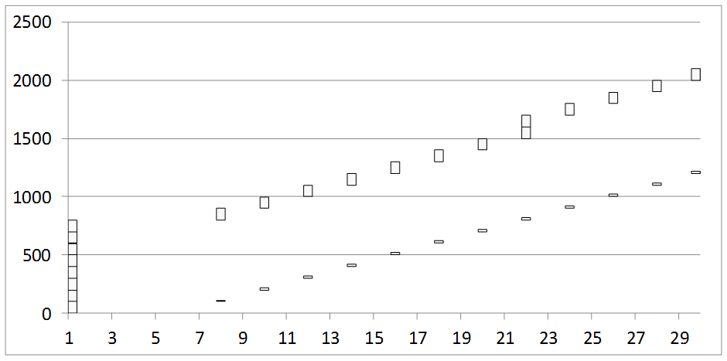

    - What is the round trip time clocked for the first packet? For the fifth packet? For the eighth packet?
RTT for first packet = 7 units as it is sent at t=1 and received at t=8
RTT for fifth packet = 15 units
RTT for eighth packet = 21 units

    - When is the window size increased to 9?
At time 22 when 8 acks have been received.

    - Since the buffers are assumed to be large enough, there will be no drops and the window size will keep increasing each time a complete round of acknowledgments for the current window are received. What is the problem with such a network?
When buffer gets large, queuing delay will also increase.

    - Suggest a method to trigger a window size reduction in such a scenario, without witnessing any loss events.
Decrement window size by some factor (say half) after some constant number of acks received or timeout occurs.

