End of semester project
Name:Soham Sonar
Report

Evaluation
- Deploying 8 peers. They can be set up on the same machine or different machines.
  - Ensure all APIs are working properly.
1. Started All the nodes
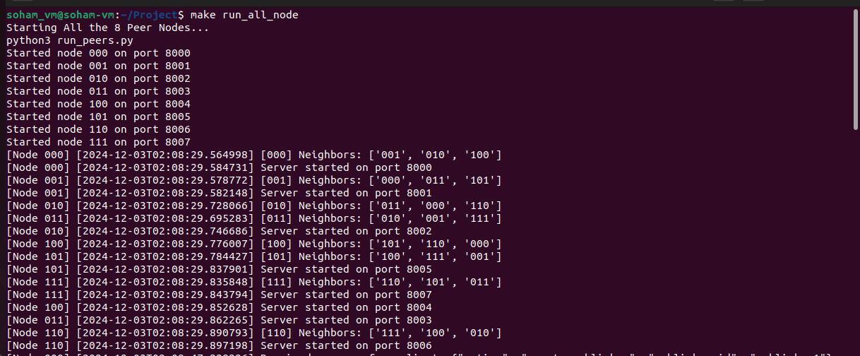
2. All APIs working properly
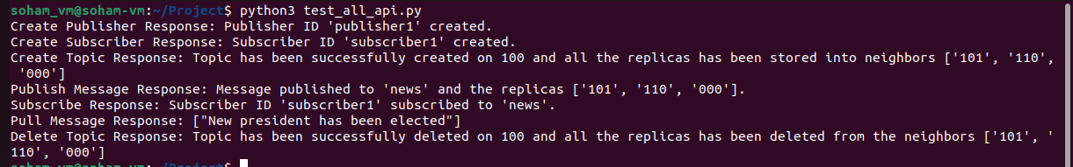
  - Ensure multiple peer nodes can simultaneously publish and subscribe to a topic.
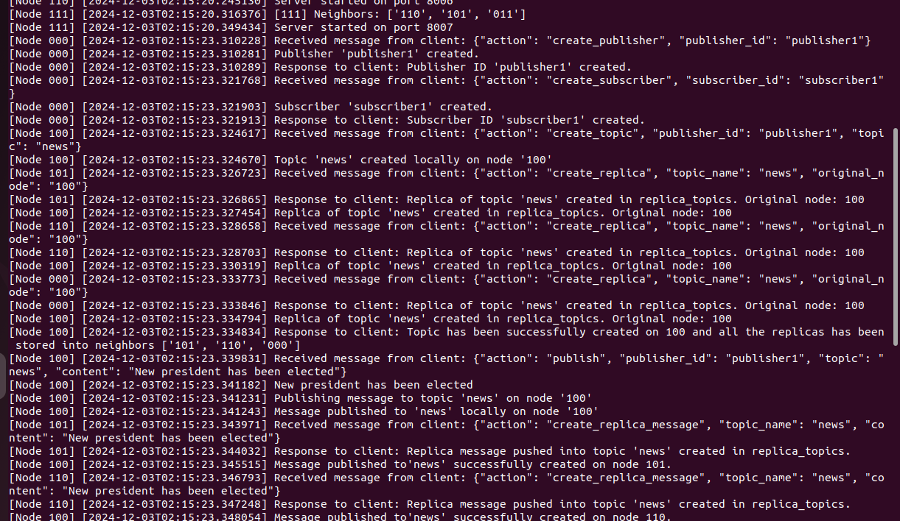
- Deploy enough peers. Prove topics can be correctly replicated on the right node.
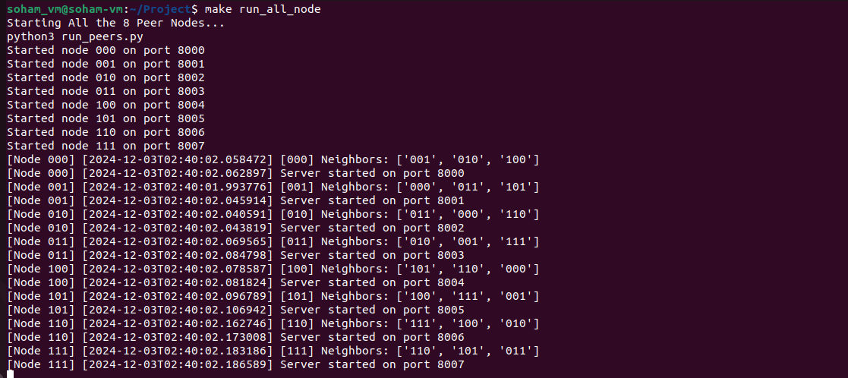

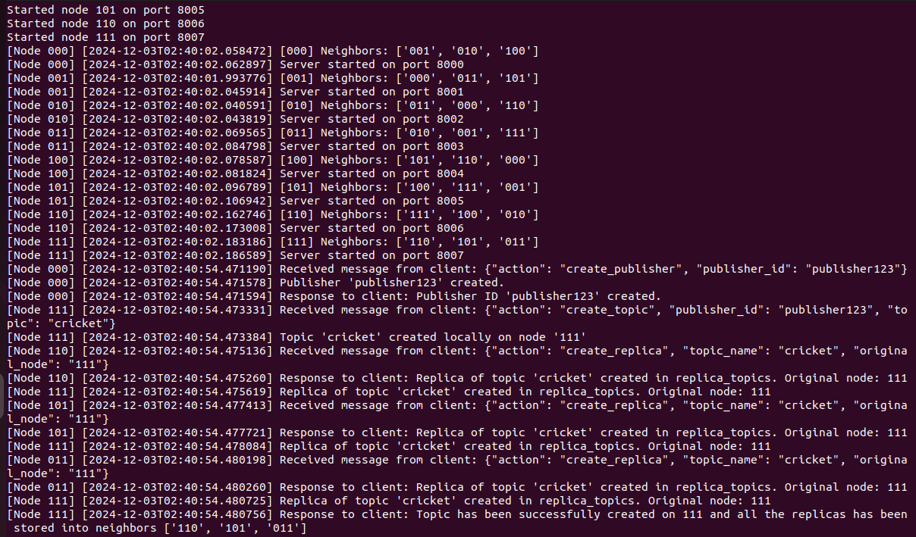
- Deploy enough peers. Prove a failed node can recover to the state before the failure.

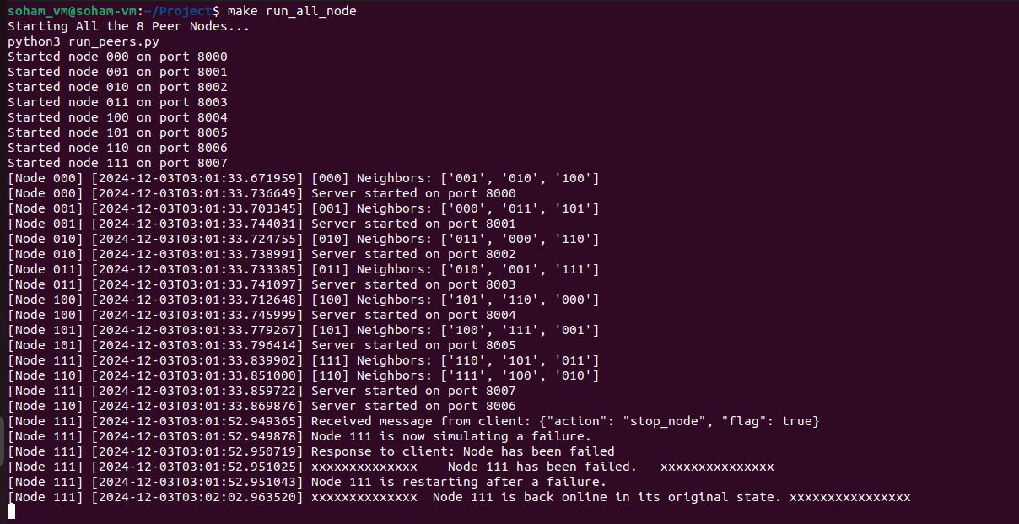
- Deploy enough peers. Prove when a node comes online, it can recover to the state before failure (if that’s the case) and fetch all topics belonging to it from other (if exists).
Running all nodes -
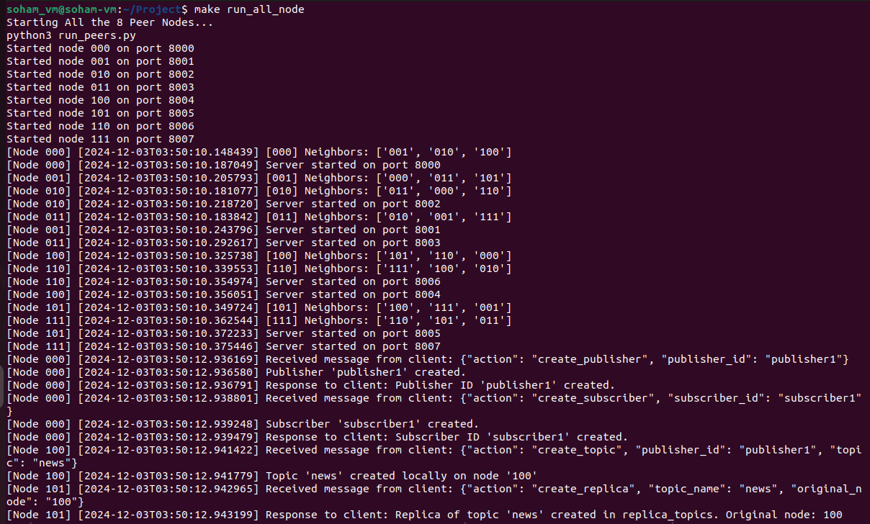
initially creating topics and publish message, then server is failed and after server is restored subscribing and pulling the original topic and message.
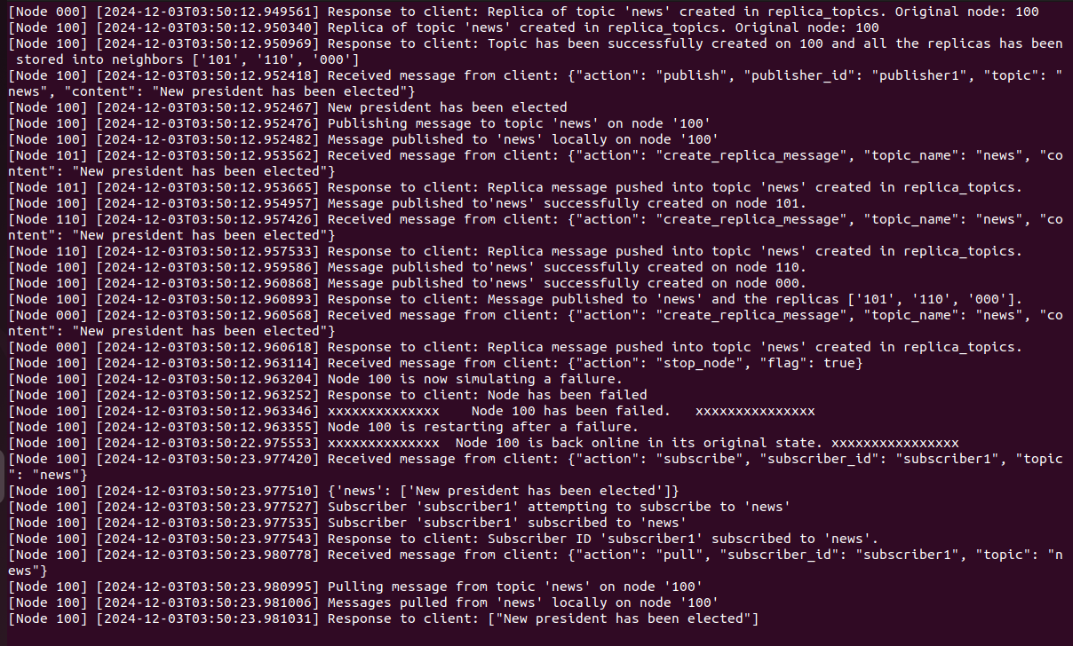
On client:
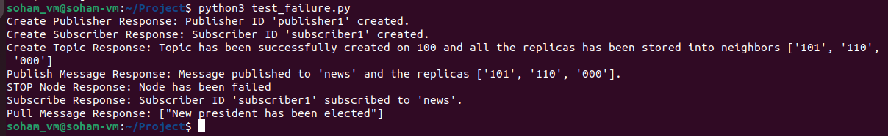
- Deploy enough peers. Prove if the “right” node for a given topic is offline, you can correctly find its replica and talk to the host node.
Peers deployed and topics are created and message is published.
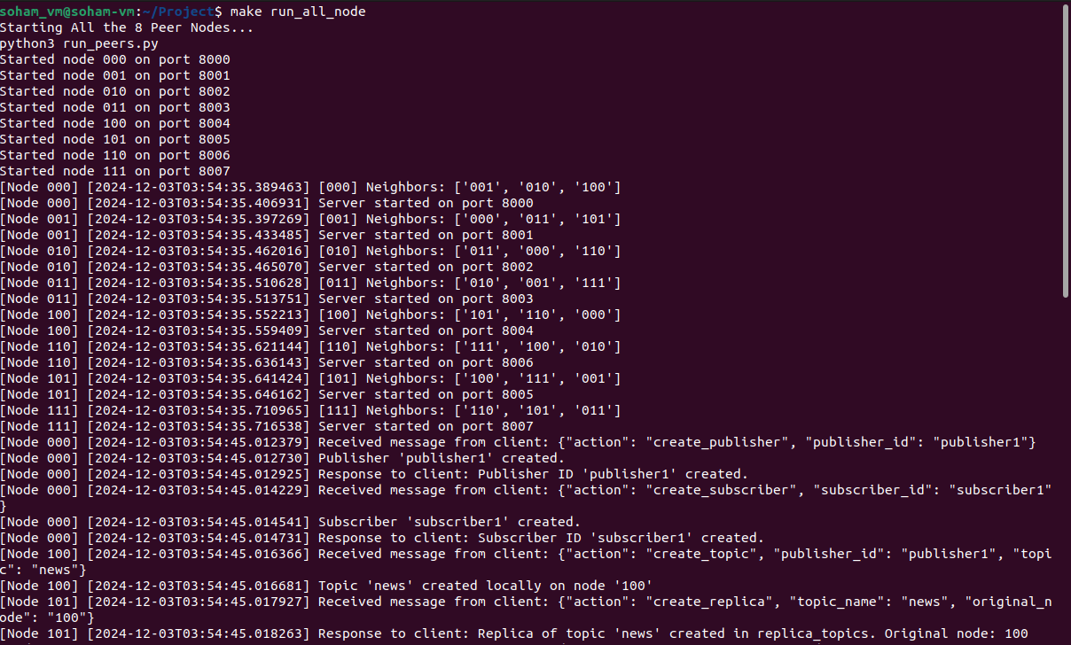
Node is Failed, And when subscribed it redirects to neighbor node and displays the replica node.
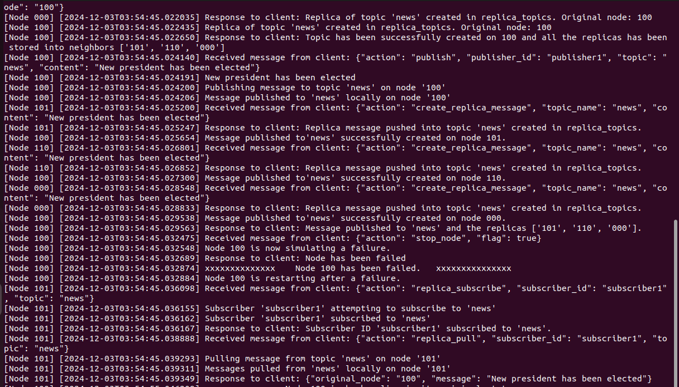
Client Response:
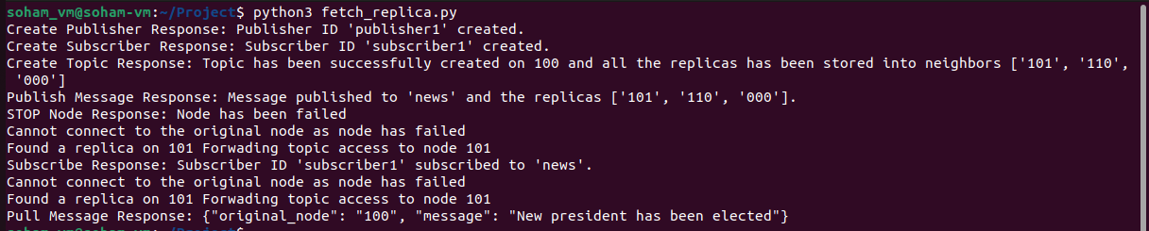
- Similar to PA2, you need to benchmark the latency and throughput of each API.
  - Deploy 8 peers. Benchmark each API on each node using randomly generated workload.
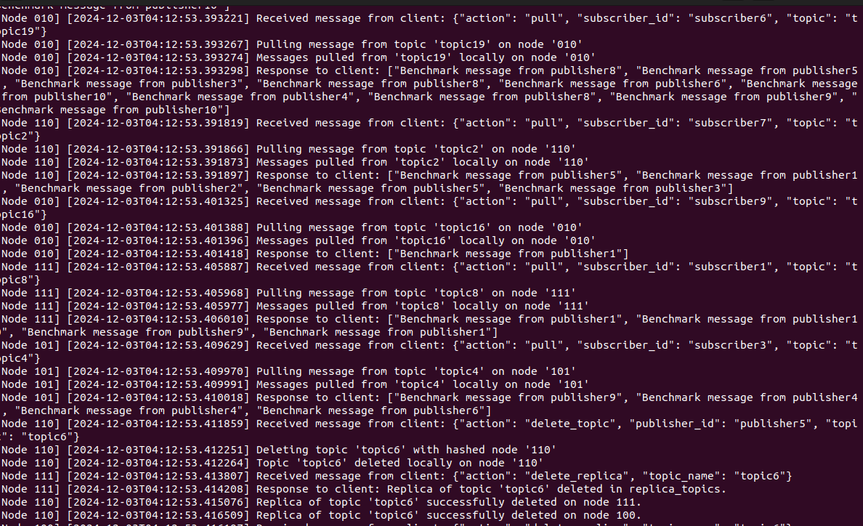
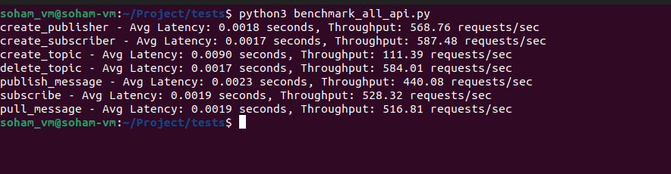

  - Graph your results

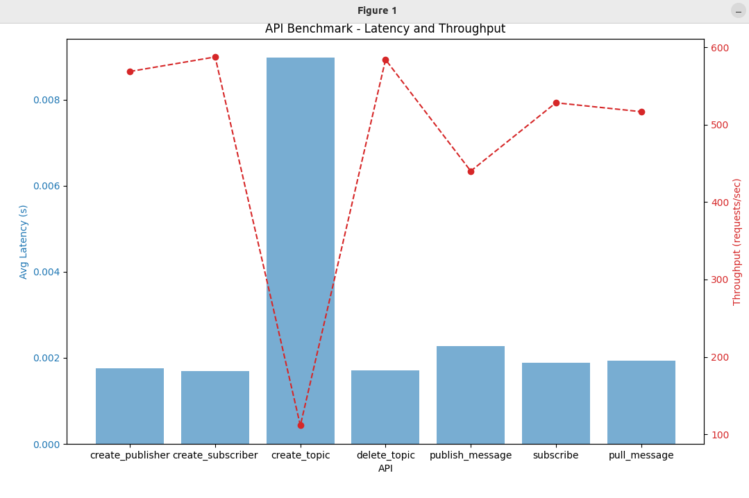
- Use sleep() in your code to manually control the communication latency between nodes. Explore in what scenarios your system is faster than your PA3 code.
Used Sleep in my code to restart server after a delay of 10 seconds after server gets failed.
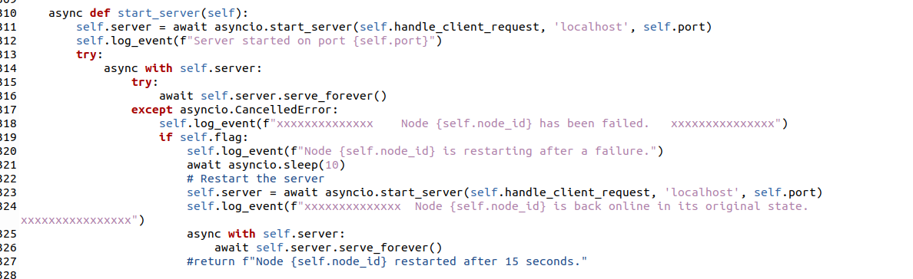
1. Reduced Latency in Failure Scenarios
- Older System:
When a node fails, the system might lose access to the topics stored on that node, leading to timeouts or errors when subscribers or publishers try to interact with those topics. This results in retries or system stalls while waiting for recovery.
- New System:
With fault tolerance (replica storage), neighbors hold replicas of the topics. If a node fails, the system can immediately redirect requests to a neighbor, reducing latency compared to waiting for the failed node to recover.
Faster in Scenarios:
  - When one or more nodes fail during high-load operations like topic subscriptions or message publishing.

2. Improved Parallelism During Node Recovery
- Older System:
Recovery from node failure might require re-distributing topics to other nodes or waiting for the failed node to come back online. During this process, operations related to the failed node can block or queue up.
- New System:
With replicas already distributed across neighboring nodes, the system doesn't need to halt operations. Neighboring nodes can handle requests seamlessly, allowing faster recovery of the system's operational state. Faster in Scenarios:
  - When nodes need to recover from failure under high request concurrency.
  - Systems requiring high availability with minimal downtime.

3. Faster Benchmarking with High Concurrency
- Older System:
Under high concurrency, failure of a single node could stall requests, as there are no fallback mechanisms. Each stalled request contributes to higher overall latency and lower throughput.
- New System:
Fault tolerance ensures that concurrent requests can be redirected to neighboring nodes holding replicas, maintaining throughput and reducing average response times.
Faster in Scenarios:
  - Benchmarks where multiple peer nodes concurrently query or publish messages with N = [4, 8].
  - Stress tests simulating random node failures during peak operations.
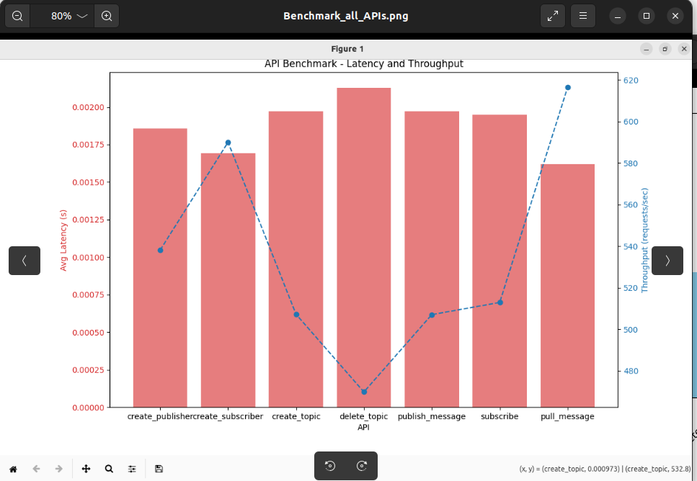
PA3 Benchmarking Graph -
Project Benchmarking Graph (New System):

Extra credits
Up to 10 points. Describe what you are curious about consistency model in distributed system, conduct experiments to solve/verify your questions on your own.

Eventual Consistency Model
The system implements an eventual consistency model, where replicas are updated asynchronously. This is evident from the following observations:
- When a topic is created or a message is published, the operation is first performed on the local node, and then replicas are updated on neighboring nodes.
- There's no explicit mechanism for immediate synchronization across all nodes.
To verify this, we can conduct the following experiment:

Replication Strategy
The system uses a neighbor-based replication strategy, where each node replicates its topics to its immediate neighbors in the hypercube. This approach provides fault tolerance.To test the fault tolerance, we can conduct the following experiment:
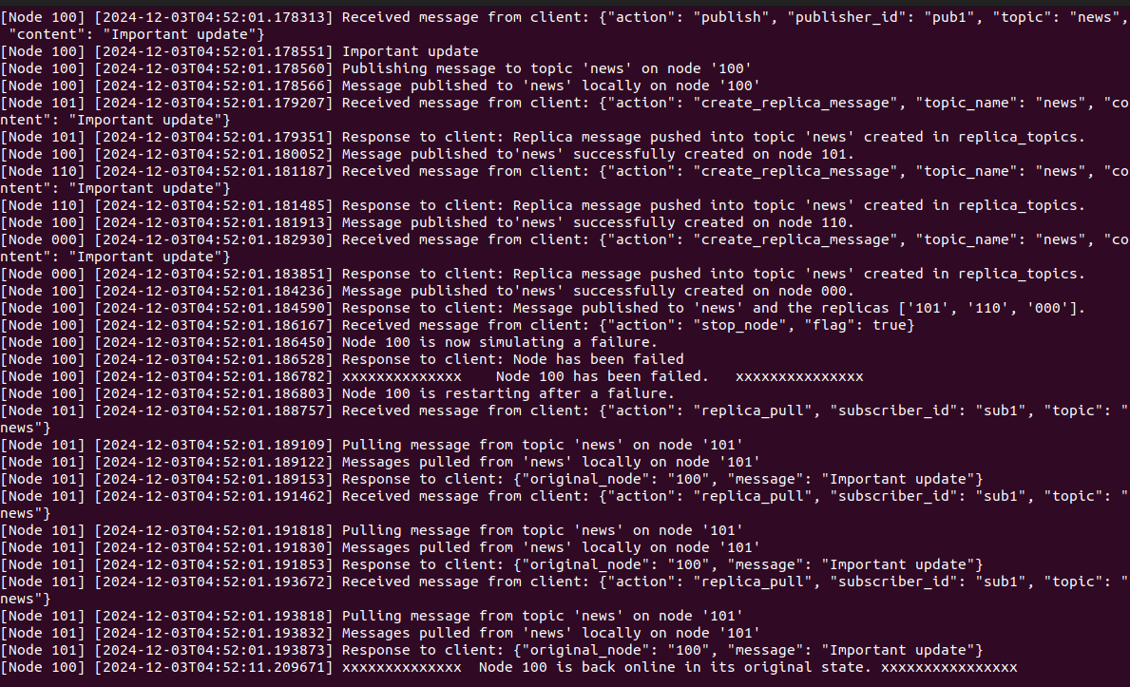
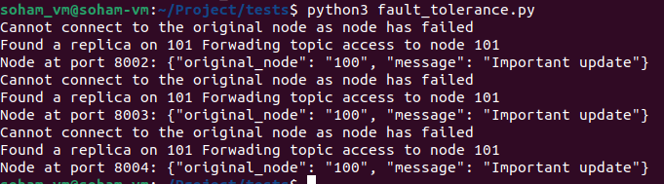
- Discussion: You should also discuss the design of your code. E.g. Do you think the APIs are sufficient? Where are the bottlenecks? You don’t have to answer exactly these questions. We look for any opinions/ideas/discussion that show you are actively thinking about this project is fine.

Discussion on Code Design

API Design
The current API set, as outlined in the design document, is functional but has room for improvement. Here's a detailed evaluation:
- Sufficiency of Current APIs:
The existing APIs for creating topics, publishing messages, subscribing to topics, and retrieving messages provide a solid foundation. However:
  - The lack of APIs for replica management (e.g., querying replica locations or manually synchronizing replicas) might limit debugging and operational flexibility.
  - APIs for node management, such as dynamically adding or removing nodes, are not explicitly defined, which could make integration with automation systems difficult.
- Potential Additions:
  - Replica Query API: Enables clients to fetch the list of nodes hosting replicas for a topic.
  - Node Status API: Reports the health and availability of nodes to facilitate monitoring.
  - Consistency Control API: Allows clients to specify their desired consistency level during operations.

Bottlenecks
The design introduces complexity and potential bottlenecks in the following areas:
- Topic Replication Synchronization:
  - Issue: Synchronizing replicas across nodes introduces latency and overhead, especially under high write loads.
  - Mitigation: Use asynchronous replication for non-critical topics and prioritize critical data with synchronous replication.
- Dynamic Topology Management:
  - Issue: Adding or removing nodes dynamically may cause delays in routing table updates and topic reassignment.
  - Mitigation: Employ a lazy synchronization strategy to update routing tables incrementally while ensuring immediate consistency for critical paths.
- Hash Function Hotspots:
  - Issue: The hashing mechanism may lead to uneven distribution of topics, causing some nodes to become overloaded.
  - Mitigation: Implement a consistent hashing with virtual nodes approach to evenly distribute load across physical nodes.
- Fault Detection and Recovery Latency:
  - Issue: Periodic heartbeat mechanisms can lead to delays in detecting node failures.
  - Mitigation: Use an event-driven failure detection system with immediate neighbor notifications.

Tradeoffs in the Current Design
- Consistency vs. Performance:
  - Stronger consistency models increase synchronization overhead, potentially degrading performance during high write activity.
  - Current choice of a primary-secondary model balances these tradeoffs, but exploring hybrid models (e.g., quorum-based) may be worthwhile.
- Complexity vs. Simplicity:
  - The hypercube topology simplifies routing but adds complexity to fault detection and topology updates.
  - Simpler topologies, like a ring, could reduce operational complexity but increase hop counts.
- Asynchronous Communication vs. Debugging Complexity:
  - Asynchronous operations improve throughput but complicate debugging and traceability.
  - Including end-to-end transaction tracing in the API design could mitigate this issue.

Areas for Future Refinement
- Logging and Monitoring:
Comprehensive logging and a centralized dashboard would allow developers to trace bottlenecks and optimize performance.
- Testing for Edge Cases:
The system should be stress-tested under:
  - High node churn (frequent addition/removal of nodes).
  - Network partition scenarios to assess how the system behaves when parts of the network are isolated.

