SQL INTERMEDIATE QUESTION ON DATASET
1 ) List each customer’s total spent from the Orders table using SUM and arrange the CustomerID in Ascending order.

Query : - select CustomerID,sum(price) As Total_sum from `core-folio-462704-q6.Customer_data.Orders `
group by CustomerID
order by CustomerID ASC;

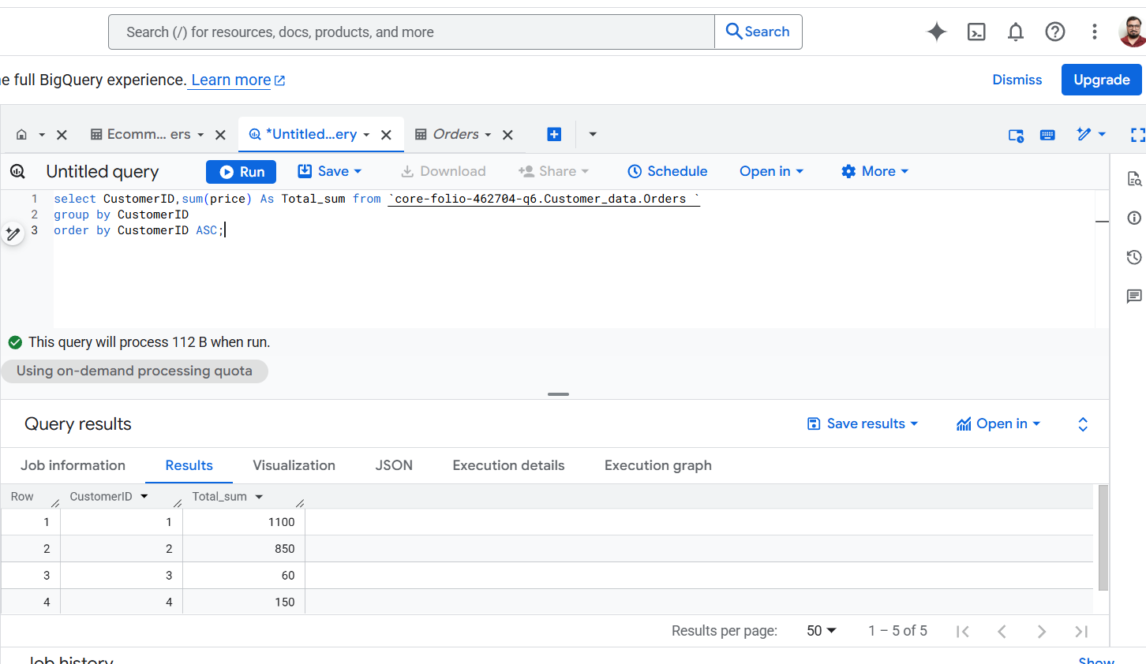

2) Find all orders made by customers from Mumbai.

Query :- select C.Name,O.CustomerID,O.OrderID,C.City from `core-folio-462704-q6.Customer_data.Orders ` As O
left join `core-folio-462704-q6.Customer_data.Ecommerce Customers`As C On O.CustomerID=C.CustomerID
Where C.City="Mumbai";

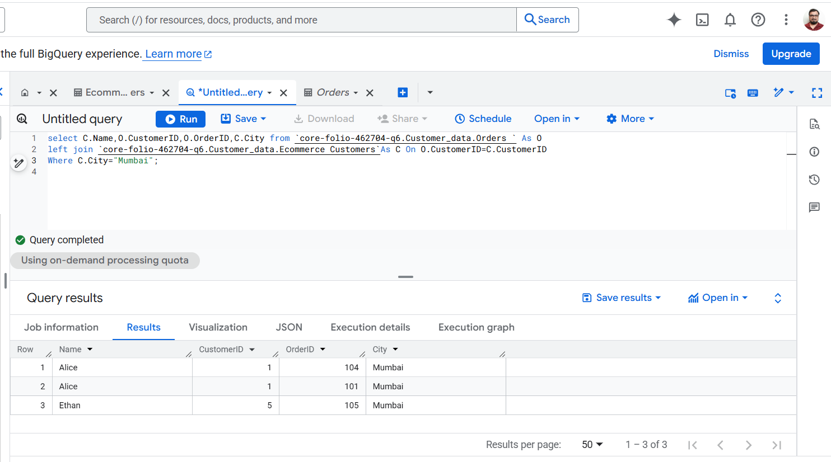
3) Show the total quantity of products ordered per customer.

Query :- select CustomerID, Product,Sum(Quantity) As Total_Quantity from `core-folio-462704-q6.Customer_data.Orders `
Group by CustomerID,Product;

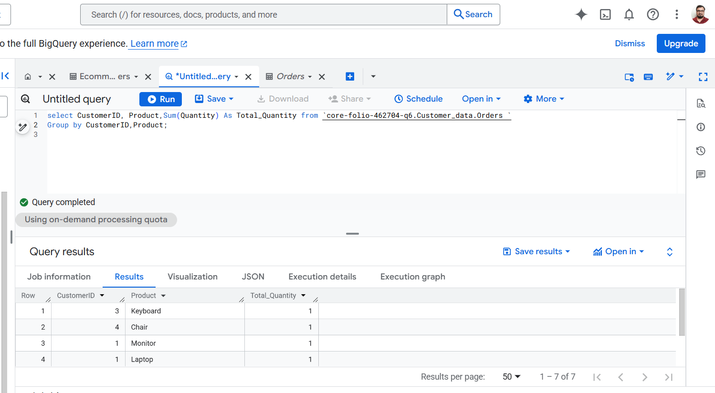

4) Find customers who have purchased a Laptop.

Query : select CustomerID, Product,Sum(Quantity) As Total_Quantity from `core-folio-462704-q6.Customer_data.Orders `
Where Product="Laptop"
Group by CustomerID, Product;

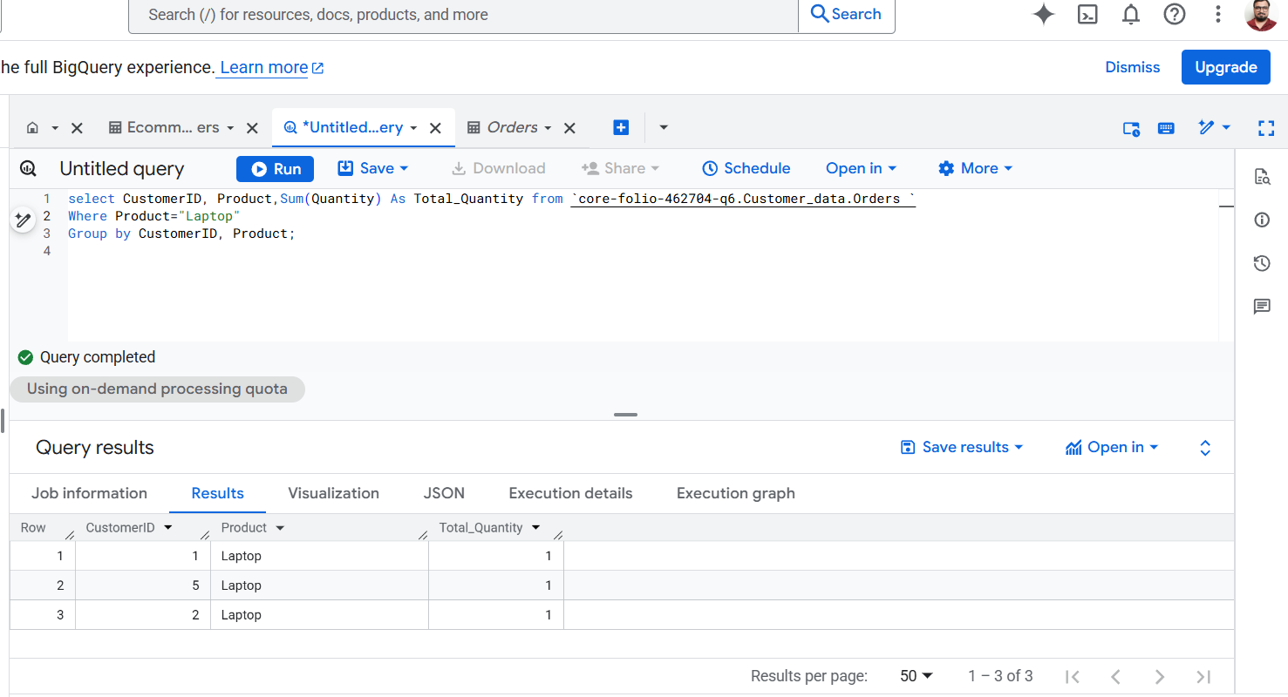

5) Join Customers and Orders to list Customer Name, Product, Quantity, and OrderDate.

QUERY :- select C.Name,O.Product,O.Quantity,O.OrderDate from `core-folio-462704-q6.Customer_data.Orders ` As O
left join `core-folio-462704-q6.Customer_data.Ecommerce Customers`As C On C.CustomerID=O.CustomerID;

