SQL ADVANCE QUESTION ON DATASET
1) Find the top 2 customers by total spent in Orders.

Query:- select O.CustomerID, C.TotalSpent from `core-folio-462704-q6.Customer_data.Orders ` As O
left join `core-folio-462704-q6.Customer_data.Ecommerce Customers`As C On C.CustomerID=O.CustomerID
Order by C.TotalSpent DESC
limit 2;
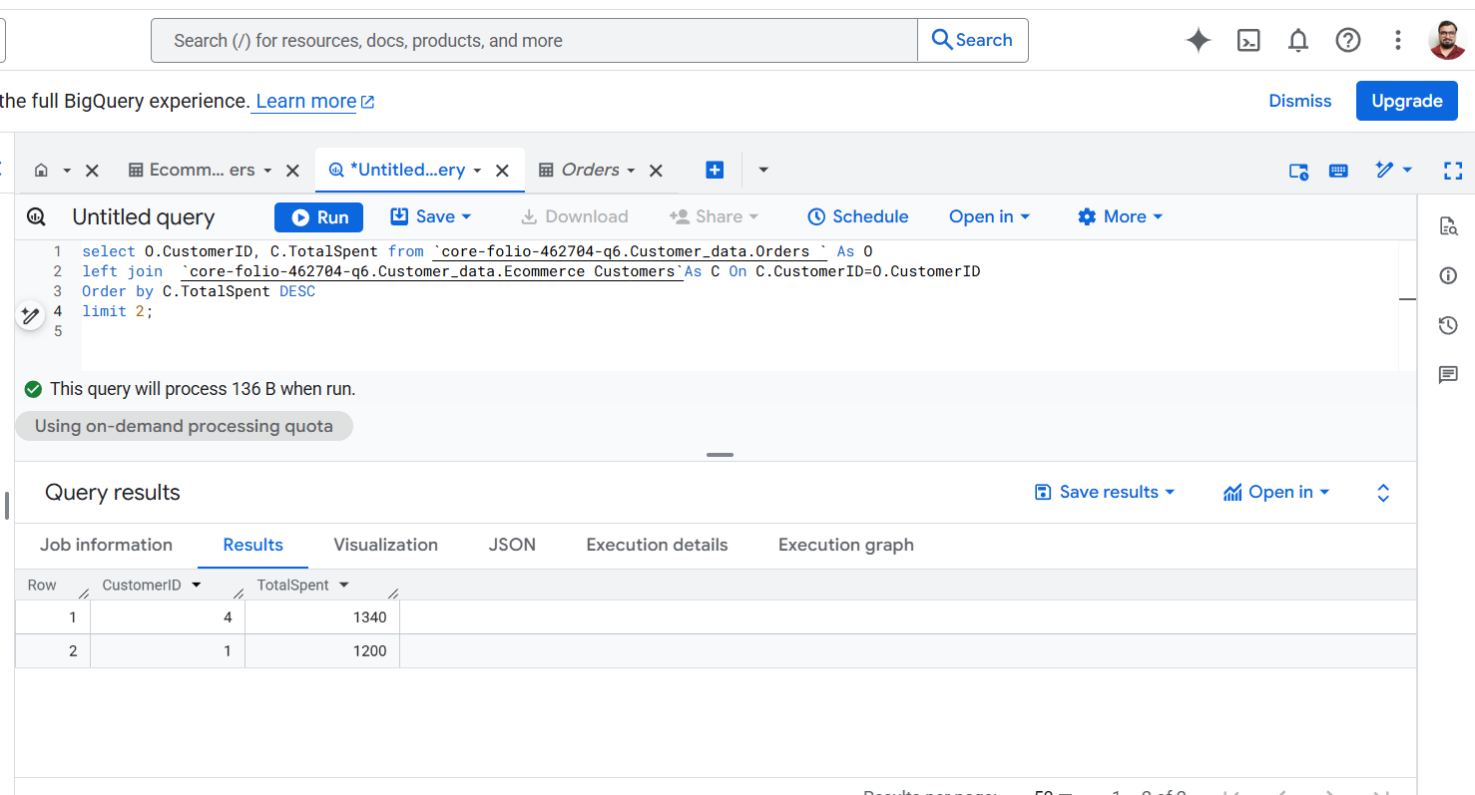

2) Identify customers who have not ordered any product.

QUERY:- select C.CustomerID,C.Name from `core-folio-462704-q6.Customer_data.Ecommerce Customers` As C
LEFT JOIN `core-folio-462704-q6.Customer_data.Orders ` As O On C.CustomerID=O.CustomerID
Where O.CustomerID Is Null;
NOTE:-There is no null value in both the table that’s why the result showing there is no data to display.

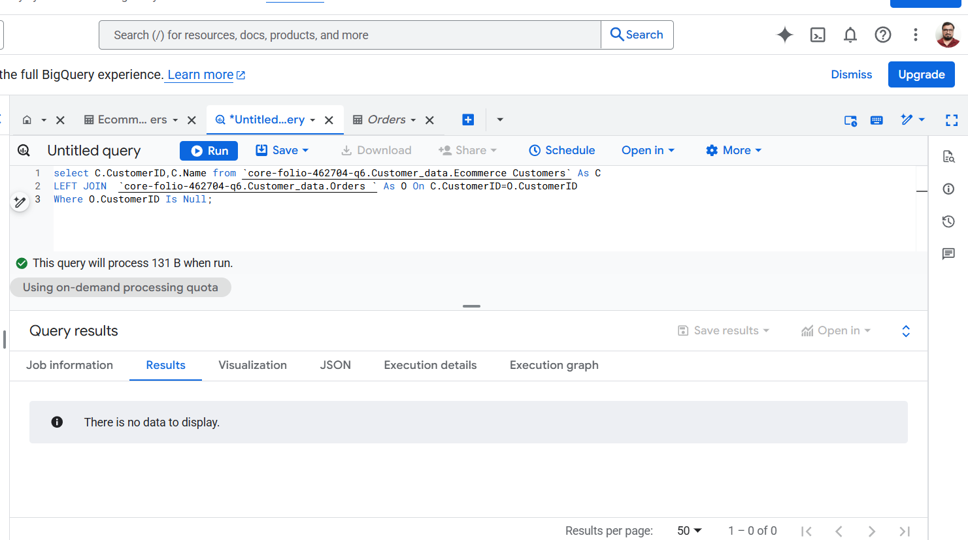
3) Calculate the running total of price ordered by each customer by OrderDate.

QUERY :- select CustomerID,Price,OrderDate,Sum(Price) Over(Partition By CustomerID Order By OrderDate )As Running_Total from `core-folio-462704-q6.Customer_data.Orders `;

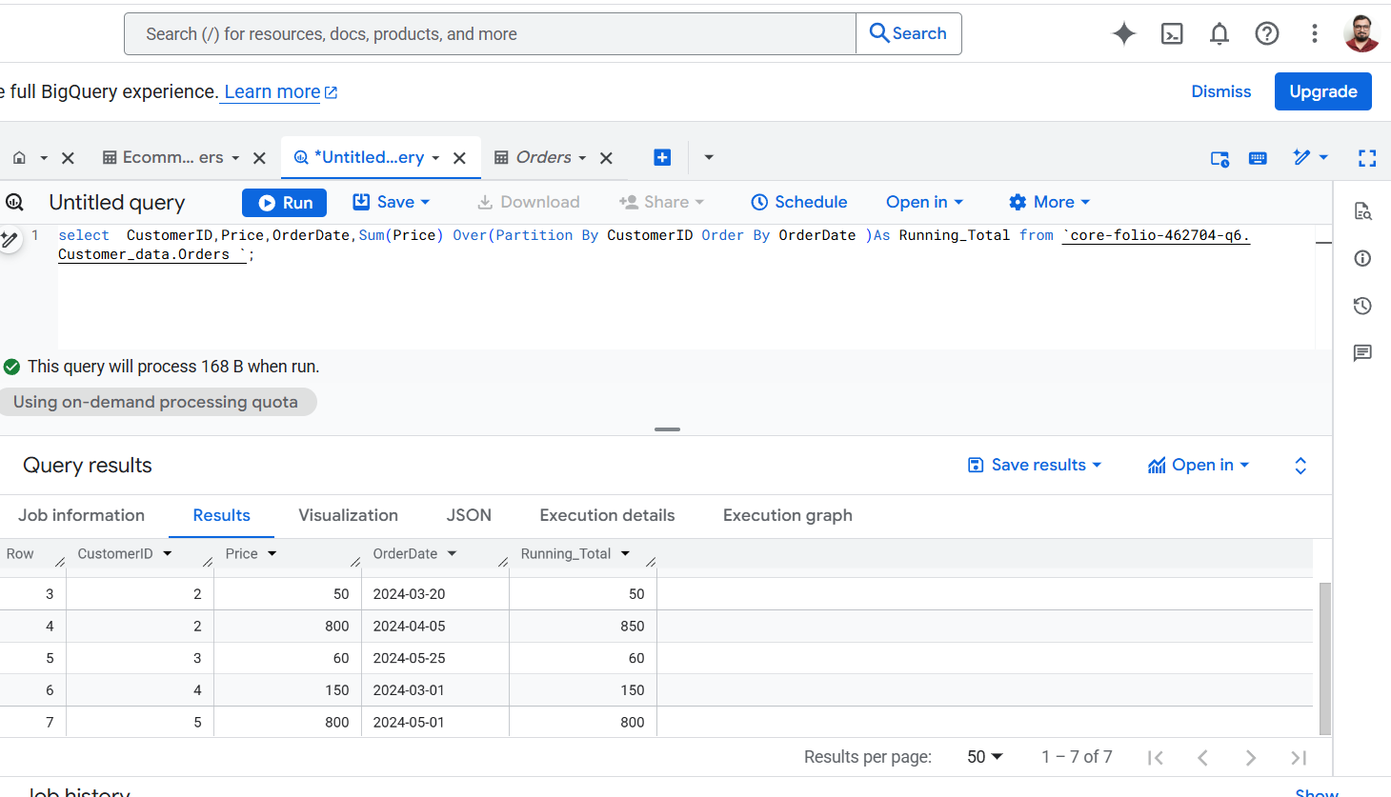

4) Find the most expensive product ordered by each customer.

QUERY :- with ranked As (SELECT CustomerID,Product,Price,DENSE_RANK() Over(Partition By CustomerID ORDER BY Price DESC)As Expensive from `core-folio-462704-q6.Customer_data.Orders `)
Select CustomerID,Product,Price From Ranked
Where Expensive =1;

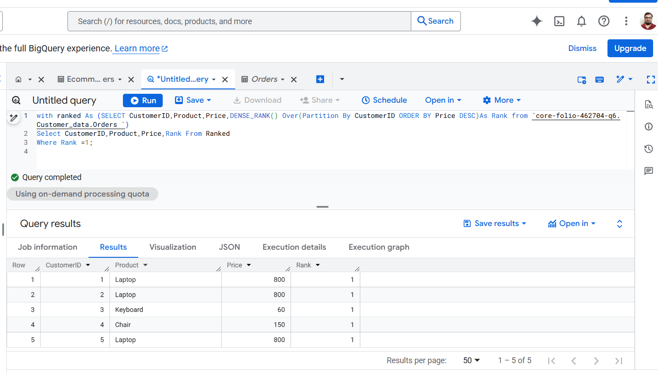

5) List customers along with the number of distinct products they purchased.

QUERY :- Select C.Name,O.CustomerID, COUNT(DISTINCT O.Product) AS Distinct_Products_Purchased,CONCAT(COUNT(DISTINCT O.Product), ' (', STRING_AGG(DISTINCT O.Product, ', '), ')') AS Product_List_Display From `core-folio-462704-q6.Customer_data.Orders ` AS O
left join `core-folio-462704-q6.Customer_data.Ecommerce Customers` As C ON C.CustomerID=O.CustomerID
Group By C.Name,O.CustomerID;

