UNIVERSITY OF VISVESVARAYA COLLEGE

OF ENGINEERING

First State Autonomous University on IIT Model
K.R. Circle Bengaluru-560001


DEPARTMENT OF COMPUTER SCIENCE AND ENGINEERING
DBMS Mini-Project on

“GAS STATION MANAGEMENT SYSTEM”

Submitted By

ARSHAN A SHAIK (U25UV22T006005)

KUSHAL SAATHWIK (U25UV22T006020)

5TH Sem B.Tech AIML
Dept. of CSE, UVCE Bengaluru-01

Under the Guidance of

Dr Samyama Gunjal GH
ASSOCIATE PROFESSOR
Dept. of CSE, UVCE Bengaluru-01

UNIVERSITY OF VISVESVARAYA COLLEGE OF ENGINEERING

First State Autonomous University on IIT Model
K.R. Circle Bengaluru-560001


CERTIFICATE

This is to certify that KUSHAL SAATHWIK of V Semester, B. Tech, Computer Science and Engineering, bearing the register number U25UV22T006020 has submitted the DBMS Mini-Project Report on "FUEL SYSTEM MANAGEMENT SYSTEM", in partial fulfilment for the DBMS Lab, prescribed by the Bangalore University for the academic year 2024-25.

Dr. Samyama Gunjal GH Dr. Thriveni J
Associate Professor Professor &Chairperson
Dept. of CSE, Dept. of CSE,
UVCE UVCE

EXAMINER 1 EXAMINER 2

ACKNOWLEDGEMENT
- We extend our heartfelt gratitude to everyone who contributed to the successful completion of this project.

- We are sincerely thankful to Dr. Thriveni J, Chairperson, Department of Computer Science and Engineering, for her continuous support and encouragement throughout our journey.

- A special note of appreciation goes to Dr. Samayam Gunjal G H, Associate Professor, Department of Computer Science and Engineering, our esteemed Project Guide, whose guidance, insights, and cooperation played a crucial role in making this project a success.

- We also express our gratitude to the Department of Computer Science and Engineering for providing the necessary resources and a supportive environment that facilitated our work.

- Moreover, we are grateful to our peers and colleagues for their valuable suggestions and constructive discussions, which greatly enhanced our learning experience.
- Lastly, we extend our deepest thanks to our family and friends for their unwavering support and motivation, which kept us inspired throughout this journey.

KUSHAL SATHWIK U25UV22T006005

ABSTRACT

Short Description and Scope of the Project:

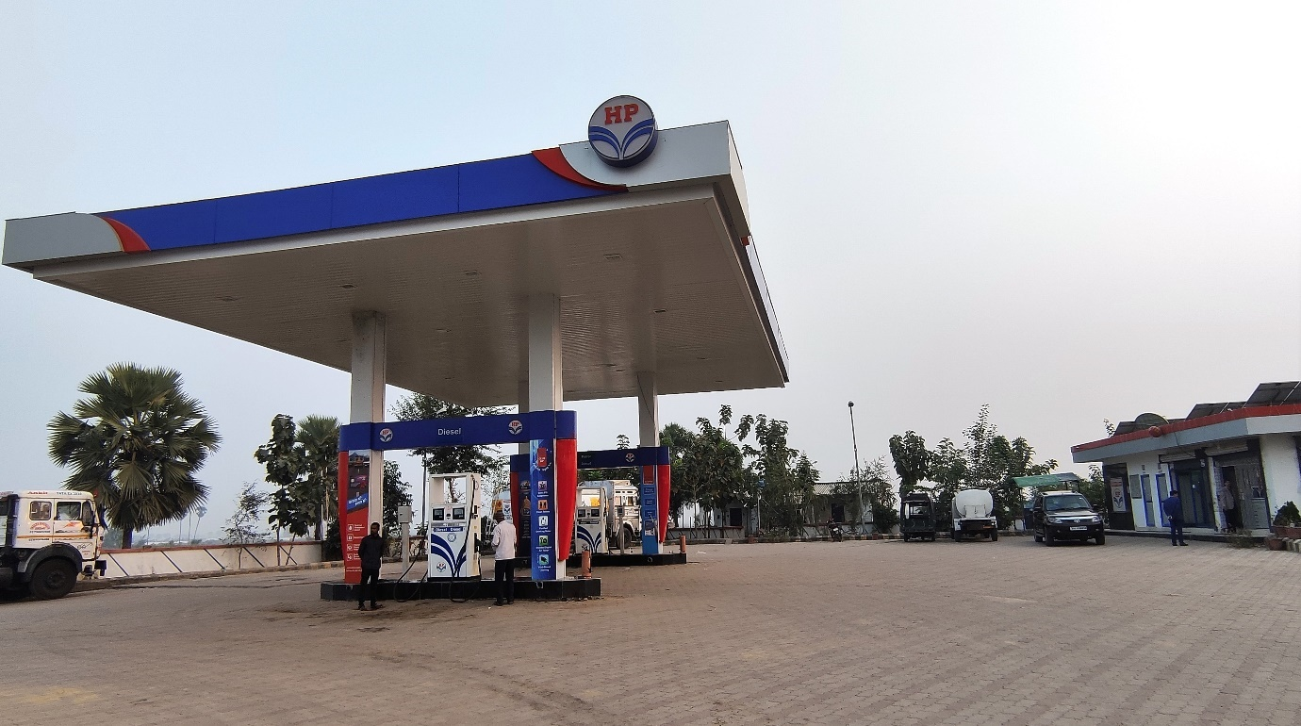

Project Overview
The Oil and Gas (O&G) industry is one of the most vital sectors, significantly contributing to the economy. It is a highly demanding and technologically advanced field that presents both opportunities and challenges for engineers. Despite its financial potential, managing O&G projects effectively is crucial due to the risks involved.
This project focuses on maintaining petrol pump data, providing managers with an efficient and convenient system to handle their operations seamlessly.

A Database Management System (DBMS) is used to create, retrieve, update, and manage data systematically. This project maintains essential details, including:
- Petrol pumps in a specific area
- Owners and employees' details
- Customer information, enabling regular customers to receive discounts and goodies
- Tanker details
- Sales data for each petrol pump

The project utilizes MySQL for data storage and CRUD operations, along with popular libraries such as Pandas and Streamlit to create an interactive and user-friendly interface.

ER Diagram:
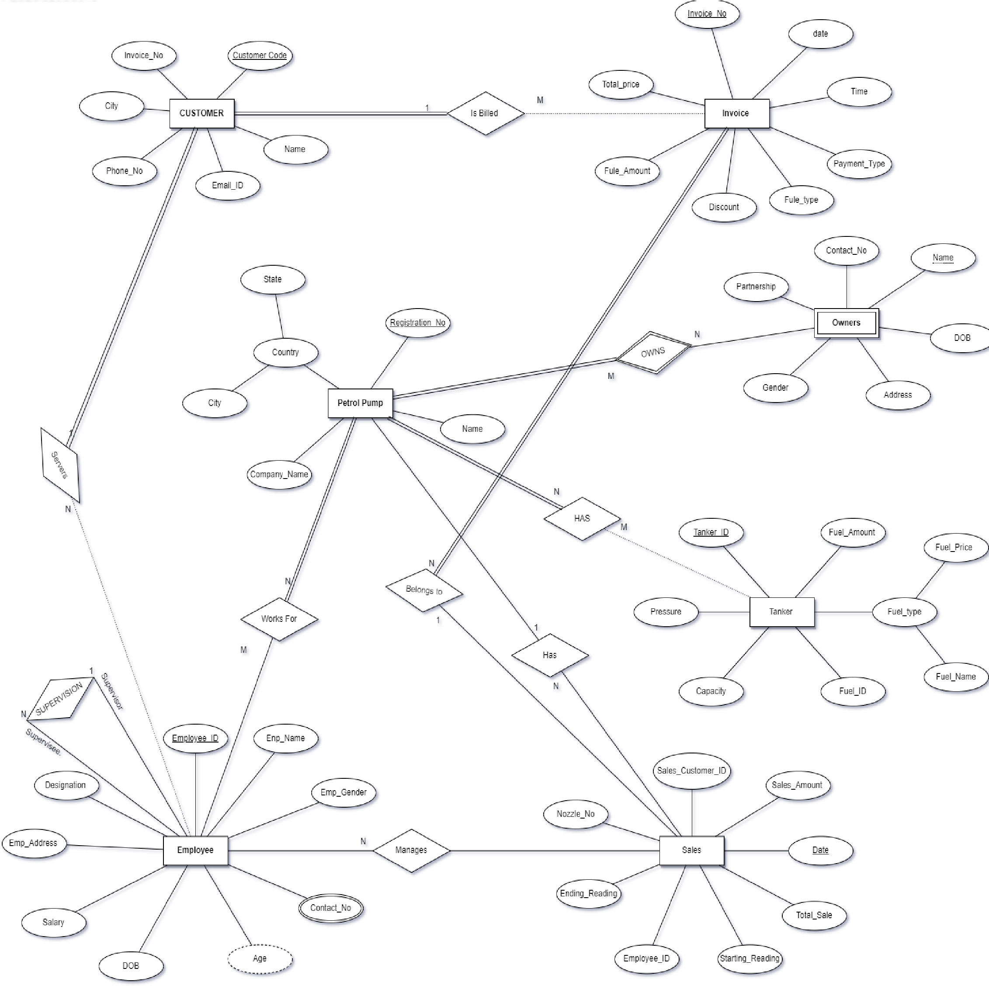


Relational Schema:

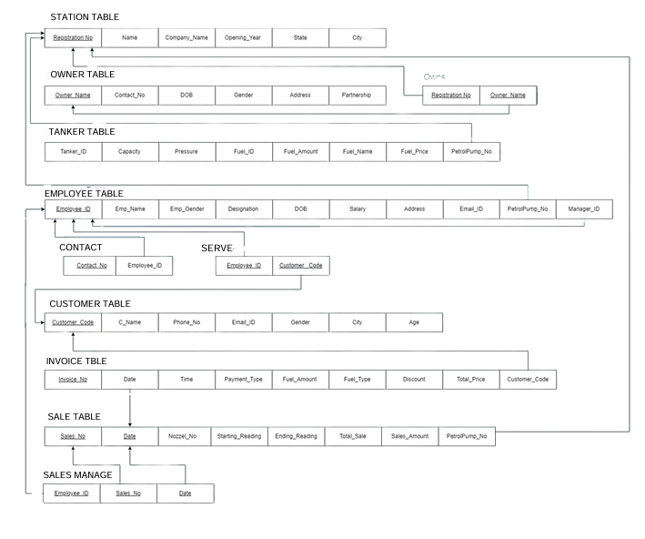

Join Queries

Querry:
SELECT PetrolPump.Registration_No FROM PetrolPump
INNER JOIN Employee ON PetrolPump.Registration_No = Employee.Petrolpump_No;
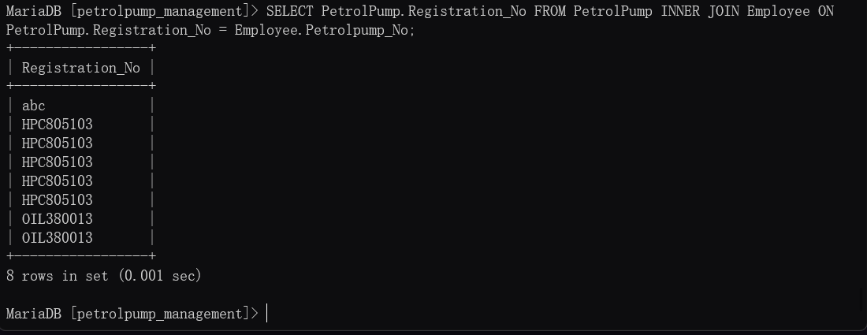

Querry:
SELECT Petrolpump.Registration_No FROM Petrolpump
LEFT JOIN Employee on Petrolpump.Registration_No = Employee.Petrolpump_No
WHERE Employee.Petrolpump_No is NULL;
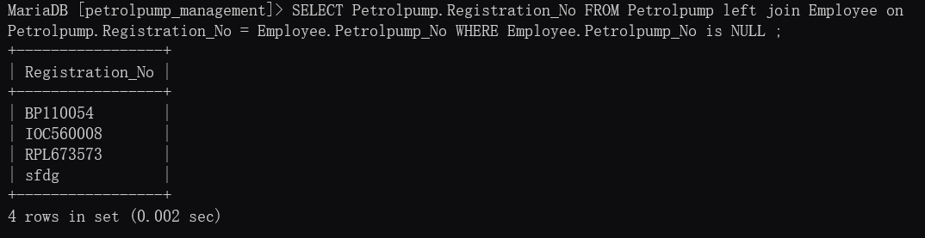

Querry:
SELECT PetrolPump.Registration_No FROM PetrolPump
LEFT JOIN Employee ON PetrolPump.Registration_No = Employee.Petrolpump_No;

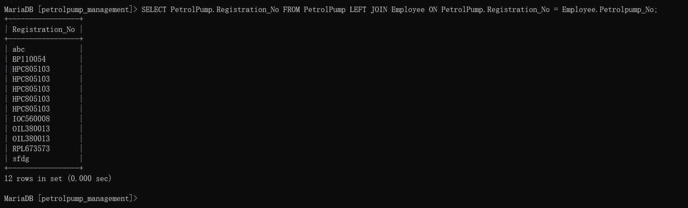

Aggregate Functions

Q1) Find the Average age of the Male customers.

Query:
SELECT avg(Age) from Customer where Gender='M';

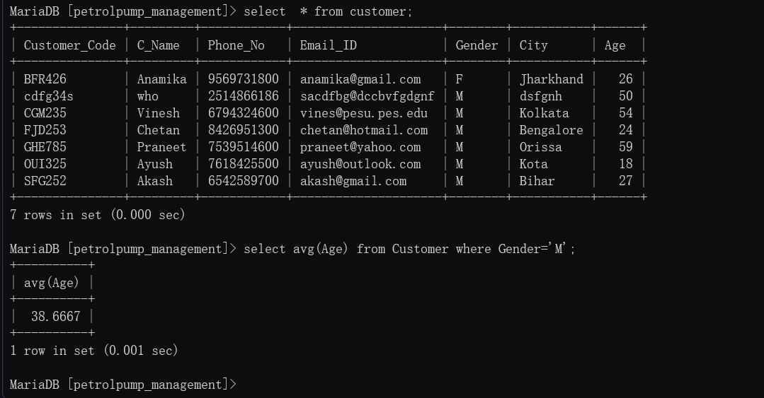

Q2) Find the name and age of Employee using the date of birth.
Query:
SELECT Emp_Name, TIMESTAMPDIFF (YEAR, DOB, CURDATE()) AS age FROM Employee;
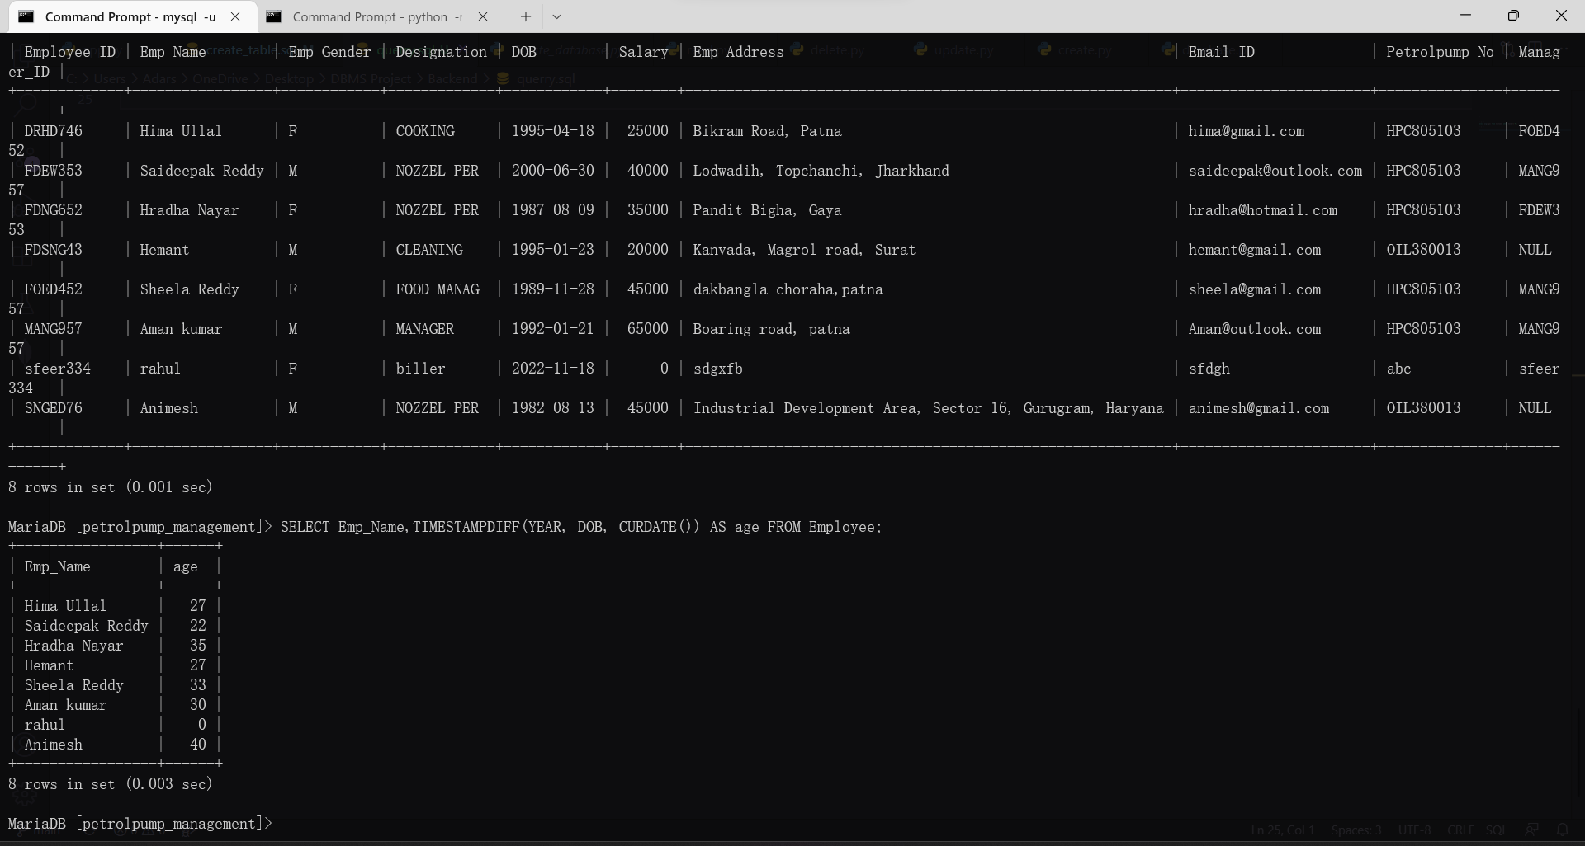

Q3) Find the Details of the Invoice Whose Total Prize is Maximum?
Query: SELECT *, max(Total_Price) from Invoice;

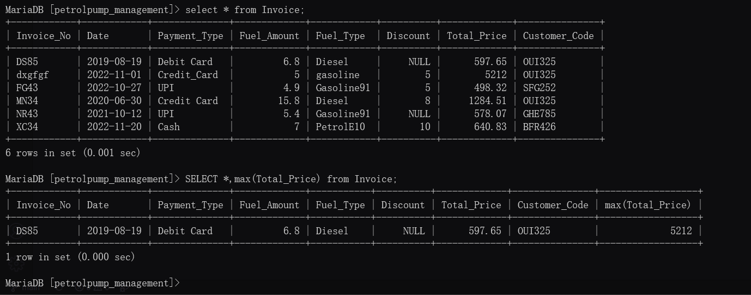

Q4) Get the details of Sales No, Sales Amount & Petrol pump No whose sales is maximum on 20 November, 2022

Query: SELECT Sales_No, Sales_Amount, Petrolpump_No, max(Sales_Amount) FROM Sales WHERE DATE='2022-11-20';

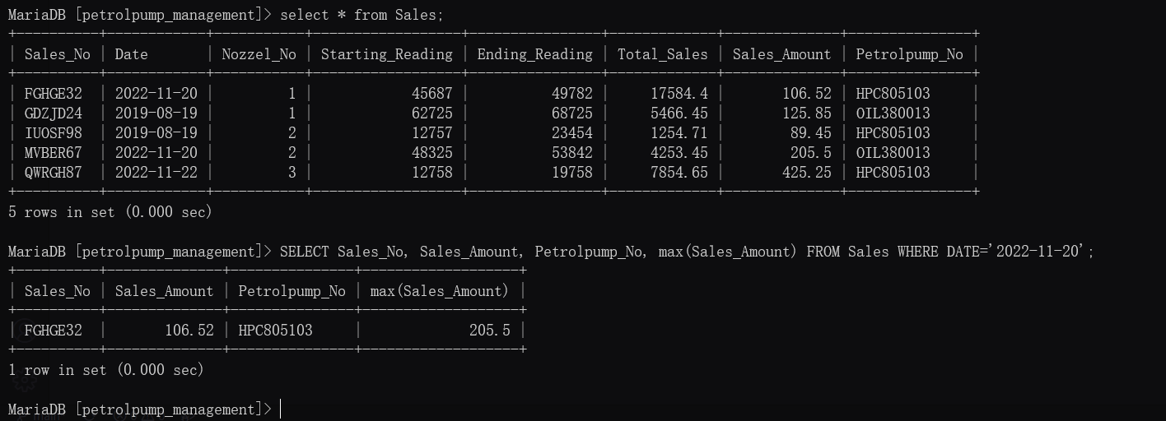

Set Operations

Showcase at least 3 Set Operations queries
Write the query in English Language, Show the equivalent SQL statement and also a screenshot of the query and the results.

Q 1) Get all the Unique names of Both the tables Owners and Employee
Query:
SELECT Owner_Name from Owners UNION SELECT EMP_Name from Employee;

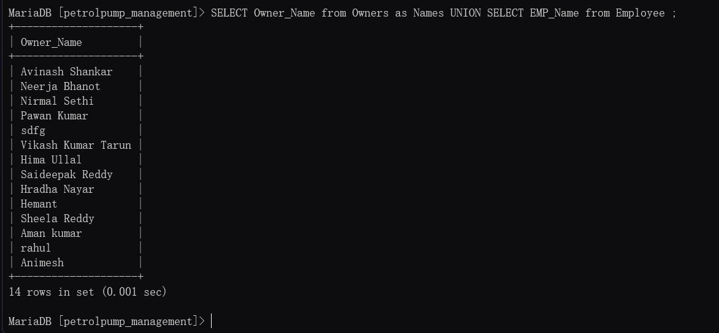

Q2) Find the Petrolpump Registration no which is Common Between both table Petrol pump and Employee?
Query:
SELECT Registration_No from Petrolpump INTERSECT SELECT Petrolpump_No from Employee;

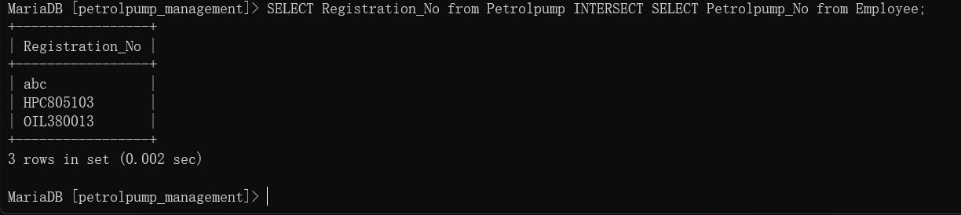

SUBQUERIES:

1) subquery to get the invoice of each PetrolPump with the highest sale:

QUERY:
SELECT *
FROM Invoice
WHERE Invoice_No IN (
SELECT Invoice_No
FROM Sales
WHERE (Petrolpump_No, Sales_Amount) IN (
SELECT Petrolpump_No, MAX(Sales_Amount)
FROM Sales
GROUP BY Petrolpump_No
)
);
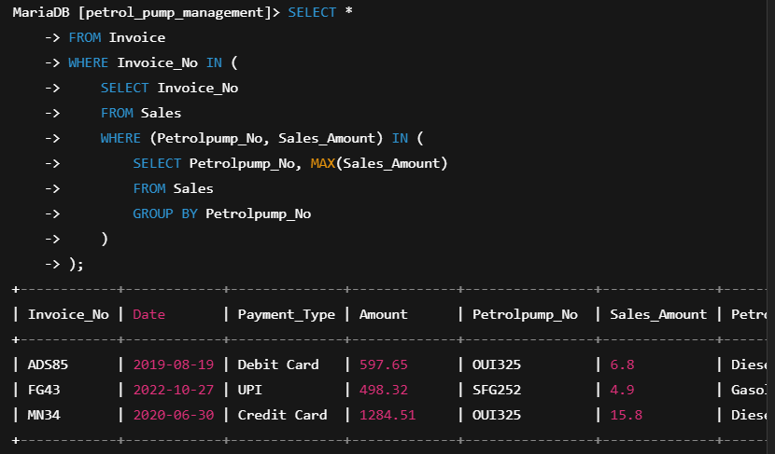

2) Which Petrol Pump(s) do not have any associated employees? Return names of all petrolpumps with no employees at all

QUERY:

SELECT Petrolpump_Name
FROM Petrolpump
WHERE Registration_No IN (
SELECT PetrolPump.Registration_No
FROM PetrolPump
LEFT JOIN Employee ON PetrolPump.Registration_No = Employee.Petrolpump_No
WHERE Employee.Petrolpump_No IS NULL
);

