# UNIVERSITY OF VISVESVARAYA COLLEGE

# OF ENGINEERING

First State Autonomous University on IIT Model

K.R. Circle Bengaluru-560001



**DEPARTMENT OF COMPUTER SCIENCE AND ENGINEERING**

**DBMS Mini-Project on**

# “GAS STATION MANAGEMENT SYSTEM”

**Submitted By**

**ARSHAN A SHAIK** (U25UV22T006005)

**KUSHAL SAATHWIK** (U25UV22T006020)

5TH Sem B.Tech AIML

Dept. of CSE, UVCE Bengaluru-01

**Under the Guidance of**

**Dr Samyama Gunjal GH**

ASSOCIATE PROFESSOR

Dept. of CSE, UVCE Bengaluru-01

# UNIVERSITY OF VISVESVARAYA COLLEGE OF ENGINEERING

First State Autonomous University on IIT Model

K.R. Circle Bengaluru-560001



**CERTIFICATE**

This is to certify that KUSHAL SAATHWIK of V Semester, B. Tech, Computer Science and Engineering, bearing the register number U25UV22T006020 has submitted the DBMS Mini-Project Report on "FUEL SYSTEM MANAGEMENT SYSTEM", in partial fulfilment for the DBMS Lab, prescribed by the Bangalore University for the academic year 2024-25.

Dr. Samyama Gunjal GH Dr. Thriveni J

Associate Professor Professor &Chairperson

Dept. of CSE, Dept. of CSE,

UVCE UVCE

**EXAMINER 1** **EXAMINER 2**

**ACKNOWLEDGEMENT**

* We extend our heartfelt gratitude to everyone who contributed to the successful completion of this project.
* We are sincerely thankful to **Dr. Thriveni J, Chairperson, Department of Computer Science and Engineering**, for her continuous support and encouragement throughout our journey.
* A special note of appreciation goes to **Dr. Samayam Gunjal G H, Associate Professor, Department of Computer Science and Engineering**, our esteemed Project Guide, whose guidance, insights, and cooperation played a crucial role in making this project a success.
* We also express our gratitude to the **Department of Computer Science and Engineering** for providing the necessary resources and a supportive environment that facilitated our work.
* Moreover, we are grateful to our peers and colleagues for their valuable suggestions and constructive discussions, which greatly enhanced our learning experience.
* Lastly, we extend our deepest thanks to our family and friends for their unwavering support and motivation, which kept us inspired throughout this journey.

KUSHAL SATHWIK U25UV22T006005

**ABSTRACT**

**Short Description and Scope of the Project**:

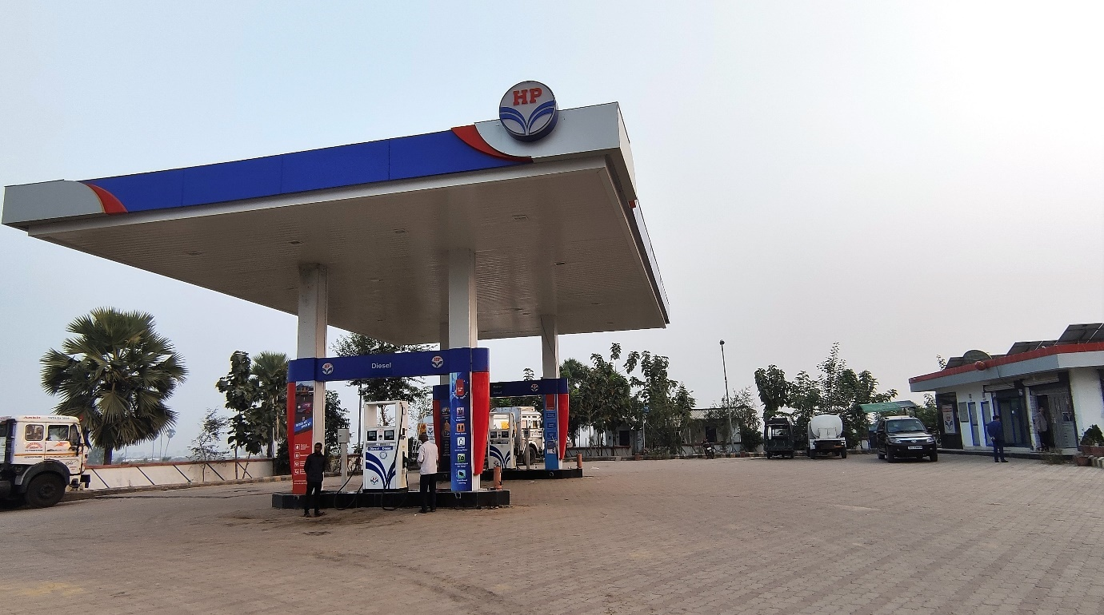

**Project Overview**

The **Oil and Gas (O&G) industry** is one of the most vital sectors, significantly contributing to the economy. It is a highly demanding and technologically advanced field that presents both opportunities and challenges for engineers. Despite its financial potential, managing O&G projects effectively is crucial due to the risks involved.

This project focuses on **maintaining petrol pump data**, providing managers with an efficient and convenient system to handle their operations seamlessly.

A **Database Management System (DBMS)** is used to create, retrieve, update, and manage data systematically. This project maintains essential details, including:

* Petrol pumps in a specific area
* Owners and employees' details
* Customer information, enabling regular customers to receive discounts and goodies
* Tanker details
* Sales data for each petrol pump

The project utilizes **MySQL** for data storage and **CRUD operations**, along with **popular libraries such as Pandas and Streamlit** to create an interactive and user-friendly interface.

**ER Diagram**:

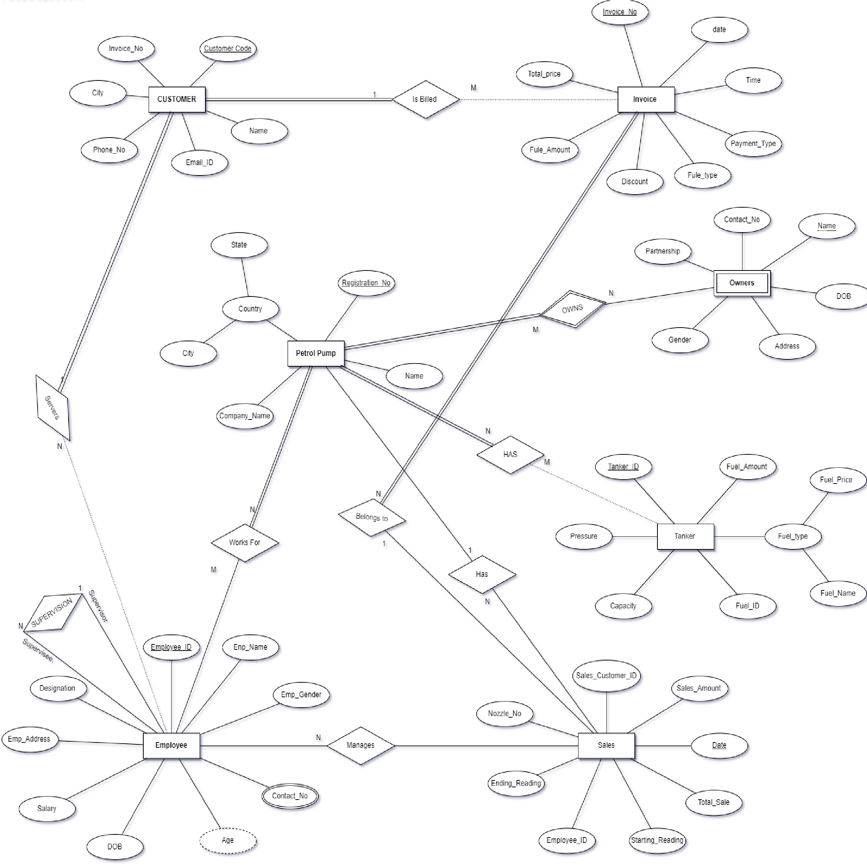

**Relational Schema:**

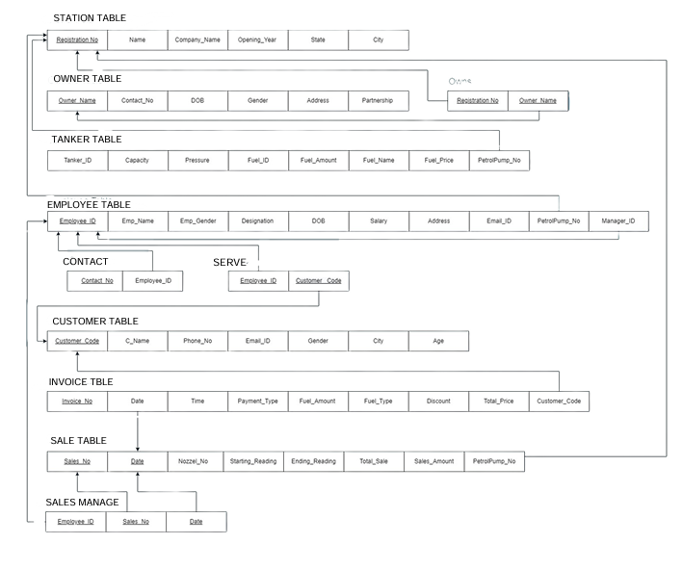

**Join Queries**

**Querry**:

SELECT PetrolPump.Registration_No FROM PetrolPump

INNER JOIN Employee ON PetrolPump.Registration_No = Employee.Petrolpump_No;

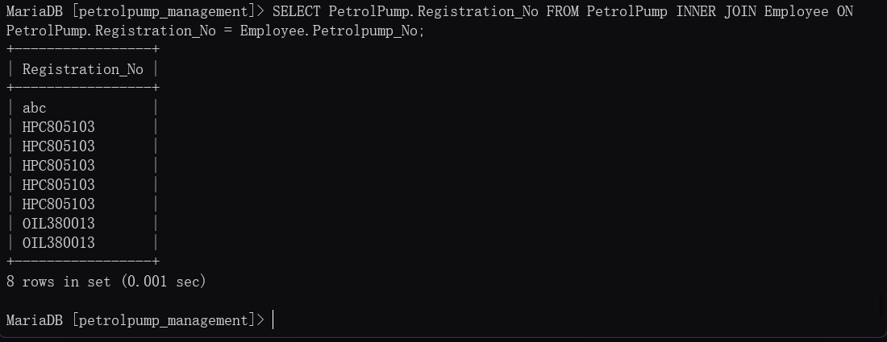

**Querry:**

SELECT Petrolpump.Registration_No FROM Petrolpump

LEFT JOIN Employee on Petrolpump.Registration_No = Employee.Petrolpump_No

WHERE Employee.Petrolpump_No is NULL;

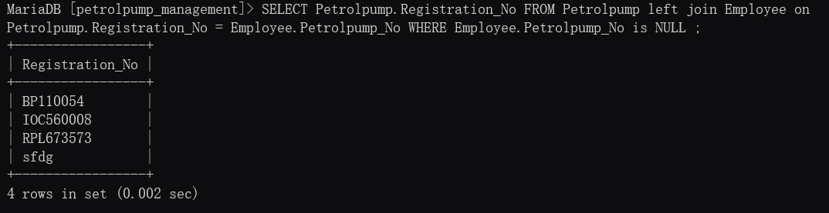

**Querry:**

SELECT PetrolPump.Registration_No FROM PetrolPump

LEFT JOIN Employee ON PetrolPump.Registration_No = Employee.Petrolpump_No;

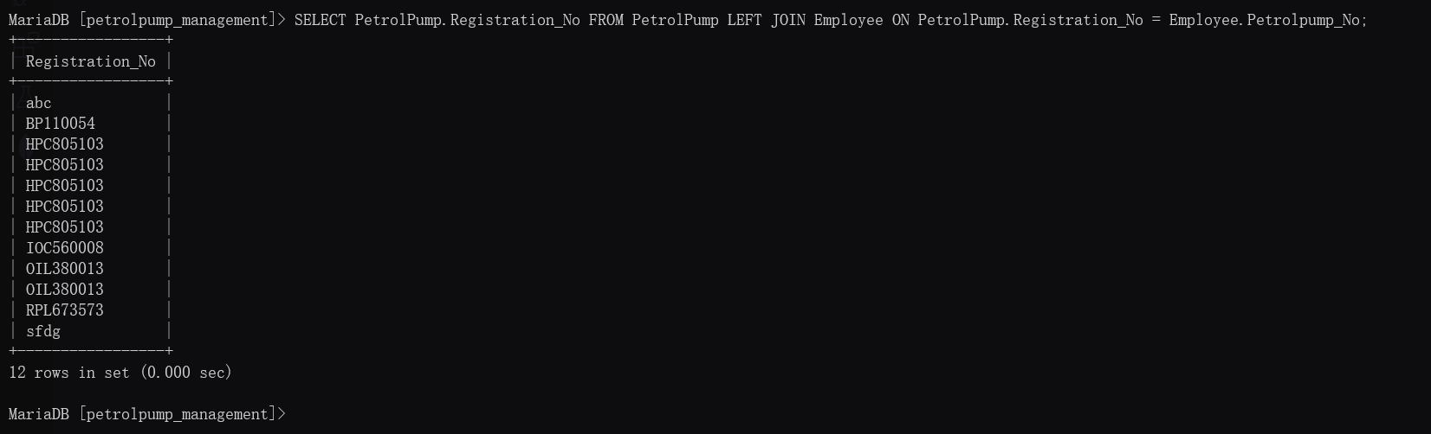

**Aggregate Functions**

**Q1) Find the Average age of the Male customers.**

**Query:**

SELECT avg(Age) from Customer where Gender='M';

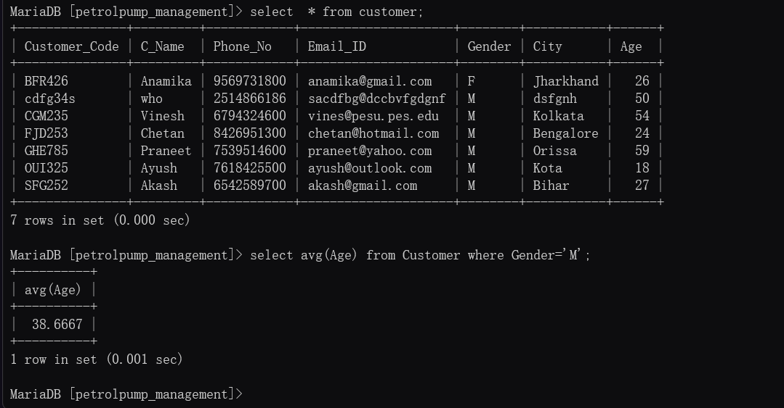

Q2) Find the name and age of Employee using the date of birth.

**Query:**

SELECT Emp_Name, TIMESTAMPDIFF (YEAR, DOB, CURDATE()) AS age FROM Employee;

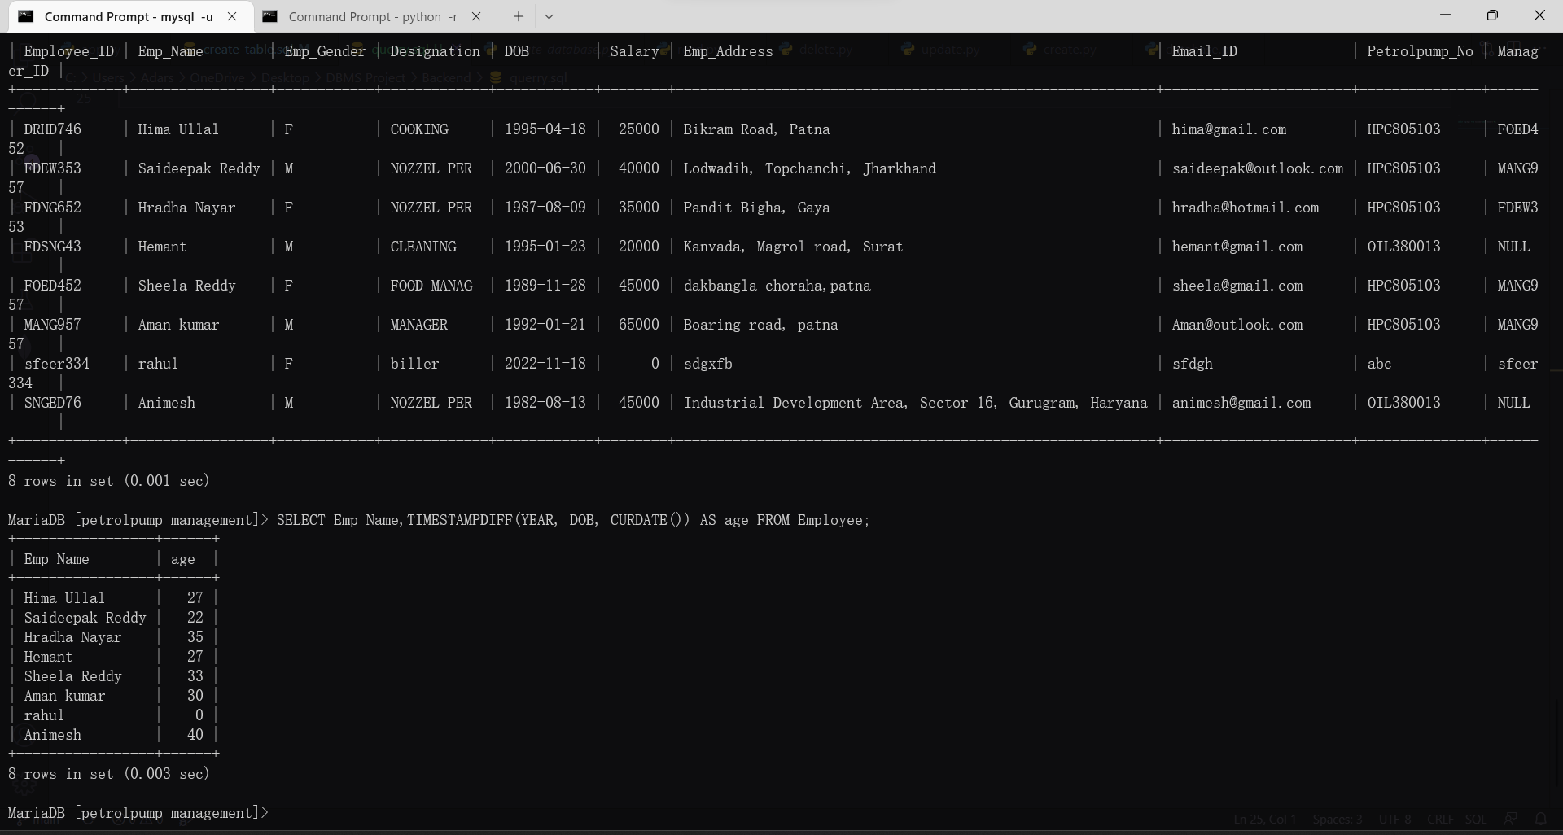

Q3) Find the Details of the Invoice Whose Total Prize is Maximum?

Query: SELECT *, max(Total_Price) from Invoice;

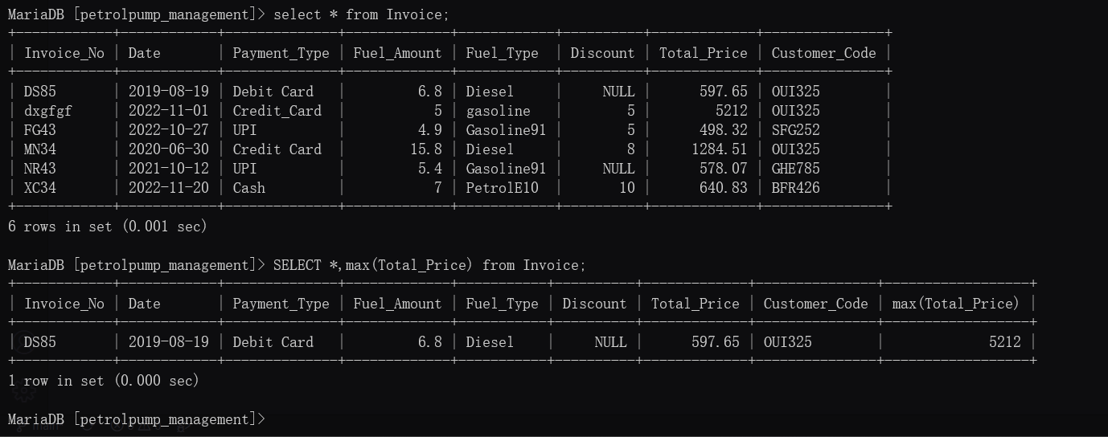

Q4) Get the details of Sales No, Sales Amount & Petrol pump No whose sales is maximum on 20 November, 2022

Query: SELECT Sales_No, Sales_Amount, Petrolpump_No, max(Sales_Amount) FROM Sales WHERE DATE='2022-11-20';

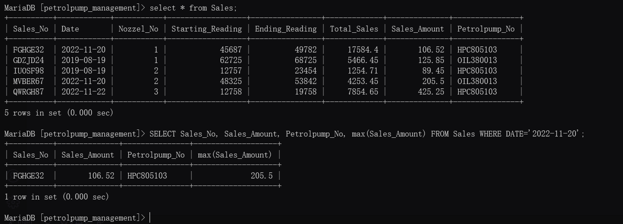

**Set Operations**

Showcase at least 3 Set Operations queries

Write the query in English Language, Show the equivalent SQL statement and also a screenshot of the query and the results.

Q 1) Get all the Unique names of Both the tables Owners and Employee

**Query**:

SELECT Owner_Name from Owners UNION SELECT EMP_Name from Employee;

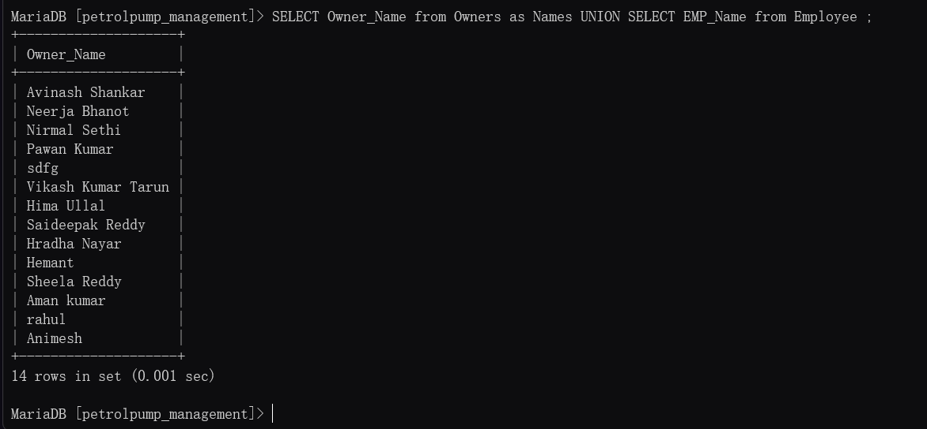

Q2) Find the Petrolpump Registration no which is Common Between both table Petrol pump and Employee?

**Query**:

SELECT Registration_No from Petrolpump INTERSECT SELECT Petrolpump_No from Employee;

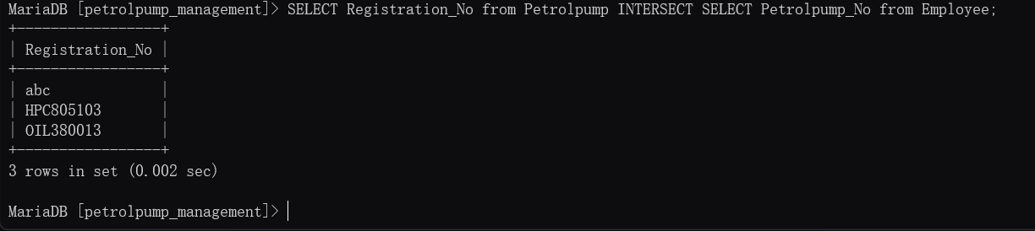

**SUBQUERIES:**

1)subquery to get the invoice of each PetrolPump with the highest sale:

**QUERY**:

SELECT *

FROM Invoice

WHERE Invoice_No IN (

SELECT Invoice_No

FROM Sales

WHERE (Petrolpump_No, Sales_Amount) IN (

SELECT Petrolpump_No, MAX(Sales_Amount)

FROM Sales

GROUP BY Petrolpump_No

)

);

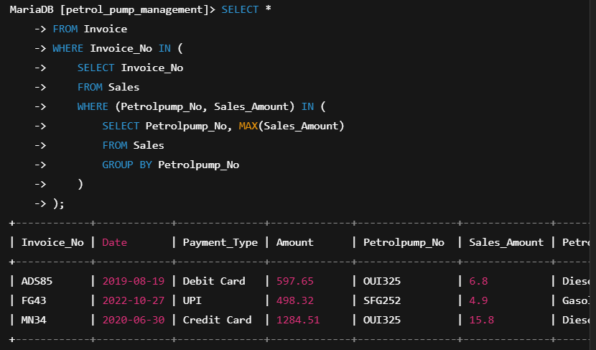

2) Which Petrol Pump(s) do not have any associated employees? Return names of all petrolpumps with no employees at all

**QUERY:**

SELECT Petrolpump_Name

FROM Petrolpump

WHERE Registration_No IN (

SELECT PetrolPump.Registration_No

FROM PetrolPump

LEFT JOIN Employee ON PetrolPump.Registration_No = Employee.Petrolpump_No

WHERE Employee.Petrolpump_No IS NULL

);

