**INTRODUCTION:**

In today's digital era, the ubiquity of cell phones has revolutionized communication, bringing unparalleled connectivity to people worldwide. However, with this convenience comes the challenge of managing their use in specific environments where their presence might pose security risks, disrupt operations, or violate established policies. To address these concerns, the development of cell phone detectors has emerged as a viable solution to detect and control the presence of active mobile devices within a given area.

Functionality of Cell Phone Detectors:

Cell phone detectors operate on the principle of detecting radio frequency (RF) signals emitted by active mobile phones during transmission. These devices scan for specific frequency bands commonly used by mobile phones, typically within the range of 800 MHz to 2.5 GHz. When a mobile phone is in use, it emits RF signals while connecting to cellular networks or engaging in communication activities such as calls, texts, or data transmission. Cell phone detectors leverage this emission to identify and locate the presence of active phones within their operational range.

Applications and Significance:

The applications of cell phone detectors span various sectors and serve multiple purposes:

1. Enhancing Security Measures: In high-security environments such as prisons, government facilities, or military installations, the clandestine use of cell phones can pose severe security threats. Cell phone detectors play a pivotal role in preventing unauthorized communication by identifying and locating active devices within these restricted areas.

2. Preserving Exam Integrity: Maintaining the integrity of examinations and assessments is crucial. Cell phone detectors are employed in educational institutions to detect and prevent cheating by identifying students or individuals attempting to use their phones during tests.

3. Enforcing No-Phone Policies: Numerous public spaces and institutions implement nophone policies to ensure privacy, prevent noise disruption, or protect sensitive equipment.

Cell phone detectors aid in enforcing these policies by identifying phone usage within restricted zones.

Types of Cell Phone Detectors:

There is a diverse range of cell phone detectors available, each with distinct features and

functionalities. These include handheld devices, stationary units installed in buildings or

**PROBLEM STATEMENT:**

Mobile phones are one of the common gadgets used to copy in the exams. They are also used to transmit audios and videos of the confidential meeting or anything alike. Even during frisking(also known as the pat search), if the concerned organisation does not have the female staff to frisk the females and male staff to frisk the males for the phones, then it creates a situation where one of the genders can bring in the mobile phone to the “NO MOBILE ZONE”. Hence a circuit is required which can detect the presence of a mobile phone.

**OBJECTIVES:**

* Create a circuit (bug) which can detect the presence of mobile phone by detecting the transmission of the Radio Frequency Signals.
* The circuit should be able to detect the mobile phones up to a suitable radius.
* The circuit should be able to notify the circuit user the presence of phone via blinking of the LED Bulb.

**METHODOLOGY**:

The components required to prepare this circuit are:

* CA3130 IC Op-Amp (1N)
* 1K Ω Resistor (1N)
* 100K Ω Resistor (1N)
* 2.2M Ω Resistor (2N)
* 47pF Capacitor (2N)
* 0.22μF Capacitor (1N)
* 100μF Capacitor (1N)
* BC548 Transistor (1N)
* LED Bulb (1N)
* 9V Battery
* 9V Battery Clip
* Wires
* Breadboard

Circuit Diagram:

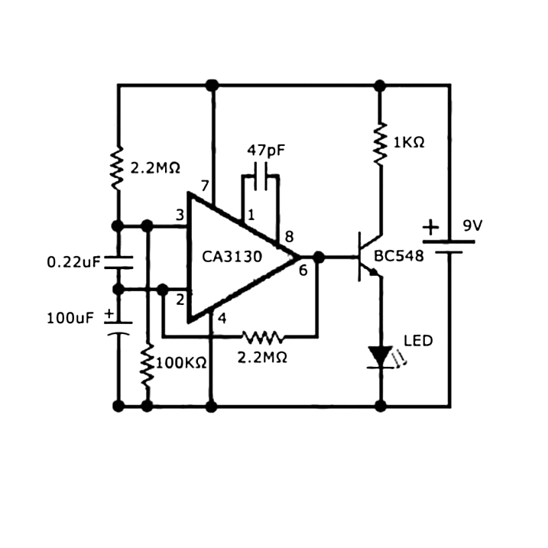

Assembling:

We place CA 3130 IC Op-Amp on the breadboard and connect pin 7 of the IC to the positive rail while linking pin 4 of the IC to the negative rail. Subsequently, we position the transistor on the breadboard. Pin 6 of the IC connects to the base of the transistor, and the collector of the transistor is linked to the positive rail of the breadboard via a 1k Ω resistor. Insert the LED into the breadboard, ensuring its anode connects to the emitter of the transistor, and its cathode connected to the negative rail.

Pin 2 of the IC connects to the base of the transistor using a 2.2M resistor. Pin 3 of the IC is connected to the negative rail of the breadboard through a 100k Ω resistor. Insert the 100μF capacitor onto the breadboard, connecting one of its pins to pin 3 of the IC and the other to the negative rail.

Connect pin 3 of the IC to the positive rail using a 2.2M resistor. Insert the 0.22μF capacitor on the breadboard, connecting one of its pins to pin 2 and the other to pin 3 of the IC. Add the 47pF capacitor onto the breadboard, linking one terminal to pin 1 of the IC and the other to pin 8. Finally, connect the terminals of 9-volt battery to the appropriate rails of the breadboard.

After the circuit connections are made, we test the circuit to make sure that all the connections are made properly and to ensure that the circuit actually works. During this testing phase, the circuit connections are checked and are checked for any short circuits or for any misconnections.

After testing the circuit for the proper connections, the circuit is checked for its proper working by ringing a cell phone within the working range of the circuit (which is approx. 1m).

It works by storing the RC signal power in the 0.22μF capacitor. The resistor and the capacitor acts as a filter to select the desired signal (the RF frequency at which the phone operates). The resistor and capacitor value are chosen such that the particular frequency is detected. The operational amplifier amplifies the capture signal because it is too low and a proper signal level needs to be applied to the base of the transistor for it to turn ON. So the output signals from the OPAMP with a 0.7 V drop (The forward voltage drop across the diode in the transistor) forward biases the LED and turns it ON.

The key to the entire circuit is the 2.2μF capacitor- You need 18mm length on the leads, and the 8mm width of the cap itself to form (essentially) a loop antenna that can detect GHz signals.

Since it detects the RF signal which is being transmitted by the mobile phone to the tower, it can work even when the mobile is in silent mode. And also since the detection is done by using 2.2μF capacitor, if we reduce the value of this capacitor or decrease the value of this capacitor, the bandwidth of the circuit also changes.

**EXPECTED OUTCOME:**

The circuit should detect the transmission of the cell phone nearby and should indicate the presence by glowing the LED Bulb. When the nearby cell phone is not transmitting, the LED should remain inactive indicating the absence of transmitting cell phone nearby.

**REFERENCES:**

https://www.youtube.com/watch?v=xW-hXU7MWnM&t=106s

https://www.electroschematics.com/mobile-bug-detector-sniffer/

https://www.circuits-diy.com/how-to-make-a-simple-mobile-phone-call-detector-circuit/