Experiment No:2.1
Experiment Name:Operation of stack
Code:

#include<stdio.h>
#define max 10
int main()
{
int a[10],top=-1,v,n,i;
printf("1 insertion\n2 deletion\n3 display\n4 quite");

while(1)
{
printf("\n\nyour choice : ");
scanf("%d",&n);
switch(n)
{
case 1:
if(top==max)
printf("stack is overflow");
else{
printf("Value:");
scanf("%d",&v);
top++;
a[top]=v;

}
break;
case 2:
if(top==-1)
printf("stack is underflow");
else{
a[top]=NULL;
top--;
}
break;
case 3:
if(top>-1)
{
for(i=0;i<=top;i++)
printf("%d \n",a[i]);
}
break;
case 4:
exit(0);
}
}
}

Output
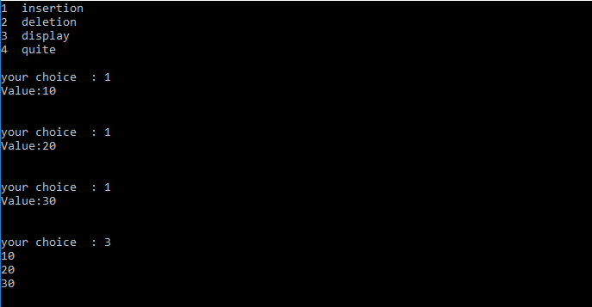
Experiment No :2.2
Experiment Name: Operation in Queue
Code:

#include<stdio.h>
main()
{
int i,n,a[20],rear=-1,count=-1,front=-
1,max=4;
for(i=0; i<=max; i++)
a[i]=0;
printf("Enter 1 for insertion\nEnter 2 for deletion\nEnter 3 for display\n");
while(1)
{

printf("Your choice :") ;
{

scanf("%d",&n);
if (n==1)
{
if(count==max)
printf("Queue is overflow\n");
else
{
if(count==-1)
{
rear=0;
front=0;
}
else if(rear==max)
{
rear=0;
}
else
rear=rear+1;
int b;
printf("Enter the value\n");
scanf("%d",&b);
a[rear]=b;
count++;
printf("Data succesfully inserted\n");
}
}
else if (n==2)
{
if(count==-1)
printf("Queue is underflow\n");
else
{
a[front]=0;
count--;
printf("Data successfully deleted\n");
if(count==-1)
{
rear=-1;
front=-1;
}
else if (front==max)
front=0;
else
front++;
}
}
else if (n==3)

{
printf("Queue values are\n");
for(i=0; i<=max; i++)
printf("%d\n",a[i]);
}
else
exit(0);
}
}
}

Output :
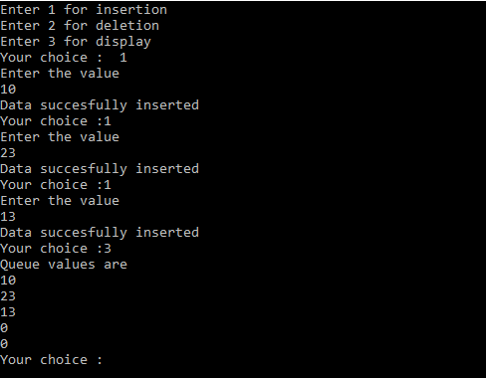
Experiment No :2.3
Experiment Name :Insertion into a Binary Search Tree
Code

#include<stdio.h>
struct mynode
{
struct mynode *ll;
int d;
struct mynode *rl;
};
typedef struct mynode node;
int main()
{
node *t,*p,*q,*a[100];
int i,j,x,n;
// printf("I am main function");
t=0,n=0;
for( ; ;)
{
printf("Enter your value\n");
scanf("%d",&x);
if(x<0)
break;
q=(node*)(malloc(sizeof(node)));
printf("q=%x\n",q);
q->d=x;
q->ll=0;
q->rl=0;
if(t==0)
t=q;
else
{
p=t;
for( ; ;)
{
if(p->d==x)
{
printf("Sorry duplicate value\n");
break;
}
else
{
if(p->d>x)
{
if(p->ll==0)
{
p->ll=q;
break;
}
else
p=p->ll;
}
else
{
if(p->rl==0)
{
p->rl=q;
break;
}
else
p=p->rl;
}
}
}
}
n++;
a[n]=q;
}
for(i=1; i<=n; i++)
{
p=a[i];
printf("%4x %4x %4d %4x\n",p,p->ll,p->d,p->rl);
}
}

Output :
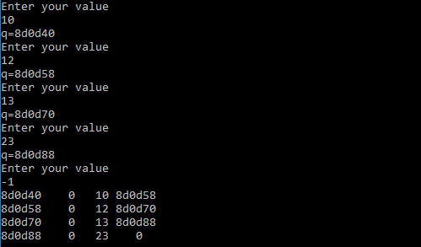
Experiment No:2.4
Experiment Name:Program of a Heap tree
code:

#include<stdio.h>
void heapsort(int[],int);
void heapify(int[],int);
void adjust(int[],int);
main()
{
int n,i;
printf("Enter the number of element\n");
scanf("%d",&n);
int a[n];
printf("Enter the elements\n");
for (i=0; i<n; i++)
scanf("%d",&a[i]);
heapsort(a,n);
printf("Final sorted elements are\n");
for (i=0; i<n; i++)
printf("%d\t",a[i]);
printf("\n");
}
void heapsort(int a[],int n)
{
int i,t;
heapify(a,n);
for (i=n-1; i>0; i--)
{
t = a[0];
a[0] = a[i];
a[i] = t;
adjust(a,i);
}
}
void heapify(int a[],int n)
{
int k,i,j,item;
for (k=1; k<n; k++)
{
item = a[k];
i = k;
j = (i-1)/2;
while((i>0)&&(item>a[j]))
{
a[i] = a[j];
i = j;
j = (i-1)/2;
}
a[i] = item;
}
}
void adjust(int a[],int n)
{
int i,j,item;
j = 0;
item = a[j];
i = 2*j+1;
while(i<=n-1)
{
if(i+1 <= n-1)
if(a[i] <a[i+1])
i++;
if(item<a[i])
{
a[j] = a[i];
j = i;
i = 2*j+1;
}
else
break;
}
a[j] = item;
}

output:
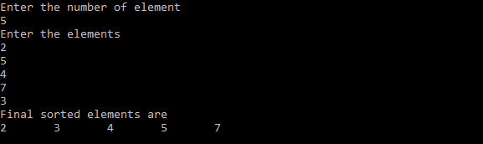

Experiment No:2.5
Experiment Name :peogram of Bubbles Sort
Code
#include <stdio.h>

int main()
{
int array[100], n, c, d, swap;

printf("Enter number of elements\n");
scanf("%d", &n);

printf("Enter %d integers\n", n);

for (c = 0; c < n; c++)
scanf("%d", &array[c]);

for (c = 0 ; c < ( n - 1 ); c++)
{
for (d = 0 ; d < n - c - 1; d++)
{
if (array[d] > array[d+1]) /* For decreasing order use < */
{
swap = array[d];
array[d] = array[d+1];
array[d+1] = swap;
}
}

}

printf("Sorted list in ascending order:\n");

for ( c = 0 ; c < n ; c++ )
printf("%d\n", array[c]);

return 0;
}

Output
