Architectural comparison table
Feature | GPU | FPGA
Computation | CUDA and Tensor Cores | DSPs and configurable logic
Parallelism | Large numbers of programmable processing units | Custom parallel processing elements
Pipelining | Optimized GPU kernels | Custom hardware pipelines
Memory | HBM, caches, shared memory | BRAM, URAM, DDR and optionally HBM
Quantization | Supports INT8, INT4 and other formats through compatible kernels | Custom circuits for selected precisions
Sparsity | Supported patterns depend on GPU and software | Specialized support for chosen sparse patterns
Flexibility | Easier to deploy different LLMs using existing frameworks | More design effort; highly customizable hardware
Main strength | High throughput, ecosystem and scalability | Specialization, data reuse and potential efficiency

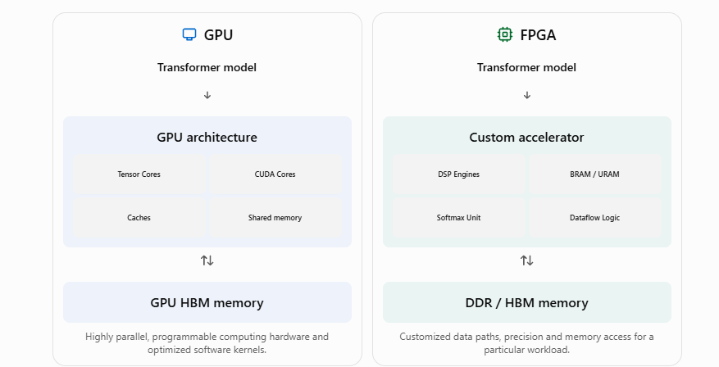

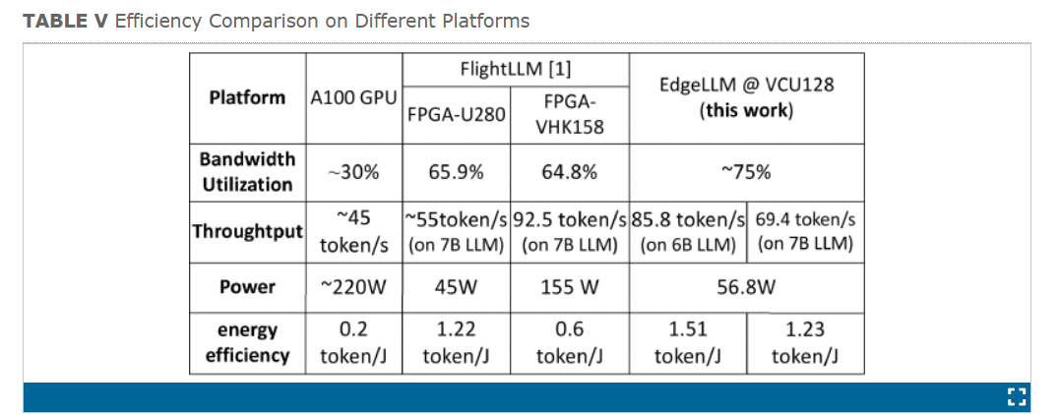
Src: https://ieeexplore.ieee.org/document/10916480
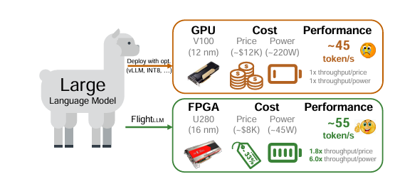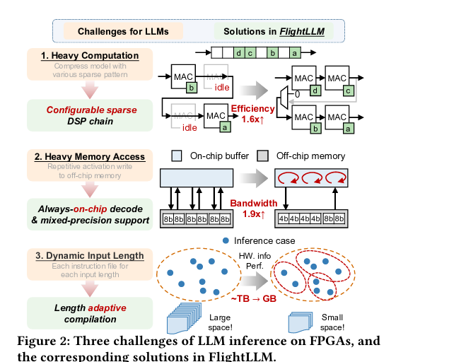
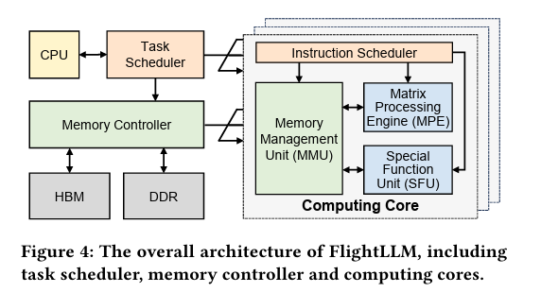

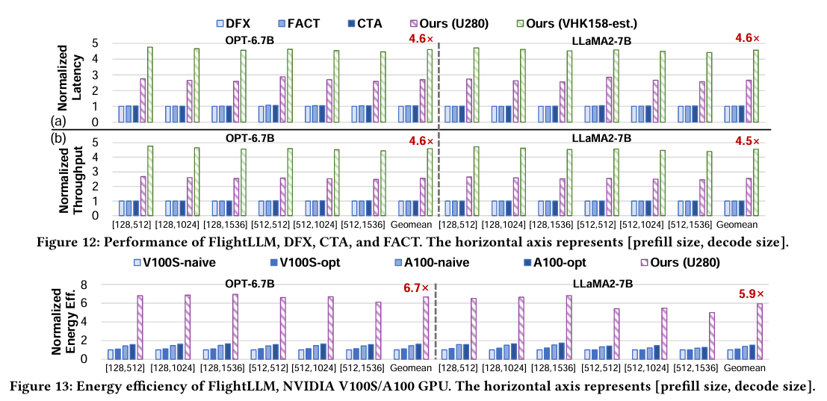
Src: https://arxiv.org/pdf/2401.03868



