
AMRITA SCHOOL OF ENGINEERING, BENGALURU

DEPARTMENT OF ELECTRONICS & COMMUNICATION ENGINEERING

B. TECH. IV SEMESTER AY 2024-2025
23ECE284 MICROCONTROLLER AND INTERFACING LABORATORY
SYSTEM DESIGN REPORT
JANUARY TO APRIL 2025

Design of a Bluetooth-Enabled Digital Clock with Alarm and Medicine Reminder using LPC2148 Microcontroller
Submitted by

R.NO NUMBER NAME SIGNATURE WITH DATE
BL.EN.U4ECE23103 A.KULADEEP
BL.EN.U4ECE23117 G.SOHAN
BL.EN.U4ECE23124 K.R.SUJAN KRISHNA
BL.EN.U4ECE23162 N.MANIKANTA

BATCH NUMBER:11

FACULTY EXAMINER SIGNATURE WITH EVALUATION

DATE:-
COMMENTS (IF ANY)
Aim:
To design and implement a medicine reminder system using the LPC2138 microcontroller interfaced with RTC, LCD, Keypad, and UART modules.

Components required along with their specifications:
- LPC2138 Microcontroller (ARM7TDMI-based, 32-bit, 60 MHz)
- 16x2 LCD Display (Hitachi HD44780 or equivalent)
- 4x4 Matrix Keypad (16 keys, digital input)
- Virtual UART Terminal (Proteus virtual peripheral)
- Crystal Oscillator (12 MHz for LPC2138)
- Power Supply (5V regulated)
- Resistors and Capacitors for reset and decoupling

Circuit diagram:

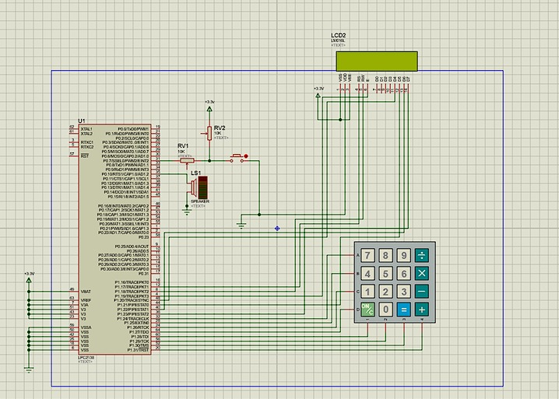
Figure 1: This circuit diagram shows a medicine reminder system using an LPC2138 microcontroller. It connects a 16x2 LCD, 4x4 keypad, and buzzer to alert the user at set times. The system allows setting medicine alarms and provides visual and audible notifications.

Theory and working principle:
The system maintains real-time clock using LPC2138's internal RTC. The user can edit current time and alarm time using a 4x4 keypad. Time and prompts are displayed on an LCD. If the alarm time matches the current time, the system displays an alert on LCD and sends a message via UART.

BLOCK DIAGRAM:-

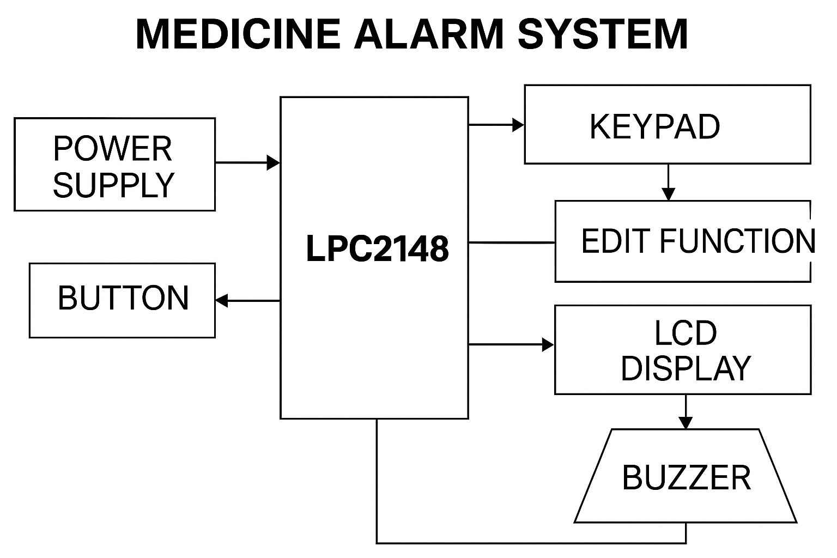

Program:
Modular C code using:
- medicine.c - main logic and ISR
#include <lpc213x.h>
#include <stdio.h>
#include <string.h>

#include "LCD Header.h"
#include "edit header.h"
#include "UART Header.h"

#define fpclk 15000000

int sec, min, hour, day, month, year;

// Define alarms
int ALARM1_HOUR = 11, ALARM1_MIN = 9, ALARM1_SEC = 30;
int ALARM2_HOUR = 11, ALARM2_MIN = 9, ALARM2_SEC = 45;
int ALARM3_HOUR = 11, ALARM3_MIN = 10, ALARM3_SEC = 0;

// Alarm enable flags
int alarm1_enabled = 1;
int alarm2_enabled = 1;
int alarm3_enabled = 1;

void beep_buzzer()
{
IODIR0 |= (1 << 10); // P0.10 as output (Speaker/Buzzer pin)
IOSET0 = (1 << 10); // Turn ON buzzer
delay_ms(2000); // 2 second beep
IOCLR0 = (1 << 10); // Turn OFF buzzer
}

void ISR_KEYPAD(void) __irq {
edit_function();

SEC = sec;
MIN = min;
HOUR = hour;
DOM = day;
MONTH = month;
YEAR = year;

EXTINT = 0x04;
VICVectAddr = 0;
}

void ISR_RTC(void) __irq {
char time_str[20], date_str[20];
int display_hour;
char ampm[3];

if (ILR & 0x01) // Tick Interrupt
{
sec = CTIME0 & 0x3F;
min = (CTIME0 >> 8) & 0x3F;
hour = (CTIME0 >> 16) & 0x1F;
day = CTIME1 & 0x1F;
month = (CTIME1 >> 8) & 0x0F;
year = (CTIME1 >> 16) & 0x0FFF;

if (hour == 0) { display_hour = 12; strcpy(ampm, "AM"); }
else if (hour < 12) { display_hour = hour; strcpy(ampm, "AM"); }
else if (hour == 12) { display_hour = 12; strcpy(ampm, "PM"); }
else { display_hour = hour - 12; strcpy(ampm, "PM"); }

ILR = 0x01; // Clear tick flag

LCD_INIT();
LCD_CMD(0x80);
sprintf(time_str, "%02d:%02d:%02d %s", display_hour, min, sec, ampm);
LCD_STRING(time_str);

LCD_CMD(0xC0);
sprintf(date_str, "%02d/%02d/%02d", day, month, year);
LCD_STRING(date_str);

// --- Check Alarm 1 ---
if (alarm1_enabled && hour == ALARM1_HOUR && min == ALARM1_MIN && sec == ALARM1_SEC)
{
LCD_INIT();
LCD_STRING("Alarm 1 Trigger!");
beep_buzzer();
alarm1_enabled = 0; // Disable after firing
}
// --- Check Alarm 2 ---
if (alarm2_enabled && hour == ALARM2_HOUR && min == ALARM2_MIN && sec == ALARM2_SEC)
{
LCD_INIT();
LCD_STRING("Alarm 2 Trigger!");
beep_buzzer();
alarm2_enabled = 0; // Disable after firing
}
// --- Check Alarm 3 ---
if (alarm3_enabled && hour == ALARM3_HOUR && min == ALARM3_MIN && sec == ALARM3_SEC)
{
LCD_INIT();
LCD_STRING("Alarm 3 Trigger!");
beep_buzzer();
alarm3_enabled = 0; // Disable after firing
}
}
else if (ILR & 0x02) {
// Alarm interrupt (optional for external alarm setting)
}

VICVectAddr = 0;
}

void RTC_Init() {
ILR = 0x03;
CCR = 0x02;
CIIR = 0x07;

PREINT = (int)(fpclk / 32768) - 1;
PREFRAC = (int)(fpclk - ((PREINT + 1) * 32768));

sec = 0; min = 9; hour = 11;
day = 15; month = 4; year = 25;

SEC = sec;
MIN = min;
HOUR = hour;
DOM = day;
MONTH = month;
YEAR = year;

AMR = 0x00;
CCR = 0x11; // RTC enable

VICIntSelect &= ~(1 << 13);
VICVectCntl1 = 0x20 | 13;
VICVectAddr1 = (unsigned long)ISR_RTC;
VICIntEnable |= (1 << 13);
}

void keypad_interrupt_init() {
PINSEL0 |= (0x3 << 14);
EXTINT = 0x04;
EXTMODE |= (1 << 2);
EXTPOLAR &= ~(1 << 2);
VICIntSelect &= ~(1 << 16);
VICVectCntl0 = 0x20 | 16;
VICVectAddr0 = (unsigned long)ISR_KEYPAD;
VICIntEnable |= (1 << 16);
}

void button_interrupt_init() {
PINSEL0 |= 0xC0000000;
EXTINT = 0x02;
EXTMODE |= (1 << 1);
EXTPOLAR &= ~(1 << 1);
VICIntSelect &= ~(1 << 15);
VICVectCntl2 = 0x20 | 15;
}

int main() {
PINSEL2 = 0x00000000;

LCD_INIT();
LCD_STRING("Time&Date:");
LCD_CMD(0xC0);
LCD_STRING("Press EDIT");

RTC_Init();
keypad_interrupt_init();
button_interrupt_init();

while (1) {
// Main loop, waiting for interrupts
}}

Simulator used for simulator-based output:
Proteus Design Suite 8.0 or higher

Inputs applied to the simulator:
- Keypad inputs: 1, 2, 3 to select and enter time/alarm values
- RTC time increment via internal mechanism

Output obtained from the simulator:
- Time displayed and updated on LCD
- "Medicine Alarm" shown on LCD and sent via UART at alarm time

Screenshot of the simulator based circuit:-

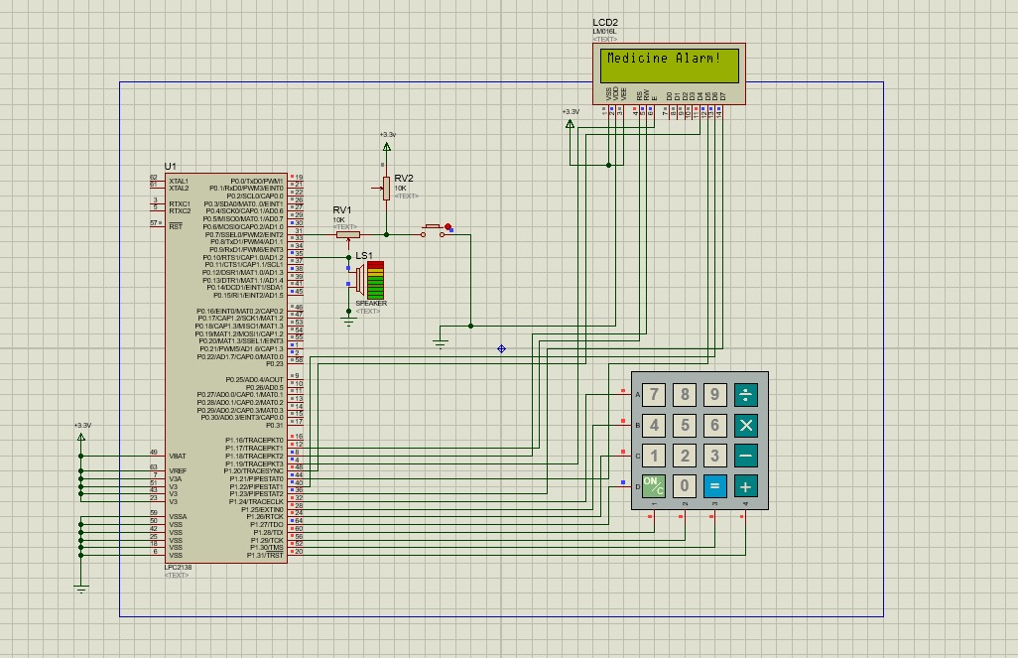

Figure 2: Simulated view of the medicine reminder system showing the active alarm state. The LCD displays the “Medicine Alarm!” message, indicating that the system successfully detects the scheduled time and triggers the notification.

Any other relevant information:
The system uses external interrupts (EXTINT) and RTC interrupts to handle user input and time management without constant polling.

Conclusion:
A fully functional medicine reminder system was developed using LPC2138, successfully integrating keypad-based input, real-time clock handling, LCD output, and UART communication.

Problems faced during the implementation:
- Keypad not detecting inputs initially due to incorrect pin configuration
- LCD flickering due to timing issues
- Alarm not triggering due to mismatched RTC configuration

Problems resolved using solutions:
- Corrected pin directions for keypad
- Added proper delays after LCD enable pulse
- Rechecked RTC initialization and mask bits for accurate alarm match

Any other comment:
This project demonstrates interrupt-driven embedded design using ARM7 and is suitable for medical or reminder applications in real-time systems.

References:
[1]. NXP Semiconductors, LPC2131/32/34/36/38 Data Sheet, Rev. 03. [Online].
Available: https://www.nxp.com/docs/en/data-sheet/LPC2131_32_34_36_38.pdf

[2]. ElectronicWings, "LPC2138 - RTC, Keypad, LCD, UART Interfacing," [Online]. Available: https://www.electronicwings.com/

[3]. Keil uVision IDE and Examples: https://www.keil.com

[4]. Proteus Design Suite: https://www.labcenter.com

