DEEMED TO BE UNIVERSITY UNDER SECTION-3 OF THE UGC ACT,1956
AMRITA SCHOOL OF ENGINEERING, BENGALURU
DEPARTMENT OF ELECTRONICS AND COMMUNICATION ENGINEERING

B. TECH. IV SEMESTER(ECE)
23ECE286 CIRCUITS AND COMMUNICATION LABORATORY
SYSTEM DESIGN REPORT
Submitted by:
REG.NO NAME
BL.EN.U4ECE23101 A.KULADEEP SAI
BL.EN.U4ECE23117 SOHAN GUDLA
BL.EN.U4ECE23124 SUJAN KRISHNA
Department of Electronics and Communication Engineering
Amrita Vishwa Vidyapeetham, Amrita Nagar, Choodasandra, Junnasandra, Bengaluru, Karnataka 560035

AIM:
To design and build a basic low-cost audio mixer circuit that combines multiple audio signals into a single output using operational amplifiers and a class D amplifier.
APPARATUS REQUIRED:

Component | Specification | Quantity
Operational Amplifier | TL072 (Dual Op-Amp IC) | 1 IC
Audio Amplifier Module | TPA3110 (Class D Audio Amplifier) | 1 Module
Resistors | 10kΩ | 3 Pieces
Capacitors | 10μF (Electrolytic) | 3 Pieces
Power Supply | 12V DC | 1 Unit
Breadboard or PCB |  | 1 Unit
Audio Input Sources | Phone / MP3 Player / Audio Device | As needed
Connecting Wires |  | As needed
Speaker | 4Ω–8Ω, Few Watts | 1

THEORY:
An audio mixer is an electronic circuit that allows multiple audio signals to be combined into one or more output signals. It is widely used in music production, broadcasting, and live sound systems.
In this design, the TL072 op-amp is used to mix the audio signals. Each input signal passes through a resistor (to isolate it and adjust gain), and the signals are summed at the inverting input of the op-amp. Capacitors are used for DC blocking and filtering.
The mixed signal is then fed into the TPA3110 class D amplifier for efficient amplification and output to a speaker. The circuit operates from a 12V power supply and is suitable for small-scale audio applications.
CIRCUIT DIAGRAM:
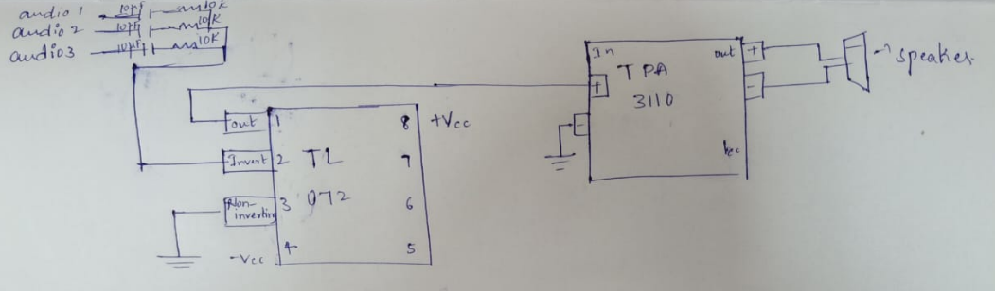

PROCEDURE:
1. Connect each audio input through a 10kΩ resistor to the inverting input of the TL072 op-amp.
2. Use 10μF capacitors in series with each input for DC isolation.
3. Connect the op-amp output to the input of the TPA3110 amplifier.
4. Power the op-amp and amplifier with a 12V DC power source.
5. Connect a speaker to the output of the TPA3110.
6. Test the system by playing audio from multiple sources and observing the mixed output.

WORKING PRINCIPLE:
The audio mixer works by summing two audio signals using the inverting input of the TL072 op-amp. Each input signal is passed through a 10kΩ resistor to ensure proper impedance matching and signal isolation. The signals are combined at the op-amp input, and the output provides a mixed version of the two inputs. This mixed signal is then passed to the TPA3110 Class D amplifier, which boosts the signal power to drive an external speaker. Capacitors ensure DC isolation, and the power supply provides necessary biasing for proper operation. The result is a single clear audio output that contains both input audio tracks combined together.
IMPLEMENTED CIRCUIT:
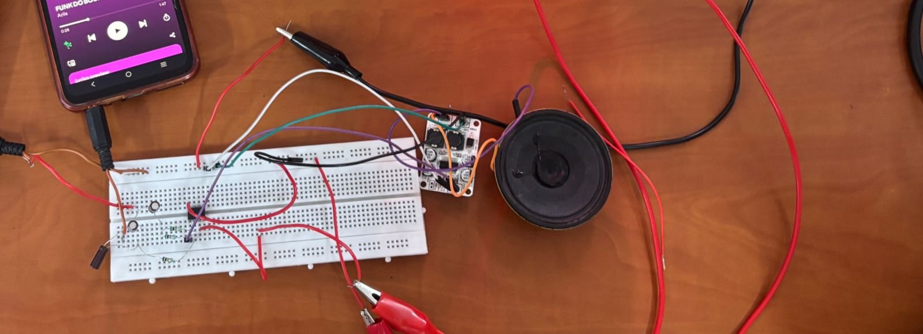
OBSERVATIONS:
- When only one audio source was connected, the output followed that input accurately.
- When both audio sources were connected, the output contained both audio tracks mixed clearly.
- Adjusting the volume of one source affected the balance of the mixed output accordingly.
- The TPA3110 amplifier produced sufficient gain with minimal distortion.
- The op-amp mixing stage showed stable and consistent performance under different signal conditions.

RESULT:
The audio mixer circuit successfully combined multiple input signals into a single output. The op-amp-based mixer effectively summed the audio sources, and the TPA3110 amplified the signal to drive a speaker. The output audio was clear and consistent, demonstrating the working of a basic audio mixer system.
CONCLUSION:
A simple audio mixer circuit was built using the TL072 op-amp and TPA3110 amplifier. The circuit effectively demonstrated summing of multiple inputs and amplification of the combined signal. It serves as a foundational example of how audio signals can be processed using basic electronic components.

