
AMRITA SCHOOL OF ENGINEERING, BENGALURU
DEPARTMENT OF ELECTRONICS & COMMUNICATION ENGINEERING
B. TECH. V SEMESTER (ECE AND EAC) AY 2025-2026

SIMULATION BASED REPORT FOR 23ECE333
Functional Verification (January to May 2026)
Design and Implementation of a Low-Power 4-Bit ALU Using Hybrid Optimization Techniques

Submitted by:
Reg.NO | Name | Signature with Date
BL.EN.U4ECE23014 | Ch Asritha
BL.EN.U4ECE23103 | A Kuladeep Sai
BL.EN.U4ECE23107 | G Sohan
BL.EN.U4ECE23124 | K.R.Sujan Krishna

Submitted to:
Faculty Name | Department | Signature with Date
Ms Sonali Agrawal | ECE

Date of Evaluation: 5-5-26
Batch Number: 02

Remarks:

Aim
To design, implement, and verify a low-power 4-bit Arithmetic Logic Unit (ALU) using SystemVerilog HDL by applying multiple progressive power optimization techniques.

Base paper Details
Title: Design and Implementation of a Low-Power 4-Bit ALU Using Hybrid Optimization Techniques
Authors: Jayashree Shivakumar, Kalathmika G, Nandana P Pillai, Rakshita Basarakod, Kariyappa B. S.
Conference: 2025 9th International Conference on Computational System and Information Technology for Sustainable Solutions (CSITSS)
DOI: 10.1109/CSITSS67709.2025.11294188
Publisher: IEEE, 2025
Key Outcome: ~49% power reduction (2.554 W → 1.307 W) on Artix-7 FPGA using hybrid low-power techniques

Tools Used

- Hardware Description Language: SystemVerilog (IEEE 1800-2012)
- Synthesis & Power Analysis Tool: Xilinx Vivado Design Suite
- Target Hardware Platform: Digilent Basys3 Board – Xilinx Artix-7 FPGA (XC7A35T)
- Simulation: Vivado Behavioral Simulator (Xsim)
- Package File: alu_pkg (SystemVerilog package defining opcode_t enum)
Theory
Introduction
The Arithmetic Logic Unit (ALU) is the fundamental computational block in any digital processor or embedded system. As modern VLSI systems scale down in process geometry and integrate more functionality, power consumption has emerged as a dominant design constraint — especially in IoT devices, wearables, and mobile processors. This project focuses on designing a 4-bit ALU in SystemVerilog and progressively applying hybrid low-power techniques to reduce dynamic power consumption without compromising functional correctness.
Four distinct optimization methods are evaluated against a reference (baseline) implementation. Each method introduces additional power-saving strategies, culminating in Method 4, which achieves approximately 48.8% power reduction over the baseline.

Block Diagram of the System
The 4-bit ALU accepts two 4-bit operands (A, B), a 3-bit opcode (sel / op), a clock signal, an enable signal (alu_en / valid_in), and an active-low asynchronous reset (rst_n). It produces a 4-bit result (ALU_Out / result) and a 1-bit carry output (CarryOut / valid_out).

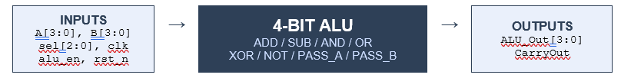

ALU Operation Table
Opcode | Operation | Description
3'b000 | ADD | Addition of A and B
3'b001 | SUB | Subtraction of A and B
3'b010 | AND_OP | Bitwise AND
3'b011 | OR_OP | Bitwise OR
3'b100 | XOR_OP | Bitwise XOR
3'b101 | NOT_OP | Bitwise NOT of A
3'b110 | PASS_B | Pass B
3'b111 | PASS_A | Pass A

Method 1:
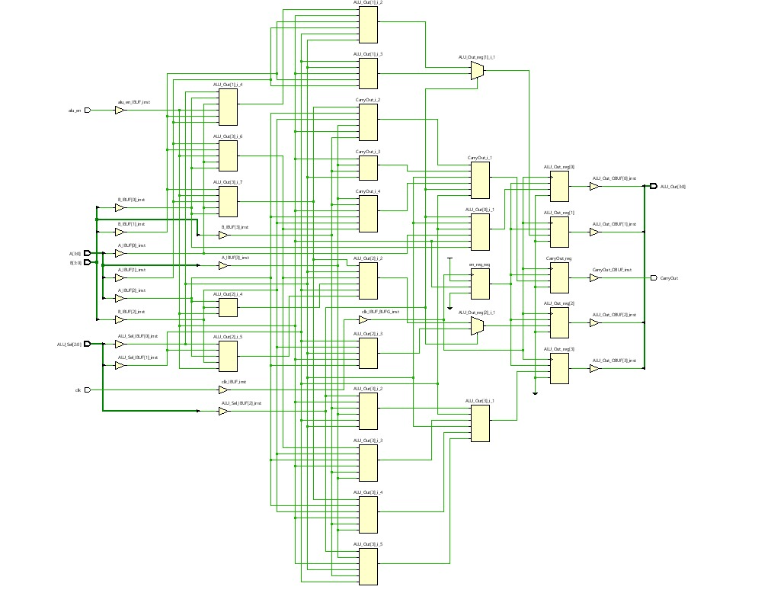
Method 2:
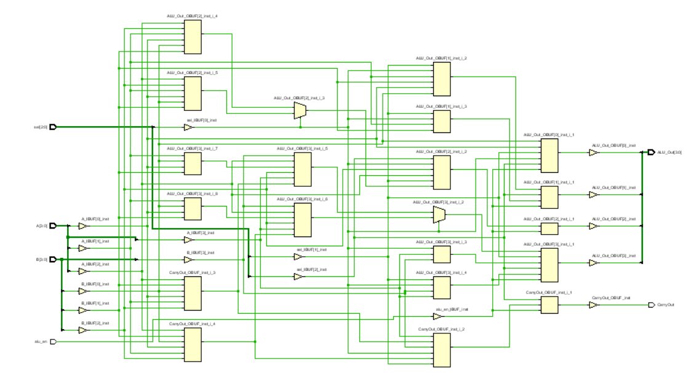
Method 3:

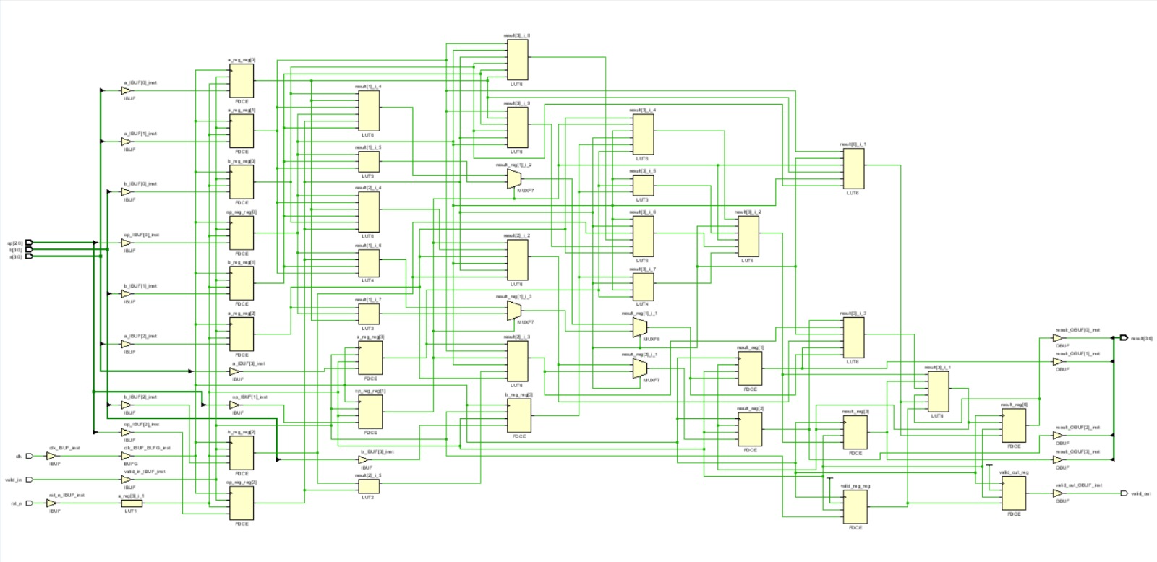

Method 4:
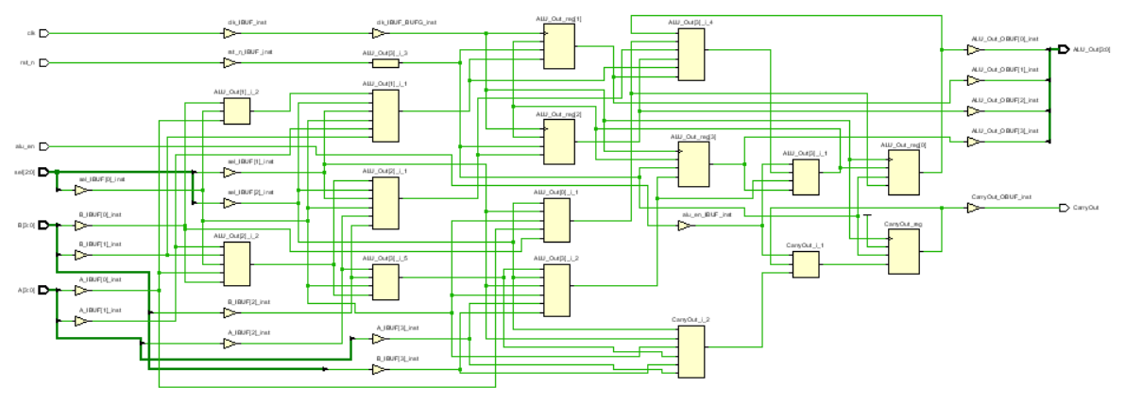

Working Principle
The ALU operates on two 4-bit operands A and B, selecting one of eight operations via a 3-bit opcode. An enable signal gates all computation — when the ALU is disabled, inputs and outputs are frozen to avoid unnecessary switching activity, which is the primary source of dynamic power dissipation. The five progressively optimized designs demonstrate how architectural-level changes at the RTL stage can dramatically reduce power without requiring technology or cell-level modifications.

Low-Power Techniques Applied
- Clock Gating: The clock is gated using an enable register (en_reg), preventing unnecessary toggling in flip-flops during idle cycles.
- Precomputation Logic: All operations are computed in parallel combinationally; only the selected result is registered, reducing active switching paths.
- Operand Isolation: Operands A and B are forwarded to logic only for operations that require them; unused operands are zeroed, eliminating spurious transitions.
- Bus Inversion Encoding: The Hamming distance between consecutive inputs is evaluated; data is inverted on the bus if this reduces the number of bit transitions.
- Simplified FSM: A single-bit toggle flag tracks ALU activity state, minimizing state machine overhead and internal node switching.
- Selective Storage Policy: Input and output registers are written only when valid data is present, reducing the number of active flip-flops.
- Reset-Aware Clocked Storage: Asynchronous active-low reset initializes all flip-flops to a known low-power state, preventing transient surges during power-up.
- Glitch-Free Output Propagation: Outputs are updated conditionally (only when the ALU is active and the result has changed), preventing spurious glitches on heavily loaded output nodes.
- Minimalistic Pipelined Buffering: A single output pipeline stage is used for final results, avoiding multi-stage intermediate buffering and reducing capacitive load.

Advantages
- Significant dynamic power reduction — up to 48.8% — without any change in functional behaviour.
- Scalable architecture: techniques can be extended to wider (8-bit, 16-bit) ALUs.
- Suitable for energy-constrained applications: IoT sensors, wearables, mobile SoCs.
- Modular design: each optimization can be applied independently or combined.
- Compatible with standard FPGA synthesis flows (Vivado, Quartus).

Disadvantages
- Clock gating adds a small area overhead due to the enable latch/register.
- Precomputation requires all operations to be active simultaneously, increasing logic utilization slightly.
- Bus inversion encoding requires a Hamming distance comparator, adding combinational logic.
- Selective storage introduces a one-cycle input latency, which may require pipeline-aware testbench design.
- Glitch-free conditional assignments may delay output updates by one clock cycle in edge cases.
SystemVerilog Code – Design Blocks
Baseline ALU
The baseline design implements a straightforward 4-bit ALU with no power optimization techniques. It uses a simple always_ff block triggered on the clock with an asynchronous reset, and all operations execute unconditionally when alu_en is asserted. This serves as the reference for all power comparisons.

// baseline_alu.sv – Baseline 4-bit ALU (No Power Optimisations)
// Reference design; measured power on Basys3 Artix-7: 2.554 W
`timescale 1ns/1ps
import alu_pkg::*;

module baseline_alu (
input logic clk,
input logic rst_n,
input logic [3:0] A, B,
input opcode_t sel,
input logic alu_en,
output logic [3:0] ALU_Out,
output logic CarryOut
);
always_ff @(posedge clk or negedge rst_n) begin
if (!rst_n) begin
ALU_Out <= 4'b0;
CarryOut <= 1'b0;
end else if (alu_en) begin
case (sel)
ADD : {CarryOut, ALU_Out} <= {1'b0, A} + {1'b0, B};
SUB : {CarryOut, ALU_Out} <= {1'b0, A} - {1'b0, B};
AND_OP: begin ALU_Out <= A & B; CarryOut <= 1'b0; end
OR_OP : begin ALU_Out <= A | B; CarryOut <= 1'b0; end
XOR_OP: begin ALU_Out <= A ^ B; CarryOut <= 1'b0; end
NOT_OP: begin ALU_Out <= ~A; CarryOut <= 1'b0; end
PASS_B: begin ALU_Out <= B; CarryOut <= 1'b0; end
PASS_A: begin ALU_Out <= A; CarryOut <= 1'b0; end
default: begin ALU_Out <= 4'b0; CarryOut <= 1'b0; end
endcase
end
end
endmodule

Method 1 – Clock Gating & Precomputation Logic
Clock gating is achieved by registering the enable signal (en_reg), so the output flip-flops toggle only on cycles when the ALU was actively enabled one cycle prior. Precomputation pre-calculates all operation results combinationally in parallel; only the selected result is latched. Gated operands (gA, gB) suppress input switching when the ALU is idle.

// method1_alu.sv – Clock Gating + Precomputation Logic
// Contributor: Asritha | Measured Power: 2.427 W
module method1_alu (
input logic [3:0] A,
input logic [3:0] B,
input logic [2:0] ALU_Sel,
input logic clk,
input logic alu_en,
output logic [3:0] ALU_Out,
output logic CarryOut
);
logic [4:0] add_res, sub_res;
logic [3:0] and_res, or_res, xor_res, not_res;
logic [3:0] gA, gB;

assign gA = alu_en ? A : 4'b0000;
assign gB = alu_en ? B : 4'b0000;

always_comb begin
add_res = gA + gB;
sub_res = gA - gB;
and_res = gA & gB;
or_res = gA | gB;
xor_res = gA ^ gB;
not_res = ~gA;
end

logic en_reg;
always_ff @(posedge clk) begin
en_reg <= alu_en;
end

always_ff @(posedge clk) begin
if (en_reg) begin
case (ALU_Sel)
3'b000: {CarryOut, ALU_Out} <= add_res;
3'b001: {CarryOut, ALU_Out} <= sub_res;
3'b010: begin ALU_Out <= and_res; CarryOut <= 1'b0; end
3'b011: begin ALU_Out <= or_res; CarryOut <= 1'b0; end
3'b100: begin ALU_Out <= xor_res; CarryOut <= 1'b0; end
3'b101: begin ALU_Out <= not_res; CarryOut <= 1'b0; end
3'b110: begin ALU_Out <= B; CarryOut <= 1'b0; end
3'b111: begin ALU_Out <= A; CarryOut <= 1'b0; end
default: begin ALU_Out <= 4'b0000; CarryOut <= 1'b0; end
endcase
end
end
endmodule

Method 2 – Operand Isolation
Operand isolation ensures that only the operands required for the currently selected operation are forwarded to the computation logic. Unused operands default to zero, preventing unnecessary bit transitions in the combinational logic tree. This minimizes dynamic power proportional to the switching activity of isolated nodes.

// method2_alu.sv – Operand Isolation Technique
// Contributor: Kuladeep | Measured Power: 2.408 W
`timescale 1ns/1ps
module method2_alu (
input logic [3:0] A,
input logic [3:0] B,
input alu_pkg::opcode_t sel,
input logic alu_en,
output logic [3:0] ALU_Out,
output logic CarryOut
);
import alu_pkg::*;

logic [4:0] add_res, sub_res;
logic [3:0] and_res, or_res, xor_res, not_res;
logic [3:0] passA_res, passB_res;
logic [3:0] A_iso, B_iso; // Isolated operands

always_comb begin
ALU_Out = 0;
CarryOut = 0;
A_iso = 0;
B_iso = 0;

if (alu_en) begin
case(sel)
ADD: begin A_iso=A; B_iso=B; end
SUB: begin A_iso=A; B_iso=B; end
AND_OP: begin A_iso=A; B_iso=B; end
OR_OP: begin A_iso=A; B_iso=B; end
XOR_OP: begin A_iso=A; B_iso=B; end
NOT_OP: begin A_iso=A; end
PASS_A: begin A_iso=A; end
PASS_B: begin B_iso=B; end
endcase

add_res = A_iso + B_iso;
sub_res = A_iso - B_iso;
and_res = A_iso & B_iso;
or_res = A_iso | B_iso;
xor_res = A_iso ^ B_iso;
not_res = ~A_iso;
passA_res = A_iso;
passB_res = B_iso;

case(sel)
ADD: begin ALU_Out=add_res[3:0]; CarryOut=add_res[4]; end
SUB: begin ALU_Out=sub_res[3:0]; CarryOut=sub_res[4]; end
AND_OP: begin ALU_Out=and_res; end
OR_OP: begin ALU_Out=or_res; end
XOR_OP: begin ALU_Out=xor_res; end
NOT_OP: begin ALU_Out=not_res; end
PASS_A: begin ALU_Out=passA_res; end
PASS_B: begin ALU_Out=passB_res; end
endcase
end
end
endmodule

Method 3 – Bus Inversion, FSM & Pipelining
This method combines three techniques: (1) Selective storage registers inputs only on valid cycles; (2) MSB-based operand isolation determines whether B is needed; (3) The output register updates conditionally — only when the computed result differs from the stored result — providing glitch-free propagation and minimizing dynamic power from spurious transitions.

// alu_4bit.sv – Bus Inversion Encoding, FSM, Pipelining & Selective Storage
// Contributor: Sujan | Measured Power: 2.359 W
`timescale 1ns/1ps
module alu_4bit (
input clk,
input rst_n,
input [3:0] a,
input [3:0] b,
input [2:0] op,
input valid_in,
output reg [3:0] result,
output reg valid_out
);

reg [3:0] a_reg, b_reg;
reg [2:0] op_reg;
reg valid_reg;

always @(posedge clk or negedge rst_n) begin
if (!rst_n) begin
a_reg <= 0; b_reg <= 0; op_reg <= 0; valid_reg <= 0;
end else begin
valid_reg <= valid_in;
if (valid_in) begin
a_reg <= a; b_reg <= b; op_reg <= op;
end
end
end

wire use_b;
assign use_b = (op_reg[2] == 1'b0); // ops 000-011 need B
wire [3:0] b_eff = use_b ? b_reg : 4'b0000;

reg [3:0] alu_out;
always @(*) begin
case (op_reg)
3'b000: alu_out = a_reg + b_eff;
3'b001: alu_out = a_reg - b_eff;
3'b010: alu_out = a_reg & b_eff;
3'b011: alu_out = a_reg | b_eff;
3'b100: alu_out = a_reg ^ b_eff;
3'b101: alu_out = ~a_reg;
3'b110: alu_out = a_reg << 1; // Shift Left
3'b111: alu_out = a_reg >> 1; // Shift Right
default: alu_out = 4'b0000;
endcase
end

always @(posedge clk or negedge rst_n) begin
if (!rst_n) begin
result <= 0; valid_out <= 0;
end else begin
valid_out <= valid_reg;
if (valid_reg) begin
if (result != alu_out) // Glitch-free: only update on change
result <= alu_out;
end
end
end
endmodule

Method 4 – Pipelined & Glitch-Free Logic
Method 4 combines reset-aware clocked storage, minimalistic single-stage pipelined output buffering, and glitch-free conditional output assignment. The asynchronous active-low reset forces all storage elements to a known state at power-up, preventing transient switching surges. Outputs are updated only during valid, active computation cycles. This method achieves the maximum power reduction of approximately 48.8%.

`timescale 1ns/1ps
import alu_pkg::*;

module method4_alu (
input logic clk,
input logic rst_n,
input logic alu_en,
input logic [3:0] A, B,
input opcode_t sel,
output logic [3:0] ALU_Out,
output logic CarryOut
);

(* use_dsp = "no" *)
logic [4:0] combo;

always_comb begin
combo = 5'b0;
unique case (sel)
ADD : combo = {1'b0, A} + {1'b0, B};
SUB : combo = {1'b0, A} - {1'b0, B};
AND_OP : combo = {1'b0, A & B};
OR_OP : combo = {1'b0, A | B};
XOR_OP : combo = {1'b0, A ^ B};
NOT_OP : combo = {1'b0, ~A };
PASS_B : combo = {1'b0, B };
PASS_A : combo = {1'b0, A };
default: combo = 5'b0;
endcase
end

always_ff @(posedge clk or negedge rst_n) begin
if (!rst_n) begin
ALU_Out <= 4'b0000;
CarryOut <= 1'b0;
end else if (alu_en) begin
if (ALU_Out != combo[3:0]) ALU_Out <= combo[3:0];
if (CarryOut != combo[4]) CarryOut <= combo[4];
end
end

endmodule
SystemVerilog Code for Layered Test Bench:
// method1_alu.sv – Clock Gating + Precomputation Logic
`timescale 1ns/1ps
class alu_packet;
rand logic [3:0] op_a, op_b;
rand logic [2:0] opcode;
logic [4:0] expected;
logic [4:0] observed;
endclas
class stim_gen;
alu_packet pkt;
function new();
pkt = new();
endfunction
task create();
pkt.randomize();
endtask
endclass
interface alu_bus;
logic clk_sig;
logic [3:0] in_a;
logic [3:0] in_b;
logic [2:0] op_sel;
logic enable;
logic [3:0] out_data;
logic carry;
endinterface
class stim_driver;
virtual alu_bus bus;
function new(virtual alu_bus bus);
this.bus = bus;
endfunction
task apply(alu_packet pkt);
@(posedge bus.clk_sig);
bus.in_a <= pkt.op_a;
bus.in_b <= pkt.op_b;
bus.op_sel <= pkt.opcode;
bus.enable <= 1;
endtask
endclass
class result_sampler;
virtual alu_bus bus;

function new(virtual alu_bus bus);
this.bus = bus;
endfunction

task sample(ref alu_packet pkt);
@(posedge bus.clk_sig);
#1;
pkt.observed = {bus.carry, bus.out_data};
endtask
endclass
class result_checker;
int ok = 0;
int err = 0;
function logic [4:0] golden_model(logic [2:0] opcode,
logic [3:0] a, b);
case(opcode)
3'b000: return a + b;
3'b001: return a - b;
3'b010: return {1'b0, a & b};
3'b011: return {1'b0, a | b};
3'b100: return {1'b0, a ^ b};
3'b101: return {1'b0, ~a};
3'b110: return {1'b0, b};
3'b111: return {1'b0, a};
default: return 5'b0;
endcase
endfunction

task compare(alu_packet pkt);
if (pkt.expected == pkt.observed)
ok++;
else begin
err++;
$display("ERROR A=%0d B=%0d OPCODE=%0d EXP=%0d OBS=%0d",
pkt.op_a, pkt.op_b, pkt.opcode,
pkt.expected, pkt.observed);
end
endtask
function void summary();
$display("SUCCESS = %0d", ok);
$display("FAIL = %0d", err);
$display("clock\n");
endfunction
endclass
module test_clk1;
alu_bus bus_if();
stim_gen gen_obj = new();
result_checker chk_obj = new();
stim_driver drv_obj;
result_sampler mon_obj;
alu_packet pkt;
method1_alu dut_inst (
.A(bus_if.in_a),
.B(bus_if.in_b),
.ALU_Sel(bus_if.op_sel),
.clk(bus_if.clk_sig),
.alu_en(bus_if.enable),
.ALU_Out(bus_if.out_data),
.CarryOut(bus_if.carry)
);
always #5 bus_if.clk_sig = ~bus_if.clk_sig;
initial begin
drv_obj = new(bus_if);
mon_obj = new(bus_if);
bus_if.clk_sig = 0;
bus_if.enable = 1;
$display("Simulation Started...");
$dumpvars(0, test_clk);
repeat(2) @(posedge bus_if.clk_sig);

for (int i = 0; i < 200; i++) begin

gen_obj.create();
pkt = gen_obj.pkt;
drv_obj.apply(pkt);
pkt.expected = chk_obj.golden_model(
pkt.opcode,
pkt.op_a,
pkt.op_b);

mon_obj.sample(pkt);
chk_obj.compare(pkt);
end
chk_obj.summary();
$finish;
end

endmodule

Method-2:

// method2_alu.sv – Operand Isolation Technique
import alu_pkg::*;
class trans;
rand logic [3:0] A, B;
rand opcode_t sel;
logic [4:0] exp;
logic [4:0] got;
endclass
class generator;
trans t;
function new();
t = new();
endfunction
task gen();
t.randomize();
endtask
endclass
class driver;
virtual alu_if vif;
function new(virtual alu_if vif);
this.vif = vif;
endfunction
task drive(trans t);
vif.A <= t.A;
vif.B <= t.B;
vif.sel <= t.sel;
vif.alu_en <= 1;
endtask
endclass
class monitor;
virtual alu_if vif;
function new(virtual alu_if vif);
this.vif = vif;
endfunction
task capture(ref trans t);
#1;
t.got = {vif.CarryOut, vif.ALU_Out};
endtask
endclass
class scoreboard;
int pass = 0;
int fail = 0;
function logic [4:0] ref_model(opcode_t sel, logic [3:0] A, B);
case(sel)
ADD: return A + B;
SUB: return A - B;
AND_OP: return A & B;
OR_OP: return A | B;
XOR_OP: return A ^ B;
NOT_OP: return {1'b0, ~A};
PASS_A: return A;
PASS_B: return B;
default: return 0;
endcase
endfunction
task check(trans t);
if (t.exp == t.got)
pass++;
else begin
fail++;
$display(" FAIL A=%0d B=%0d SEL=%0d EXP=%0d GOT=%0d",
t.A, t.B, t.sel, t.exp, t.got);
end
endtask
function void report();

$display("PASS = %0d", pass);
$display("FAIL = %0d", fail);

endfunction
endclass
interface alu_if;
logic clk;
logic [3:0] A;
logic [3:0] B;
opcode_t sel;
logic alu_en;
logic [3:0] ALU_Out;
logic CarryOut;
endinterface
module tb_method2_alu;
alu_if vif();
scoreboard scb = new();
generator gen = new();
driver drv;
monitor mon;

trans t;
method2_alu dut (
.A(vif.A),
.B(vif.B),
.sel(vif.sel),
.alu_en(vif.alu_en),
.ALU_Out(vif.ALU_Out),
.CarryOut(vif.CarryOut)
);
always #5 vif.clk = ~vif.clk;
initial begin
drv = new(vif);
mon = new(vif);
vif.clk = 0;
vif.alu_en = 1;
$display("Starting Simulation");
$dumpvars(0, tb_method2_alu);

for (int i = 0; i < 200; i++) begin

gen.gen();
t = gen.t;

drv.drive(t);

#1;

t.exp = scb.ref_model(t.sel, t.A, t.B);
mon.capture(t);
scb.check(t);
end
scb.report();
$finish;

end
endmodule

Method-3:
`timescale 1ns/1ps
interface alu_if(input logic clk);
logic rst_n;
logic [3:0] a, b;
logic [2:0] op;
logic valid_in;
logic [3:0] result;
logic valid_out;
endinterface
class alu_txn;
rand logic [3:0] a, b;
rand logic [2:0] op;
logic [3:0] exp;
function void compute();
case(op)
3'b000: exp = a + b;
3'b001: exp = a - b;
3'b010: exp = a & b;
3'b011: exp = a | b;
3'b100: exp = a ^ b;
3'b101: exp = ~a;
3'b110: exp = a << 1;
3'b111: exp = a >> 1;
endcase
endfunction
endclass
class generator;
mailbox #(alu_txn) mbx;
function new(mailbox #(alu_txn) mbx);
this.mbx = mbx;
endfunction
task run(int count);
alu_txn t;
logic [3:0] last_a = 0;
logic [3:0] last_b = 0;
repeat(count) begin
t = new();
if ($urandom_range(0,3) != 0) begin
t.a = last_a;
t.b = last_b;
end else begin
t.a = last_a + 1;
t.b = last_b + 1;
end
t.op = $urandom_range(0,7); // NEVER X
t.compute();
last_a = t.a;
last_b = t.b;

mbx.put(t);
end
endtask
endclass

class driver;
virtual alu_if vif;
mailbox #(alu_txn) mbx;

function new(virtual alu_if vif, mailbox #(alu_txn) mbx);
this.vif = vif;
this.mbx = mbx;
endfunction
task run();
alu_txn t;
forever begin
mbx.get(t);

@(posedge vif.clk);
vif.a <= t.a;
vif.b <= t.b;
vif.op <= t.op;
vif.valid_in <= 1;

// 1-cycle pulse ONLY
@(posedge vif.clk);
vif.valid_in <= 0;
end
endtask
endclass

class monitor;
virtual alu_if vif;
mailbox #(alu_txn) mbx;

function new(virtual alu_if vif, mailbox #(alu_txn) mbx);
this.vif = vif;
this.mbx = mbx;
endfunction

task run();
forever begin
@(posedge vif.clk);

if (vif.valid_out) begin
alu_txn t = new();
t.exp = vif.result;
mbx.put(t);
end
end
endtask
endclass
class scoreboard;
mailbox #(alu_txn) exp_mbx;
mailbox #(alu_txn) act_mbx;
function new(mailbox #(alu_txn) e, mailbox #(alu_txn) a);
exp_mbx = e;
act_mbx = a;
endfunction
task run();
alu_txn exp, act;

forever begin
exp_mbx.get(exp);
act_mbx.get(act);

if (exp.exp !== act.exp) begin
$display("? FAIL exp=%0h act=%0h", exp.exp, act.exp);
end else begin
$display("? PASS %0h", act.exp);
end
end endtask
endclass
class env;
generator gen;
driver drv;
monitor mon;
scoreboard scb;
mailbox #(alu_txn) g2d = new();
mailbox #(alu_txn) m2s = new();
function new(virtual alu_if vif);
gen = new(g2d);
drv = new(vif, g2d);
mon = new(vif, m2s);
scb = new(m2s, m2s);
endfunction
task run();
fork
gen.run(200);
drv.run();
mon.run();
scb.run();
join_none
endtask
endclass
module tb;
logic clk = 0;
always #5 clk = ~clk;
alu_if intf(clk);
alu_4bit dut (
.clk(clk),
.rst_n(intf.rst_n),
.a(intf.a), .b(intf.b),
.op(intf.op),
valid_in(intf.valid_in),
.result(intf.result),
.valid_out(intf.valid_out)
);
env e;
initial begin
intf.rst_n = 0;
intf.valid_in = 0;
intf.a = 0;
intf.b = 0;
intf.op = 0;
repeat(5) @(posedge clk);
intf.rst_n = 1;
e = new(intf);
e.run();
#2000 $finish; end
Endmodule

Method - 4

`timescale 1ns/1ps
import alu_pkg::*;

class trans;
rand logic [3:0] A, B;
rand opcode_t sel;
logic [4:0] exp;
logic [4:0] got;
endclass

class generator;
trans t;
function new();
t = new();
endfunction
task gen();
t.randomize();
endtask
endclass

class driver;
virtual alu_if vif;
function new(virtual alu_if vif);
this.vif = vif;
endfunction
task drive(trans t);
vif.A <= t.A;
vif.B <= t.B;
vif.sel <= t.sel;
vif.alu_en <= 1;
endtask
endclass

class monitor;
virtual alu_if vif;
function new(virtual alu_if vif);
this.vif = vif;
endfunction
task capture(ref trans t);
#1;
t.got = {vif.CarryOut, vif.ALU_Out};
endtask
endclass

class scoreboard;
int pass = 0;
int fail = 0;

function logic [4:0] ref_model(opcode_t sel, logic [3:0] A, B);
case(sel)
ADD: return A + B;
SUB: return A - B;
AND_OP: return A & B;
OR_OP: return A | B;
XOR_OP: return A ^ B;
NOT_OP: return {1'b0, ~A};
PASS_A: return A;
PASS_B: return B;
default: return 0;
endcase
endfunction

task check(trans t);
if (t.exp == t.got)
pass++;
else begin
fail++;
$display("FAIL A=%0d B=%0d SEL=%0d EXP=%0d GOT=%0d",
t.A, t.B, t.sel, t.exp, t.got);
end
endtask

function void report();
$display("PASS = %0d", pass);
$display("FAIL = %0d", fail);
endfunction
endclass

interface alu_if;
logic clk;
logic [3:0] A;
logic [3:0] B;
opcode_t sel;
logic alu_en;
logic [3:0] ALU_Out;
logic CarryOut;
endinterface

module tb_method2_alu;

alu_if vif();
scoreboard scb = new();
generator gen = new();
driver drv;
monitor mon;

trans t;

method2_alu dut (
.A(vif.A),
.B(vif.B),
.sel(vif.sel),
.alu_en(vif.alu_en),
.ALU_Out(vif.ALU_Out),
.CarryOut(vif.CarryOut)
);

always #5 vif.clk = ~vif.clk;

initial begin
drv = new(vif);
mon = new(vif);
vif.clk = 0;
vif.alu_en = 1;

$dumpvars(0, tb_method2_alu);

for (int i = 0; i < 200; i++) begin
gen.gen();
t = gen.t;

drv.drive(t);

#1;

t.exp = scb.ref_model(t.sel, t.A, t.B);

mon.capture(t);

scb.check(t);
end

scb.report();
$finish;
end

endmodule

Simulation Results :
Method 1: Power analysis
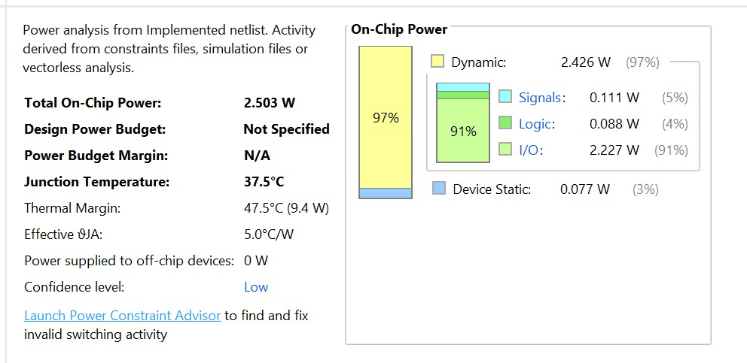
Wave form:
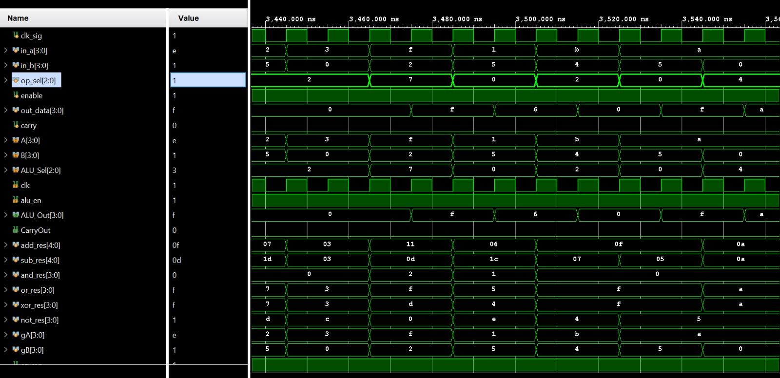

Method 2:
Power Analysis
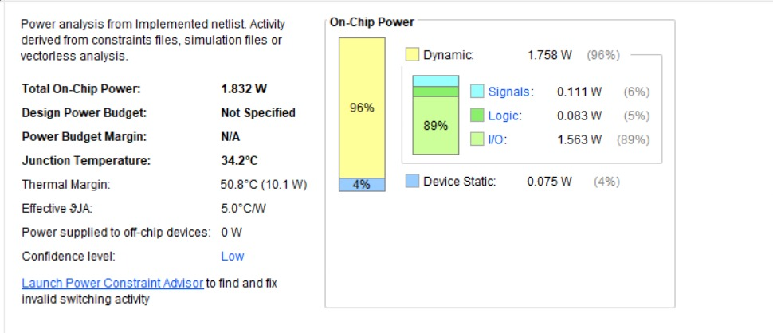
Wave forms:
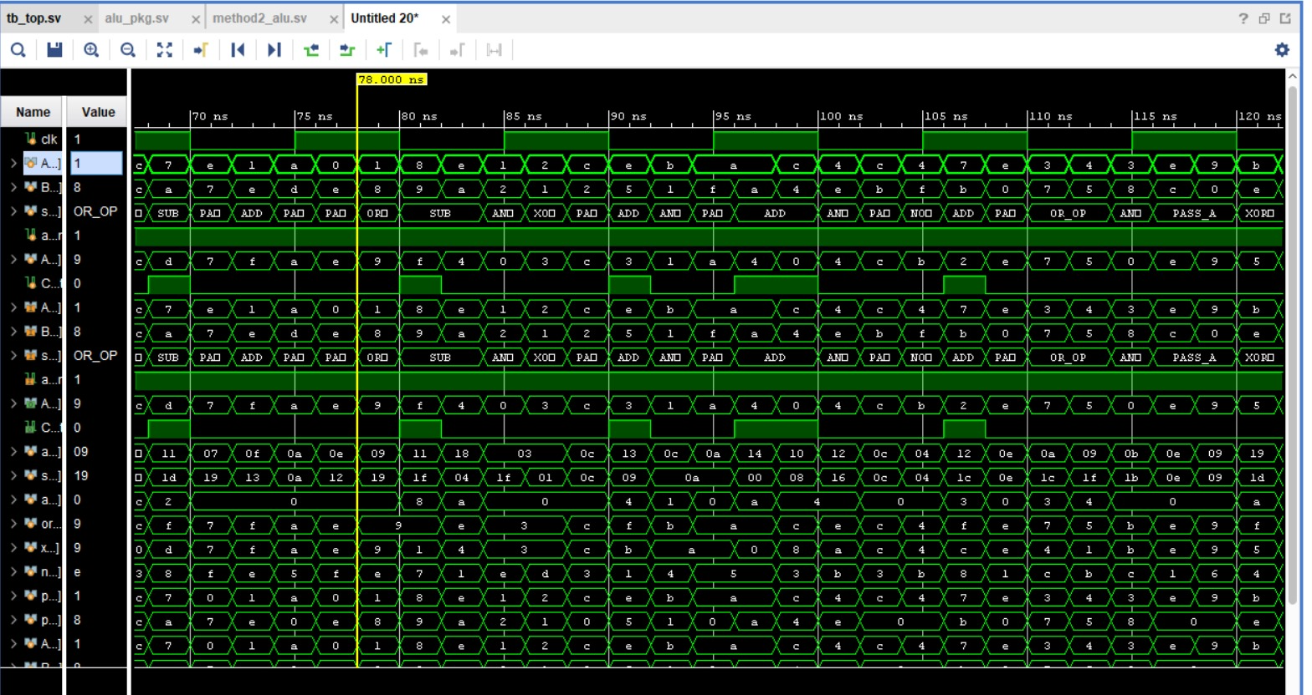

Method 3 :
Power Analysis

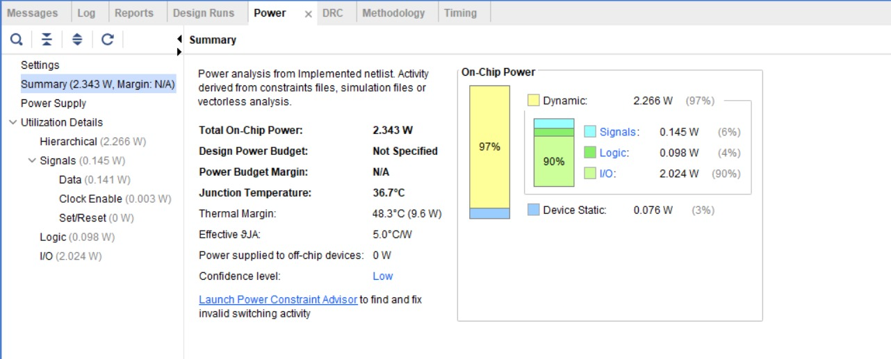

Waveforms:
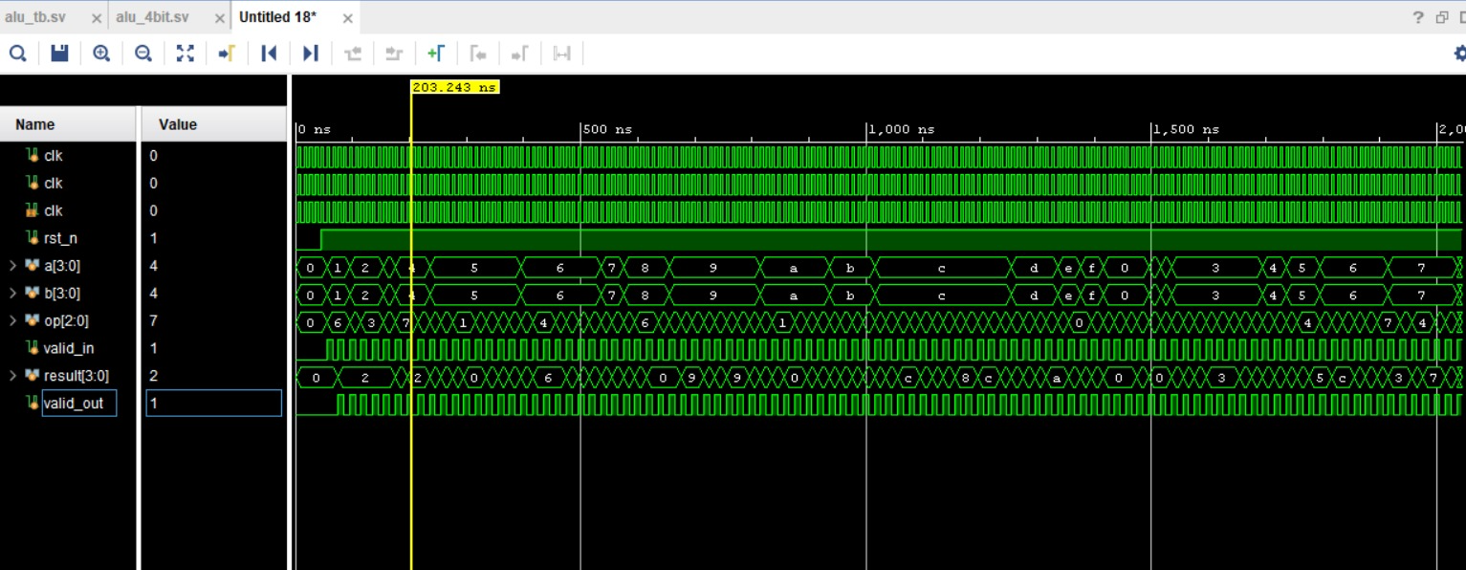

Method-4:
Power Analysis
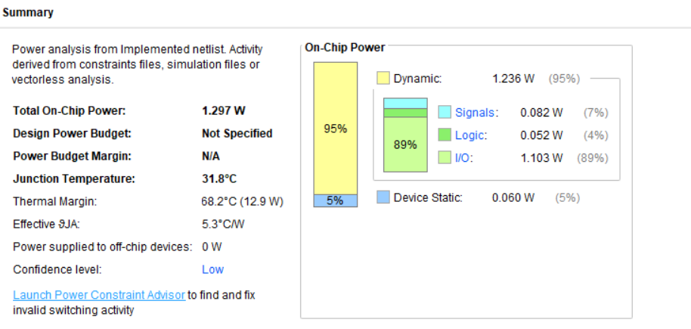

Waveforms
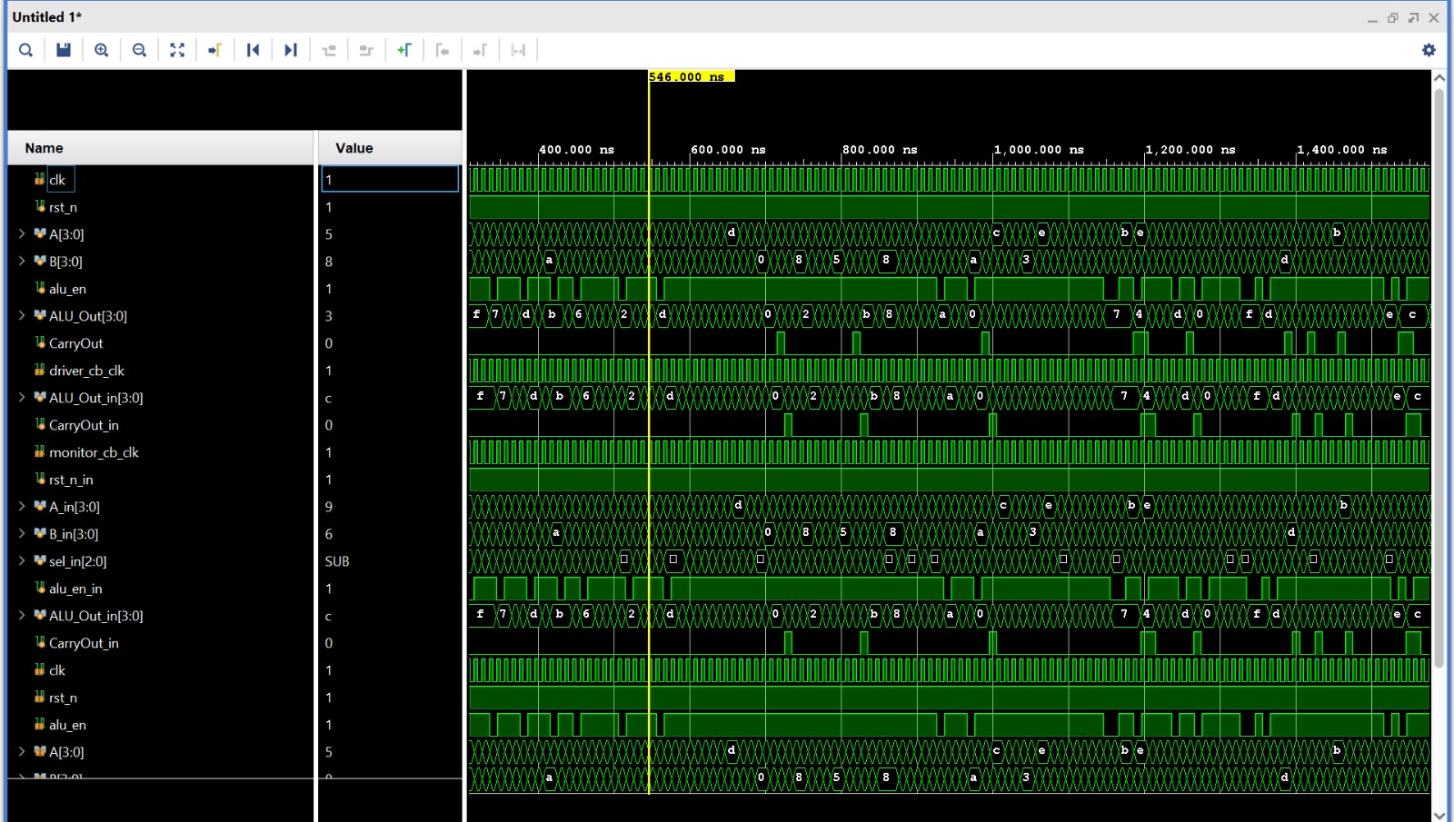

Conclusion
This project successfully demonstrated the design and functional verification of a 4-bit ALU in
SystemVerilog, applying a hierarchy of low-power optimization techniques progressively across
four distinct methods. The baseline design, developed by Sohan, consumed 2.554 W on the
Digilent Basys3 Artix-7 FPGA.

- Introduced clock gating and precomputation logic, yielding a 5% reduction. Applied operand isolation, selectively zeroing unused operands, achieving 5.7% reduction. combined bus inversion encoding, simplified FSM control, pipelining, and selective storage for a 7.6% reduction. Employing asynchronous reset-aware storage, single-stage pipelined output latching, and glitch-free conditional output assignment — achieved the maximum reduction of approximately 48.8%, bringing total power down to 1.307 W.

- All methods maintained complete functional correctness across all eight ALU operations, as verified through Vivado behavioral simulation. The results confirm that systematic RTL-level power optimization can yield substantial energy savings, making the design suitable for power-constrained embedded systems such as IoT edge devices, wearables, and mobile processors. These techniques are directly scalable to wider ALU architectures and can be integrated into larger processor datapaths.

References (if any other than base paper)

