**WHS MANAGEMENT PLAN**

**Provided by: Geosurv Pty Ltd**

**Principal Contractor: Adam Winchester**

**Project: George Street Sydney - Metricon**

|  |  |  |  |
| --- | --- | --- | --- |
| **The personnel below confirm they have read the contents of the safety plan and understand their roles and the safe work methods to be adopted on this project** | | | |
| **Name** | **Position** | **Signature** | **Date** |
| Michael Croft | Surveyor |  | 28 January 2019 |
| Andrew Dade | Surveyor |  | 28 January 2019 |
| Adam Krahel | Surveyor |  | 28 January 2019 |
| Andrew Argirou | Surveyor |  | 28 January 2019 |
| Alexander Bledzki | Surveyor |  | 28 January 2019 |
| Brady McWilliam | Surveyor |  | 28 January 2019 |
| Christian Zannis | Surveyor |  | 28 January 2019 |
| Christopher Popovacki | Surveyor |  | 28 January 2019 |
| Edward Chalmers | Surveyor |  | 28 January 2019 |
| Greg Purvis | Surveyor |  | 28 January 2019 |
| James Attard | Surveyor |  | 28 January 2019 |
| Jonathan Caouette | Surveyor |  | 28 January 2019 |
| Jonathan Tutte | Surveyor |  | 28 January 2019 |
| Kurt Farrugia | Surveyor |  | 28 January 2019 |
| Martin Nguyen | Surveyor |  | 28 January 2019 |
| Michael Rodokal | Surveyor |  | 28 January 2019 |
| Mitchell Paulinich | Surveyor |  | 28 January 2019 |
| Nicholas Thompson | Surveyor |  | 28 January 2019 |
| Patrick Ferreira | Surveyor |  | 28 January 2019 |
| Rhys Robinson | Surveyor |  | 28 January 2019 |
| Robert Terteli | Surveyor |  | 28 January 2019 |
| Rodante Reyes | Surveyor |  | 28 January 2019 |
| Rowan Turner | Surveyor |  | 28 January 2019 |
| Ryan Sellars | Surveyor |  | 28 January 2019 |
| Saeid Tahriri | Surveyor |  | 28 January 2019 |
| Sam Stillman | Surveyor |  | 28 January 2019 |
| Tarak Saab | Surveyor |  | 28 January 2019 |
| Tim Hepworth | Surveyor |  | 28 January 2019 |
| Wayne Heaton | Surveyor |  | 28 January 2019 |
| Callum Berkley | Survey Assistant |  | 28 January 2019 |
| Glenn McFall | Registered Surveyor |  | 28 January 2019 |
| Gregory Ireton Gibson | Registered Surveyor |  | 28 January 2019 |
| Peter Vandergraaf | Registered Surveyor |  | 28 January 2019 |
| Coulton Gibson | Survey Technician |  | 28 January 2019 |
| Domenic Vaccari | Survey Technician |  | 28 January 2019 |
| Scott Ireland | Survey Technician |  | 28 January 2019 |
| Nicola Modonesi | Scanning Technician |  | 28 January 2019 |
| Luke Berkley | Scanning Technician |  | 28 January 2019 |
| Nikola Rasic | Scanning Technician |  | 28 January 2019 |
| Pavel Ursu | Scanning Technician |  | 28 January 2019 |

TABLE OF CONTENTS

1. INTRODUCTION 3

2. SAFETY POLICY 4

3. ROLES AND RESPONSIBILITIES 5

4. DOCUMENT CONTROL 5

5. HAZARD IDENTIFICATION AND RISK ASSESSMENT 5

6. HAZARDOUS SUBSTANCES 7

7. SAFE WORK METHOD STATEMENT (SWMS) 7

8. SKILLS AND COMPETENCIES 8

9. WH&S INDUCTION 9

10. WORKERS COMPENSATION, REHABILITATION AND RETURN TO WORK 9

11. HAZARD REPORTING 11

12. PERSONAL PROTECTIVE EQUIPMENT (PPE) 13

13. TOOL BOX TALKS 13

14. FIRST AID AND INCIDENT INVESTIGATION 14

15. FORMS 14

16. REFERENCES 14

17. CERTIFICATES OF CURRENCY FOR PUBLIC LIABILITY AND

PROFESSIONAL INDEMNITY INSURANCE 15

18. WORKERS COMPENSATION INSURANCE INFORMATION 17

19. PROFORMA FORMS 1 TO 9 18

20. GEOSURV PTY LTD WH&S GUIDELINES 38

21. TABLE OF REVISIONS FOR GEOSURV PTY LTD SUBBY PACK 42

SCHEDULE A – SAFETY DATA SHEETS

1. INTRODUCTION

This document sets out the safety management strategy to be adopted by Geosurv Pty Ltd and its employees during the course of the surveying contract as part of this project.

The document is not designed to replace the Schedule of Health and Safety Environmental requirements as stated in the Special Conditions of Contract, but will be used to provide verification of the actions of Geosurv Pty Ltd and its nominated subcontractors in relation to these requirements.

This document and subsequent additions will be made available to the principle contractor for the purpose of auditing.

Geosurv Pty Ltd will provide Michael Croft as the person on site responsible for coordination of the Scope of Works and its safety,

Our peak number of employees on the site will be: Two (2)

Geosurv Pty Ltd does not intend to subcontract part of the works.

Sections of the Subby Pack not applicable to our works have been deleted/not completed. We confirm that if at any time during our Subcontracted works, if the previously identified ‘not applicable’ works become ‘applicable’, we will update the Subby Pack accordingly, and advise the Principal contractor immediately.



Signed: ___________________________________________ Date: 28/01/2019

**Michael Croft – Director/Principal Surveyor**

2. SAFETY POLICY

**Work Health and Safety (WH&S) Policy Statement**

**Geosurv Pty Ltd**

At Geosurv Pty Ltd, people are our most important asset and their health and safety is our greatest responsibility.

The objectives of our WH&S Policy are:

To provide an accident free and safe workplace;

To ensure that all potential accidents are controlled and prevented;

To identify and control all potential hazards in the work place through hazard identification and risk analysis; and

To comply with all relevant legislation.

For this Policy to succeed, we must be rely on the following:

Careful and concise planning of all work activities;

Ensure all members are staff are made fully aware of objectives;

Ensure all members of staff are committed to achieving the objectives; and

A complete understanding of the work process and all WH&S risks.



Signed: ___________________________________________Date: 28/01/2019

**Michael Croft – Director/Principal Surveyor**

3. ROLES AND RESPONSIBILITIES

Michael Croft is responsible for all Work Health and Safety issues and reporting and is the site representative for this project. All staff will report any issues to Michael Croft, who will report accordingly.

As a Sub-Contractor, he will ensure that he:

* Prepares a Safe Work Method Statement (SWMS) prior to the commencement of the project and review the document should conditions on the site change significantly;
* Works in accordance with all legislation, regulations, codes of practice, guidelines, directives and notices of all relevant authorities, their site safety plan and their Safe Work Method Statement (SWMS) were applicable;
* Complies with any specific site safety requirements as directed by the Contractor or;
* Maintains and provides on request all documentation required by the safety management system;
* Maintains up to date insurance’s, licenses and certificates for himself;
* Supplies all relevant SDS for the products used to undertake their work; and
* Has been inducted in the Safety Management System.



Signed: ___________________________________________ Date: 28/01/2019

**Michael Croft – Director/Principal Surveyor**

4. DOCUMENT CONTROL

Geosurv Pty Ltd and its employees are responsible for:

* Completing and reading the Subby Pack and providing a copy to the Contractor prior to commencement of work on the site;
* Maintaining an up to date version of the Subby Pack including destruction of all. All obsolete pages;
* Providing an updated copy to the Contractor whenever changes occur; and
* Reviewing the Subby Pack at intervals of not more than one month to ensure it is up to date. A revision list for this Subby Pack can be found on page 42 of this document.

5. HAZARD IDENTIFICATION AND RISK ASSESSMENT

Procedure

Work Health and Safety Legislation requires anyone in control of the workplace to identify the potential hazards of the proposed work, assess the risks involved and develop controls to eliminate or minimize the risk.

**Identify Hazards**

The job will be broken down into activities, which follow the sequence of construction. These activities are provided in a Safe Work Method Statement (SWMS) which is a list of job procedures, and other work related practices. This document details how the Scope of Work will be carried out.

For each of the work activities and associated job steps identified in the SWMS provided Geosurv Pty Ltd will identify potential hazards.

To assist this process resources such as the following will be used: -

* WorkCover and trade based Codes of Practice and other publications, e.g. safety alerts;
* Hazard Profiles for specific trade groups; Workplace experience; and
* Consultation (e.g. Tool Box Talks) with workers experienced in the task to be undertaken.

**Assess Risks (Risk Matrix)**

For each potential workplace hazard identified a Risk Class will be determined by referring to the categories below. The attached Risk Class management tool will be used to determine the requirement for management of the risks identified.

|  |  |  |  |  |  |
| --- | --- | --- | --- | --- | --- |
| **LIKELIHOOD (L)** | | | **CONSEQUENCE (C) - IMPACT** | | |
| **A** | **Almost Certain** | Expected to be the most likely outcome 90-100% probable. | **1** | **Insignificant** | First aid injury/ illness, (FAI) minor localised harm to the environment. |
| **B** | **Likely** | Will probably occur in most circumstances 51-90% probable. | **2** | **Minor** | Medically Treated Injury/ illness, (MTI) minor short term harm to the environment. |
| **C** | **Possible** | Might occur at some time 30-50% probable. | **3** | **Moderate** | Lost Time Injury/ illness, (LTI) serious medium term harm to the environment. |
| **D** | **Unlikely** | Could occur, but would not be expected 10-29% probable. | **4** | **Major** | Single fatality. Serious irreversible injury/disease. Permanent localised harm to the environment. |
| **E** | **Rare** | No known occurrence in similar circumstances. Less than 10% probable. | **5** | **Catastrophic** | Multiple fatalities. Permanent and Extensive harm to the environment. |

|  |  |  |  |  |  |
| --- | --- | --- | --- | --- | --- |
| **(L)** | **1** | **2** | **3** | **4** | **5** |
| **A** | **M**(8) | **M**(13) | **H**(18) | **E**(23) | **E**(25) |
| **B** | **M**(7) | **M**(12) | **H**(17) | **H**(21) | **E**(24) |
| **C** | **L**(4) | **M**(11) | **H**(16) | **H**(20) | **H**(22) |
| **D** | **L**(3) | **M**(6) | **M**(10) | **H**(15) | **H**(19) |
| **E** | **L**(1) | **L**(2) | **L**(5) | **M**(9) | **H**(14) |

|  |  |  |  |
| --- | --- | --- | --- |
| **LOW** - The task is relatively safe and can be managed by procedures and routine JSEA/SWMS procedures. No further action is required, unless additional hazards arise during the work. | **MEDIUM** - Identified Control Measures are capable of reducing the risk by eliminating or minimising to an acceptable level. Critical Activities and Monitoring identified and implemented by Management. | **HIGH -** Risk level must be reduced where possible by higher level Critical Controls, review by Management including consultation with work crew, and training in revised work system. | **EXTREME** -Unacceptable risk level. The work activity should be halted until Critical Controls are implemented which reduce the risk to high or less. |

**Hierarchy of Controls**

**Eliminate** – remove hazard completely; **Substitute –** replace with less hazardous; **Isolate –** physical barriers, separation; **Engineer -** automating, guarding, ventilation; **Administrate -** reduce exposure, training, procedures, consultation; **PPE -** to be used in addition to other higher level Control Measures

**Selection and Use**

Where identified, all Extreme, High and Medium risks will be recorded on a detailed SWMS. Low risks will be minimised as far as possible but will not be recorded on a SWMS.

A Risk Class will be used to determine the level of controls required to eliminate or minimize a potential hazard.

The higher the Risk Class, the more extensive the controls to be provided.

6. HAZARDOUS SUBSTANCES

Procedure

Prior to hazardous substances being used on a project Geosurv Pty Ltd will submit a Safety Data Sheet (SDS) to the Principal Contractor for approval. No substances will be brought on site without approval of the current SDS by the Principal Contractor. All substances to be brought on site will be listed in Form 8

Selection

Geosurv Pty Ltd will consider the following when selecting hazardous substances:

|  |  |
| --- | --- |
| * Flammability and explosivity; | * Toxicity (short and long term); |
| * Carcinogenic classification if relevant | * Chemical action and instability; |
| * Corrosive properties; | * Extent of PPC required; |
| * Environmental hazards; | * Storage requirements. |

Storage

All storage and use of hazardous substances will be in accordance with the SDS

All hazardous substances will be stored in their original containers with the label intact at all times.

Hazardous substances of any quantity will not be stored in crib rooms, container sheds or offices.

Use

Where practicable the material with the lowers possible hazard capability that meets the technical requirements for the job will be used.

Refer to WorkCover and National Work Health and Safety Publications for advice, ie *List of Designated Hazardous Substances (NWHSCH 1005/1999)*.

Advice on a substance may be obtained from a chemical database, eg Chemwatch.

Prior to using the hazardous substance all workers involved in its use will be provided with adequate information and training to allow safe completion of the required task.

7. SAFE WORK METHOD STATEMENT (SWMS)

A SWMS (Form 1) should as a minimum should contain:

* The name of the company
* A description of the work activity or task to be undertaken
* The date the SWMS was developed
* The name and signature of the person who developed the SWMS
* The job number and name of the principal contractor
* All job steps involved in doing the work
* Potential hazards associated with the job task to be undertaken
* The controls that will be put in place to eliminate or minimize the potential hazards identified
* Controls as high as practicable
* The name of the person responsible for ensuring that controls are in place.

The SWMS will be completed and signed by an appropriately qualified person representing Geosurv Pty Ltd who is competent in the work activity to be undertaken.

The SWMS Will be reviewed and signed by the appropriate principal contractor representative on the project.

The SWMS will be evaluated on how well hazards have been identified for the work activity to be undertaken and whether the suggested controls eliminate the potential hazard or minimize the risk of injury.

**Controls should be as high as practicable in the “Best to Worst” guide as shown below**

**1. Remove the hazard completely**

BEST

CONTROL

WORST

CONTROL

e.g. remove risk of electrocution by using compressed air driven tools.

**2. Separate people from the hazard**

e.g. guards on power tools,

e.g. use effective barriers and edge protection,

e.g. enclose noisy machinery.

**3. Use an engineered control**

e.g. use Earth leakage device (safety switch) on electrical power source.

e.g. use a machine to lift heavy objects.

e.g. use scaffolding rather than ladders to reduce risk of falls.

**4. Change work practices**

e.g. training in lifting techniques.

e.g. tagging procedures.

**5. Provide personal protection** (PPE)

e.g. hearing protection, eye protection etc.

NOTE: PPE should be the last barrier to protect people when all else fails.

8. SKILLS AND COMPETENCIES

## 

## Procedure

Geosurv Pty Ltd will ensure that its employees are adequately trained to a level of competency sufficient to ensure their health and safety when at work.

### Selection and Use

The Skills and Competency Register (Form 2) will be provided to the appropriate Principal Contractor’s representative on site for review.

Workers will be selected for specific tasks based on their level of skill and competency to undertake the work safely.

Where workers are unskilled in the required task appropriate training will be provided prior to commencement of the work and recorded on the Training Attendance Register (Form 4)

9. WH&S INDUCTION

## Procedure

Geosurv Pty Ltd and its employees will ensure that persons carrying out the nominated work have relevant training including Work Health and Safety (WH&S) Induction Training. Workers will not carry out construction work until they have received the minimum requirements for Work Health and Safety induction training:

* Industry (general) induction – (where required by Legislation)
* Work Activity Work Health and Safety induction; and
* Site Specific Work Health and Safety Induction.

Records of induction will be maintained in accordance with current Legislation.

### Selection and Use

All workers will receive the above three minimum Work Health and Safety induction training requirements before work on site commences and a record of the training provided on the Induction Register Form 3 and/or the SWMS as appropriate.

10. WORKERS COMPENSATION, REHABILITATION AND RETURN TO WORK

## Procedure

Geosurv Pty Ltd will provide Workers Compensation Insurance for all employees and other persons deemed to be employees under relevant Workers Compensation Legislation. The trade and occupation of each employee on site and their salaries will be recorded. A record of the insurance will be provided with an attached *current* copy of the policy details issued by the insurer.

**Return to Work Program**

Our management is committed to providing a safe and healthy working environment for all its employees. This policy recognises that this is the responsibility of management working in cooperation and consultation with employees, to ensure ongoing active prevention of injury and illness in our workplace.

This policy is the cornerstone of a program developed to embody the prevention, compensation and rehabilitation principles which are central to risk management.

**Prevention**

The program will ensure that:

1. Suitable plant and equipment are provided and maintained.

2. Safe systems of work are implemented and observed.

3. Adequate information, training, supervision and instruction is provided.

4. Relevant Acts, Regulations, codes of practices and standards are the minimum acceptable requirements throughout the organisation.

**Compensation**

Effective WorkCover claims management is undertaken to ensure that injured employees receive appropriate compensation and that the organisation minimises its losses.

**Rehabilitation/Return to Work**

Management recognises and accepts its obligations under the Workers Compensation Act 1987, Workplace Injury Management and Workers Compensation Act 1998 and Workers Compensation Regulation 2003, to assist in the rehabilitation of employees who are injured or ill as a result of their work.

**Procedures**

The company’s commitment to return to work means:

1. Notification of Injuries.

- All injuries must be notified to the supervisor as soon as possible.

- All injuries will be recorded in the register of injuries.

- Our workers compensation insurer will be notified of any injuries within 48 hours.

2. Recovery.

- Geosurv will offer immediate first aid and/or medical treatment if an injury occurs.

- The injured work must nominate a treating doctor who will be responsible for the medical management of the injury and assist in planning return to work.

3. Return to Work.

- We will arrange a suitable person to explain the return to work process to the injured worker.

- We will arrange for the worker’s return to work as soon as medical advice suggests it is appropriate.

- We will ensure that the injured worker is offered the assistance of our Rehabilitation Provider if it becomes evident that they are not likely to resume their pre-injury duties, or cannot do so without changes to the workplace or work practices.

4. Suitable Duties.

- When the injured worker, according to medical advice, is capable or returning to work we will develop an individual return to work plan.

- We will undertake to provide suitable duties that are consistent with medical advice and that are meaningful, productive and appropriate for the injured worker’s physical and psychological condition depending on the individual circumstances of the injured worker.

- Our suitable duties may be:

- The same job with different hours or modified duties

- A different job

- Full time or part time

5. Dispute Resolution.

- If disagreements about the return to work program or suitable duties arise, we will work together with the injured worker to try and resolve them.

- If we are unable to resolve the dispute, we will involve our insurer, an accredited rehabilitation provider, the treating doctor or an injury management consultant.

**Contacts**

The workplace contact for return to work program is Michael Croft Tel: 1300554675 Fax: 1300859564

Preferred Doctor/Medical Centre

Name: Caringbah Family Practice

Tel: (02) 9525 6666 Fax: (02) 9524 1436

Address: 379 Port Hacking Road, Caringbah NSW 2229

Rehabilitation Provider

Name: Actevate Workplace Health Systems

Tel: 1300 663 155 Fax: 1300 669 355

Address: Level 10, 23 Hunter Street, Sydney NSW 2000

PO Box 3408 Sydney NSW 2001

Workers Compensation Insurer

Name: Employers Mutual NSW Limited

Tel: (02) 8251 9000 Fax: (02) 8251 9495

Address: Level 3, 345 George Street, Sydney NSW 2000

GPO Box 4143, Sydney NSW 2001

WorkCover Claims Assistance Service on 13 10 50

WorkCover Compensation Commission for conciliation of all claims for most workers www.wcc.nsw.gov.au

RETURN TO WORK CO-ORDINATOR

The person responsible for ensuring the organisation’s Return to Work Program is implemented is Michael Croft. l employees have a duty and responsibility to take reasonable care for their own health and safety and for others affected by their actions at work. Management seeks the cooperation of all employees in realising our health and safety objectives and creating a safe working environment.

POLICY REVIEW

This policy will be regularly reviewed in the light of legislative and corporate changes. Policy on specific Work Health and Safety Issues will be developed and published to all employees at regular intervals.



Signed: ___________________________________________ Date: 28/01/2019

**Michael Croft – Director/Principal Surveyor**

11. HAZARD REPORTING

## Procedure

Geosurv Pty Ltd will encourage all employees to report hazards immediately. Our supervisor on site will investigate all reported hazards and document corrective actions. Corrective actions will be signed off when completed. The procedure and responsibilities for reporting hazards are outlined on the next page. The supervisor will complete a Hazard Report (Form 6) where hazards cannot be corrected immediately.

Geosurv Pty Ltd and its employees will issue our Hazard Report form to all the safety committee representatives, and Principal contractor. A number of forms for employee use will be placed in the appropriate crib shed.

### Assessment

When a hazard is identified in the workplace a Risk Class will be assessed immediately using the categories outlined in the hazard identification and risk assessment section of this Subby Pack. The Risk Class will determine the appropriate level of response required to protect the health and safety of workers – i.e. immediate, within 24 hours, within 48 hours and so on.

### 

### Corrective Actions

The Hazard Report will be signed by the inspection team leader and presented to the site supervisor if he/she is not part of the team.

The above-mentioned supervisor shall sign off the report when satisfied that all items on the report have been satisfactorily actioned. Copies of the signed off reports will be recorded in this Subby Pack.

**Hazard Reporting Procedure and Responsibility**

Employee identifies hazard

Can the hazard be controlled immediately?

Yes – do it

NO

What is the Risk Class?

What controls are required? Area closed for immediate rectification? Temporary control measure needed?

**Hazard controlled**

Employee notifies supervisor and completes Hazard Report for supervisor

Supervisor established corrective action and deadline

Supervisor implements corrective action.

Supervisor’s Manager confirms corrective action in place. **Hazard Controlled**

Supervisor signs off and files Hazard Report.

12. PERSONAL PROTECTIVE EQUIPMENT (PPE)

## Procedure

Where other means of protection are not practicable Geosurv Pty Ltd will supply clothing or equipment designed to protect part, or all, of the body. This equipment may include: gloves, hearing protection, high visibility garments, breathing apparatus, thermal wear, eye protection, sun cream, safety belts and harnesses. Steel cap boots and hard hats are the minimum requirement for entry to a construction site.

### Assessment

During the development of control measures for SWMS the “Best” to “Worst” guide to controls outlined in the SWMS section of this Subby Pack will be used to help minimise reliance on PPE.

### 

### Selection and Use

Geosurv Pty Ltd will ensure all items of PPE are manufactured, used and maintained in accordance with the relevant Australian Standard. Proof of Australian Standard compliance will be provided, e.g. labelling.

All issues of PPE to each individual will be recorded on the PPE Issue Record Form 5.

Each employee will be instructed and or trained in the correct use of each PPE item prior to use.

13. TOOL BOX TALKS

## Procedure

WH&S Legislation requires the identification of potential workplace hazards, the assessment of the risk of the hazard and the development of controls to eliminate, or minimise, the risk. To assist in hazard identification and the development of controls Geosurv Pty Ltd employees will attend a Tool Box Talk conducted by Michael Croft at required intervals.

Tool Box Talks will be held weekly and all will be recorded and signed off by participants (Form 9). Any corrective action will be followed up and signed off by the nominated person.

### 

### Consultation

Geosurv Pty Ltd recognises that consultation with workers is essential in identifying potential hazards that can be eliminated, or minimised, before injuries occur.

Tool Box Talks will be used to help Supervisors manage safety, to provide a forum for workers to have their say about safety issues and to help ensure safety awareness is maintained throughout the project. Where required specific safety issues will be raised, accidents reviewed, SWMS’s developed and presented for evaluation and familiarisation or safety alerts discussed.

Tool Box Talks will be used to induct workers into and “sign off” their understanding of the controls provided in SWMS for the specific work in which they will be involved.

14. FIRST AID AND ACCIDENT INVESTIGATION

## Procedure

Geosurv Pty Ltd and its employees will rely on the provision of First-aid services by the Principal Contractor where Michael Croft or another nominated person will provide first aid services.

### Reporting

All injuries will be reported to the appropriate First Aid Officer on site. Injuries will be recorded in the First aid report / Register of Injuries book or its equivalent.

Records will be kept for a minimum of 5 years. Where the injury results in an absence from the workplace of 7 days or more the injury and its circumstances will be reported to WorkCover NSW using the appropriate form.

### Investigation

Geosurv Pty Ltd will investigate all accidents within 36 hours. Investigation will be recorded on Incident Report and Investigation form (Form 7) or its equivalent.

Accidents will be recorded by: **Michael Croft**

Accidents will be investigated by: **Michael Croft**

Accidents will be reported to WorkCover by: **Michael Croft**

Copies of Incident / Accident Reports are to be provided to the Principal Contractor.

15. FORMS

Safe Work Method Statement Form 1

Skills and Competency Register Form 2

Induction Register Form 3

Training Attendance Register Form 4

PPE Issue Record Form 5

Hazard Report Form 6

Incident Report and Investigation Form Form 7

Hazardous Substances Register and Risk Assessment Form 8

Tool Box Talk Recorded Form 9

16. REFERENCES

Occupational Health and Safety Act 2011

Occupational Health and Safety Regulations 2011

Surveyors Act 2007

Australian Standard AS4360/2004 Risk Management

Codes of Practice: WH&S Induction Training for Construction Work; Control of Workplace Hazardous Substances

17. CERTIFICATES OF CURRENCY FOR PUBLIC LIABILITY AND PROFESSIONAL INDEMNITY

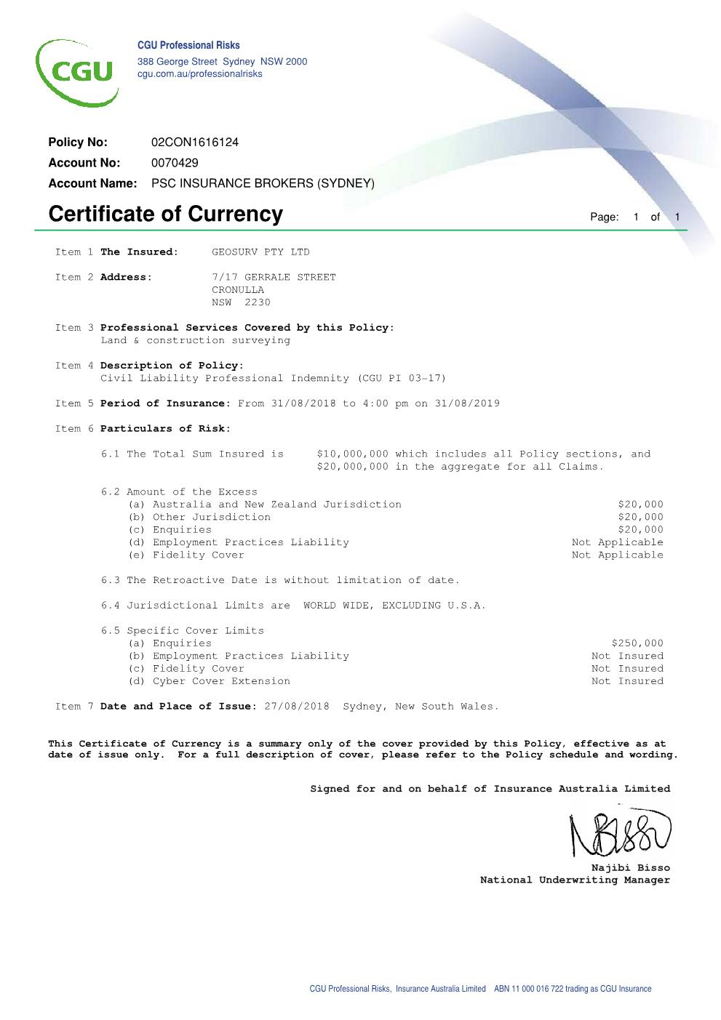

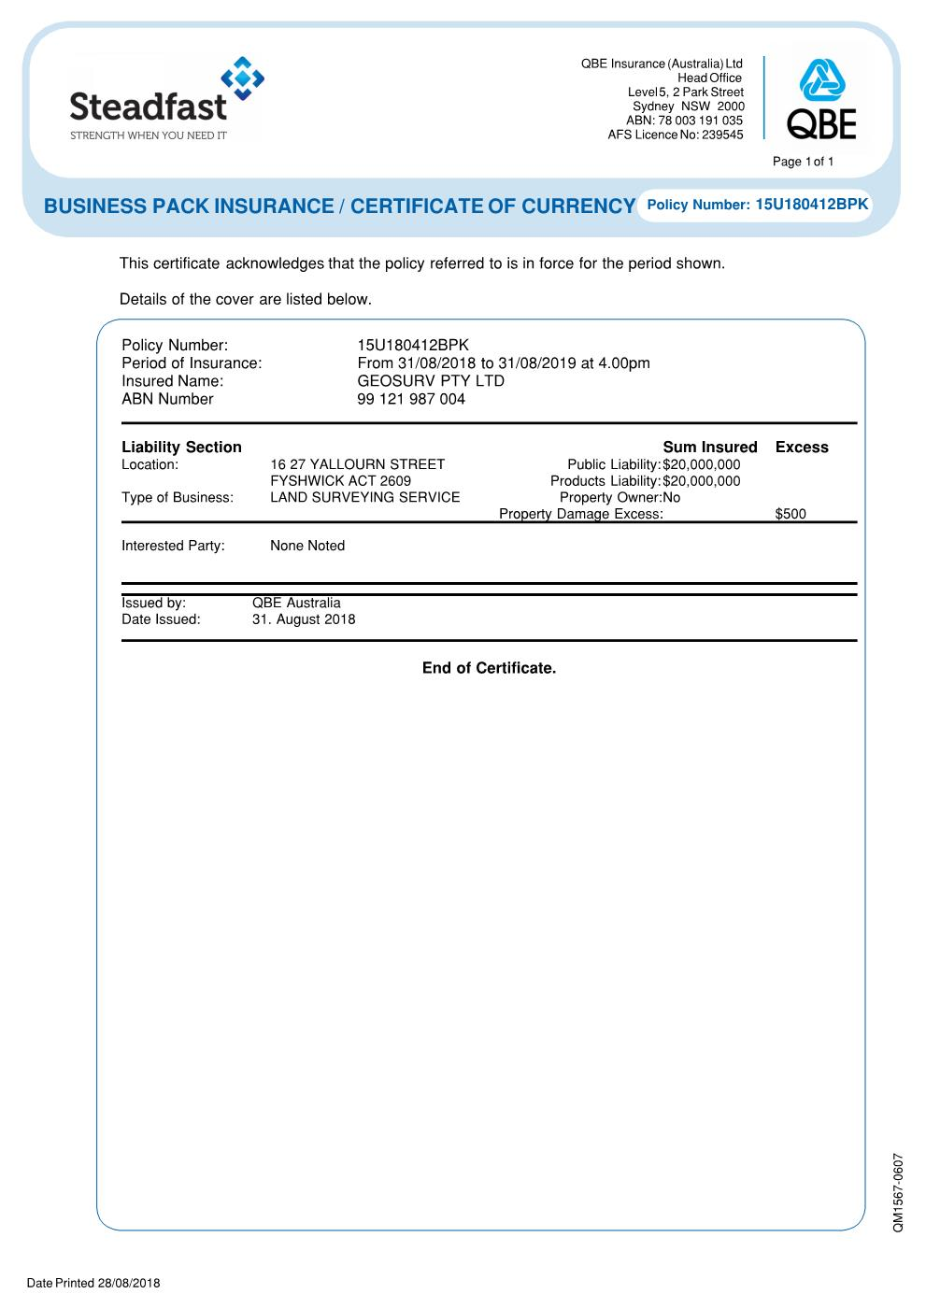

18. WORKERS COMPENSATION INSURANCE INFORMATION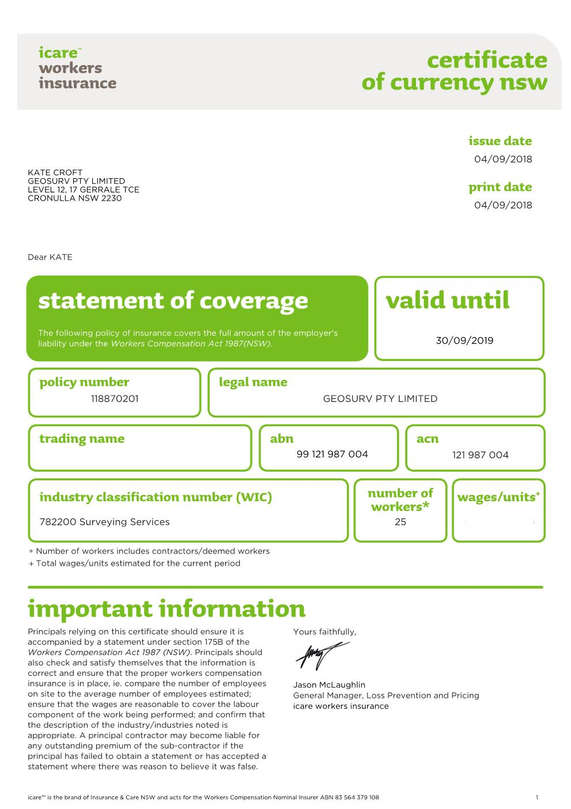

|  |  |  |
| --- | --- | --- |
| **Geosurv Pty Ltd**  **Level 29 Chifley Tower**  **2 Chifley Place**  **Sydney NSW 2000**  **Phone: 1300 554 675 Fax (02) 92932930**  **ABN: 99 121 987 004** | *Safe Work Method Statement* |  |
| **SWMS #«JobNumber»** |
| **DATE: 28 January 2019** |

**SWMS TITLE: Site Surveying (including Set-Out Surveys and As-Built Surveys)**

**ISSUE NUMBER: Revision 1**

**DATE: 28/01/2019**

**NEXT REVIEW DATE: 1/12/2018**

**JOB NUMBER: «JobNumber»**

**WORK LOCATION: «JobName»**

**PRINCIPAL CONTRACTOR: «ClientName»**

**NAME OF SUPERVISOR: Andrew Dade (Ph: 0416 010 483)**

**MANAGEMENT WHS REP: Michael Croft (Ph: 0438 100 508)**

|  |  |  |  |  |
| --- | --- | --- | --- | --- |
| Job / Scope of Works: Site Surveying including Set-Out Surveys and As-Built Survey | | | | I certify that this SWMS:-   * has been reviewed by me * has been developed in consultation with workers; * workers have the relevant competencies * SWMS is endorsed for compliance with WorkCover Guidelines for the preparation of SWMS; and * SWMS is approved for use   Signed by Senior Management Company Representative for use  Name: Michael Croft    Position: Director  Signed off:  Date: 28 January 2019 |
| Warning Signs and Protective Barriers/Equipment to be used: N/A | | | |
| PPE to be used for this work activity: High visibility clothing, steel cap ankle high lace up boots, hard hat, protective eyewear to AS1337, appropriate gloves, long sleeved shirt, full-length trousers | | http://www.seton.net.au/images/signs/signs/S0233.gifhttp://www.seton.net.au/images/signs/signs/S0122.gif | |
| **Training:** All workers to have their Work Health and Safety General induction for Construction Work Certificate on site at all times and attend the site-specific induction, to be inducted in to this Safe Work Method Statement and attend site specific/task specific toolbox talks where work is out of the ordinary. Workers inexperienced in an area to be on-site trained and supervised by experienced peers. All training required on site is to be done by the nominated Supervisor. The Supervisor will be responsible for the training and ensuring that all his workers are using the correct techniques and if any are observed in not doing so, they will be instructed on how to use the correct techniques. | | | |
| Legislation:  Work Health and Safety Act 2011  Work Health and Safety Regulations 2017  Surveyors Act 2007  Available at Geosurv Office and File Server. | Codes of Practice (COP), Guides:  WH&S Induction Training for Construction Work; Control of Workplace Hazardous Substances  Geosurv Health and Safety Manual  Available at Geosurv Office and File Server  Standards:  Australian Standard AS4360/2004 Risk Management  Available at Geosurv Office and File Server. | | Qualifications / Licenses / Certificates of Competency:  OHS General Induction (White Card)  Diploma of Surveying |

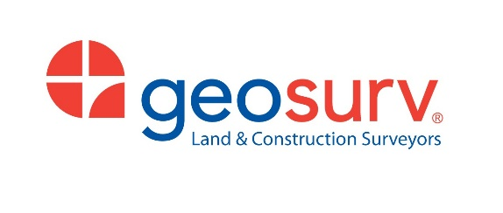

|  |  |  |
| --- | --- | --- |
| Personnel Duties and Responsibilities: | | Training/Competency (Skills) Required to Complete Work: |
| Supervisor  Ensure all work is carried out in accordance with the job specification and the safe work method statement.  Provide necessary training in the use of this SWMS.  Inspect and advise possible hazards, approve work areas, work methods and safety measures, plant, equipment and power tools  Issue PPE and provide training for same | | WHS General induction for Construction Work, site induction, induction into this SWMS, trained in the specific substances listed in the Hazardous Substance register |
| Surveyor / All Staff  Ensure all work is carried out in accordance with the job specification and the safe work method statement.  Issue PPE and provide training for same | | WHS General induction for Construction Work, site induction, induction into this SWMS, trained in the specific substances listed in the Hazardous Substance register |
| Emergency Preparedness:  Site Induction, Vehicles to have fire extinguishers, First Aid Kits to be available on site and in vehicles, Qualified First Aiders on site. | | |
| **Plant/Equipment: Theodolite** | **Maintenance Checks:** **Yearly calibration conducted January 2018** | |
| **Work Cover Approvals: Lloyd Brown** | **Site Personal Responsible for review of SWMS: Andrew Dade** | |
| **This SWMS was prepared by: Lloyd Brown** | **Person Responsible for Training: Lloyd Brown** | |
|  |  | |

**Risk Matrix**

|  |  |  |  |  |  |  |  |  |  |  |  |  |  |
| --- | --- | --- | --- | --- | --- | --- | --- | --- | --- | --- | --- | --- | --- |
| **LIKELIHOOD (L)** | | | | **CONSEQUENCE (C) - IMPACT** | | | | **(L)** | **1** | **2** | **3** | **4** | **5** |
| **A** | **Almost Certain** | Expected to be the most likely outcome 90-100% probable. | | **1** | **Insignificant** | First aid injury/ illness, (FAI) minor localised harm to the environment. | | **A** | **M**(8) | **M**(13) | **H**(18) | **E**(23) | **E**(25) |
| **B** | **Likely** | Will probably occur in most circumstances 51-90% probable. | | **2** | **Minor** | Medically Treated Injury/ illness, (MTI) minor short-term harm to the environment. | | **B** | **M**(7) | **M**(12) | **H**(17) | **H**(21) | **E**(24) |
| **C** | **Possible** | Might occur at some time 30-50% probable. | | **3** | **Moderate** | Lost Time Injury/ illness, (LTI) serious medium-term harm to the environment. | | **C** | **L**(4) | **M**(11) | **H**(16) | **H**(20) | **H**(22) |
| **D** | **Unlikely** | Could occur but would not be expected 10-29% probable. | | **4** | **Major** | Single fatality. Serious irreversible injury/disease. Permanent localised harm to the environment. | | **D** | **L**(3) | **M**(6) | **M**(10) | **H**(15) | **H**(19) |
| **E** | **Rare** | No known occurrence in similar circumstances. Less than 10% probable. | | **5** | **Catastrophic** | Multiple fatalities. Permanent and Extensive harm to the environment. | | **E** | **L**(1) | **L**(2) | **L**(5) | **M**(9) | **H**(14) |
| **HIERARCHY OF CONTROLS - Eliminate** – remove hazard completely; **Substitute –** replace with less hazardous; **Isolate –** physical barriers, separation; **Engineer -** automating, guarding, ventilation; **Administrate -** reduce exposure, training, procedures, consultation; **PPE -** to be used in addition to other higher level Control Measures | | | | | | | | | | | | | |
| **LOW** - The task is relatively safe and can be managed by procedures and routine JSEA/SWMS procedures. No further action is required, unless additional hazards arise during the work. | | | **MEDIUM** - Identified Control Measures are capable of reducing the risk by eliminating or minimising to an acceptable level. Critical Activities and Monitoring identified and implemented by Management. | | | | **HIGH -** Risk level must be reduced where possible by higher level Critical Controls, review by Management including consultation with work crew, and training in revised work system. | **EXTREME** -Unacceptable risk level. The work activity should be halted until Critical Controls are implemented which reduce the risk to high or less. | | | | | |
|



**High Risk Construction Work (HRCW)**

|  |  |  |  |  |
| --- | --- | --- | --- | --- |
| **High Risk Construction Work (HRCW) involved:**  **Note:** HRCW not included or likely to be included in the Scope of Works are not included in this list | **WHS Legislation HRCW** | Risk of falls from greater than 2 metres | Temporary load-bearing support  structures | Demolition of load-bearing structure |
| Likely to involve disturbing asbestos | Use of Explosives | Work in confined spaces |
| Work in or near shaft or trench with an excavated depth greater than 1.5m or a in tunnel | Work on or near energised electrical installations or services | Work on or near pressurised gas  pipes or mains |
| Work on or near chemical, fuel or  refrigerant lines | Work on, in or adjacent to road, rail shipping or other major traffic corridor | Work in an area with contaminated  or flammable atmosphere |
| Work with tilt up or pre-cast concrete | Work in or near a drowning risk | Work in an area with movement of  powered mobile plant |
| **High Risk Work** | Site Security and Public Safety | Lifting Operations | Stressing Operations |
| Work causing Fire Risks | Work Adjacent to Live Rail | Compressed Air Work |
| Heavy Vehicle Operations | Other (Please Specify) | |
| **Have workers and their HSR(s) been consulted about the SWMS?** | | Workers:  YES  NO  HSRs  YES  NO | **Has the SWMS been developed based on a site-specific risk assessment?** | YES  NO [**NOTE**: A SafeWork NSW Inspector may ask to sight evidence of the risk assessment) |

**Site Specific Additional Safety Planning Information**

|  |
| --- |
| **Relevant Permits / Authority Licences / Approvals / Certificates / Pre-Investigations / Engineering Details:**  Work at Height  Ground Disturbance  Confined Space Entry  Hot Works  Crane Workbox  Road Occupancy Licence  Asbestos Work  Demolition Licence  Lift StudyCritical Lift StudyDual Crane Lift StudySafety Data SheetSynthetic Sling Working Near Overhead Services  Isolation  Work under Direct Supervision   Hammer Drilling and Power Fixing in Concrete  Core Drilling and Saw Cutting Concrete  Pressure Testing of Pipework  Rail Access |



| **Scope and Sequence of Work:** Site Surveying (including Set-Out Surveys and As-Built Surveys) | | | | | |
| --- | --- | --- | --- | --- | --- |
| **Step #** | **Job Step Detail** | **Step #** | **Job Step Detail** | **Step #** | **Job Step Detail** |
| 1 | Arrive at site | 2 | Inspect Site for Hazards | 3 | Fixed and Mobile Plant Awareness |
| 4 | Site Surveying Works | 5 | Packing up of equipment and leaving site |  |  |

|  |  |  |  |  |  |
| --- | --- | --- | --- | --- | --- |
| **Task Step**  **Step by step sequence of activities** | **Hazards**  **Identify hazards associated with each step** | **Risk**  **Before** | **Controls** | **Risk**  **After** | **Responsible Person** |
| 1. Arrive at Site | All parties not advised of possible activities | H(16) | Induction into Geosurv Safety Plan and SWMS before entering site  Confirm with «ClientName» and provide copies  Inform «JobName» Site Office/Foreman prior to commencement  All employees to be site specifically inducted, carry site induction credentials and work cover induction card | L(5) | Supervisor / All Staff |
| 2. Inspect Site for Hazards | Access/Egress/Weather pits, trip hazards, uneven surfaces, dirt tracks, busy roads, machinery, access routes etc | H(17) | Check «JobName» notice board for Weekly Hazards Site notices.  Document and report any hazards. (Take photo if camera available)  Complete a Geosurv Take 5  Ensure all PPE is worn – Steel capped boots, hi viz vests, hard hart, safety glasses | L(5) | Supervisor / All Staff |
| 3. Fixed and Mobile Plant Awareness  **(HRCW)** | Vehicle/person collision | H(21) | Do not set out within 15m of plant and machinery.  Make driver aware that you are working in the area.  Do not enter operating plan zone unless approved by operator and stopped possible work elsewhere until machinery has finished. Set up in clear visibility of vehicle movements and wear appropriate PPE, hi viz, hard hat, gloves, boots | M(9) | Supervisor / All Staff |
| 4. Site Surveying Works  **(HRCW)** | Access/Egress | H(17) | Use designated access routes to access the «JobName» Site  Do not set up theodolite on roadways  Use witch’s hats in pedestrian ways  Inspect Scaffold and check safe work loads  Do not modify scaffold | L(5) | Supervisor / All Staff |
| Noise above 85dB/A | M(11) | Correct PPE - hi viz, hard hat, gloves, glasses, boots | L(5) | Supervisor / All Staff |
| General Surrounding – reo bars, scratches | M(10) | Ensure care is taken in areas of concern  Know where first aid and nearest hospital are  Cap reo, stop work and inform supervisor | L(5) | Supervisor / All Staff |
| Hammer in nails/pegs  Spray paint marks | M(11) | Ensure care is taken with use  Use correct manual handling techniques and wear correct PPE  Ensure SDS training has taken place | L(5) | Supervisor / All Staff |
| Dust, noise, water | M(10) | Advise Inform «JobName» Site site office of work area and wear correct PPE including - hi viz, hard hat, gloves, glasses, boots, dust masks, ear plugs where required  Ensure area has been dewatered and access has been approved  Indicate area of work and be aware of other contractors in the area | L(5) | Supervisor / All Staff |



|  |  |  |  |  |  |
| --- | --- | --- | --- | --- | --- |
| **Task Step**  **Step by step sequence of activities** | **Hazards**  **Identify hazards associated with each step** | **Risk**  **Before** | **Controls** | **Risk**  **After** | **Responsible Person** |
|  | Sun exposure whilst working outdoors | M(12) | Apply high UV rated sunscreen  Work in the shade where possible  Sustain fluid levels  Wear appropriate UV protective clothing | L(2) | Supervisor / All Staff |
| Eye damage whilst using lasers | M(10) | Use signage to indicate that laser is being used  Turn off the beam off when working face to face with others  Do not look directly into the beam  Be aware of surrounding workers | L(5) | Supervisor / All Staff |
| Irritating eyes and/or poisoning from spray paint | M(10) | Do not spray anywhere near face or body  Keep lid on when not in use  See SDS Sheet attached to this SWMS | L(5) | Supervisor / All Staff |
| Being hit by a car whilst working on the road | H(21) | Wear high visibility clothing at all times  Where possible carry out survey works remotely  Any work that must be carried out on the road should be done so at non-peak times  Any work that must be carried out on the road there will be a third person available to monitor traffic  Traffic Control to be used for work on the road  Traffic Control works to be positioned behind a physical barrier and or shadow vehicle in accordance with an approved Traffic Control Procedure | M(9) | Supervisor / All Staff |
| Falls into excavations, penetrations, and/or from suspended decks in areas with a height greater than 1.5 metres. | H(15) | Obtain confirmation from «ClientName», prior to accessing suspended slabs.  All open penetrations must be fenced or securely covered.  All slab edges must be fenced.  Advise «ClientName» immediately of any areas not secured or fenced adequately.  Observe and keep out of «JobName» exclusion zones delineating excavation, penetration or slab edge. | M(9) | Supervisor / All Staff |
| Working near/under high level works  Falling tools/materials | H(15) | Observe and keep out of «JobName» exclusion zones delineating high level works | M(9) | Supervisor / All Staff |
| 5. Packing up of equipment and leaving site | Improper emergency response | H(16) | Adhere to «JobName» emergency action plan, as per induction | L(5) | Supervisor / All Staff |
| Minor incidents |  | Ensure that you collect all equipment and do not leave anything lying around for others to trip on  Be aware of your surroundings |  |  |
| Leaving Site | M(11) | Follow «JobName» site rules when leaving the site  Sign out or Inform «JobName» Site Office/Foreman you are leaving site | L(2) | Supervisor / All Staff |



**Implementation, Monitoring and Review**

Work Health and Safety Regulation 2011, Clauses 299 (2)(d) and Clause 38 require that the SWMS describes how risk control measures are to be implemented, monitored and reviewed. The table below outlines the processes that supervisors must follow to meet these requirements for high risk construction work.

|  |  |  |
| --- | --- | --- |
| **IMPLEMENTATION** | **MONITORING** | **REVIEW** |
| To ensure that this SWMS is implemented correctly the following must be done –   * All workers involved in this activity will be competent and have completed all relevant verifications of competency (VOCs) and WorkCover and RMS licenses. * Workers involved in this work activity are to be trained in this work activity and the integrated functions of the activity. * The workers are to be consulted with prior to commencing this work activity in relation to the proposed work method, the high risk construction work (HRCW) identified as forming part of this activity, the hazards and risks related to this HRCW and the measures to implemented to control the risks. * Any changes agreed during the consultation phase are to be incorporated into the SWMS prior to commencing work. * All workers are to be trained in the final SWMS and associated processes and sign off the attached training record. * Prior to commencement of the work activity, all relevant permits are to be completed and approved. | The functionality of the SWMS is to be monitored by –   * Conducting a regular program of documented workplace inspections, job observations, testing, data and trend analysis and SWMS field audits to validate the operation of the SWMS. * SWMS field audits are to determine level of conformance with actual work. If non-conformances are observed, stop the work immediately and engage the workers in a consultation to why the SWMS is not being complied with. * A Take 5 check is to be completed at the commencement of each day. * A Take 5 check is to be completed if site conditions change throughout the day.   If the work method has changed, then the SWMS is to be re – written to reflect the current work method and workers retrained in the SWMS.  Workers are to work in accordance with the SWMS to ensure safe execution of work activity. | A review of a SWMS is required to be completed –   * In the event of an incident occurring; * If the SWMS is deemed to be impracticable through consultation with the workers; * If new hazards have been identified through risk assessments, hazard alerts or a Take 5 check. * If the work method has changed including changes to the workplace, working environment, a system of work, a process or a procedure; * Every three months for continuing operations covered by a SWMS; and * If an operation covered by a SWMS is restarting after a break in time of > two weeks prior to recommencing work.   When a review is conducted it should be done in consultation with the workers involved.  Reviewing the control measures also involves considering whether a higher order control measure is now reasonably practicable.  The WHS management plan for the construction project should also be reviewed and revised (where necessary) when control measures have been reviewed. |
| **EMERGENCY PREPAREDNESS** | | |
| All workplaces must have an emergency plan that covers a range of potential incidents.  Rescue equipment and a reliable communication system to contact any necessary emergency services, should be readily accessible at the workplace. | The emergency procedures must clearly explain how to respond and evacuate Workers from the workplace in a controlled manner.  Contact numbers for emergency services should be prominently displayed. | A register of all persons who are at the construction workplace on a particular day should be kept so everyone can be accounted for.  The emergency plan and evacuation procedures must be tested on a regular basis. |



**Hazardous Substance Register**

The following chemical products exist on site. Note: SDS must be no more than 5 years old

|  |  |  |  |  |  |  |  |  |  |  |  |
| --- | --- | --- | --- | --- | --- | --- | --- | --- | --- | --- | --- |
| **SDS**  **Number** | **Chemical Name** | **Storage Location** | **Amount Stored**  **(Up to)** | **Dangerous Goods Class** | **Hazardous Substance**  **(Yes/No)** | **SDS Issue Date**  **(>5years must be renewed)** | **Preliminary Risk Assessment Controls**  **(as stated by SDS)**  **First Consideration MUST be!**  **IS THERE A SAFER PRODUCT?** | | | **\*Detailed Risk Assessment Required Prior to Use?**  **\*(see footer below)** | |
| 1 | Spot Marking Paint | Car and Person | 10 cans car | 2.1 | YES | 17/01/2017 | eyewear | gloves | protect clothing | Yes | No |
| natural ventilation | spill kit | respiratory protection |
|  |  |  |  |  |  |  | eyewear | gloves | protect clothing | Yes | No |
| natural ventilation | spill kit | respiratory protection |
|  |  |  |  |  |  |  | eyewear | gloves | protect clothing | Yes | No |
| natural ventilation | spill kit | respiratory protection |
|  |  |  |  |  |  |  | eyewear | gloves | protect clothing | Yes | No |
| natural ventilation | spill kit | respiratory protection |
|  |  |  |  |  |  |  | eyewear | gloves | protect clothing | Yes | No |
| natural ventilation | spill kit | respiratory protection |

*NO = i.e. a separate documented risk assessment is not required as the substances is being used in accordance with the SDS and for the purpose for which it was intended (i.e. simple and obvious assessment)

*YES = i.e. detailed chemical risk assessment is required as the substance is being mixed or used in a manner that increases the risk controls required above those indicated on the SDS



**Safe Work Method Statement Register**

I confirm that I have been involved in and/or been able to add value to this SWMS. I have read, understand and will comply with the preceding Safe Work Method Statement and I am aware that all persons engaged in this project are to provide and maintain a safe work environment. I will not undertake to perform any work for which I am not properly qualified (as required by WorkCover) or equipped for and will seek instruction from my Supervisor should I be required to perform work which I believe may cause injury to myself, my work colleagues or the general public. My company has provided awareness training in the hazards and control associated with the chemicals listed in the hazardous substance register attached.

|  |  |  |  |  |  |  |
| --- | --- | --- | --- | --- | --- | --- |
| **NAME** | **ROLE** | **TICKET** | **EXPERIENCE** | **SIGNATURE** | **DATE** | **TIME** |
| Michael Croft | Surveyor | CGI00813191SEQ2 | 20 YRS |  |  |  |
| Andrew Dade | Surveyor | CGI00733828SEQ1 | 15 YRS |  |  |  |
| Adam Krahel | Surveyor | CGI0296469SEQ01 | 3 YRS |  |  |  |
| Alexander Bledzki | Surveyor | CGI1468713SEQ01 | 1 YRS |  |  |  |
| Andrew Argirou | Surveyor | CGI00904746SEQ1 | 11 YRS |  |  |  |
| Brady McWilliam | Surveyor | QLD Govt: 1627464 | 4 YRS |  |  |  |
| Christian Zannis | Surveyor | CGI0136354SEQ01 | 4 YRS |  |  |  |
| Christopher Popovacki | Surveyor | CGI01246248SEQ1 | 9 YRS |  |  |  |
| Edward Chalmers | Surveyor | WA Card: 411678 | 4 YRS |  |  |  |
| Greg Purvis | Surveyor | CGI00856290SEQ1 | 11 YRS |  |  |  |
| James Attard | Surveyor | CGI00887922SEQ1 | 7 YRS |  |  |  |
| Jonathan Caouette | Surveyor | QLD Govt: 2289428 | 1 YRS |  |  |  |
| Jonathan Tutte | Surveyor | CGI0310756SEQ01 | 11 YRS |  |  |  |
| Kurt Farrugia | Surveyor | CGI0237901SEQ01 | 4 YRS |  |  |  |
| Martin Nguyen | Surveyor | CGI0224665SEQ01 | 5 YRS |  |  |  |
| Michael Rodokal | Surveyor | CGI01299271SEQ1 | 9 YRS |  |  |  |
| Mitchell Paulinich | Surveyor | CGI905875SEQ03 | 12 YRS |  |  |  |
| Nicholas Thompson | Surveyor | QLD Govt: 1883954 | 3 YRS |  |  |  |
| Patrick Ferreira | Surveyor | CGI01421469SEQ1 | 4 YRS |  |  |  |
| Rhys Robinson | Surveyor | CGI01371899SEQ1 | 8 YRS |  |  |  |
| Robert Terteli | Surveyor | QLD Govt: 2219139 | 10 YRS |  |  |  |
| Rodante Reyes | Surveyor | WA Card: 523987 | 6 YRS |  |  |  |
| Rowan Turner | Surveyor | QLD Govt: 1643545 | 3 YRS |  |  |  |
| Ryan Sellars | Surveyor | CGI00982498SEQ1 | 11 YRS |  |  |  |
| Saeid Tahriri | Surveyor | QLD Govt: 2284817 | 1 YRS |  |  |  |
| Sam Stillman | Surveyor | 000506757402 | 7 YRS |  |  |  |
| Tarak Saab | Surveyor | CGI0336324SEQ01 | 3 YRS |  |  |  |
| Tim Hepworth | Surveyor | CGI01111105SEQ2 | 8 YRS |  |  |  |
| Wayne Heaton | Surveyor | QLD Govt: 1022799 | 25 YRS |  |  |  |
| Callum Berkley | Survey Assistant | CGI0401943SEQ01 | 2 YRS |  |  |  |
| Coulton Gibson | Survey Technician | CGI0264512SEQ01 | 5 YRS |  |  |  |
| Domenic Vaccari | Survey Technician | QLD Govt: 1916472 | 2 YRS |  |  |  |
| Scott Ireland | Survey Technician | QLD Govt: 2281659 | 1 YRS |  |  |  |
| Nicola Modonesi | Scanning Technician | CGI0270024SEQ01 | 10 YRS |  |  |  |
| Luke Berkley | Scanning Technician | CGI0251403SEQ01 | 5 YRS |  |  |  |
| Nikola Rasic | Scanning Technician | CGI631424SEQ02 | 13 YRS |  |  |  |
| Pavel Ursu | Scanning Technician | CPCCWHS1001 2266233 | 1 YRS |  |  |  |

**Skills and Competency Register**

|  |  |  |  |  |
| --- | --- | --- | --- | --- |
| **Job No: «JobNumber»**  **Project: «JobName»**  **Client: «ClientName»** | | | **Company Name: Geosurv Pty Ltd** | |
| **Employee Name** | **Work on this project** | **Skills / Competencies / Years of Experience**  **(e.g. tickets / qualifications)** | | |
| Michael Croft | Surveyor | Qualified Surveyor, CGI00813191SEQ2 | | 20 YRS |
| Andrew Dade | Surveyor | Qualified Surveyor, CGI00733828SEQ1, Work Safely at Heights, CPCCCM1006A, ID No: 023428 - 02 | | 15 YRS |
| Adam Krahel | Surveyor | Surveyor, CGI0296469SEQ01 | | 3 YRS |
| Alexander Bledzki | Surveyor | Surveyor, CGI1468713SEQ01 | | 1 YRS |
| Andrew Argirou | Surveyor | Surveyor, CGI00904746SEQ1 | | 11 YRS |
| Brady McWilliam | Surveyor | Surveyor, QLD Govt Card No: 1627464 | | 4 YRS |
| Christian Zannis | Surveyor | Surveyor, CGI0136354SEQ01 | | 4 YRS |
| Christopher Popovacki | Surveyor | Surveyor, CGI01246248SEQ1, First Aid, Allens Training Pty Ltd Cert No: 110327-661170, Confined Space Course Cert No: 1415004, Rail Industry Worker 001 001 142 Issued 04/02/16 | | 9 YRS |
| Edward Chalmers | Surveyor | Surveyor, OH&S WorkSafe WA Card No: 411678 | | 4 YRS |
| Greg Purvis | Surveyor | Qualified Surveyor, CGI00856290SEQ1, First Aid, Allens Training Pty Ltd, Cert No: 77517-470702, Asbestos Awareness, 10314NAT, Card No: 03427 | | 11 YRS |
| James Attard | Surveyor | Qualified Surveyor, CGI00887922SEQ1 | | 7 YRS |
| Jonathan Caouette | Surveyor | Surveyor, Qld Govt Card No: 2289428 | | 1 YRS |
| Jonathan Tutte | Surveyor | Surveyor, CGI0310756SEQ1, Rail Industry Worker 000 696 161 Issued 29/02/16, Implement Traffic Control Plans Card No.: 0029173498 Exp: 10/02/2019 Confined Space Course completed through Pinnacle Safety and Training, Work Safely at Heights Course completed through Pinnacle Safety and Training | | 11 YRS |
| Kurt Farrugia | Surveyor | Surveyor, CGI0237901SEQ01 | | 4 YRS |
| Martin Nguyen | Surveyor | Surveyor, CGI0224665SEQ01 | | 5 YRS |
| Michael Rodokal | Surveyor | Surveyor, CGI01299271SEQ1 | | 9 YRS |
| Mitchell Paulinich | Surveyor | Surveyor, CGI905875SEQ03 | | 12 YRS |
| Nicholas Thompson | Surveyor | Surveyor, QLD Govt Card No: 1883954, Work Safely in the Construction Industry, Implement Traffic Control Plans Card No: 0040316361, Worker on Foot | | 3 YRS |
| Patrick Ferreira | Surveyor | Qualified Surveyor, CGI01421469SEQ1, Asbestos Awareness, 10314NAT, Height Safety Engineers | | 4 YRS |
| Rhys Robinson | Surveyor | Surveyor, CGI01371899SEQ1, Rail Industry Worker 001 118 503 issued 08/09/16, Traffic Controller 0041147234 | | 8 YRS |
| Robert Terteli | Surveyor | Surveyor, QLD Govt Card No: 2219139 | | 10 YRS |
| Rodante Reyes | Surveyor | Surveyor, WA Card: 523987, Safely access the rail corridor, Identify & report asbestos materials and/or products | | 6 YRS |
| Rowan Turner | Surveyor | Surveyor, QLD Govt Card No: 1643545 | | 3 YRS |
| Ryan Sellars | Surveyor | Surveyor, CGI00982498SEQ1 | | 11 YRS |
| Saeid Tahriri | Surveyor | Surveyor, QLD Govt Card No: 2284817 | | 1 YRS |
| Sam Stillman | Surveyor | Surveyor, 000506757402, First Aid CBD College Cert No:472534 | | 10 YRS |
| Tarak Saab | Surveyor | Surveyor, CGI0336324SEQ01 | | 3 YRS |
| Tim Hepworth | Surveyor | Surveyor, CGI01111105SEQ2 | | 8 YRS |
| Wayne Heaton | Surveyor | Qualified Surveyor, QLD Govt Card No: 1022799 | | 25 YRS |
| Callum Berkley | Survey Assistant | Survey Assistant, CGI0401943SEQ01 | | 2 YRS |

**Skills and Competency Register** (continued)

|  |  |  |  |  |
| --- | --- | --- | --- | --- |
| **Job No: «JobNumber»**  **Project: «JobName»**  **Client: «ClientName»** | | | **Company Name: Geosurv Pty Ltd** | |
| **Employee Name** | **Work on this project** | **Skills / Competencies / Years of Experience**  **(e.g. tickets / qualifications)** | | |
| Glenn McFall | Registered Surveyor | Registered Surveyor, CGI00851572SEQ1, Implement Traffic Control Plans Card No: 0034228612 Exp: 15/9/2019, Worker on Foot RMS Issued: 31/10/13 Exp: 31/10/18 Rail Industry Worker RSN0010082812-100 Issued: 12/12/12 Exp: 12/11/17, Provide First Aid Renewal: 20/10/2019 | | 35 YRS |
| Greg Gibson | Registered Surveyor | Registered Surveyor, CGI00757921SEQ1 | | 35 YRS |
| Peter Vandergraaf | Registered Surveyor | Registered Surveyor, CGI501639SEQ02 | | 35 YRS |
| Coulton Gibson | Survey Technician | Survey Technician, CGI0264512SEQ01 | | 4 YRS |
| Domenic Vaccari | Survey Technician | Survey Technician, QLD Govt Card No: 1916472 | | 2 YRS |
| Scott Ireland | Survey Technician | Survey Technician, QLD Govt Card No: 2281659 | | 1 YRS |
| Nicola Modonesi | Scanning Technician | Scanning Technician, CGI0270024SEQ01 | | 10 YRS |
| Luke Berkley | Scanning Technician | Scanning Technician, CGI0251403SEQ01 | | 5 YRS |
| Nikola Rasic | Scanning Technician | Scanning Technician, CGI631424SEQ02 | |  |
| Pavel Ursu | Scanning Technician | Scanning Technician, CPCCWHS1001 2266233 | | 1 YRS |

**Induction Register**

|  |  |  |  |  |  |  |
| --- | --- | --- | --- | --- | --- | --- |
| **Job No: «JobNumber»**  **Project: «JobName»**  **Client: «ClientName»** | | | | **Company Name: Geosurv Pty Ltd** | | |
| Employee Name | **Course Description**  **1, 2 or 3** | **Card No/Reg No** | **Date of Course** | | **Duration** | **Conducted by** |
| Michael Croft | 1 | CGI00813191SEQ2 | 15/06/1999 | |  | WorkCover Acc No 00015 |
| Andrew Dade | 1 | CGI00733828SEQ1 | 07/12/2005 | |  | WorkCover Acc No 01048 |
| Adam Krahel | 1 | CGI0296469SEQ01 | 01/02/2014 | |  | WorkCover NSW |
| Alexander Bledzki | 1 | CGI1468713SEQ01 | 23/02/2017 | |  | WorkCover NSW |
| Andrew Argirou | 1 | CGI00904746SEQ1 | 10/07/2006 | |  | WorkCover NSW |
| Brady McWilliam | 1 | 1627464 | 20/02/2013 | |  | Qld Govt |
| Christian Zannis | 1 | CGI0136354SEQ01 | 09/08/2011 | |  | WorkCover NSW |
| Christopher Popovacki | 1 | CGI01246248SEQ1 | 01/12/2008 | |  | WorkCover NSW |
| Edward Chalmers | 1 | 411678 | 16/03/2011 | |  | WorkSafe WA |
| Greg Purvis | 1 | CGI00856290SEQ1 | 15/05/2006 | |  | WorkCover Acc No 03345 |
| James Attard | 1 | CGI00887922SEQ1 | 21/06/2006 | |  | NSW Dept Ed 03893 |
| Jonathan Caouette | 1 | 2289428 | 01/02/2018 | |  | Qld Govt |
| Jonathan Tutte | 1 | CGI0310756SEQ1 | 02/05/2014 | |  | WorkCover NSW |
| Kurt Farrugia | 1 | CGI0237901SEQ01 | 05/11/2012 | |  | WorkCover NSW |
| Martin Nguyen | 1 | CGI0224665SEQ01 | 17/08/2012 | |  | WorkCover NSW |
| Michael Rodokal | 1 | CGI01299271SEQ1 | 10/07/2009 | |  | WorkCover NSW |
| Mitchell Paulinich | 1 | CGI905875SEQ03 | 14/06/2006 | |  | WorkCover NSW |
| Nicholas Thompson | 1 | 1883954 | 26/05/2015 | |  | Qld Govt |
| Patrick Ferreira | 1 | CGI01421469SEQ1 | 14/02/2011 | |  | WorkCover NSW |
| Rhys Robin | 1 | CGI01371899SEQ1 | 15/06/2010 | |  | WorkCover NSW |
| Robert Terteli | 1 | 2219139 | 22/08/2017 | |  | Qld Govt |
| Rodante Reyes | 1 | 523987 | 18/04/2012 | |  | WorkSafe WA |
| Rowan Turner | 1 | 1643545 | 19/10/2012 | |  | Qld Govt |
| Ryan Sellars | 1 | CGI00982498SEQ1 | 05/10/2006 | |  | WorkCover NSW |
| Saeid Tahriri | 1 | 2284817 | 05/03/2018 | |  | Qld Govt |
| Sam Stillman | 1 | 000506757402 | 07/07/2009 | |  | WorkSafe VIC |
| Tarak Saab | 1 | CGI0336324SEQ01 | 30/10/2014 | |  | WorkCover NSW |
| Tim Hepworth | 1 | CGI01111105SEQ2 | 23/10/2007 | |  | WorkCover 00620 |
| Wayne Heaton | 1 | 1022799 | 17/07/2009 | |  | Qld Govt |
| Callum Berkley | 1 | CGI0401943SEQ01 | 24/02/2016 | |  | WorkCover NSW |
| Glenn McFall | 1 | CGI00851572SEQ1 | 10/05/2006 | |  | WorkCover NSW |
| Greg Gibson | 1 | CGI00757921SEQ1 | 04/02/2006 | |  | WorkCover 00015 |
| Peter Vandergraaf | 1 | CGI501639SEQ02 | 04/06/2001 | |  | WorkCover NSW |
| Coulton Gibson | 1 | CGI0264512SEQ01 | 12/06/2013 | |  | WorkCover NSW |
| Domenic Vaccari | 1 | 1916472 | 25/09/2015 | |  | Qld Govt |
| Scott Ireland | 1 | 2281659 | 06/02/2018 | |  | Qld Govt |
| Nicola Modonesi | 1 | CGI0270024SEQ01 | 01/07/2013 | |  | WorkCover NSW |
| Luke Berkley | 1 | CGI0251403SEQ01 | 08/03/13 | |  | WorkCover NSW |
| Nikola Rasic | 1 | CGI631424SEQ02 | 19/05/2005 | |  | WorkCover NSW |
| Pavel Ursu | 1 | 2266233 | 11/12/2017 | |  | Express Online Training |

Course Description Key:

1. Industry (general) Induction
2. Work Activity Induction
3. Site Specific Induction

**Training Attendance Register**

|  |  |  |  |
| --- | --- | --- | --- |
| **Course Name:**  **Geosurv Health and Safety Manual** | | **Course Location:**  **Onboarding at Geosurv Office or Online Delivery** | |
| **Employee Name** | **Position** | **Training Type** | **Date:** |
| Michael Croft | Surveyor | Online | 23/06/2017 |
| Andrew Dade | Surveyor | Online | 23/06/2017 |
| Adam Krahel | Surveyor | Onboarding | 20/11/2017 |
| Alexander Bledzki | Surveyor | Online | 07/11/2018 |
| Andrew Argirou | Surveyor | Online | 23/06/2017 |
| Brady McWilliam | Surveyor | Onboarding | 18/10/2017 |
| Christian Zannis | Surveyor | Online | 23/06/2017 |
| Christopher Popovacki | Surveyor | Onboarding | 10/07/2017 |
| Edward Chalmers | Surveyor | Online | 23/06/2017 |
| Greg Purvis | Surveyor | Online | 23/06/2017 |
| James Attard | Surveyor | Online | 23/06/2017 |
| Jonathan Caouette | Surveyor | Online | 26/02/2018 |
| Jonathan Tutte | Surveyor | Online | 23/06/2017 |
| Kurt Farrugia | Surveyor | Online | 23/06/2017 |
| Martin Nguyen | Surveyor | Online | 23/06/2017 |
| Michael Rodokal | Surveyor | Online | 23/06/2017 |
| Mitchell Paulinich | Surveyor | Online | 17/12/2018 |
| Nicholas Thompson | Surveyor | Online | 14/01/2019 |
| Patrick Ferreira | Surveyor | Online | 23/06/2017 |
| Rhys Robinson | Surveyor | Online | 03/12/2018 |
| Robert Terteli | Surveyor | Online | 23/06/2017 |
| Rodante Reyes | Surveyor | Online | 29/10/2018 |
| Rowan Turner | Surveyor | Online | 23/06/2017 |
| Ryan Sellars | Surveyor | Online | 17/04/2018 |
| Saeid Tahriri | Surveyor | Online | 09/04/2018 |
| Sam Stillman | Surveyor | Online | 23/06/2017 |
| Tarak Saab | Surveyor | Online | 23/06/2017 |
| Tim Hepworth | Surveyor | Online | 03/09/2018 |
| Wayne Heaton | Surveyor | Online | 23/06/2017 |
| Callum Berkley | Survey Assistant | Online | 09/07/2018 |
| Glenn McFall | Registered Surveyor | Online | 23/06/2017 |
| Greg Gibson | Registered Surveyor | Online | 23/06/2017 |
| Peter Vandergraaf | Registered Surveyor | Onboarding | 11/09/2017 |
| Coulton Gibson | Survey Technician | Online | 23/06/2017 |
| Domenic Vaccari | Survey Technician | Online | 23/06/2017 |
| Scott Ireland | Survey Technician | Online | 18/12/2018 |
| Nicola Modonesi | Scanning Technician | Online | 23/06/2017 |
| Luke Berkley | Scanning Technician | Online | 26/11/2018 |
| Nikola Rasic | Scanning Technician | Online | 06/08/2018 |
| Pavel Ursu | Scanning Technician | Onboarding | 14/12/2017 |
| **Training Company** | | **Names of Trainers** | |
| Geosurv | | Andrew Dade | |
| Geosurv | | Lloyd Brown | |

**PPE Issue Register**

|  |  |  |  |  |  |  |  |
| --- | --- | --- | --- | --- | --- | --- | --- |
| **Job No: «JobNumber»**  **Project: «JobName»**  **Client: «ClientName»** | | | | **Company Name: Geosurv Pty Ltd** | | | |
| Employee Name | **Boots** | **Hard Hat** | **Hi-Viz** | **Glasses** | **Gloves** | **Long Sleeves** | **Ear Protection** |
|  |  |  |  |  | http://www.seton.net.au/images/signs/signs/S0122.gif | http://www.seton.net.au/images/signs/signs/S0233.gif |
| **Date** | **Date** | **Date** | **Date** | **Date** | **Date** | **Date** |
|  |  |  |  |  |  |  |  |
|  |  |  |  |  |  |  |  |
|  |  |  |  |  |  |  |  |
|  |  |  |  |  |  |  |  |
|  |  |  |  |  |  |  |  |
|  |  |  |  |  |  |  |  |
|  |  |  |  |  |  |  |  |
|  |  |  |  |  |  |  |  |
|  |  |  |  |  |  |  |  |
|  |  |  |  |  |  |  |  |
|  |  |  |  |  |  |  |  |
|  |  |  |  |  |  |  |  |
|  |  |  |  |  |  |  |  |
|  |  |  |  |  |  |  |  |
|  |  |  |  |  |  |  |  |
|  |  |  |  |  |  |  |  |
|  |  |  |  |  |  |  |  |
|  |  |  |  |  |  |  |  |
|  |  |  |  |  |  |  |  |
|  |  |  |  |  |  |  |  |
|  |  |  |  |  |  |  |  |
|  |  |  |  |  |  |  |  |
|  |  |  |  |  |  |  |  |
|  |  |  |  |  |  |  |  |
|  |  |  |  |  |  |  |  |
|  |  |  |  |  |  |  |  |
|  |  |  |  |  |  |  |  |
|  |  |  |  |  |  |  |  |
|  |  |  |  |  |  |  |  |
|  |  |  |  |  |  |  |  |
|  |  |  |  |  |  |  |  |
|  |  |  |  |  |  |  |  |
|  |  |  |  |  |  |  |  |
|  |  |  |  |  |  |  |  |
|  |  |  |  |  |  |  |  |
|  |  |  |  |  |  |  |  |
|  |  |  |  |  |  |  |  |

**Hazard Report** (Page 1)

|  |  |
| --- | --- |
| **Job No: «JobNumber»**  **Project: «JobName»**  **Client: «ClientName»** | **Company Name: Geosurv Pty Ltd** |

|  |  |  |  |  |  |
| --- | --- | --- | --- | --- | --- |
| **Hazard Identification Details** State only known facts, do not include opinions or assumptions | | | | | |
| Description |  | | | | |
| Location |  | | | | |
| Type of hazard |  | | | | |
| Reported by: |  | Date Reported: |  | Time Reported: |  |

|  |  |  |  |
| --- | --- | --- | --- |
| **Hazard Assessment Details** Assess the risk of the hazard | | | |
|  | | | |
| **Risk level prior to controls:** | | | |
| Low | Medium | High | Extreme |

| **Controls Required** List all actions required to control the hazard and make the area/task safe. | | | | | |
| --- | --- | --- | --- | --- | --- |
| Control description |  | | | | |
| Responsible person |  | | | | |
| Date Due |  | Date Completed |  | Completed by: |  |
|  | | | | | |
| Control description |  | | | | |
| Responsible person |  | | | | |
| Date Due |  | Date Completed |  | Completed by: |  |
|  | | | | | |
| Control description |  | | | | |
| Responsible person |  | | | | |
| Date Due |  | Date Completed |  | Completed by: |  |

|  |  |  |  |
| --- | --- | --- | --- |
| Risk level after controls: | | | |
| Low | Medium | High | Extreme |

**Hazard Report** (Page 2)

|  |  |
| --- | --- |
| **Job No: «JobNumber»**  **Project: «JobName»**  **Client: «ClientName»** | **Company Name: Geosurv Pty Ltd** |

| **Supervisor Review** | | |
| --- | --- | --- |
| Corrective action completed?  Comments: | Yes: | No |
| Is it safe to continue working?  Comments: | Yes: | No |
| Name: | Date: | Signature: |

| **Safety Committee Review** | | |
| --- | --- | --- |
| Corrective action completed?  Comments: | Yes: | No |
| Is it safe to continue working?  Comments: | Yes: | No |
| Name: | Date: | Signature: |

| **WHS Manager Review** | | |
| --- | --- | --- |
| Corrective action completed?  Comments: | Yes: | No |
| Is it safe to continue working?  Comments: | Yes: | No |
| Name: | Date: | Signature: |

**Incident Report and Investigation** (Page 1)

|  |  |  |  |  |
| --- | --- | --- | --- | --- |
| **Incident Details** | | | | |
| Date of incident |  | | Incident reported by |  |
| Time of incident |  | | How was the incident reported |  |
| Date incident reported |  | | Incident type |  |
|  | | | | |
| Location | | | | |
| Location | **«JobName»** | | | |
| Project Name | **«JobName»** | | Job Number | **«JobNumber»** |
|  | | | | |
| People Involved | | | | |
| Name of person | | Company | Role person played | |
|  | |  |  | |
|  | |  |  | |
|  | |  |  | |
|  | |  |  | |
|  | | | | |
| Incident Description | | | | |
| **Short description of incident** | | | | |
|  | | | | |
| **What happened before and during the incident?** What happened immediately before and during the incident (indicate the work being undertaken, the sequence of events, any injuries. | | | | |
|  | | | | |
| **What are the consequences?** What were the consequences? (i.e. what was the extent of the injury and/or damage?) | | | | |
|  | | | | |
| **What is the status of the situation now?** What is the status of the situation now, including the status of any injured people? | | | | |
|  | | | | |

**Incident Report and Investigation** (Page 2)

|  |  |
| --- | --- |
| What actions have been taken? What actions have been taken to control the situation and make the area / task / job safe? | |
|  | |
| **Equipment Damage.** (Identify Damaged Equipment) | |
|  | |
|  | |
| Incident Reporting: | |
| **Comments by Geosurv employee** | |
| Name: | Date: |
| **Comments by other party** | |
| Name: | Date: |
| **Comments by witness** | |
| Name: | Date: |
| **Comments by Site Foreman/Manager** | |
| Name: | Date: |

|  |  |  |  |
| --- | --- | --- | --- |
| **Risks and Impact of Incident** | | | |
| **Primary impact** | | **Secondary impact** | |
| Impact type |  | Impact type |  |
| Actual consequence |  | Actual consequence |  |
| Potential consequence |  | Potential consequence |  |
| Potential likelihood |  | Potential likelihood |  |
| Risk |  | Risk |  |

**Incident Report and Investigation** (Page 3)

|  |
| --- |
| **Incident Investigation** |
| **Contributing factors:** |
| **Evidence:** |

|  |  |  |  |  |  |  |  |
| --- | --- | --- | --- | --- | --- | --- | --- |
| **Actions** List all actions against the contributing factors identified to prevent reoccurrence of the incident. | | | | | | | |
| Action description |  | | | | | | |
| Responsible person |  | | | | | | |
| Date Due |  | Date Completed |  | | | Completed by: |  |
|  | | | | | | | |
| Action description |  | | | | | | |
| Responsible person |  | | | | | | |
| Date Due |  | Date Completed |  | | | Completed by: |  |
|  | | | | | | | |
| Action description |  | | | | | | |
| Responsible person |  | | | | | | |
| Date Due |  | Date Completed |  | | | Completed by: |  |
|  | | | | | | | |
| Incident Investigators Summary | | | | | | | |
| **Comments:** | | | | | | | |
| Name: |  | | | Date: | Signature: | | |

**Hazardous Substances Register and Risk Assessment**

|  |  |
| --- | --- |
| **Job No: «JobNumber»**  **Project: «JobName»**  **Client: «ClientName»** | **Company Name: Geosurv Pty Ltd** |

| **The following hazardous substances exist on site. A copy of the SDS has been forwarded to the person responsible for First Aid and is listed under the relevant subcontractor using the substance to increase first aid response time.** |
| --- |

|  |  |  |  |  |  |
| --- | --- | --- | --- | --- | --- |
| Product Name | **Application** | **Product Labelled Y/N** | **SDS**  **Y/N** | **Risk Assessment**  **(Class 1, 2 or 3)** | **Control/s based on the risk class** |
| Spot Marking Paint | Line Marking | Y | Y | 2 | Only use in well ventilated areas.  Always spray away from face.  Keep lid on and stored when not in use.  Dispose of empty cans in appropriate manner |
|  |  |  |  |  |  |
|  |  |  |  |  |  |
|  |  |  |  |  |  |
|  |  |  |  |  |  |
|  |  |  |  |  |  |
| **Class 1: (High risk)** Does the substance and its associated hazards have the potential to kill, or cause permanent disability?  **Class 2: (Medium Risk)** Does the substance and its associated hazards have the potential to cause serious injury or illness, which will temporarily disable?  **Class 3: (Low Risk)** Does the substance and its associated hazards have the potential to cause a minor injury which would not disable? | | | | | |

**Tool Box Talk**

|  |  |
| --- | --- |
| **Job No: «JobNumber»**  **Project: «JobName»**  **Client: «ClientName»** | **Company Name: Geosurv Pty Ltd** |

|  |  |  |  |  |  |  |  |  |
| --- | --- | --- | --- | --- | --- | --- | --- | --- |
| Topic | | | | | | | | |
| Presenter(s) |  | | | | | | | |
| Responsible person |  | | | | | | | |
| Date: |  | | Time: | |  | Duration: | |  |
|  | | | | | | | | |
| Persons Present | | | | | | | | |
| Name: | | Signature: | | Name: | | | Signature: | |
|  | |  | |  | | |  | |
|  | |  | |  | | |  | |
|  | |  | |  | | |  | |
|  | |  | |  | | |  | |
|  | |  | |  | | |  | |
|  | |  | |  | | |  | |
|  | |  | |  | | |  | |
|  | |  | |  | | |  | |
|  | |  | |  | | |  | |
|  | |  | |  | | |  | |
|  | |  | |  | | |  | |
|  | |  | |  | | |  | |
|  | | | | | | | | |
| Comments and Points Raised | | | | | | | | |
|  | | | | | | | | |

|  |  |  |  |  |  |
| --- | --- | --- | --- | --- | --- |
| **Actions** List actions as a result of the toolbox talk. | | | | | |
| Actions |  | | | | |
| Responsible person |  | | | | |
| Date Due |  | Date Completed |  | Completed by: |  |

20. GEOSURV PTY LTD WH&S GUIDLINES

All Geosurv Pty Ltd employees must comply with the following safety rules. These rules will also be presented at the safety Induction and a copy will be made available to new starters on request.

**Geosurv Health and Safety Manual**

This subby pack must be read in conjunction with the Geosurv Health and Safety Manual

**Induction record**

Geosurv Pty Ltd will ensure all workers who commence work on site are inducted by the Principal Contractor prior to starting work.

**Mandatory PPE**

All persons must wear mandatory Personal Protective Equipment on the construction site, and associated work areas. Mandatory PPE, as a minimum, will include hard hats, high visibility vests and steel capped safety boots.

**Other PPE and Safety Equipment**

Safety eye protection (glasses, goggles or full-face shields), hearing protection (ear plugs, ear muffs), respiratory protection (respirators, dust masks, breathing apparatus), hand protection (safety gloves, gauntlets, chemical gloves) and safety harness and lanyards must be worn as required.

**Alcohol and Non-prescription Drugs**

The bringing and consumption of alcohol and non-prescription drugs on this site is prohibited.

**Accidents/Incident and Injuries**

All such events and any similar dangerous occurrence must be reported immediately to the supervisor for the work area. In the event of an incident occurring causing personal injury employees must contact their direct supervisor after taking care of any injured persons and making the area safe. If medical attention is required contact will be made with the Principal Contractor to arrange assistance. The direct supervisor will complete an Accident Report and Investigation, which will need to be completed within 24 hours.

**First Aid**

All injured persons requiring first aid treatment must obtain immediate treatment by contacting the first aider who will administer the treatment (or provide a medical referral) and who will record all details in the Company’s Register of Injuries. A first aid kit is available in every company vehicle.

**Fire Prevention**

Care will be taken at all times to ensure work activities do not create fire hazards.

**Housekeeping**

All work areas are to be kept clean and tidy, with all safety hazards cleaned up promptly and disposed of in rubbish/dump bins and/or recycling bins as applicable. All exposed sharp hazards (protruding nails, sharp edges, etc.) are to be made safe in the appropriate manner.

**Chemicals and Hazardous Substances**

All chemicals and hazardous substances must be stored in compliance with the Material Safety Data Sheet (SDS). Details of all substances used on site are recorded on the Substances Register. The register is to be supported by a copy of the Material Safety Data Sheet (M.S.D.S)

**Working at Height**

All elevated works must be carried out in accordance with Regulations, WorkCover directives and Codes of Practice.

**Manual Handling**

1. Always look for a better way of doing things to avoid manual handling risks

Never lift a heavy box from the floor … can some of the contents be removed to make it lighter?

Is it possible to put a shelf outside the door so you can put down the load before you open the door?

Can you get the materials supplied in smaller packages?

Is there a lighter tool which will still do the job?

Would a small trolley help?

Balance the load by carrying equal cases in each hand

2. Place or store heavy objects at waist level

Try to avoid picking up heavy objects from the floor.

Use a hand truck to shift heavy loads from the floor.

If the load is difficult to slide or tip over onto its edge, it is too heavy to lift and you need to manage the risk.

3. Use good lifting techniques

Use the following steps to help you lift safely:

Keep the load in close to your body. Lift smoothly - avoid sudden jerks.

Use a semi-squat lifting posture

Spread your feet apart to provide a good stable base of support.

4. Watch where you are going when carrying a load

Walk forward.

Make sure you can see past the load.

If you need to carry a load down steps, make sure you can see where you are placing your feet.

5. Move your feet to turn. Avoid twisting when bent over

Straighten up first and then step around or swivel on the balls of your feet.

If you twist your back when it is bent, you will greatly increase your risk of injury.

6. Make sure you have a good grip on your load and that it will not fall apart and has no sharp edges

Many injuries are caused by people trying to re-grasp a slipping load.

Many injuries are caused by people trying to recover a falling load.

If a load is slipping or falling, get your feet out of the road and let it fall.

7. Remember the ‘8 second’ rule and have the right equipment available

If it takes more than ‘8 seconds’ to make an adjustment or to get the right tool, people will make do with what they have.

If trolleys, lifting aids, or load shifting equipment are needed to minimise the risk, make sure they are nearby when required.

8. Prepare for the moving of the load

Clear an area near waist height to place the load when you put it down.

Clear the path you will take in advance.

Identify any obstructions that cannot be cleared.

Open doors.

9. Wear old clothes or protective gear when you handle dirty loads

10. Stop physical work if you are tired and fatigued

**Toolbox Talks**

Geosurv Pty Ltd and its employers will be required to attend weekly toolbox meetings in which they will receive instruction in safe procedures to be adopted in carrying out the works. They will be required to confirm that they have received this instruction and that they have had the opportunity to make comment by signing the appropriate register. A copy will be provided to the principal contractor.

Safe Work Method Statements (SWMS)

Geosurv Pty Ltd is responsible for implementing an effective hazard control process (a Risk Management strategy) by identifying, assessing and controlling site-specific hazards and work activity hazards. A Safe Work Method Statement (SWMS) is required in order to have appropriate hazard controls in place before the work commences.

Hazard Classification and Risk Assessments will be carried out, and the control measures will be applied.

Site Safety Inspections

Site Safety inspections will be carried out weekly and a site safety inspection form will be completed, and a copy provided to the builder, Contractor and a copy will be kept for the records of Geosurv Pty Ltd

Emergency Procedures

All Geosurv personnel will adhere to the site rules and emergency procedures of the specific site that they are attending. These emergency procedures should be advised at the time of site specific induction. Generally, please ensure that in the case of an emergency, stop work immediately, proceed to the nearest exit and follow the principal contractor site procedures for emergencies.

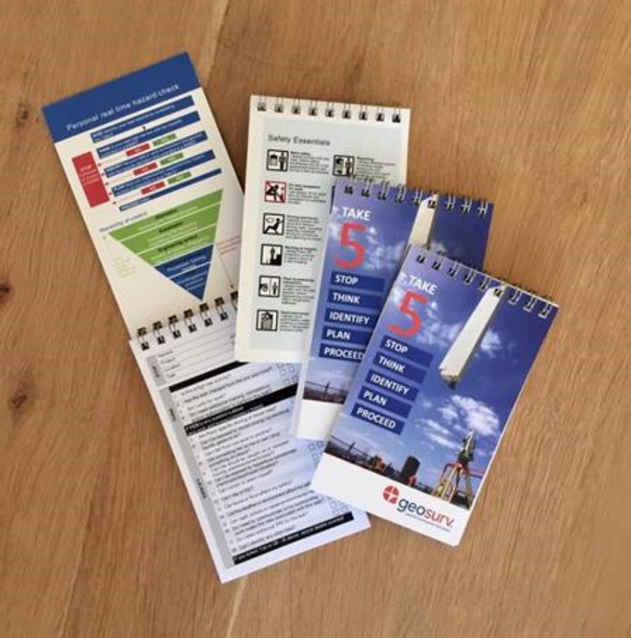**TAKE 5**

A TAKE 5 checklist and/or a SWMS is required to be completed at the start of every day and/or at the start of a job and/or when your task changes (i.e. task changes from concrete set out to formwork set out. Condition and risk would have changed)

TAKE 5 reminds us of the simple things that our brain tends to forget. It is used to prompt us to stop and take a moment to assess the situation and our immediate work environment. Checking for potential safety hazards allows us to manage risk, whilst minimising the chance of injury, and it takes only five minutes.

TAKE 5 forces us to ask, “Am I safe to work?” by concentrating on the task at hand, and completing the checklist before we engage in the activity

The TAKE 5 process involves the following steps:

STOP – think about the potential dangers associated with the job.

THINK – about any hazards or immediate danger.

IDENTIFY– the risk. Consider any possible threat of damage or injury.

PLAN – Implement suitable control measures to reduce risk. Ensure other persons on site who are affected by the same matter are informed about the hazard

PROCEED – complete the task safely

**Safety Essentials**

We take safety very personally. Safety is everybody’s business, every day. Health and safety incidents are not inevitable, they are preventable.

Geosurv’s Safety Essentials programme is designed to offer practical lessons to use in the efficient and effective management of health and safety risks specific to day to day operations - be it on a project site or in the office.

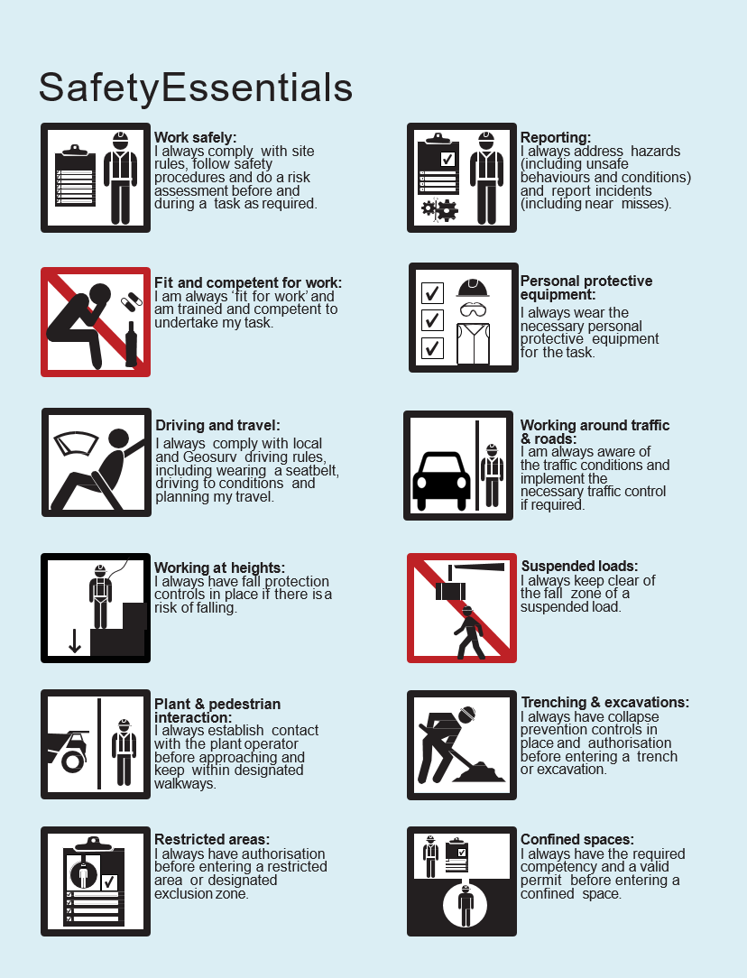At Geosurv, the aspirational goal is zero harm. Within our industry, a wide variety of risks exist across our activities. We have a duty to protect ourselves, our colleagues, clients, and all which are involved in projects, including the public, from harm.

Safety Essentials address situations frequently encountered in workplaces and industries where we are typically engaged. Strict compliance with our Safety Essentials is pivotal to preventing incidents, in our own and in contractor environments. Achieving this requires personal ownership of health and safety, education, and the courage to step in as soon as people see something being done incorrectly or where a situation has the potential for harm.

By sharing these principles and meeting their stringent standards, we go a long way to preventing harm to ourselves and others.

As we go about doing our work in any environment, Geosurv expects people to embrace the Safety Essentials in a positive way and to embed them in everything they do.

For violations of our Safety Essentials, we apply the general principle that if people choose not to comply, people choose not to work for Geosurv.

This is how seriously Geosurv views the Safety Essentials

**Table of Revisions for Geosurv Pty Ltd Subby Pack**

|  |  |  |
| --- | --- | --- |
| **Date** | **Revised by** | **Revision Number** |
| 15 Jan 17 | C Johnson | 17.01 |
| 15 Feb 17 | C Johnson | 17.02 |
| 15 Mar 17 | C Johnson | 17.03 |
| 15 Apr 17 | C Johnson | 17.04 |
| 15 May 17 | C Johnson | 17.05 |
| 16 June 17 | C Johnson | 17.06 |
| 16 July 17 | C Johnson | 17.07 |
| 16 Aug 17 | C Johnson | 17.08 |
| 16 Sept 17 | C Johnson | 17.09 |
| 16 Oct 17 | C Johnson | 17.10 |
| 16 Nov 17 | C Johnson | 17.11 |
| 16 Dec 17 | C Johnson | 17.12 |
| 15 Jan 18 | C Johnson | 18.01 |
| 15 Feb 18 | C Johnson | 18.02 |
| 27 Mar 18 | L Brown | 18.03 |
| 31 May 18 | L Brown | 18.04 |
| 2 July 18 | Y Ritchie | 18.05 |
| 29 Aug 18 | Y Ritchie | 18.06 |
| 18 Oct 18 | Y Ritchie | 18.07 |
| 20 Nov 18 | Y Ritchie | 18.08 |
| 19 Dec 18 | Y Ritchie | 18.09 |
| 10 Jan 19 | Y Ritchie | 19.01 |
|  |  |  |
|  |  |  |
|  |  |  |
|  |  |  |
|  |  |  |













