SQL to MongoDB Mapping
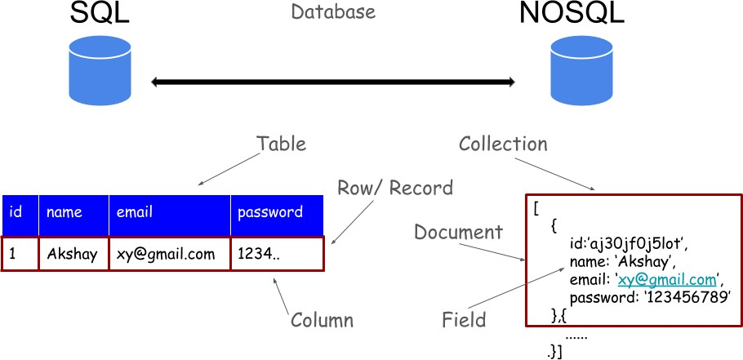
SQL | MongoDB
CREATE TABLE lju (
id MEDIUMINT NOT NULL AUTO_INCREMENT,
user_id Varchar(20), age Number,
status char(1), PRIMARY KEY (id)
)
ALTER TABLE lju ADD join_date DATETIME
ALTER TABLE lju DROP COLUMN
join_date
DROP TABLE lju
INSERT INTO lju (name, age, status)
VALUES (“Test”, 45, "A")
SELECT *FROM lju
SELECT id, name FROM lju
SELECT name, status FROM lju
SELECT * FROM lju WHERE status = "A"
SELECT name FROM lju WHERE status = "A"
SELECT * FROM lju WHERE status
!= "A"
SELECT * FROM lju
WHERE status = "A" AND age = 50
SELECT * FROM lju WHERE status = "A" OR age = 30
SELECT * FROM lju WHERE age > 25
SELECT * FROM lju WHERE age <= 25
SELECT * FROM lju
WHERE age > 25 AND age<= 50
SELECT * from lju where name=”abc” and age=20
SELECT * FROM lju
WHERE status = "A" ORDER BY age ASC
SELECT * FROM lju
WHERE status = "A" ORDER BY age DESC
SELECT COUNT(*) FROM lju
SELECT COUNT(*) FROM lju
WHERE age > 30
SELECT * FROM lju LIMIT 1
SELECT * FROM lju LIMIT 2 OFFSET 3;
EXPLAIN SELECT *
FROM lju WHERE status = "A"
UPDATE lju SET status = "C"
WHERE age > 25
UPDATE lju SET age = age + 3
WHERE status = "A"
DELETE FROM lju WHERE status =
"D"
DELETE FROM lju
SELECT *
FROM lju
WHERE name NOT IN ('aaa','abc','bbb');
SELECT name
FROM lju
WHERE age IN (20,23,33);

