CSE212- DATABASE SYSTEMS LAB

SOHANUZZAMAN SOAD

MAHADY AL HADY

SUPPLY CHAIN MANAGEMENT SYSTEM

UNIVERSITY OF ASIA PACIFIC

2020

**Supply Chain**

A supply chain is a network between a company and its suppliers to produce and distribute a specific product to the final buyer. This network includes different activities, people, entities, information, and resources.

Supply chains are developed by companies so they can reduce their costs and remain competitive in the business landscape.

**Supply Chain Management**

Supply chain management is a process used by companies to ensure that their supplychain is efficient and cost-effective. A supplychain is the collection of steps that a company takes to transform raw materials into a final product.

**Activities of a supply chain management**

1.Customer Relationship Management.

2.Customer Service Management.

3.Demand Management.

4.Order Fulfilment.

5.Manufacturing Flow Management.

6.Procurement.

7.Product Development and Commercialisation.

8.Returns Management

**Benefits of Supply Chain Management System**

1.Higher Efficiency Rate.

2.Reduce Cost Effects.

3.Raise Output.

4.Raised Your Business Profit Level.

5.Boost Cooperation.

6.Lowers Delay in Processes.

7.Enhanced SupplyChain Network.

Supply chain is a very efficient, time saving & cost effective method to ensure huge production in a short time with less time. A supply chain have some procedure to complete the production like at first when a **customer** orderproduct from any online shop then after fulfill all details of that customer **order** goes to the **employee** who is incharge of that management. The desired product order goes with it’s unique order id by which it can be recognize. After that the employee check the status of that product, order list, quantity, availability etc. Then he confirm that product order which goes to **order products** with it’s unique order id, quantity, product id and customer id for next step. Now it’s time to approve the order in **purchase order** option with some unique identity feature. Next step is **suppliers** who manage the product for customer demand then it goes to **shippers** for shipment the product in the **warehouse** where all the ordered products stored for serialize tag & some unique identity tag. After that it goes to **transport** system to deliver all the product to the customer house where customer address, name, id every details included for hassle free marketing system. That’s the main thim of supply chain system.

.

**ER Diagram:**

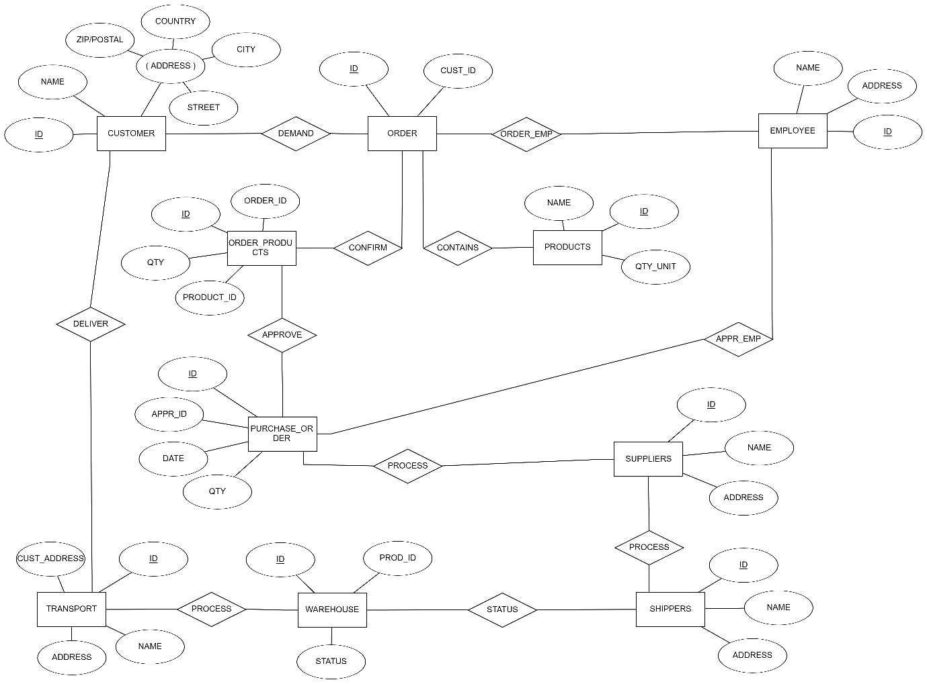

**Schema Diagram:**

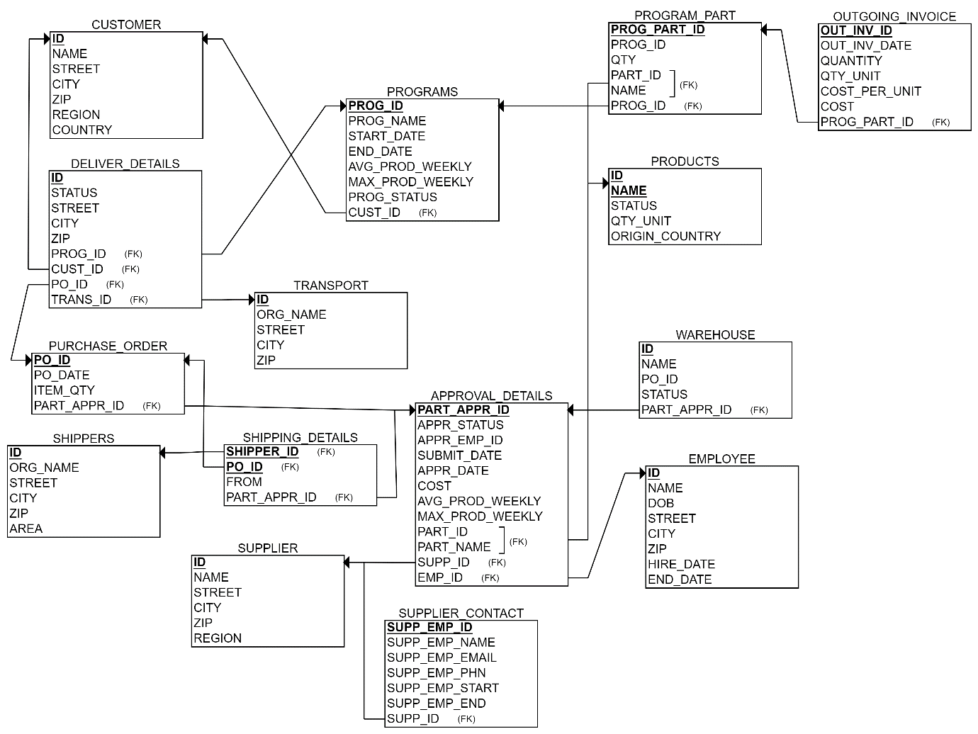

**Query:**

1. **Select ID, Name of all Customer of Hong Kong:**

**SQL:** select id,name from CUSTOMER

where COUNTRY='hong kong'

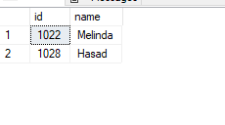

1. **Select All Open Program ID with Customer ID:**

**SQL:** select prog_id,cust_id from PROGRAMS

where prog_status ='open'

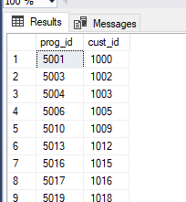

1. **Select all Program_ID with Product Name:**

**SQL:** select program_part.prog_id,PRODUCTS.NAME from PROGRAM_part, PRODUCTS

where PROGRAM_PART.PART_ID = PRODUCTS.ID

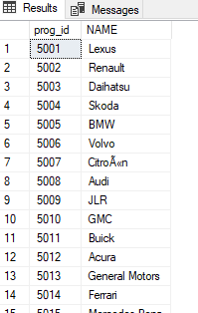

1. Display all available Products:

SQL: select* from PRODUCTS

where STATUS='AVAILABLE'

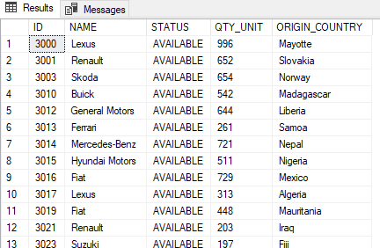

1. List of Employee Who Hired After 2019:

SQL: select* from EMPLOYEE

where HIRE_DATE like '%2019%'

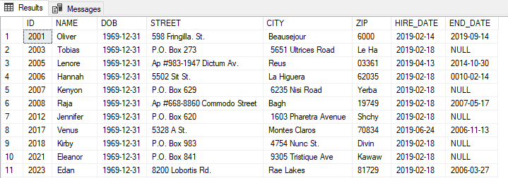

1. List of all Employee of Supplier ID 4015:

SQL: select*from SUPP_CONTACT

where [SUPPLIER ID]='4015'

