LAB 5: STATIC CODE ANALYSIS
Vehicle Service Management System
Name: Soha Rafiq | SRN: PES1UG24AM278

1. Aim
To improve the quality, security and maintainability of a Python program using three static code analysis tools: Pylint, Bandit and Flake8.
2. Tools Used
- Pylint: Identifies code quality issues, naming convention violations and potential programming errors.
- Bandit: Identifies potential security vulnerabilities in Python code.
- Flake8: Checks adherence to Python coding standards and formatting guidelines.
3. Issues Identified and Fixes Implemented
Tool | Issue Identified | Fix Implemented
Pylint | Mutable default argument | Replaced empty list with None
Pylint | Broad exception handling | Replaced Exception with KeyError
Pylint | Missing docstrings | Added module and function documentation
Pylint | Invalid naming conventions | Converted function and variable names to snake_case
Pylint | Unspecified file encoding | Added UTF-8 encoding
Bandit | Hardcoded password | Removed unused hardcoded credential
Bandit | Weak MD5 hashing | Replaced MD5 with SHA-256
Bandit | subprocess with shell=True | Replaced with shutil.copy2()
Flake8 | Missing whitespace | Corrected spacing
Flake8 | Insufficient blank lines | Added required blank lines
Flake8 | Excessive line length | Reformatted long statements
Bandit | Risk associated with subprocess module | Replaced subprocess with shutil

4. Before and After Analysis
Pylint
- Before: 4.66/10
- After: 10.00/10
- Improvement: 5.34 points
Bandit
- Before: 4 security findings (2 high severity and 2 low severity).
- After: No issues identified.
Flake8
- Before: 4 formatting violations.
- After: No formatting violations.
5. Functional Verification
The updated Python program was executed successfully.
The program demonstrated:
- Adding vehicle service records.
- Cancelling service entries.
- Calculating total service costs.
- Generating job card identifiers.
- Identifying the busiest vehicle.
- Saving and loading service records using JSON.
The program executed without errors, and the expected output was generated.
6. GitHub Version Control
Three commits were created and pushed successfully to the personal GitHub fork.
Commit ID | Commit Message
e4b8471 | Fix code quality issues identified by Pylint
c264dbf | Fix security issues identified by Bandit
feec8b1 | Fix formatting issues identified by Flake8
Repository: https://github.com/soharafiq/L5_39_vehicle_service

7. Reflection
1. What is the importance of static code analysis?
Static code analysis helps identify potential bugs, security vulnerabilities and coding standard violations without executing the program. It improves code quality and makes software easier to maintain.
2. What is the difference between Pylint, Bandit and Flake8?
Pylint focuses on code quality and programming practices, Bandit focuses on security vulnerabilities, and Flake8 focuses on formatting and PEP 8 compliance.
3. What did you learn from this lab?
I learned how to use multiple static analysis tools to identify different categories of problems in Python programs. I also learned how to interpret tool reports, prioritize security issues and improve code quality through systematic debugging.
4. How does static analysis improve software development?
It helps developers identify issues early in the development process, reduces potential security risks and encourages consistent coding practices. This makes software more reliable and maintainable.
8. Conclusion
The Vehicle Service Management System was successfully analysed using Pylint, Bandit and Flake8. The identified issues were addressed, resulting in a Pylint score of 10/10, zero Bandit findings and zero Flake8 violations. The lab demonstrated the importance of static code analysis in improving Python code quality, security and maintainability.

  - Original Pylint score (4.66/10)
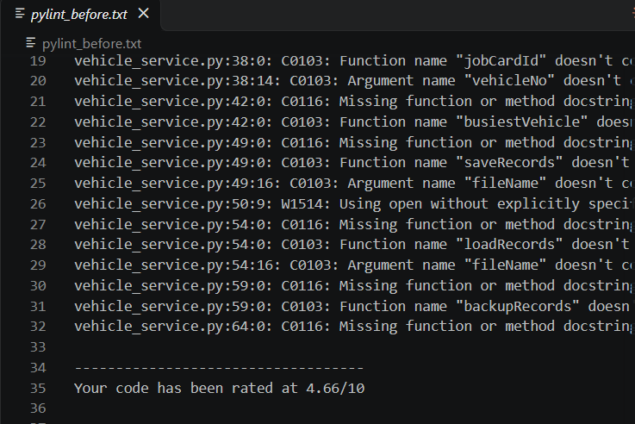
2. Final Pylint score (10/10)
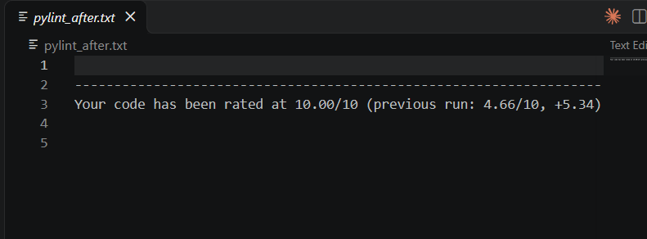
3. Original Bandit findings
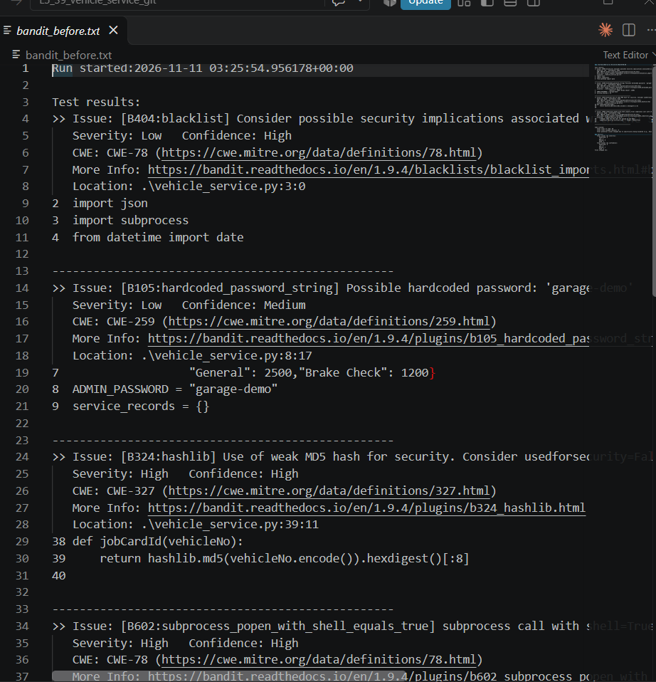
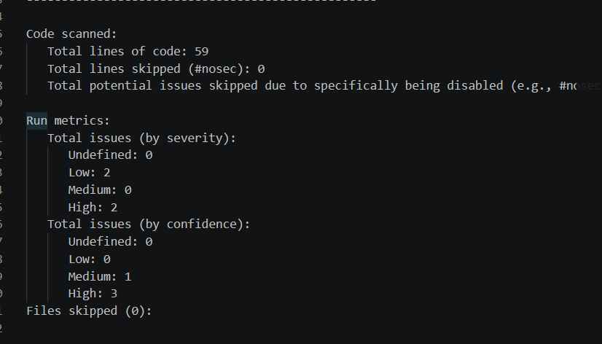
4. Final Bandit findings
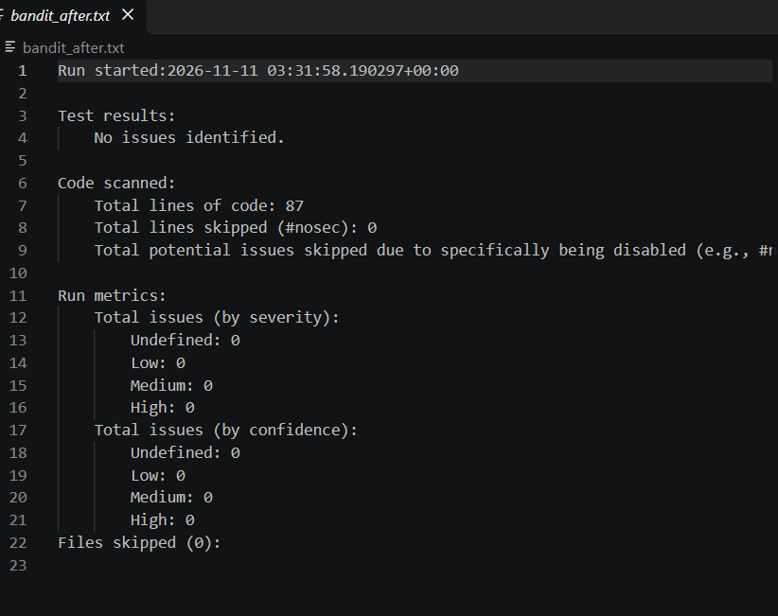
5. Original Flake8 violations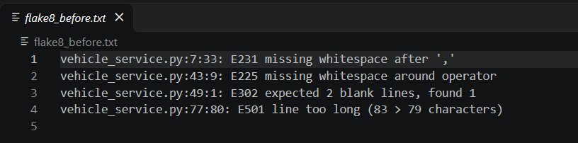
6. Final Flake8 result
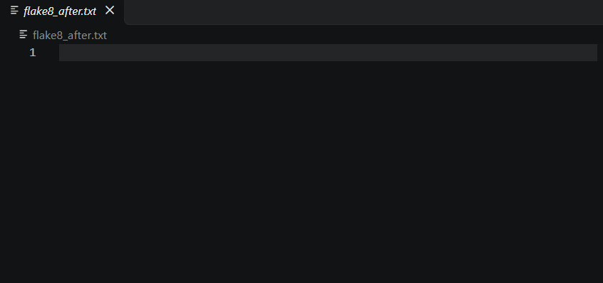

7. Program Execution
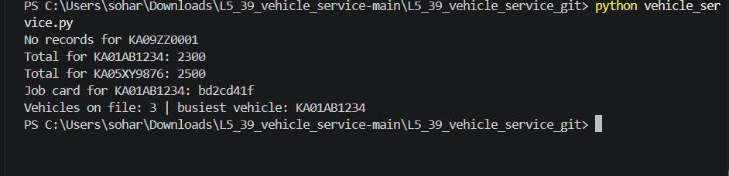
8. Git Commits


