1. Created 2 files student and employee and commited them
2. Created a new file dept.txt and pushed it into staging area

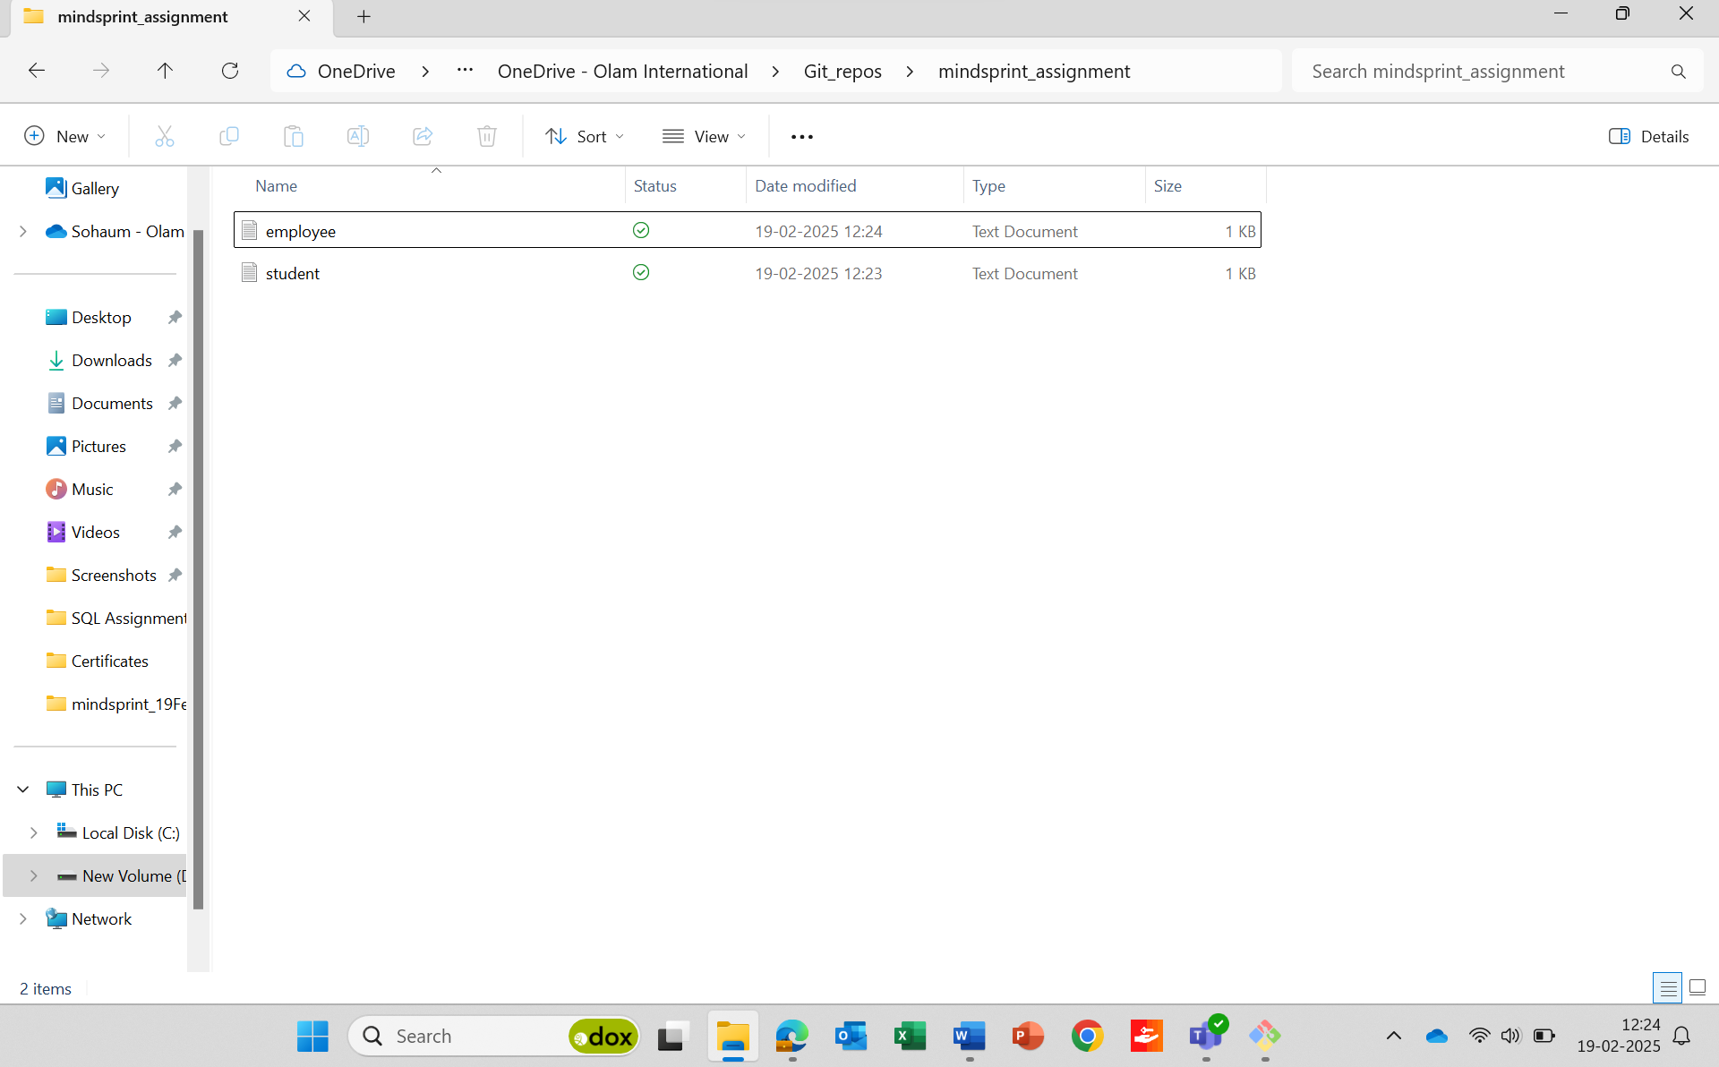

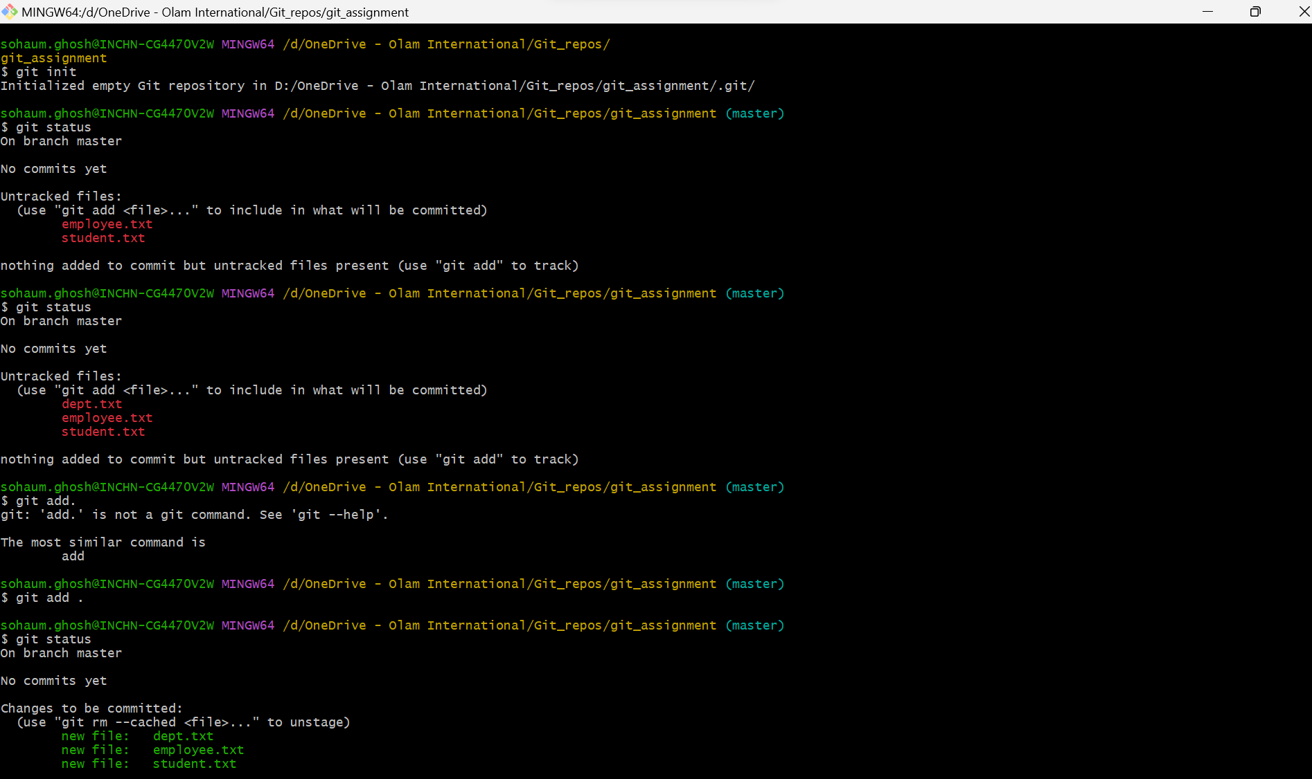

1. Pushed dept,student,employee into remote repos

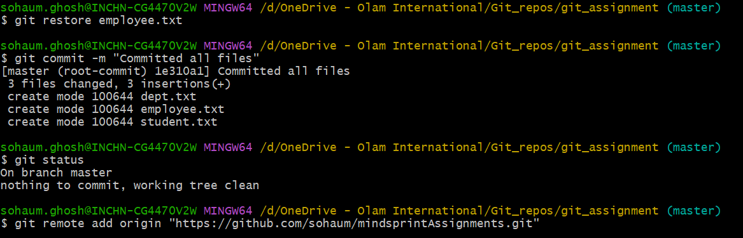

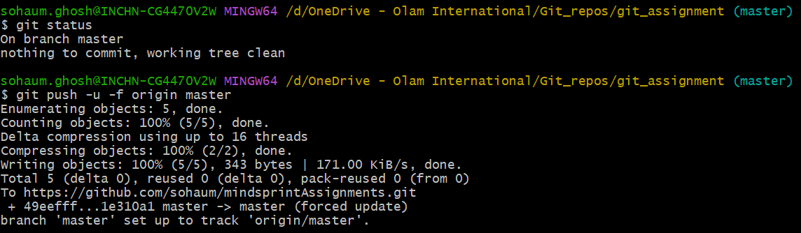

1. Created a new file hello.txt in remote repo and brought it to working directory

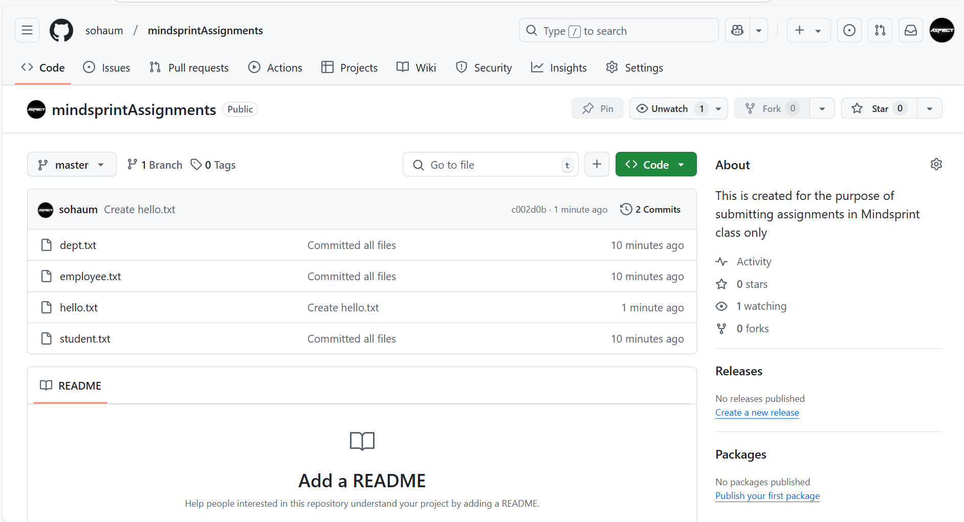

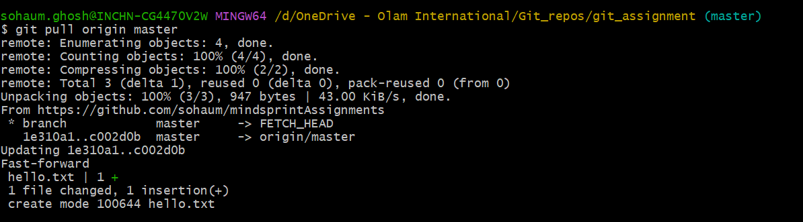

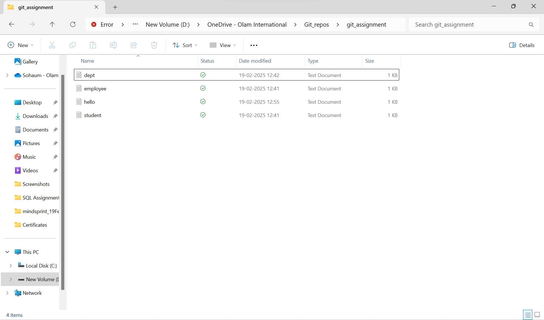

1. Sent all files from working directories to remote repos
2. Removed hello.txt from remote and synced in working directory

