


Submitted to
Mr. Hassan Raza
Visiting Faculty
Department of Computer Science
COMSATS University Islamabad
Submitted by
Name | Registration ID
Sohayel Mahmud | SP26-BCS-114
Tauhidur Rahman Shishir | SP26-BCS-119
Md Ehtiyaz Tawsif Abid | SP26-BCT-062

Tauhidur Rahman Shishir
Registration ID: SP26-BCS-119
BS Computer Science
COMSATS University Islamabad
CSC103: Programming Fundamentals
Final Lab Project
Student Management System
June 1, 2026
COMSATS University islamabad
Park Road, Tarlai Kalan, Islamabad 45550, Pakistan
Table of Contents
0
Project Description 2
Task Distribution 2
Features of System 2
Modules and Entities 3
1. Main Menu Module 3
2. Teacher Authentication Module 3
3. Add Record Function 3
4. View Records Function 3
5. Search Record Function 3
6. Update Record Function 3
7. Remove Record Function 4
8. Student Login & Dashboard Module 4
9. Report Card & Grade Calculation Module 4
10. File Management Module 4
11. Input Validation Module 4
Source Code 4
Screenshots of All Possible Outputs 17
Case 1 (Main Menu): 17
Case 2 (Teacher Login): 17
Case 3 (Teacher Dashboard): 17
Case 4 (Add Student): 18
Case 5 (View All Records): 19
Case 6 (Update Records): 19
Case 7 (Search Student): 19
Case 8 (Removing Student): 19
Case 9 (Student login): 20
Case 10 (View Report Card or Export via Student Dashboard): 20
Conclusion 21

Project Description
The Student Management System is a console-based Java application designed to digitize and streamline the academic record-keeping process within an educational institution. The system provides a centralized platform where a teacher, acting as the administrator, can efficiently manage the complete data of enrolled students, including their personal details, academic marks, and attendance information. The application supports two distinct user roles — Teacher and Student — each equipped with a separate, secured login interface and a role-specific dashboard. The Teacher Dashboard grants full control over student records, enabling operations such as adding, viewing, updating, searching, and removing entries. Students can log in using their unique Student ID to access a personalized report card displaying their academic performance and grade. All data is persistently stored on disk through text files, ensuring no information is lost between program sessions. The system enforces rigorous input validation across all fields and handles all potential runtime exceptions, guaranteeing that the application does not crash under any user input scenario.

Task Distribution
Team Member | Registration No. | Responsibilities
Sohayel Mahmud | SP26-BCS-114 | Teacher Login & Authentication, Teacher Dashboard Menu, Add Record, Remove Record, Update Record, Search Record, View all Records.
Tauhidur Rahman Shishir | SP26-BCS-119 | Student Login & Dashboard, Report Card Generation & Export (roll_report.txt, e.g. 111_report.txt), Input Validation Helper Methods.
Md Ehtiyaz Tawsif Abid | SP26-BCT-062 | Main Menu, Load Data from File & Save Data to File (Students.txt), Grade Calculation

Features of System
- Dual Login System: Separate and secured login portals for the Teacher (Admin) and the Student, each providing a role-specific dashboard with distinct operations.
- Teacher Dashboard (Full CRUD): The teacher can Add, View, Update, Search, and Remove student records through a structured, menu-driven interface.
- Student Dashboard: Students log in using their unique ID to view a detailed on-screen report card or export it permanently as a text file.
- Automated Grade & GPA Calculation: The system automatically computes a letter grade (A through F) and a corresponding grade point on a 4.0 scale based on the student's marks.
- Persistent File Storage: All student records are saved to students.txt and teacher credentials to credentials.txt in Text format, ensuring data survives between sessions.
- Report Card File Export: Students can export a fully formatted report card to a uniquely named file ([StudentID]_report.txt, e.g. 121_report.txt) for permanent reference.
- Comprehensive Input Validation: All numeric fields are validated for correct data type and acceptable range — Age (18–30), Marks (0–100), Attendance (0–100) — with descriptive error messages on violation.
- Duplicate ID Prevention: The system checks all existing records before adding a new entry, rejecting any Student ID that already exists in the database.
- Exception Handling Throughout: Every input and file operation is enclosed in try-catch blocks to gracefully handle NumberFormatException, Exception and IOException without crashing.
- Login Attempt Limiting: The Teacher login restricts failed attempts to a maximum of 3 before automatically returning to the main menu.
- Formatted Tabular Record Display: All student records are presented in a neatly bordered, column-aligned ASCII table for easy readability.
- Array-Based In-Memory Storage: Student data is managed using parallel arrays supporting up to 100 student records during runtime.

Modules and Entities

1. Main Menu Module
Loads student records and teacher credentials at startup. Displays Teacher Login, Student View, and Exit options in a continuous loop. All inputs are protected with exception handling.

2. Teacher Authentication Module
Verifies Teacher ID and password using stored credentials. Allows up to three login attempts before returning to the main menu. Successful login opens the Teacher Dashboard.

3. Add Record Function
Adds a new student's ID, Name, Age, Marks, and Attendance to the system. Checks for duplicate IDs and validates all inputs. Records are saved to the file immediately.

4. View Records Function
Displays all student records in a formatted table with proper alignment. Shows ID, Name, Age, Marks, and Attendance. Displays a message if no records exist.

5. Search Record Function
Searches for a student using their unique ID. Displays all student details if found. Shows a not-found message when no match exists.

6. Update Record Function
Allows modification of a student's Marks and Attendance. Verifies the Student ID before updating. Changes are saved to the file instantly.

7. Remove Record Function
Deletes a student record using the Student ID. Shifts remaining records to maintain array order. Updates the file immediately after deletion.

8. Student Login & Dashboard Module
Allows students to log in using their Student ID. Provides options to view or export their report card. Handles invalid inputs safely.

9. Report Card & Grade Calculation Module
Generates a complete report card with grades, GPA, and pass/fail status. Uses marks to calculate letter grades and grade points. Reports can be viewed or exported to a text file.

10. File Management Module
Handles loading and saving of student and teacher data. Uses text files for permanent storage. All file operations include exception handling.

11. Input Validation Module
Uses reusable methods to validate integer and decimal inputs. Ensures values are within acceptable ranges. Prevents invalid data entry throughout the system.

Source Code
import java.util.*;
import java.io.*;

public class BCS_114_BCS_119_BCT_062_Student_Management {
public static Scanner input = new Scanner(System.in);

public static final String FILE_NAME = "students.txt";
public static final int MAX = 100;

// data arrays
public static int[] studentIDs = new int[MAX];
public static String[] studentNames = new String[MAX];
public static int[] studentAges = new int[MAX];
public static double[] studentMarks = new double[MAX];
public static int[] studentAttendance = new int[MAX];
public static int currentCount = 0;

// teacher login id & pass
public static final String CRED_FILE = "credentials.txt";
public static String teacherID = "admin";
public static String teacherPassword = "123";

// teacher login validation
public static boolean teacherLogin() {
System.out.println("\n--- Teacher Login ---");
int attempts = 3;

while (attempts > 0) {
System.out.print("Enter teacher id: ");
String idInput = input.nextLine();
System.out.print("Enter password: ");
String passInput = input.nextLine();

// validate credentials
if (idInput.equals(teacherID) && passInput.equals(teacherPassword)) {
System.out.println("Login successful!");
return true;
} else {
attempts--;
System.out.println("Invalid ID or Password! Attempts remaining: " + attempts);
}
}
System.out.println("Login failed! Returning to main menu.");
return false;
}

// teacher login
public static void teacherMenu() {
int op = -1;
do {
System.out.println("\n====================================");
System.out.println("--- Welcome to Teacher Dashboard ---");
System.out.println("====================================");
System.out.println("1. Add Student Record");
System.out.println("2. View All Records");
System.out.println("3. Update Student Record");
System.out.println("4. Search Student Record");
System.out.println("5. Remove Student Record");
System.out.println("0. Log Out");
System.out.print("Select operation: ");

try {
op = Integer.parseInt(input.nextLine());
switch (op) {
case 1:
addRecord();
break;
case 2:
viewRecords();
break;
case 3:
updateRecord();
break;
case 4:
searchRecord();
break;
case 5:
removeStudent();
break;
case 0:
System.out.println("Exiting Teacher Dashboard...");
break;
default:
System.out.println("Invalid operation! Try again.");
}
} catch (NumberFormatException e) {
System.out.println("Invalid input! Please enter a number.");
op = -1; // reset to keep loop running
}
} while (op != 0);
}

// valid input
public static int getValidInt(String prompt, int min, int max) {
while (true) {
try {
System.out.print(prompt);
int val = Integer.parseInt(input.nextLine());
if (val < min || val > max) {
System.out.println("Invalid range! Must be between " + min + " and " + max + ".");
continue;
}
return val;
} catch (NumberFormatException e) {
System.out.println("Invalid input! Please enter a valid number.");
}
}
}

public static double getValidDouble(String prompt, double min, double max) {
while (true) {
try {
System.out.print(prompt);
double val = Double.parseDouble(input.nextLine());
if (val < min || val > max) {
System.out.println("Invalid range! Must be between " + min + " and " + max + ".");
continue;
}
return val;
} catch (NumberFormatException e) {
System.out.println("Invalid input! Please enter a valid decimal number.");
}
}
}

// add record
public static void addRecord() {
System.out.println("\n--- Add New Student Record ---");
if (currentCount >= MAX) {
System.out.println("Database is full! Cannot add more students.");
return;
}

// ID input & validation
int id = 0;
while (true) {
try {
System.out.print("Enter Student ID: ");
id = Integer.parseInt(input.nextLine());

// duplicate ID check
boolean exists = false;
for (int i = 0; i < currentCount; i++) {
if (studentIDs[i] == id) {
exists = true;
break;
}
}
if (exists) {
System.out.println("This ID already exists! Try a unique ID.");
continue;
}
break;
} catch (NumberFormatException e) {
System.out.println("Invalid ID! Please enter an integer number.");
}
}

// name input
System.out.print("Enter Student Name: ");
String name = input.nextLine().replace(",", " ");

// age input & validation
int age = getValidInt("Enter Age (18-30): ", 18, 30);
int attendance = getValidInt("Enter Attendance Percentage (0-100): ", 0, 100);
double marks = getValidDouble("Enter Marks (0-100): ", 0, 100);

// save data
studentIDs[currentCount] = id;
studentNames[currentCount] = name;
studentAges[currentCount] = age;
studentMarks[currentCount] = marks;
studentAttendance[currentCount] = attendance;

currentCount++;

// save immediately to file
saveDataToFile();
System.out.println("Student record added successfully and saved to file!");
}

// view record
public static void viewRecords() {
System.out.println(
"\n============================= ALL STUDENT RECORDS =============================");
if (currentCount == 0) {
System.out.println("No records found! Add some students first.");
return;
}

// table top border
System.out.println("+------------+----------------------+------------+------------+---------------+");
System.out.printf("| %-10s | %-20s | %-10s | %-10s | %-13s |\n", "ID", "Name", "Age", "Marks", "Attendance");
// header separator
System.out.println("+------------+----------------------+------------+------------+---------------+");

// table data
for (int i = 0; i < currentCount; i++) {
System.out.printf("| %-10d | %-20s | %-10d | %-10.2f | %-13s |\n", studentIDs[i], studentNames[i],
studentAges[i], studentMarks[i], studentAttendance[i] + "%");
}

// table bottom border
System.out.println("+------------+----------------------+------------+------------+---------------+");
}

// search student by id
public static void searchRecord() {
System.out.println("\n--- Search Student Record ---");
if (currentCount == 0) {
System.out.println("No records found! Database is empty.");
return;
}

int searchid = 0;
try {
System.out.print("Enter student ID to search: ");
searchid = Integer.parseInt(input.nextLine());
} catch (NumberFormatException e) {
System.out.println("Invalid ID! ID must be an integer.");
return;
}

int foundindex = -1;
for (int i = 0; i < currentCount; i++) {
if (studentIDs[i] == searchid) {
foundindex = i;
break;
}
}

if (foundindex != -1) {
System.out.println("\nRecord found:");
System.out.println("ID: " + studentIDs[foundindex]);
System.out.println("Name: " + studentNames[foundindex]);
System.out.println("Age: " + studentAges[foundindex]);
System.out.println("Marks: " + studentMarks[foundindex]);
System.out.println("Attendance: " + studentAttendance[foundindex] + "%");
} else {
System.out.println("Student with ID " + searchid + " not found.");
}
}

// update marks and attendance
// update marks and attendance
public static void updateRecord() {
System.out.println("\n--- Update Student Record ---");
if (currentCount == 0) {
System.out.println("No records found! database is empty.");
return;
}

int searchid = 0;
try {
System.out.print("Enter student id to update: ");
searchid = Integer.parseInt(input.nextLine());
} catch (NumberFormatException e) {
System.out.println("Invalid ID! ID must be an integer.");
return;
}

int foundindex = -1;
for (int i = 0; i < currentCount; i++) {
if (studentIDs[i] == searchid) {
foundindex = i;
break;
}
}

if (foundindex == -1) {
System.out.println("Student id not found.");
return;
}

System.out.println("Updating record for: " + studentNames[foundindex]);

// update data
studentAttendance[foundindex] = getValidInt("Enter Attendance Percentage (0-100): ", 0, 100);
studentMarks[foundindex] = getValidDouble("Enter Marks (0-100): ", 0, 100);

// saave the file
saveDataToFile();
System.out.println("Record updated successfully and saved to file!");
}

// remove student record by id
public static void removeStudent() {
System.out.println("\n--- Remove Student Record ---");
if (currentCount == 0) {
System.out.println("No records found! Database is empty.");
return;
}

int searchid = 0;
try {
System.out.print("Enter student ID to remove: ");
searchid = Integer.parseInt(input.nextLine());
} catch (NumberFormatException e) {
System.out.println("Invalid ID! ID must be an integer.");
return;
}

int foundindex = -1;
for (int i = 0; i < currentCount; i++) {
if (studentIDs[i] == searchid) {
foundindex = i;
break;
}
}

if (foundindex == -1) {
System.out.println("Student ID not found.");
return;
}

System.out.println("Removing record for: " + studentNames[foundindex]);

for (int i = foundindex; i < currentCount - 1; i++) {
studentIDs[i] = studentIDs[i + 1];
studentNames[i] = studentNames[i + 1];
studentAges[i] = studentAges[i + 1];
studentMarks[i] = studentMarks[i + 1];
studentAttendance[i] = studentAttendance[i + 1];
}

currentCount--;
saveDataToFile();
System.out.println("Student record removed successfully and saved to file!");
}

// load data from txt file to arrays
public static void loadDataFromFile() {
File file = new File(FILE_NAME);
if (!file.exists()) {
return; // no file found, starting fresh
}

try (Scanner filehandler = new Scanner(file)) {
currentCount = 0;
while (filehandler.hasNextLine() && currentCount < MAX) {
String line = filehandler.nextLine();
if (line.trim().isEmpty())
continue; // skip blank lines

// split data by comma
String[] tokens = line.split(",");
studentIDs[currentCount] = Integer.parseInt(tokens[0]);
studentNames[currentCount] = tokens[1];
studentAges[currentCount] = Integer.parseInt(tokens[2]);
studentMarks[currentCount] = Double.parseDouble(tokens[3]);
studentAttendance[currentCount] = Integer.parseInt(tokens[4]);
currentCount++;
}
} catch (Exception e) {
System.out.println("Error loading data from file!");
}
}

// save current arrays to txt file
public static void saveDataToFile() {
try (PrintWriter writer = new PrintWriter(new FileWriter(FILE_NAME))) {
for (int i = 0; i < currentCount; i++) {
// writing in csv format: id,name,age,marks,attendance
writer.println(studentIDs[i] + "," +
studentNames[i] + "," +
studentAges[i] + "," +
studentMarks[i] + "," +
studentAttendance[i]);
}
} catch (IOException e) {
System.out.println("Error saving data to file!");
}
}

// load teacher credentials from file
public static void loadCredentials() {
File file = new File(CRED_FILE);
if (!file.exists()) {
saveCredentials(); // create file with default login if it doesn't exist
return;
}
try (Scanner filehandler = new Scanner(file)) {
if (filehandler.hasNextLine()) {
String line = filehandler.nextLine();
String[] tokens = line.split(",");
if (tokens.length == 2) {
teacherID = tokens[0];
teacherPassword = tokens[1];
}
}
} catch (Exception e) {
System.out.println("Error loading credentials!");
}
}

// save teacher credentials to file
public static void saveCredentials() {
try (PrintWriter writer = new PrintWriter(new FileWriter(CRED_FILE))) {
writer.println(teacherID + "," + teacherPassword);
} catch (IOException e) {
System.out.println("Error saving credentials!");
}
}

// student login and validation
public static void studentMenu() {
System.out.println("\n--- Student Login ---");
if (currentCount == 0) {
System.out.println("No records in the system yet.");
return;
}

int searchid = 0;
try {
System.out.print("Enter your student ID to login: ");
searchid = Integer.parseInt(input.nextLine());
} catch (NumberFormatException e) {
System.out.println("Invalid ID! ID must be an integer number.");
return;
}

int foundindex = -1;
for (int i = 0; i < currentCount; i++) {
if (studentIDs[i] == searchid) {
foundindex = i;
break;
}
}

if (foundindex != -1) {
System.out.println("Login successful! WELCOME, " + studentNames[foundindex] + " !!!");
studentDashboard(foundindex);
} else {
System.out.println("Student ID not found. Login failed!");
}
}

// separate method for student operations loop
public static void studentDashboard(int index) {
int op = -1;
do {
System.out.println("\n--- Student Dashboard ---");
System.out.println("1. View Report Card");
System.out.println("2. Export Report Card to File");
System.out.println("0. Log Out");
System.out.print("Select operation: ");

try {
op = Integer.parseInt(input.nextLine());
switch (op) {
case 1:
printReportCard(index);
break;
case 2:
exportReportCard(index);
break;
case 0:
System.out.println("Exiting Student Dashboard...");
break;
default:
System.out.println("Invalid operation! Try again.");
}
} catch (NumberFormatException e) {
System.out.println("Invalid input! Please enter a number.");
op = -1;
}
} while (op != 0);
}

// grade calculator
public static String[] calculateGrade(double m) {
String letter = "F";
double gradePoint = 0.0;
String status = "FAIL";

if (m >= 85) {
letter = "A";
gradePoint = 4.0;
status = "PASS (Excellent)";
} else if (m >= 80) {
letter = "A-";
gradePoint = 3.7;
status = "PASS";
} else if (m >= 75) {
letter = "B+";
gradePoint = 3.3;
status = "PASS";
} else if (m >= 71) {
letter = "B";
gradePoint = 3.0;
status = "PASS";
} else if (m >= 68) {
letter = "B-";
gradePoint = 2.7;
status = "PASS";
} else if (m >= 64) {
letter = "C+";
gradePoint = 2.3;
status = "PASS";
} else if (m >= 61) {
letter = "C";
gradePoint = 2.0;
status = "PASS";
} else if (m >= 58) {
letter = "C-";
gradePoint = 1.7;
status = "PASS";
} else if (m >= 50) {
letter = "D";
gradePoint = 1.3;
status = "PASS (Minimum Passing)";
} else {
letter = "F";
gradePoint = 0.0;
status = "FAIL";
}

return new String[] { status, letter, String.valueOf(gradePoint) };
}

// sub-method to just print report card on console
public static void printReportCard(int index) {
System.out.println("\n====================================");
System.out.println(" STUDENT REPORT CARD ");
System.out.println("====================================");
System.out.println("ID: " + studentIDs[index]);
System.out.println("Name: " + studentNames[index]);
System.out.println("Age: " + studentAges[index]);
System.out.println("Marks: " + studentMarks[index] + " / 100");
System.out.println("Attendance: " + studentAttendance[index] + "%");
System.out.println("====================================");

String[] gradeData = calculateGrade(studentMarks[index]);
String status = gradeData[0];
String letter = gradeData[1];
String gradePoint = gradeData[2];

System.out.println("Status: " + status);
System.out.println("Letter Grade: " + letter + " Grade Point: " + gradePoint);
System.out.println("====================================");
}

// sub-method to export report card to text file
public static void exportReportCard(int index) {
String filename = studentIDs[index] + "_report.txt";
try (PrintWriter writer = new PrintWriter(new FileWriter(filename))) {
writer.println("====================================");
writer.println(" STUDENT REPORT CARD ");
writer.println("====================================");
writer.println("ID: " + studentIDs[index]);
writer.println("Name: " + studentNames[index]);
writer.println("Age: " + studentAges[index]);
writer.println("Marks: " + studentMarks[index] + " / 100");
writer.println("Attendance: " + studentAttendance[index] + "%");
writer.println("====================================");

String[] gradeData = calculateGrade(studentMarks[index]);
String status = gradeData[0];
String letter = gradeData[1];
String gradePoint = gradeData[2];

writer.println("Status: " + status);
writer.println("Letter Grade: " + letter + " Grade Point: " + gradePoint);
writer.println("====================================");
System.out.println("Report exported successfully to " + filename);
} catch (IOException e) {
System.out.println("Error exporting report card!");
}
}

public static void main(String[] args) throws IOException {
loadDataFromFile();
loadCredentials();

int identity = 0;
boolean keepRunning = true;

while (keepRunning) {
try {
System.out.println("\n=== STUDENT MANAGEMENT SYSTEM ===");
System.out.println("1. Teacher Login");
System.out.println("2. Student View");
System.out.println("0. Exit Program");
System.out.print("Enter identity: ");
identity = Integer.parseInt(input.nextLine());

switch (identity) {
case 1:
if (teacherLogin()) {
teacherMenu();
}
break;
case 2:
studentMenu();
break;
case 0:
keepRunning = false;
break;
default:
System.out.println("Invalid identity! Please enter 1, 2, or 0.");
}
} catch (NumberFormatException e) {
System.out.println("Invalid input! Please enter a number.");
}
}

saveDataToFile();
System.out.println("Data saved successfully. Goodbye!");
}
}

Screenshots of All Possible Outputs

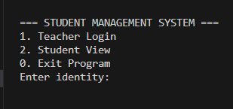
Case 1 (Main Menu):

Figure 1 Home Menu for Selecting Identity

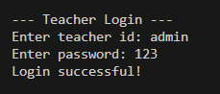
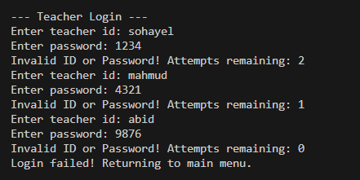
Case 2 (Teacher Login):
Figure 3 Login Successful for Teachers
Figure 2 Failed Login Attempted for Teachers

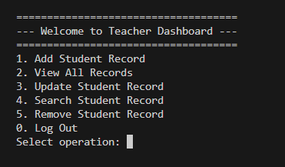
Case 3 (Teacher Dashboard):
Figure 4 Teachers Dashboard

Case 4 (Add Student):
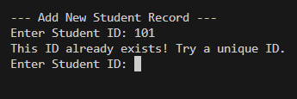
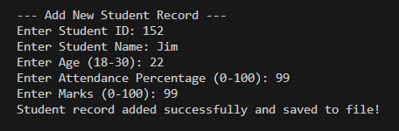

Figure 6 Failed Adding for Duplicate ID
Figure 5 Successfully Added a student
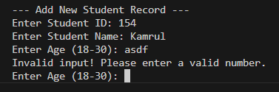
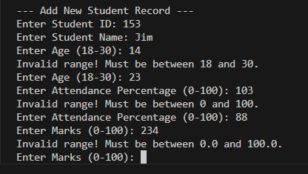
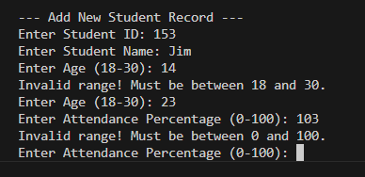
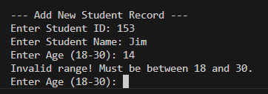
Figure 10 Invalid type for Age
Figure 9 Outrange for Marks
Figure 7 Outrange for Age
Figure 8 Outrange for Attendance
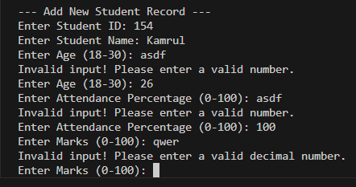
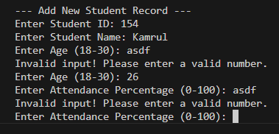
Figure 12 Invalid type of Marks
Figure 11 Invalid type for Attendance

Case 5 (View All Records):
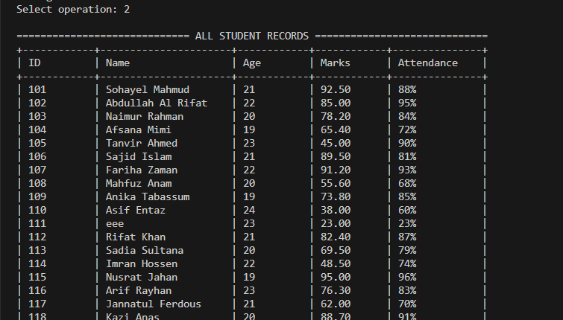
Figure 13 View All the Students Data

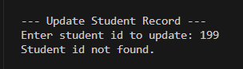
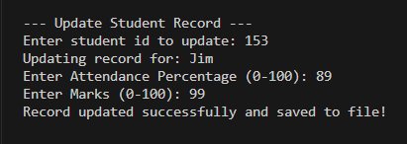
Case 6 (Update Records):
Figure 15 Invalid Student ID for Update
Figure 14 Successfully Updated Student Data

Case 7 (Search Student):

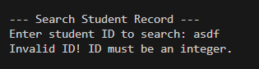
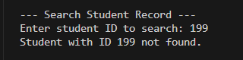
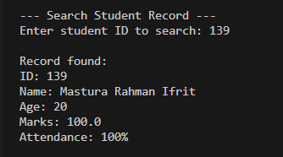
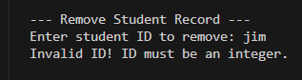
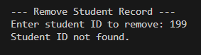
Case 8 (Removing Student):
Figure 18 ID not Found for Removing Student
Figure 17 Student ID not Found
Figure 16 Successfully Searching Student Data
Figure 20 Invalid Input type for Searching Student
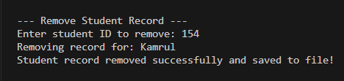
Figure 21 Invalid Input Type for Removing Student
Figure 19 Removing Student Successfully

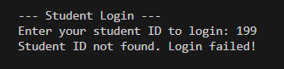
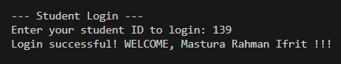
Case 9 (Student login):
Figure 23 Failed Student Login
Figure 22 Successfully Student Login

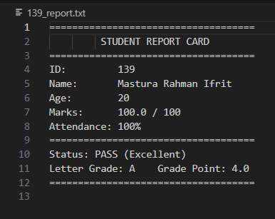
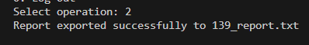
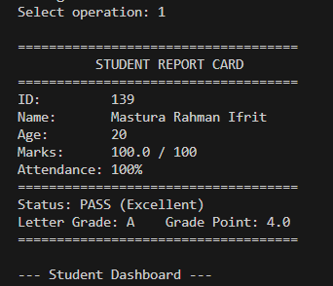
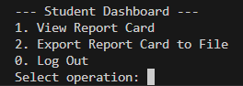
Case 10 (View Report Card or Export via Student Dashboard):
Figure 25 Export Report in a .txt File
Figure 26 Print Report on Terminal
Figure 24 Student Dashboard

Conclusion
The Student Management System successfully fulfills all the objectives set out for this project by delivering a fully functional, menu-driven console application built in Java. The system effectively implements a dual-role login mechanism, granting the Teacher administrative control over all student records while providing Students with secure, read-only access to their personal academic data. All core operations — Add, View, Update, Search, and Remove — have been implemented with robust input validation and exception handling, ensuring the application remains stable and crash-free under all user interactions. The use of parallel arrays demonstrates a solid understanding of array-based data management in Java, while file handling through text-based storage ensures that all records persist permanently on disk between program sessions. The automated grade calculation and report card export features add meaningful academic utility to the system beyond basic record management. Overall, this project provided valuable hands-on experience in applying core programming fundamentals — including arrays, file I/O, exception handling, input validation, and modular method design — in the context of a real-world, team-developed application.

