NAME:MD SOHEB

ROLL:13

BATCH:54

meal of sir house

Table of Contents

INTRODUCTION 2

MEMBERS 2

MEAL DISCRIPTION 3

MEAL CHART 4

MEAL BUGET 5

## INTRODUCTION

There are 5 of us living in the house.we all eat together.We are all students of Barisal University.Now we will describe our daily meals.

## MEMBERS

## MEAL DISCRIPTION

We eat 3 meals in a day.We usually eat vegetable,stuw,pulses,eggs,fish and meat. 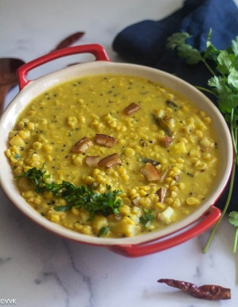 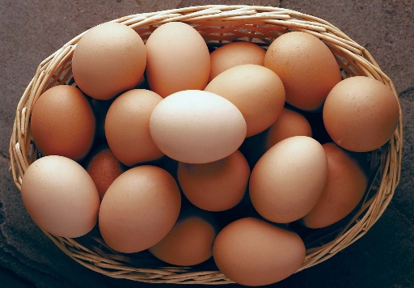 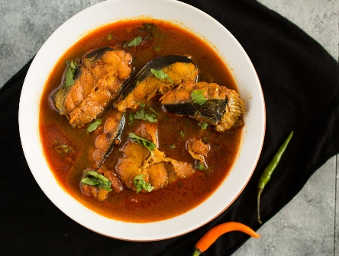

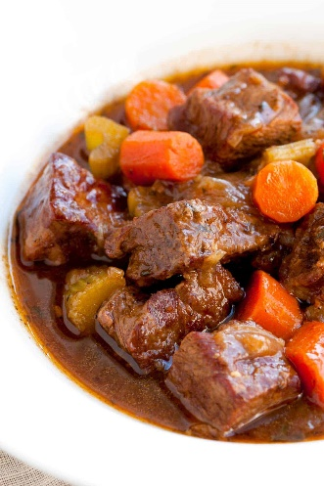 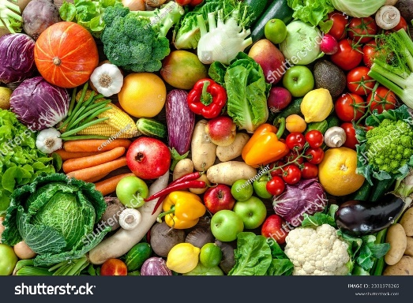

## MEAL CHART

|  |  |
| --- | --- |
| DAY | ITEMS |
| SATURDAY | VORTA,DAL,FISH |
| SUNDAY | VORTA,DAL,MEAT |
| MONDAY | VORTA,DAL,EGGS |
| TUESDAY | VORTA,DAL,FISH |
| WEDNESDAY | VORTA,DAL,MEAT |
| THURSDAY | VORTA,DAL,EGGS |
| FRIDAY | VORTA,POLAW,MEAT |

## MEAL BUGET