
Assignment 2
Assignment: Project Proposal
Project Title: Design and Evaluation of a Lightweight SSH Access Behavior Profiling and Anomaly Alerting Agent for Small-Scale Cloud Servers Used by Small and Medium Enterprises

Date assigned: 03/03/2025
Date completed: 05/09/2025

Intake code: APDMF2501CYS(PR)
Module code: CT095 6 M RMCE
Subject: Research Methodology in Computing and Engineering

SUBMITTED BY | SUBMITTED TO
Name: Md Sohel Rana  TP Number: TP086217 | TS. DR. SE YONG A/L EH NOUM  Assistant Professor  Asia Pacific University of Technology & Innovation  Kuala Lumpur, Malaysia  Email: seyong@apu.edu.my

TABLE OF CONTENTS

ABSTRACT 6
CHAPTER 1: INTRODUCTION 7
CHAPTER 2: LITERATURE REVIEW 9
2.1. SSH Vulnerabilities and Attack Vectors 9
2.2. Anomaly Detection Techniques 10
2.2.1. Rule-Based and Statistical Methods: 10
2.2.2. Machine Learning Methodologies: 10
2.2.3. Unsupervised Learning: 10
2.2.4. Supervised and Deep Learning: 10
2.2.5. Hybrid Systems: 11
2.3. Cybersecurity Challenges in Asian SMEs 12
2.3.1. Financial Constraints: 12
2.3.2. Skills gap: 12
2.3.3. Low Awareness: 12
2.3.4. Infrastructure Limitations: 12
2.4. The Identified Research Gap 12
2.5. Problem Statement 13
2.6. Research Questions and Objectives 14
2.6.1. Research Questions 14
2.6.2. Aim and Objectives 15
CHAPTER 3: TECHNICAL FRAMEWORK PROPOSAL 17
3.1. System Architecture 17
3.1.1. Data Collection Layer: 18
3.1.2. Layer of Data Processing: 19
3.1.3. Analysis Layer: 19
3.1.4. Alert and Response Layer: 20
3.1.5. Storage and Management Layer: 20
3.2. Alert Notification Process 20
3.3. Technology Stack 22
3.4. Implementation Details 23
3.4.1. SSH Log Processing: 23
3.4.2. Database Schema: 25
3.4.3. Performance Specifications: 26
3.5. Methodology 26
3.5.1. Phase 1: Data Collection and Preparation 26
3.5.2. Phase 2: System Development and Implementation 27
3.5.3. Phase 3: Evaluation and Validation 27
CHAPTER 4: IMPLEMENTATION STRATEGY 30
4.1. Phased Deployment Plan 30
4.2. Risk Assessment and Mitigation Strategies 31
4.3. Success Metrics (KPIs) 32
4.4. Timeline and Resources 33
4.5. Key Milestones: 33
4.6. Gantt Chart: 34
4.7. Required Resources: 34
4.8. Expected Outcomes and Significance 34
4.8.1. Expected Outcomes 34
4.9. Budget And Resource Allocation 35
4.9.1. Personnel Costs 35
4.9.2. Hardware & Software Costs 36
4.9.3. Contributions In-Kind & Cost Sharing 37
4.9.4. Significance of the Research 38
CHAPTER 5: CONCLUSION 40
5.1. Conclusion 40
5.2. Future Work 40
REFERENCES 42

LIST OF FIGURES
Figure 1: SSSA High-Level System Architecture …………………………………….18
Figure 2: Alert Notification Process………………………………………………….. 21
Figure 3: Processing SSH logs workflow ……………………………………….…….23
Figure 4: Gantt Chart……………………………………………………………………34

LIST OF TABLES
Table 1: Cyberattack Statistics on South Asian SMEs (2023–2025) ……………7
Table 2: Common SSH Misconfigurations and Attack Vectors …………………9
Table 3: Comparison of Anomaly Detection Approaches ………………………11
Table 4: Technology Stack ………………………………………………………22
Table 5: Risk Assessment and Mitigation Strategies ……………………………31
Table 6: Timeline and Resources ………………………………………….…….33
Table 7: Personnel Costs ……………………………………………………..….35
Table 8: Hardware & Software Costs ……………………………………..…….36

ABSTRACT
In this study, the project intends to design, develop and test a lightweight, affordable SSH anomaly detection system that suits the needs and limitations of Small and Medium Enterprises (SMEs) in South Asia. The research fills a gap of dire importance in cybersecurity as SMEs are becoming more vulnerable to advanced cyberattacks and they cannot afford enterprise-level security measures. The main research question is as follows: How do we develop a lightweight and log-based SSH anomaly detector system that will offer effective security to SMEs in resource-constrained environments? The paper will use a mixed-methods approach, combining both a quantitative approach to analyzing the SSS log data provided with an extensive review of the reported technical and financial issues of the SMEs in the area. The suggested system relies on open source technologies such as Python, MySQL, and the machine-learning algorithm of isolation forest to make a scalable and automated monitoring agent with a modular design. Behavioral indicators that the agent will be analyzing will be to identify and raise alarm on anomalous activity in real-time based on behaviors that look like: login patterns, geographic location, sessions, and history of commands. The assessment plan consists of performance benchmarking to the CICIDS2017 data, usability testing, and the cost benefit analysis as the proof of the effectiveness, efficiency, and financial sustainability of the system in the target SME sector. The projected results are the development of an anomaly detection tool ready to be used in production, a full implementation framework, and a set of recommendations to be taken in order to improve the cybersecurity posture of South Asian SMEs, which will lead to the economic resilience of the region.
Keywords: SSH, anomaly detection, cybersecurity, SME, South Asia, machine learning, log analysis, open-source

CHAPTER 1: INTRODUCTION

SMEs are the main driving force of the South Asian economies, and more than half a century of economic progress in India alone has more than 63 million enterprises, generating plenty of GDP and employment opportunities (Cyber Peace Institute, 2024). The fast digitalization, which has been accelerated due to the recent global environment, caused the widespread use of cloud infrastructure and remote management utilities, and Secure Shell (SSH) is a major protocol used to access administration. Nevertheless, an equivalent development in cybersecurity maturity has not kept pace with this digital dependence. As a result, SSH has emerged as a serious and commonly exploited attack surface to this vulnerable industry.
Table 1: Cyberattack Statistics on South Asian SMEs (2023–2025)
Category | Statistic
Breaches | 83% of Indian organizations reported a breach (2023)
Malware | 94.2% of all South Asian malware detections were in India
Ransomware | 88% of SMEs vs 39% of large organizations affected
Financial Impact | Average cost per attack: $184,000
Closure | 60% of SMEs shut down within 6 months post-attack
The danger is real and present, it is not theoretical. In 2023, 83% of Indian organizations reported that they had suffered a cybersecurity breach and 94.2% of all malware detections in South Asia was in India (Cyber Peace Institute, 2024; IDSA, 2025). SMEs are the most impacted, with 88 percent of smaller organizations experiencing ransomware in breach incidents, which is 39 percent in larger organizations (Verizon, 2025). The operational and financial impacts are disastrous. Attacks often involve a cost of more than $184000, and the most worrying fact is that 60 percent of attack Indian SMEs are irredeemable, as they either close down within six months (Fortinet, 2024; Prime InfoServ, 2025).
A certain set of challenges that are inherent to the South Asian SME environment compounds this vulnerability. Fewer than 24% of Indian businesses should be said to possess sufficient cybersecurity preparedness, a minuscule 13 percent of SMEs have a formal policy on cybersecurity (Cyber Peace Institute, 2024; Prime InfoServ, 2025). The reasons behind this gap include extreme budget constraints, an acute lack of technical talent (India has a shortage of 3 million cybersecurity specialists), and lack of awareness, with 92 percent of MSME operators in Bangladesh saying that cybersecurity is not relevant to their business (Cyber Peace Institute, 2024).
Current commercial security measures, including enterprise-class Security Information and event management (SIEM) tools and Intrusion Detection Systems (IDS), are usually too costly, complicated, and resource-intensive to be used by SMEs. Whereas lower-level tools such as Fail2ban can help reduce brute-force attacks, they fail to curb other less overt forms of attack such as credential abuse or insider threats. This leaves a security lapse that is very risky as the least equipped businesses are the most vulnerable ones.
This research proposal directly fills this critical gap by presenting a project to design, develop and test a light, inexpensive, and efficient SSH anomaly detection system. The proposed system will enable SMEs to protect against contemporary cyber threat categories by equipping them with an accessible and practical security solution that does not entail heavy capital expenditure or expertise because it will use open-source and machine learning tools to analyze the logs and enable a response.
The other section of this proposal outlines the background of the research, problem statement, methodology, technical framework and anticipated results of this crucial project.

CHAPTER 2: LITERATURE REVIEW

The SSS security and SME cybersecurity literature present a disconnect that has been well documented yet remains a common occurrence. Although sophisticated detection methods are in the state of constant development in the academic community, they have yet to be implemented on a more practical scale in the resource-limited SME setting. The review will look at the existing knowledge on SSS vulnerabilities, existing methods of detection, the specific challenges to SMEs and the gap in research this proposal intends to fill.
  - SSH Vulnerabilities and Attack Vectors
SSH, in the same way as being inherently secure in its design, is most commonly compromised by bad implementation and management techniques, particularly in the case of SMEs. The weaknesses that are common are the usage of weak or default passwords, the inability to rotate SSH keys, uncontrolled key lifecycle, and the absence of audit of the session (Dahal, 2025; Keytos, 2023). Such misconfigurations are low-hanging fruit to the attackers. In the APAC region, system intrusion, which frequently starts with a breached credential or brute-force attack against SSH and RDP interfaces, has become the cause of 83 percent of breaches (Verizon, 2025). The danger is further increased by the emergence of Initial Access Brokers (IABs) who solely deal in selling access to hacked networks, frequently obtained as a result of these entry-level SSH vulnerabilities (INTERPOL, 2024).
Table 2: Common SSH Misconfigurations and Attack Vectors
Misconfiguration / Vulnerability | Description
Weak/Default Passwords | Easy to guess or unchanged default credentials
Poor SSH Key Management | Keys not rotated, unmanaged lifecycle
Lack of Session Auditing | No monitoring or logging of SSH sessions
Open to All IPs | No geolocation/IP restrictions applied
Credential Sharing | Multiple users sharing same account/keys

  - Anomaly Detection Techniques
The SSH anomaly detection research has reached its maturity and is no longer limited to basic rule-based systems but complex machine learning models are at hand.
    - Rule-Based and Statistical Methods:
Some of the simplest types of protection are represented by such tools as Fail2ban, which tracks the authentication logs and blocks the suspicious IP addresses (RunCloud, 2024; SigNoz, 2025). Although it can work well against more basic brute-force attacks, more subtle threats cannot be detected. Statistical techniques that define a standard of normal behavior and signaling anomalies present a point of increased leverage but may be susceptible to large false-positive rates.
    - Machine Learning Methodologies:
Machine learning is far and away the most popular method of modern research due to its capability to identify new and sophisticated attack patterns.
    - Unsupervised Learning:
The algorithms such as Isolation Forest or One-Class SVM are especially well-adapted to log analysis, since they are able to detect outliers without requiring attack examples (Foster, 2022). Isolation Forest has been found to be very efficient in catching unusual logins (scikit-learn documentation). This tendency in open-source tools can be illustrated by the incorporation of the Random Cut Forest algorithm to detect anomalies in real-time (Wazuh, 2023).
    - Supervised and Deep Learning:
Supervised models such as the Random Forest and deep learning networks such as Long Short-Term Memory (LSTM) have shown very high accuracy, frequently above 99 percent on benchmark datasets, such as CICIDS2017 (ICCK, 2025; Nature, 2025). These models are, however, costly to train on large and labeled datasets as well as to consume substantial computational resources, which are beyond the capabilities of most SMEs.
    - Hybrid Systems:
Hybrid systems are the most promising methods of the practical deployment. An integrated approach of rule-based engines to known threats and ML-based anomaly detectors to novel threats is a sensible and balanced solution. Active research is underway to use SSH honeypots such as Cowrie to gather real-world attack data to train these hybrid models (Aakrsht, 2022).
Table 3: Comparison of Anomaly Detection Approaches
Approach | Strengths | Weaknesses | Suitability for SMEs
Rule-Based (e.g., Fail2ban) | Simple, effective for brute-force attacks | Cannot detect subtle/insider threats | Low-cost but limited protection
Statistical Methods | Can define baseline normal behavior | High false positives possible | Moderate feasibility
Machine Learning (Unsupervised – Isolation Forest, One-Class SVM) | Detects novel/unseen anomalies, no labeled data needed | Needs tuning, some compute required | Good balance of accuracy and resource use
Machine Learning (Supervised / Deep Learning – Random Forest, LSTM) | High accuracy (>99%) on benchmarks | Requires large labeled datasets, high resources | Not feasible for SMEs
Hybrid Systems | Combines rules + ML, better coverage | Complex to design, still needs tuning | Promising but requires simplified implementation

  - Cybersecurity Challenges in Asian SMEs
The hypothetical potential of these high-tech approaches does not always translate into practice in the case of Asian SMEs because of the combination of the well-known challenges:
    - Financial Constraints:
Cybersecurity has frequently been treated as a cost center and not as an investment. The mean breach costs are already much higher than the average security budget (184,000), and 63 percent of the SMEs in Sri Lanka currently spend less than 300 on security (Fortinet, 2024; ResearchGate, 2022).
    - Skills gap:
This is the skills crisis. India in particular requires 3 million cybersecurity professionals in the short run and 83 per cent of APAC firms struggle to hire certified individuals (Cyber Peace Institute, 2024; Fortinet, 2024). This compels the SMEs to work with non-specialized employees, which greatly enhances alteration of misconfiguration.
    - Low Awareness:
A low level of security awareness both at the management level and at the employee level. In Bangladesh, 92 percent of operators of MSMEs are unaware of it, and half of all managers in Nepal rate cybersecurity as low importance (Cyber Peace Institute, 2024; Journal of Small Business and Enterprise Development, 2023).
    - Infrastructure Limitations:
Most of the SMEs use obsolete systems and lack of internet access, especially in the rural markets, and thus they are not able to use most of the modern solutions of security that are cloud-based (UNDP, 2023).
  - The Identified Research Gap
It is clear in the literature that there is a wide divide between the potential of the current anomaly detection systems, and their deployment in learning and enterprise settings, and the realities of SME operations in South Asia. On the one hand, high-accuracy models are resource-intensive, but on the other hand, there is a clear dearth of solutions which are lightweight, cost-effective, automated, and can be used by non-technical personnel. Current studies have tended to view the performance of algorithms in a vacuum, without sufficiently considering the key non-functional needs of the SME context, including usability, low maintenance, and low resource footprint. This research project will fill this gap directly by creating and testing a system in which these SME-based requirements are the design concern, rather than an after-thought.
  - Problem Statement
A combination of insecure settings, shortage of resources, and absence of technicians makes SMEs in South Asia a critically vulnerable group when it comes to SSH-based cyberattacks. All of these organizations form the backbone of the regional economy and often use default or weak credentials, do not manage the lifecycle of SSH keys and do not have any form of session monitoring, which can be easily abused by attackers (Dahal, 2025). Statistics indicate that 74 percent of Indian SMEs have fallen victims of cyberattacks; system intrusion through compromised credentials is the most prevalent attack types in the APAC region (Prime InfoServ, 2025; Verizon, 2025).
Although commercial SSH monitoring and anomaly detection tools on an enterprise level are available, their very high price and complexity coupled with resource demands make them well beyond the ability of the typical SME to afford. On the other hand, the less powerful open-source solutions, such as Fail2ban, address only a limited range of threats (i.e., brute-force attacks) and fail to do anything with credential misuse, insider threats, and more advanced, low-and-slow intrusion. This puts SMEs in an unenviable situation: they are the most vulnerable targets of cybercrime yet they do not have access to appropriate defense tools.
The lightweight, affordable and automated SSH anomaly detection system that is specifically designed to fit the context of the operational and financial constraints of South Asian SMEs is clearly needed and urgently required. Such a system should be simple to implement on low-spec servers, need only a small amount of configuration and maintenance, and have easy to understand, actionable alerts, and need not require a dedicated security team to interpret. This study will solve this issue by creating and testing a new solution that uses the behavioral analysis of logs and machine learning to fill this critical gap in SME cybersecurity.
  - Research Questions and Objectives
    - Research Questions
In order to frame this study, the following research questions (primary and secondary) have been developed:
- Primary Research Question:
How can we design and implement a lightweight, log-based SSH anomaly detection system to offer effective and cost effective cybersecurity to SMEs that operate in resource constrained setups?
- Secondary Research Questions:
- What are the latest and the most widely used SSH attack patterns and misconfigurations in the South Asian environment against SMEs?
- Which predictors of anomalous activity can be determined using only standard SSH logs (e.g., time of logins, IP geolocation, length of a session, frequency of commands)?
- What can be done to an open-source technology stack (Python, MySQL, Grafana) to design a scalable and low-maintenance monitoring platform that is easy to use by non-technical users?
- How does an Isolation Forest-based machine learning model perform in detection of SSH anomalies with accuracy, precision, recall, and resources use relative to benchmark data sets?
- How could the system be made usable so that alerts are comprehendible and operative to the SME owners and employees who have not been trained in cybersecurity formally?

Aim and Objectives
- Aim: The overall objective of this study is to design, develop and test a lightweight, cheap and automated SSH anomaly detection agent that improves the cybersecurity posture of the SMEs in South Asia by monitoring user activities and notifying of suspicious activity with great accuracy and low administrative burden.
- Objectives: In order to accomplish this goal the following goals have been identified:
- To carry out a thorough literature review and national cybersecurity reports on the literature to define and classify typical SSS vulnerabilities and attack vectors that are applicable to South Asian SMEs.
- In a way that is resource efficient to develop a multi-layer system architecture with open-source technologies that meets the fundamental needs of data collection, processing, analysis, and alerting.
- To create a workable prototype of the SSH anomaly detection agent based on Python to process log, MySQL to store the data, and Isolation Forest model to create the main detection engine.
- In order to use multi-channel notification system and easy to use Grafana dashboard to make sure that alerts are timely, clear and actionable to non-technical users.
- To strictly test the prototype performance against the benchmark dataset of CICIDS2017, such important indicators as the detection rate, false positive rate, and resource (CPU/memory) utilization are to be measured.
- To develop a full technical documentation and implementation guide, a step-based deployment plan, and risk analysis to support uptake by the intended SME community.
- To derive the findings into a research report that is comprehensive and presents an evidence based solution and adds to the body of knowledge on practical cybersecurity among SMEs.

CHAPTER 3: TECHNICAL FRAMEWORK PROPOSAL

This section describes the overall technical architecture of the Lightweight SSH Anomaly Detection System proposed. It is structured based on the values of modularity, scalability and resource efficiency, and uses a managed stack of open-source technologies to provide enterprise-tiered functionality on the budget of an SME.
  - System Architecture
The system has a 5-layer architecture that will provide a separation of concern and allow it to be developed and deployed in phases.

Figure 1: SSSA High-Level System Architecture, which illustrates the five different layers of data collection down to storage and management..

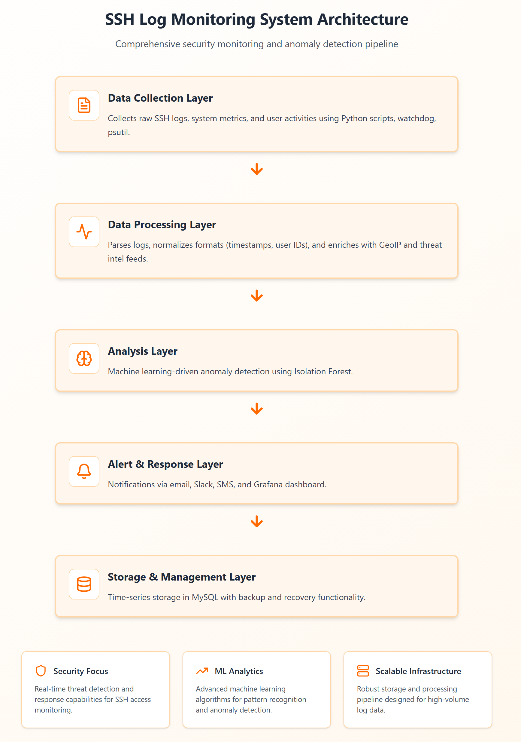
    - Data Collection Layer:
It is the core of the system as it collects raw data. Components Python scripts with libraries such as watchdog and psutil.
- Functionality:
  - Real-time monitoring of SSH authentication logs (/var/log/auth.log, /var/log/secure).
  - Collection of system metrics (CPU, memory, network I/O).
  - History of user activity, such as commands history, and length of stay.
    - Layer of Data Processing:
Unstructured raw logs are converted to structured data that can be analyzed.
- Components: Python with pandas for data manipulation.
- Functionality:
  - Parsing: Parses structured fields (timestamp, user, IP, auth status) out of raw log strings.
  - Normalization: Standardizes data formats (e.g., timestamps to UTC).
  - Enrichment: adds GeoIP to the data supporting source IP addresses and compares with known threat intelligence feeds.
    - Analysis Layer:
This is the middle of the system where detection is made.
- Components: scikit-learn for machine learning.
- Functionality:
  - Feature Extraction: Generates behavioral features based on processed data (e.g., how often a user logs in, how long a user session lasts, etc.).
  - Anomaly Detection Engine: It is based on the use of Isolation Forest which is used to detect outliers on the data on behavior. The model is selected because it is efficient and effective in high dimensional spaces without labeled data.
  - Rule-Based Engine: This is a secondary engine that looks at easy, known-bad rules (e.g. blacklisted IP logins, sensitive commands).
  - Risk Scoring: Determines a risk score to every event by the joint output of the anomaly and rule-based engines.
    - Alert and Response Layer:
Communicates findings to the user.
- Components: Grafana for visualization, Python smtplib and webhooks for notifications.
- Functionality:
  - Notification System: Sends alerts via multiple channels (email, Slack, SMS) based on the severity of the risk score.
  - Dashboard Interface: A pre-configured Grafana dashboard provides real-time visualization of login activity, detected anomalies, geographic trends, and system health.
  - Automated Response (Future Scope): A framework for configurable actions, such as temporarily blocking a suspicious IP address using iptables.
    - Storage and Management Layer:
Manages data and system configuration.
- Components: MySQL database, YAML configuration files.
- Functionality:
  - Time-Series Database: MySQL is used for its robustness, support for time-series data, and advanced indexing, storing all processed logs and alerts.
  - Configuration Management: A simple YAML file allows users to configure log paths, alert thresholds, and notification settings without code changes.
  - Backup and Recovery: Automated daily backups of the database and configuration files ensure system resilience.
  - Alert Notification Process
Alert Notification Process: This process plays a crucial role in the SSH Anomaly Detection System, as it ensures that detected anomalies are promptly notified to system administrators or relevant personnel. This practice enables early identification and response to any potential security threats, especially for SMEs with limited resources.
Figure 2: Alert Notification Process. This illustrates the system’s communication workflow.
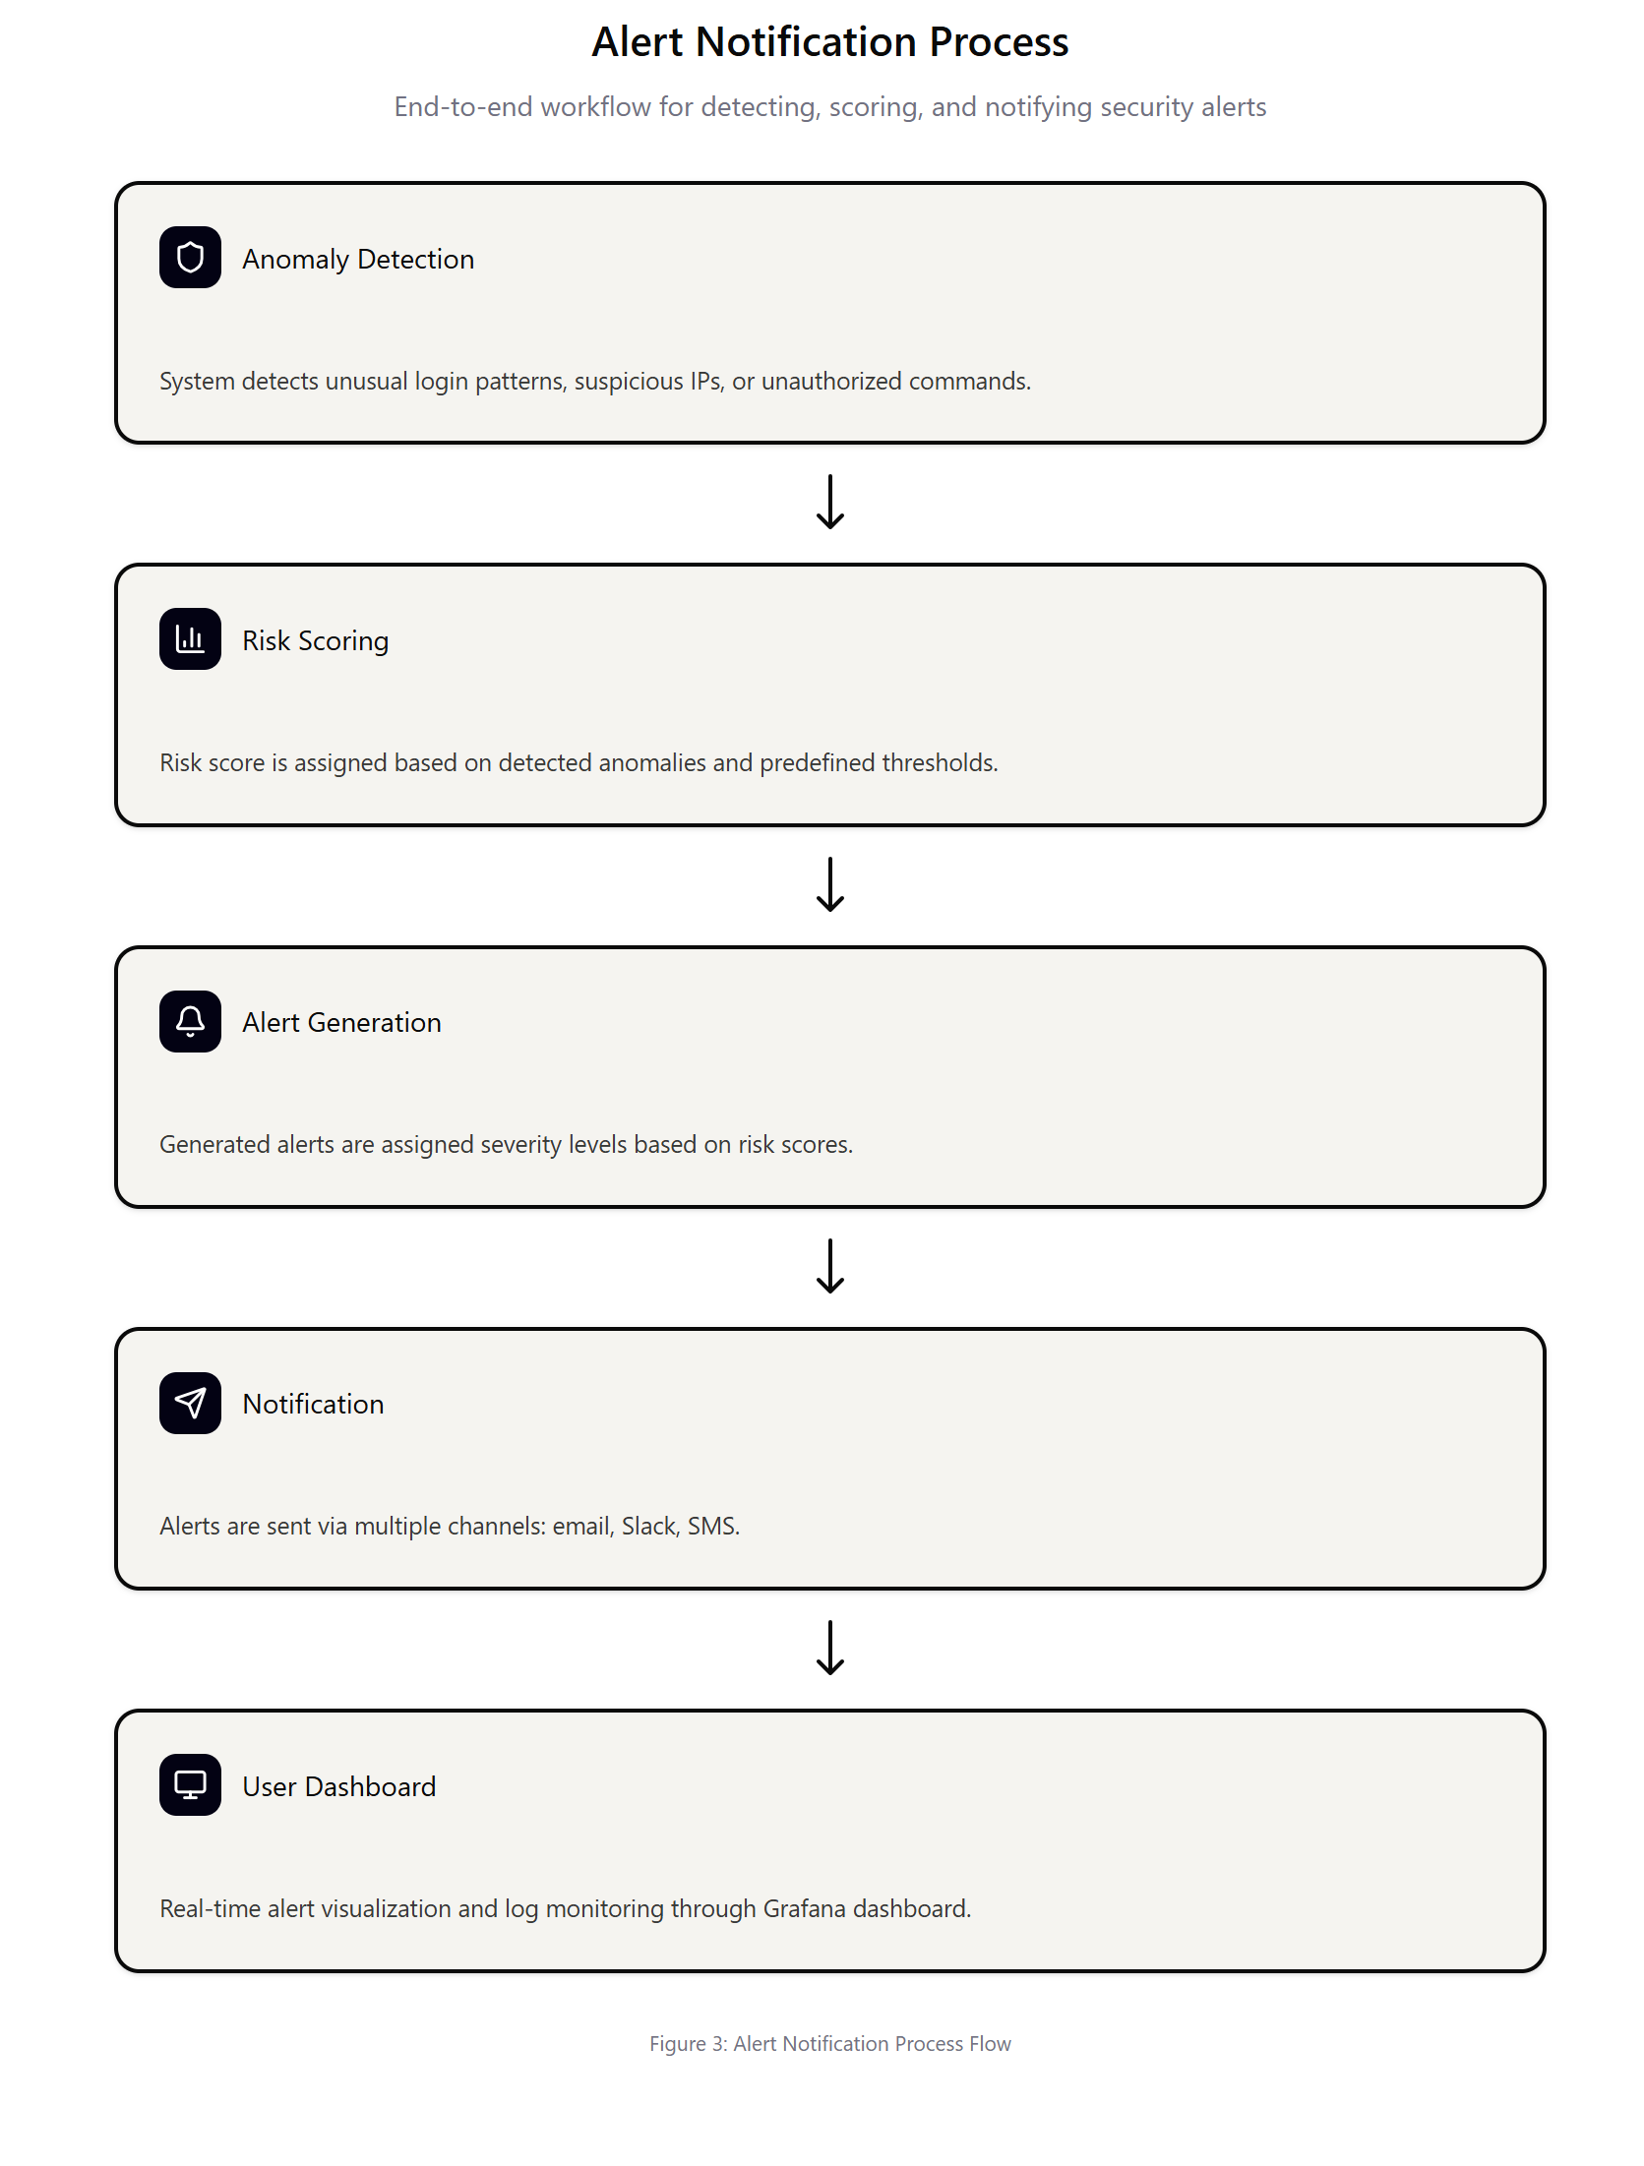

- Detection Layer
Anomaly Detection Engine: This component monitors SSH logs for suspicious activities, such as dubious login attempts, unusual session durations, or command execution. Machine learning algorithms such as Isolation Forest are used to map these anomalies which in turn flag possible attack or misconfiguration scenarios.
- Risk Scoring Layer
Once an anomaly is spotted, a risk score is assigned to the anomaly depending on the severity of the anomaly. The system also considers factors such as the number of failed login attempts, the geographic location of the IP address, and the type of commands being run. This risk score is used to rank the alerts in order of priority and identify what corrective action is required.
- Alert Generation Layer
After the values are scored, an alert is created that matches the severity of the anomaly. Low severity anomalies may lead to informational alerting, whereas high severity anomalies, such as brute force attacks or unauthorized access, will create critical alerts requiring immediate action.
- Notification Layer
Alerts are delivered via multiple channels such as email, SMS and Slack depending on how critical they are. The notification system ensures that the right personnel receive notifications in real-time, allowing for timely communication with the right resource in order to react against potential threats.
- User Dashboard Layer
A real-time dashboard (e.g., Grafana) shows the on-going alert and provides an interface for administrators to immediately respond. Dashboard allows to filter alerts based on the severity, historical results, as well as alerting solutions like blocking IPs, or locking accounts.

  - Technology Stack
The technology stack is composed entirely of mature, well-supported open-source projects.
Table 4: Technology stac
Component | Technology | Justification
Language | Python 3.10+ | Extensive libraries for data science (pandas, scikit-learn), system interaction (psutil), and web hooks. Rapid development cycle.
Database | MySQL 8 + | Superior performance for time-series data, advanced indexing (GIN, GiST), and proven reliability.
ML Framework | scikit-learn | Industry standard for classical machine learning. Provides a robust and efficient implementation of Isolation Forest.
Visualization | Grafana | Powerful, flexible, and industry-standard for time-series visualization. Easily integrates with MySQL. Provides professional dashboards out-of-the-box.
Deployment | Docker/ Shell script auto deployment | Encapsulates the application and its dependencies, ensuring consistent deployment and simplifying installation for non-technical users.

Implementation Details

SSH Log Processing:
This will be a Python service which will continuously check SSH log files. Regular expressions to match new entries are enriched with GeoIP data and sent to the MySQL database.
Figure 3: The processing SSH logs workflow, including real-time file monitoring and database storage.
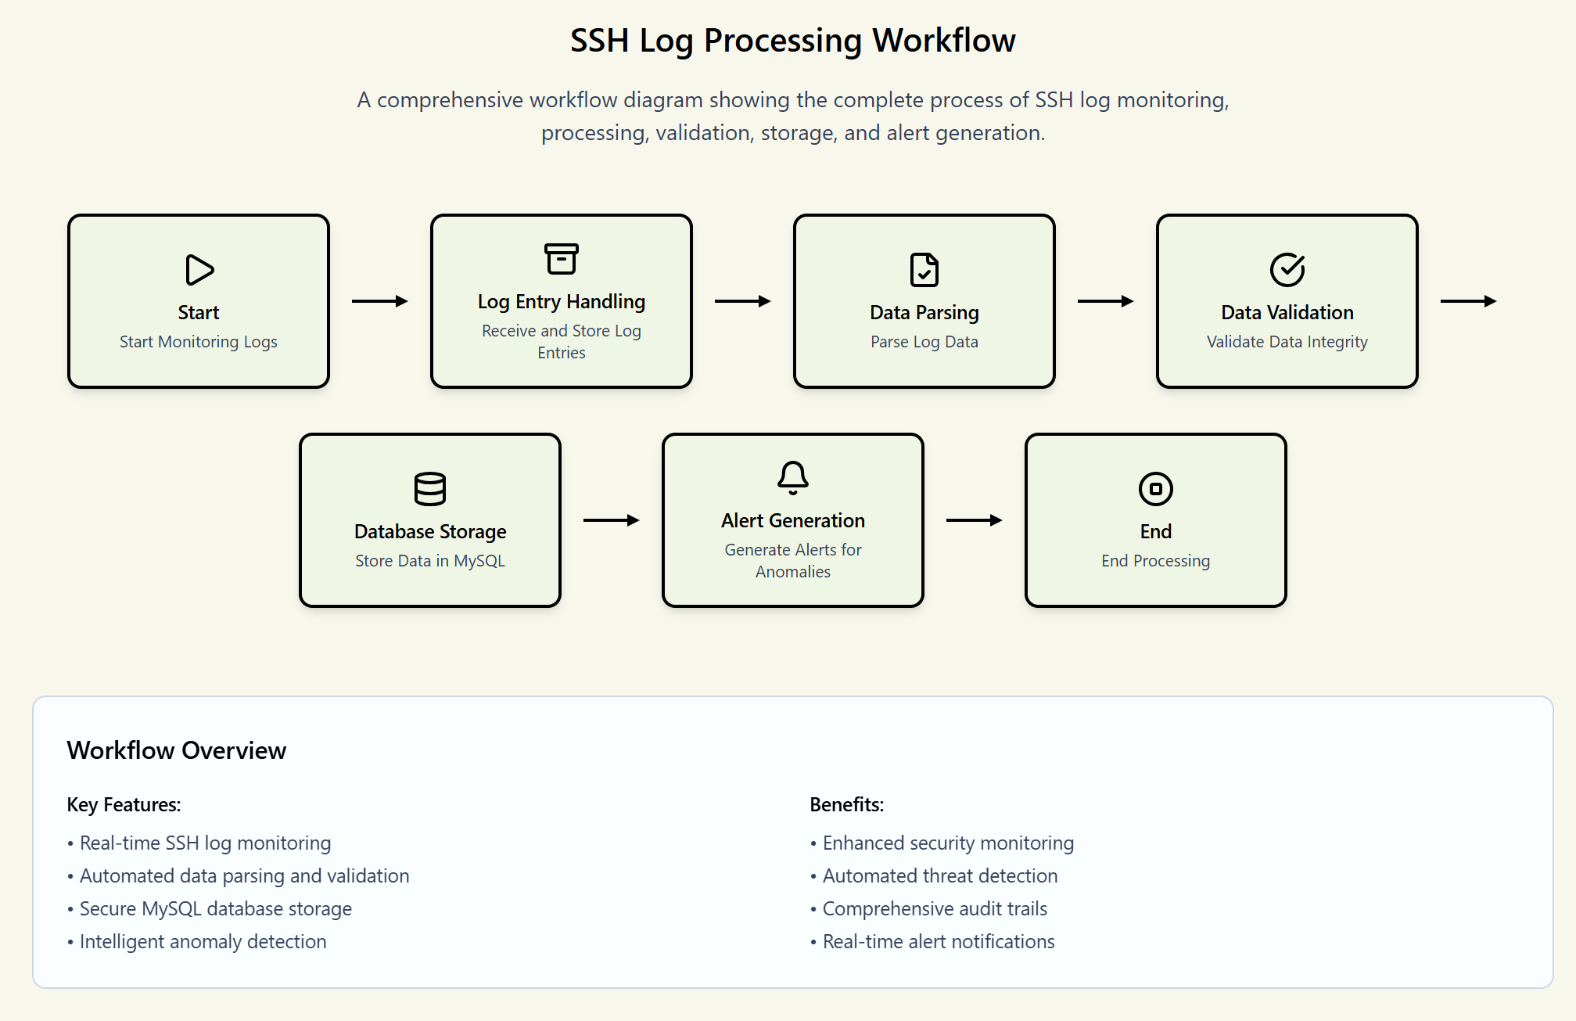

- Real-Time File Monitoring
The process starts by monitoring ssh log files in real time. The system is a script (written in Python) that requires libraries like the watchdog and python-psutil as well as key log files (from where you want to get the logs, e.g. /var/log/auth.log and /var/log/secure) that will be monitored for new log entries. This step helps to keep the system synchronized with the latest activity on the server and to identify any suspicious access attempts or anomalies when they happen.
- Log Entry Handling
Once new entries have been detected the logs are processed and saved for further processing. Each log entry usually includes data items such as time stamp, IP address, user ID and authentication status. As log data is being generated it is being slated in a temporary staging area for later processing and parsing to identify the characteristics from the raw data. This step helps to ensure that all data is correctly captured on incoming data before any transformations are applied.
- Data Parsing
At this stage, the raw log data is parsed in order to retrieve useful information from unstructured log messages. The parsing step extracts usually important fields (such as user, IP address, state of authentication, ...) from the log strings by using regular expressions. This step is important because it allows unstructured log entries to be converted into a structured format suitable for analysis and use in an anomaly detection system.
- Data Normalization
After the parser has run through the data, the format is normalized, so it is consistent. Timestamps are converted over to UTC format, user ID is normalized, and other differences in the data format are resolved. After normalization, the log entries are standardized so that they may be easily compared and analyzed in later stages.
- Data Enrichment
Once the data has been parsed and normalized, it is enriched. In this step the information added to the logs includes some context. For instance, the GeoIP data is appended to the IP addresses in order to determine the geo-registered location of each login attempt. Enrichment can also include taking advantage of threat intelligence feeds to flag known bad IP addresses. This enriched data will add more context to the detection of anomalies and improve the overall analysis process.
- Storage in Database
The enriched data is then stored in a database (such as MySQL) for long term storage and further analysis. The log entries are sent to a time-series database which can then be queried and analyzed efficiently over time. The database schema will be so constituted as to store at least timestamp, user id, IP address, authentication status, risk score, etc., in view of the significance of such data for later analysis and reporting purposes.
- Anomaly Detection
After storage, faults are detected in the data with an approach based on machine learning. The anomaly detection engine uses algorithms like Isolation Forest which detects the behavior that is working in a different way from normal. For instance, if a user was logging in from a different geographic location or if the user tried multiple failed logins within a short period of time, that could be notified as an anomaly. This process helps to focus personnel attention on suspicious and relevant events for further investigation.
- Vigilance - Warning and Response
Once anomalies are identified, they are classified as alerts at various severity levels. High-risk anomalies are converted to critical alerts, which are sent through email, SMS, or Slack for appropriate personnel to address. The alerts are shown on a Grafana dashboard that offers real-time overview and visualization of the SSH log data and anomalies.
    - Database Schema:
The sshlogs table in MySQL will be time partitioned (e.g. month) to maintain high query performance as the data increases. The main rows will consist of timestamp, sourceip, username, authstatus, isanomaly (boolean) and risk_score.
    - Performance Specifications:
- Minimum Requirements: 2 CPU Cores, 4GB RAM, 50GB Storage.
- Target Performance: Process up to 10,000 log events per minute with a detection latency of under 30 seconds on minimum-spec hardware.
  - Methodology
The methodology that will be used in this study is a design-based, quantitative approach to the design and testing of an SSH anomaly detection system. The methodology is organized into 3 phases:
- Data Collection and Preparation,
- System Development and Implementation, and
- Evaluation and Validation.
    - Phase 1: Data Collection and Preparation
The machine learning model is built and tested by using realistic data of high quality. In this respect, two main data sources will be applied:
- Benchmark Dataset: CICIDS2017 will be the main model to use in training and testing. It is open-source and peer-reviewed dataset containing a large range of network traffic, containing labeled SSH brute-force attack data sets (University of New Brunswick, 2017). This gives a standardized and reproducible standard of measuring model performance.
- Simulated Data: In order to complement the benchmark data and test the system against an expanded domain of subtle anomalies, a simulated dataset will be created. The server that will be used to model a typical SME environment is an Ubuntu 22.04 server. The regular user operation (e.g. cron jobs, file transfer, code update, etc.) will be coded and executed during a sequence of weeks to yield an estimate of normal activity. Then, all kinds of anomalous activity are going to be added, such as: Logins at uncharacteristic geographic locations. Logins outside of normal business hours. Sudden increases in failed login attempts from a single IP. Use of sensitive commands by non-administrative users. Unusually long or short session durations.
Pre-processing and anonymization of all the data will ensure privacy protection and features will be designed to be inputted into the machine learning model.
    - Phase 2: System Development and Implementation
After the technical structure as indicated in previous Section, a working prototype of the system will be created. This phase will involve:
- Component Development: Implement the Python scripts of the data collection, processing and analysis layers.
- Database Setup: Setup of the MySQL database, table schema and time-series partitioning.
- Model Training: Model training of the Isolation Forest model with Phase 1 prepared data. To obtain an optimal sensitivity and false positives trade-off, the contamination hyperparameter will be tuned.
- Dashboard and Alerting: Implification of the Grafana dashboard to display important metrics and the email and webhook channels of notification.
- Containerization: Wrapping up the complete application in a Docker container so that it is easy to deploy.
    - Phase 3: Evaluation and Validation
The prototype will be rigorously evaluated using a set of defined metrics to determine its effectiveness, performance and appropriateness in the target environment.
- Evaluation Framework: The evaluation will focus on two main aspects, model performance and system performance.

- Model Performance Evaluation: The trained Isolation Forest model will be evaluated on a held-out set of the CICIDS2017 dataset in conjunction with simulated anomalous data. The following traditional anomaly-detection metrics will be used:
  - Accuracy: The ratio of correctly classified cases (total) relative to the number of total cases.
  - Precision: The fraction of detected anomalies that are true anomalies and thus false-positive rates.
  - Aspirational recall (Sensitivity): The proportion of true anomalies correctly identified (false negatives).
  - F1-Score: A measure obtained by calculating the harmonic mean of precision and recall, which makes it a single metric that balances both issues.
  - Area Under the Receiver Operating Characteristic Curve (AUC-ROC): A metric of the model's ability to discriminate between classes.
  - System Performance Evaluation: The whole system will be implemented on a virtual machine with a minimum requirement of 2 CPU and 4 GB RAM.
  - Resource Utilization: CPU and memory use will be measured across changing load conditions (from idle to processing +10,000 logs/minute) to ensure the system's lightweight nature.
  - Detection Latency: The time that blows from the point at which a log event happens to the point at which an alert is created will be measured.
  - Scalability: The system will be validated to see what the maximum log ingestion rate can be before any performance degradation is felt.
  - Validation: Validation of the results of the evaluation will be made to determine whether the system achieves the main research objectives. Success will be measured in terms of being able to achieve high detection accuracy (F1-Score > 0.90) with low resources and a low false-positive rate, thereby making it viable for deployment in resource constrained SME environments.

CHAPTER 4: IMPLEMENTATION STRATEGY

An effective project must have a strong technical solution but also a plan to undertake it, to manage the risks and measure the success. In this section, a staged implementation plan, risks, and key performance indicators (KPIs) of the proposed system will be presented.

Phased Deployment Plan
The staged implementation will be carried out in four phases that will make it well-planned and manageable so that the development can be iterative and feedback-oriented.
- Phase 1: Foundation Setup (Weeks 1-4): the initial phase aims at building the foundation infrastructure. Things that will be done include feeding the server, hardening the operating system, installing and configuring PostgreQL and Grafana, and writing the initial data collection scripts to scrape and store SSH logs.
- Phase 2: Core Engine Development (Weeks 5-8): The focus shifts to the analysis layer. This includes training the first Isolation Forest model, the logic to score risks, and constructing the simplest alerting engine that sends alerts on the results of the model.
- Phase 3: User Interface and Integration (Weeks 9-12): This level of development is focused on the user-facing elements. Grafana dashboard will be completely set up, multiple channel notifications (email, Slack) will be introduced, and the whole application will be made containerized using Docker to make it easier to deploy.
- Phase 4: Testing and Finalization (Weeks 13-16): The last stage of the plan is to do final testing of the end-to-end system. This involves performance benchmarking, user acceptance testing (UAT) on a sample group, completion of documentation and preparation of final report.

Risk Assessment and Mitigation Strategies
Potential risks have been identified and categorized with corresponding mitigation strategies.
Table 5: Risk Assessment and mitigation strategies
Risk Category | Description | Probability | Impact | Mitigation Strategy
Technical | High False Positive Rate: The ML model generates too many incorrect alerts, leading to alert fatigue and mistrust in the system. | Medium | High | - Tune the Isolation Forest contamination parameter during training.- Implement a feedback mechanism for users to label false positives.- Use an ensemble of models or a secondary rule-based filter.
Technical | Performance Bottlenecks: The system consumes too many resources, impacting the performance of the host server. | Medium | High | - Optimize database queries and ensure proper indexing.- Implement batch processing for log analysis.- Conduct rigorous load testing to identify and fix bottlenecks before deployment.
Operational | Low User Adoption: SME owners find the system too complex to install or interpret, leading to it being ignored. | High | High | - Create a simple, one-command installation script using Docker.- Design the Grafana dashboard with clear, non-technical language.- Provide comprehensive, easy-to-follow documentation and video tutorials.
Data | Insufficient Training Data: Lack of diverse, real-world log data leads to a poorly generalized model. | Medium | High | - Augment the CICIDS2017 dataset with a comprehensive simulated dataset.- Research and incorporate other publicly available anonymized SSH log datasets.- Design the system to continuously learn and adapt from the logs it processes post-deployment.

Success Metrics (KPIs)
The project will be measured against a set of tangible KPIs related to security effectiveness, operational efficiency, and business impact.
- Security Effectiveness:
  - Detection Accuracy (F1-Score): Target > 90% on the benchmark dataset
  - False Positive Rate: Target <5% Simulation environment
  - Mean Time to Detect (MTTD): Target < 5 minutes from event to detection
- Operational Efficiency:
  - System Availability Target > 99.5% uptime
- Resource Utilization: Keep average CPU and memory utilization on a minimum-spec server to < 70% under normal load.
- Deployment Time: Targeted at < 30 minutes for a new installation using the Docker-based script.
- Business Impact (for SMEs):
  - Reduced Admin Overhead: For a reduction of 75% time spent manually reviewing logs
  - Cost-Effectiveness: The overall cost of ownership (hardware + deployment) must be less than 10% of similar commercial solution.

Timeline and Resources
This research project is designed to be completed within a 4-month (16-week) timeframe. The following Gantt chart illustrates the schedule for the major phases and deliverables.
Table 6: Timeline and Resources
Phase | Duration | Key Activities
1. Literature Review & Setup | Weeks 1–2 | Finalise research questions, review SSH vulnerabilities and SME challenges.
2. Data Collection | Weeks 3–6 | Gather and anonymise real/simulated SSH logs; prepare datasets.
3. Tool Design & Development | Weeks 7–10 | Build lightweight SSH anomaly detection tool; configure log-based detection.
4. Testing & Evaluation | Weeks 11–13 | Deploy in SME-like environment; measure accuracy, false positives, resource usage.
5. Final Report & Submission | Weeks 14–16 | Compile results, write report, prepare for oral defence.
  - Key Milestones:
- Week 4: Completion of literature review and data preparation.
- Week 8: Functional prototype of the analysis engine is complete.
- Week 12: Fully integrated system with dashboard and alerting is ready for testing.
- Week 14: Completion of all testing and evaluation.
- Week 16: Final research report submitted.
  - Gantt Chart:
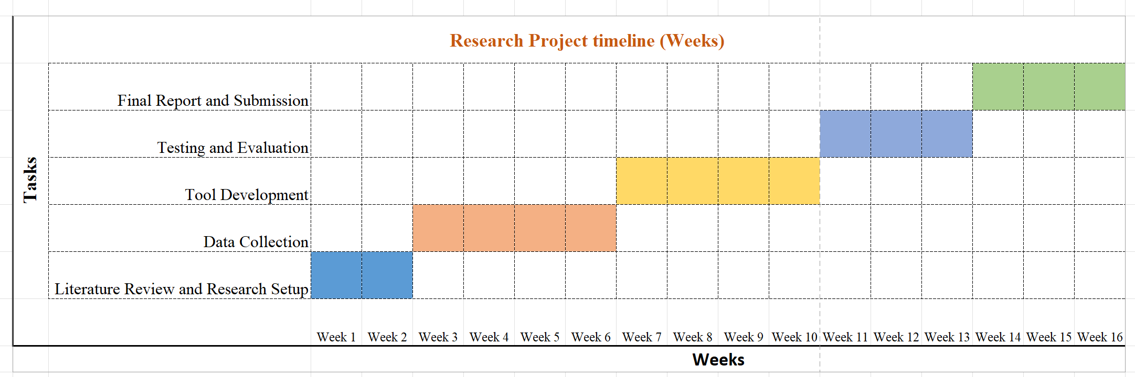
  - Required Resources:
- Hardware: A cloud-based Virtual Private Server (VPS) with the following specifications: 4 CPU Cores, 8GB RAM, 100GB SSD Storage. This will serve as the development and testing environment.
- Software: All software used will be open-source, including Ubuntu Server, Python, MySQL, Grafana, and Docker.
- Datasets: Access to the public CICIDS2017 dataset.
- Personnel: The research will be conducted by the principal investigator with guidance from the academic supervisor.

Expected Outcomes and Significance
This research will yield important results that cater to an important and unserved area of cybersecurity with tangible benefits to the South Asian SME community and valuable additions to the academic body of knowledge.
    - Expected Outcomes
- Functional lightweight SSH Anomaly Detection Tool: The main deliverable will be a production ready, free and open source tool that will be containerised with Docker for easy deployment. The tool will perform real-time monitoring and alerting on SSH activity on Linux servers, and is optimized for low-resource environments.
- Comprehensive Technical Documentation: The project will result in comprehensive technical documentation, including system architecture diagrams, database schemata, and API specifications. This model will become a template for other developers or organizations who want to create their own lightweight security monitoring solutions.
- An Evaluation Report Based on Recent Research: A comprehensive report will be generated describing the performance of the system against the CICIDS2017 benchmark data. This will give empirical evidence on the effectiveness of the tool, including quantified measures of accuracy, precision, recall and resource consumption.
- Implementation Guide for SMEs: A functional manual will be developed to guide the non-technical users through the installation, configuration and day-to-day use of the tool. This guide is very important in ensuring that the tool is accessible for and embraced by the intended audience.

  - Budget And Resource Allocation
The project is developed to be extremely cost-effective and uses open-source technologies to ensure the lowest possible financial outlay. The total budget is designed to address only the bare minimum development, test and documentation resources required for products. All figures are approximate in US Dollars ($).

    - Personnel Costs
Most of the work will be done by the principal investigator. A small budget for a technical consultant to ensure robustness and for validation purposes is included.
Table 7: Personnel Costs
Item | Description | Hours | Rate ($) | Total ($) | Rationale
Principal Investigator | Research, system design, development, testing, and report writing. | 320 | 25 | 8,000 | Stipend for dedicated work over the 16-week project timeline (40 hrs/week).
Technical Consultant | Independent peer review of the ML model and security architecture. | 20 | 50 | 1,000 | Expert validation to ensure methodological soundness and robustness.
 |  |  | Subtotal: | $9,000

    - Hardware & Software Costs
Cloud-based infrastructure is going to be used for the development and testing to assure reproducibility and to mimic the real-world deployment environment.

Table 8: Hardware & Software Costs
Item | Description | Duration | Unit Cost | Total (USD) | Justification
Cloud VPS (Dev/Test) | 4 vCPU, 8GB RAM, 100GB SSD Storage. | 4 months | $30 / month | $120 | Primary environment for development, testing, and performance benchmarking.
Cloud VPS (Staging) | 2 vCPU, 4GB RAM, 50GB SSD Storage. | 2 months | $15 / month | $30 | A "minimum-spec" server to validate performance claims under constrained conditions.
 |  |  | Subtotal: | $150
Software | All primary software (Python, MySQL, Grafana, Docker) is open-source. | - | $0 | $0 | No licensing fees required.

    - Contributions In-Kind & Cost Sharing
This project has in-kind contributions that bring a substantial value to the project in reducing the project's financial cost:
- Academic Supervision: Academic supervision will be given by the academic supervisor in his/her institutional capacity.
- Software Licenses: The use of Ubuntu, Python, and other open-source tools is a significant cost avoidance.
- Datasets: CICIDS2017 dataset is freely available

This budget proves that a highly advanced, machine learning-enabled security system can be built and implemented for a fraction of the cost of a commercial enterprise solution that directly caters to the budget limitations of South Asian SMEs. The total cost of ownership for an SME would just be a server hardware minimum to run the tool, which is already a sunk cost for most businesses.

Significance of the Research
The importance of this project goes beyond academic, economic and social spheres.
- Academic Significance: Bridging Theory and Practice: This research is a bridge between theoretical/state-of-the-art anomaly detection models and the practical deployment constraints of real-world resource-constrained environments. It is about being objective about a solution which is not only correct but practically feasible.
  - Applied Machine Learning
  - This paper presents a concrete case study on how the algorithm Isolation Forest may be used for a specific cybersecurity problem and adds to the body of knowledge on lightweight machine learning for security. Open-Source Contribution
  - By releasing a fully open-source tool and framework, this research offers a platform for other researchers to build upon, test, and improve.
- Economic and Social Significance: SME Resilience Boost: With an accessible and cost-effective security solution, the project goes directly towards bolstering the cybersecurity posture of SMEs, which form the backbone of South Asian economies. If these businesses are protected from devastating cyberattacks, jobs can be saved and the economy can remain stable.
  - Democratizing Cybersecurity: This work prompts a challenge to the idea that good cybersecurity is only for large enterprises with deep pockets. It shows that robust security monitoring can be done using open source tools with intelligent design and within the reach of a significantly larger audience.
  - Reducing the Impact of Cybercrime: A widely used and effective tool can greatly decrease the success rate of SSH-based attacks in the region, reducing the financial losses and operational disruptions caused by cybercrime. This helps make the digital environment safer and more reliable for everyone.
In conclusion, this research is not just a technical exercise; it is an effort to develop a practical, high-impact solution to a critical real-world problem, and make a positive impact on the digital future of small businesses in South Asia, more secure and resilient.

CHAPTER 5: CONCLUSION

  - Conclusion
This research proposal describes a critical and timely effort to design a lightweight, open source SSH anomaly detection system suitable for the SMEs of South Asia, which have known limitations. By using machine learning and log analysis, the proposed system aims at offering an affordable, automated, and effective cybersecurity solution that closes the gap between cutting-edge academic research and practical, real-world deployment.
The growing threat landscape, coupled with the critical constraints in terms of both resources and awareness on the part of SMEs, makes such a tool all the more critical. Thereby, this project will lead to a working prototype, but also to comprehensive documentation and implementation guidelines for accessibility and adoption, based on a systematic approach to data collection, system development, and rigorous evaluation.
Ultimately, this research is anticipated to equip SMEs with capabilities to more effectively protect themselves from the looming SSHD-based attacks and therefore the resilience of their operations to ensure a positive contribution to the regional economy at large. The findings of this work will not only contribute to the academic literature on practical lightweight cybersecurity solutions, but also will form the basis of future developments for SME-based threat detection.
  - Future Work
Several directions for further investigation and development emerge from this proposal:
- Adaptive Learning Mechanisms: Future iterations could incorporate incremental or online learning techniques, allowing the model to update its understanding of normal behavior over time without requiring full retraining. This would enhance adaptability to evolving user patterns and emerging threats.
- Multi-Protocol Support: Expanding the detection framework to include other common administrative and network protocols such as RDP (Remote Desktop Protocol) and HTTP/S would offer a more comprehensive security monitoring solution suitable for diverse IT environments.
- Automated Response Integration: While the current system focuses on detection and alerting, subsequent phases could explore lightweight automated responses--such as temporary IP blocking, session termination, or user account suspension--based on configurable risk thresholds.
- Real-World Deployment Studies: Field testing within actual SME environments across South Asia will be essential to validate usability, performance, and effectiveness. Such studies could also gather qualitative feedback to refine user experience and operational integration.
These pathways hold promise for extending the impact and applicability of the proposed system, ultimately contributing to a more secure and resilient digital ecosystem for SMEs.

REFERENCES

Aakrsht. (2022). Implementing and analysing Cowrie honeypot system. Medium. Retrieved from https://aakrsht.medium.com/implementing-and-analysing-cowrie-honeypot-system-fbaa0c1798ff
Cyber Peace Institute. (2024). From Vulnerability to Resilience: Cybersecurity Challenges for MSMEs in the APAC Region. Retrieved from https://cyberpeaceinstitute.org/wp-content/uploads/2024/11/From-Vulnerability-to-Resilience_APAC-Region.pdf
Dahal, S. (2025). SSH vulnerabilities and how to protect against them. GetAstra.
Fortinet. (2024). 2024 Cybersecurity Skills Gap Report. Retrieved from https://www.fortinet.com/content/dam/fortinet/assets/reports/2024-cybersecurity-skills-gap-report.pdf
Foster, L. (2022). Anomaly detection in system logs using machine learning. Medium. Retrieved from https://medium.com/@lfoster49203/anomaly-detection-in-system-logs-using-machine-learning-scikit-learn-pandas-b7e893ad0a95
ICCK Transactions on Cybersecurity. (2025). AI-Driven Intrusion Detection System Using SSH Honeypots. Retrieved from https://www.icck.org/article/abs/tc.2025.521799
Institute for Defence Studies and Analyses (IDSA). (2025). Major Events and Trends in Cybersecurity in 2024. Retrieved from https://www.idsa.in/wp-content/uploads/2025/01/ICCOE_Report_2024.pdf
INTERPOL. (2024). Asia and South Pacific Cyberthreat Assessment Report 2024. Retrieved from https://www.interpol.int/content/download/22308/file/Asia%20and%20South%20Pacific%20Cyberthreat%20Assessment%20Report%202024-4.pdf
Journal of Small Business and Enterprise Development. (2023). Cybersecurity adoption in SMEs: A study of the Nepalese service sector.
Keytos. (2023). What are the most common SSH vulnerabilities?.
Milvus. (2023). What metrics are used for anomaly detection performance?. Retrieved from https://milvus.io/ai-quick-reference/what-metrics-are-used-for-anomaly-detection-performance
Nature. (2025). An optimized LSTM-based deep learning model for anomaly detection in network traffic. Retrieved from https://www.nature.com/articles/s41598-025-85248-z
Prime InfoServ. (2025). India’s SME Cybersecurity Crisis: Real Incidents, Real Lessons (2024–2025). Retrieved from https://primeinfoserv.com/indias-sme-cybersecurity-crisis-real-incidents-real-lessons-2024-2025/
ResearchGate. (2022). Cybersecurity issues and challenges for small and medium enterprises (SMEs) in Sri Lanka.
RunCloud. (2024). What is Fail2Ban with setup & configuration?.
SigNoz. (2025). SSH Logs: Complete Guide to Security Monitoring and Analysis. Retrieved from https://signoz.io/guides/ssh-logs/
UNDP. (2023). Bhutan Digital Development and Transformation Strategy.
University of New Brunswick. (2017). Intrusion detection evaluation dataset (CIC-IDS2017). Retrieved from https://www.unb.ca/cic/datasets/ids-2017.html
Verizon. (2025). 2025 Data Breach Investigations Report. Retrieved from https://www.verizon.com/business/resources/Tea/reports/2025-dbir-data-breach-investigations-report.pdf
Wazuh. (2023). Enhancing IT Security with Anomaly Detection. Retrieved from https://wazuh.com/blog/enhancing-it-security-with-anomaly-detection/

