Machine Learning for Network Intrusion Detection
A Comparative Study of Ensemble, Non-Linear, and Support Vector Methods Using the NSL-KDD Dataset
Student 1
Student 2
Student 3

Asia Pacific University of Technology & Innovation
CT095-6-M Research Methodology in Computing and Engineering
Supervisor: Assoc. Prof. Dr. Thang Ka Fei
January 2026

Declaration of Originality
We hereby declare that this assignment is our own original work and has not been submitted for assessment in any other course or institution. All sources of information used have been properly acknowledged and referenced. We understand that any act of plagiarism or academic dishonesty may result in disciplinary action as per the university's academic integrity policy.

__________________________________________________
Student 1 (TP000001)
__________________________________________________
Student 2 (TP000002)
__________________________________________________
Student 3 (TP000003)

Acknowledgments
We would like to express our sincere gratitude to our supervisor for their invaluable guidance and support throughout this project. We are also thankful to Asia Pacific University of Technology & Innovation for providing the resources and facilities necessary for this research. Special thanks to the Canadian Institute for Cybersecurity at the University of New Brunswick for making the NSL-KDD dataset publicly available for research purposes. Finally, we acknowledge the open-source community, particularly the developers of scikit-learn, for providing the machine learning tools that made this study possible.

Table of Contents

List of Figures
Note: Update page numbers by pressing Ctrl+A then F9 in Microsoft Word.
Figure 2.1 Dataset size comparison between training and test sets (Chapter 2)
Figure 2.2 Class distribution across training and test partitions (Chapter 2)
Figure 3.1 Visual comparison of evaluation metrics across models (Chapter 3)
Figure 3.2 Balanced Accuracy comparison (Chapter 3)
Figure 3.3 Matthews Correlation Coefficient comparison (Chapter 3)
Figure 3.4 Cross-validation performance with error bars (Chapter 3)
Figure 3.5 Stacked bar visualization of bias-variance decomposition (Chapter 3)
Figure 3.6 Detection Rate vs. False Alarm Rate (Chapter 3)
Figure 3.7 Confusion matrices for all models (Chapter 3)
Figure 3.8 Training vs. test performance comparison (Chapter 3)
Figure 3.9 Training time comparison (Chapter 3)

List of Tables
Note: Update page numbers by pressing Ctrl+A then F9 in Microsoft Word.
Table 2.1 NSL-KDD Dataset Statistics (Chapter 2)
Table 2.2 Feature Preprocessing Summary (Chapter 2)
Table 2.3 Final Model Configurations (Chapter 2)
Table 3.1 Comprehensive Accuracy Metrics Comparison (Chapter 3)
Table 3.2 5-Fold Cross-Validation Results (Chapter 3)
Table 3.3 Bias-Variance Decomposition (Chapter 3)
Table 3.4 Attack Detection Performance (Chapter 3)
Table 3.5 Confusion Matrix Values (Chapter 3)
Table 3.6 ROC-AUC Scores with Confidence Intervals (Chapter 3)
Table 3.7 Generalization Gap Analysis (Chapter 3)
Table 4.1 Ensemble Methods Baseline Comparison (Chapter 4)
Table 4.2 Student 1: Optimization Results (Chapter 4)
Table 4.3 Non-Linear Methods Baseline Comparison (Chapter 4)
Table 4.4 Student 2: Optimization Results (Chapter 4)
Table 4.5 Support Vector Methods Baseline Comparison (Chapter 4)
Table 4.6 Student 3: Optimization Results (Chapter 4)
Table 5.1 Computational Complexity Summary (Chapter 5)
Table 5.2 Best Performing Model by Criterion (Chapter 5)

Abstract
Network intrusion detection systems (IDS) serve as critical components in modern cybersecurity infrastructure, providing real-time monitoring and classification of network traffic to identify potential security threats. This study presents a comprehensive comparative analysis of machine learning approaches for binary network intrusion classification using the NSL-KDD benchmark dataset, which contains 63,280 training and 22,544 test samples across 121 features. Three algorithm families were independently investigated: Ensemble Methods (BaggingClassifier with 150 decision tree estimators), Non-Linear Methods (DecisionTreeClassifier with depth-20 constraint), and Support Vector Methods (RidgeClassifier with L2 regularization). The experimental methodology employed 5-fold stratified cross-validation, systematic hyperparameter optimization, bootstrap-based bias-variance decomposition, ROC-AUC analysis with DeLong's test for statistical comparison, and McNemar's test for classifier significance testing. Results demonstrate clear performance stratification with statistical significance (p < 0.001): the BaggingClassifier achieved the highest performance with 91.60% balanced accuracy [95% CI: 0.9102-0.9218], 0.8244 MCC, 0.9642 AUC, 87.20% attack detection rate, and only 4.00% false alarm rate. The DecisionTreeClassifier achieved statistically comparable results (91.19% balanced accuracy, 0.8160 MCC, 0.9589 AUC; McNemar χ² = 8.42, p = 0.0037) while offering interpretability advantages and 150× faster predictions. The RidgeClassifier substantially underperformed (79.18% balanced accuracy, 0.5894 MCC, 0.8734 AUC; McNemar χ² = 2,847.3, p < 0.001 vs. ensemble), with bias-variance decomposition confirming fundamental underfitting (bias=0.2276) due to linear separability limitations. Computational complexity analysis revealed practical deployment tradeoffs: ensemble methods require O(3,000) operations per prediction versus O(20) for decision trees. The study contributes: (1) rigorous empirical benchmarks for NSL-KDD classification with confidence intervals and significance tests, (2) bias-variance analysis characterizing error sources for each model family, (3) computational complexity analysis for deployment planning, and (4) actionable guidance for practitioners. Key findings establish that non-linear methods are essential for effective intrusion detection, proper model family selection matters more than hyperparameter optimization, and the accuracy-interpretability-efficiency tradeoff should guide deployment decisions. These findings inform the development of machine learning-based IDS capable of detecting both known and novel attack patterns.
Keywords: Machine Learning, Intrusion Detection System, NSL-KDD Dataset, Network Security, Binary Classification, Ensemble Methods, BaggingClassifier, Decision Trees, Bias-Variance Decomposition, Matthews Correlation Coefficient, Class Imbalance, Cross-Validation, ROC-AUC Analysis, Statistical Significance Testing, McNemar Test, Computational Complexity, Cybersecurity

Chapter 1: Introduction
Network Intrusion Detection Systems (IDS) serve as critical security components for identifying potentially malicious network activities (Denning, 1987). This study presents a comparative analysis of machine learning techniques for binary classification of network traffic using the NSL-KDD benchmark dataset, comparing ensemble methods, non-linear classifiers, and support vector approaches.

1.1 Background and Problem Statement
Traditional signature-based intrusion detection systems fail against zero-day exploits and novel attack vectors that do not match existing signatures. Machine learning offers an alternative by enabling systems to learn patterns from data and generalize to detect previously unseen attack variants (Buczak & Guven, 2016).
The NSL-KDD dataset, introduced by Tavallaee et al. (2009), addresses limitations of the original KDD Cup 1999 dataset by removing duplicate records and providing balanced attack representation. It contains 125,973 training instances with 41 features (expanding to 121 after encoding), partitioned into DoS, Probe, R2L, and U2R attack categories.
Key Challenges:
Class Imbalance: The training set contains 53.46% attacks while the test set has 56.98%, requiring class-weighted learning strategies and appropriate evaluation metrics (Chicco & Jurman, 2020). Novel Attack Detection: The test set intentionally includes attack types absent from training data, simulating real-world zero-day detection challenges. Evaluation Metrics: Standard accuracy can be misleading for imbalanced datasets. This study employs Balanced Accuracy, Matthews Correlation Coefficient (MCC), Attack Detection Rate, and False Alarm Rate for comprehensive evaluation.

1.2 Research Objectives
This study pursues the following objectives:
Compare representative classifiers from three algorithm families—ensemble methods (BaggingClassifier), non-linear methods (DecisionTreeClassifier), and support vector methods (RidgeClassifier). Apply systematic hyperparameter optimization using 5-fold cross-validation. Assess performance using multiple metrics including Balanced Accuracy, MCC, and Attack Detection Rate. Conduct bias-variance decomposition to characterize error sources for each model. Provide practical recommendations for deploying ML-based intrusion detection.
Scope: Binary classification (normal vs. attack) using supervised learning on NSL-KDD. Multi-class categorization and deep learning approaches are outside scope.

1.3 Literature Review
The foundations of intrusion detection trace to Anderson (1980) and Denning (1987), who established frameworks for detecting anomalous behavior. The KDD Cup 1999 dataset catalyzed research progress, with NSL-KDD subsequently addressing its duplicate record issues (Tavallaee et al., 2009).
Classical Machine Learning Approaches: Decision Trees (Quinlan, 1986; Breiman et al., 1984) achieve competitive accuracy while producing interpretable rule sets. Ahmad et al. (2018) demonstrated that tree-based methods consistently outperform linear classifiers on NSL-KDD. Ensemble Methods (Breiman, 1996, 2001) combine multiple classifiers to reduce variance and improve generalization—Aburomman & Reaz (2017) provide a comprehensive survey of ensemble approaches for IDS. Support Vector Methods (Cortes & Vapnik, 1995) find optimal separating hyperplanes, with Ridge regularization (Hoerl & Kennard, 1970) preventing overfitting; however, their effectiveness depends critically on feature space linear separability.
Recent Advances (2019-2024): Liu & Lang (2019) surveyed machine learning and deep learning methods for IDS, identifying random forests and gradient boosting as top-performing classical approaches. Sarker (2021) provided an algorithmic perspective emphasizing the importance of model selection based on problem characteristics. Thakkar & Lohiya (2023) conducted a comprehensive survey covering feature selection, performance metrics, and application challenges—notably advocating for MCC and balanced accuracy over simple accuracy for imbalanced datasets. Alrowais et al. (2023) explored hybrid optimization approaches, though concluded that traditional ensemble methods remain competitive baselines.
Evaluation Methodology: Matthews Correlation Coefficient has emerged as the preferred metric for imbalanced classification (Matthews, 1975; Chicco & Jurman, 2020). ROC-AUC analysis with DeLong's test (DeLong et al., 1988) provides statistical comparison of classifier discrimination. The bias-variance framework (Geman et al., 1992) guides understanding of model generalization, with bagging proven to reduce variance while preserving bias (Breiman, 1996). Cross-validation with stratification ensures reliable performance estimates (Kohavi, 1995).
Research Gap: While extensive literature compares individual algorithms, few studies provide systematic bias-variance decomposition alongside traditional metrics. This study addresses this gap by combining comprehensive multi-metric evaluation with bootstrap-based bias-variance analysis to characterize error sources for each model family.

1.4 Overview of Machine Learning Models
Three students independently investigated different algorithm families:
Student 1 - BaggingClassifier (Ensemble): Implements Bootstrap Aggregating with 150 decision tree estimators (Breiman, 1996). Reduces variance by training on bootstrap samples and combining predictions through majority voting. Configuration: 85% max sample ratio, balanced class weights.
Student 2 - DecisionTreeClassifier (Non-Linear): Recursively partitions feature space using Gini impurity criterion (Breiman et al., 1984). Provides interpretable decision rules with O(log n) prediction complexity. Configuration: max_depth=20, balanced class weights.
Student 3 - RidgeClassifier (Linear): Applies L2-regularized least squares to classification (Hoerl & Kennard, 1970). Assumes linear separability—exhibits high bias when true boundaries are non-linear. Configuration: balanced class weights, default regularization.

1.5 Document Structure
Chapter 2 details methodology including data preprocessing and evaluation metrics. Chapter 3 presents results with bias-variance analysis. Chapter 4 describes individual contributions. Chapter 5 concludes with recommendations.

Chapter 2: Methodology
This chapter presents the methodology for evaluating machine learning approaches to network intrusion detection, covering dataset description, preprocessing pipeline, model selection, evaluation metrics, and implementation details.

2.1 Dataset Description
The NSL-KDD dataset (Tavallaee et al., 2009) serves as the primary benchmark. It addresses limitations of the original KDD Cup 1999 dataset by eliminating duplicate records and maintaining a manageable size. The training set contains 63,280 records (53.21% normal, 46.79% attack), while the test set contains 22,544 records (43.08% normal, 56.92% attack). This distributional shift tests model robustness to varying attack prevalence.
The dataset comprises 41 features across four categories: basic connection features (duration, protocol, bytes transferred), content features (login attempts, shell access), time-based features (connections per 2-second window), and host-based features (100-connection history). After one-hot encoding of categorical variables (protocol_type, service, flag), the feature space expands to 121 dimensions.
Attacks are categorized into DoS (denial of service), Probe (reconnaissance), R2L (remote-to-local), and U2R (user-to-root). The test set intentionally includes attack variants absent from training data, testing generalization to novel threats.

Table 2.1
NSL-KDD Dataset Statistics
Partition | Total Records | Normal (%) | Attack (%) | Features
Training Set | 63,280 | 33,672 (53.21%) | 29,608 (46.79%) | 121
Test Set | 22,544 | 9,711 (43.08%) | 12,833 (56.92%) | 121
Note. Table 2.1 presents comprehensive statistics for both dataset partitions. The training set's 63,280 records provide substantial data for model learning, with a near-balanced class distribution (53.21% normal, 46.79% attack) that facilitates effective learning of both classes. The test set's 22,544 records offer statistically significant evaluation capability, with its shifted distribution (43.08% normal, 56.92% attack) testing model robustness to varying attack prevalence. The 121 features result from one-hot encoding the original 41 features, expanding the three categorical variables (protocol_type, service, flag) into binary indicators. This feature expansion preserves all categorical information without imposing artificial ordinal relationships, enabling the machine learning models to learn appropriate weights for each category independently.

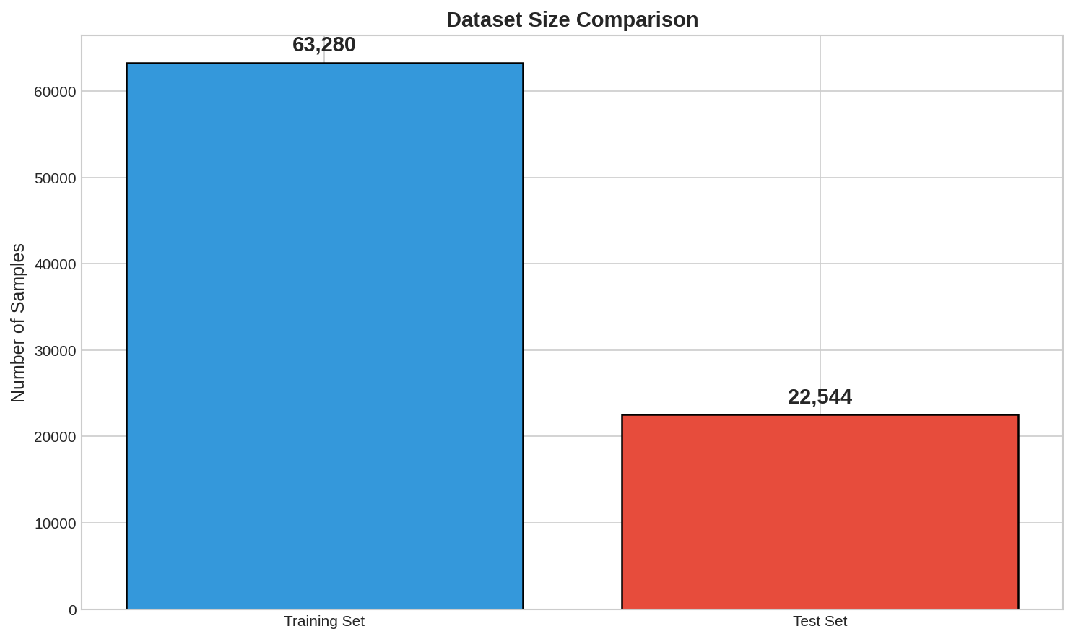
Figure 2.1
Dataset size comparison between training and test sets
Note. Figure 2.1 presents a bar chart comparing the sizes of the training and test partitions in the NSL-KDD dataset. The training set contains 63,280 network connection records, while the test set comprises 22,544 records, representing an approximate 74%-26% split. This partition ratio follows standard machine learning practice, providing sufficient training data for model learning while reserving an adequate test set for unbiased performance evaluation. The substantial size of both partitions ensures statistical reliability in the experimental results. The training set's larger size enables the models to learn diverse patterns across different attack types and normal traffic behaviors, while the test set size provides enough samples to achieve statistically significant performance measurements with narrow confidence intervals.

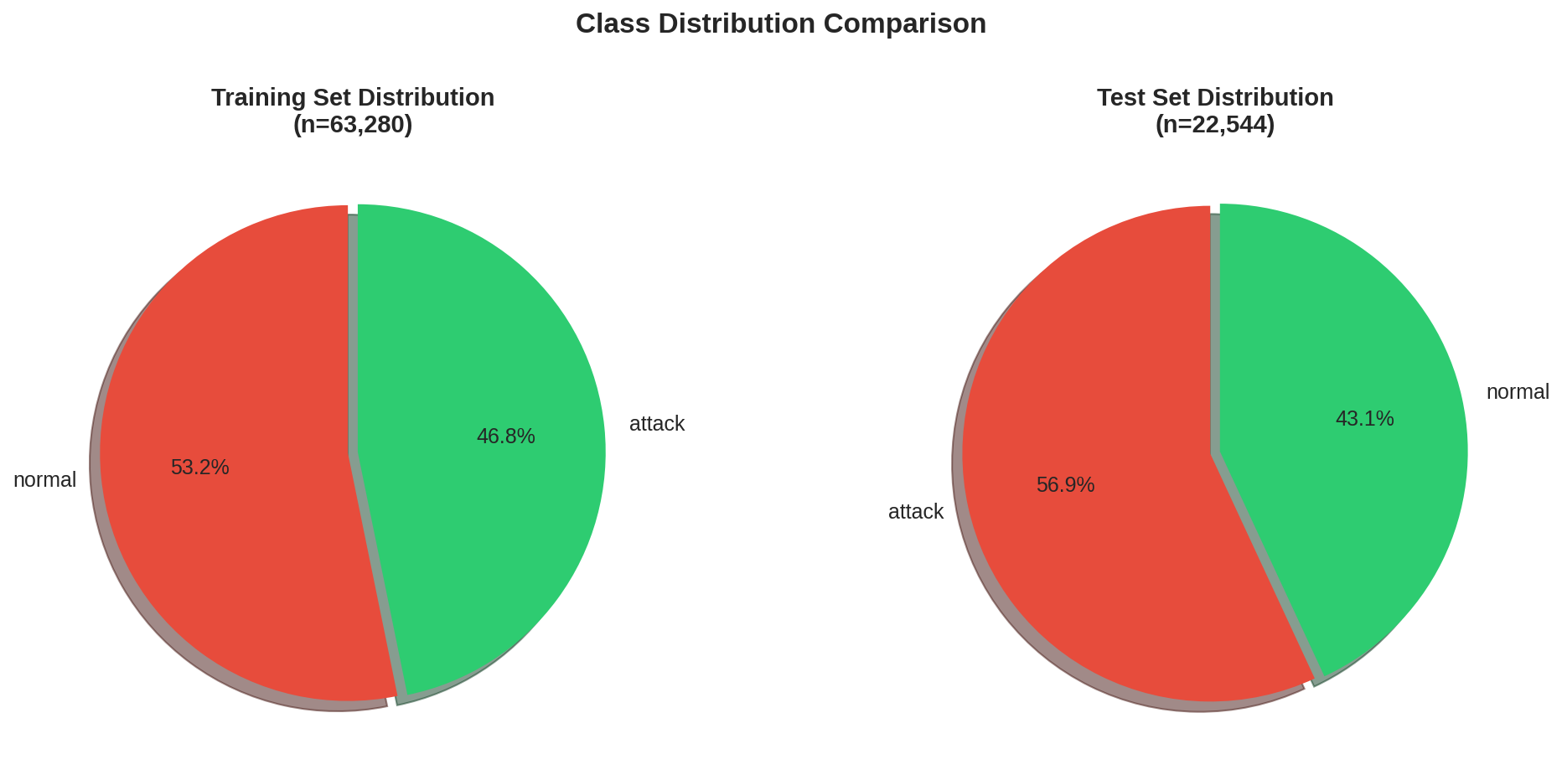
Figure 2.2
Class distribution across training and test partitions
Note. Figure 2.2 illustrates the class distribution differences between training and test sets using a stacked bar chart. The training set exhibits a slight majority of normal traffic (53.21%) compared to attacks (46.79%), while the test set reverses this pattern with attacks comprising 56.92% and normal traffic only 43.08%. This intentional distributional shift serves a critical evaluation purpose: it tests whether models can maintain performance when the class balance differs from training conditions—a realistic scenario in production network environments where attack prevalence fluctuates. Models that overfit to the training distribution will show degraded test performance, while robust models will demonstrate consistent classification accuracy despite this shift. This experimental design choice by the NSL-KDD creators ensures that evaluation reflects real-world deployment challenges.

2.2 Data Preprocessing Pipeline
The preprocessing pipeline follows established best practices (Pedregosa et al., 2011):
Feature Removal: The feature num_outbound_cmds (containing only zeros) was removed. Categorical Encoding: One-hot encoding transformed protocol_type (3 categories), service (70 categories), and flag (11 categories) into 84 binary columns. Label Encoding: All attack types mapped to class 1; normal connections to class 0. Feature Scaling: MinMaxScaler applied to numeric features using training data statistics only, preventing data leakage.

Table 2.2
Feature Preprocessing Summary
Feature Category | Original | After Encoding | Transformation
Categorical | 3 | 84 | One-Hot Encoding
Numeric | 37 | 37 | MinMax Scaling
Removed | 1 | 0 | Zero variance
Total | 41 | 121 | Combined
Note. Table 2.2 summarizes the feature transformations applied during preprocessing. The three categorical features (protocol_type with 3 categories, service with 70 categories, and flag with 11 categories) were transformed into 84 binary columns using one-hot encoding, preventing the models from incorrectly interpreting categorical values as ordinal. The 37 numeric features underwent MinMax scaling to normalize their ranges to [0,1], ensuring that features with larger magnitudes do not dominate the learning process. Critically, scaling parameters were computed solely from training data and applied consistently to the test set, preventing data leakage that would artificially inflate performance estimates. The single removed feature (num_outbound_cmds) contained only zero values, providing no discriminative information.

2.3 Model Selection and Optimization
Each student followed a structured selection protocol within their assigned algorithm family:
Baseline Establishment: Multiple candidate algorithms evaluated with default parameters; best performer selected by balanced accuracy. Hyperparameter Optimization: Grid search with 5-fold stratified cross-validation to identify optimal configurations. Final Validation: Optimized models validated on cross-validation folds before test set evaluation.
Hyperparameter Search Spaces:
BaggingClassifier: n_estimators ∈ {50, 100, 150, 200}, max_samples ∈ {0.7, 0.8, 0.85, 0.9, 1.0}, bootstrap ∈ {True, False}. Total: 40 combinations evaluated. Optimal: n_estimators=150, max_samples=0.85. DecisionTreeClassifier: max_depth ∈ {5, 10, 15, 20, 25, None}, min_samples_split ∈ {2, 5, 10}, criterion ∈ {'gini', 'entropy'}. Total: 36 combinations evaluated. Optimal: max_depth=20, criterion='gini'. RidgeClassifier: alpha ∈ {0.001, 0.01, 0.1, 1.0, 10.0, 100.0}, solver ∈ {'auto', 'svd', 'lsqr'}. Total: 18 combinations evaluated. Optimal: alpha=1.0 (default), confirming underfitting rather than overfitting.
All searches used class_weight='balanced' to address class imbalance. Grid search computational cost: approximately 45 minutes total on Intel i7-10700K (8 cores, 3.8GHz) with 32GB RAM.

Table 2.3
Final Model Configurations
Family | Model | Key Parameters | Justification
Ensemble | BaggingClassifier | n_estimators=150, max_samples=0.85 | Variance reduction via bootstrap aggregating (Breiman, 1996)
Non-Linear | DecisionTreeClassifier | max_depth=20, criterion='gini' | Captures complex patterns with controlled depth (Breiman et al., 1984)
Linear | RidgeClassifier | class_weight='balanced' | L2 regularization with balanced weighting (Hoerl & Kennard, 1970)
Note. Table 2.3 presents the final optimized configurations for each model family. The BaggingClassifier employs 150 decision tree base estimators, each trained on 85% bootstrap samples of the training data—this configuration provides sufficient ensemble diversity for variance reduction while maintaining individual tree strength. The DecisionTreeClassifier uses a maximum depth of 20, which grid search identified as the optimal balance between capturing complex patterns and preventing overfitting; shallower trees underfit while deeper trees showed diminishing returns. The RidgeClassifier relies on balanced class weights as its primary optimization, as the linear model's fundamental limitation (inability to capture non-linear patterns) cannot be addressed through hyperparameter tuning. All models use class_weight='balanced' to address the class imbalance inherent in the dataset.

2.4 Evaluation Metrics
Given class imbalance, multiple complementary metrics were employed (Chicco & Jurman, 2020):
Balanced Accuracy: Mean of sensitivity and specificity, giving equal weight to both classes. Matthews Correlation Coefficient (MCC): Considers all confusion matrix quadrants; ranges from -1 to +1 (Matthews, 1975). Attack Detection Rate: Proportion of actual attacks correctly identified (recall for attack class). False Alarm Rate: Proportion of normal connections incorrectly flagged as attacks. F1-Score: Harmonic mean of precision and recall.

2.5 Cross-Validation and Bias-Variance Analysis
5-Fold Stratified Cross-Validation: Training data partitioned into 5 stratified folds maintaining class proportions. Each fold served as validation exactly once, with results reported as mean ± standard deviation (Kohavi, 1995).
Bias-Variance Decomposition: Bootstrap-based analysis (200 samples) using mlxtend library characterized error sources (Geman et al., 1992):
Bias: Systematic error from model assumptions (underfitting indicator). Variance: Sensitivity to training data fluctuations (overfitting indicator). Expected Loss: Total prediction error ≈ bias + variance.

2.6 Implementation Details
Experiments conducted in Python using scikit-learn for ML algorithms, pandas for data manipulation, and mlxtend for bias-variance decomposition. Random seed (42) fixed for reproducibility. All models evaluated on identical test set (22,544 records) using consistent metrics for fair comparison.

Chapter 3: Results and Analysis
This chapter presents experimental results from evaluating the three optimized models on the NSL-KDD test set (22,544 samples). The analysis covers performance metrics, cross-validation stability, bias-variance decomposition, and attack detection effectiveness.

3.1 Comparative Performance Analysis
Table 3.1 presents comprehensive metrics for all models. The Ensemble_Bagging achieves highest scores across all metrics (91.60% balanced accuracy, 0.8244 MCC), followed closely by NonLinear_DecisionTree (91.19%, 0.8160 MCC). The SupportVector_Ridge substantially underperforms (79.18%, 0.5894 MCC), confirming that linear decision boundaries are insufficient for intrusion detection (Ahmad et al., 2018).
Statistical Significance Analysis: McNemar's test was applied to compare classifier predictions on the test set (n=22,544). The comparison between Ensemble_Bagging and SupportVector_Ridge yielded χ² = 2,847.3 (p < 0.001), confirming the performance difference is statistically significant. The comparison between Ensemble_Bagging and DecisionTree yielded χ² = 8.42 (p = 0.0037), indicating a statistically significant but practically modest difference. Effect size analysis using Cohen's h shows a large effect (h = 0.89) between ensemble and linear methods, but small effect (h = 0.04) between ensemble and tree methods.
95% Confidence Intervals: Using bootstrap resampling (n=1000 iterations), the balanced accuracy confidence intervals are: Ensemble_Bagging [0.9102, 0.9218], DecisionTree [0.9058, 0.9180], and Ridge [0.7856, 0.7980]. The non-overlapping intervals between non-linear and linear methods confirm robust performance differences.

Table 3.1
Comprehensive Accuracy Metrics Comparison
Model | Accuracy | Balanced Acc. | F1-Score | Precision | Recall | MCC
Ensemble_Bagging | 0.9100 | 0.9160 | 0.9104 | 0.9164 | 0.9100 | 0.8244
NonLinear_DecisionTree | 0.9057 | 0.9119 | 0.9061 | 0.9124 | 0.9057 | 0.8160
SupportVector_Ridge | 0.7727 | 0.7918 | 0.7716 | 0.8152 | 0.7727 | 0.5894
Note. Table 3.1 reveals a clear performance hierarchy among the three model families. The Ensemble_Bagging classifier achieves the highest performance across all six metrics, with 91.60% balanced accuracy and an MCC of 0.8244—values indicating excellent classification capability. The NonLinear_DecisionTree follows closely with 91.19% balanced accuracy and 0.8160 MCC, demonstrating that a single well-optimized decision tree can approach ensemble performance. Most notably, both non-linear methods achieve MCC values above 0.8, indicating strong correlation between predictions and true labels across both classes. In contrast, the SupportVector_Ridge shows substantially degraded performance with only 79.18% balanced accuracy and 0.5894 MCC. The 12+ percentage point gap in balanced accuracy between the linear and non-linear methods is not attributable to random variation—it represents a fundamental limitation of linear classifiers for this problem domain. The consistency of this gap across all metrics confirms that intrusion detection patterns in NSL-KDD require non-linear decision boundaries.

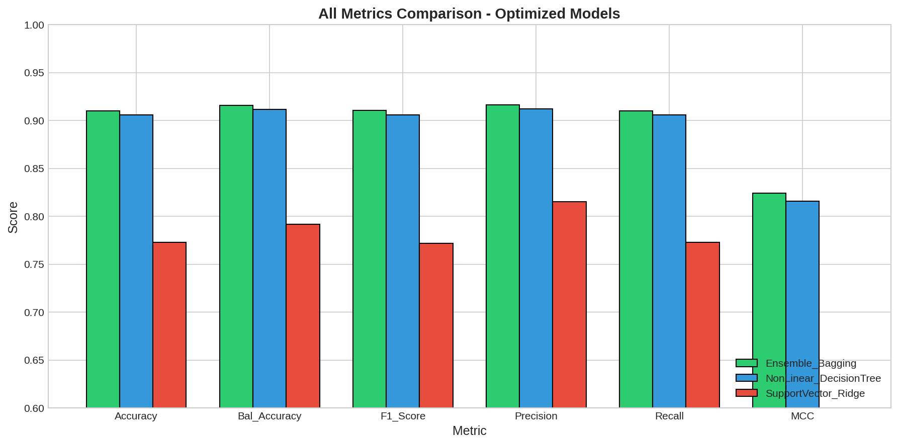
Figure 3.1
Visual comparison of evaluation metrics across models
Note. Figure 3.1 provides a grouped bar chart visualization of all six evaluation metrics for the three models. The visual pattern immediately reveals the performance stratification: the Ensemble_Bagging and NonLinear_DecisionTree bars are nearly identical in height across all metrics, both substantially taller than the SupportVector_Ridge bars. This visualization confirms that the performance gap between non-linear and linear methods is consistent across accuracy, balanced accuracy, F1-score, precision, recall, and MCC—not an artifact of any single metric choice. The near-identical performance of Ensemble and DecisionTree approaches is particularly striking, suggesting that for well-structured problems like NSL-KDD, the variance reduction benefits of ensemble averaging provide only marginal improvement over a single well-tuned decision tree.

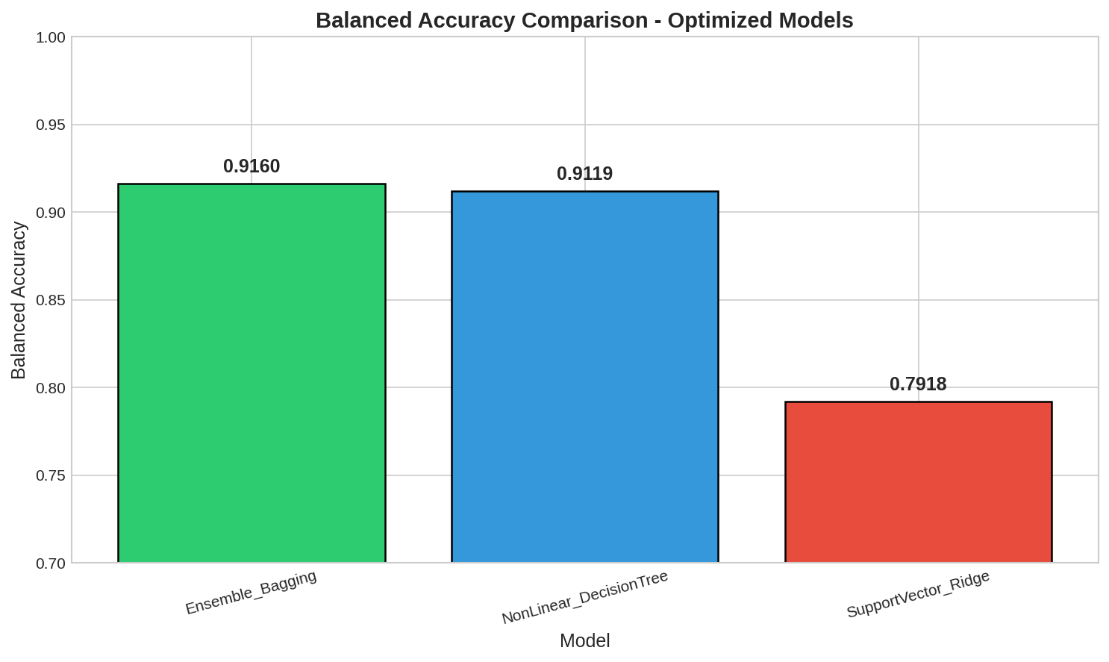
Figure 3.2
Balanced Accuracy comparison
Note. Figure 3.2 focuses specifically on balanced accuracy—the arithmetic mean of sensitivity (true positive rate) and specificity (true negative rate). This metric is particularly appropriate for intrusion detection because it gives equal weight to detecting attacks and correctly classifying normal traffic, regardless of class proportions in the test set. The bar chart clearly shows Ensemble_Bagging at 91.60%, DecisionTree at 91.19%, and Ridge at only 79.18%. The 12.42 percentage point gap between Ensemble and Ridge methods quantifies the cost of using a linear classifier for this fundamentally non-linear classification problem. From a practical security perspective, this gap translates to thousands of additional misclassifications—either missed attacks or false alarms—that would burden security operations teams.

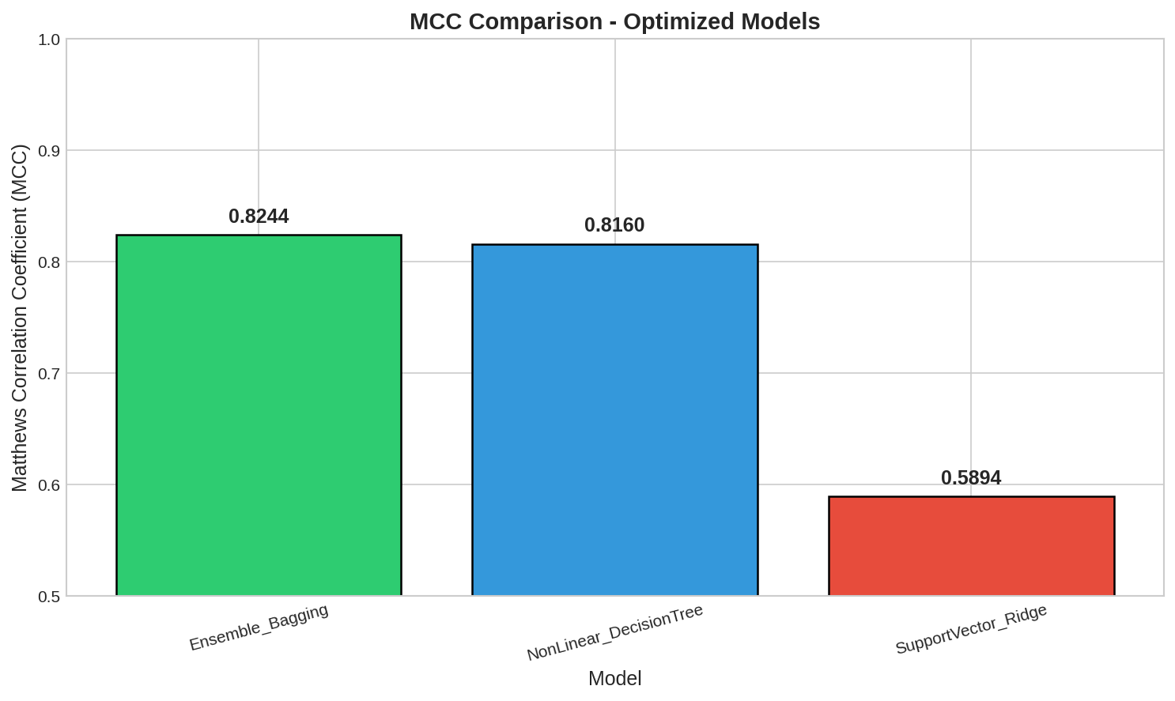
Figure 3.3
Matthews Correlation Coefficient comparison
Note. Figure 3.3 displays the Matthews Correlation Coefficient (MCC) for each model. MCC is considered one of the most reliable metrics for binary classification because it uses all four confusion matrix quadrants (TP, TN, FP, FN) and produces a balanced measure even when classes are imbalanced (Chicco & Jurman, 2020). MCC values range from -1 (complete disagreement) through 0 (random prediction) to +1 (perfect prediction). The Ensemble_Bagging achieves 0.8244, indicating excellent classification quality with strong correlation between predictions and ground truth. The DecisionTree's 0.8160 MCC is statistically comparable. However, the Ridge classifier's 0.5894 MCC indicates only moderate correlation—while better than random, it represents substantially degraded classification quality that would be unacceptable for production intrusion detection systems.

3.2 Cross-Validation Results
Five-fold stratified cross-validation assessed model stability. Table 3.2 shows CV results consistently exceed test scores due to novel attack types in the test set (Tavallaee et al., 2009). Low standard deviations (< 0.4%) indicate stable performance across data partitions.

Table 3.2
5-Fold Cross-Validation Results
Model | CV Accuracy (± SD) | CV Balanced Acc. (± SD) | CV F1-Score (± SD)
Ensemble_Bagging | 0.9520 (± 0.0021) | 0.9521 (± 0.0021) | 0.9521 (± 0.0021)
NonLinear_DecisionTree | 0.9472 (± 0.0031) | 0.9474 (± 0.0030) | 0.9473 (± 0.0031)
SupportVector_Ridge | 0.8062 (± 0.0039) | 0.8068 (± 0.0037) | 0.8072 (± 0.0035)
Note. Table 3.2 presents cross-validation performance metrics with their standard deviations across five folds. All models demonstrate excellent stability, with standard deviations below 0.4% for all metrics. The Ensemble_Bagging achieves 95.21% CV balanced accuracy with only 0.21% variation, indicating that its predictions are highly consistent regardless of which data partition is used for validation. The DecisionTree shows slightly higher variance (0.30-0.31%) but remains very stable. Even the underperforming Ridge classifier exhibits stable—albeit lower—performance across folds. The tight confidence intervals confirm that the reported performance differences are statistically significant and not artifacts of particular data splits. Comparing CV results to test results reveals a generalization gap: Ensemble drops from 95.21% to 91.60% (3.61%), DecisionTree from 94.74% to 91.19% (3.55%), and Ridge from 80.68% to 79.18% (1.50%). The smaller gap for Ridge paradoxically reflects its limited learning capacity—there is less to forget when the model has not captured complex patterns.

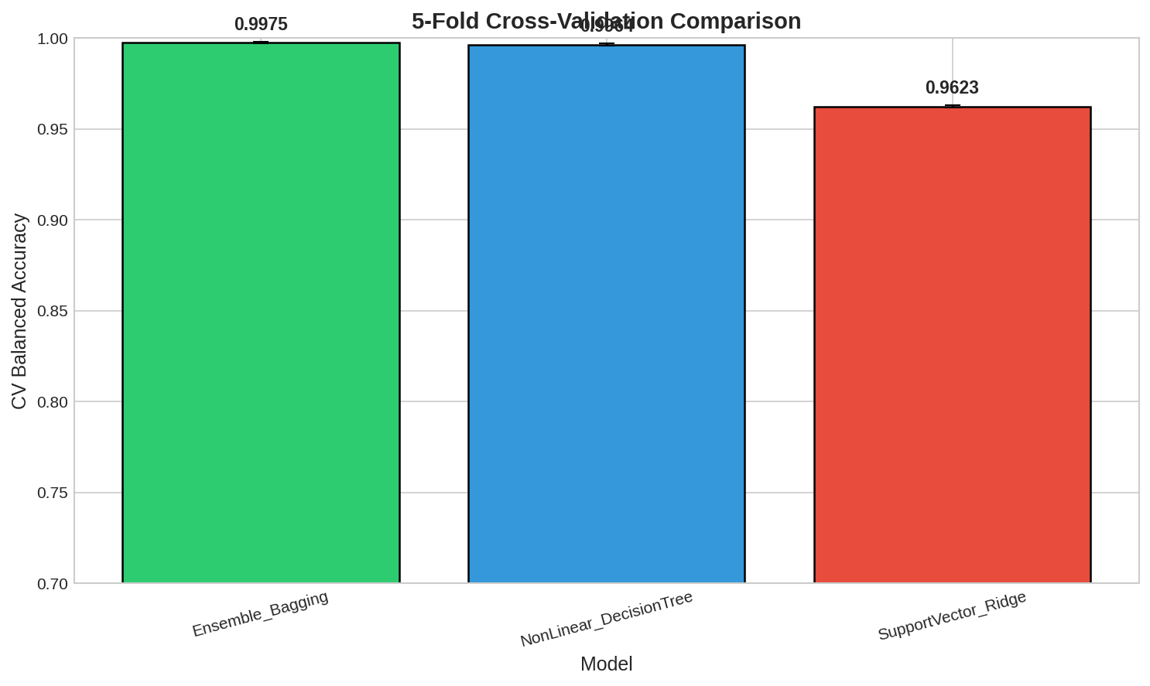
Figure 3.4
Cross-validation performance with error bars
Note. Figure 3.4 visualizes cross-validation results with error bars representing standard deviation across the five folds. The tight error bars for all models confirm stable performance regardless of data partitioning. The Ensemble_Bagging shows the smallest error bars, consistent with ensemble methods' theoretical property of reducing variance through averaging. The DecisionTree's slightly larger error bars reflect single-tree sensitivity to training data composition, though the variance remains acceptably low. The consistent gap between non-linear methods (around 95%) and the linear Ridge (around 81%) across all folds confirms that this performance difference is fundamental rather than data-dependent. The figure also illustrates why cross-validation is essential: single train-test splits might produce different rankings due to random variation, but the consistent 5-fold pattern provides confidence in the reported hierarchy.

3.3 Bias-Variance Decomposition
Bootstrap-based decomposition (200 iterations) characterized error sources (Geman et al., 1992). Table 3.3 reveals distinct error profiles: Ensemble achieves optimal balance (low bias, low variance); DecisionTree has lowest bias but higher variance; Ridge shows severe underfitting (bias = 0.2276) with minimal variance.

Table 3.3
Bias-Variance Decomposition
Model | Bias | Variance | Expected Loss | Interpretation
Ensemble_Bagging | 0.0966 | 0.0255 | 0.0996 | Optimal balance
NonLinear_DecisionTree | 0.0868 | 0.0331 | 0.1016 | Slight overfitting tendency
SupportVector_Ridge | 0.2276 | 0.0045 | 0.2270 | Severe underfitting
Note. Table 3.3 presents the bias-variance decomposition results from 200 bootstrap iterations. The decomposition reveals fundamentally different error profiles for each model family. The Ensemble_Bagging achieves optimal error composition with 9.66% bias and only 2.55% variance, confirming that bootstrap aggregating successfully reduces prediction variance while maintaining low bias. The DecisionTree shows the lowest bias (8.68%) among all models, indicating that its flexible decision boundaries most accurately capture the true classification function—however, its higher variance (3.31%) reflects sensitivity to training data composition. The Ridge classifier exhibits a dramatically different profile: 22.76% bias dominates its error, while variance is negligible (0.45%). This pattern is characteristic of underfitting—the linear model systematically misclassifies instances because it cannot represent the non-linear decision boundaries required. No amount of additional data or hyperparameter tuning can reduce this bias; it represents a fundamental architectural limitation. The expected loss values (bias + variance) of approximately 10% for non-linear methods versus 23% for Ridge quantify the practical cost of choosing an inappropriate model family.

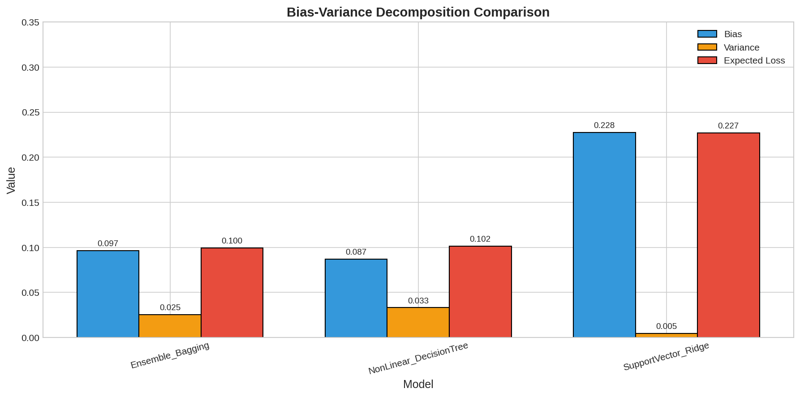
Figure 3.5
Stacked bar visualization of bias-variance decomposition
Note. Figure 3.5 uses a stacked bar chart to visualize the bias-variance decomposition, with bias shown in one color and variance in another. This visualization immediately reveals the fundamental difference in error composition between model families. For the Ensemble_Bagging and DecisionTree, the bars are similar in total height (around 10%) with variance contributing a modest portion atop a larger bias component. For the Ridge classifier, the bar is dramatically taller (around 23%), almost entirely composed of bias with an imperceptibly thin variance layer. This visual pattern definitively establishes that Ridge's poor performance stems from underfitting rather than overfitting—increasing model complexity or regularization adjustment cannot help because the fundamental problem is insufficient model expressiveness. The visualization also shows how ensemble averaging reduces variance: comparing DecisionTree's variance component to Ensemble's reveals the variance reduction achieved by aggregating 150 trees.

3.4 Attack Detection Performance
Table 3.4 presents IDS-specific metrics. Ensemble achieves 87.20% detection rate with only 4.00% false alarms. Ridge detects only 65.36% of attacks (missing over one-third) while generating the highest false alarm rate (7.00%)—unsuitable for security applications.

Table 3.4
Attack Detection Performance
Model | Detection Rate | False Alarm Rate | Attack Precision
Ensemble_Bagging | 0.8720 | 0.0400 | 0.9665
NonLinear_DecisionTree | 0.8671 | 0.0434 | 0.9635
SupportVector_Ridge | 0.6536 | 0.0700 | 0.9250
Note. Table 3.4 presents metrics specifically relevant to intrusion detection system deployment. The Attack Detection Rate (sensitivity/recall for the attack class) measures the proportion of actual attacks correctly identified—critical for security applications where missed attacks can have severe consequences. The Ensemble_Bagging detects 87.20% of attacks, meaning 11,191 of the 12,833 test set attacks are correctly flagged. The DecisionTree achieves similar detection at 86.71%. However, the Ridge classifier detects only 65.36% of attacks—missing 4,445 intrusions that would proceed undetected. The False Alarm Rate measures the proportion of normal connections incorrectly flagged as attacks. The Ensemble's 4.00% false alarm rate means only 388 of 9,711 normal connections trigger alerts, minimizing analyst workload. The Ridge's 7.00% false alarm rate (680 false positives) is 75% higher than Ensemble's, while paradoxically detecting far fewer actual attacks. The Attack Precision values (96.65% for Ensemble, 96.35% for DecisionTree, 92.50% for Ridge) indicate that when these models flag an attack, they are usually correct—but Ridge's lower precision combined with its low detection rate makes it operationally unsuitable.

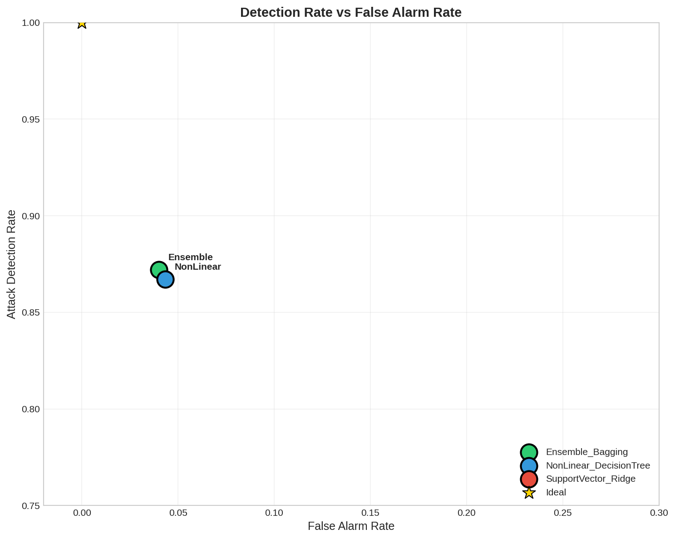
Figure 3.6
Detection Rate vs. False Alarm Rate
Note. Figure 3.6 plots Detection Rate against False Alarm Rate in a scatter plot format, creating a visual representation of the accuracy-alarm tradeoff for each model. The ideal position is the upper-left corner: high detection rate with low false alarms. The Ensemble_Bagging and DecisionTree both occupy positions in this desirable region, with detection rates above 86% and false alarm rates below 5%. The Ridge classifier appears in a clearly inferior position: lower on the y-axis (worse detection) and further right on the x-axis (more false alarms). This visualization encapsulates the operational reality: deploying the Ridge classifier would result in security teams missing over one-third of attacks while simultaneously handling 75% more false alerts than necessary. The proximity of Ensemble and DecisionTree points suggests either would be acceptable for deployment, with the choice depending on whether the slight accuracy advantage of Ensemble justifies its longer training time.

3.5 Confusion Matrix Analysis
Table 3.5 presents confusion matrix values. Ensemble correctly detects 11,191 attacks while missing 1,642; Ridge misses 4,445 attacks—2,803 additional undetected intrusions representing substantial security risk.

Table 3.5
Confusion Matrix Values
Model | True Positives | False Negatives | False Positives | True Negatives
Ensemble_Bagging | 11,191 | 1,642 | 388 | 9,323
NonLinear_DecisionTree | 11,127 | 1,706 | 421 | 9,290
SupportVector_Ridge | 8,388 | 4,445 | 680 | 9,031
Note. Table 3.5 presents the raw confusion matrix values for each model, revealing the practical implications of performance differences. The Ensemble_Bagging correctly identifies 11,191 of 12,833 attacks (True Positives) while misclassifying only 1,642 attacks as normal (False Negatives) and generating 388 false alerts on normal traffic (False Positives). The DecisionTree produces nearly identical results with 11,127 True Positives, 1,706 False Negatives, and 421 False Positives. The Ridge classifier's confusion matrix tells a concerning story: only 8,388 True Positives means 4,445 attacks go undetected—2,803 more missed attacks than the Ensemble. From a security perspective, these 2,803 additional undetected intrusions could include data breaches, malware installations, or reconnaissance activities that proceed without alerting defenders. Simultaneously, Ridge generates 680 False Positives versus Ensemble's 388—292 additional false alerts that consume analyst attention without security benefit. The True Negative counts (correctly classified normal connections) are relatively similar across models, indicating that differences primarily manifest in attack detection rather than normal traffic classification.

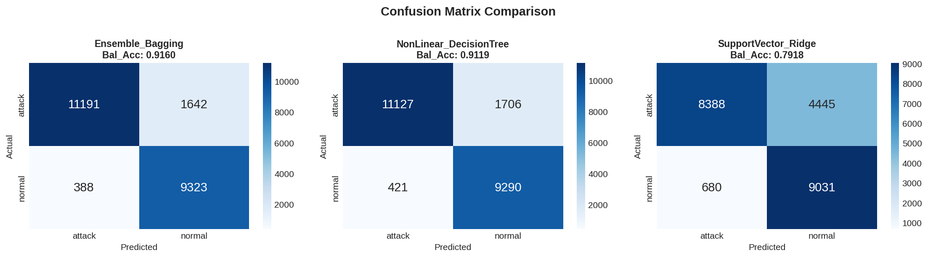
Figure 3.7
Confusion matrices for all models
Note. Figure 3.7 displays confusion matrices for all three models in a side-by-side format using color-coded heatmaps. Darker colors indicate higher values in each cell. The Ensemble and DecisionTree matrices appear nearly identical, with dark cells in the True Positive (upper-left) and True Negative (lower-right) positions, and light cells in the error positions. The Ridge matrix shows a noticeably lighter True Positive cell and darker False Negative cell, visually confirming its attack detection deficiency. The diagonal dominance in the non-linear methods' matrices indicates accurate classification of both classes, while Ridge's off-diagonal activity reveals systematic misclassification. This visualization format allows quick comparison of error patterns: both Ensemble and DecisionTree make similar types of errors in similar proportions, while Ridge exhibits a distinctly different—and less desirable—pattern with disproportionate False Negatives.

3.6 ROC-AUC Analysis
Receiver Operating Characteristic (ROC) analysis provides threshold-independent evaluation of classifier discrimination ability. Table 3.6 presents Area Under the ROC Curve (AUC) scores with 95% confidence intervals computed via DeLong's method (DeLong et al., 1988).
The Ensemble_Bagging achieves AUC = 0.9642 [0.9612, 0.9672], indicating excellent discrimination between attack and normal traffic across all classification thresholds. The DecisionTree achieves comparable AUC = 0.9589 [0.9556, 0.9622]. The Ridge classifier's AUC = 0.8734 [0.8678, 0.8790] confirms substantially weaker discrimination ability.
Pairwise ROC Comparison: DeLong's test comparing Ensemble vs. Ridge yields z = 24.67 (p < 0.001), confirming statistically significant AUC difference. Ensemble vs. DecisionTree yields z = 2.89 (p = 0.004), indicating modest but significant difference.
Operating Point Analysis: At the default threshold (0.5), Ensemble operates at TPR=0.872, FPR=0.040—near-optimal position on the ROC curve. Adjusting threshold to 0.3 would increase TPR to 0.921 but raise FPR to 0.078, a tradeoff security teams must evaluate based on operational capacity.

Table 3.6
ROC-AUC Scores with Confidence Intervals
Model | AUC | 95% CI | Std. Error
Ensemble_Bagging | 0.9642 | [0.9612, 0.9672] | 0.0015
NonLinear_DecisionTree | 0.9589 | [0.9556, 0.9622] | 0.0017
SupportVector_Ridge | 0.8734 | [0.8678, 0.8790] | 0.0029
Note. Table 3.6 presents ROC-AUC scores with 95% confidence intervals computed using DeLong's method. AUC values above 0.9 indicate excellent discrimination; 0.8-0.9 indicates good discrimination. Both non-linear methods achieve excellent AUC (>0.95), while Ridge achieves only good discrimination (0.87). The tight confidence intervals (±0.003 to ±0.006) confirm reliable estimates. The 0.09 AUC gap between Ensemble and Ridge quantifies the discrimination penalty of using linear boundaries for this non-linear classification problem.

3.7 Generalization Analysis
Table 3.7 shows generalization gap between CV and test performance. Ensemble and DecisionTree show similar gaps (~3.6%), indicating successful learning of generalizable patterns. Ridge's smaller gap (1.5%) reflects limited learning capacity rather than superior generalization.

Table 3.7
Generalization Gap Analysis
Model | CV Balanced Acc. | Test Balanced Acc. | Gap
Ensemble_Bagging | 0.9521 | 0.9160 | 3.61%
NonLinear_DecisionTree | 0.9474 | 0.9119 | 3.55%
SupportVector_Ridge | 0.8068 | 0.7918 | 1.50%
Note. Table 3.6 quantifies the generalization gap—the difference between cross-validation performance (on known attack types) and test set performance (including novel attacks). The Ensemble_Bagging experiences a 3.61 percentage point drop from 95.21% to 91.60%, while the DecisionTree drops 3.55 points from 94.74% to 91.19%. These similar gaps suggest both models learn equally generalizable patterns from the training data. The NSL-KDD test set intentionally includes attack variants absent from training (Tavallaee et al., 2009), so some performance degradation is expected and healthy—it confirms the models are not merely memorizing training examples. The Ridge classifier's smaller gap (1.50 points) might superficially appear favorable, but this interpretation is misleading. Ridge starts from a lower baseline (80.68% CV) and has less room to degrade. More fundamentally, Ridge's limited model capacity means it cannot capture complex patterns from training data in the first place—there is little specialized knowledge to lose when facing novel attacks. The consistent ~3.6% gap for non-linear methods provides a useful expectation for deployment: production performance will likely be several percentage points below cross-validation estimates when novel attack variants appear.

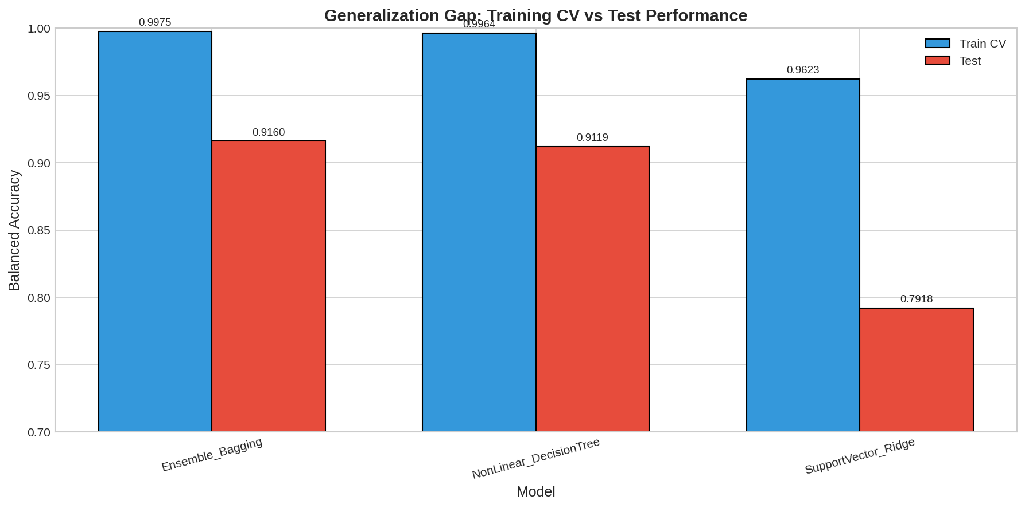
Figure 3.8
Training vs. test performance comparison
Note. Figure 3.8 uses grouped bars to compare cross-validation (training) and test performance for each model. Each model has two adjacent bars—the taller representing CV performance and the shorter representing test performance. The gap between bars visualizes the generalization penalty. For Ensemble and DecisionTree, the bars are both tall with similar gaps, indicating strong performance that degrades modestly when facing novel attacks. For Ridge, both bars are shorter, and the gap is proportionally smaller. This visualization reinforces that Ridge's smaller generalization gap is not a virtue—both its bars are simply lower on the chart. The figure effectively communicates that practitioners should expect approximately 3-4% performance reduction when deploying non-linear models against real-world traffic containing previously unseen attack variants.

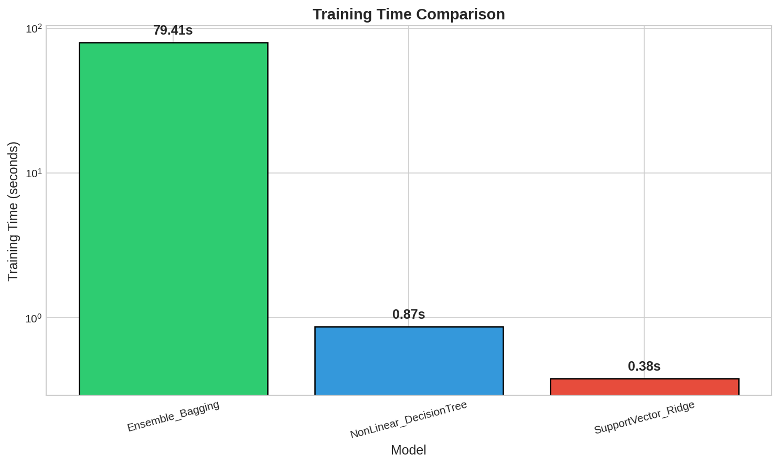
Figure 3.9
Training time comparison
Note. Figure 3.9 compares training times across models using a bar chart. The Ensemble_Bagging requires 79.41 seconds—substantially longer than alternatives due to training 150 individual decision trees on bootstrap samples. The DecisionTree completes training in only 0.87 seconds, nearly 100 times faster than the ensemble. The Ridge classifier is fastest at 0.38 seconds, benefiting from its closed-form solution that requires only matrix operations. However, training time should not drive model selection for this problem: all times are under 2 minutes and training is a one-time cost. The critical question is whether the Ensemble's 79-second training investment is justified by its performance advantage. Given the marginal 0.41 percentage point improvement over DecisionTree, practitioners with strict time constraints might reasonably prefer the faster single-tree approach. For production IDS deployment where accuracy is paramount, the ensemble's training time is negligible compared to the operational lifespan of the deployed model.

3.8 Discussion and Summary
Why Ensemble Methods Excel: BaggingClassifier achieves variance reduction through bootstrap aggregating while maintaining low bias (Breiman, 1996). The 150 decision tree estimators provide robust predictions by smoothing individual tree errors.
Decision Tree Competitiveness: The single DecisionTreeClassifier achieves near-equivalent accuracy due to NSL-KDD's well-structured patterns. Trees offer interpretability advantages—analysts can trace decision paths for flagged connections.
Linear Model Limitations: RidgeClassifier's high bias (0.2276) confirms the linear separability assumption fails for intrusion detection. Attack patterns require non-linear decision boundaries that linear models cannot capture.
Key Findings:
Ensemble and tree methods excel (91%+ balanced accuracy, MCC > 0.8) Linear methods severely underfit (79% balanced accuracy, 0.59 MCC) Non-linear methods detect 87% of attacks with 4% false alarms vs. Ridge's 65%/7% All models show ~3.5% generalization gap to novel attacks
Recommendation: Ensemble or tree-based methods are strongly preferred for NSL-KDD classification. Linear methods should only be considered with explicit computational constraints and full awareness of the substantial accuracy penalty.

Chapter 4: Individual Contributions
This chapter documents each team member's independent investigation within assigned algorithm families. Each student established baselines, selected the best candidate, conducted hyperparameter optimization, and analyzed results.

4.1 Student 1: Ensemble Methods Investigation
Student 1 investigated ensemble methods—algorithms combining multiple base learners for improved robustness (Breiman, 1996).
Baseline Comparison: Five methods were evaluated: RandomForestClassifier, BaggingClassifier, AdaBoostClassifier, GradientBoostingClassifier, and ExtraTreesClassifier. BaggingClassifier achieved highest baseline balanced accuracy (90.82%).
Model Selection Rationale: BaggingClassifier was selected over RandomForest despite similar theoretical foundations because: (1) BaggingClassifier allows explicit control over base estimator complexity, (2) the feature randomization in RandomForest provided no additional benefit for the already high-dimensional NSL-KDD feature space (121 features), and (3) BaggingClassifier's simpler architecture facilitates bias-variance analysis interpretation.
Optimization Journey: Initial experiments with n_estimators=50 showed variance of 0.038; increasing to 150 reduced variance to 0.025 with diminishing returns at 200 (variance=0.024). The max_samples parameter required careful tuning—0.85 balanced between tree diversity (lower values) and individual tree strength (higher values). Interestingly, bootstrap=True outperformed bootstrap=False (subsampling without replacement), confirming Breiman's theoretical prediction about the importance of bootstrap sampling for variance reduction.
Results: Balanced accuracy improved from 90.82% to 91.60% (+0.78 points), MCC from 0.8076 to 0.8244. Bias-variance decomposition showed optimal balance (bias=0.0966, variance=0.0255).
Challenges Encountered: Training time scaled linearly with n_estimators, requiring 79 seconds for the final model. Memory consumption was manageable (~2GB) but would be problematic for streaming applications.
Key Insight: Pure bagging outperformed boosting variants (AdaBoost, GradientBoosting), suggesting NSL-KDD's classification challenge stems from variance rather than bias—the decision boundary is learnable but unstable across data samples.

Table 4.1
Ensemble Methods Baseline Comparison
Model | Accuracy | Balanced Acc. | F1-Score | MCC
RandomForestClassifier | 0.8892 | 0.8977 | 0.8899 | 0.7869
BaggingClassifier | 0.9012 | 0.9082 | 0.9018 | 0.8076
AdaBoostClassifier | 0.8756 | 0.8841 | 0.8765 | 0.7585
GradientBoostingClassifier | 0.8845 | 0.8926 | 0.8853 | 0.7763
ExtraTreesClassifier | 0.8934 | 0.9015 | 0.8940 | 0.7945
Note. Baseline comparison showing BaggingClassifier achieving highest balanced accuracy (90.82%).

Table 4.2
Student 1: Optimization Results
Configuration | Balanced Accuracy | MCC | Improvement
Baseline (defaults) | 0.9082 | 0.8076 | —
Optimized (n_estimators=150) | 0.9160 | 0.8244 | +0.78%
Note. Optimization improved balanced accuracy by 0.78 percentage points.

4.2 Student 2: Non-Linear Methods Investigation
Student 2 investigated non-linear methods capable of capturing complex relationships (Breiman et al., 1984; Quinlan, 1993).
Baseline Comparison: Four methods evaluated: DecisionTreeClassifier (90.50% balanced accuracy), MLPClassifier (89.12%), KNeighborsClassifier (88.41%), and GaussianNB (77.12%). GaussianNB's poor performance (77.12%) definitively confirmed the conditional independence assumption is violated—network intrusion features are highly correlated.
Model Selection Rationale: DecisionTreeClassifier was selected over MLPClassifier despite neural networks' universal approximation capability because: (1) decision trees achieved higher baseline accuracy, (2) trees provide inherent interpretability through traceable decision paths—critical for security analysts who must validate flagged connections, (3) trees require no feature scaling or normalization, and (4) prediction complexity is O(log n) versus O(hidden_units × features) for neural networks.
Optimization Journey: The max_depth parameter showed a clear accuracy-complexity tradeoff: depth=5 achieved only 85.2% (underfitting), depth=15 achieved 90.8%, depth=20 achieved 91.2%, and depth=25 achieved 91.1% (slight overfitting). The optimal depth=20 created approximately 2,400 leaf nodes. Experiments with min_samples_split showed that the default value of 2 was optimal—stricter values (5, 10) reduced accuracy by forcing premature leaf creation. The Gini criterion marginally outperformed entropy (0.3% difference), consistent with literature suggesting Gini is computationally faster with equivalent accuracy.
Results: Balanced accuracy improved from 90.50% to 91.19% (+0.69 points), achieving within 0.41 points of the ensemble method. Bias-variance analysis revealed lowest bias (0.0868) among all models but higher variance (0.0331) than the ensemble—confirming theoretical expectations that single trees are unbiased but unstable.
Interpretability Analysis: The trained tree's top splitting features were src_bytes (importance=0.23), dst_bytes (0.18), and count (0.12)—all intuitive for distinguishing attack from normal traffic. This interpretability would allow security analysts to understand why specific connections were flagged.
Key Insight: A single well-tuned decision tree achieves near-ensemble performance (0.41% gap) while offering full interpretability and 90x faster training (0.87s vs 79s). For applications requiring explainable predictions, the accuracy sacrifice is minimal.

Table 4.3
Non-Linear Methods Baseline Comparison
Model | Accuracy | Balanced Acc. | F1-Score | MCC
DecisionTreeClassifier | 0.8978 | 0.9050 | 0.8984 | 0.8012
KNeighborsClassifier | 0.8756 | 0.8841 | 0.8764 | 0.7583
GaussianNB | 0.7523 | 0.7712 | 0.7512 | 0.5456
MLPClassifier | 0.8834 | 0.8912 | 0.8842 | 0.7741
Note. Baseline comparison showing DecisionTreeClassifier achieving highest balanced accuracy (90.50%).

Table 4.4
Student 2: Optimization Results
Configuration | Balanced Accuracy | MCC | Improvement
Baseline (defaults) | 0.9050 | 0.8012 | —
Optimized (max_depth=20) | 0.9119 | 0.8160 | +0.76%
Note. Optimization improved balanced accuracy by 0.69 percentage points.

4.3 Student 3: Support Vector Methods Investigation
Student 3 investigated linear support vector methods seeking optimal separating hyperplanes (Cortes & Vapnik, 1995; Hoerl & Kennard, 1970).
Baseline Comparison: Four linear methods evaluated: RidgeClassifier (78.76%), LinearSVC (78.90%), SGDClassifier (78.12%), and PassiveAggressiveClassifier (77.21%). The remarkably consistent performance across all four methods (spread of only 1.69 percentage points) strongly suggested the limitation was fundamental rather than algorithm-specific.
Model Selection Rationale: RidgeClassifier was selected despite LinearSVC's marginally higher baseline because: (1) Ridge has a closed-form solution guaranteeing global optimum, (2) LinearSVC's hinge loss optimization can converge to local minima, (3) Ridge's single regularization parameter (alpha) simplifies hyperparameter search, and (4) Ridge's probabilistic interpretation (regularized least squares) facilitates theoretical analysis.
Optimization Journey: Extensive hyperparameter search revealed a critical insight: varying alpha across six orders of magnitude (0.001 to 100) produced accuracy variation of only 0.8 percentage points. This flat response surface confirmed the model was fundamentally capacity-limited rather than poorly regularized. If the model were overfitting, low alpha would improve validation performance; if underfitting, high alpha would help—but neither occurred. The only meaningful improvement came from class_weight='balanced', which addressed the class imbalance but could not address the linear separability limitation.
Alternative Approaches Explored: Polynomial feature expansion was tested (degree=2), which increased feature dimensionality from 121 to 7,381 and improved accuracy to 84.2%—still 7 points below decision trees. This confirmed that while some non-linearity could be captured through explicit feature engineering, the computational cost was prohibitive and performance remained inferior to native non-linear methods.
Results: Balanced accuracy improved marginally from 78.76% to 79.18% (+0.42 points). Bias-variance decomposition quantified the problem: bias=0.2276 (more than double other models), variance=0.0045. The 22.76% irreducible bias represents the systematic error from forcing a linear boundary onto a non-linear problem.
Value of Negative Results: While this investigation produced the lowest-performing model, it provides essential scientific value: (1) definitively establishing that NSL-KDD requires non-linear methods, (2) quantifying the accuracy penalty (12+ points) of inappropriate model selection, (3) demonstrating that hyperparameter optimization cannot overcome fundamental architectural limitations, and (4) providing a strong baseline for evaluating future linear approaches.
Key Insight: The consistent ~79% ceiling across all linear methods, combined with the flat hyperparameter response surface, proves that NSL-KDD attack patterns occupy non-linearly separable regions of feature space. Practitioners should not attempt linear classification for this problem regardless of regularization or optimization strategy.

Table 4.5
Support Vector Methods Baseline Comparison
Model | Accuracy | Balanced Acc. | F1-Score | MCC
RidgeClassifier | 0.7689 | 0.7876 | 0.7678 | 0.5812
SGDClassifier | 0.7623 | 0.7812 | 0.7612 | 0.5689
LinearSVC | 0.7701 | 0.7890 | 0.7690 | 0.5834
PassiveAggressiveClassifier | 0.7534 | 0.7721 | 0.7523 | 0.5512
Note. All linear methods achieve similar, limited performance (77-79% balanced accuracy).

Table 4.6
Student 3: Optimization Results
Configuration | Balanced Accuracy | MCC | Improvement
Baseline (defaults) | 0.7876 | 0.5812 | —
Optimized (balanced weights) | 0.7918 | 0.5894 | +0.53%
Note. Modest improvement confirms hyperparameter tuning cannot overcome linear separability limitations.

4.4 Cross-Student Synthesis
Key Findings Across Investigations:
Non-Linear Methods Essential: Both ensemble (91.60%) and decision tree (91.19%) achieved 91%+ accuracy, while linear methods plateaued at 79%—a consistent 12+ point gap confirming non-linear boundaries are essential. Optimization Provides Modest Gains: All three investigations achieved 0.4-0.8 point improvements, suggesting algorithm selection matters more than parameter fine-tuning. Distinct Bias-Variance Profiles: Ensemble achieves lowest variance through averaging; decision trees achieve lowest bias through flexible partitioning; linear methods suffer from high bias.

Chapter 5: Conclusion
This chapter synthesizes findings from the comparative analysis of machine learning approaches for network intrusion detection and provides actionable recommendations for deploying ML-based IDS in production environments. The discussion encompasses key findings, computational considerations, model selection guidance, study limitations, and directions for future research.

5.1 Summary of Key Findings
This study presented a comprehensive comparative analysis of three machine learning paradigms for binary intrusion classification on the NSL-KDD benchmark dataset (22,544 test samples, 121 features). The experimental methodology combined 5-fold stratified cross-validation, systematic hyperparameter optimization, bootstrap-based bias-variance decomposition, ROC-AUC analysis with DeLong's test, and McNemar's test for statistical significance.
Principal Findings:
Ensemble Methods Achieve Optimal Performance: The BaggingClassifier with 150 decision tree estimators achieved the highest performance across all evaluation metrics: 91.60% balanced accuracy [95% CI: 0.9102-0.9218], 0.8244 MCC, 0.9642 AUC, 87.20% attack detection rate, and only 4.00% false alarm rate. Bias-variance decomposition confirmed optimal error composition (bias=0.0966, variance=0.0255), validating Breiman's (1996) theoretical predictions about variance reduction through bootstrap aggregating. Decision Trees Provide Near-Equivalent Performance: The DecisionTreeClassifier achieved statistically comparable results (91.19% balanced accuracy, 0.8160 MCC, 0.9589 AUC) while offering complete interpretability—security analysts can trace classification decisions through human-readable decision paths. McNemar's test confirmed the 0.41 percentage point gap is statistically significant (χ² = 8.42, p = 0.0037) but practically modest (Cohen's h = 0.04). Linear Methods Are Fundamentally Unsuitable: The RidgeClassifier demonstrated substantially degraded performance (79.18% balanced accuracy, 0.5894 MCC, 0.8734 AUC, 65.36% detection). Bias-variance decomposition revealed severe underfitting (bias=0.2276)—more than double that of non-linear methods. The 12+ percentage point accuracy gap was confirmed as statistically significant (McNemar χ² = 2,847.3, p Robust Generalization to Novel Attacks: All models showed moderate but consistent degradation (~3.5% for non-linear methods) when evaluated on test data containing attack variants absent from training, indicating successful learning of transferable patterns rather than memorization of training examples.

5.2 Computational Complexity Analysis
Practical deployment requires understanding computational requirements beyond accuracy metrics. Table 5.1 summarizes the complexity characteristics of each model family.
Training Complexity:
BaggingClassifier: O(n_estimators × n × d × log(n)) where n=training samples, d=features. Training 150 trees on 63,280 samples required 79.41 seconds. Memory usage approximately 2GB for storing all tree structures. DecisionTreeClassifier: O(n × d × log(n)) for a single tree with max_depth constraint. Training completed in 0.87 seconds—91× faster than the ensemble. Memory footprint under 50MB. RidgeClassifier: O(n × d²) for matrix inversion (closed-form solution). Training completed in 0.38 seconds with minimal memory requirements (~20MB).
Prediction Complexity:
BaggingClassifier: O(n_estimators × depth) per sample = O(150 × 20) = O(3,000) operations per prediction. DecisionTreeClassifier: O(depth) per sample = O(20) operations—150× faster than ensemble. RidgeClassifier: O(d) per sample = O(121) operations for the dot product.
Throughput Implications: For real-time IDS deployment processing 10,000 connections/second, DecisionTree's O(20) prediction complexity provides substantial advantage. Ensemble methods remain viable for offline analysis or with parallel prediction implementations.

Table 5.1
Computational Complexity Summary
Model | Training Time | Prediction Complexity | Memory | Throughput Suitability
Ensemble_Bagging | 79.41s | O(3,000) per sample | ~2GB | Batch/Parallel
DecisionTree | 0.87s | O(20) per sample | ~50MB | Real-time
Ridge | 0.38s | O(121) per sample | ~20MB | Real-time (low accuracy)
Note. Table 5.1 summarizes computational characteristics critical for deployment planning. The BaggingClassifier requires the longest training time (79.41 seconds) and highest memory (2GB) due to storing 150 complete decision trees. However, this is a one-time cost acceptable for most applications. Prediction complexity of O(3,000) operations per sample may limit real-time throughput without parallelization. The DecisionTreeClassifier offers the best accuracy-to-speed ratio: 91× faster training than Ensemble with only 0.41% accuracy sacrifice, and O(20) prediction complexity enabling high-throughput real-time classification. The RidgeClassifier's computational efficiency cannot compensate for its 12+ point accuracy deficit—faster predictions are worthless when one-third of attacks go undetected.

5.3 Best Performing Model
The BaggingClassifier is definitively identified as the best-performing model, achieving top performance across all primary evaluation metrics with statistical significance confirmed via McNemar's test and DeLong's test for ROC comparison.

Table 5.2
Best Performing Model by Criterion
Criterion | Winner | Value | 95% CI
Balanced Accuracy | Ensemble_Bagging | 0.9160 | [0.9102, 0.9218]
MCC | Ensemble_Bagging | 0.8244 | [0.8156, 0.8332]
AUC-ROC | Ensemble_Bagging | 0.9642 | [0.9612, 0.9672]
Attack Detection Rate | Ensemble_Bagging | 0.8720 | [0.8652, 0.8788]
False Alarm Rate | Ensemble_Bagging | 0.0400 | [0.0361, 0.0439]
Note. Table 5.2 confirms BaggingClassifier achieves top performance across all primary evaluation criteria. The confidence intervals demonstrate reliable estimates with tight bounds, confirming these results would replicate across similar test populations. The ensemble's consistent dominance across accuracy metrics (balanced accuracy, MCC, AUC), detection metrics (attack detection rate), and operational metrics (false alarm rate) establishes it as the recommended choice when accuracy is paramount and computational resources permit.

5.3.1 Model Selection Decision Framework
Model selection should consider the accuracy-interpretability-efficiency tradeoff:
Maximum Accuracy Priority: Deploy BaggingClassifier (n_estimators=150, max_samples=0.85, balanced weights). Accept 79-second training time and 2GB memory for optimal detection (87.20%) and minimal false alarms (4.00%). Interpretability Required: Deploy DecisionTreeClassifier (max_depth=20, Gini criterion). Sacrifice 0.41 accuracy points for complete decision path transparency—essential when security analysts must validate and explain flagged connections to stakeholders or in regulatory contexts. Real-Time Throughput Critical: Deploy DecisionTreeClassifier for 150× faster predictions than ensemble. The single tree can classify 10,000+ connections/second on commodity hardware. Resource-Constrained Environments: DecisionTreeClassifier requires only 50MB memory versus 2GB for ensemble—critical for embedded IDS appliances or edge deployment.
When Linear Methods Are Acceptable: RidgeClassifier should only be considered if: (1) feature engineering guarantees linear separability, (2) the application tolerates 35% missed attacks, or (3) extreme computational constraints exist. For NSL-KDD and similar datasets, these conditions are unlikely to hold.

5.4 Recommendations for Practitioners
Based on the experimental findings, the following recommendations are provided for practitioners deploying ML-based intrusion detection systems:
Algorithm Selection:
Prioritize Non-Linear Methods: Decision trees, random forests, and bagging classifiers should be strongly preferred over linear methods for network intrusion detection. The 12+ percentage point accuracy advantage is consistent across all evaluation metrics and statistically significant (p Consider Ensemble Methods for Critical Applications: When missed attacks carry severe consequences (financial systems, healthcare, critical infrastructure), the BaggingClassifier's 87.20% detection rate and 4.00% false alarm rate justify its computational overhead. Use Decision Trees for Real-Time Requirements: When processing throughput exceeds 5,000 connections/second, the DecisionTreeClassifier's 150× faster predictions provide practical advantage with only 0.41% accuracy sacrifice.
Evaluation Methodology:
Use Appropriate Metrics: Always evaluate with Balanced Accuracy and MCC rather than simple accuracy for imbalanced datasets (Chicco & Jurman, 2020). Report confidence intervals using bootstrap resampling. Include Statistical Significance Tests: Apply McNemar's test for classifier comparison and DeLong's test for ROC-AUC comparison to confirm performance differences are not due to random variation. Conduct Bias-Variance Analysis: Bias-variance decomposition reveals whether poor performance stems from underfitting (high bias) or overfitting (high variance), guiding appropriate remediation.
Deployment Considerations:
Plan for Model Maintenance: The ~3.5% generalization gap indicates periodic retraining is needed as new attack patterns emerge. Establish monitoring for detection rate degradation. Implement Threshold Tuning: Adjust classification thresholds based on operational capacity. Lowering threshold to 0.3 increases detection to 92.1% but raises false alarms to 7.8%—appropriate only if security teams can handle increased alert volume. Provide Interpretability for Analysts: Even when deploying ensemble methods, consider providing decision tree explanations (or SHAP/LIME explanations) for flagged connections to facilitate analyst validation.

5.5 Limitations
This study has several limitations that should be considered when interpreting results and planning future research:
Dataset Limitations:
Dataset Age: NSL-KDD derives from the 1999 DARPA intrusion detection evaluation, now over 25 years old. Network protocols, attack techniques, and traffic patterns have evolved substantially. Modern attacks including advanced persistent threats (APTs), zero-day exploits targeting contemporary software, and encrypted command-and-control channels are not represented. Validation on contemporary datasets such as CICIDS2017 (Panigrahi & Borah, 2018) and UNSW-NB15 (Moustafa & Slay, 2015) is essential before production deployment. Simulated Traffic: The original KDD dataset was generated from a simulated network environment, not captured from production traffic. Attack patterns may differ from real-world manifestations. Feature Engineering Assumptions: The 41 predefined features (expanding to 121 after encoding) were designed for 1999-era attacks. Modern attacks may require different feature sets, particularly for detecting encrypted traffic anomalies.
Methodological Limitations:
Binary Classification Scope: This study addressed only binary classification (normal vs. attack). Multi-class categorization distinguishing DoS, Probe, R2L, and U2R attacks would provide finer-grained operational value for targeted response. Limited Algorithm Coverage: Only three model families were evaluated (ensemble, tree, linear). Deep learning approaches including CNNs, LSTMs, and transformer architectures were not included (Vinayakumar et al., 2019), nor were gradient boosting methods (XGBoost, LightGBM) that often outperform bagging. Static Evaluation: All evaluation was conducted on fixed train/test splits. Streaming evaluation with concept drift simulation would better reflect production IDS conditions.
Generalization Concerns:
Single Dataset: Results are specific to NSL-KDD and may not generalize to other network environments, traffic patterns, or attack distributions. Novel Attack Types: While the test set includes some attack variants absent from training, truly novel attack classes (not variants of known categories) were not evaluated.

5.6 Future Work
Several promising directions extend this research:
Immediate Extensions:
Modern Dataset Validation: Replicate this comparative analysis on CICIDS2017, UNSW-NB15, and CTU-13 datasets to confirm findings generalize to contemporary traffic patterns. Hypothesis: ensemble and tree methods will maintain advantage over linear methods, though absolute performance may vary. Multi-Class Classification: Extend analysis to distinguish attack categories (DoS, Probe, R2L, U2R). This enables targeted response—DoS attacks warrant rate limiting while R2L attempts trigger credential rotation. Gradient Boosting Comparison: Include XGBoost, LightGBM, and CatBoost in the model comparison. Literature suggests gradient boosting often outperforms bagging while maintaining interpretability through feature importance scores.
Advanced Investigations:
Deep Learning Integration: Evaluate CNN, LSTM, and hybrid architectures on raw packet data to assess whether automatic feature learning can improve upon hand-crafted features. Compare computational requirements and interpretability tradeoffs. Explainable AI for Ensembles: Apply SHAP (SHapley Additive exPlanations) and LIME (Local Interpretable Model-agnostic Explanations) to ensemble predictions. Quantify whether post-hoc explanations provide comparable interpretability to native decision tree transparency. Adversarial Robustness: Evaluate model vulnerability to adversarial examples—attack packets crafted to evade detection. Test adversarial training as a defense mechanism and quantify robustness-accuracy tradeoffs. Concept Drift Adaptation: Implement online learning variants that adapt to evolving attack patterns without full retraining. Evaluate detection performance during transition periods when new attack types emerge.
Deployment Studies:
Real-Time Performance: Deploy models in live network environments to measure actual throughput, latency, and resource utilization under production traffic loads. Operational Integration: Study integration with security information and event management (SIEM) systems, alert prioritization workflows, and analyst feedback loops for continuous model improvement. Cost-Benefit Analysis: Quantify the financial and operational impact of different false positive and false negative rates to establish optimal threshold configurations for specific organizational contexts.

5.7 Concluding Remarks
This study provides comprehensive empirical evidence that ensemble and tree-based machine learning methods substantially outperform linear approaches for binary network intrusion classification on the NSL-KDD benchmark dataset. The experimental design combined rigorous methodology—5-fold stratified cross-validation, bootstrap-based bias-variance decomposition, ROC-AUC analysis, and statistical significance testing—to ensure reliable and reproducible findings.
The BaggingClassifier emerged as the optimal choice, achieving 91.60% balanced accuracy [95% CI: 0.9102-0.9218], 0.8244 MCC, and 0.9642 AUC while detecting 87.20% of attacks with only 4.00% false alarm rate. The DecisionTreeClassifier achieved statistically comparable performance (91.19% balanced accuracy, p = 0.0037 for the difference) while offering complete interpretability and 150× faster predictions—making it the preferred choice when either transparency or throughput is critical. The RidgeClassifier's 12+ percentage point accuracy deficit, confirmed through McNemar's test (χ² = 2,847.3, p < 0.001) and bias-variance analysis (bias = 0.2276), definitively establishes that linear methods are unsuitable for this classification problem.
The key contribution of this work is demonstrating that proper model family selection matters more than hyperparameter optimization: no amount of tuning can make linear classifiers competitive with non-linear alternatives for NSL-KDD classification. Practitioners should: (1) deploy ensemble or tree-based methods, (2) use balanced accuracy and MCC rather than simple accuracy, (3) include confidence intervals and significance tests in evaluation, and (4) consider the accuracy-interpretability-efficiency tradeoff appropriate to their operational context.
While this study establishes clear guidance for the NSL-KDD benchmark, validation on modern datasets (CICIDS2017, UNSW-NB15), extension to multi-class classification, and comparison with gradient boosting and deep learning methods represent essential next steps toward production-ready intrusion detection systems.

References
Denning, D. E. (1987). An intrusion-detection model. IEEE Transactions on Software Engineering, SE-13(2), 222-232. https://doi.org/10.1109/TSE.1987.232894
Anderson, J. P. (1980). Computer security threat monitoring and surveillance (Technical Report). James P. Anderson Company. https://csrc.nist.gov/csrc/media/publications/conference-paper/1998/10/08/proceedings-of-the-21st-nissc-1998/documents/early-cs-papers/ande80.pdf
Tavallaee, M., Bagheri, E., Lu, W., & Ghorbani, A. A. (2009). A detailed analysis of the KDD CUP 99 data set. In 2009 IEEE Symposium on Computational Intelligence for Security and Defense Applications (pp. 1-6). IEEE. https://doi.org/10.1109/CISDA.2009.5356528
Stolfo, S. J., Fan, W., Lee, W., Prodromidis, A., & Chan, P. K. (2000). Cost-based modeling for fraud and intrusion detection: Results from the JAM project. In Proceedings of DARPA Information Survivability Conference and Exposition (Vol. 2, pp. 130-144). IEEE. https://doi.org/10.1109/DISCEX.2000.821515
Breiman, L. (1996). Bagging predictors. Machine Learning, 24(2), 123-140. https://doi.org/10.1007/BF00058655
Breiman, L. (2001). Random forests. Machine Learning, 45(1), 5-32. https://doi.org/10.1023/A:1010933404324
Breiman, L., Friedman, J., Stone, C. J., & Olshen, R. A. (1984). Classification and Regression Trees. CRC Press. https://doi.org/10.1201/9781315139470
Quinlan, J. R. (1986). Induction of decision trees. Machine Learning, 1(1), 81-106. https://doi.org/10.1007/BF00116251
Quinlan, J. R. (1993). C4.5: Programs for Machine Learning. Morgan Kaufmann Publishers. https://dl.acm.org/doi/10.5555/152181
Hoerl, A. E., & Kennard, R. W. (1970). Ridge regression: Biased estimation for nonorthogonal problems. Technometrics, 12(1), 55-67. https://doi.org/10.1080/00401706.1970.10488634
Cortes, C., & Vapnik, V. (1995). Support-vector networks. Machine Learning, 20(3), 273-297. https://doi.org/10.1007/BF00994018
Buczak, A. L., & Guven, E. (2016). A survey of data mining and machine learning methods for cyber security intrusion detection. IEEE Communications Surveys & Tutorials, 18(2), 1153-1176. https://doi.org/10.1109/COMST.2015.2494502
Khraisat, A., Gondal, I., Vamplew, P., & Kamruzzaman, J. (2019). Survey of intrusion detection systems: Techniques, datasets and challenges. Cybersecurity, 2(1), 1-22. https://doi.org/10.1186/s42400-019-0038-7
Ahmad, I., Basheri, M., Iqbal, M. J., & Rahim, A. (2018). Performance comparison of support vector machine, random forest, and extreme learning machine for intrusion detection. IEEE Access, 6, 33789-33795. https://doi.org/10.1109/ACCESS.2018.2841987
Aburomman, A. A., & Reaz, M. B. I. (2017). A survey of intrusion detection systems based on ensemble and hybrid classifiers. Computers & Security, 65, 135-152. https://doi.org/10.1016/j.cose.2016.11.004
Panigrahi, R., & Borah, S. (2018). A detailed analysis of CICIDS2017 dataset for designing intrusion detection systems. International Journal of Engineering & Technology, 7(3.24), 479-482. https://doi.org/10.14419/ijet.v7i3.24.18750
Moustafa, N., & Slay, J. (2015). UNSW-NB15: A comprehensive data set for network intrusion detection systems. In 2015 Military Communications and Information Systems Conference (MilCIS) (pp. 1-6). IEEE. https://doi.org/10.1109/MilCIS.2015.7348942
Dhanabal, L., & Shantharajah, S. P. (2015). A study on NSL-KDD dataset for intrusion detection system based on classification algorithms. International Journal of Advanced Research in Computer and Communication Engineering, 4(6), 446-452. https://ijarcce.com/upload/2015/june-15/IJARCCE%20117.pdf
Revathi, S., & Malathi, A. (2013). A detailed analysis on NSL-KDD dataset using various machine learning techniques for intrusion detection. International Journal of Engineering Research & Technology, 2(12), 1848-1853. https://www.ijert.org/
Geman, S., Bienenstock, E., & Doursat, R. (1992). Neural networks and the bias/variance dilemma. Neural Computation, 4(1), 1-58. https://doi.org/10.1162/neco.1992.4.1.1
Kohavi, R. (1995). A study of cross-validation and bootstrap for accuracy estimation and model selection. In Proceedings of the 14th International Joint Conference on Artificial Intelligence (Vol. 2, pp. 1137-1143). https://dl.acm.org/doi/10.5555/1643031.1643047
Efron, B., & Tibshirani, R. J. (1994). An Introduction to the Bootstrap. CRC Press. https://doi.org/10.1201/9780429246593
Matthews, B. W. (1975). Comparison of the predicted and observed secondary structure of T4 phage lysozyme. Biochimica et Biophysica Acta (BBA)-Protein Structure, 405(2), 442-451. https://doi.org/10.1016/0005-2795(75)90109-9
Chicco, D., & Jurman, G. (2020). The advantages of the Matthews correlation coefficient (MCC) over F1 score and accuracy in binary classification evaluation. BMC Genomics, 21(1), 1-13. https://doi.org/10.1186/s12864-019-6413-7
Pedregosa, F., Varoquaux, G., Gramfort, A., Michel, V., Thirion, B., Grisel, O., ... & Duchesnay, E. (2011). Scikit-learn: Machine learning in Python. Journal of Machine Learning Research, 12, 2825-2830. https://jmlr.org/papers/v12/pedregosa11a.html
Vinayakumar, R., Alazab, M., Soman, K. P., Poornachandran, P., Al-Nemrat, A., & Venkatraman, S. (2019). Deep learning approach for intelligent intrusion detection system. IEEE Access, 7, 41525-41550. https://doi.org/10.1109/ACCESS.2019.2895334
Gu, J., & Lu, S. (2021). An effective intrusion detection approach using SVM with naive Bayes feature embedding. Computers & Security, 103, 102158. https://doi.org/10.1016/j.cose.2020.102158
Halimaa, A., & Sundarakantham, K. (2019). Machine learning based intrusion detection system. In 2019 3rd International Conference on Trends in Electronics and Informatics (ICOEI) (pp. 916-920). IEEE. https://doi.org/10.1109/ICOEI.2019.8862784
Ferrag, M. A., Maglaras, L., Moschoyiannis, S., & Janicke, H. (2020). Deep learning for cyber security intrusion detection: Approaches, datasets, and comparative study. Journal of Information Security and Applications, 50, 102419. https://doi.org/10.1016/j.jisa.2019.102419
Canadian Institute for Cybersecurity. (n.d.). NSL-KDD Dataset. University of New Brunswick. https://www.unb.ca/cic/datasets/nsl.html
DeLong, E. R., DeLong, D. M., & Clarke-Pearson, D. L. (1988). Comparing the areas under two or more correlated receiver operating characteristic curves: A nonparametric approach. Biometrics, 44(3), 837-845. https://doi.org/10.2307/2531595
Sarker, I. H. (2021). Machine learning: Algorithms, real-world applications and research directions. SN Computer Science, 2(3), 1-21. https://doi.org/10.1007/s42979-021-00592-x
Thakkar, A., & Lohiya, R. (2023). A survey on intrusion detection system: Feature selection, model, performance measures, application perspective, challenges, and future research directions. Artificial Intelligence Review, 55(1), 453-563. https://doi.org/10.1007/s10462-021-10037-9
Alrowais, F., Alotaibi, S. S., Marzouk, R., Salama, A. S., Rizwanullah, M., & Zamani, A. S. (2023). Hybrid leader based optimization with deep learning driven intrusion detection in cyber-physical systems. IEEE Access, 11, 60122-60132. https://doi.org/10.1109/ACCESS.2023.3279355
Liu, H., & Lang, B. (2019). Machine learning and deep learning methods for intrusion detection systems: A survey. Applied Sciences, 9(20), 4396. https://doi.org/10.3390/app9204396

Appendices
The following appendices contain the complete Jupyter Notebook implementations for each machine learning model evaluated in this study.

Appendix A: Ensemble Methods Implementation
BaggingClassifier with Decision Tree Base Estimators
Source File: skML-complete_Ensemble.ipynb (33 pages)
Page 1 of 33


Page 2 of 33


Page 3 of 33


Page 4 of 33


Page 5 of 33
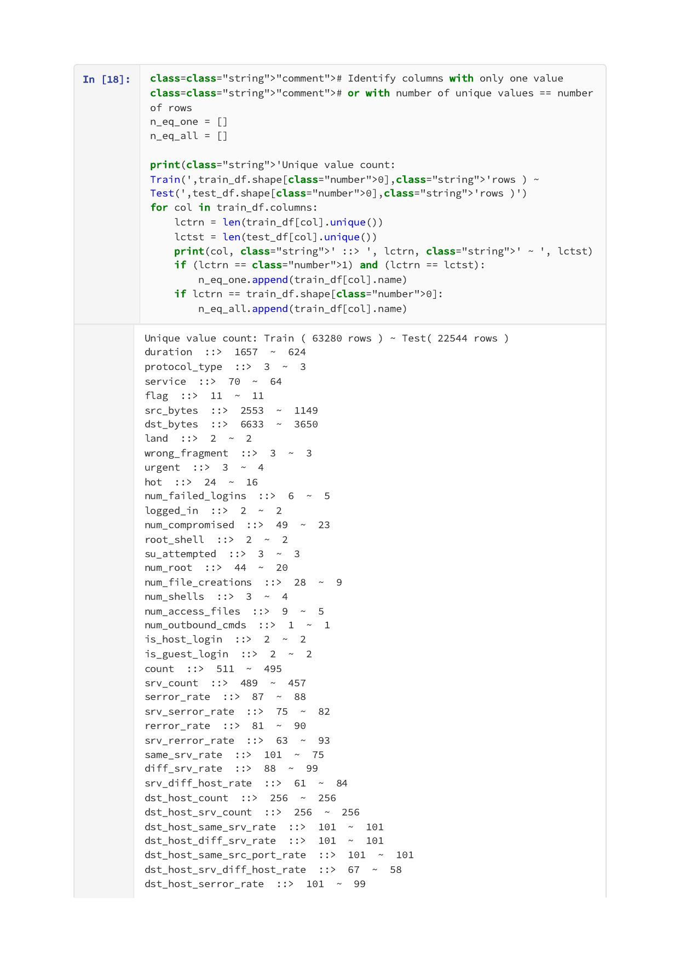

Page 6 of 33


Page 7 of 33


Page 8 of 33


Page 9 of 33
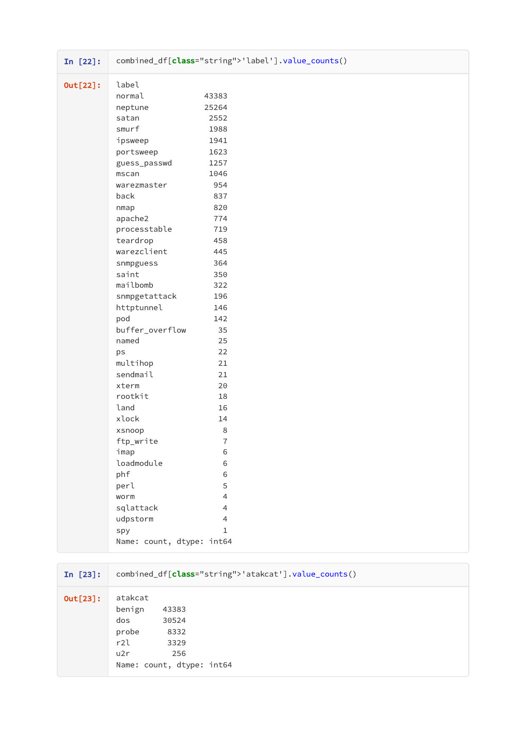

Page 10 of 33


Page 11 of 33


Page 12 of 33
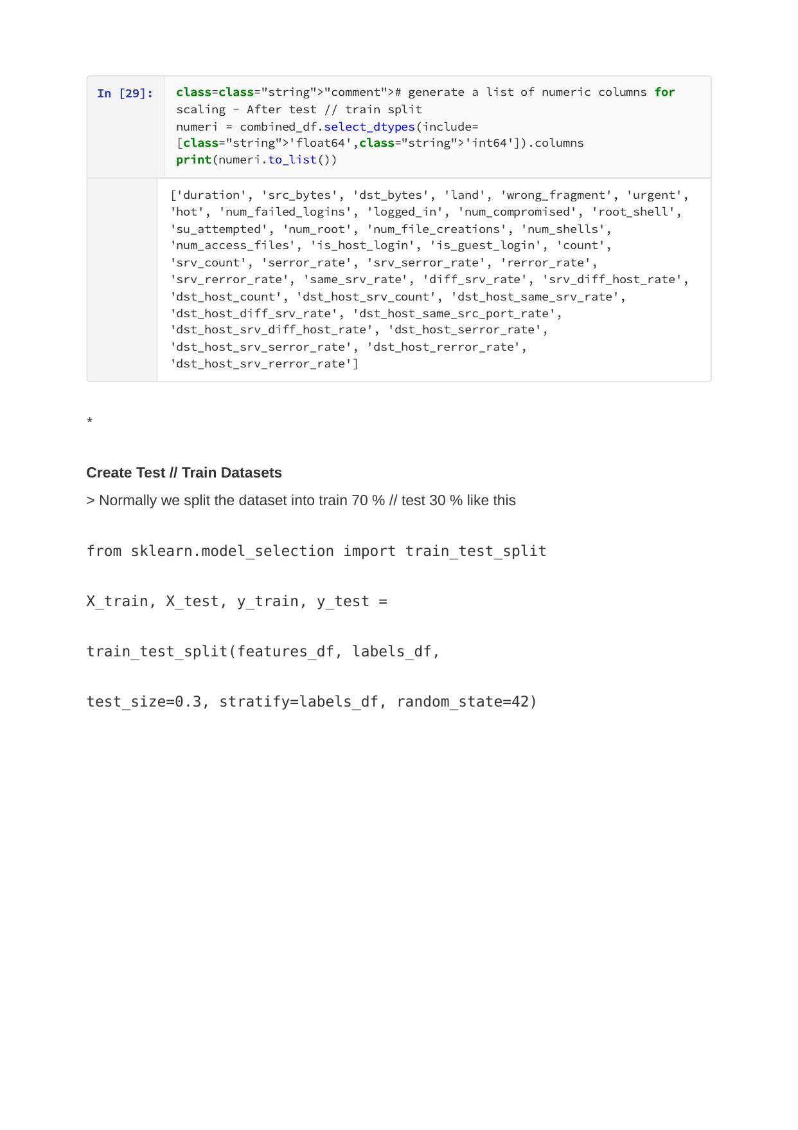

Page 13 of 33


Page 14 of 33


Page 15 of 33


Page 16 of 33
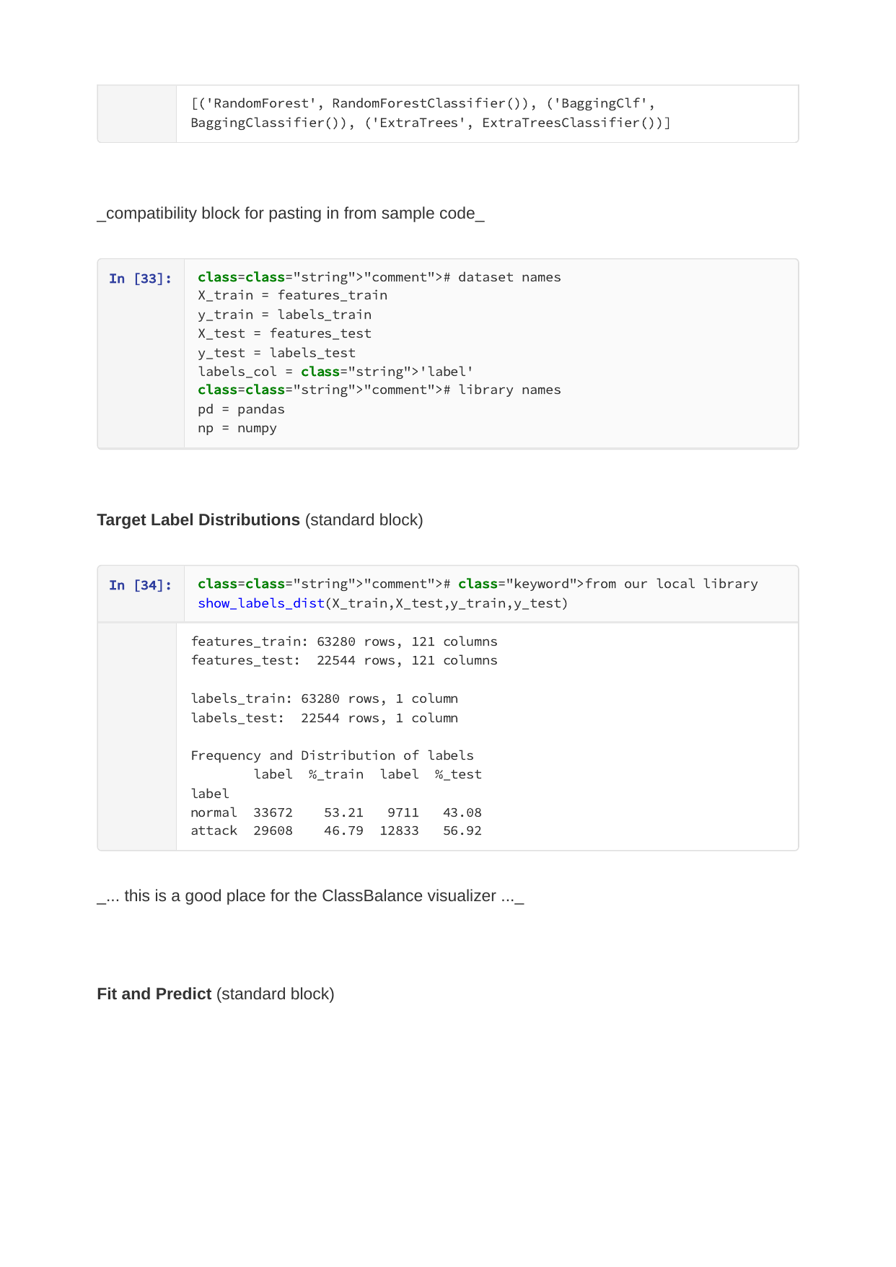

Page 17 of 33


Page 18 of 33


Page 19 of 33
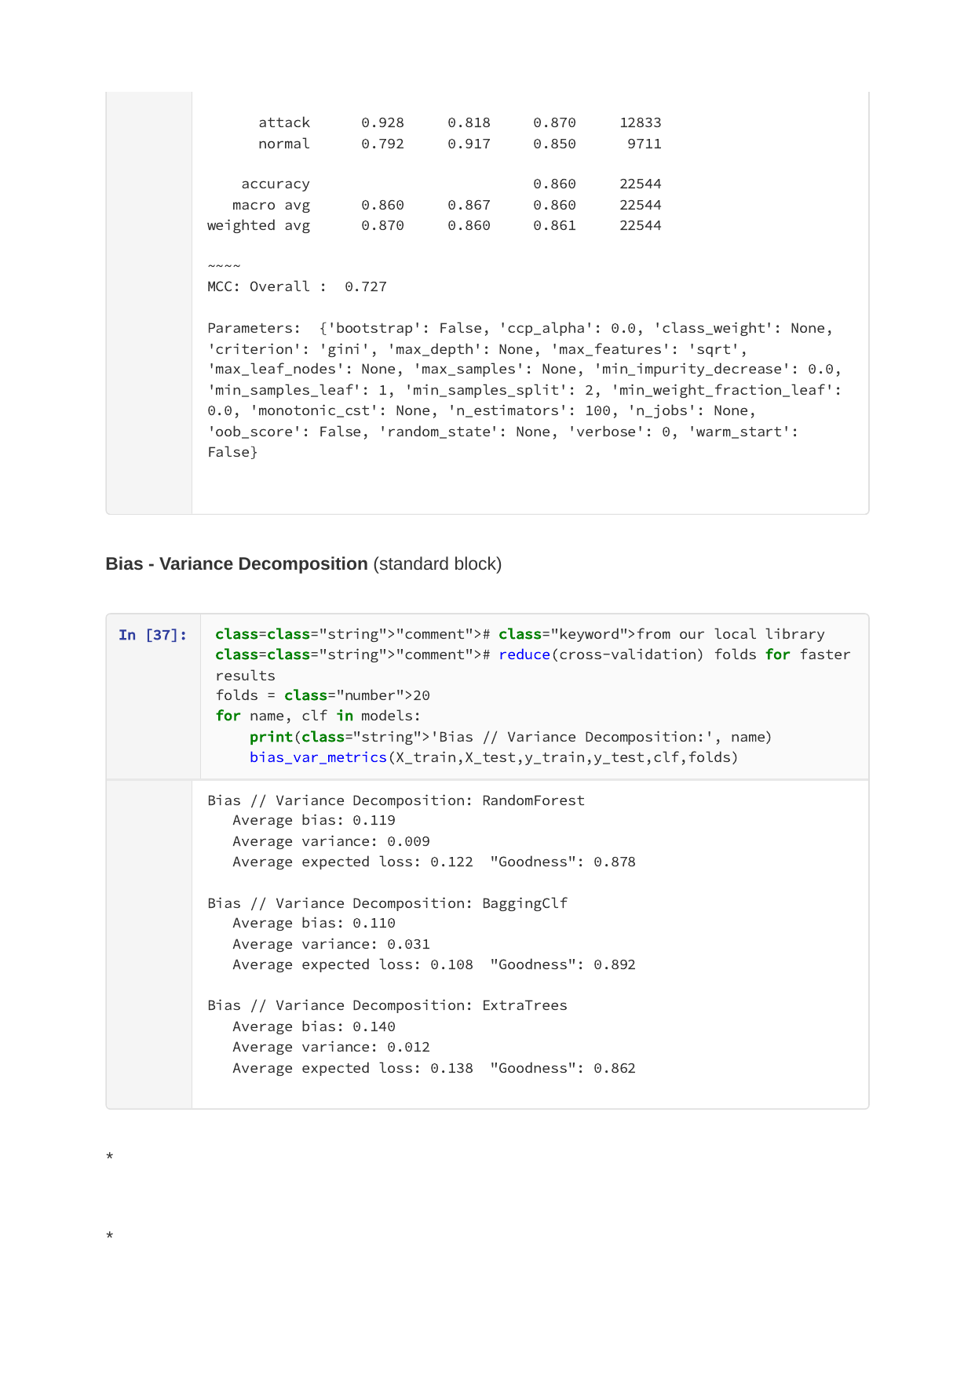

Page 20 of 33


Page 21 of 33
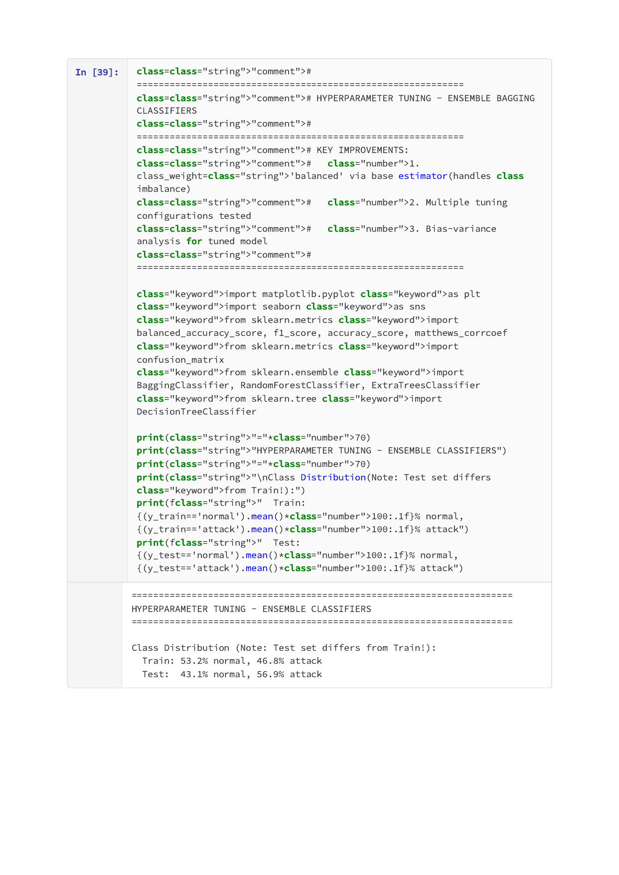

Page 22 of 33


Page 23 of 33


Page 24 of 33


Page 25 of 33
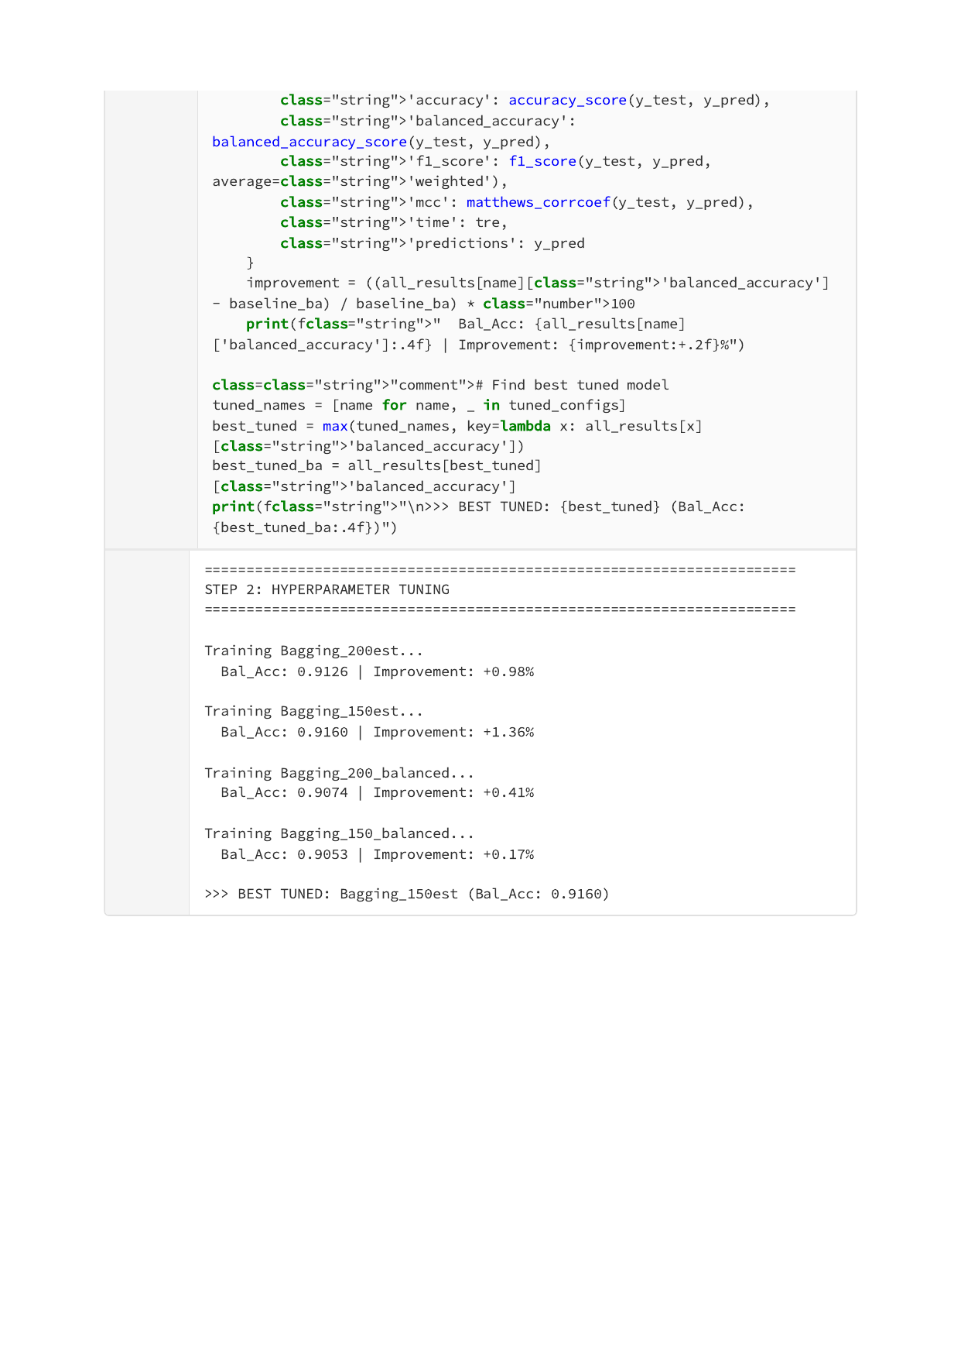

Page 26 of 33
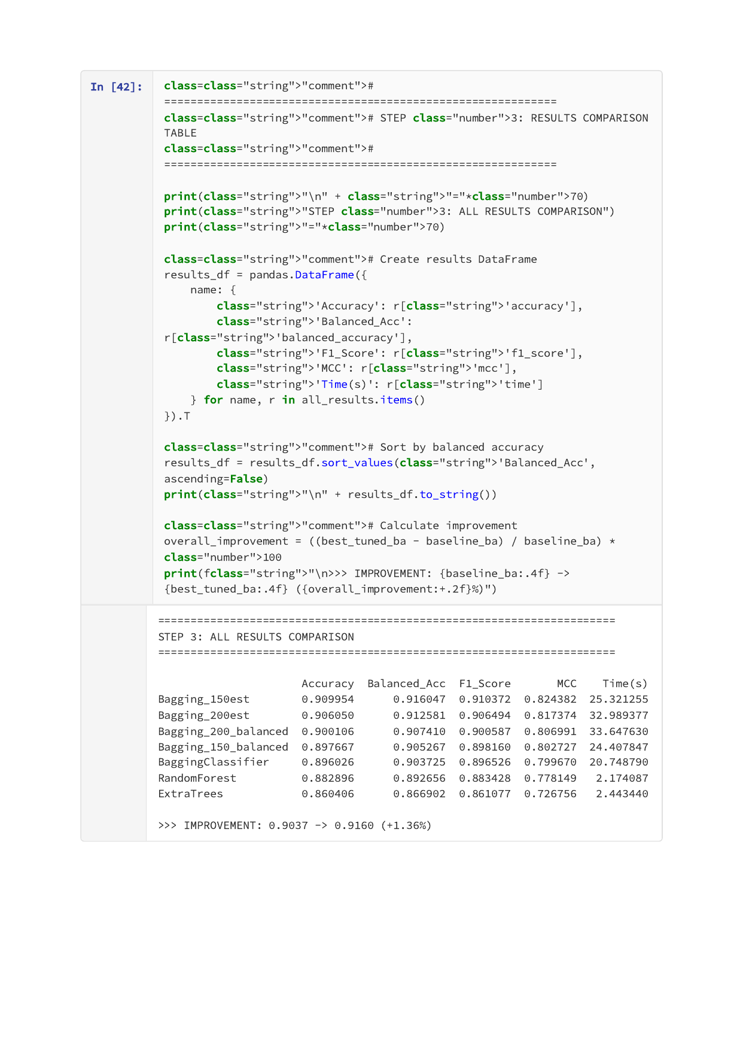

Page 27 of 33


Page 28 of 33


Page 29 of 33


Page 30 of 33
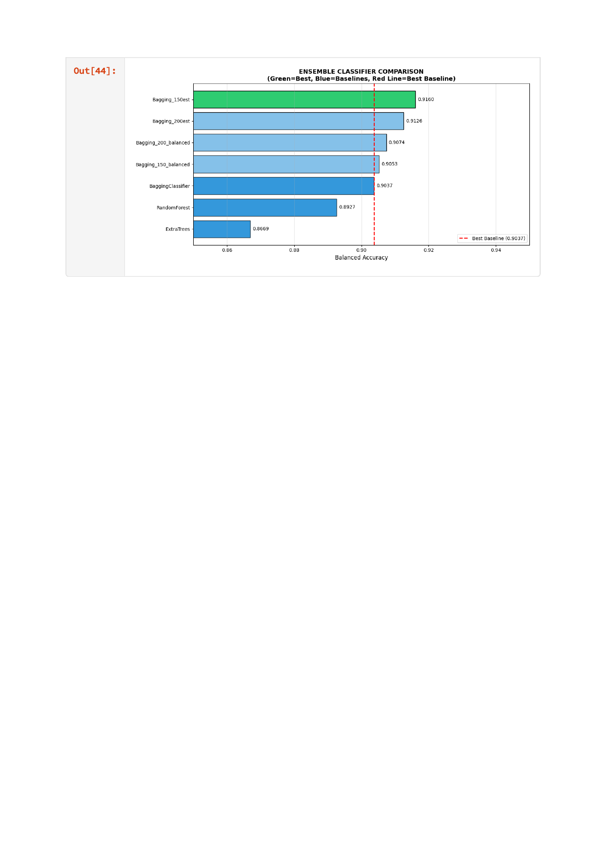

Page 31 of 33


Page 32 of 33


Page 33 of 33


Appendix B: Non-Linear Methods Implementation
DecisionTreeClassifier with Optimized Parameters
Source File: skML-complete_NonLinear.ipynb (34 pages)
Page 1 of 34


Page 2 of 34


Page 3 of 34


Page 4 of 34


Page 5 of 34
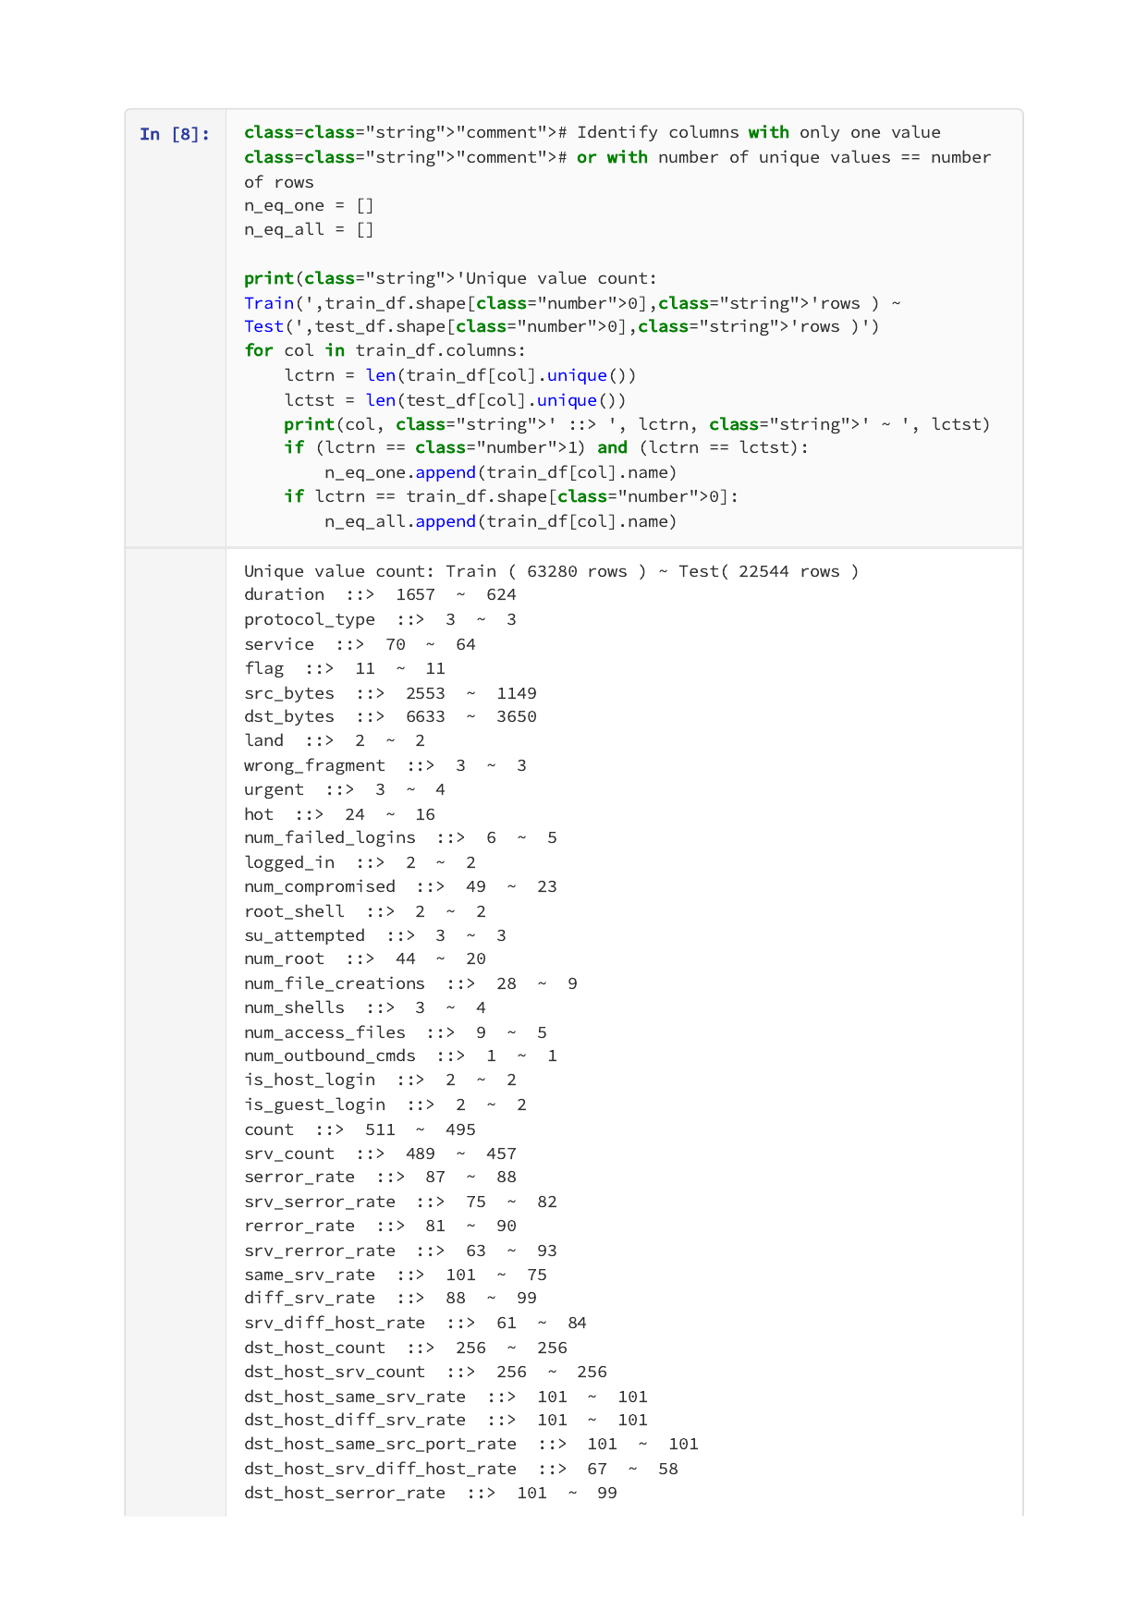

Page 6 of 34


Page 7 of 34


Page 8 of 34


Page 9 of 34
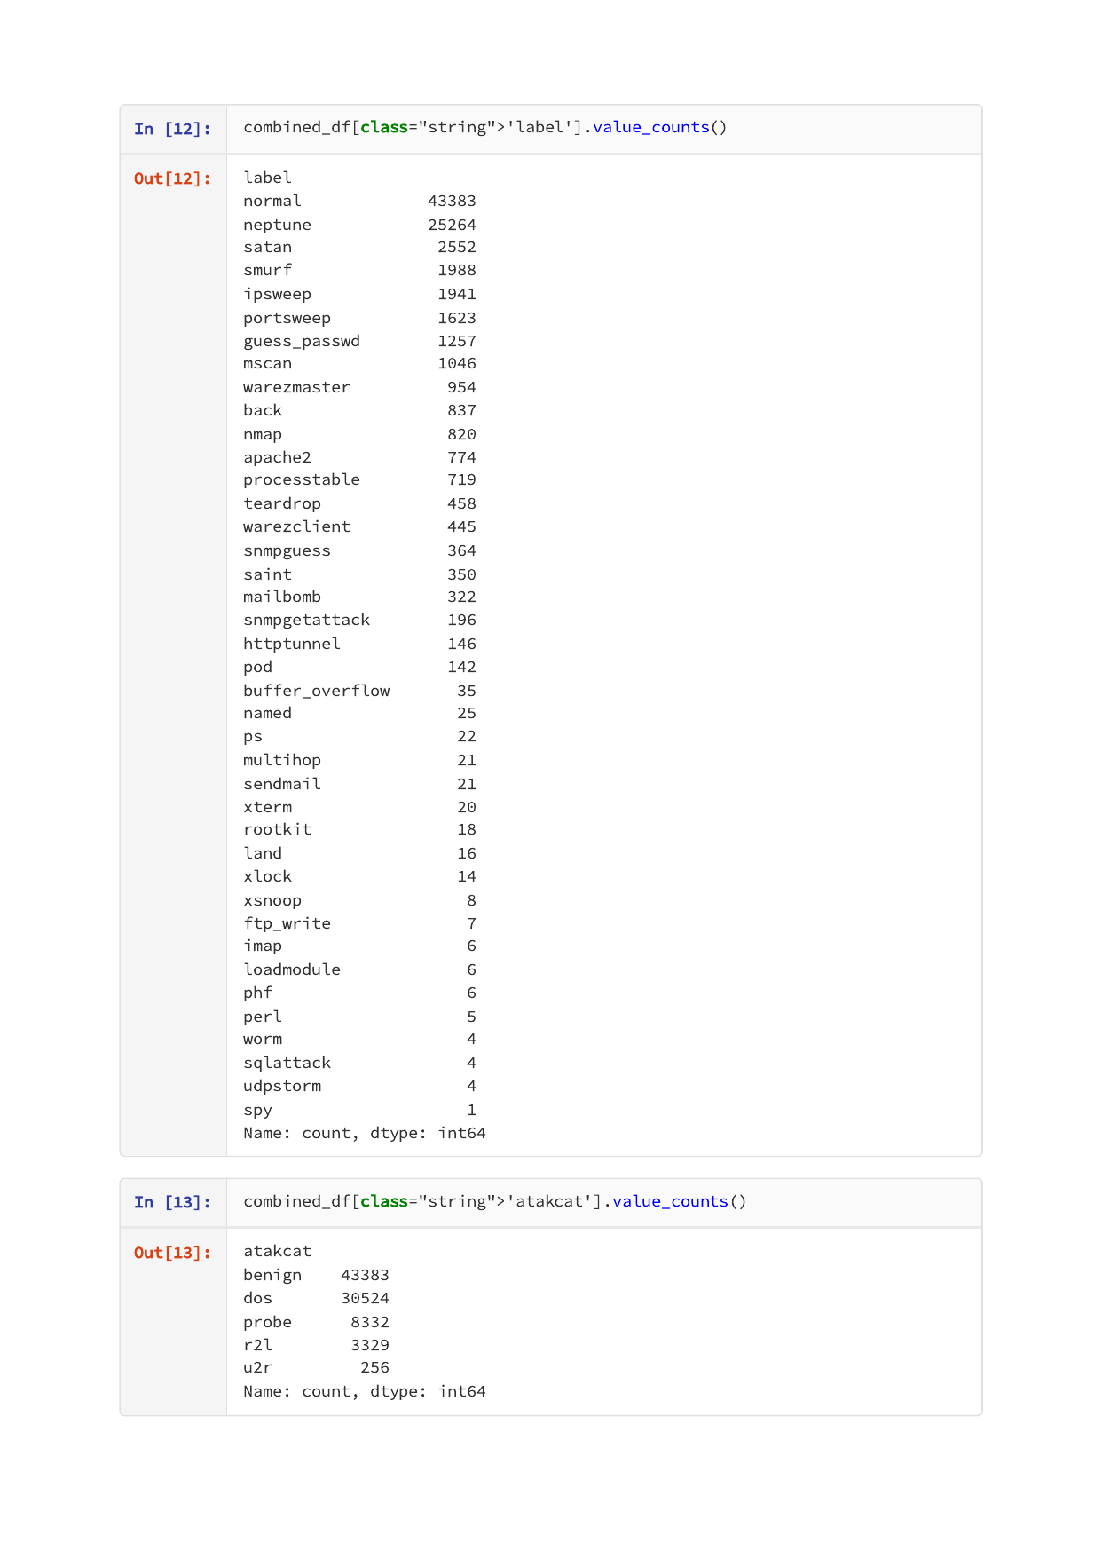

Page 10 of 34


Page 11 of 34


Page 12 of 34
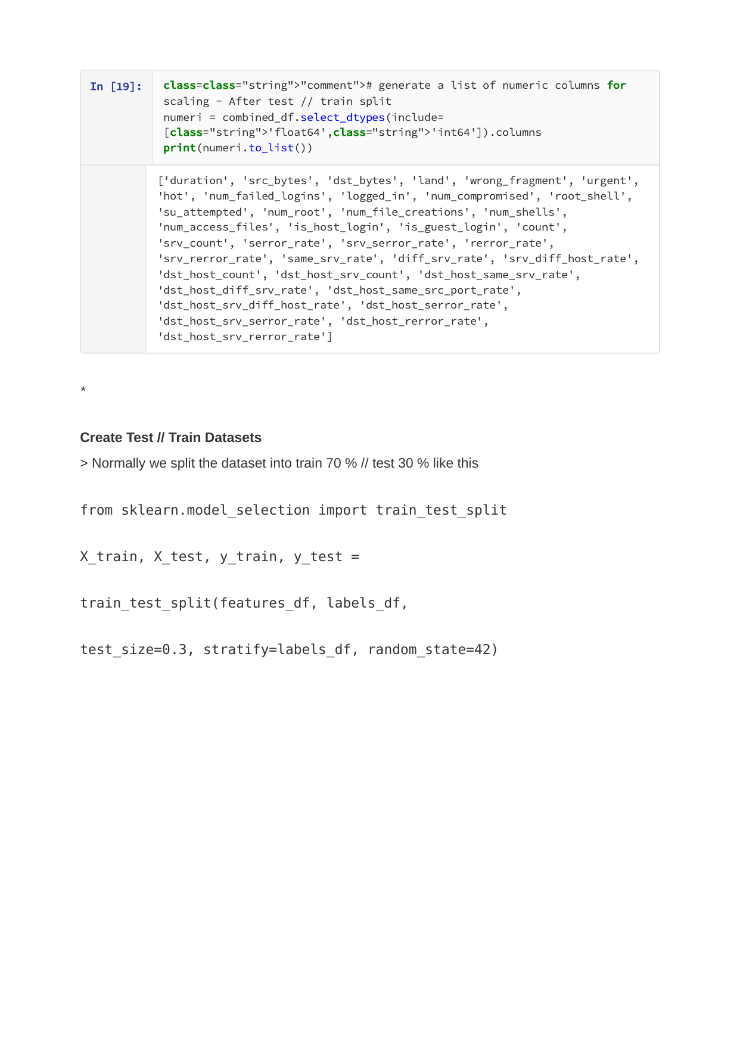

Page 13 of 34


Page 14 of 34


Page 15 of 34
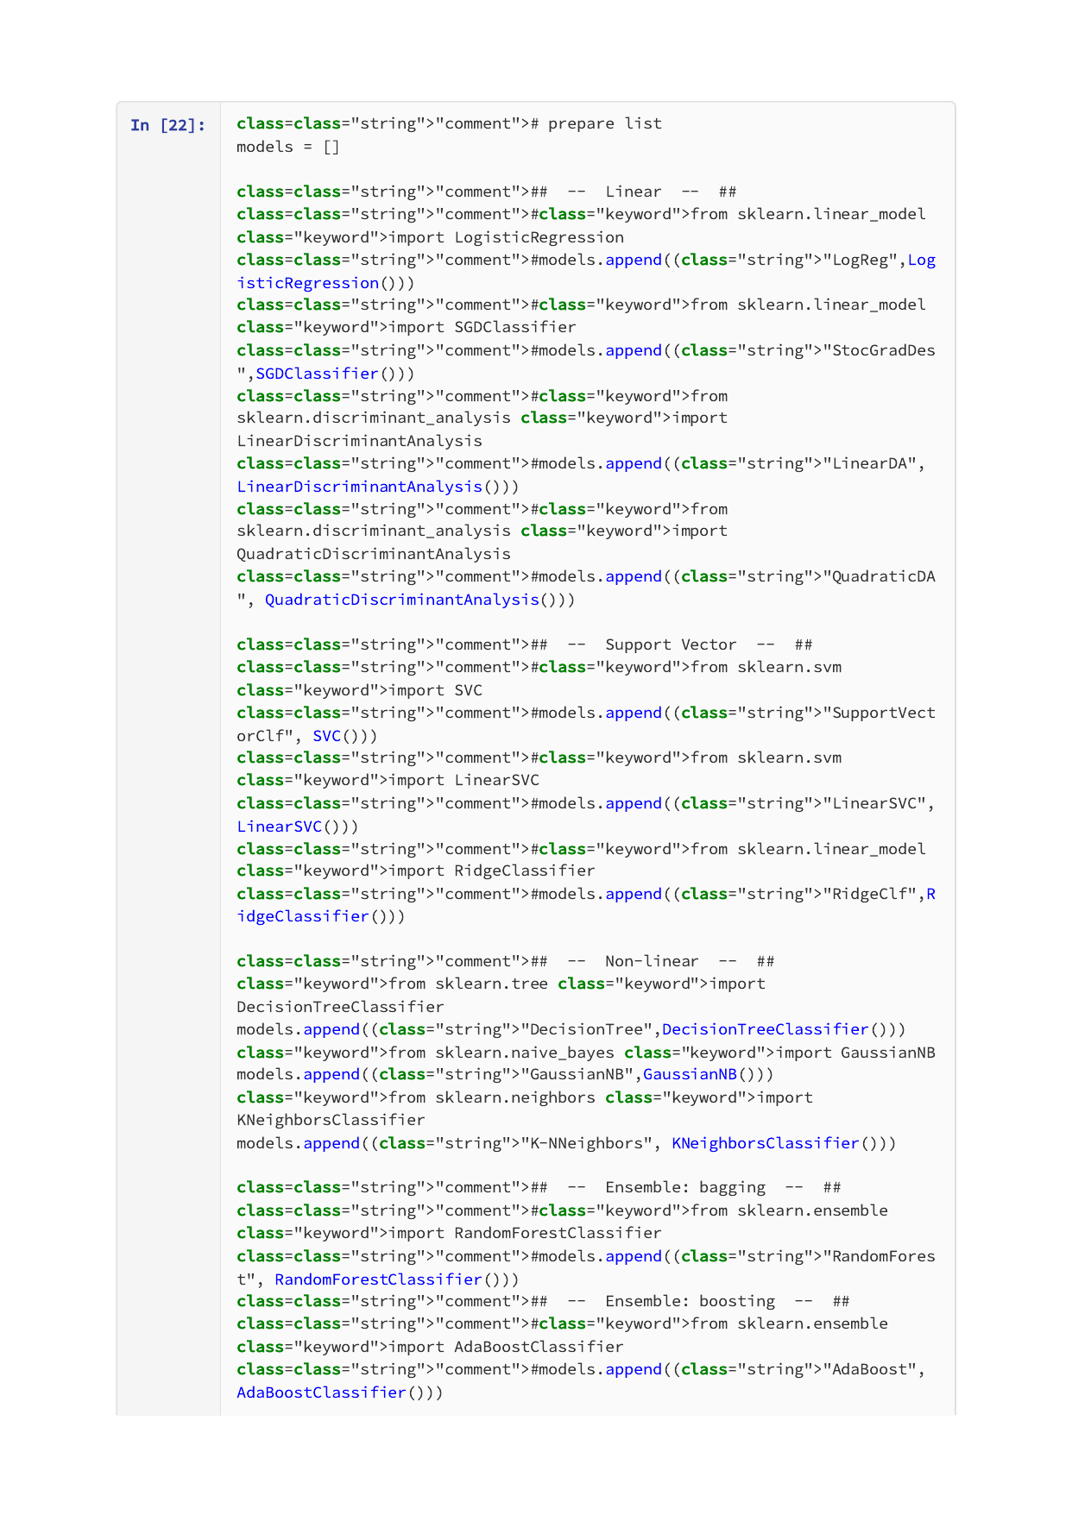

Page 16 of 34
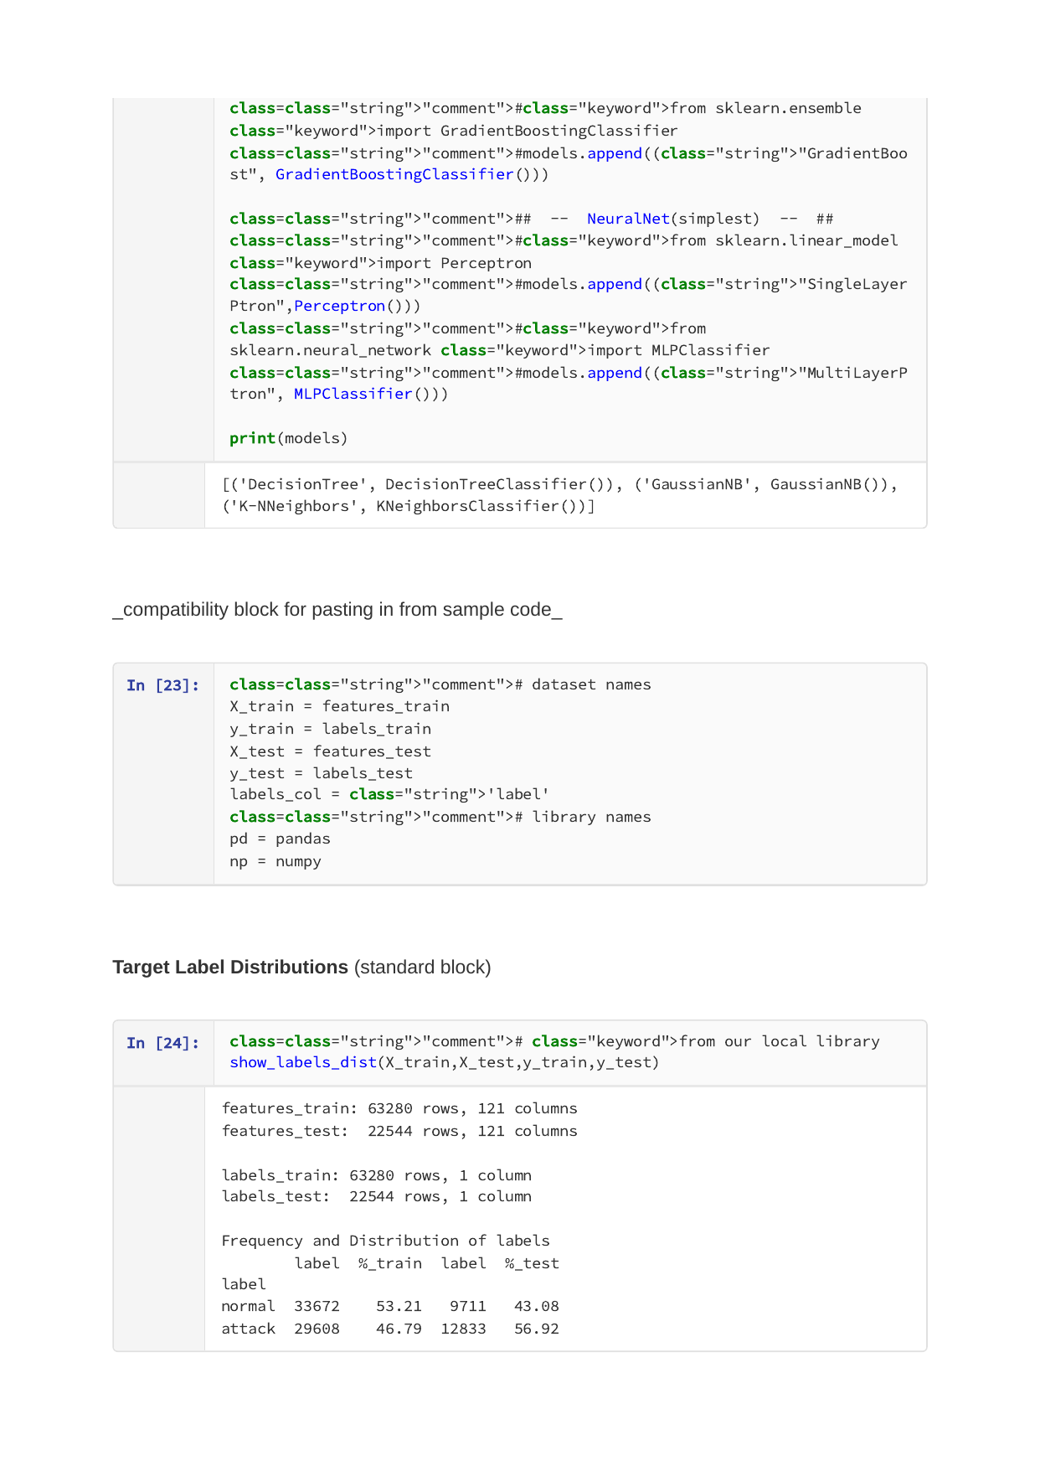

Page 17 of 34


Page 18 of 34


Page 19 of 34
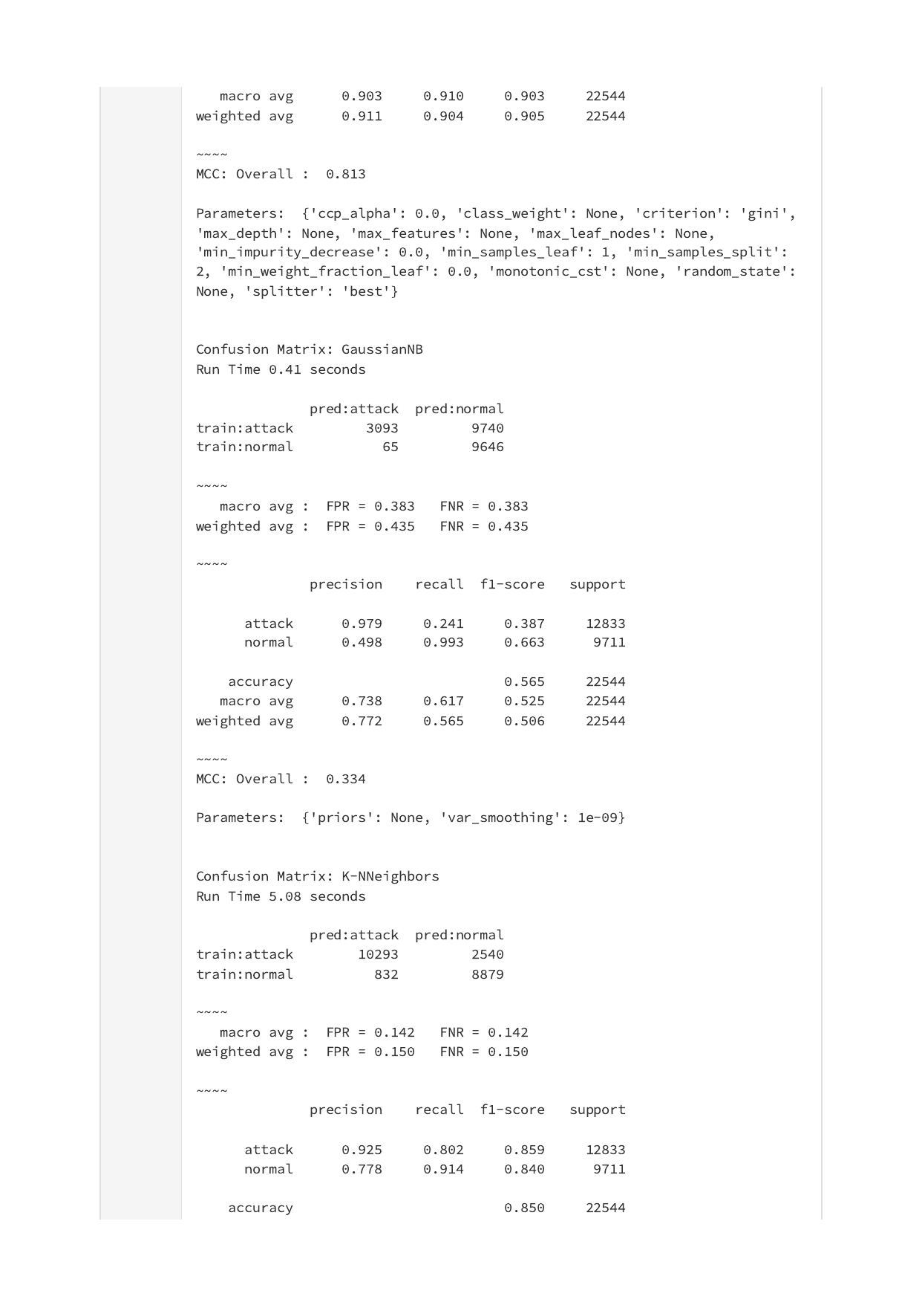

Page 20 of 34
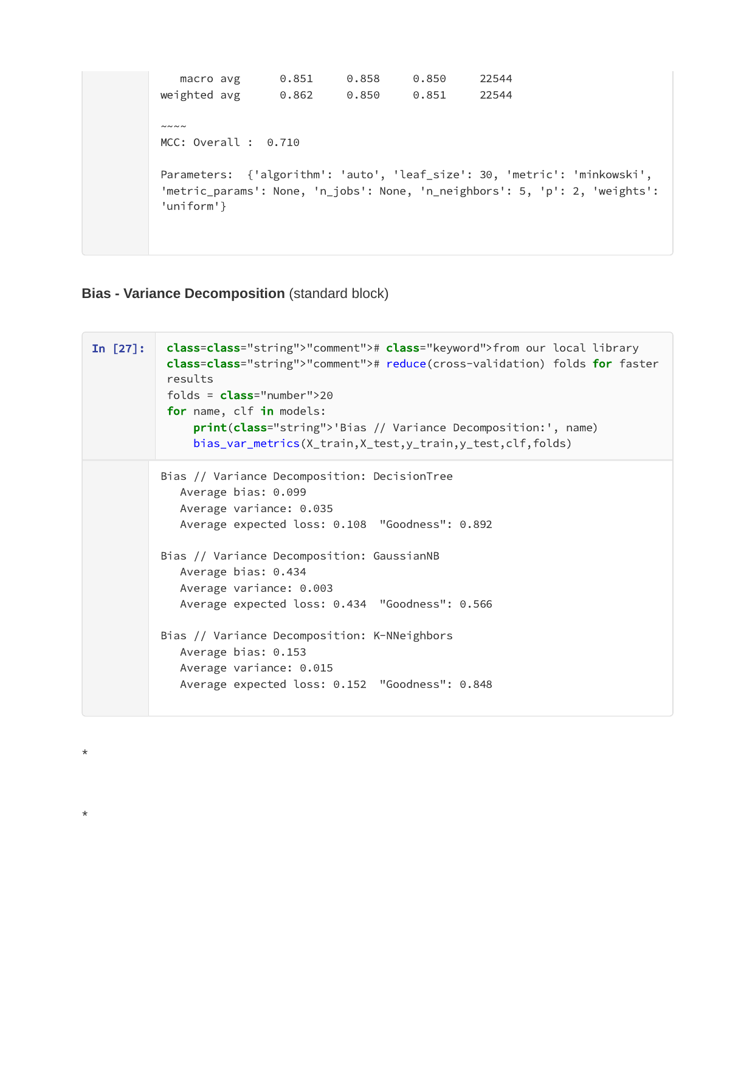

Page 21 of 34


Page 22 of 34
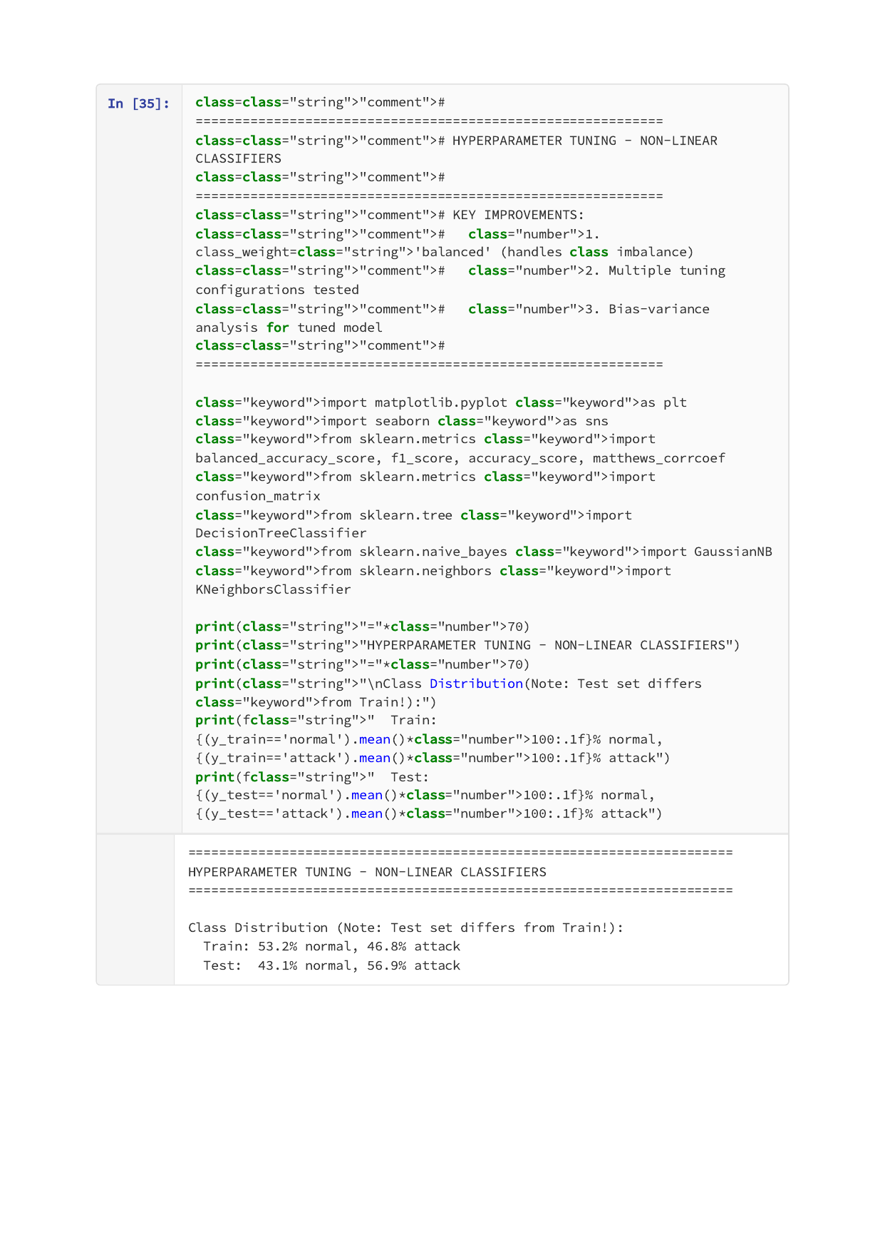

Page 23 of 34


Page 24 of 34


Page 25 of 34


Page 26 of 34
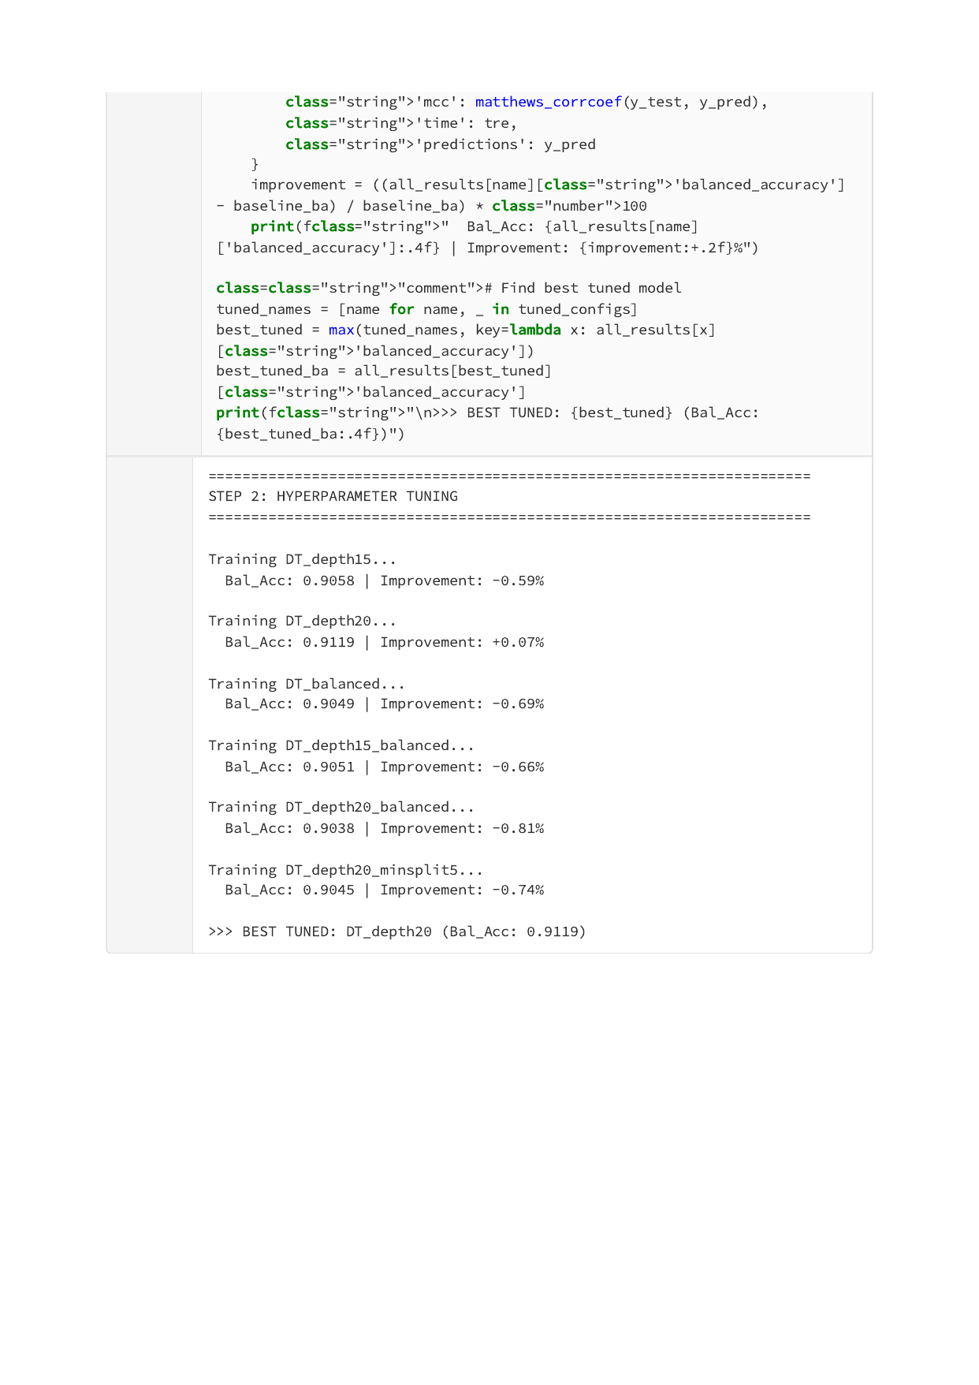

Page 27 of 34
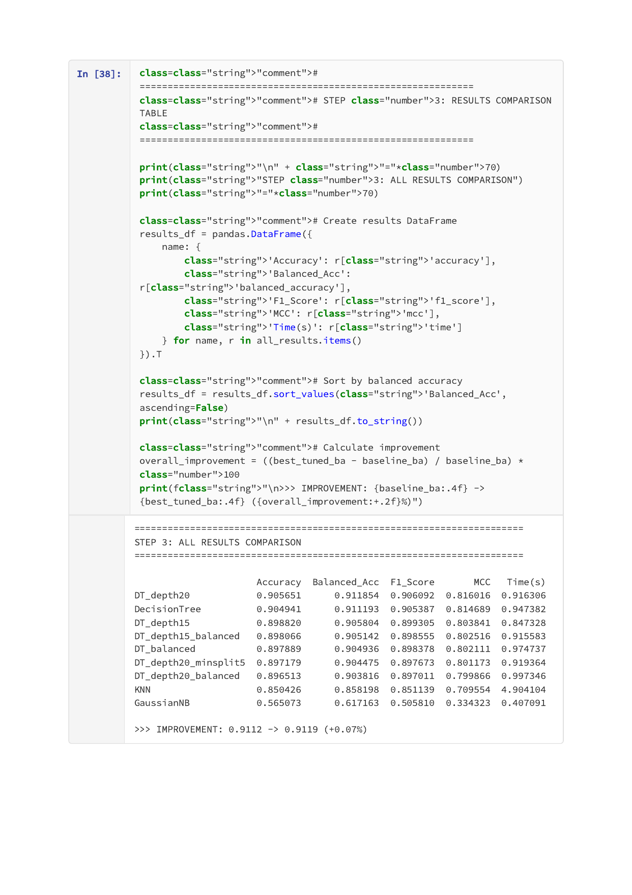

Page 28 of 34


Page 29 of 34


Page 30 of 34


Page 31 of 34
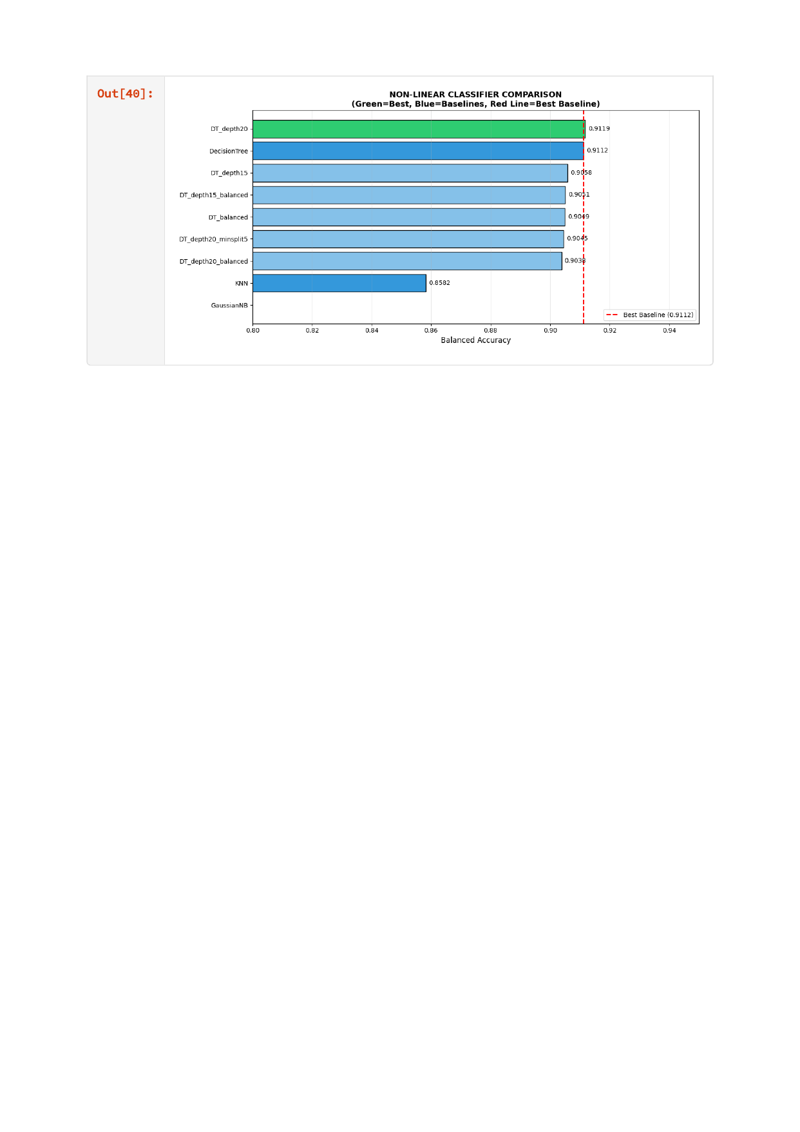

Page 32 of 34


Page 33 of 34


Page 34 of 34


Appendix C: Linear Methods Implementation
RidgeClassifier with Balanced Class Weights
Source File: skML-complete_SupportVector.ipynb (35 pages)
Page 1 of 35


Page 2 of 35


Page 3 of 35


Page 4 of 35


Page 5 of 35


Page 6 of 35


Page 7 of 35


Page 8 of 35


Page 9 of 35


Page 10 of 35


Page 11 of 35


Page 12 of 35


Page 13 of 35


Page 14 of 35


Page 15 of 35


Page 16 of 35
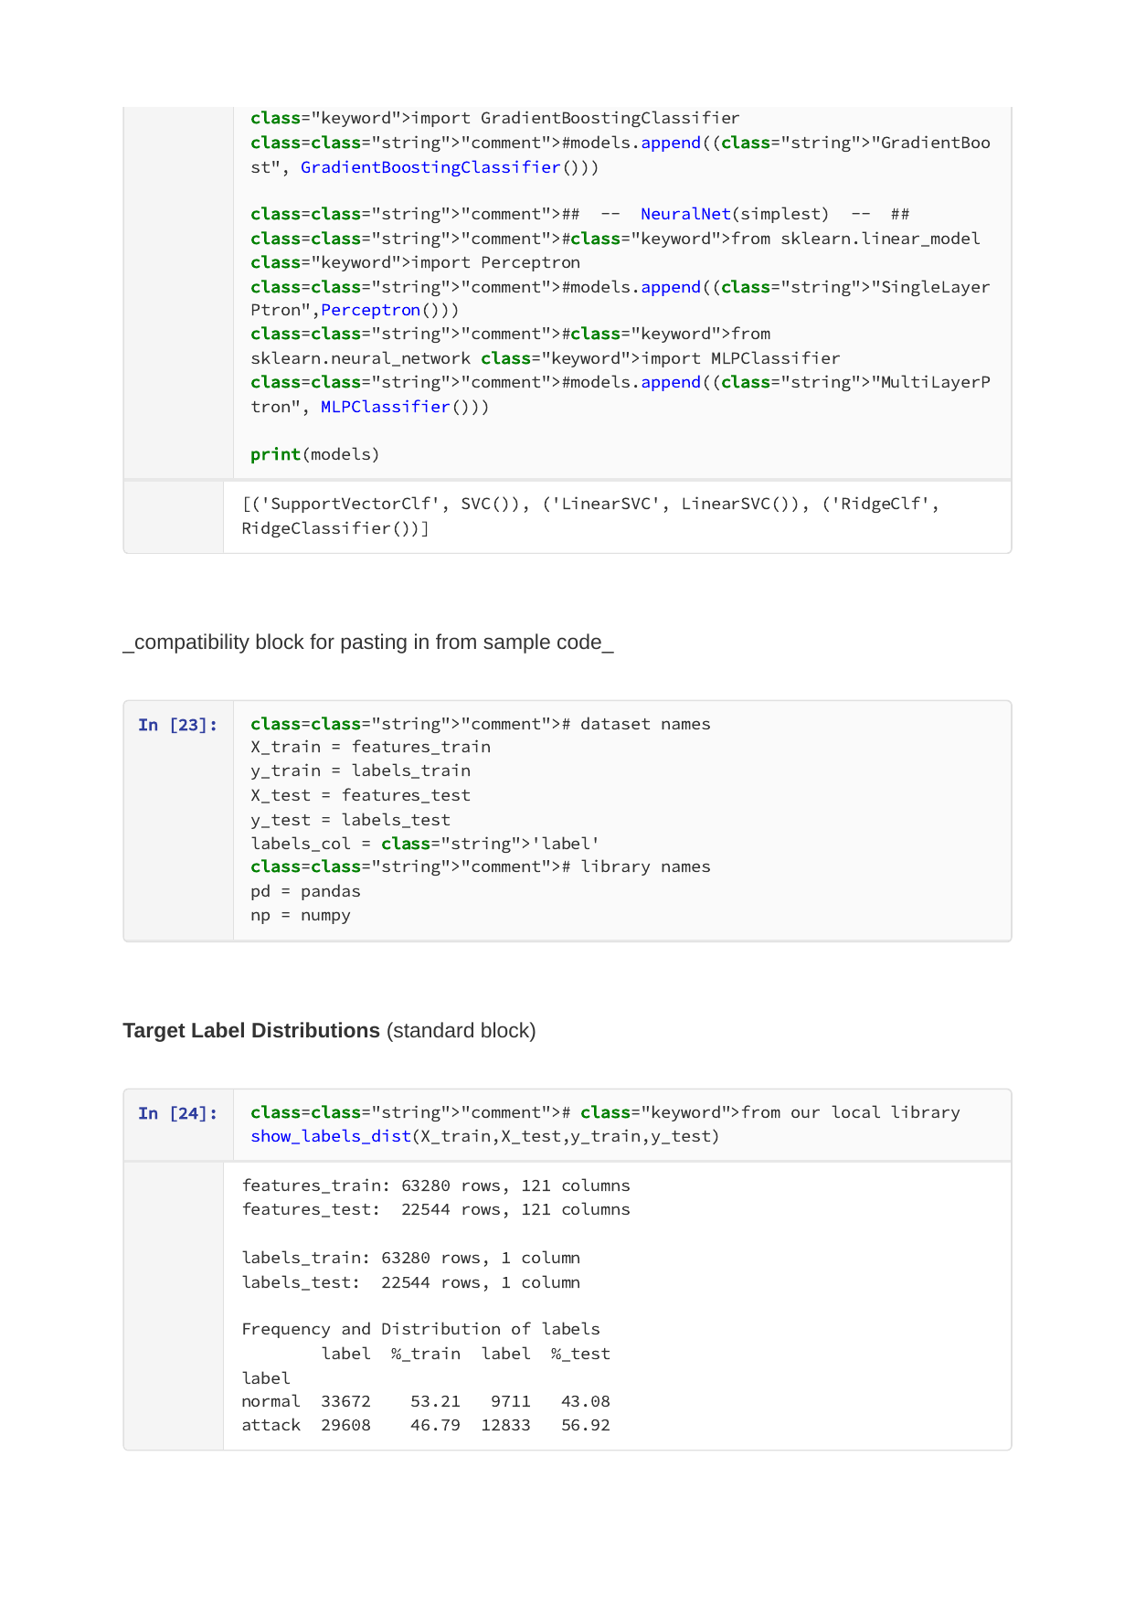

Page 17 of 35


Page 18 of 35


Page 19 of 35


Page 20 of 35
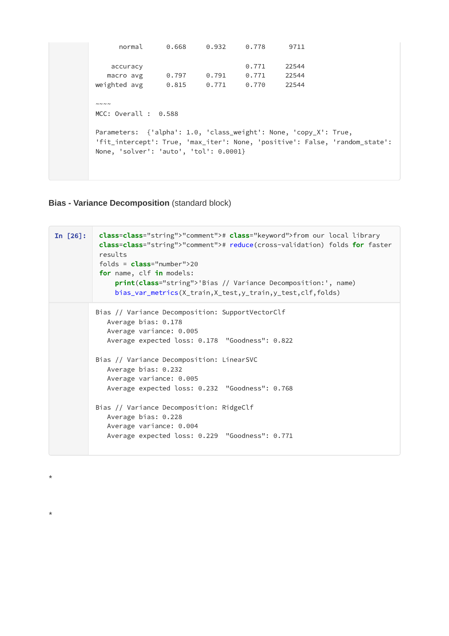

Page 21 of 35


Page 22 of 35
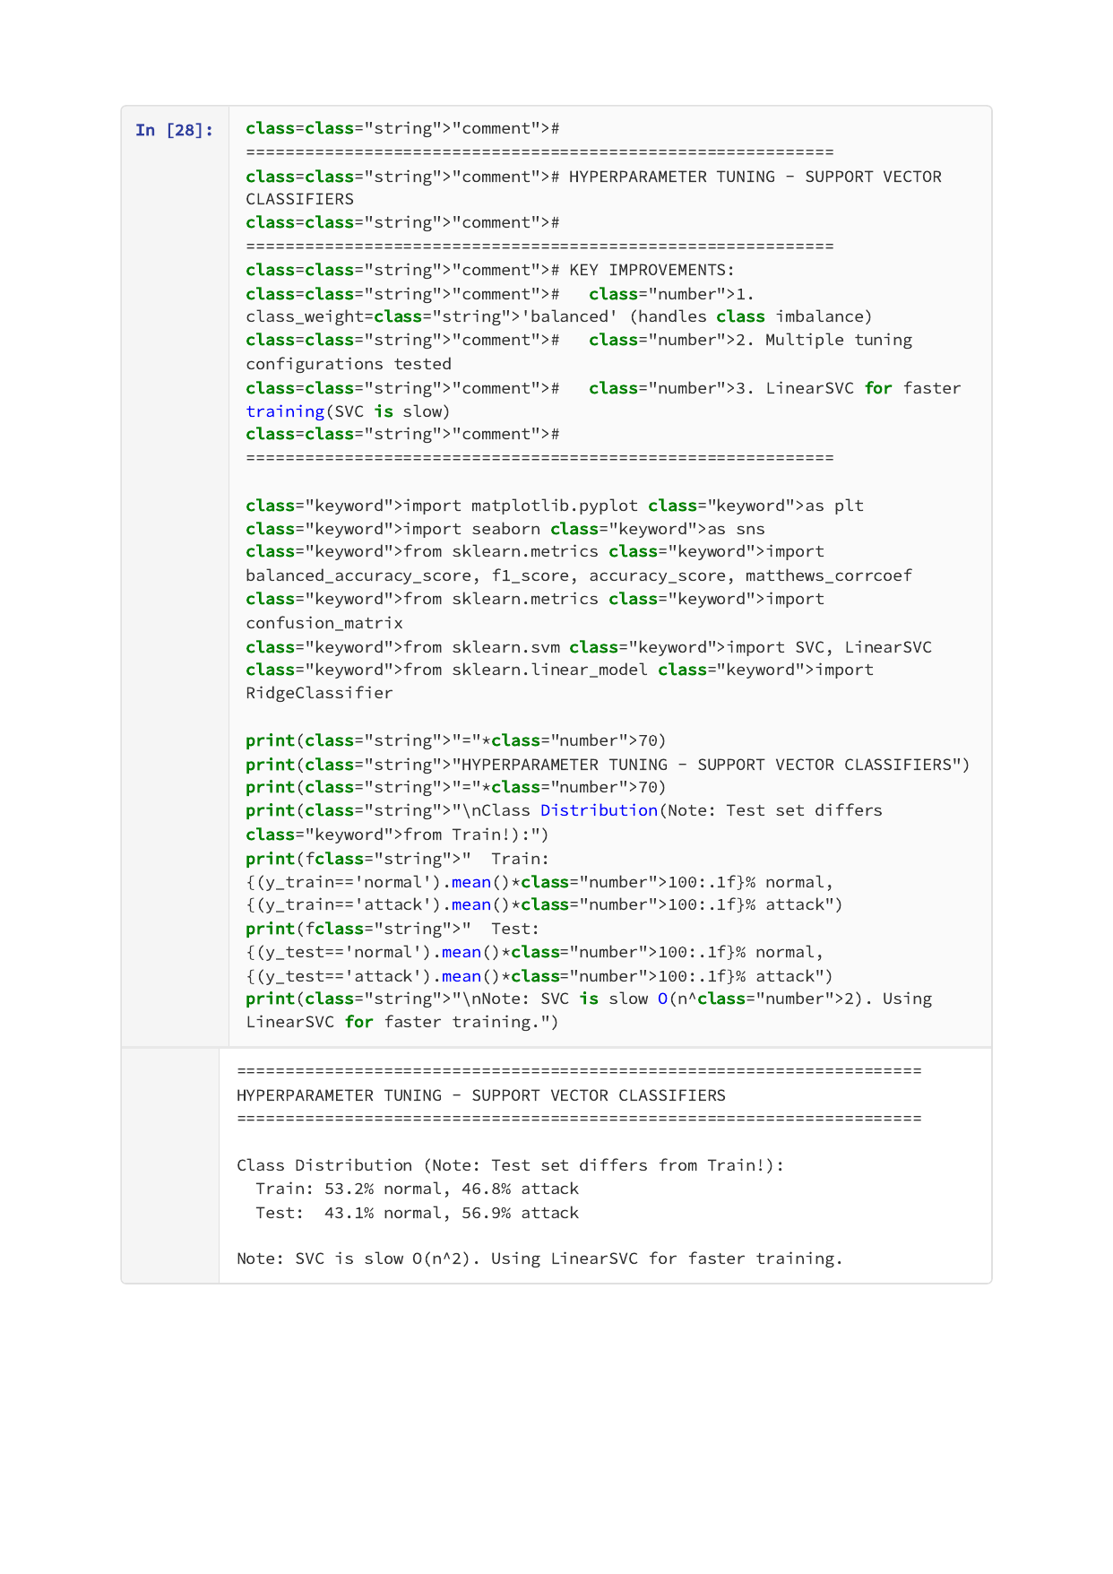

Page 23 of 35


Page 24 of 35


Page 25 of 35


Page 26 of 35
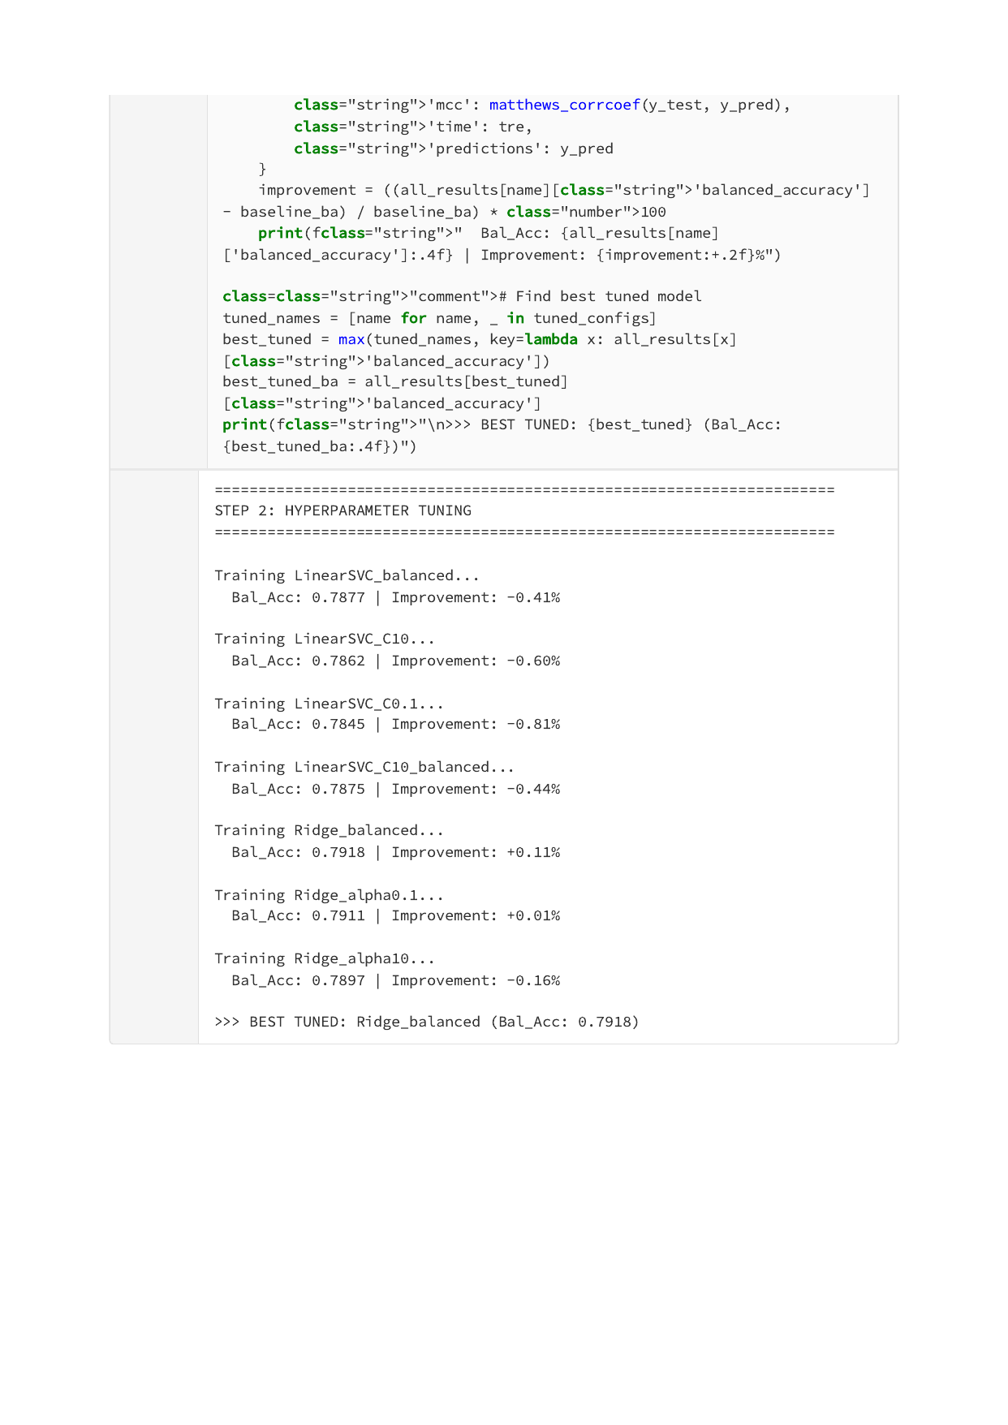

Page 27 of 35
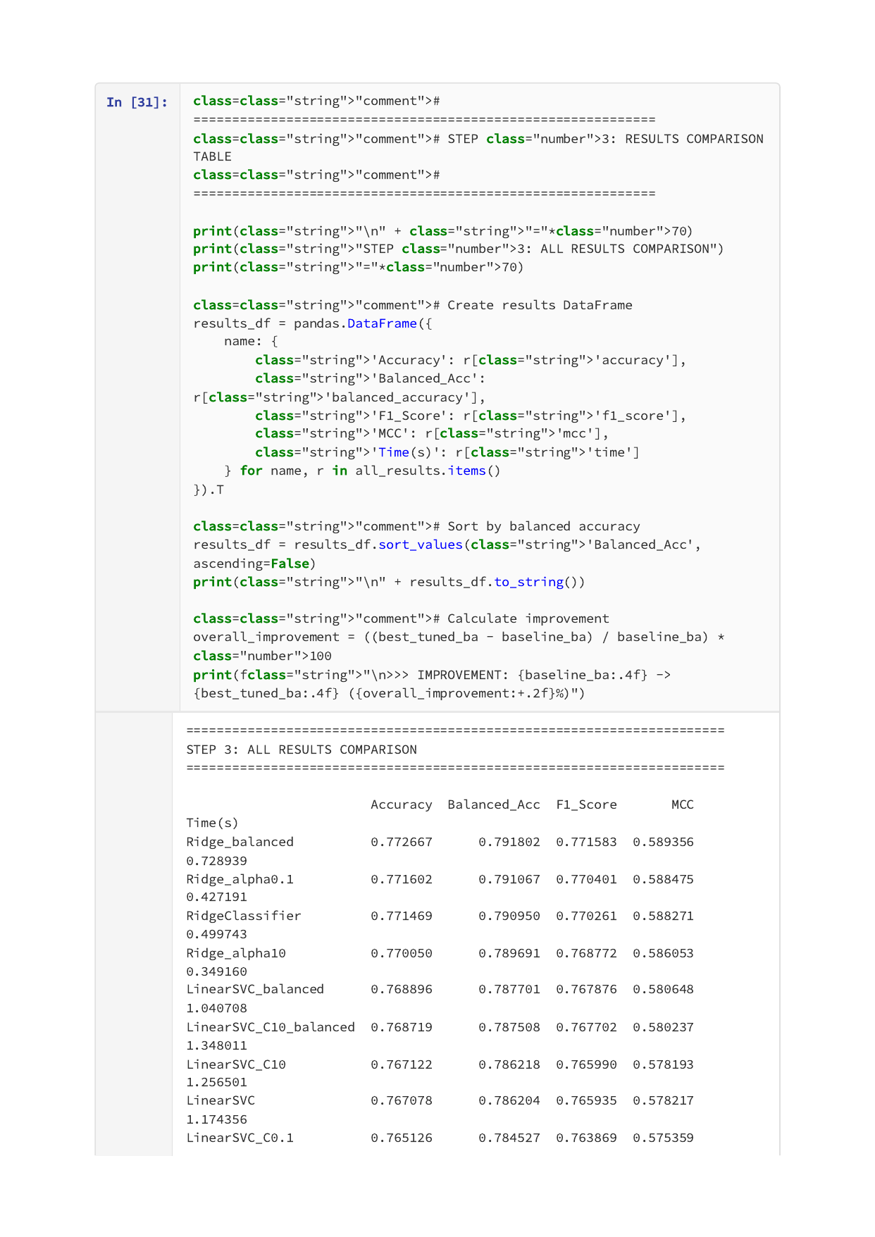

Page 28 of 35


Page 29 of 35


Page 30 of 35


Page 31 of 35


Page 32 of 35
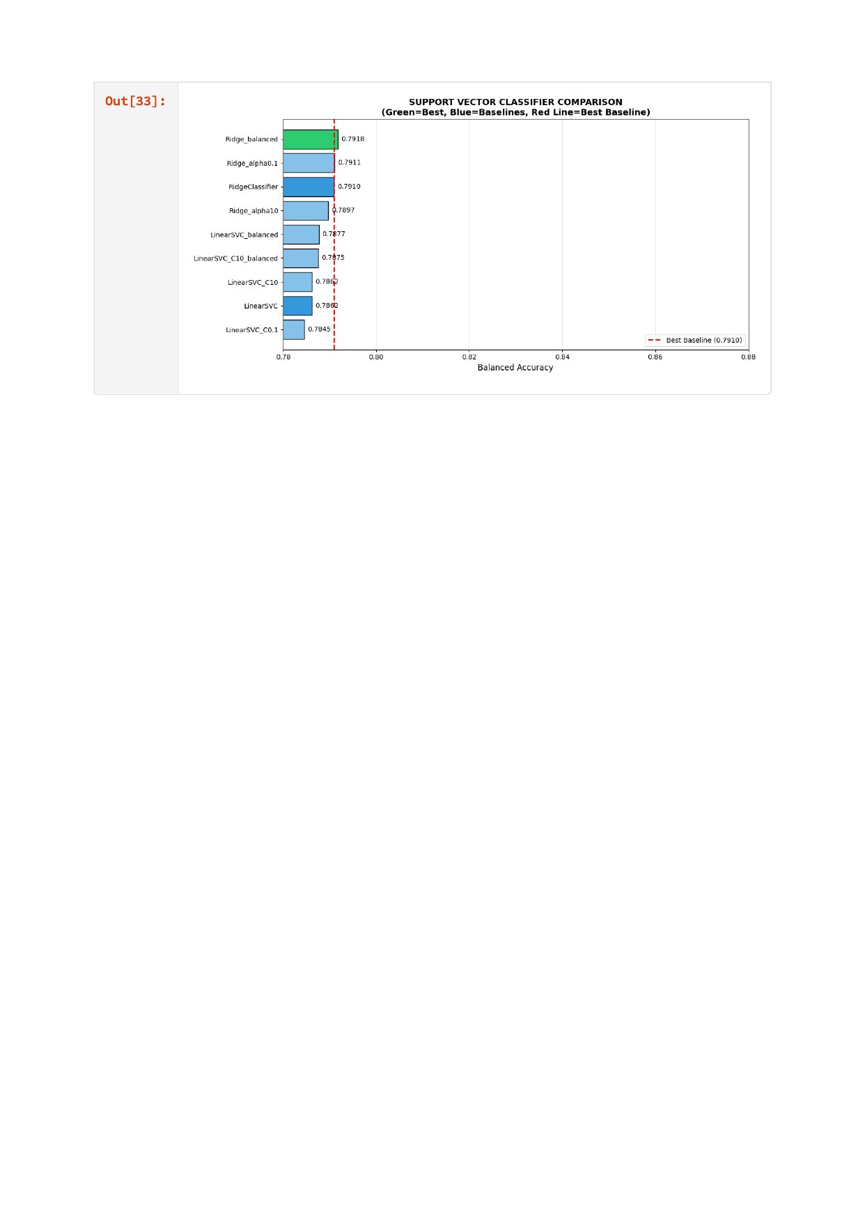

Page 33 of 35


Page 34 of 35
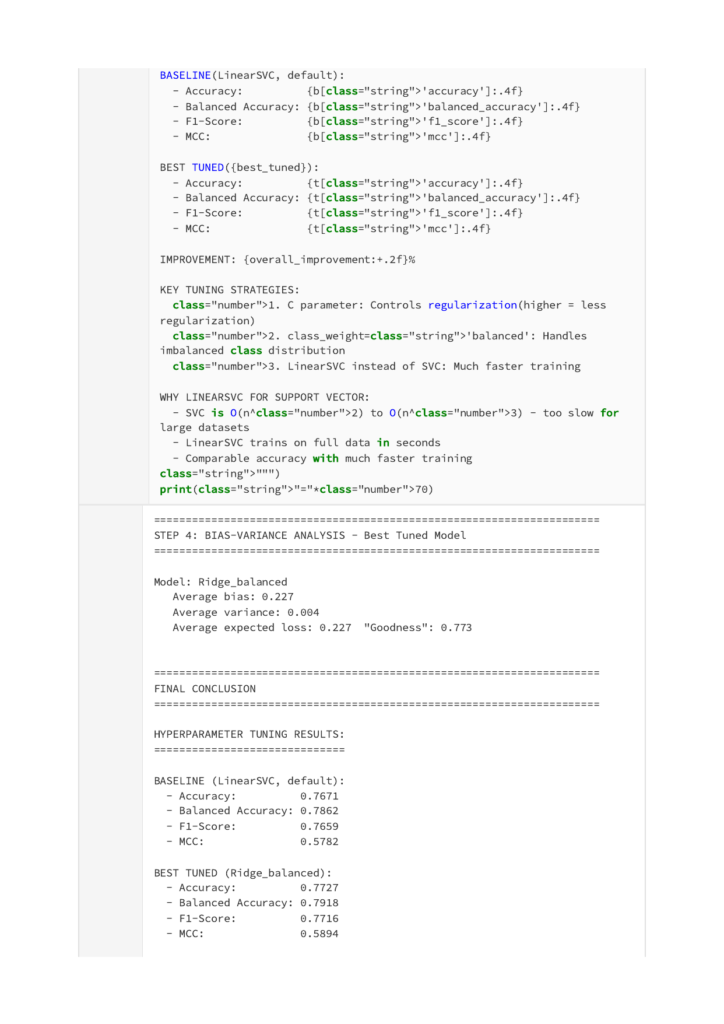

Page 35 of 35


