Evaluating a Microsoft Copilot Studio Agent for Ontario Hospital News Monitoring
Approach, ground truth, experiments, results and recommendations
Prepared by: Sohen Patel
Prepared for: Supervisors and the Ontario Health project team
Date: September 2026 Status: Draft for supervisor review
About this document
This report puts in one place everything done on the Hospital News Agent evaluation: what the agent is, how the evaluation was designed, how the ground-truth dataset was prepared and from which sources, every experiment with the exact prompt used and its results, what the results mean, and what I recommend changing in the agent.
Numbers come from the final validated analysis files (listed in Appendix E). Where earlier documents or slide decks disagree with those files, the files win and the difference is recorded in Appendix F. Recommendations marked [Added from results] are extra suggestions drawn from the experiments; the others come from my earlier notes.

Contents
1. Executive summary 3
2. Background and objectives 3
Timeline 4
People and teams 4
3. The agent 4
4. Evaluation design 5
4.1 Systems compared and how outputs were collected 5
4.2 Hospitals, windows and runs 6
4.3 How answers were scored (main study) 6
5. Ground-truth dataset 7
5.1 Why I built a new one 7
5.2 How it was prepared 7
5.3 Sources used 8
5.4 What the final dataset contains 8
5.5 Version history 8
5.6 Wendy's team review and what it means for the results 9
6. Experiments 9
Experiment 1 – First baseline (28 August) 9
Experiment 2 – Main study on the updated ground truth (30–31 August) 10
Experiment 3 – CEO prompt variations on a short window (late August – early September) 13
Experiments 4 and 5 – The 5-year CEO task: baseline vs chain-of-thought 14
7. What the results say 15
7.1 By task 15
7.2 What is specific to the Copilot agent 15
8. Limitations and caveats 16
9. Recommendations for improving the agent 16
9.1 From my earlier notes 16
9.2 Additional recommendations from the results 17
10. Suggested next steps 17
Appendix A – Prompts 19
A.1 V0 – baseline with explicit dates (Experiments 1, 2 and 4) 19
A.2 V1 – persona and structured scope rules (Experiment 3) 19
A.3 V2 – chain-of-thought turnover test with worked examples (Experiments 3 and 5) 20
A.4 Per-task V1 and V2 prompts written but not run 22
A.5 'V3' – completeness checklist and recall-first directive (written, not run) 23
A.6 Extraction and judging prompts 24
A.7 Agent instructions (revised version) 26
Appendix B – Ground-truth source URLs by hospital 28
Appendix C – Metric definitions used in earlier experiments 28
Appendix D – Additional figures 29
Appendix E – Where the data lives 30
Appendix F – Discrepancies found in the source material 30

1. Executive summary
The Hospital News Agent is a Microsoft Copilot Studio agent that searches for Ontario hospital news. I evaluated it against ChatGPT, Claude, Gemini and Perplexity on three tasks: CEO and board leadership changes, PHIPA decisions, and interim supervisors appointed by the province. Because no independent answer key existed, I built a ground-truth dataset by hand from primary sources and scored every system against it.

Main findings
- CEO task is hard for every system. The best systems, the Copilot agent and ChatGPT, each found about 26% of the 243 in-scope CEO/board events (95% CI 21%–32%). Gemini found about 13%. Only 3 of 10 system pairs can be told apart statistically; the other 7 have overlapping intervals.
- The problem is missing events, not invented ones. After adjudication, precision on the CEO and supervisor tasks was 100% for every system. Across all systems only one item was a complete fabrication (Copilot, Arnprior, Run 4) and two ChatGPT PHIPA items were mischaracterised policy documents.
- On narrow, well-sourced tasks the Copilot agent did very well, but the samples are tiny. It found 3 of 3 PHIPA decisions and 4 of 4 supervisors. ChatGPT and Gemini found 1 of 3 PHIPA decisions; Claude and Perplexity found none.
- Copilot's answers change from run to run. Across five runs the average overlap (Jaccard) on the CEO task was 0.61, and only 33% of the items it ever found appeared in all five runs.
- Most errors are about detail, not existence. Among matched CEO items, role was right about 41% of the time and date about 59% for Copilot. 214 of 297 matched items (all systems) came without a citation link.
- Prompting matters on the large 5-year CEO task. Adding a step-by-step 'turnover test' with worked examples raised Copilot's F1 from 0.247 to 0.419 and ChatGPT's from 0.254 to 0.569, and cut hallucination sharply. The same technique hurt on a small 6-month gold set. These comparisons are not fully like-for-like (Section 8).

What I recommend
- Put the authoritative sources (IPC decisions, Orders in Council) and a small, curated list of hospital sites directly into the agent's knowledge sources, and stop the agent from browsing the open web for the CEO task.
- Consider shortening the CEO window, and add rules for citations, Foundation-vs-hospital roles and shorter outputs.
- Grow the evaluation beyond three hospitals per task, fix the citation-capture gap, and get an independent second reviewer for the ground truth. Full list in Section 9.

2. Background and objectives
The project started in July 2026 as a workplan to (1) review what Microsoft Copilot and Copilot Studio can do, (2) build an evaluation framework for information retrieval, summarisation and presentation of results, and (3) work with the agent's owners to see how configuration changes affect performance. The evaluation centres on an existing Copilot Studio agent that Wendy's team uses to monitor hospital news for Hospital Performance Management.
Task | What the system must return | Window | Ground-truth source
CEO / leadership changes | Incoming and outgoing CEOs, executives (VP/Chief level) and board members, incl. Foundation chairs and officers | 16 Jul 2021 – 16 Jul 2026 (5 yrs) | Hospital sites, annual reports, board minutes, Sunshine List
PHIPA decisions | Privacy-commissioner decisions in which the hospital is the custodian (corrections excluded) | 16 Jan 2026 – 16 Jul 2026 (6 mths) | IPC decisions database
Interim supervisors | Supervisors appointed to a hospital by the Government of Ontario | 16 Jul 2021 – 16 Jul 2026 (5 yrs) | Ontario Orders in Council

Timeline
When (2026) | What happened
13–24 Jul | Started. Reviewed the agent, drafted the evaluation framework, tightened the agent instructions; first progress report (24 Jul).
31 Jul | Metrics agreed: Copilot Studio built-in metrics plus custom precision/recall; first slide deck.
5–7 Aug | Agreed with Wendy's team: same prompt, a new chat for every run, M365 Copilot only. Five runs per prompt justified from the literature.
14–20 Aug | Deck feedback (use the Ontario Health template, keep it high-level); meeting with Susan.
25 Aug | Outputs collected from all five systems (model versions recorded on this date).
27–28 Aug | Found that the earlier analysis treated the agent's own output as truth, so built an independent ground truth. First evaluation presented (Erick, Senthujan).
30–31 Aug | Main evaluation on the updated ground truth (Experiment 2): matching, adjudication, confidence intervals; matching bug found and repaired.
Early Sep | CEO prompt experiments (Experiments 3–5); Wendy's team reviewed CEO ground-truth rows; final deck.

People and teams
- Senthujan Senkaiahliyan – supervisor; set direction (custom evaluation, repeat runs, translational deck).
- Susan and her team – Copilot Studio optimisation; reviewed the deck.
- Wendy's team – runs and manually reviews the agent; developing the agent; reviewed the CEO ground-truth rows.
- Michal – deployed the agent and owns the 'Ontario Hospitals by Region' document.
- Erick, Davood Astakary's group, Ryan Monte – reviewers / second use case, as named in meeting notes.

3. The agent
The Hospital News Agent is built in Microsoft Copilot Studio and used through Microsoft 365 Copilot. Wendy's team was already using it when I joined; my work was to review it, tighten its instructions and evaluate it. The instructions tell it to identify and summarise Ontario hospital news, group results by region, hospital and date, and cite every item with a working link.

How the instructions are organised
Section | Key rules
1. Scope | Default window is the last 12 months. Eight most recent items per hospital (three to five per hospital for a region-wide sweep). Very broad requests get a 'please narrow' reply.
2. Search and source | Prefer mainstream media (CBC, Globe and Mail, Toronto Star, CTV, Global) and hospital sites, then regulators, then aggregators; never an aggregator alone. PHIPA items come from the IPC PHIPA decisions page, never the 'Cases of Note' page. Paywalled sites: use only what is visible, never invent a link.
3. Match hospitals to regions | 'Ontario Hospitals by Region' (144 hospitals, six regions) is the only source of truth for region. Normalise names; roll campuses up to the parent; label anything unmatched.
4. Content rules | Own words, neutral tone; attribute allegations; no patient names; 'no results' is not 'no news'.
5. Format | One table per hospital: Date | Headline | Summary (about 40 words) | Source | Link. Descriptive link text; closing coverage line.

The earlier version of the instructions defined 'news' with explicit include/exclude lists and capped output at the top 10 articles in 12 months. The revised version (full text in Appendix A.7) closes gaps in scope, deduplication, paywalled sources and patient privacy, and uses 8 items per hospital.

Platform facts that matter for performance
- Only one document is a knowledge source today (Ontario Hospitals by Region). Sources such as the IPC and Orders in Council are named in the instructions but not attached as knowledge sources.
- A Word file is searched by chunk-based semantic retrieval, which is probabilistic. An exact-match lookup (Dataverse or Power Automate) would be more reliable for region assignment.
- Copilot Studio often falls back to bullets instead of tables, and automatic citations are not rendered in Teams once the output is customised.
- The instruction field has a size limit (reports range from about 5,000 to 8,000 characters), so long rule lists have to be short.
- The agent can only use public information. It cannot see personal mailboxes or local files.
- Model: the agent's underlying model is recorded as GPT-5 Reasoning in the 'Models Used' document; project notes also list Claude and other GPT variants as selectable. This should be confirmed before publication (Appendix F).

4. Evaluation design

4.1 Systems compared and how outputs were collected
System | Version recorded | Notes
Microsoft Copilot (Hospital News Agent) | Copilot Studio agent, GPT-5 Reasoning; updated version as of 25 Aug 2026 | Run through the M365 agent; five runs per hospital and task
ChatGPT | GPT-5.6 Luna, 'Think Smart' mode | Free tier; one run for comparisons
Claude | Sonnet 5, low effort, extended thinking off | Set to avoid usage limits
Gemini | 3.1 Pro with extended thinking; 3.5 Flash-Lite after limits were hit | Free tier; limits reached quickly
Perplexity | Sonar (default search model) | Free tier

All outputs were collected by hand in each product's web interface. Every LLM was used through a new Google account with no chat history, and every run used a new chat. The outputs were saved as Word documents, one per system, hospital and run.

4.2 Hospitals, windows and runs
Task | Hospitals (Experiment 2 onward) | Window
CEO / leadership | Mackenzie Health, North York General Hospital, Arnprior Regional Health | 5 years
Interim supervisor | London Health Sciences Centre, Renfrew Victoria Hospital, Stevenson Memorial Hospital | 5 years
PHIPA | The Ottawa Hospital, Baycrest, Hamilton Health Sciences | 6 months

The first evaluation (Experiment 1) used six hospitals per task, one per Ontario Health region. For the updated evaluation I narrowed to three hospitals per task whose events could be verified against primary sources. The evaluation cut-off is 16 July 2026, the date the earlier team analysis was shared. Copilot was run five times per hospital and task; every other system was run once. All cross-system numbers use Copilot's Run 1 only, so that no system gets more chances than another; Runs 2–5 are used only for Copilot's own consistency analysis.

4.3 How answers were scored (main study)
Each answer was converted to structured items (person or issue, role, direction, date, source), matched to the ground truth on person and hospital, and every unmatched item was adjudicated by hand:
Bucket | Meaning | Counts against the system?
A – Gold gap | Correct and verifiable, but missing from the ground truth | No (ground truth is updated)
B – Hallucination | Person or event does not exist, or is fabricated | Yes – hallucination rate
C – Wrong attribution | Real person, but wrong hospital, role or entity (e.g. Foundation instead of hospital) | Yes – precision
D – Out of window | Correct but outside the evaluation window | No
E – Out of scope | Real but excluded by the scope rule (Foundation CEOs, committee-only members, non-voting members, administrative staff) | No

Metric | Definition
Recall | Matched in-scope ground-truth items ÷ all in-scope ground-truth items (overall, by confidence tier, and on the independent subset)
Precision | (Matched + bucket A) ÷ returned items after removing buckets D, E and matches to out-of-scope rows
Hallucination rate | Bucket B items ÷ all returned items
Field accuracy | Share of matched items with correct role, date and direction (documented tolerances applied)
Specificity (0–3) | One point each for an exact YYYY-MM-DD date, a named non-generic source, and a stated role. A proxy for how checkable the claim is
Omission rate | Share of matched items with a required field (name, role, date, link) left blank
Consistency | Copilot only: mean pairwise Jaccard overlap of items across the five runs, and share of items present in all five
Confidence intervals | Bootstrap 95% intervals, 1,000 resamples

Documented tolerances count either date or title as correct where two official sources differ (for example an elected date versus a took-office date; 'Chief Nursing Executive' versus 'Chief Nurse Executive'), while distinct offices such as Vice Chair and Second Vice Chair are never conflated. For supervisors the commencement date is used where one is published, otherwise the order date.
Two changes were made to the plan on 31 August 2026 and are disclosed here because they affect interpretation. First, citation validity could not be scored because links were not always copied when outputs were collected (my collection error, not a system property), so specificity is reported instead. Second, a matching bug was found: when a person had several ground-truth rows at one hospital, the matcher accepted the first name match without checking the date or direction. A repair step re-scored and repointed 161 matches across 26 files, which raised recall for every system and improved role and date accuracy. All numbers in this report are after the repair.

5. Ground-truth dataset

5.1 Why I built a new one
The team analysis that came first compared each tool with the agent's own output, so the agent effectively marked its own homework. To measure recall honestly I needed an answer key that did not come from the systems being tested. Each row had to be traceable to an exact, checkable source, and I needed to know which rows were discovered independently and which were first reported by one of the systems.

5.2 How it was prepared
- Starting point. An initial dataset from the five systems' answers and Wendy's team's analysis (112 CEO rows).
- Verification. Every row was checked against a primary source, and landing-page links were replaced with the exact document. Roughly 54 landing-page links were upgraded to exact URLs across the three hospitals.
- Gap search. I searched board minutes, annual reports, expense-disclosure pages and the Sunshine List for people the systems had not surfaced. This grew the CEO ground truth from 112 to 243 in-scope rows.
- Field audit. Names, roles and dates were audited row by row (Mackenzie 115 rows, North York General 78, Arnprior 52 at the final audit), correcting, among other things, two appointments that were a year out and a Vice Chair versus Second Vice Chair mix-up.
- Scope adjudication. One consistent scope rule was applied to all rows (below).
- Provenance tagging. Each row is tagged as newly added (not found by any tool), verified by Wendy's team analysis, or included after a scope change, so recall can be reported on an independent subset.
Scope rule for the CEO task
In scope: board directors and governors (hospital and Foundation), Foundation chairs and board officers, and senior leadership (VP, Chief and equivalent).
Out of scope: Foundation CEOs, committee-only members with no board seat, non-voting community members, and administrative or trainee staff.

Each CEO row carries a confidence tier: A – a specific dated announcement or record; B – confirmed on a directory page but no date published; C – date inferred or given only to month or year. A blank date is a documented state, not an omission.

5.3 Sources used
Task / hospital | Sources
CEO – Arnprior Regional Health | Public reports and board pages on the hospital site; Annual Reports to the Community 2021-22 to 2025-26 and audited financial statements; news releases; board minutes (June and September 2023); Ontario Sunshine List
CEO – Mackenzie Health | News page, Executive Leadership and Board of Directors pages; Foundation board page; Organizational Structure chart (effective July 2025); the 'Mackenzie Health Insider'; open board minutes (16 of 17 sets, Feb 2023 – Oct 2025); Sunshine List
CEO – North York General Hospital | Board of Governors, Leadership Team and Clinical Chiefs pages; news and media pages; Fiscal Accountability page (expense disclosures with exact start and end dates); an archived 2022 page with full rosters; Sunshine List
Interim supervisor (all) | Ontario Orders in Council (ontario.ca/search/orders-in-council); hospital-published supervisor reports for commencement dates
PHIPA (all) | Information and Privacy Commissioner decisions database (decisions.ipc.on.ca), PHIPA and general orders sections

Searches of mainstream media (CBC, Globe and Mail, Toronto Star, CTV, Global) for the three CEO hospitals turned up no names that were not already on the hospitals' own sites. The hospital newsroom is effectively the only announcement channel.

5.4 What the final dataset contains
CEO gold set | Rows | In scope | Tier A | Tier B | Tier C
Mackenzie Health | 116 | 114 | 96 | 15 | 3
North York General Hospital | 80 | 78 | 45 | 15 | 18
Arnprior Regional Health | 52 | 51 | 30 | 13 | 8
CEO total | 248 | 243 | 171 | 43 | 29

Of the 243 in-scope CEO rows, 146 were newly added by me (not found by any tool), 85 were also in Wendy's team analysis, and 12 were included after the scope rule was widened. The five out-of-scope rows are Foundation CEOs.
Task | Rows | In scope | Contents
PHIPA | 6 | 3 | Ottawa: PHIPA Decision 340 and PO-4820 (in scope), Decision 326 (a correction request, out). Hamilton: PHIPA Decision 338 (in), pediatric death review orders (out – FIPPA, not PHIPA). Baycrest: confirmed zero events.
Interim supervisor | 5 | 4 | Stevenson Memorial: two supervisors in scope, one investigator (s.8) out. Renfrew Victoria: one supervisor. London Health Sciences Centre: one supervisor.

5.5 Version history
Stage | CEO rows | What changed
First-evaluation set (28 Aug) | 99 (80 in scope), 6 hospitals | Built by pooling AI outputs; executive roles excluded; some AGM-based dates were wrong; two attempts to close gaps with a second LLM produced one fabricated roster.
Updated drafts v0–v3 (28–29 Aug) | 66 → 112 | New three-hospital design; 'included/excluded' then 'status' column added.
Draft chain (29–30 Aug) | 128 → 243 | Minutes, expense disclosures and Sunshine List added; confidence tiers introduced; links upgraded.
Read Me / Corrections version (30 Aug) | 243 | Hand-off to Wendy's team with legend, corrections and change log.
Wendy's team review (early Sep) | 243 (153 reviewed) | Team agreed with 35 reviewed rows and disagreed with 118 (see 5.6).
Scoring version (31 Aug) | 248 (243 in scope) | Five rows added after systems surfaced real people who were then verified (Arnprior Chiefs of Staff, Mackenzie Professional Staff Association president, two NYGH chiefs); one date completed.

5.6 Wendy's team review and what it means for the results
Wendy's team reviewed the 153 highlighted rows. They agreed with 35 and disagreed with 118. The main reasons for disagreement were that the linked page shows current membership rather than a change event (about 60 rows), that the link does not name the person, dead links, Foundation roles they consider out of scope, re-elections that are not turnover, and dates outside the window. They also supplied corrected links for 13 rows.
Those comments arrived after the scoring version was frozen and have not yet been applied to it. Two consequences: some in-scope rows describe people who are confirmed in post rather than events that changed, which lowers every system's measured recall; and 'Verified by Wendy's team' means the name appeared in their analysis, not that a reviewer checked the row. I treat the current numbers as valid for comparing systems on one shared answer key, but not as a final measure of absolute recall (Section 8).

6. Experiments
Five experiments were run. Their gold sets, matching rules and definitions differ, so results should be read within an experiment, not compared across rows of different experiments.
# | Experiment | Question | Gold set | Prompt
1 | First baseline | How do the systems compare on the first answer key? Deterministic matching vs LLM-as-judge | v1, 6 hospitals/task (116 rows) | V0
2 | Main study | Full 5-system × 3-task evaluation with adjudication and confidence intervals | Updated, 3 hospitals/task (259 rows) | V0
3 | CEO prompts, short window | Does prompt engineering help on a small 6-month CEO set? | 16 items (V0, V1); 7 items (V2) | V0, V1, V2
4 | CEO 5-year baseline | How do systems do on the verified 5-year CEO set? | 133 items | V0 (5-yr)
5 | CEO 5-year, chain of thought | Does the step-by-step prompt help on the 5-year set? | 133 items | V2 (5-yr)

Experiment 1 – First baseline (28 August)
Purpose. Run the original prompt with explicit dates (V0) through Copilot (five runs) and the four LLMs, and score with two methods: deterministic name/date matching, and Claude acting as an LLM judge on relevance, groundedness, completeness and answer relevancy. Prompt: V0 for all three tasks (Appendix A.1). Gold set: first-evaluation set – CEO 99 rows (80 in scope), PHIPA 9 (3), supervisor 8 (4) – across six hospitals per task.
Table 1. Deterministic scoring, prompt V0 (a blank F1 means precision and recall were both zero). Copilot rows pool all five runs, so its gold counts are five times larger.
System | Task | Gold | Returned | Matched | Recall | Precision | F1
ChatGPT | ceo | 80 | 81 | 29 | 0.362 | 0.358 | 0.360
ChatGPT | phipa | 3 | 9 | 1 | 0.333 | 0.111 | 0.166
ChatGPT | supervisor | 4 | 7 | 3 | 0.750 | 0.429 | 0.546
Claude | ceo | 80 | 45 | 16 | 0.200 | 0.356 | 0.256
Claude | phipa | 3 | 5 | 0 | 0.000 | 0.000 | –
Claude | supervisor | 4 | 9 | 3 | 0.750 | 0.333 | 0.461
Gemini | ceo | 80 | 20 | 11 | 0.138 | 0.550 | 0.221
Gemini | phipa | 3 | 6 | 0 | 0.000 | 0.000 | –
Gemini | supervisor | 4 | 8 | 4 | 1.000 | 0.500 | 0.667
MS Copilot Agent (5 runs pooled) | ceo | 400 | 380 | 174 | 0.435 | 0.458 | 0.446
MS Copilot Agent (5 runs pooled) | phipa | 15 | 43 | 6 | 0.400 | 0.140 | 0.207
MS Copilot Agent (5 runs pooled) | supervisor | 20 | 45 | 8 | 0.400 | 0.178 | 0.246
Perplexity | ceo | 80 | 61 | 15 | 0.188 | 0.246 | 0.213
Perplexity | phipa | 3 | 12 | 0 | 0.000 | 0.000 | –
Perplexity | supervisor | 4 | 6 | 0 | 0.000 | 0.000 | –

Table 2. LLM-as-judge scores averaged over tasks (Claude was the judge and also a system under test).
System | Recall | Precision | F1 | Relevance (0–3) | Groundedness (0–3) | Completeness | Answer relevancy
ChatGPT | 0.436 | 0.595 | 0.779 | 0.667 | 0.630 | 0.539 | 0.667
Claude | 0.462 | 0.883 | 0.839 | 0.741 | 0.796 | 0.682 | 0.722
Gemini | 0.457 | 0.672 | 0.715 | 0.796 | 0.685 | 0.682 | 0.759
MS Copilot Agent | 0.641 | 0.428 | 0.592 | 0.833 | 0.611 | 0.713 | 0.797
Perplexity | 0.357 | 0.800 | 0.839 | 0.630 | 0.537 | 0.568 | 0.611

Takeaways. Copilot had the highest recall on the first answer key and the best relevance, but lower precision. Its individual runs were unstable: CEO F1 ranged from 0.38 to 0.51 across runs, one PHIPA run and one supervisor run matched nothing. PHIPA is where the gap between systems is largest: Copilot and Gemini found the Hamilton decision while others found none, which I attribute partly to infrastructure (Copilot fetched public organisation pages without being flagged as a bot). This experiment is superseded because its answer key was partly built from the systems' own outputs.

Experiment 2 – Main study on the updated ground truth (30–31 August)
Purpose. The reference evaluation: five systems, three tasks, independent ground truth, adjudication of every unmatched item, bootstrap confidence intervals and Copilot's five-run consistency. Prompt: V0 with explicit dates (the wording of Wendy's team's original prompt, with only the dates made exact). Extraction and matching: 671 items were extracted from the 81 response files by rule (every item, including ones that look wrong), matched, and adjudicated as in Section 4.3.
I'm a Chief Regional Officer for Ontario Health, interested in hospital performance management. Provide an exhaustive list of hospital leadership, CEO and board member changes in the [INSERT HOSPITAL] between July 16, 2021 and July 16, 2026, formatted as Hospital → Issue → Paragraph blurb → Date → Source → Source link.

(PHIPA and supervisor prompts differ only in the task sentence and window – Appendix A.1.)

Table 3. Main-study results (Copilot Run 1; adjudicated). *F1 derived from recall and precision. Precision is undefined where a system returned no in-scope items.
Task | System | Recall [95% CI] | Precision | F1* | Halluc. | Specificity (0–3)
CEO / leadership | ChatGPT | 26% [21%–31%] (n=243) | 100% (n=67) | 0.41 | 0% | 2.73
 | Claude | 18% [13%–23%] (n=243) | 100% (n=48) | 0.31 | 0% | 2.79
 | Gemini | 13% [9%–17%] (n=243) | 100% (n=31) | 0.23 | 0% | 2.61
 | MS Copilot Agent | 26% [21%–32%] (n=243) | 100% (n=64) | 0.41 | 0% | 2.89
 | Perplexity | 23% [18%–28%] (n=243) | 100% (n=56) | 0.37 | 0% | 2.95
PHIPA | ChatGPT | 33% [0%–100%] (n=3) | 33% (n=3) | 0.33 | 50% | 2.00
 | Claude | 0% [0%–0%] (n=3) | – (n=0) | – | – | –
 | Gemini | 33% [0%–100%] (n=3) | 100% (n=1) | 0.50 | 0% | 2.00
 | MS Copilot Agent | 100% [100%–100%] (n=3) | 100% (n=3) | 1.00 | 0% | 2.00
 | Perplexity | 0% [0%–0%] (n=3) | – (n=0) | – | – | –
Interim supervisor | ChatGPT | 100% [100%–100%] (n=4) | 100% (n=6) | 1.00 | 0% | 3.00
 | Claude | 100% [100%–100%] (n=4) | 100% (n=5) | 1.00 | 0% | 2.80
 | Gemini | 100% [100%–100%] (n=4) | 100% (n=5) | 1.00 | 0% | 2.80
 | MS Copilot Agent | 100% [100%–100%] (n=4) | 100% (n=6) | 1.00 | 0% | 3.00
 | Perplexity | 100% [100%–100%] (n=4) | 100% (n=4) | 1.00 | 0% | 2.50

What this shows.
- On the CEO task recall was low for everyone: Copilot and ChatGPT 26%, Perplexity 23%, Claude 18%, Gemini 13%. Only Gemini is statistically lower than the top three. Seven of ten pairs cannot be separated.
- Precision on CEO and supervisor was 100% for every system that returned items. The failures are omissions.
- PHIPA and supervisor samples are 3 and 4 gold items. One item swings recall by 25–33 points, so those cells describe what happened, not a reliable ranking.
- Specificity was high (2.6–2.95 on CEO): systems usually state a date, a source name and a role. Copilot scored 2.89 with 94% of items at the maximum. This is a proxy for checkability, not proof that a link resolves.
Table 4. CEO recall by confidence tier and on the independently discovered subset.
System | Tier A (dated) | Tier B (undated) | Tier C (approx.) | Independent subset (n=146)
ChatGPT | 31.0% | 7.0% | 24.1% | 11.0%
Claude | 25.7% | 0.0% | 0.0% | 4.8%
Gemini | 18.1% | 0.0% | 0.0% | 1.4%
MS Copilot Agent | 34.5% | 2.3% | 10.3% | 9.6%
Perplexity | 32.2% | 0.0% | 3.4% | 9.6%

Every system does worse on the independent subset than overall, which is what circularity would predict: part of each system's credit comes from rows that the systems themselves helped surface. Recall on undated (Tier B) rows is close to zero for every system, meaning the systems mostly find people who were announced, not people who quietly appear in board minutes.
Table 5. CEO field accuracy on matched items, and error counts across all tasks (Run 1 basis).
System | Role correct | Date correct | Direction correct | Wrong-role errors | Wrong-date errors | Fabricated / mischar-acterised
ChatGPT | 45% (n=67) | 59% (n=64) | 100% (n=49) | 41 | 29 | 2
Claude | 38% (n=48) | 73% (n=48) | 97% (n=36) | 33 | 17 | 0
Gemini | 26% (n=31) | 58% (n=31) | 100% (n=29) | 26 | 16 | 0
MS Copilot Agent | 41% (n=64) | 59% (n=63) | 100% (n=51) | 41 | 29 | 0
Perplexity | 16% (n=56) | 52% (n=56) | 100% (n=45) | 48 | 28 | 0

The two ChatGPT entries in the last column are the PHIPA policy documents reported as decisions. The one complete fabrication (Copilot, Arnprior, Run 4) is not in this column because the cross-system tables use Run 1 only.
Direction (incoming vs outgoing) is almost always right, but part of that is circular after the matching repair (Section 8). Role is the weakest field: systems write 'Chair' where the record says 'Board Chair' or 'Second Vice Chair', or drop half of a combined title.
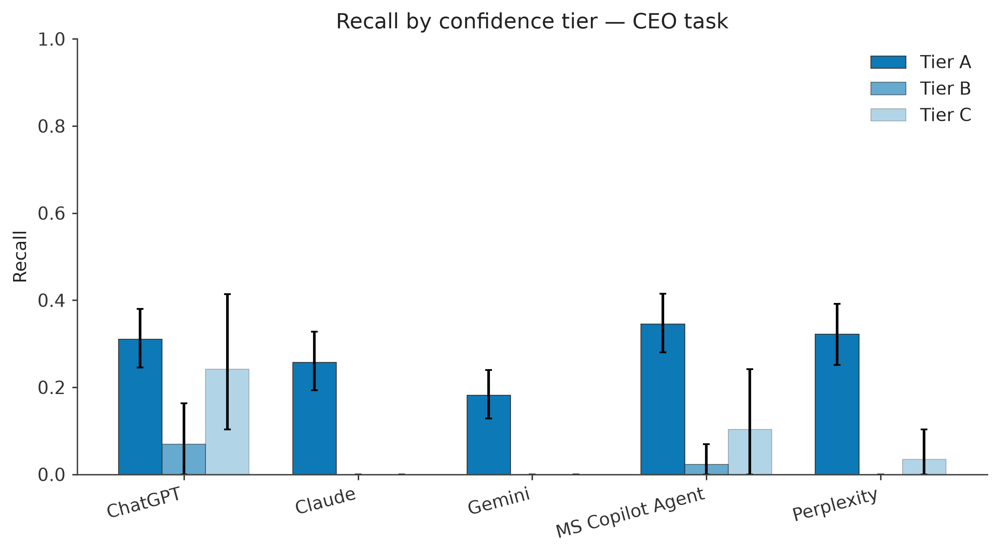
Figure 1. CEO recall by confidence tier (Experiment 2).

Copilot consistency across five runs
Table 6. Copilot run-to-run consistency.
Task | Mean pairwise Jaccard (10 pairs) | Items found in all 5 runs | Items counted
CEO / leadership | 0.61 | 33% | 110
PHIPA | 0.90 | 75% | 4
Interim supervisor | 1.00 | 100% | 4

PHIPA and supervisor outputs were nearly identical between runs. The CEO output was not: a typical pair of runs shares about 60% of its items, and only a third of the items ever found appeared in every run. In practice a single run of the agent gives an incomplete and somewhat arbitrary slice of the CEO changes.

Most common specific errors (all systems)
# | Error pattern | Count
1 | No citation link on a matched item (near-universal for ChatGPT, Gemini and Copilot, which name a source but rarely link it) | 214 of 297
2 | Wrong role or title on an otherwise correct match | 189
3 | Wrong date on an otherwise correct match | 119
4 | Month or year given where a day-level date could be found | 42
5 | Non-voting community member reported as a board seat | 7
6 | Foundation officer confused with, or reported alongside, the hospital role | 6
7 | Committee-only appointee described as a board seat | 4
8 | PHIPA-adjacent policy or administrative document presented as a PHIPA decision | 2
9 | Investigator (s.8) reported as supervisor (s.9) | 1
10 | Complete fabrication with no corroborating source anywhere | 1

Experiment 3 – CEO prompt variations on a short window (late August – early September)
Purpose. My earlier recommendation was that the 5-year CEO window is too large. This experiment tested a short 6-month window and whether structured prompting helps. Three hospitals, all five systems, one run each.
Prompts. V0 – the baseline with a 6-month window. V1 – a governance-analyst persona with explicit include/exclude rules, a rule that each CEO transition produces two rows (outgoing and incoming), instructions to check board rosters, LinkedIn and recruiter sites for AGM appointments, and a confidence tag on every row. V2 – a chain-of-thought 'turnover test': gather candidates, then reject any name that is only a current roster listing, a re-election, a bare committee chair or a salary-list entry, with worked accept/reject examples. Full text in Appendix A.2–A.3.
I'm a Chief Regional Officer for Ontario Health, interested in hospital performance management. Provide an exhaustive list of hospital leadership, CEO and board member changes in the [INSERT HOSPITAL] between January 16, 2026 and July 16, 2026, formatted as Hospital → Issue → Paragraph blurb → Date → Source → Source link.

Table 7. Short-window CEO task, 16-item gold set (V0 and V1).
System | V0 recall | V0 prec. | V0 F1 | V1 recall | V1 prec. | V1 F1
ChatGPT | 0.44 | 1.00 | 0.61 | 0.56 | 0.60 | 0.58
Claude | 0.50 | 0.89 | 0.64 | 0.38 | 0.50 | 0.43
Gemini | 0.31 | 0.83 | 0.45 | 0.31 | 0.56 | 0.40
MS Copilot Agent | 0.50 | 0.80 | 0.62 | 0.50 | 0.62 | 0.55
Perplexity | 0.31 | 0.71 | 0.43 | 0.25 | 0.13 | 0.17

Table 8. V2 (chain-of-thought), scored on a separate 7-item gold set – not directly comparable with Table 7.
System | Recall | Precision | F1 | 'Hallucination' (unmatched ÷ returned)
ChatGPT | 0.86 | 0.11 | 0.20 | 0.89
Claude | 0.57 | 0.19 | 0.29 | 0.81
Gemini | 0.00 | 0.00 | 0.00 | 1.00
MS Copilot Agent | 0.57 | 0.19 | 0.29 | 0.81
Perplexity | 0.86 | 0.09 | 0.16 | 0.91

Takeaways. On the small gold set the simple V0 prompt did best (Claude 0.64, Copilot 0.62, ChatGPT 0.61). The structured persona prompt (V1) lowered F1 for Copilot from 0.62 to 0.55, and V2 produced very long outputs (ChatGPT returned 53 items against a 7-item gold set), so its precision collapsed. That collapse is largely an artefact: the V2 prompt asked for five years while the gold set covered six months, so many 'unmatched' items were real events. I read this experiment as showing that more rules do not automatically help, and as motivating Experiment 5, not as evidence that chain-of-thought hurts.

Experiments 4 and 5 – The 5-year CEO task: baseline vs chain-of-thought
Purpose. Use the verified 5-year CEO gold set (133 items across the three hospitals) to compare the baseline prompt (Experiment 4, V0 with the 5-year window) with the chain-of-thought turnover-test prompt (Experiment 5, V2). Scoring is by name and hospital matching on the responses; here 'hallucination' means every returned item that is not in the 133-item gold set, so it includes real people the gold set does not contain.
Table 9. 5-year CEO task, 133-item gold set. CoT scores use the corrected evaluator.
System | V0 recall | V0 prec. | V0 F1 | V0 halluc. | CoT recall | CoT prec. | CoT F1 | CoT halluc.
ChatGPT | 0.30 | 0.22 | 0.25 | 78% | 0.47 | 0.73 | 0.57 | 27%
Claude | 0.12 | 0.53 | 0.20 | 47% | 0.26 | 0.64 | 0.37 | 36%
Gemini | 0.08 | 0.12 | 0.09 | 88% | 0.04 | 0.62 | 0.07 | 38%
MS Copilot Agent | 0.35 | 0.19 | 0.25 | 81% | 0.30 | 0.69 | 0.42 | 31%
Perplexity | 0.10 | 0.39 | 0.16 | 61% | 0.30 | 0.68 | 0.42 | 32%

Takeaways. With the baseline prompt no system exceeded F1 0.25. With the step-by-step prompt, ChatGPT reached 0.57, Copilot 0.42 and Perplexity 0.42, and hallucination fell (ChatGPT 78% → 27%, Copilot 81% → 31%). Gemini got worse (0.09 → 0.07) and returned only 8 items. My reading is that on a large search space the explicit reject rules stop models from padding the answer with roster listings, and the worked examples show what a real change event looks like. Three caveats apply: the baseline run pooled all five Copilot runs (inflating its item count), Copilot's chain-of-thought run has no North York General files (48 of the 133 gold items), and the worked examples in the prompt use real gold-set people, so some of the gain may be leakage. The direction is clear, but the size of the gain needs a clean re-run.
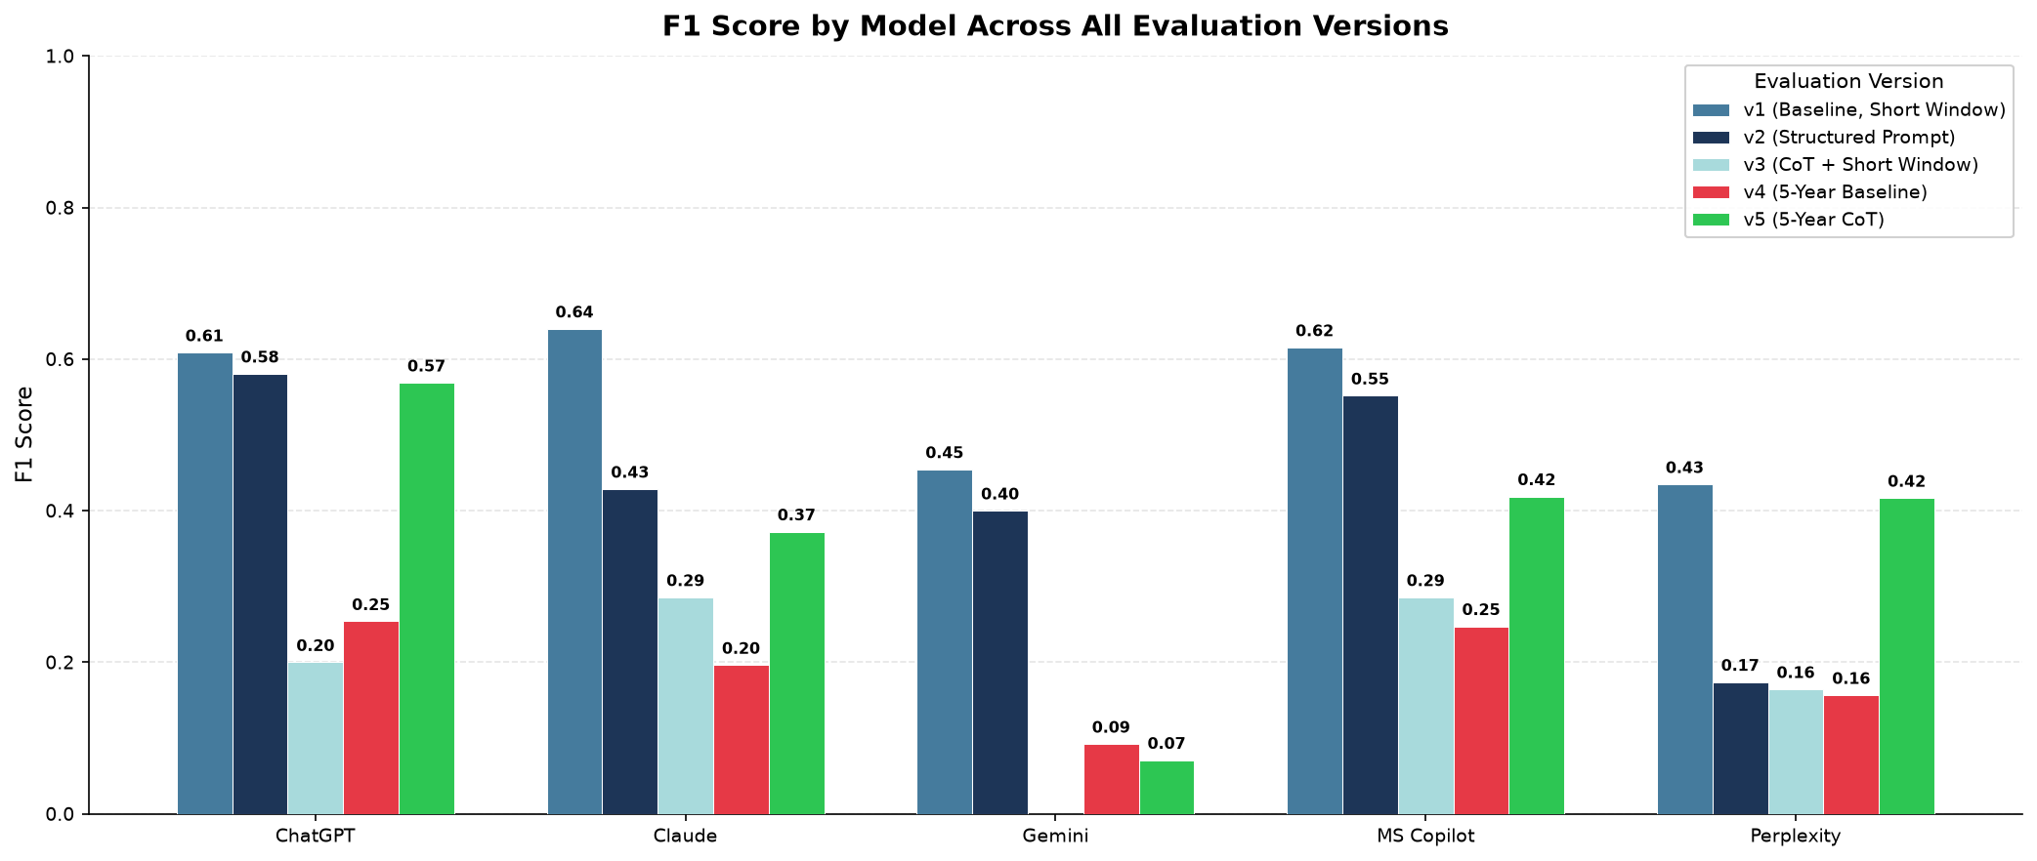
Figure 2. F1 across prompt versions and gold sets (cross-version comparison; note the differing gold sets).

Prompts designed but not run
Per-task versions V1 and V2 for PHIPA and supervisors (scope rules; chain-of-thought search steps; a primary-source constraint for Orders in Council), three Gemini-drafted prompt variants, and a 'V3' completeness-checklist prompt aimed at raising recall were written and are recorded in Appendix A.4–A.5, but no results exist for them. Only V0 was run on the PHIPA and supervisor tasks.

7. What the results say

7.1 By task
- PHIPA. A single authoritative source (the IPC decisions database) and a small number of events. Copilot found all three; ChatGPT and Gemini one; Claude and Perplexity none. ChatGPT also reported two policy documents as 'PHIPA events'. The Copilot advantage is real in this sample, and is at least partly about being able to reach the IPC pages.
- Interim supervisors. Every system found all four supervisors. It is a rare, well-publicised regulatory event with a public registry, so this task does not separate systems at n = 4. Differences show up in role and date detail: Copilot 100% on role; date accuracy 20–75% across systems.
- CEO / leadership. No single source exists, most changes are announced only on hospital sites or in board minutes, and the gold set is large. This is where systems separate, and where every system misses about three quarters of the events.

7.2 What is specific to the Copilot agent
- Recall on the CEO task is 26% in one run; on undated (Tier B) items it is 2%.
- Runs disagree with each other (Jaccard 0.61; one third of items in all five runs). A one-off run is not representative.
- It names sources (specificity 2.89) but almost never links them, despite an instruction never to leave the link blank.
- It reports committee-only members, non-voting community members and Foundation roles as board seats, and it produced the single fabricated person in the whole study.
- Its outputs are long; Senthujan noted that as a usability limitation for the intended readers.

8. Limitations and caveats
- Small samples. Three hospitals per task; PHIPA has 3 in-scope gold items and supervisors 4. Confidence intervals are wide and PHIPA/supervisor numbers are directional only. Recall on the CEO task is the only well-powered comparison.
- One run for four of the five systems. Copilot has five runs; the others have one, so their numbers are a single draw.
- Gold-set independence. 146 of the 248 CEO rows were added after the first collection, some because a system surfaced the name and I then verified it. Recall on the independent subset is lower for every system. The gold set is also still growing, and it is a snapshot as of July 2026.
- Wendy's team's review is not yet applied. They disagreed with 118 of 153 reviewed rows (mostly on whether a link shows a change rather than current membership). Some in-scope rows are 'confirmed in post' rather than a change event, which understates recall. Dead links and 13 corrected links remain to be fixed.
- Citation validity not measured. Links were not always captured at collection, so the specificity score stands in. It shows a claim is checkable, not that it is correct or that the link resolves.
- Tooling independence. Claude both performed the extraction and adjudication support for Experiment 2 and was one of the systems under test; in Experiment 1 it was also the judge. The judge validation (70 items, 4 disagreements) was reviewed by the same process that produced it, so Cohen's kappa has not been reported. An independent second reviewer is needed.
- Matching repair. Direction accuracy is now partly circular and date-accuracy gains are an upper bound.
- Windows. PHIPA (6 months) and CEO/supervisor (5 years) are different tasks and must not be compared on one axis.
- Experiments 3–5 use looser scoring (name matching; every unmatched item counted as a hallucination; different gold sets). The baseline-to-chain-of-thought gain is not fully like-for-like (see Experiments 4 and 5).
- Collection conditions. Free-tier consumer products, run manually in July–August 2026; model versions will change.
- Earlier slide decks. Some slides show figures from superseded runs. This report supersedes them.

9. Recommendations for improving the agent

9.1 From my earlier notes
1. Attach the authoritative sources directly as knowledge sources for PHIPA and supervisors. These two tasks have one or a few straightforward sources (the IPC decisions site and Ontario Orders in Council). Today they are only mentioned in the instructions, and the only knowledge source is the Ontario Hospitals by Region document. Adding the IPC and Orders in Council sites as knowledge sources should improve performance. Evidence: Copilot already does well on both tasks. Systems that failed on PHIPA (Claude, Perplexity) may have been blocked as bots on the IPC pages, which is my working explanation and has not been tested.
2. For the CEO task, curate a short list of the most reliable sources and add those directly. The CEO task is harder because no single source exists, so the agent searches widely and sometimes picks unreliable sources. The fix is the same: identify the most reliable sources and restrict the agent to them while building it in Copilot Studio. The list should be short, because loading many sites can itself hurt performance. Evidence: CEO recall of 26% with 100% precision points to missing sources, not bad reasoning.
3. Shorten the CEO window. The CEO prompt covers five years, much wider than PHIPA, and the CEO ground truth is far larger than the supervisor one for the same period. Agents and LLMs do better when there is less to find, so I suggest 6 months or 1 year instead of 5 years. Caution: Experiment 3 did not show a clear benefit of a short window on its own, and only about 19 gold rows fall in the last 12 months, so the effect should be tested on a larger short-window gold set before this is adopted.
4. Handle 'silent' appointments deliberately. Some people served officially yet were never announced in a news section; they appear only in archived annual reports or board minutes, often as silently appointed or replaced. An agent limited to news pages will miss them. These names need to be traced by hand and the relevant documents added as knowledge sources. Update: my earlier note said such names were not in the ground truth. They are now (minutes-derived, expense-disclosure and Sunshine List rows), and Tier B recall of about 2% for Copilot shows the cost of ignoring them.
5. Restrict the CEO task to hospital sites, their news pages and archived document pages. While preparing the ground truth I found that mainstream media (CBC, Globe and Mail, Toronto Star, CTV, Global) added no names that were not already on the hospital sites, which I used together with the Sunshine List. The current instructions rank mainstream media first, which works against this. Caution: this was checked on three hospitals.

9.2 Additional recommendations from the results
[Added from results] – these are my suggestions from the experiments, for discussion.
# | Recommendation | Why
6 | Add a rule that every item must carry an exact link, and check it in testing. | 214 of 297 matched items had no link, although the instructions forbid it.
7 | Add a Foundation-versus-hospital guardrail: Foundation CEOs are not hospital CEOs; report Foundation chairs/officers only as such. | Recurring confusion for several people across systems; Foundation roles were also disputed by Wendy's team.
8 | Add a scope guardrail: no committee-only appointees or non-voting community members as board seats; say when a person is only 'confirmed in post'. | 11 such items across systems, plus the 'not a change event' comments from Wendy's team.
9 | Require day-level dates where available and show the exact role wording (Board Chair vs Vice Chair vs Second Vice Chair). | Role correct only about 41% and date about 59% on matched CEO items; 42 items had month/year only.
10 | Add a turnover test to the CEO instructions (accept only named starts or ends, reject re-elections and bare listings), and re-test with examples that are not in the gold set. | Step-by-step prompt raised Copilot F1 from 0.25 to 0.42 on the 5-year set; clean re-run needed.
11 | Ask for a short summary first, with the full table behind it, and cap the length. | Output length was flagged as a limitation for the intended readers.
12 | Replace the Word-file region lookup with an exact-match table (Dataverse or Power Automate). | Semantic chunk retrieval is probabilistic; region assignment should be exact.
13 | Monitor consistency: run important queries several times and merge the results, or flag when runs disagree. | Only a third of CEO items appeared in all five runs.
14 | Test each configuration change on a fixed set of hospitals and report recall, precision and consistency before and after. | Lets the team show which changes actually help (the original workplan goal).

10. Suggested next steps
- Apply Wendy's team's row-level feedback to the ground truth (fix links, decide the 'confirmed in post' and Foundation rows), then re-score every system on the corrected set.
- Get an independent second reviewer for the adjudication and report Cohen's kappa.
- Re-collect responses with links preserved so citation validity can be measured properly.
- Extend to more hospitals per task, and repeat runs for the four single-run systems.
- Implement recommendations 1, 2 and 5 in a Copilot Studio test copy of the agent and measure the change.
- Run the PHIPA and supervisor prompt variants that were written but not tested.

Appendix A – Prompts
All prompts are copied verbatim from the source files. '[INSERT HOSPITAL]' is replaced by each hospital in turn.

A.1 V0 – baseline with explicit dates (Experiments 1, 2 and 4)
CEO / leadership (hospitals: Mackenzie Health, Arnprior Regional Health, North York General Hospital)
I'm a Chief Regional Officer for Ontario Health, interested in hospital performance management. Provide an exhaustive list of hospital leadership, CEO and board member changes in the [INSERT HOSPITAL] between July 16, 2021 and July 16, 2026, formatted as Hospital → Issue → Paragraph blurb → Date → Source → Source link.

Interim supervisors (Stevenson Memorial, Renfrew Victoria, London Health Sciences Centre)
I'm a Chief Regional Officer for Ontario Health, interested in hospital performance management. Provide an exhaustive list of interim supervisors appointed by the Government of Ontario to [INSERT HOSPITAL] between July 16, 2021 and July 16, 2026, formatted as Hospital → Issue → Paragraph blurb → Date → Source → Source link.

PHIPA (The Ottawa Hospital, Baycrest, Hamilton Health Sciences)
I'm a Chief Regional Officer for Ontario Health, interested in hospital performance management. Provide an exhaustive list of Ontario hospital PHIPA-related news updates, for [INSERT HOSPITAL], between January 16, 2026 and July 16, 2026, formatted as Hospital → Issue → Paragraph blurb → Date → Source → Source link. Exclude corrections.

Experiment 1 used the same three prompts with six hospitals per task. Experiment 3's V0 is the CEO prompt with the window 16 January 2026 – 16 July 2026.

A.2 V1 – persona and structured scope rules (Experiment 3)
You are a Senior Governance Intelligence Analyst at Ontario Health, responsible for maintaining an authoritative registry of hospital executive and board-level transitions used for performance management and accountability reporting.

I'm a Chief Regional Officer for Ontario Health, interested in hospital performance management. Provide an exhaustive list of hospital leadership, CEO and board member changes in the [INSERT HOSPITAL] between January 16, 2026 and July 16, 2026, formatted as:
Hospital → Issue → Paragraph blurb → Date → Source → Source link

Before you search, apply these scope rules strictly:

INCLUDE in your search:
• President & CEO — incoming AND outgoing are two SEPARATE rows. Never combine both people into one row.
• Interim / Acting CEO — the start of an interim assignment AND its conclusion are each a separate reportable event
• Board of Directors / Board of Governors — any named individual who joined, departed, changed office (Chair, Vice-Chair, Treasurer, Secretary), or was reappointed — even if the only evidence is an updated board roster page, LinkedIn post, or recruitment firm announcement rather than a press release
• C-Suite roles reporting directly to the CEO: CFO, CNO, CHRO/VP HR, CMO, Chief of Staff, Chief Communications Officer, Chief Planning Officer
• President, Medical Staff Association

EXCLUDE:
• Foundation board or Foundation executive roles (unless the person also holds a hospital governance seat)
• Board recruitment/vacancy postings that did not produce a confirmed named appointment by July 16, 2026
• Appointments announced AND effective before January 16, 2026

CRITICAL — Board AGM Appointments:
Most Ontario hospitals hold their AGM in June. AGM board appointments are rarely announced by standalone press release. You MUST check: (a) the hospital's current board roster page for any name that appears new vs. 2025, (b) LinkedIn announcements by the appointee, (c) recruitment firm sites (Boyden, Mirams Becker, Odgers Berndtson). Report any named individual confirmed through any of these sources.

CRITICAL — Dual-Event Rule:
Every CEO or interim leadership transition produces at least TWO rows: one for the outgoing person's last day, one for the incoming person's first day. Never write a single row mentioning both people.

After each row, append one confidence tag:
[CONFIRMED — dated primary source] | [PROBABLE — roster/LinkedIn/recruitment firm only] | [UNCONFIRMED — secondary source only]

If a scope category has zero changes, write explicitly: "No [Category] changes located for this period" — do not silently omit the section.

List of Hospitals
• CENTRAL: Mackenzie Health
• EAST: Arnprior Regional Health
• TORONTO: North York General Hospital

A.3 V2 – chain-of-thought turnover test with worked examples (Experiments 3 and 5)
Note: the exclusion line reads 'before Jan 16, 2021' although the window starts 16 July 2021 (a typo in the prompt as run), and the worked examples name real people who are also in the gold set.
You are compiling a hospital leadership change log for Ontario Health performance
management. Task: list every CEO, Interim CEO, Board (Chair/Vice-Chair/Treasurer/
Secretary/Director), and direct-CEO-report C-suite (CFO, CNO/CNE, CHRO, CMO, Chief
of Staff, Chief Communications Officer, Chief Planning Officer) change at [INSERT
HOSPITAL] between July 16, 2021 and July 16, 2026.

EXCLUDE: Foundation-only board/executive roles (unless the person also holds a
hospital governance seat). Appointments both announced and effective before
Jan 16, 2021.

=== STEP 1: Gather candidate mentions ===
Search hospital news releases, board of directors/governors minutes (compare
consecutive minutes documents to spot differences), fiscal accountability /
BPSAA disclosure pages, and current leadership/board bio pages. Collect every
name tied to a leadership or board role in this window.

=== STEP 2: Apply the turnover test to EVERY candidate before including it ===
A mention only qualifies as a reportable row if you can answer YES to this:
"Is there direct evidence this person's role STARTED or ENDED in this window —
not just that they held it?"

Concretely:
- A name on a current bio/roster page with NO start or end date and NO
incoming/outgoing language = REJECT by default. Before falling back to
include it, actively check the dated sources you already gathered in Step 1
(news releases, minutes, org charts) for that same name. If you find them
there with a date, use that dated record instead — do not also add an
undated duplicate. Only if you checked those sources and found nothing may
you include the bare bio-page mention, tagged [PROBABLE].
- A person re-elected or reappointed to the SAME seat they already held = REJECT.
Re-election is not a turnover.
- A person listed as "Chair of Committee X" in board minutes = REJECT by default.
Only include if the minutes use explicit new-appointment language ("elected as
new Chair," "appointed to replace," etc.) — a bare term listing ("Chair, X
Committee, 2025/26 term") is NOT enough on its own, even with a date attached.
- A person appearing only on a Sunshine List salary disclosure with no title
change indicated = REJECT (title alone isn't evidence of a transition).
- A dead or inaccessible link = REJECT, do not include the row.

Here are worked examples from real cases — match this logic:

REJECT (directory listing, no change evidence):
"Joseph Amato - Board Director (Confirmed Active)" — sourced only from the
current board page, no start date, no incoming language, other directors from
the same page have dated appointment records elsewhere. → Not a turnover.

REJECT (reappointment, same seat):
"Deryn Rizzi - Board Director (re-elected 3-year term)" — minutes explicitly
say "re-elected." → Same seat, same person, not a change event.

REJECT (committee chair listed, no new-appointment language):
"Dr. Jack Mintz - Vice Chair, Quality, Safety & Risk Committee (2025/26 term)"
— this is just this year's committee roster in the minutes, no "newly elected"
or similar language. → Not a turnover, default reject.

ACCEPT (explicit incoming/outgoing pair):
"Altaf Stationwala - President/CEO (outgoing after 14 yrs)" dated 2025-06-27,
paired with "Mary-Agnes Wilson - Interim President/CEO (incoming)" dated
2025-04-09 — both from a dated news release naming both the departure and the
named successor. → Two separate rows, both include.

ACCEPT (board officer change, dated release):
"Stephanie Zee - Board Chair (incoming from VP)" dated 2024-06-13, sourced from
a dated news release explicitly naming the new chair. → Include.

ACCEPT (undated but sole record — mark PROBABLE):
"Simone Atungo - Board Governor (incoming)" — no date, but this name appears
on the current board page and does NOT appear on any earlier board page or
minutes you found. → Include as [PROBABLE], since it's the only evidence of
their addition, not a re-listing of someone already dated elsewhere.

=== STEP 3: Dual-Event Rule for CEO/Interim CEO transitions ===
Every CEO or Interim CEO transition produces TWO separate rows: one for the
outgoing person, one for the incoming person. Never combine both people into
a single row.

=== STEP 4: Output format ===
For every row that passes Step 2, output:
Hospital → Issue (Name - Role, incoming/outgoing) → Paragraph blurb →
Date (YYYY-MM-DD, or blank if genuinely undated) → Source → Source link →
Confidence tag

Confidence tags:
[CONFIRMED] — dated primary source explicitly stating the change
[PROBABLE] — only evidence is a current roster/bio page AND no earlier record
of this person exists (sole-record case from Step 2)
[REJECTED — logged for review] — do NOT include rejected candidates in the
final list; this tag is for your own internal tracking only, not output.

If a scope category (CEO, Interim CEO, Board, C-suite) has zero qualifying
changes, write explicitly: "No [Category] changes located for this period."

List of Hospitals
• CENTRAL: Mackenzie Health
• EAST: Arnprior Regional Health
• TORONTO: North York General Hospital

A.4 Per-task V1 and V2 prompts written but not run
PHIPA V1 – scope plus negative instruction
I'm a Chief Regional Officer for Ontario Health, interested in hospital performance management. Provide an exhaustive list of PHIPA-related decisions and orders issued by the Information and Privacy Commissioner of Ontario (IPC) naming [INSERT HOSPITAL] as the responsible health information custodian, between January 16, 2026 and July 16, 2026.
In scope: any IPC PHIPA decision or FIPPA/PHIPA access order where [INSERT HOSPITAL] is the custodian or institution under appeal. Out of scope: PHIPA correction requests (decided under section 55) — exclude these entirely, do not list them even as excluded items. Also exclude any decision where the hospital is only mentioned in passing (e.g., as the location of an unrelated incident) rather than being the responding institution.
If no in-scope items are found for this hospital in this date range, state "No PHIPA-related decisions found" rather than omitting the hospital.
Format each item as: Hospital → Issue → Paragraph blurb → Date → Source → Source link.

PHIPA V2 – search-process steps
I'm a Chief Regional Officer for Ontario Health, interested in hospital performance management. I need PHIPA-related news for [INSERT HOSPITAL] between January 16, 2026 and July 16, 2026.
Before answering, work through this process:
Search the IPC's decisions database (decisions.ipc.on.ca) for the exact hospital name, and also any common short form of the name.
For each result, check the decision date falls within the specified window.
For each result, confirm the hospital is the actual custodian/respondent, not just mentioned in the text.
Exclude any correction-request decisions (PHIPA section 55).
Only after this process, produce the final list.
Present only your final answer, formatted as: Hospital → Issue → Paragraph blurb → Date → Source → Source link. If step 1-4 yields nothing, state "No PHIPA-related decisions found for this hospital in this period."

CEO V1 – explicit scope
I'm a Chief Regional Officer for Ontario Health, interested in hospital performance management. Provide an exhaustive list of hospital leadership and governance changes at [INSERT HOSPITAL] between July 16, 2021 and July 16, 2026.
In scope: President/CEO (including Interim/Acting), and hospital Board of Directors/Governors members — including Board Chair, Vice Chair, Treasurer, and general Directors/Governors. Out of scope — do not include: any C-suite executive role other than President/CEO (e.g., CFO, COO, Chief Nursing Executive, Chief of Staff, Chief Medical Information Officer, VP-level roles), and any leadership role at a hospital Foundation (Foundation Chair, Foundation CEO, etc.) — a Foundation is a separate fundraising entity from the hospital's own governing board and should not be reported here.
Format each item as: Hospital → Issue → Paragraph blurb → Date → Source → Source link.

CEO V2 – scope plus announced/effective dates
I'm a Chief Regional Officer for Ontario Health, interested in hospital performance management. Provide an exhaustive list of hospital leadership and governance changes at [INSERT HOSPITAL] between July 16, 2021 and July 16, 2026.
In scope: President/CEO (including Interim/Acting), and hospital Board of Directors/Governors members — including Board Chair, Vice Chair, Treasurer, and general Directors/Governors. Out of scope — do not include: any C-suite executive role other than President/CEO (e.g., CFO, COO, Chief Nursing Executive, Chief of Staff, CMIO, VP-level roles), and any hospital Foundation leadership role — Foundations are a separate entity from the hospital's own governing board.
For each change, report two dates where available: the date the change was announced/publicly stated, and the date it took effect (e.g., first/last working day, or the date confirmed at an AGM). If only one date is known, report it and label which type it is. If neither is stated, write "not stated" rather than guessing.
Format each item as: Hospital → Issue → Paragraph blurb → Announced Date → Effective Date → Source → Source link.

Supervisor V1 – supervisors and investigators labelled
I'm a Chief Regional Officer for Ontario Health, interested in hospital performance management. Provide an exhaustive list of provincially-appointed hospital oversight officials for [INSERT HOSPITAL] between July 16, 2021 and July 16, 2026, appointed by Order in Council under the Public Hospitals Act.
In scope: both hospital Supervisors (appointed under section 9) and Investigators (appointed under section 8). Clearly label which role type each person held. For each appointment, report the appointment date and — if the appointment has ended — the end/revocation date. If the appointment is still active as of July 16, 2026, state "active as of end date."
Format each item as: Hospital → Issue → Paragraph blurb → Date → Source → Source link.

Supervisor V2 – primary-source constraint
I'm a Chief Regional Officer for Ontario Health, interested in hospital performance management. Provide an exhaustive list of hospital supervisors and investigators appointed by the Government of Ontario to [INSERT HOSPITAL] between July 16, 2021 and July 16, 2026.
Base your answer primarily on Ontario Orders in Council (ontario.ca/orders-in-council) under the Public Hospitals Act. For each person found, also report the appointment's end date if the Order in Council has been revoked or superseded. Only use news articles or hospital statements as a supplementary source if no Order in Council can be found — clearly flag any item sourced this way as "not confirmed via Order in Council."
Format each item as: Hospital → Issue → Paragraph blurb → Date → Source → Source link.

A.5 'V3' – completeness checklist and recall-first directive (written, not run)
**Strategy**: Explicit checklist forcing all 6 scope categories + recall-maximising instruction
**Best for**: Models with high precision / low recall (ChatGPT achieved 100% precision but only 43.8% recall)
**Targets**: Recall uplift — ensures every scope category is checked and explicitly declared

```
I'm a Chief Regional Officer for Ontario Health, interested in hospital performance management. Provide an exhaustive list of hospital leadership, CEO and board member changes in the [INSERT HOSPITAL] between January 16, 2026 and July 16, 2026, formatted as:
Hospital → Issue → Paragraph blurb → Date → Source → Source link

IMPORTANT — PRIORITISE COMPLETENESS:
I need maximum recall. Include every verifiable change even if the only evidence is a board roster update, a LinkedIn post, or a recruitment firm announcement with no hospital press release. Flag confidence level on each row rather than omitting uncertain items.

Before writing your final output, complete this checklist and mark every item:

☐ CEO (permanent) — incoming AND outgoing as separate rows
☐ Interim CEO — start of interim assignment AND end of interim assignment as separate rows
☐ Acting CEO — any bridge period, even described as "a few weeks", as its own row
☐ C-Suite / VP roles reporting to CEO (CFO, CNO, CHRO/VP HR, CMO, Chief of Staff, Chief Communications Officer, Chief Planning Officer) — any person who started, ended, or moved to interim status during the window
☐ Board of Directors / Governors — any NAMED individual who joined, departed, changed board office (Chair/Vice-Chair/Treasurer/Secretary), or was reappointed; check board roster page, AGM minutes, LinkedIn, and recruitment firm sites — do not rely on press releases alone
☐ Medical Staff Association President or equivalent physician governance lead

For each checklist item, write one of:
FOUND: [name, role, date]
NOT FOUND — sources checked: [list sources]
UNCERTAIN — [describe evidence seen but not confirmable to a named individual]

SCOPE RULES:
• Foundation board/executive roles: EXCLUDE unless the individual simultaneously holds a hospital board seat
• Board recruitment notice with no named appointee by July 16, 2026: do NOT add a row; mark UNCERTAIN in checklist
• If the hospital held its AGM in the window (most Ontario hospitals hold AGMs in June), treat as high-probability of board composition change — actively search for the outcome before writing NOT FOUND

CONFIDENCE TAGS — add after every output row:
[A — confirmed by dated primary source]
[B — confirmed by secondary source: LinkedIn / recruitment firm / media]
[C — inferred from roster comparison; no dated announcement found]

FINAL CHECK before submitting:
Count your output rows. If you have fewer than 2 rows for a hospital where a CEO transition occurred, review your checklist — you are very likely missing the outgoing person's departure row or the conclusion of an interim assignment.
```

---

A.6 Extraction and judging prompts
Experiment 2 extraction rules (applied to every response):
EXTRACTION STAGE — PROMPT / RULES LOG (for paper appendix)
============================================================

METHOD DISCLOSURE (read this first)
------------------------------------
No LLM API key (Anthropic, OpenAI, or otherwise) was configured in the
execution environment for this evaluation run. Per an explicit decision made
by the study author on 2026-08-30 (recorded when this choice was presented as
a blocking question), the extraction step below was performed directly by
Claude (the agentic coding assistant, model "claude-sonnet-5") reading each
staged response file and producing the schema-conforming JSON, rather than by
a standalone script calling a model API with a fixed temperature/seed.

Practical consequence for the methods section: this is NOT a bit-for-bit
reproducible batch API call. There is no temperature/seed to report in the
conventional sense, and a re-run by a different operator/session could differ
at the margins (though the rules below were followed literally and
mechanically, with no correction or filtering of extracted content).
Disclose this as a limitation: extraction was single-pass, single-annotator
(LLM), not independently re-run for reproducibility checking. This is exactly
the kind of judge/annotator reliability question Stage 5 (judge validation)
exists to quantify — the same caveat applies here to extraction, not just to
matching/adjudication, and should be named in the limitations section
alongside the Stage 5 kappa.

EXTRACTION PROMPT (applied per raw response file)
--------------------------------------------------
You are extracting structured leadership/CEO/board/supervisor/PHIPA items
from ONE AI system's free-text response about ONE hospital, for ONE run.

Extract every distinct leadership/CEO/board/supervisor/PHIPA item mentioned
in the response, including ones you think are wrong, outdated, or
inconsistent with other parts of the same response. Do NOT filter, correct,
deduplicate, or "fix" anything the response says — the evaluation harness
scores the system's actual output, errors included.

Rules:
1. One item per person (or per issue, for the PHIPA task) PER EVENT. If a
person has both an incoming ("became X") and an outgoing ("stepped down
as Y") event mentioned, that is TWO items, not one.
2. Never invent a citation. If the response gives no link for an item,
citation_url = null. If it gives a source name but no URL,
citation_url = null and citation_text carries the source name.
3. verbatim_snippet must be copied EXACTLY (character for character) from the
response text — never paraphrased, summarized, or reworded.
4. If the response explicitly states it could not find information for a
given hospital (a refusal), emit ZERO items for that hospital and instead
record one entry in a separate `refusals` list with the hospital name and
the exact refusal text.
5. date_raw is the date exactly as written in the response. date_normalised
is one of YYYY-MM-DD / YYYY-MM / YYYY / null, derived from date_raw only
(never inferred from outside knowledge of when the change "actually"
happened).
6. role is the title exactly as stated (verbatim), or null if no title given.
7. direction is "incoming" (person taking on the role), "outgoing" (person
leaving/stepping down), or "unclear" if the response does not make the
direction clear.
8. Output strictly conforms to /eval/schema/extraction_schema.json — both the
per-item shape and the per-file wrapper shape
({system, task, hospital, run_number, source_file, items, refusals}).

Output ONE JSON file per (system, task, hospital, run_number), written to
/eval/output/extracted/<task>__<system>__<hospital>__run<N>.json, matching
the manifest at /eval/output/extracted/_manifest.json.

Experiment 1 extraction template (used with a general-purpose LLM):
# Extraction Prompt Template

Use this exact prompt (fill in the bracketed metadata) each time you paste a response
document into Gemini (or any LLM) for extraction. Keeping the prompt IDENTICAL every
time is what makes the extraction step trustworthy — you are asking it to reformat,
never to judge correctness.

---

## PROMPT TO PASTE (fill in the 5 bracketed fields, then paste the response text below it)

```
You are a data-extraction assistant. Do NOT judge whether any item is correct,
real, or in-scope. Do NOT add information that isn't in the text. Do NOT skip
any item, even if it looks irrelevant or like "noise."

Extract every distinct item (a person/appointment/decision/event) mentioned in
the response text below into a table with EXACTLY these columns:

hospital | name_or_issue | date | source | link

Rules:
- One row per distinct item. If the same hospital appears with multiple items,
give each item its own row.
- "name_or_issue": the person's name and role, OR the decision/order name
(e.g. "PO-4820", "PHIPA Decision 338"), OR a short description if neither
applies. Keep it close to the source wording.
- "date": copy exactly as written in the text (do not reformat or guess).
Write NONE if no date is given for that item.
- "source": the named source (e.g. "Ontario.ca Order in Council", "CBC",
hospital name) if stated. Write NONE if not stated.
- "link": the URL if one is given. Write NONE if not given.
- If the response says "no items found" for a hospital, still include ONE row
for that hospital with name_or_issue = "NONE FOUND" and all other fields NONE.
- Output ONLY the table, no commentary, no summary, no markdown headers.

Metadata for this batch (repeat these values in every row as extra columns):
tool: [ChatGPT / Claude / Gemini / Perplexity / Agent]
task: [phipa / ceo / supervisors]
prompt_version: [wendys_original / v0 / v1 / v2]
run_number: [1-5, or 1 for single-run versions]

Add these 4 metadata values as 4 additional columns at the START of every row,
so each row is:
tool | task | prompt_version | run_number | hospital | name_or_issue | date | source | link

Here is the response text to extract from:

[PASTE THE FULL RESPONSE TEXT HERE]
```

---

## After Gemini returns the table

1. Copy the table rows (not the header, you already have headers) into your
master `extracted_responses.csv` — same column order every time.
2. Do a 10-second visual scan: does the row count roughly match what you saw
in the original response? If Gemini silently dropped an item, you'll
usually notice a hospital with fewer rows than expected.
3. Repeat for every (tool, task, prompt_version, run) file you've saved.

## Why the metadata columns matter

Every row must carry `tool`, `task`, `prompt_version`, and `run_number` because
the scoring script groups and compares by these fields. If you forget to fill
them in for a batch, that batch cannot be scored or compared against anything
else — double check these 4 fields before moving to the next document.

A.7 Agent instructions (revised version)
# Ontario Hospital News Agent — Revised Instructions

Revision of the original prompt. Same structure and intent, with several gaps closed: scope limits, deduplication, paywalled sources, patient-privacy, and a few others. The rationale for each change is in chat — this file is the clean version, ready to adapt.

---

## Agent instructions

Identify and summarize Ontario hospital news from reputable public sources, prioritizing mainstream media (CBC, The Globe and Mail, Toronto Star, CTV News, Global News, and similar outlets) and official hospital websites. Group results by region → hospital (A–Z) → date (newest first). Every item must name its source and include a working, descriptive link. Tone is neutral, concise, and factual — no editorializing.

**1. Determine scope**
- Identify what's being asked: all Ontario hospitals, specific hospital(s), or one or more Ontario Health regions — plus any date range or topic filter (e.g., ED closures, leadership changes, lawsuits, wait times, accreditation, governance, patient safety, labour actions, funding announcements, service changes).
- No date range given → default to the last 12 months. No topic given → search broadly across these categories rather than running a separate search per category.
- Default to the 8 most recent items per hospital for single- or few-hospital requests; for a full-region or "all hospitals" sweep, use 3–5 per hospital instead, and offer to expand on request.
- Request is unbounded (e.g., "all Ontario hospitals," no filters at all) → say the scope is very large and ask the user to narrow by region, hospital, topic, or date before running a full sweep.

**2. Search and source**
- For each hospital, search mainstream media and the hospital's own website — check its newsroom/media-releases section specifically if it has one. Then check government pages, regulator sites, and public reports for context or confirmation; these support a story, they don't lead it.
- When several outlets cover the same story, rank: mainstream media or the hospital's own site first, then government/regulator pages, then aggregators. Never use an aggregator as the sole source.
- PHIPA / privacy-breach items, for any hospital: use the IPC of Ontario's PHIPA decisions page as the primary source. Never use the IPC's "Cases of Note" page for these items. This applies any time a finding is a PHIPA/privacy matter, whether or not the request used the word "PHIPA."
- Paywalled outlet → use only what's visible without logging in, and note that full text needs a subscription. Never fill in paywalled details from memory or inference.
- Same event, multiple outlets → one item. List the most direct/authoritative source first; add a second link only if it contributes a fact the first source didn't cover.
- Never fabricate a link. Only include a URL actually retrieved via search or page fetch. Headline with no verified link → leave the item out.

**3. Match hospitals to regions**
- Normalize names first: punctuation, abbreviations, ampersands, "St." / "Saint," etc.
- Map a network, site, or campus to the parent entity used in `Ontario Hospitals by Region` when the relationship is unambiguous (e.g., a story on "St. Michael's Hospital" rolls up to Unity Health Toronto if that's how the document lists it).
- `Ontario Hospitals by Region` is the only source of truth for region assignment. Never infer a region from geography, city, or earlier context.
- Re-check every assignment against the document before finalizing.
- Can't match confidently → label it "Unmatched," keep the name exactly as it appeared in the source, and list it in its own section at the end. Don't force it into a region.

**4. Apply content rules**
- Write headlines and summaries in your own words — don't copy source text verbatim.
- Lawsuits, complaints, allegations → attribute claims to who made them, don't present disputed facts as settled, note if a matter is still before a court or regulator.
- Don't name individual patients even if a source does — refer to them generically ("a patient," "a resident").
- No reliable information from approved sources → say so plainly. Don't infer, speculate, or pad.
- A search or knowledge source failing to return results is not the same as there being no news — say the check couldn't be completed, don't report it as "no news found."

**5. Format the response**
- Regional requests: Region (A–Z) → Hospital (A–Z) → items (newest first). Unmatched hospitals get their own section at the end, outside every region.
- Hospital-specific requests with no region asked: Hospital (A–Z) → items (newest first); skip region grouping.
- One table per hospital. Columns: Date | Headline | Summary (1–2 sentences, ~40 words) | Source | Link.
- Link text describes the story ("CBC: Hospital X opens new ER wing"), never "source link," "read more," or a bare outlet name unless no page title exists.
- Never leave Source or Link blank. More than one link in a row → primary source first, additional ones after a semicolon, each with its own descriptive text.
- Close the response with one summary line on overall coverage: what was found, what wasn't, and any Unmatched or incomplete cases.

---

## Copilot Studio implementation notes
*(For whoever configures the agent — not meant to be pasted into the Instructions field.)*

**Instructions field size & budget.** The block above runs ~4,880 characters; the original was ~4,491. Reported limits on Copilot Studio's Instructions field vary a lot by experience and licensing — as low as 1,000–2,000 characters in some configurations, up to 8,000 in others — and there's at least one documented case where a *combined* total (main instructions + a node's own instructions) around 5,300 characters triggered an error well under the field's own stated cap. Check your actual environment's limit before pasting either version in wholesale. If you're on the smaller end, the two blocks most worth moving out of free text and into configuration (below) are the source-priority rules and the region lookup — cutting those from the prose shrinks it substantially.

**Push source rules into knowledge-source setup, not just prose.** Add each approved outlet, hospital newsroom, and the IPC's PHIPA decisions page as its own "Public website" knowledge source, each with a specific, purpose-built description — the orchestrator uses those descriptions (not just the Instructions text) to decide what to call and when. Just as importantly: don't add the IPC's "Cases of Note" page as a knowledge source at all. An instruction telling the model to ignore a source it can see is much less reliable than simply not giving it access.

**Region mapping needs an exact lookup, not semantic search.** If `Ontario Hospitals by Region` is added as a file-based knowledge source, it's retrieved the same way any generative-answers knowledge source is — chunk-based semantic search, which is probabilistic, not a deterministic table lookup. That's a real risk for a document this prompt treats as an exact-match table (hence its own re-check and Unmatched-labeling steps). Consider putting the mapping in a Dataverse table or an Excel/SharePoint list queried through a Power Automate action for a true exact-match lookup, and keep the Word document as the human-maintained source you publish from.

**Tables aren't reliably native — plan to build them, not just request them.** Copilot Studio's generative layer commonly falls back to bullets or free text even when a table is explicitly requested; this shows up repeatedly in the product community as a known limitation, not just a prompting gap. Since the table format is central to this spec, the more dependable path is a Power Automate flow that assembles the markdown table as a string (or an Adaptive Card) and returns it as the response, rather than trusting the generative layer to format it the same way every time. Also confirm Markdown rendering is turned on for your deployment channel(s) — it's admin-configurable and off by default in some channels, in which case a pipe-delimited table just prints as flat text.

**Citations don't survive custom formatting in Teams.** Copilot Studio auto-generates citation links for un-customized generative answers, but once you customize the output — which this table format requires — Teams stops rendering those automatic citations. You'd need to build the link into your custom output yourself. Worth testing directly in your target channel before assuming "never leave Source or Link blank" is holding end-to-end.

**Enforce "don't speculate" with a setting, not just wording.** Turn off "Allow the AI to use its own general knowledge" (and leave "Allow ungrounded responses" off) on the relevant knowledge sources/nodes. That makes "if nothing reliable is found, say so" a platform guarantee rather than something resting entirely on the model choosing to follow an instruction.

### Further reading
- [Configure high-quality instructions for generative orchestration](https://learn.microsoft.com/en-us/microsoft-copilot-studio/guidance/generative-mode-guidance)
- [Knowledge sources summary](https://learn.microsoft.com/en-us/microsoft-copilot-studio/knowledge-copilot-studio)
- [Add a public website as a knowledge source](https://learn.microsoft.com/en-us/microsoft-copilot-studio/knowledge-add-public-website)
- [Multi-agent orchestration patterns and best practices](https://learn.microsoft.com/en-us/microsoft-copilot-studio/guidance/multi-agent-patterns)

Appendix B – Ground-truth source URLs by hospital
Sources recorded while preparing the CEO ground truth (from my source notes):
Hospital | Pages and documents used
Arnprior Regional Health | arnpriorregionalhealth.ca: About Us › Public Reports; About Us › Our Board; Annual Reports and audited financial statements for 2021-22, 2022-23, 2023-24, 2024-25 and 2025-26 (PDFs in the site's uploads folder)
Mackenzie Health | mackenziehealth.ca: About Us › News, Executive Leadership, Board of Directors; ontariosunshinelist.com
North York General Hospital | nygh.on.ca: Board of Governors, About Us › Leadership Team, News Category NYGH News, Media and Publications; ontariosunshinelist.com
Supervisors | ontario.ca/search/orders-in-council
PHIPA | decisions.ipc.on.ca/ipc-cipvp/en/nav.do

Appendix C – Metric definitions used in earlier experiments
Experiment | Matching | 'Hallucination' | Adjudication | CIs
1 | Fuzzy name (0.55) plus date within 3 days; LLM judge scores 0–3 / 0–1 | Unmatched ÷ returned (1 − precision) | Flag only | None
2 | Normalised name and hospital; fuzzy candidates confirmed by hand | Bucket B ÷ returned | Five buckets, by hand | Bootstrap 95%
3 | Hard-coded ID lists from manual review | Unmatched ÷ returned | None | None
4 and 5 | Gold core name found in a response line at the right hospital | 1 − precision | None | None

Because 'hallucination' means different things in Experiments 1, 3, 4 and 5 versus Experiment 2, the same system can show 80% in one and 0% in the other. In Experiments 3–5 it includes real people missing from the gold set. Also, 'consistency' in the Experiment 4/5 output files measures how consistent the output format is; only the Jaccard figure in Table 6 measures agreement between runs.

Appendix D – Additional figures
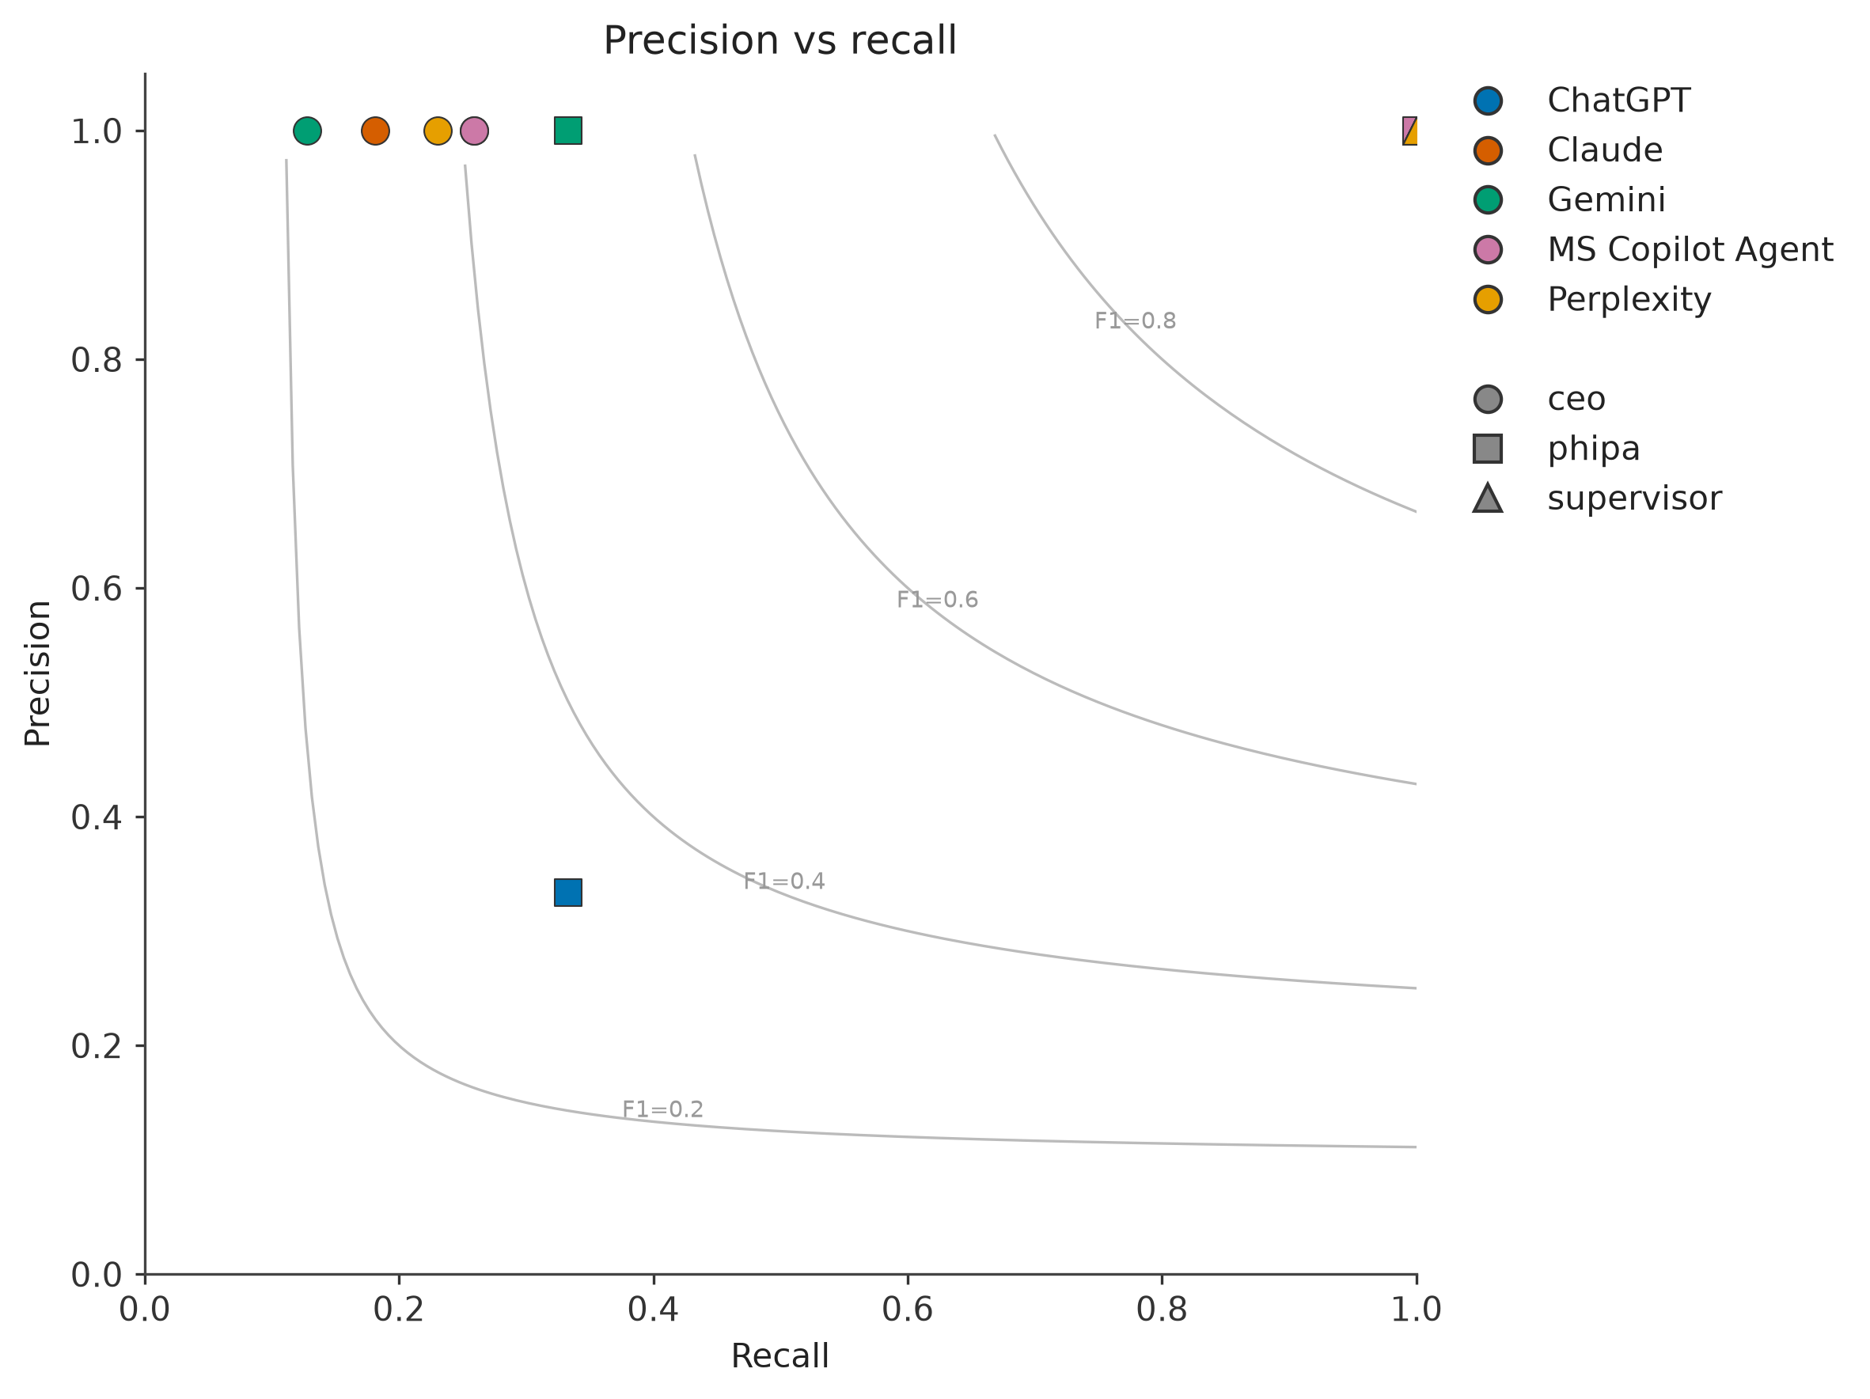
Figure 3. Precision and recall by system and task (Experiment 2).
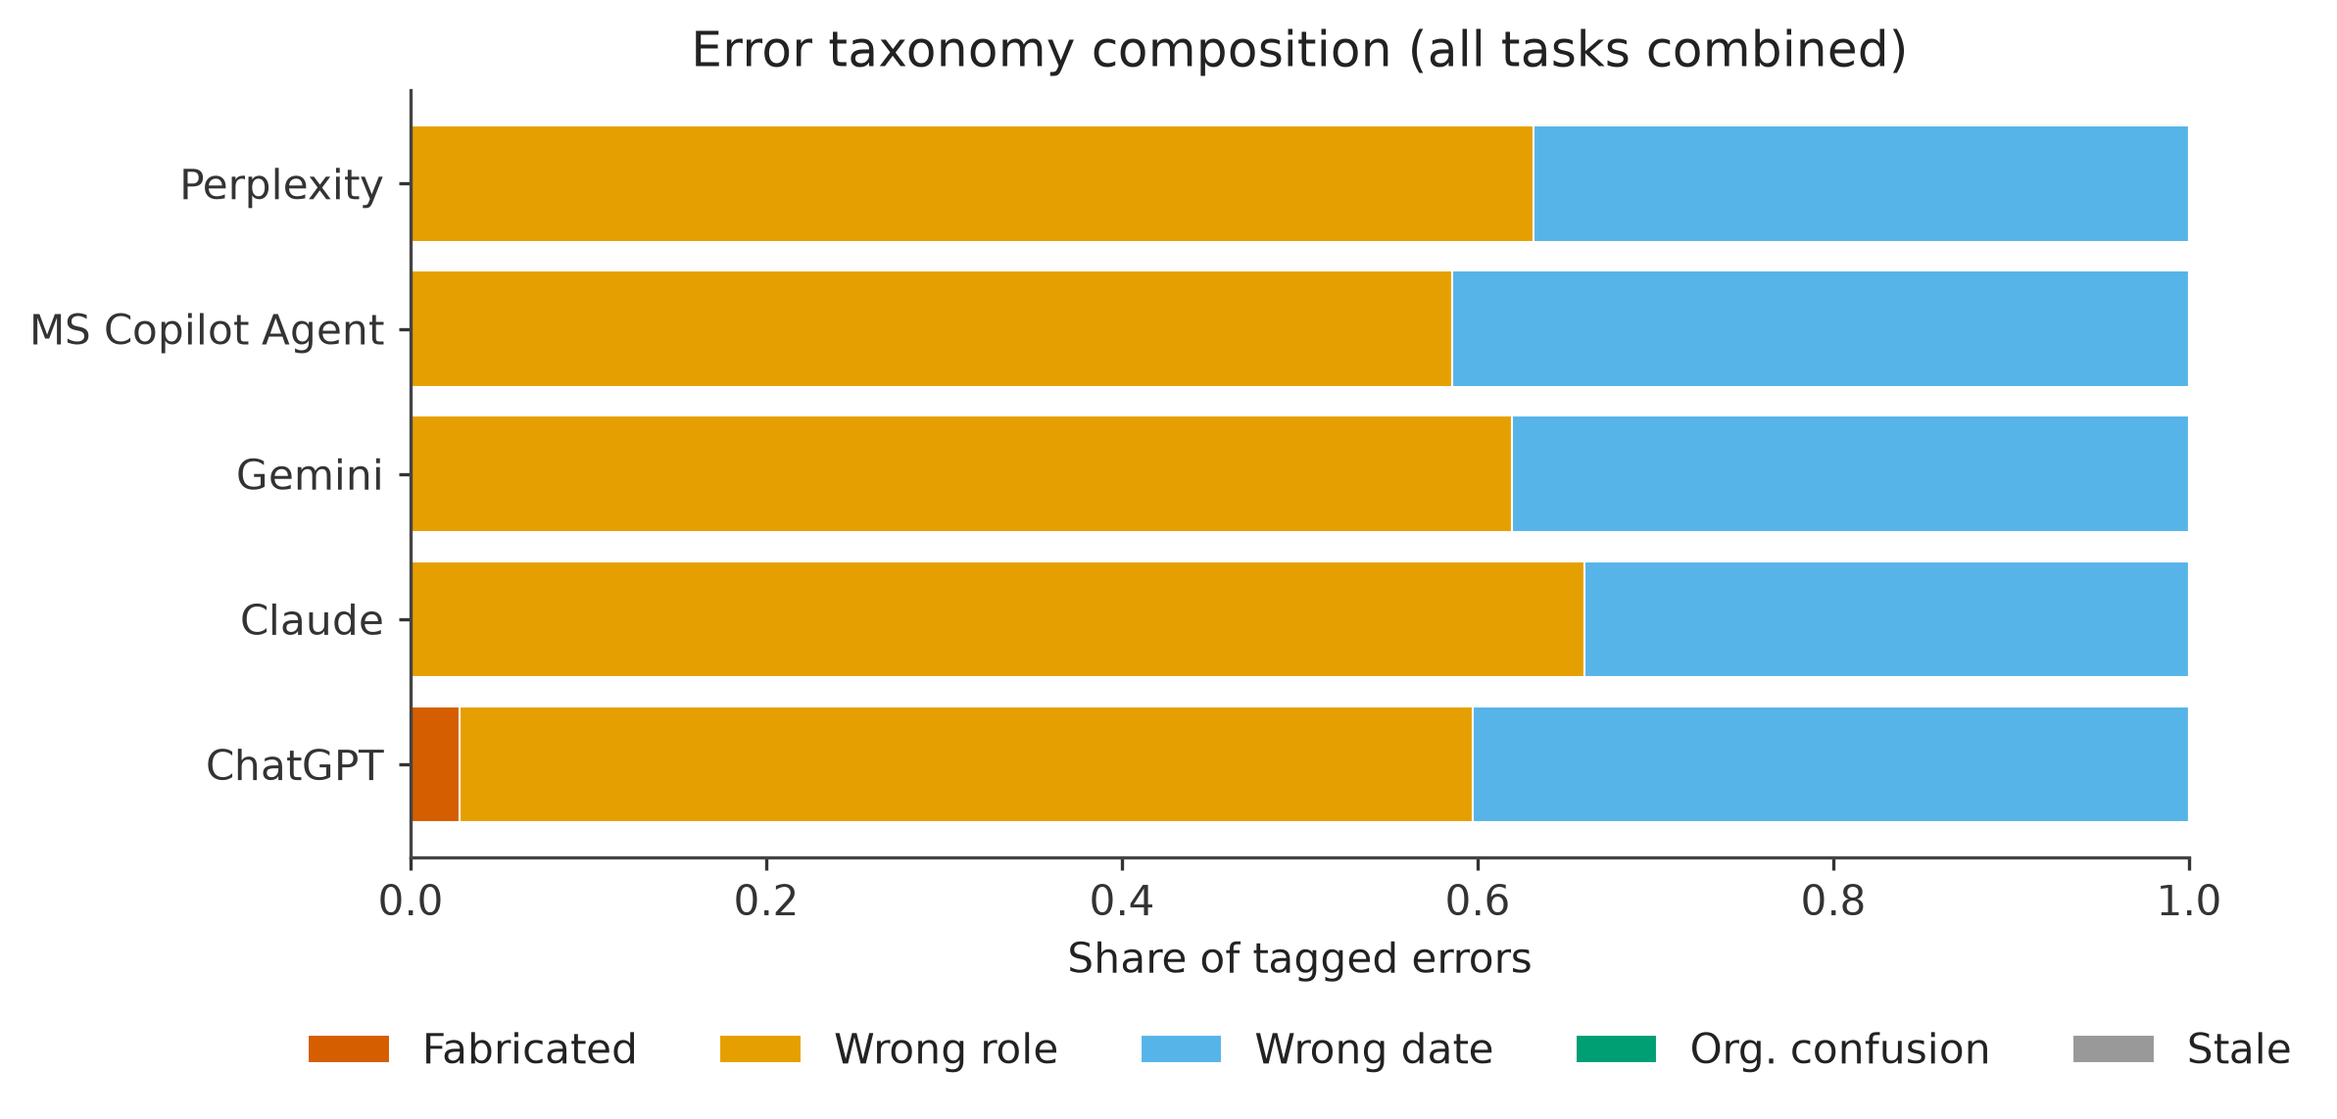
Figure 4. Error taxonomy by system (Experiment 2).
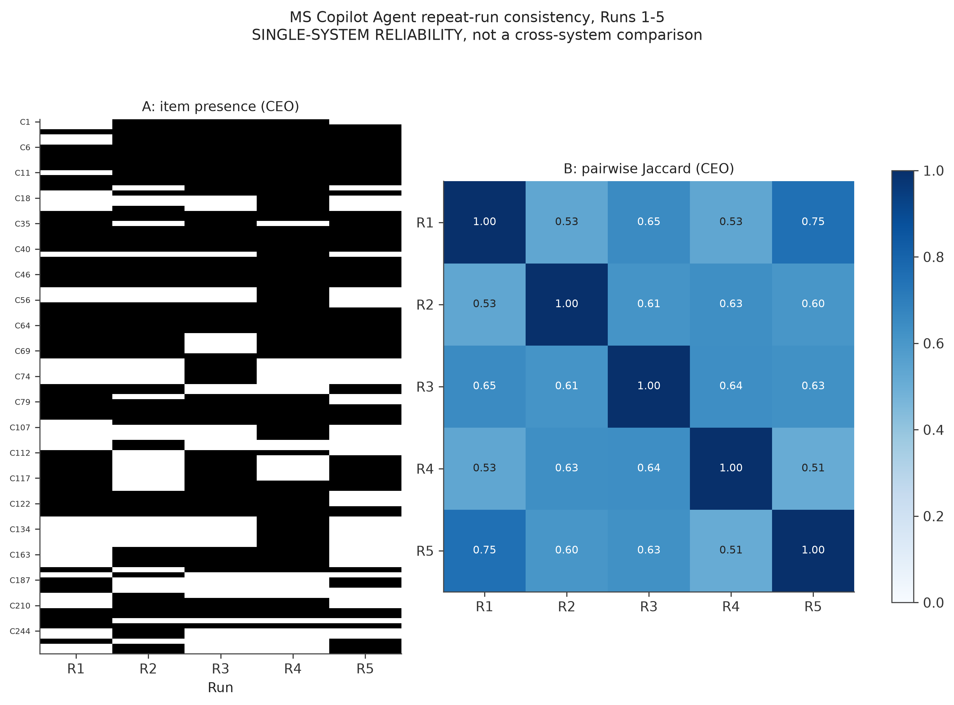
Figure 5. Copilot run-to-run consistency (Experiment 2).

Appendix E – Where the data lives
What | Location
Code, responses, outputs for every experiment | GitHub: sohenpatel22/hospital-news-agent-evaluation › experiments/exp01 … exp05
Main-study metrics | experiments/exp02_updated_gold_full_eval/output/scores/metrics.csv; docs/reports/RESULTS_SUMMARY.md
CEO prompt experiments | experiments/exp03…exp05 (Metrics folders); experiments/cross_version_comparison
Ground-truth versions | data/gold/ (history) and the multi-sheet ground_truth_dataset.xlsx used for scoring
Prompts | docs/prompts/enhanced_prompts.md; the 'Prompt' documents inside each raw_responses folder
Observability | Langfuse project with one trace per experiment × prompt × system × task, and per-hospital traces for Experiment 2

Appendix F – Discrepancies found in the source material
Recorded so that the differences are visible and can be settled. In each case this report uses the value in the 'Used here' column.
Item | What the documents say | Used here
CEO gold-set size | 243 in scope / 248 rows (metrics, results summary); sheet shows 250 rows; write-up says 243 | 243 in scope, 248 rows
Confidence tiers (in-scope CEO) | 171/45/27, 172/44/27 and 176/43/29 in different documents | 171 / 43 / 29, counted from the workbook
Number newly added | '141' in the hand-off Read Me, '146' in the final workbook | 146
Copilot base model | Models Used: GPT-5 Reasoning; project notes: default Claude Sonnet 4.6 with selectable models | GPT-5 Reasoning as recorded; to be confirmed
Hallucination rate for the same systems | 0% (Experiment 2) vs 78–88% (Experiments 4/5) | Definitions differ (Appendix C)
CEO F1 for V2 in cross-version report | Short report lists older V2 values (e.g. Claude 0.50); full report lists corrected values (0.29) | Corrected values
'Consistency' in the Experiment 4/5 files | Presented beside Jaccard figures elsewhere | Format consistency; only Table 6 is run agreement
Deck figures | Slides 28–36 mix Experiment 1, 2 and 3 results and repeat the same text on four 'experiments' | This report's tables
Copilot runs per hospital | Notes mention 3, 5 and 10 runs and 5 hospitals in different meetings | 5 runs, 3 hospitals per task
Hospitals in the evaluation plan | Plan lists the same three hospitals for every task | Task-specific lists (Section 4.2)
Deck definition of specificity | Deck: 'positive only when relevant'; analysis: 0–3 checkability score | 0–3 score
Date typo | Some notes say outputs were captured 'on or before 25 August 2025' | 25 August 2026
Empty documents | The rubric and 'standard procedure' Word files are empty | Procedure taken from the evaluation plan

