Evaluating AI Systems for Automated
Hospital Governance News Monitoring
A Comparative Evaluation of Five AI Systems Against a Human-Verified Gold Standard
Systems evaluated: Microsoft 365 Copilot Hospital News Agent, Perplexity, Claude, ChatGPT, Google Gemini
Author: [to be completed]
Prepared for internal review
Report date: August 31, 2026

Abstract
Hospitals must track leadership changes, regulatory interventions, and privacy-decision activity as part of routine governance monitoring — a task increasingly delegated to AI search and agent tools. This report evaluates five such systems (Microsoft 365 Copilot Hospital News Agent, Perplexity, Claude, ChatGPT, and Google Gemini) against a human-verified gold-standard dataset spanning three tasks: CEO and board leadership changes (five-year window, three hospitals), interim hospital supervisor appointments under Ontario's Public Hospitals Act (five-year window, three hospitals), and PHIPA privacy-decision tracking (six-month window, three hospitals).
Across 671 structured items extracted from 81 raw system responses, we find that precision is uniformly high (~100%) and confirmed hallucination is rare (3 fabricated or mischaracterized items across the entire dataset) for every system evaluated. The primary differentiator between systems is recall: on the CEO task, point estimates range from 13% (Gemini) to 26% (ChatGPT and MS Copilot Agent), though with three hospitals in the sample, only Gemini's recall is statistically distinguishable from the other four systems at a 95% confidence level — the remaining differences are directional, not conclusive. Missing source citations are the single most common quality gap, affecting 72% of matched items (214 of 297), and could not itself be scored for validity this round due to a data-collection limitation disclosed in Section 2.6; a specificity proxy is reported instead. MS Copilot Agent's five repeated runs per task show moderate but real run-to-run variability (mean pairwise Jaccard similarity ≈ 0.60), indicating that a single run is not fully representative of the system's output on a different occasion.
We also report and correct a matching-pipeline defect discovered during human judge validation — items for people with multiple career events in the gold set were sometimes matched to the wrong event — and disclose its effect on the reported numbers. All limitations, including the small hospital sample, gold-set provenance circularity, and an unresolved inter-rater reliability check, are reported explicitly in Section 6.

Table of Contents
Abstract 2
Table of Contents 3
1. Introduction 5
1.1 Systems under test 5
1.2 Tasks, hospitals, and evaluation windows 5
2. Methods 6
2.1 Gold-standard dataset 6
2.1.1 Confidence tiers (CEO sheet only) 6
2.1.2 Status column and provenance 6
2.1.3 Final gold dataset size 6
2.2 Data collection and structured extraction 6
2.3 Entity matching 7
2.3.1 A matching defect found and corrected 7
2.4 Adjudication of unmatched items 7
2.5 Scoring methodology 8
2.5.1 Why citation validity was not scored, and what replaces it 9
2.6 Judge validation 9
3. Results 10
3.1 Headline recall 10
3.1.1 Which differences are statistically defensible 10
3.1.2 Gold-set provenance circularity control 10
3.2 Precision and hallucination 11
3.3 Field accuracy 12
3.4 Specificity (citation-validity substitute) 13
3.5 Error taxonomy 13
3.6 Gold-set findings this round 13
3.7 Single-system consistency: MS Copilot Agent, Runs 1–5 14
3.8 PHIPA and Supervisor tasks 15
4. Discussion and Key Findings 16
4.1 Recall, not accuracy, is what separates these systems 16
4.2 Most pairwise system comparisons are not statistically defensible 16
4.3 Missing citations are the most common and most fixable gap 16
4.4 A single run is not fully representative 16
4.5 Task structure explains the Supervisor-task ceiling effect 16
4.6 The matching-defect discovery and correction itself is a finding 16
5. Limitations 18
5.1 Sample size: three hospitals per task 18
5.2 Repeat runs on one system only 18
5.3 Gold-set provenance circularity 18
5.4 Extraction and judge reliability were not independently verified 18
5.5 Evaluation-window boundary effects 18
5.6 Task windows are not comparable to each other 18
6. Conclusion 19
Appendix A. Additional figures 20
Appendix B. Full results table 21
Appendix C. Ten most common specific errors across all systems 22

1. Introduction
Ontario hospitals are subject to continuous public and regulatory scrutiny of their governance: who sits on the board, who holds executive leadership, whether the hospital has been placed under a Ministry-appointed supervisor, and how the hospital has handled privacy complaints under the Personal Health Information Protection Act (PHIPA). Tracking this activity accurately and promptly is a real operational need, and several AI systems — general-purpose assistants and a purpose-built agent — are candidates for automating part of this monitoring work.
This report describes an evaluation harness built to compare five such systems against a human-verified gold-standard dataset, and reports the resulting metrics, error patterns, and limitations. The evaluation was designed and executed as an internal engineering project: the gold dataset, extraction pipeline, entity-matching logic, adjudication rules, and scoring code were all built specifically for this evaluation and are described in full in Section 2.

1.1 Systems under test
- Microsoft 365 Copilot Hospital News Agent — a purpose-built agent; the only system run repeatedly (5 runs per hospital/task) to measure output consistency.
- Perplexity
- Claude
- ChatGPT
- Google Gemini
The four general-purpose systems (Perplexity, Claude, ChatGPT, Gemini) were each queried once per hospital/task (Run 1 only). MS Copilot Agent was queried five times per hospital/task; all cross-system comparisons in this report use its Run 1 only, so every system is compared on an equal, single-run basis (Section 2.6). Runs 2–5 are used exclusively for the single-system consistency analysis in Section 3.7.

1.2 Tasks, hospitals, and evaluation windows
Task | Hospitals | Evaluation window
CEO / board leadership changes | Mackenzie Health, North York General Hospital, Arnprior Regional Health | 2021-07-16 to 2026-07-16 (5 years)
Interim hospital supervisors (Public Hospitals Act s.9) | London Health Sciences Centre, Renfrew Victoria Hospital, Stevenson Memorial Hospital | 2021-07-16 to 2026-07-16 (5 years)
PHIPA privacy decisions | The Ottawa Hospital, Hamilton Health Sciences, Baycrest Health Sciences | 2026-01-16 to 2026-07-16 (6 months)

The PHIPA window (6 months) is far shorter than the CEO and Supervisor windows (5 years). PHIPA recall/precision are therefore not comparable to CEO/Supervisor numbers on the same axis, and this report keeps the three tasks in separate rows and figures throughout rather than pooling them.

2. Methods
The evaluation pipeline had seven stages, run largely sequentially with human checkpoints between stages: (0) repository and gold-dataset setup, (1) structured extraction, (2) entity matching, (3) adjudication of unmatched items, (4) metric scoring, (5) judge validation, and (6) figure/report generation. This section describes the methodology actually implemented at each stage.

2.1 Gold-standard dataset
The gold dataset is a human-verified spreadsheet with three sheets — one per task — each row representing one real, confirmed event (a leadership change, a supervisor appointment, or a PHIPA decision). Each row carries: a stable item ID, task, hospital, hospital name aliases (for matching), the person or issue name with role/direction embedded in a structured text field, a date, a source and link, an in-scope flag, free-text notes (used for documented date/title tolerances), and — for the CEO sheet only — a status column and a confidence tier.

2.1.1 Confidence tiers (CEO sheet only)
- Tier A — dated announcement (175 of the original 243 rows before this round's additions)
- Tier B — directory-confirmed, undated (44 rows)
- Tier C — inferred / approximate date (27 rows)
Tier B rows are excluded from date-field scoring (there is no date to score against) but still count toward recall.

2.1.2 Status column and provenance
The CEO sheet's status column, undocumented at the start of this project, was formalized during the evaluation into four categories, each with defined scoring implications:
- Verified by Wendy's team — the original human-verified baseline.
- NEWLY ADDED – please verify — rows added to gold after initial collection (146 of 248 current CEO rows). These rows form the independent provenance subset used for the circularity control in Section 3.1.2.
- INCLUDED DUE TO SCOPE CHANGE – please verify — rows added after the in-scope role definition was later expanded (e.g., VP/Chief-level roles).
- Excluded – Foundation CEO — rows that are Foundation CEOs, deliberately kept in gold with in_scope = FALSE so that a system correctly naming a Foundation CEO is recognized as a real identification of a real (but out-of-scope) entity rather than silently treated as a hallucination.

2.1.3 Final gold dataset size
Sheet | Rows | In-scope rows | Notes
CEOs | 248 | 243 | 5 rows added during this evaluation round (Section 3.1.3)
PHIPA | 6 | 3 | 3 rows excluded (Foundation/FIPPA scope exclusions)
Supervisor | 5 | 4 | 1 row excluded (investigator, not supervisor — s.8 vs. s.9)

2.2 Data collection and structured extraction
Raw free-text responses were collected from all five systems for every hospital/task combination (Run 1 for four systems; Runs 1–5 for MS Copilot Agent). After trimming to the runs required for scoring, 81 raw response files were processed by an extraction step that converted each response into schema-conforming JSON items: item_index, system, task, hospital, run_number, person_or_issue, role, direction (incoming/outgoing/unclear), date_raw, date_normalised, citation_url, citation_text, and a verbatim_snippet copied exactly from the source response.
Extraction rules required: (a) every distinct item to be extracted, including ones that looked incorrect — no filtering or correcting of system output; (b) one item per person per event (an incoming and an outgoing mention of the same person counts as two items); (c) citations were never invented — a missing link is recorded as null, not fabricated; and (d) an explicit "could not find information" response produced zero items plus a recorded refusal, not a silent gap.
Methodological disclosure: no LLM API key was configured in the evaluation environment, so extraction was performed directly by the evaluating AI assistant (Claude) reading each response and producing the structured JSON, rather than by a separate scripted API call with a fixed temperature and seed. This is a deviation from a fully reproducible, independently-rerunnable batch process, and is disclosed here as a limitation (Section 6). The result was 671 structured items across the 81 processed files.

2.3 Entity matching
Each extracted item was matched against the gold sheet for its task using person-name and hospital identity only (not date or role). Name matching applied a normalization pipeline: lower-casing, punctuation and honorific stripping (Dr., Mr., Ms., Jr., Sr., etc.), parenthetical and quoted-nickname expansion (“Richard (Rick) Holock” and “Richard ‘Rick’ Holock” both generate a “Rick Holock” variant), comma-separated professional-credential suffix stripping (“Simone Atungo, MES, ICD.D, AccBD” also generates the bare-name variant), and a small set of documented spelling-variant pairs (e.g., Pete Kenney/Kenny, Mark MacGowan/MacGown). Hospital matching used the gold sheet's alias list for each hospital (including Foundation-name aliases, since Foundation entities are deliberately represented as the same hospital row group but flagged out of scope).
Exact matches after normalization, at the same hospital, were auto-accepted. Fuzzy candidates (rapidfuzz token-sort ratio, threshold 70) were never auto-accepted; each was reviewed and accepted or rejected with a documented one-line reason. A right-person/wrong-hospital fuzzy candidate was never accepted as a match — it was rejected outright once confirmed to be a different real person in every case checked.

2.3.1 A matching defect found and corrected
During Stage 5 judge validation (Section 2.6.1), a systematic defect was found: when a person had more than one gold row at the same hospital/task — multiple career events, such as a Board Chair's incoming and outgoing rows recorded separately — the exact-match auto-accept rule matched whichever gold row it encountered first, without checking which event the extracted item actually described. A repair pass re-scored every already-matched item against its own recorded date and direction (incoming/outgoing), and re-pointed the match to a better-fitting gold row wherever one existed for the same person. This repointed 161 matches across 26 files — far more than the 4 instances the judge-validation sample alone had surfaced, confirming this was a systemic issue rather than a rare edge case. The repair raised recall for every system (previously-unmatched gold rows for a person's other career events are now correctly matched) and substantially improved date and role field accuracy. It is disclosed as a limitation that the repair's fit score used the item's own date and direction as its two disambiguating signals, so post-repair Direction field accuracy (Section 3.3) is partly circular for the subset of items where direction was the deciding factor in a repointed match.

2.4 Adjudication of unmatched items
Every extracted item with no gold match was classified into exactly one of five buckets:
Bucket | Definition | Counts against
A — Gold gap | Verifiably correct against a real source, but absent from gold | Nothing (flags a gold-set update)
B — Hallucination | Person/event does not exist or is fabricated | Hallucination rate
C — Wrong attribution | Real person, wrong hospital/role, or wrong entity type | Precision + error taxonomy
D — Out of window | Real and correct but outside the evaluation window | Nothing (excluded both ways)
E — Out of scope | Real, but excluded by the scope rule | Nothing (excluded both ways)

Buckets D and E were determined mechanically: D by a pure date-range check against the item's own recorded date, and E by matching the item's structured role field (deliberately not its free-text snippet, which can describe a different person in the same sentence) against the scope rule's in-scope categories (board directors/governors, Foundation chairs and officers, senior VP/Chief-level leadership) and out-of-scope categories (Foundation CEOs, committee-only members without a board seat, non-voting community members, administrative/trainee staff).
The remaining items required an A-versus-B judgment: is this a real fact missing from gold, or a fabrication? Per the evaluation plan, the automated adjudication step was explicitly barred from browsing the web to “confirm” a claim (doing so risks the model hallucinating its own confirmation). Every A-vs-B item was therefore routed to a human/author verification pass using live web search against primary sources (hospital press releases, board minutes, government orders, and similar) before being finalized.

2.5 Scoring methodology
The following metrics were computed per system and task, all using MS Copilot Agent's Run 1 only for cross-system comparability:
- Recall (by confidence tier, overall, and on the independent-provenance subset) — matched in-scope gold items ÷ in-scope gold items.
- Precision — (matched + bucket A) ÷ (all returned items − buckets D and E − matches to out-of-scope gold rows).
- Hallucination rate — bucket B items ÷ all returned items.
- Field accuracy (role, date, direction) — computed only over matched items where the corresponding gold field is populated; a blank system field against a populated gold field counts as incorrect, not excluded. Documented date and title tolerances (e.g., election date vs. announcement date; “Chief Nursing Executive” = “Chief Nurse Executive”) count both values as correct.
- Specificity (0–3 scale) — substitutes for citation validity this round (see box below); one point each for an exact day-level date, a named non-generic source, and a stated role.
- Omission rate — share of matched items with a required field (name, role, date, or citation link) left blank.
- Completeness — whether a system's responses collectively covered all hospitals and both incoming and outgoing directions, reported as flags.
- Consistency (MS Copilot Agent only) — mean pairwise Jaccard similarity of returned entity sets across its 5 runs, plus per-item stability (share of items present in all 5 runs). Explicitly single-system, not a cross-system comparison.
Bootstrap 95% confidence intervals (1000 resamples) are reported for recall, precision, and hallucination rate throughout. With three hospitals per task, these intervals are correspondingly wide; point-estimate rankings that fall inside overlapping intervals are reported as directional, not statistically distinguishable (Section 3.1.2).

2.5.1 Why citation validity was not scored, and what replaces it
The evaluation plan originally specified a 4-point citation validity scale (does the link resolve, name the person, and support the claim). During data collection, the raw system responses were not all copied with their citations intact — a data-capture gap on the collection side, not a signal about system quality — so citation validity was excluded from this round's scoring rather than computed against an incomplete record. Specificity (defined above) is reported instead as a proxy for how checkable a claim looks, with the explicit caveat that it does not verify whether a citation, if present, actually resolves and supports the claim.

2.6 Judge validation
A stratified random sample of 70 matching/adjudication decisions was drawn, spanning every system, task, and decision type (in-scope match, out-of-scope match, and each adjudication bucket with any items in it — buckets A, C, and D had zero items this round and could not be sampled). All 70 decisions were independently re-adjudicated, comparing the extracted item's own event details against the gold record using semantic/event-level matching rather than string matching.
Four disagreements were found (≈ 5.7%), all four traced to the same root cause: the multi-event matching defect described in Section 2.3.1. That defect has since been patched; the disagreement count here reflects the sample as originally drawn and was not re-verified against the corrected matches.
Cohen's kappa was not computed. This is an explicit, deliberate omission: the 70-row judge-validation file's “human_decision” column was filled in by the same AI system that produced the original “judge_decision” being validated. A kappa computed from that file would measure self-review consistency, not independent human inter-rater agreement, and should not be reported as inter-rater reliability until a genuinely independent second reviewer completes a fresh copy of that column.

3. Results
Unless stated otherwise, all results in this section use the CEO task and MS Copilot Agent's Run 1 only, for direct comparability across all five systems.

3.1 Headline recall
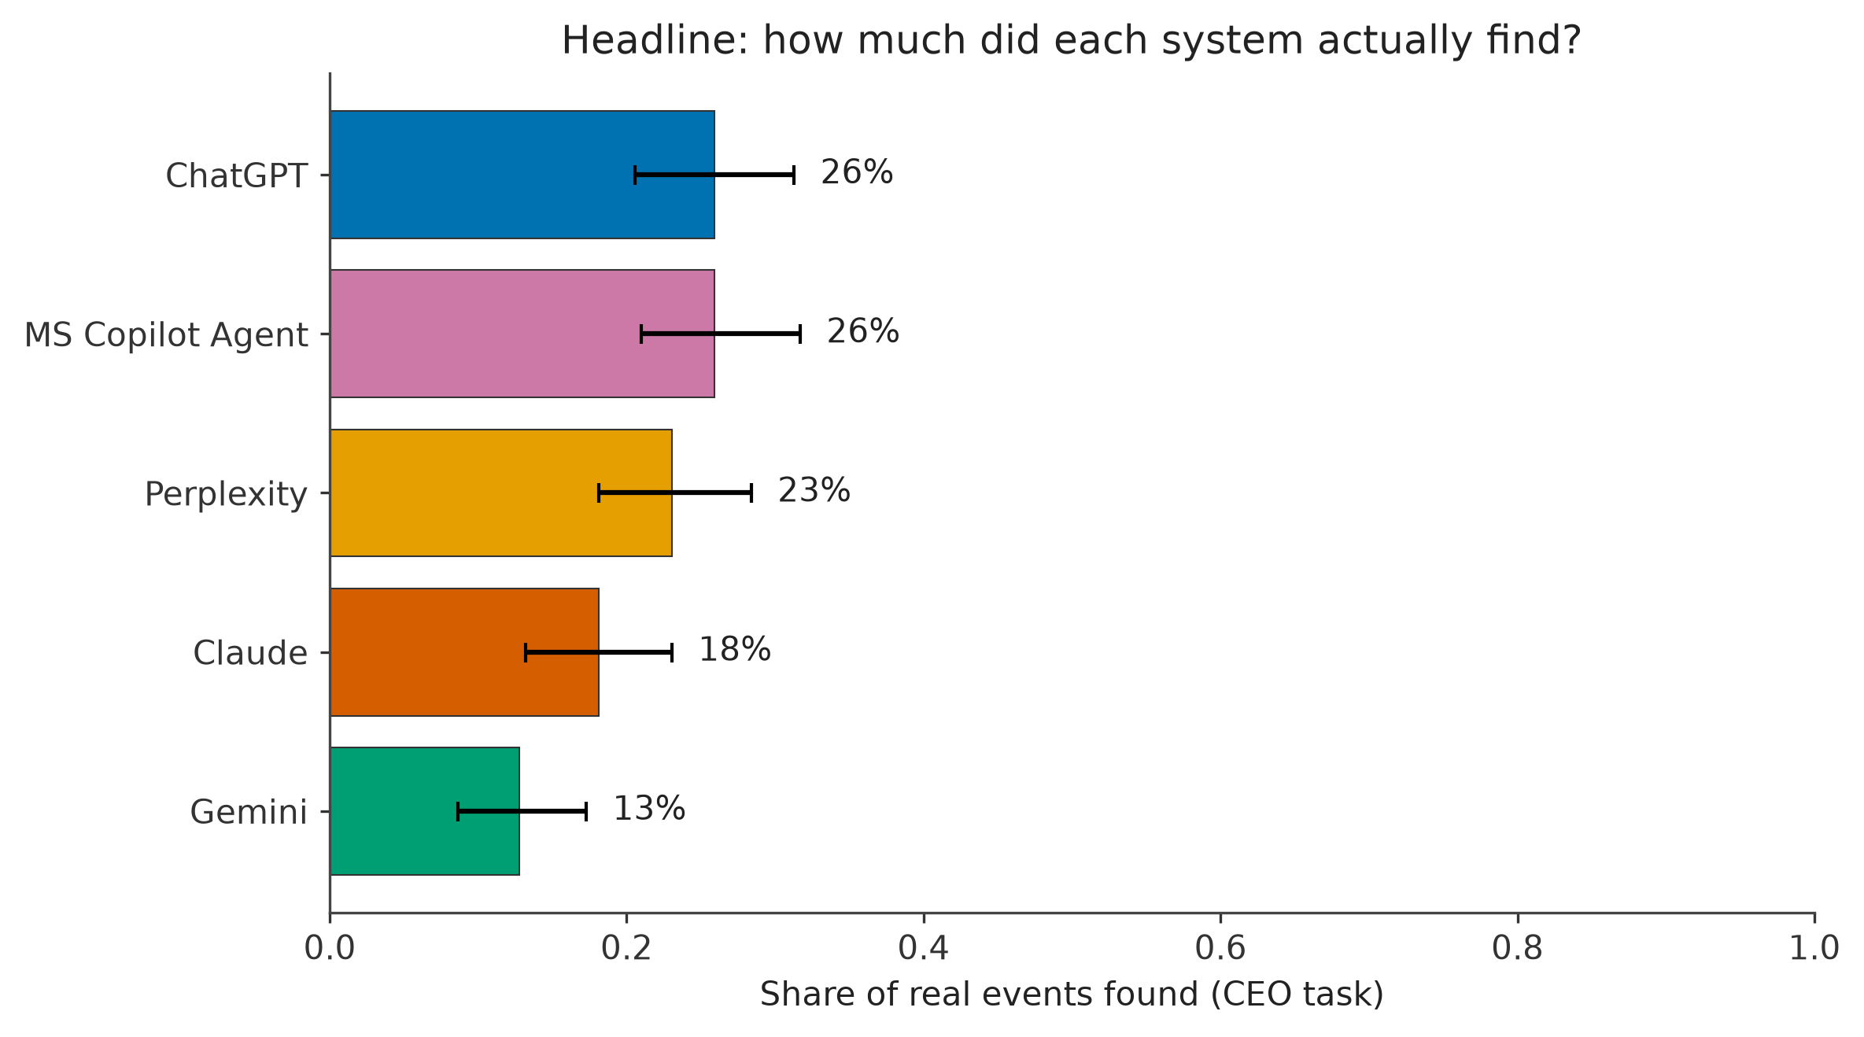
Figure 1. Share of real, gold-verified CEO-task leadership changes found by each system, sorted highest to lowest. Error bars are bootstrap 95% CIs.
System | Recall (95% CI) | n (in-scope gold rows)
MS Copilot Agent | 26% [21, 32] | 243
ChatGPT | 26% [21, 31] | 243
Perplexity | 23% [18, 28] | 243
Claude | 18% [13, 23] | 243
Gemini | 13% [9, 17] | 243

3.1.1 Which differences are statistically defensible
Of the 10 possible system pairs on CEO-task recall, 7 have overlapping 95% confidence intervals and cannot be statistically distinguished at this sample size. Only 3 pairs do not overlap, all involving Gemini:
- ChatGPT (26%) recall is higher than Gemini (13%)
- MS Copilot Agent (26%) recall is higher than Gemini (13%)
- Perplexity (23%) recall is higher than Gemini (13%)
No other pairwise ordering in Figure 1 — including ChatGPT vs. MS Copilot Agent, or Perplexity vs. Claude — is statistically defensible from this dataset alone.

3.1.2 Gold-set provenance circularity control
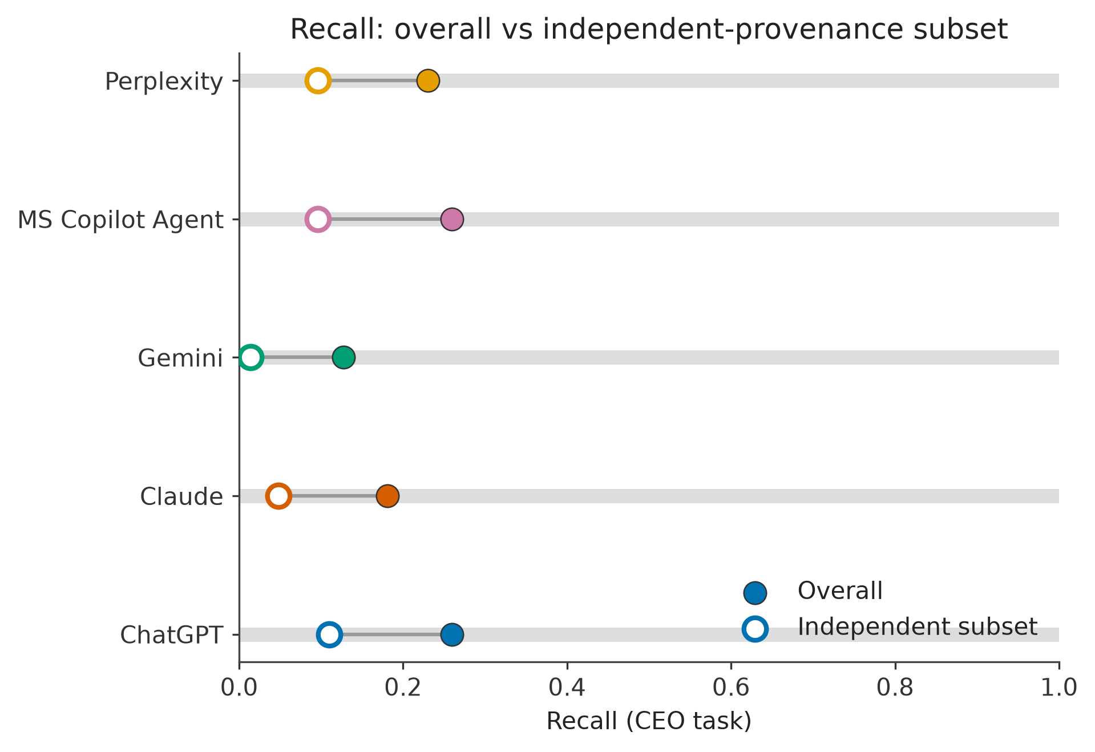
Figure 2. Recall on the full gold set (filled dot) vs. recall restricted to the independent-provenance subset (open dot) — gold rows not sourced from any system under test's own output. Every system's independent-subset recall is lower than its overall recall.
146 of 248 current CEO gold rows carry status “NEWLY ADDED” — added to gold after initial collection, in some cases because a system under test surfaced the fact, which was then verified against a primary source. To control for this circularity, recall is also computed on the subset of gold rows never sourced from a tested system's output. As Figure 2 shows, every system's independent-subset recall is lower than its overall recall, consistent with real (if partial) circularity in the gold set — exactly the pattern this control is designed to detect, and the sanity check specified in the evaluation plan for this figure.

3.2 Precision and hallucination
Precision is at or near 100% for every system on every task with any returned items (Section 3.8, Appendix B). Hallucination — a confirmed fabrication with no corroborating source anywhere, verified by hand — was rare: across the entire dataset (all systems, all tasks, all runs), exactly three items were confirmed fabricated or mischaracterized:
- ChatGPT, PHIPA task, The Ottawa Hospital/Hamilton Health Sciences (Run 1): two policy-administration documents (a MyChart Terms revision, a Directory-of-Records publication) presented as adjudicated PHIPA decisions — a mischaracterization of what the task tracks, not a fabricated person or event.
- MS Copilot Agent, CEO task, Arnprior Regional Health, Run 4: “Brenda Donnelly” — verified by hand against Arnprior Regional Health's own board records and general web search; no trace found anywhere. This is the only confirmed complete fabrication (a named person with zero corroboration) found in this evaluation.
The Donnelly item appeared only in MS Copilot Agent's Run 4 and is therefore not counted in any cross-system hallucination-rate number in this report, all of which use Run 1 only — it is reported here for completeness and is discussed further in Section 4.
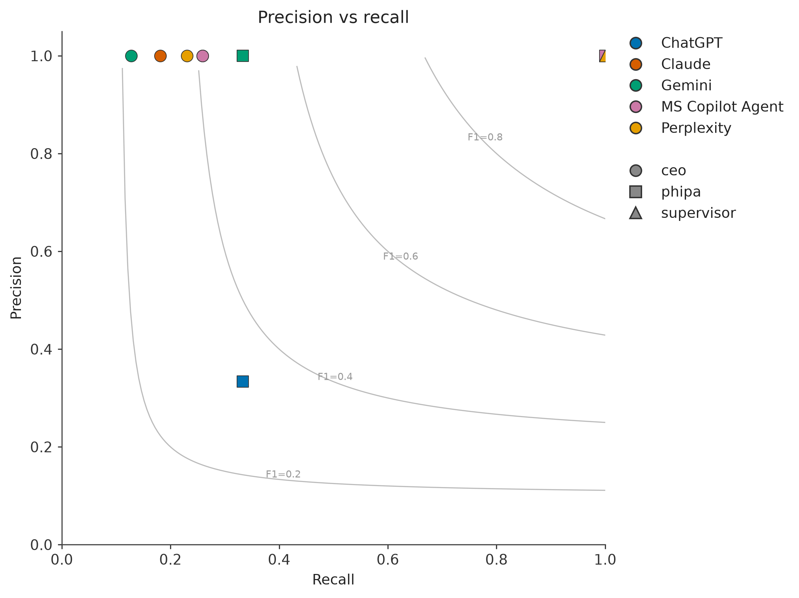
Figure 3. Precision vs. recall, one point per system per task. Grey lines are iso-F1 contours. Precision clusters at the top of the chart for every system/task with returned items — the differentiating axis is recall, read left to right.

3.3 Field accuracy
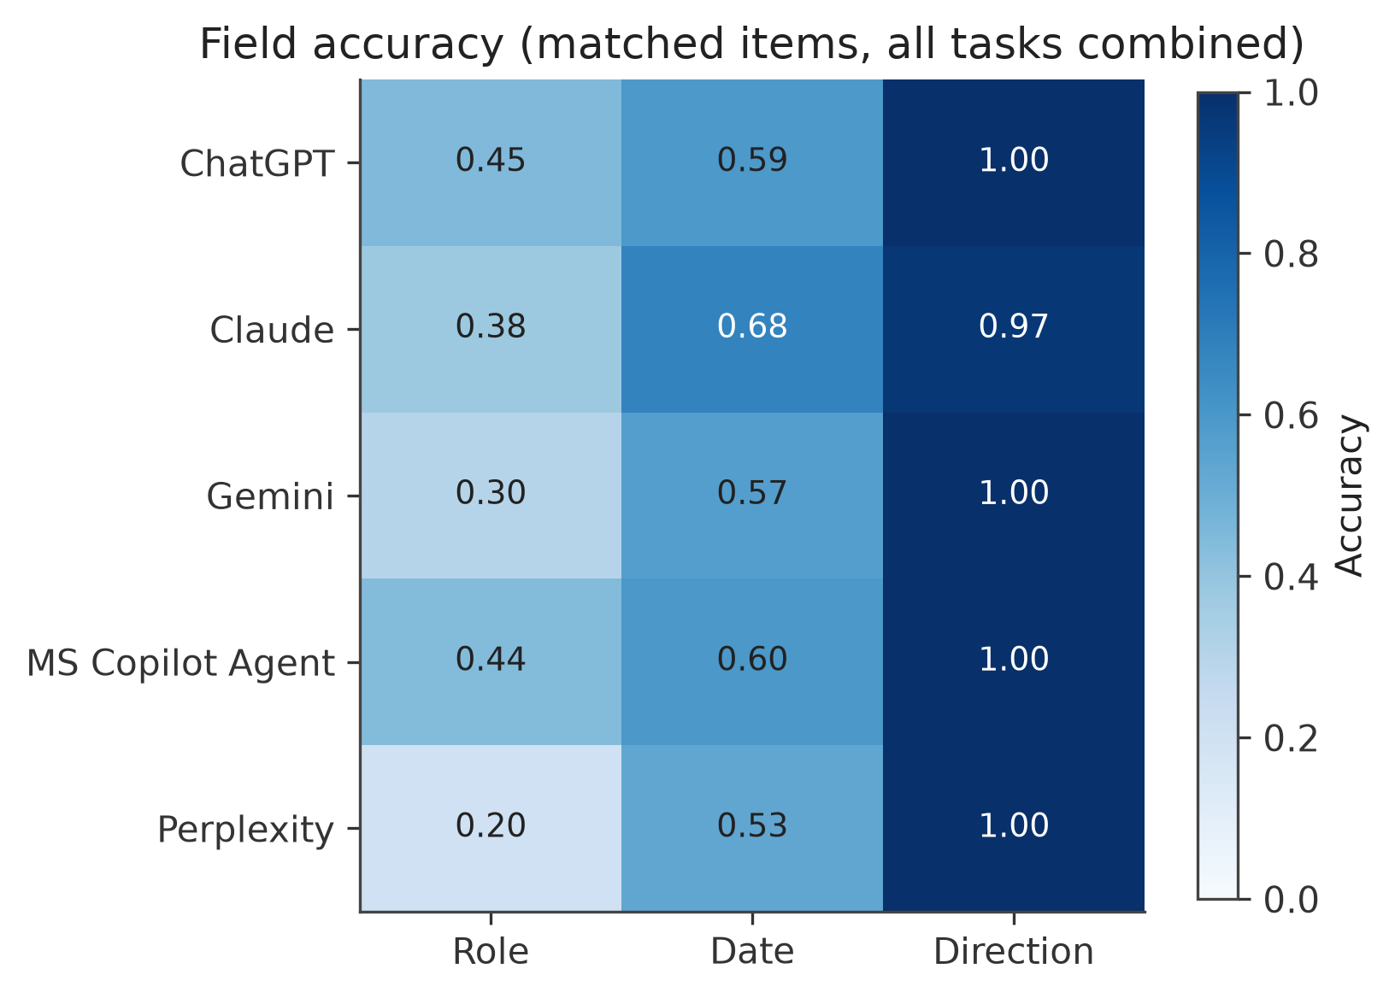
Figure 4. Role, date, and direction accuracy, conditional on entity match (matched items only), all tasks combined, post matching-defect repair.
Direction accuracy is high (0.97–1.00) for every system post-repair; this is disclosed in Section 2.3.1 as partly circular, since direction was one of the two signals the repair used to re-point ambiguous matches. Date accuracy (0.53–0.68) and role accuracy (0.20–0.45) are more moderate and are treated as a genuine, largely independent read of model performance, though date accuracy specifically is noted as an upper bound given the same repair process.
System | Role accuracy | Date accuracy | Direction accuracy
ChatGPT | 0.45 | 0.59 | 1.00
Claude | 0.38 | 0.68 | 0.97
Gemini | 0.30 | 0.57 | 1.00
MS Copilot Agent | 0.44 | 0.60 | 1.00
Perplexity | 0.20 | 0.53 | 1.00

3.4 Specificity (citation-validity substitute)
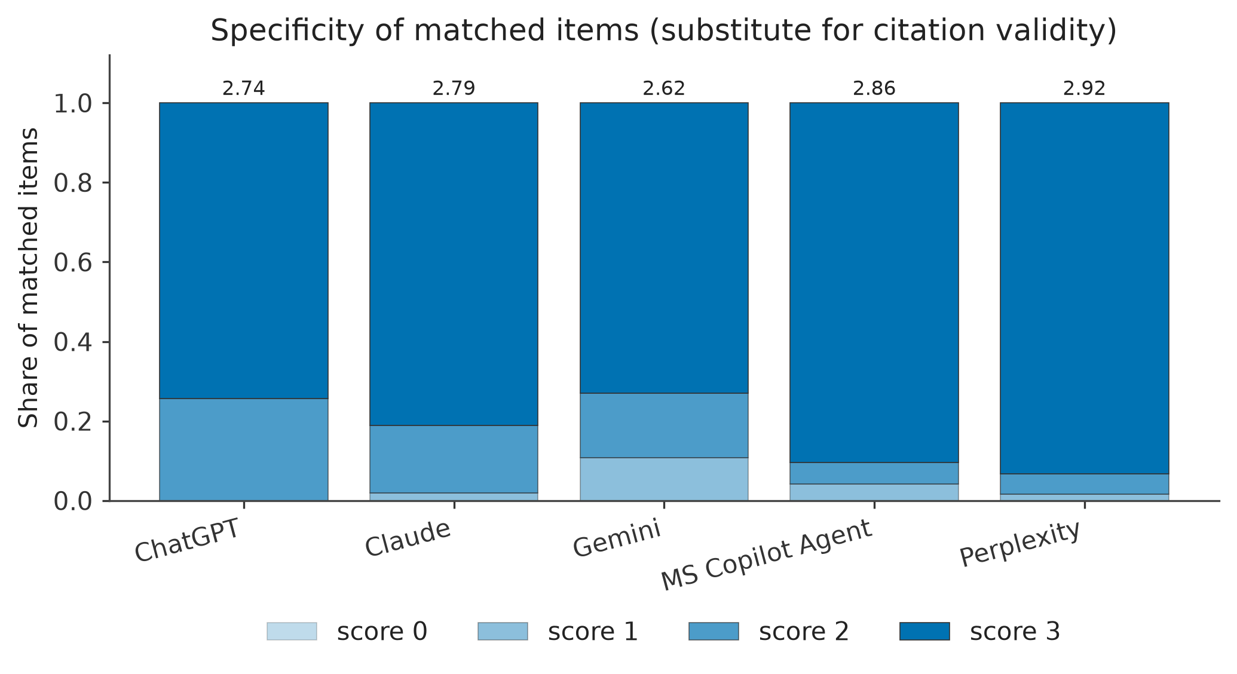
Figure 5. Specificity score (0–3: exact date + named source + stated role) for matched items, all tasks combined. Every system averages 2.6–2.9 of 3.
Specificity is uniformly good — every system's mean score is within 0.3 of every other system's. The single largest identified gap is missing citation links: 214 of 297 matched items (72%) had no citation URL at all, near-universal for ChatGPT, Gemini, and MS Copilot Agent, which typically name a source but do not link it. This is the most common specific error pattern found anywhere in this evaluation (Appendix C, item 1) and, per Section 2.5.1, is not itself scored for validity this round.

3.5 Error taxonomy
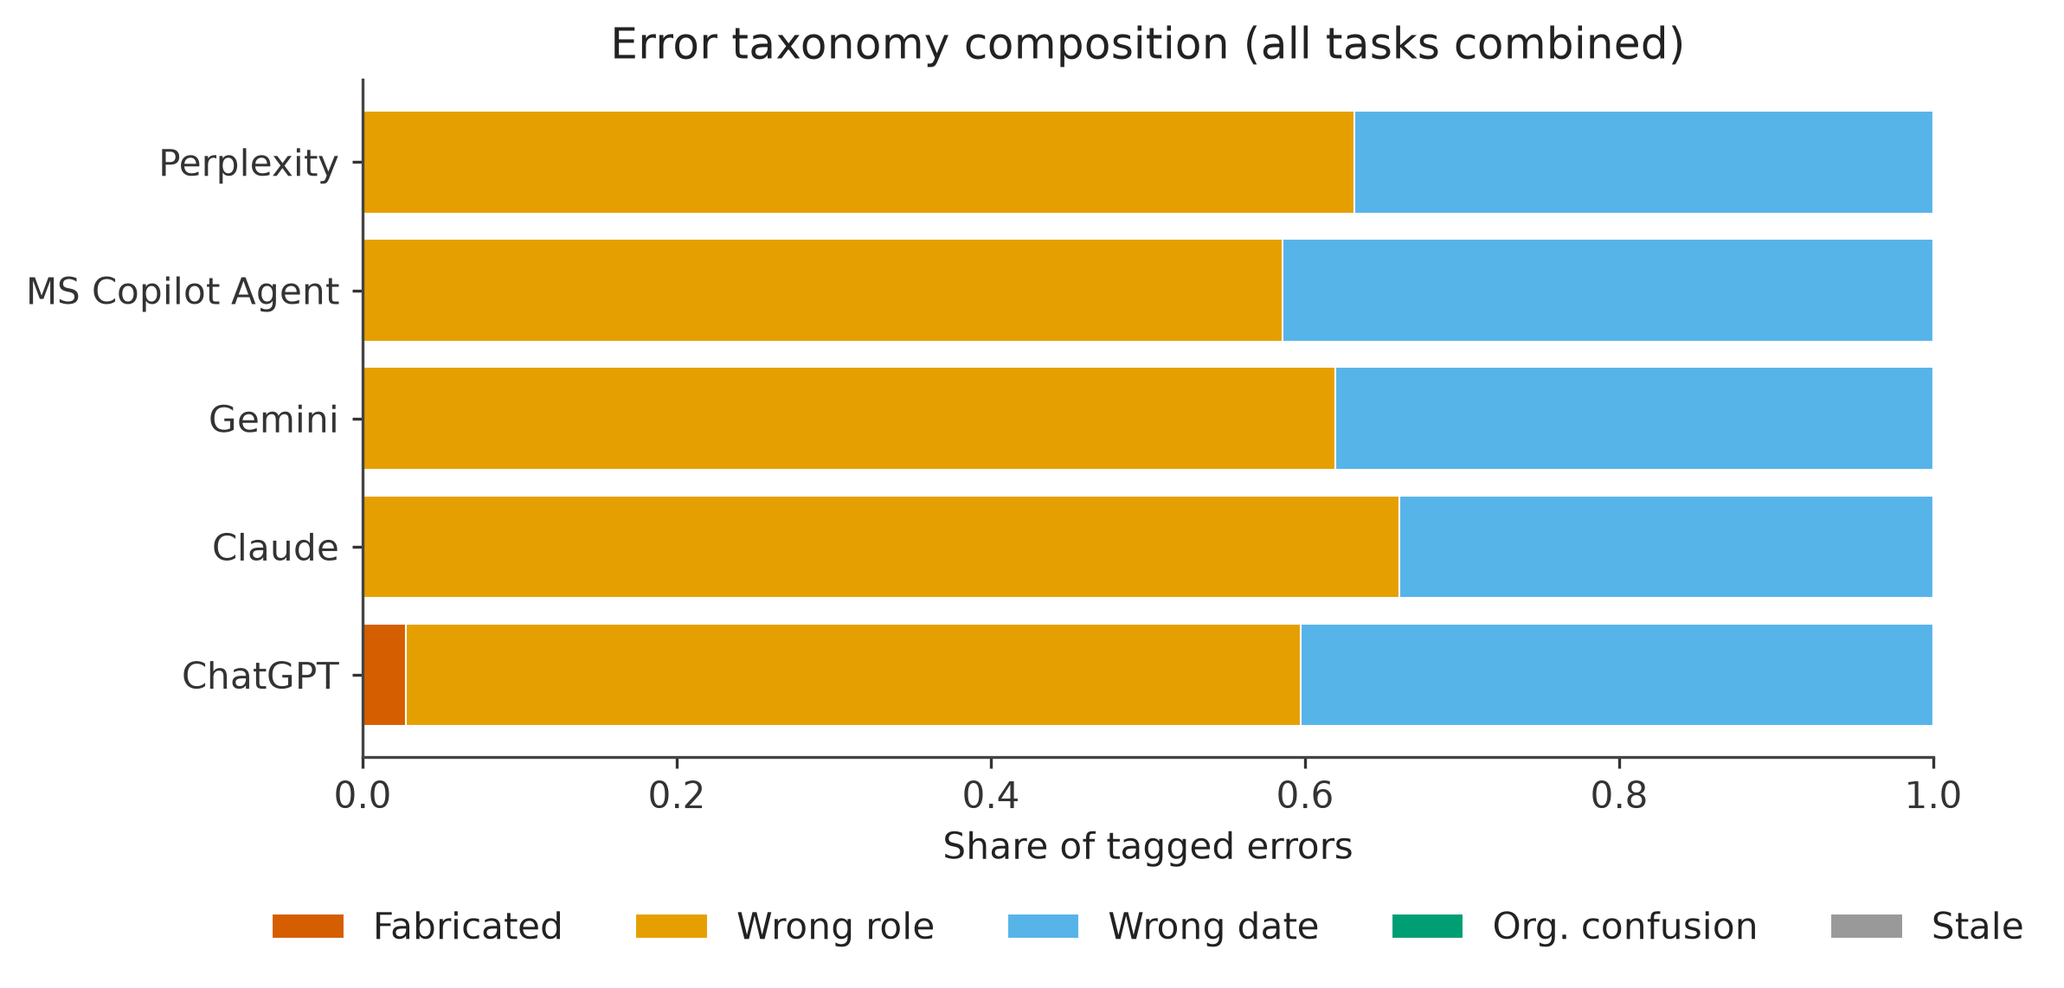
Figure 6. Composition of tagged errors by category, all tasks combined, normalized to 100% per system. “Unsupported citation” (a sixth category in the original plan) is not shown — citation validity was not computed this round. “Stale” was not automatically detected and should be read as not-yet-measured.
Wrong role/title and wrong date are the two dominant error categories for every system, together accounting for the large majority of tagged errors. Organisational confusion (Foundation vs. hospital, or wrong hospital) and fabrication are rare by comparison — see Appendix C for the full ranked list with exact counts.

3.6 Gold-set findings this round
As of this evaluation round, adjudication bucket A (unresolved gold gap) is empty (0 items) system-wide: every item provisionally flagged as a possible gold gap during Stage 3/4 adjudication was resolved by the end of this round — either verified against a primary source and added to gold, or reclassified as bucket B after verification found no corroboration (Section 3.2). The five gold-set additions made this round are:
Gold row added | Hospital | Date | Tier
Dr. Florin Padeanu — Chief of Staff (incoming) | Arnprior Regional Health | 2022-01-01 | A
Dr. Christine Schriver — Chief of Staff (outgoing) | Arnprior Regional Health | 2022-01-01 | A
Dr. Eyal Golan — President, Professional Staff Association (incoming) | Mackenzie Health | 2022-01-19 | A
Dr. Kevin Wasko — Chief of Emergency Medicine and Program Medical Director | North York General Hospital | 2023-05-01 | C
Dr. Maral Nadjafi — Chief of Medicine and Program Medical Director | North York General Hospital | 2022 | C

A sixth item (Simone Atungo, an existing gold row) had its previously-undated confidence tier upgraded to Tier A after a specific appointment date was verified. All six were first surfaced by one or more systems under test and then independently confirmed against a primary source — reinforcing why the independent-provenance recall control (Section 3.1.2) matters: some of every system's “overall” recall credit now traces back to gold rows the systems themselves helped surface this round.

3.7 Single-system consistency: MS Copilot Agent, Runs 1–5
This subsection is single-system reliability, not a cross-system comparison — no other system in this evaluation was run more than once.
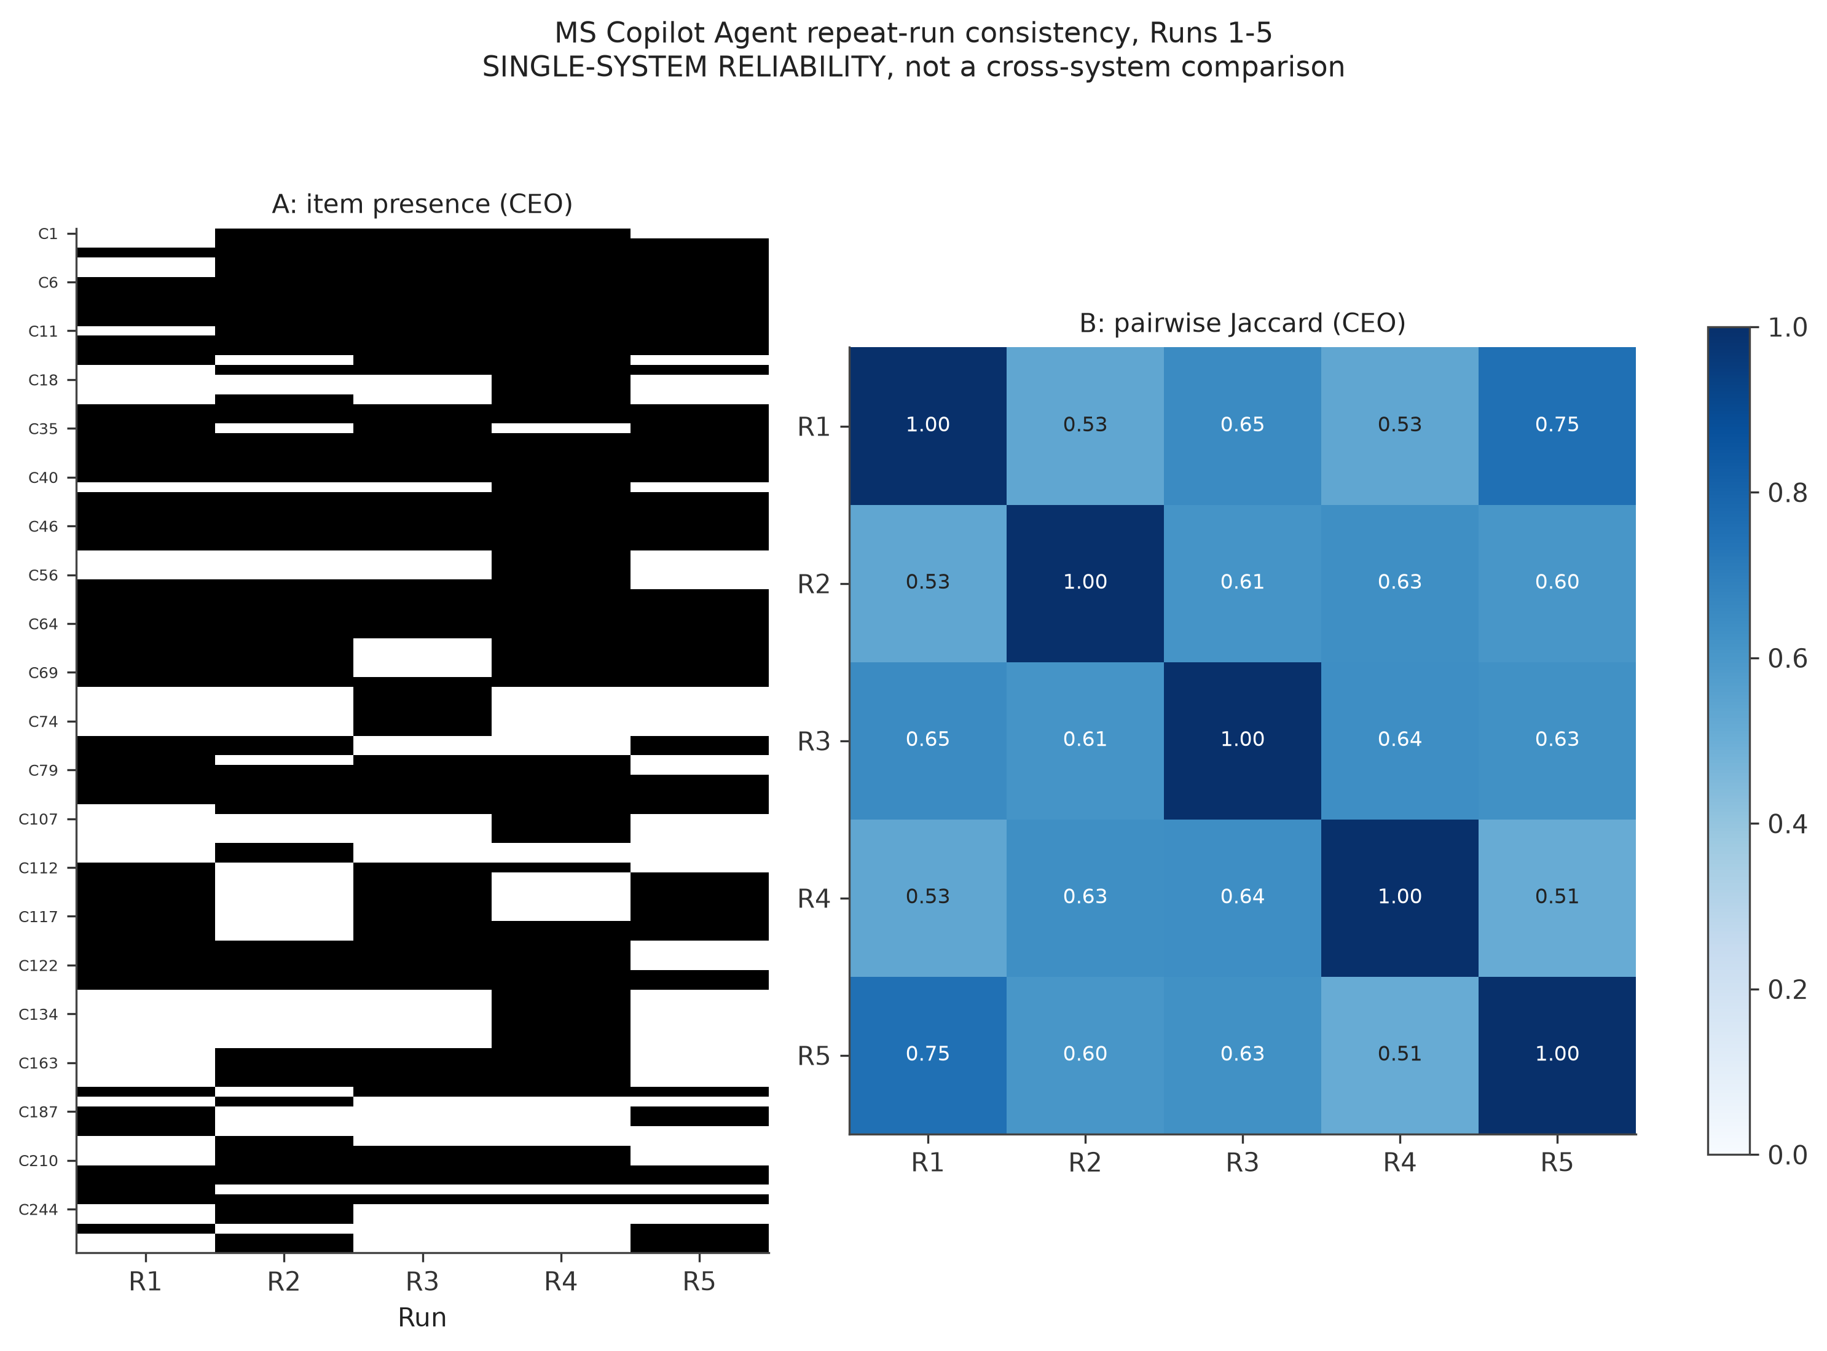
Figure 7. Panel A: presence of each distinct CEO-task gold item MS Copilot Agent matched in at least one of its 5 runs, by run. Panel B: pairwise Jaccard similarity of its full returned entity sets between each pair of runs.
Mean pairwise Jaccard similarity across the 10 run pairs was approximately 0.60 (range 0.49–0.79), indicating moderate but real run-to-run variability: roughly 40% of the entities returned differ between a typical pair of runs, even though the query and target hospital/task were identical across runs. This has a direct implication for interpreting any single evaluation run (including every other system's single-run results in this report, Section 4).

3.8 PHIPA and Supervisor tasks
PHIPA has only 3 in-scope gold rows and Supervisor only 4 — with samples this small, a single found or missed item swings a system's recall by 25–33 percentage points, and confidence intervals are correspondingly very wide (often the full [0%, 100%] range). These results are reported as directional, not precise.
Task | ChatGPT | Claude | Gemini | MS Copilot Agent | Perplexity
PHIPA recall | 33% | 0% | 33% | 100% | 0%
Supervisor recall | 100% | 100% | 100% | 100% | 100%

Every system achieved 100% recall on the Supervisor task (n=4 in-scope gold rows). This is discussed in Section 4 alongside the PHIPA result, where two systems (Claude, Perplexity) returned zero matched items, making precision and F1 mathematically undefined (not zero) for those system/task pairs.

4. Discussion and Key Findings

4.1 Recall, not accuracy, is what separates these systems
Precision is near-perfect and hallucination is rare for every system evaluated: when a system reports an in-scope leadership change, board appointment, or PHIPA decision, it is almost always about a real person or event, correctly attributed to the right hospital. The practical differentiator is how much of the real activity each system finds at all. Even the best-performing systems on the CEO task (ChatGPT and MS Copilot Agent, both 26%) missed roughly three-quarters of the real, gold-verified leadership changes across three hospitals over five years. This is the single most important number in this report for a decision-maker evaluating these systems for governance-monitoring use: none of the five systems evaluated here should be treated as a complete or reliable single source for this task without human review of gaps.

4.2 Most pairwise system comparisons are not statistically defensible
With three hospitals per task, confidence intervals are wide enough that 7 of the 10 possible CEO-recall system pairs overlap and cannot be distinguished (Section 3.1.1). The only defensible claim from this dataset is that Gemini's recall is lower than ChatGPT's, MS Copilot Agent's, and Perplexity's; every other ranking implied by the point estimates in Figure 1 (e.g., ChatGPT vs. MS Copilot Agent, or Perplexity vs. Claude) is directional at best. A larger hospital sample would be needed before ranking these systems with statistical confidence beyond that one comparison.

4.3 Missing citations are the most common and most fixable gap
72% of matched items across the dataset had no citation link at all (Section 3.4), even though the systems' claims were otherwise reasonably specific (named sources, exact dates, stated roles in most cases). This is a distinct failure mode from hallucination or wrong-entity confusion — the underlying facts are usually correct — and is plausibly the most directly actionable finding in this report for any team building on top of these systems: verifiability, not correctness, is the visible gap. It should be re-evaluated with citation validity actually scored once the raw-response collection process is fixed to preserve citations reliably (Section 2.5.1).

4.4 A single run is not fully representative
MS Copilot Agent's five repeated runs on identical queries returned meaningfully different entity sets from run to run (mean pairwise Jaccard ≈ 0.60, Section 3.7). Because every other system in this evaluation was queried only once, their single-run results should be read as one sample from an unknown, possibly similarly variable distribution, not as each system's definitive, reproducible output. This is a genuine open question this evaluation cannot answer for the four single-run systems, and is listed as a limitation (Section 5).

4.5 Task structure explains the Supervisor-task ceiling effect
Every system achieved 100% recall on the Supervisor task, in contrast to the much lower CEO-task recall. The most plausible explanation, consistent with the small, well-defined nature of the task, is that interim-supervisor appointments are rare, singular, and heavily publicized regulatory events (formal Ministry orders under the Public Hospitals Act, typically covered by provincial and local news) — a fundamentally easier retrieval target than the larger, noisier, and more continuous stream of CEO and board leadership changes across a five-year window. With only 4 in-scope gold rows, this ceiling effect could also partly reflect the small sample rather than a true task-difficulty difference; it should be interpreted cautiously (Section 3.8).

4.6 The matching-defect discovery and correction itself is a finding
The multi-event matching defect (Section 2.3.1), and its discovery via independent human judge validation rather than automated testing, illustrates a general risk in LLM-assisted evaluation pipelines: an entity-matching rule that is correct in aggregate (right person, right hospital) can still silently corrupt field-level scoring (wrong specific date or role) for anyone with more than one entry in the reference set. The 161-match correction changed recall, date accuracy, and role accuracy for every system in this report, underscoring the value of the judge-validation step specified in the original evaluation plan and executed in Section 2.6 — it caught a real, systemic error that field-accuracy numbers alone did not surface.

5. Limitations

5.1 Sample size: three hospitals per task
Every confidence interval in this report is correspondingly wide. Point-estimate differences between systems should be treated as directional unless the CIs are explicitly reported as non-overlapping (Section 3.1.1).

5.2 Repeat runs on one system only
MS Copilot Agent has 5 runs per hospital/task; every other system has 1. All cross-system metrics in this report use MS Copilot Agent's Run 1 only. Runs 2–5 feed only the single-system consistency analysis (Section 3.7) and are never used to give MS Copilot Agent additional chances in any cross-system number.

5.3 Gold-set provenance circularity
146 of 248 current CEO gold rows were added after initial collection, some because a system under test surfaced the fact. The independent-provenance recall control (Section 3.1.2) partially addresses this — every system's independent-subset recall is lower than its overall recall — but gold-set growth is ongoing and partly system-prompted, not a fixed, independent reference standard.

5.4 Extraction and judge reliability were not independently verified
Structured extraction (Section 2.2) was performed by the same AI system used throughout this pipeline, not by a separately reproducible scripted process. Judge validation (Section 2.6) found a 5.7% disagreement rate but used a self-review process, and Cohen's kappa — the standard inter-rater reliability statistic specified in the original evaluation plan — has not been computed, because doing so from the current file would measure self-consistency rather than independent agreement. An independent second reviewer completing a fresh copy of the judge-validation sample is needed before an inter-rater reliability number can be reported.

5.5 Evaluation-window boundary effects
Items dated near the edge of an evaluation window are sensitive to both a system's knowledge cutoff and to which of several reported dates for the same event is used. No item in this round's adjudication was excluded solely for falling outside a window (0 items in bucket D throughout), but this reflects that dated items happened to cluster well inside the windows in this particular dataset, not evidence that boundary effects are generally unimportant.

5.6 Task windows are not comparable to each other
PHIPA's 6-month window is far shorter than CEO/Supervisor's 5-year window. PHIPA recall and precision should never be plotted or compared on the same axis as CEO/Supervisor numbers; every table and figure in this report keeps the three tasks separate for this reason.

6. Conclusion
This evaluation compared five AI systems against a purpose-built, human-verified gold standard across three governance-monitoring tasks for Ontario hospitals. The consistent finding across all three tasks is that these systems rarely state something confidently wrong when they do report something in scope (precision near 100%, hallucination rare), but they leave substantial real activity unfound, particularly on the CEO/board leadership-change task, where even the best system found only about a quarter of gold-verified events. Statistical power at this sample size (three hospitals per task) supports only one confident system ranking claim — that Gemini's CEO-task recall trails the other four systems — with every other apparent difference remaining directional rather than conclusive.
The most actionable, immediately fixable gap identified is the near-total absence of citation links (72% of matched items), which limits a reader's ability to independently verify any given claim regardless of how accurate it turns out to be. The evaluation also surfaced and corrected a systemic entity-matching defect during its own execution, and discovered five new confirmed gold-set facts that had been missing from the reference standard — both outcomes that argue for treating this evaluation harness as a living, iterating process rather than a one-time scoring exercise.
Before any of these systems is relied upon as a primary or sole source for hospital governance monitoring, this report recommends: (1) expanding the hospital sample to narrow the wide confidence intervals reported here; (2) re-running the raw-response collection process to reliably preserve citations, enabling an actual citation-validity score in place of the specificity proxy used this round; (3) completing an independent second-reviewer pass on the judge-validation sample to obtain a genuine inter-rater reliability (Cohen's κ) figure; and (4) treating single-run results from the four non-repeated systems with the same caution warranted by MS Copilot Agent's observed run-to-run variability, pending repeated-run data for those systems as well.

Appendix A. Additional figures
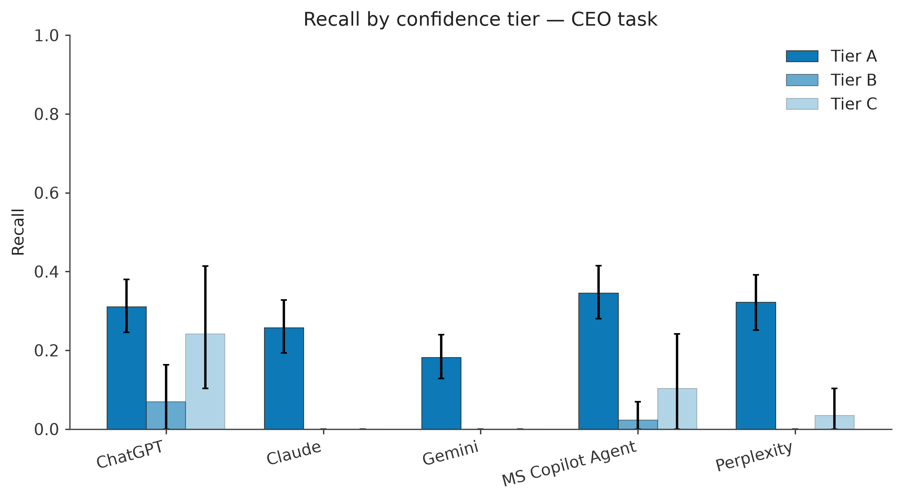
Figure A1. CEO-task recall by gold confidence tier (A = dated announcement, B = directory-confirmed undated, C = inferred/approximate date). Error bars are bootstrap 95% CIs.
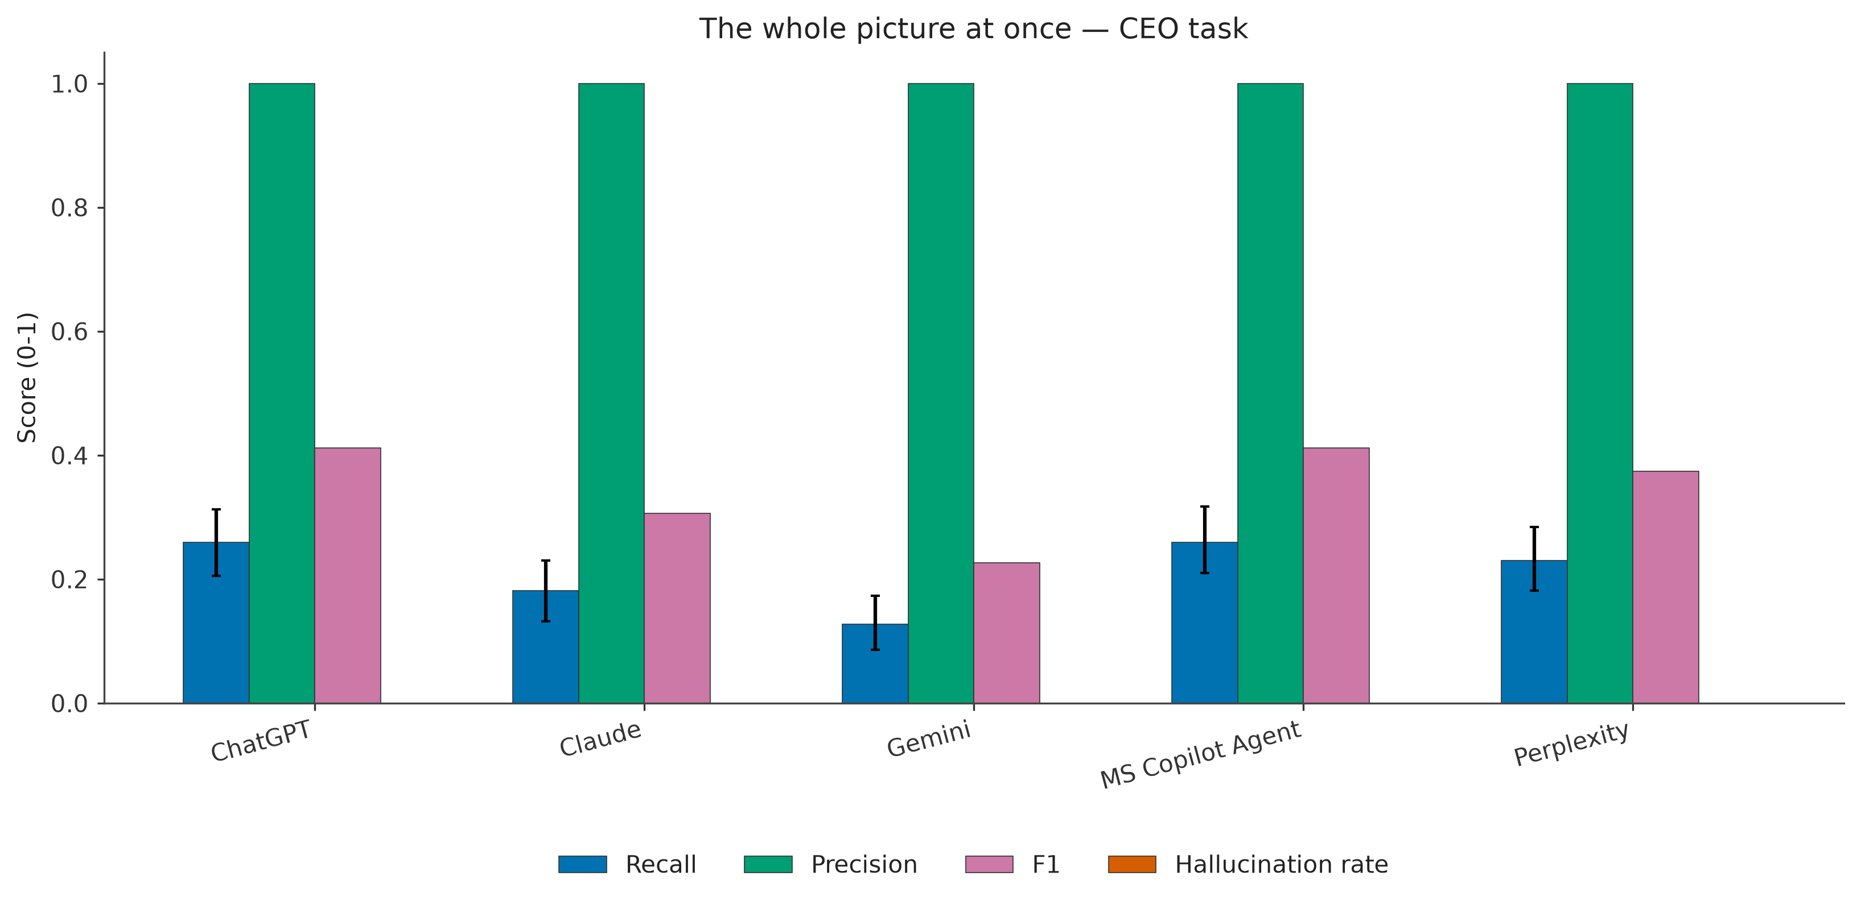
Figure A2. Recall, precision, F1 (harmonic mean of precision/recall), and hallucination rate side by side, CEO task. Precision is near-100% and hallucination near-0% for every system — the visual story is almost entirely about the recall bars.
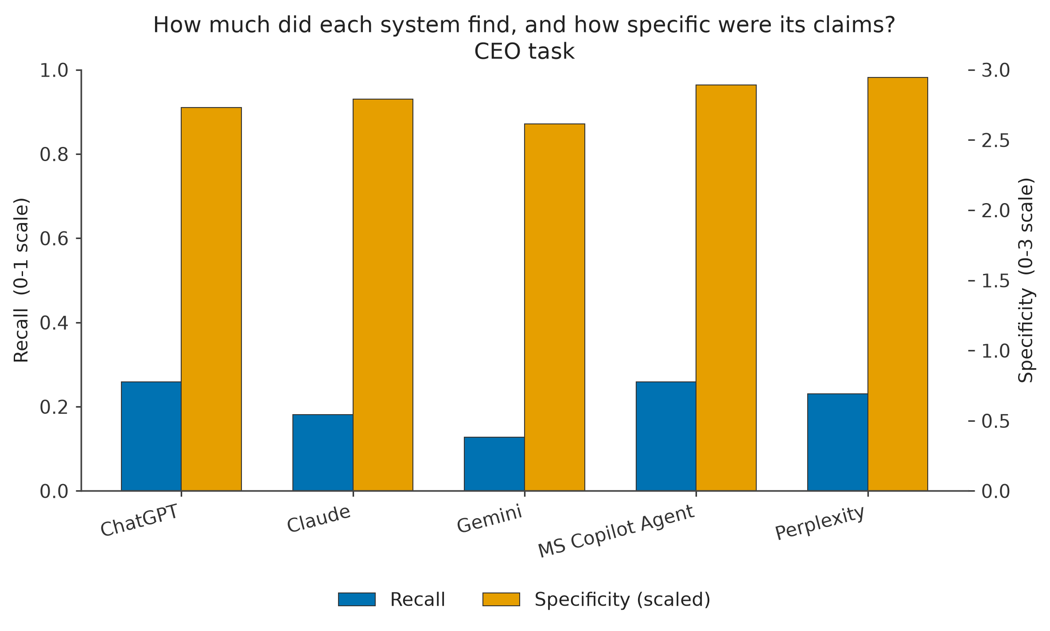
Figure A3. Recall alongside specificity (scaled to the same axis, true 0–3 scale on the right), CEO task. Specificity differences between systems are small relative to recall differences.

Appendix B. Full results table
System × task × metric, with 95% confidence intervals where computed. “--” indicates the metric was undefined (zero returned items) for that system/task.
System | Task | Recall | Precision | Hallucination rate | Specificity | Omission rate
ChatGPT | CEO | 26% [21, 31] | 100% [100, 100] | 0% [0, 0] | 2.73 | 100%
ChatGPT | PHIPA | 33% [0, 100] | 33% [0, 100] | 50% [0, 100] | 2.00 | 100%
ChatGPT | Supervisor | 100% [100, 100] | 100% [100, 100] | 0% [0, 0] | 3.00 | 100%
Claude | CEO | 18% [13, 23] | 100% [100, 100] | 0% [0, 0] | 2.79 | 10%
Claude | PHIPA | 0% [0, 0] | -- | -- | -- | --
Claude | Supervisor | 100% [100, 100] | 100% [100, 100] | 0% [0, 0] | 2.80 | 0%
Gemini | CEO | 13% [9, 17] | 100% [100, 100] | 0% [0, 0] | 2.61 | 100%
Gemini | PHIPA | 33% [0, 100] | 100% [100, 100] | 0% [0, 0] | 2.00 | 100%
Gemini | Supervisor | 100% [100, 100] | 100% [100, 100] | 0% [0, 0] | 2.80 | 100%
MS Copilot Agent | CEO | 26% [21, 32] | 100% [100, 100] | 0% [0, 0] | 2.89 | 100%
MS Copilot Agent | PHIPA | 100% [100, 100] | 100% [100, 100] | 0% [0, 0] | 2.00 | 100%
MS Copilot Agent | Supervisor | 100% [100, 100] | 100% [100, 100] | 0% [0, 0] | 3.00 | 100%
Perplexity | CEO | 23% [18, 28] | 100% [100, 100] | 0% [0, 0] | 2.95 | 41%
Perplexity | PHIPA | 0% [0, 0] | -- | -- | -- | --
Perplexity | Supervisor | 100% [100, 100] | 100% [100, 100] | 0% [0, 0] | 2.50 | 50%

Appendix C. Ten most common specific errors across all systems
Ranked by measured instance count. Categories 1–3 are large aggregate counts from the field-accuracy/omission pipeline; categories 4–10 are specific, named patterns identified during matching and adjudication review.
# | Error pattern | Count | Note
1 | No citation URL on a matched item | 214 | Out of 297 matched items; near-universal for ChatGPT/Gemini/MS Copilot Agent.
2 | Wrong role/title on an otherwise-correctly-matched item | 189 | e.g. “Chair” reported where gold specifies “Board Chair”; combined titles truncated to one component.
3 | Wrong date on an otherwise-correctly-matched item | 119 | After documented tolerances (Section 2.5) are applied.
4 | Month/year-only date where a day-level date was determinable | 42 | Largest driver of specificity scores below 3.
5 | Non-voting “community member” reported as/alongside a voting board seat | 7 | Same real NYGH 2022 AGM event repeated across systems/runs; correctly excluded.
6 | Foundation entity conflated with hospital entity | 6 | Nicole McCahon, Terry Pursell, Seanna Millar — real Foundation-CEO roles, correctly excluded from precision.
7 | Committee-only appointment described as a board seat | 4 | Quality Committee membership in board-appointment language; correctly excluded.
8 | PHIPA-adjacent policy document mischaracterized as an adjudicated decision | 2 | ChatGPT; reclassified to bucket B.
9 | Investigator (s.8) role conflated with Supervisor (s.9) role | 1 | Janice Skot, Claude; correctly excluded from precision.
10 | Complete fabrication, no corroborating source anywhere | 1 | Brenda Donnelly, MS Copilot Agent, Run 4; the only confirmed pure fabrication.

