RAG_SYSTEM_OUTPUT_SCREENS

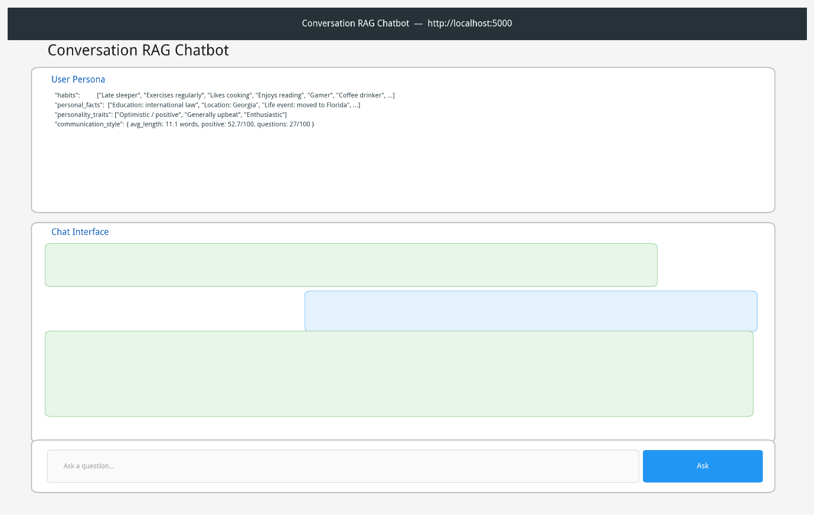
Fig1:_web_ui_overview
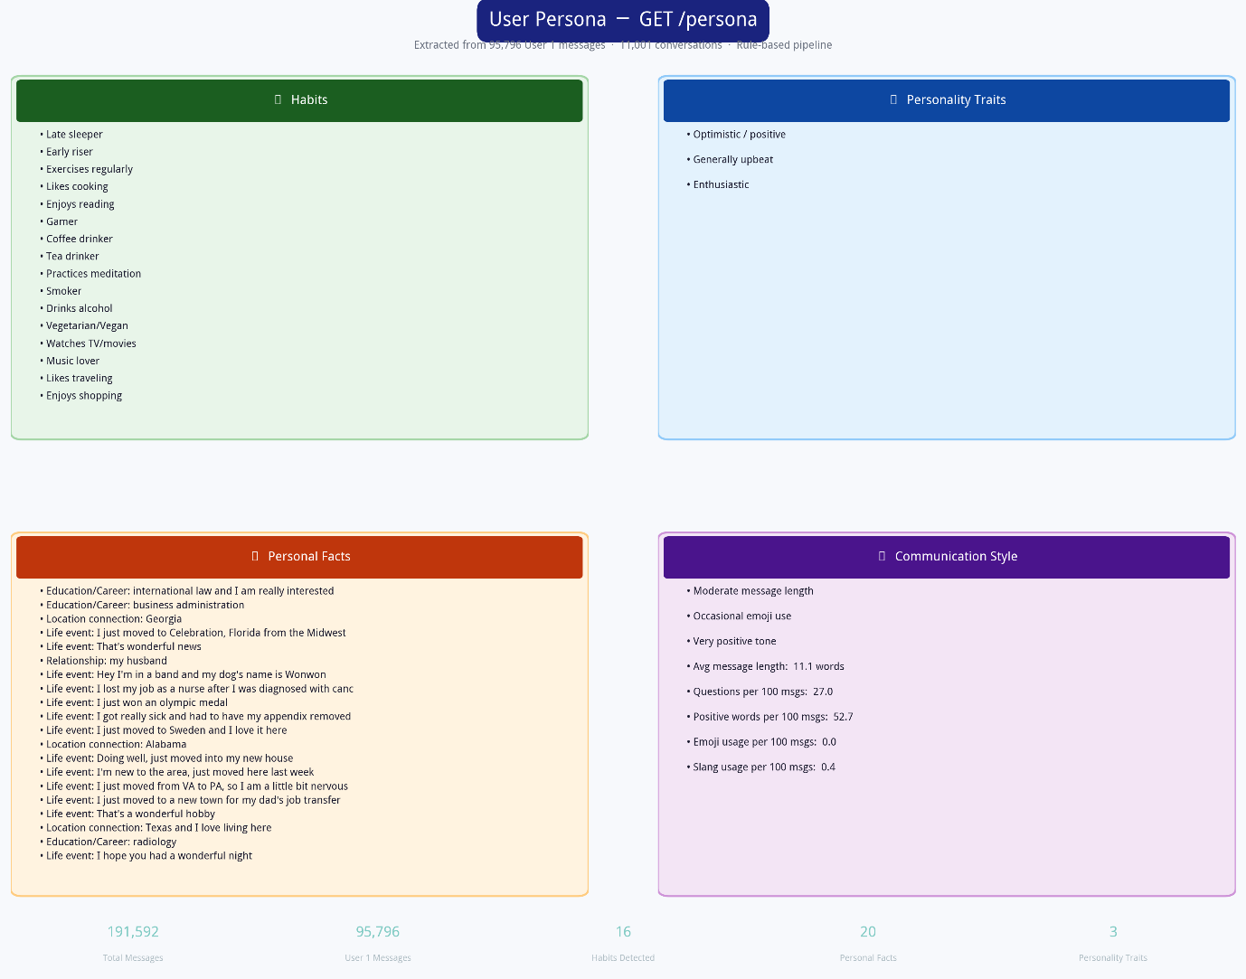

Fig2: persona_json
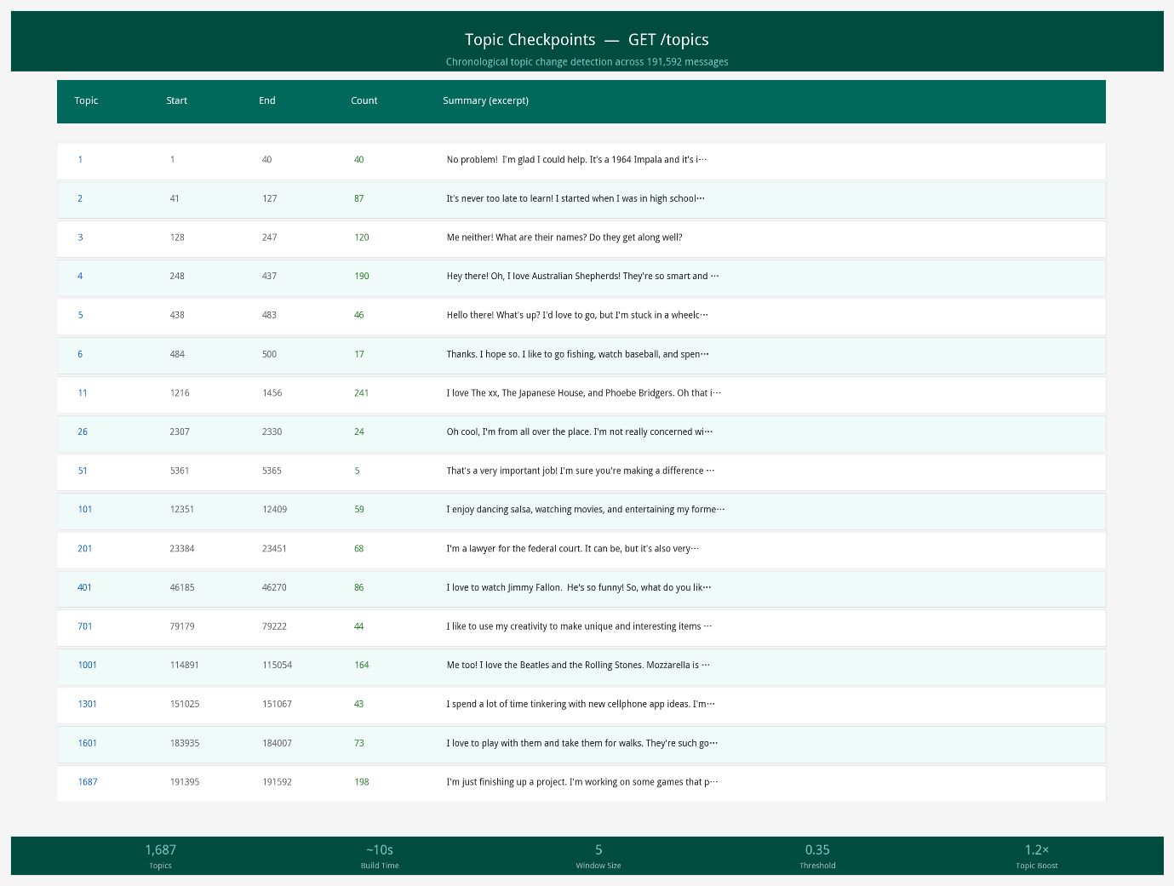
Fig3:topic_checkpoints
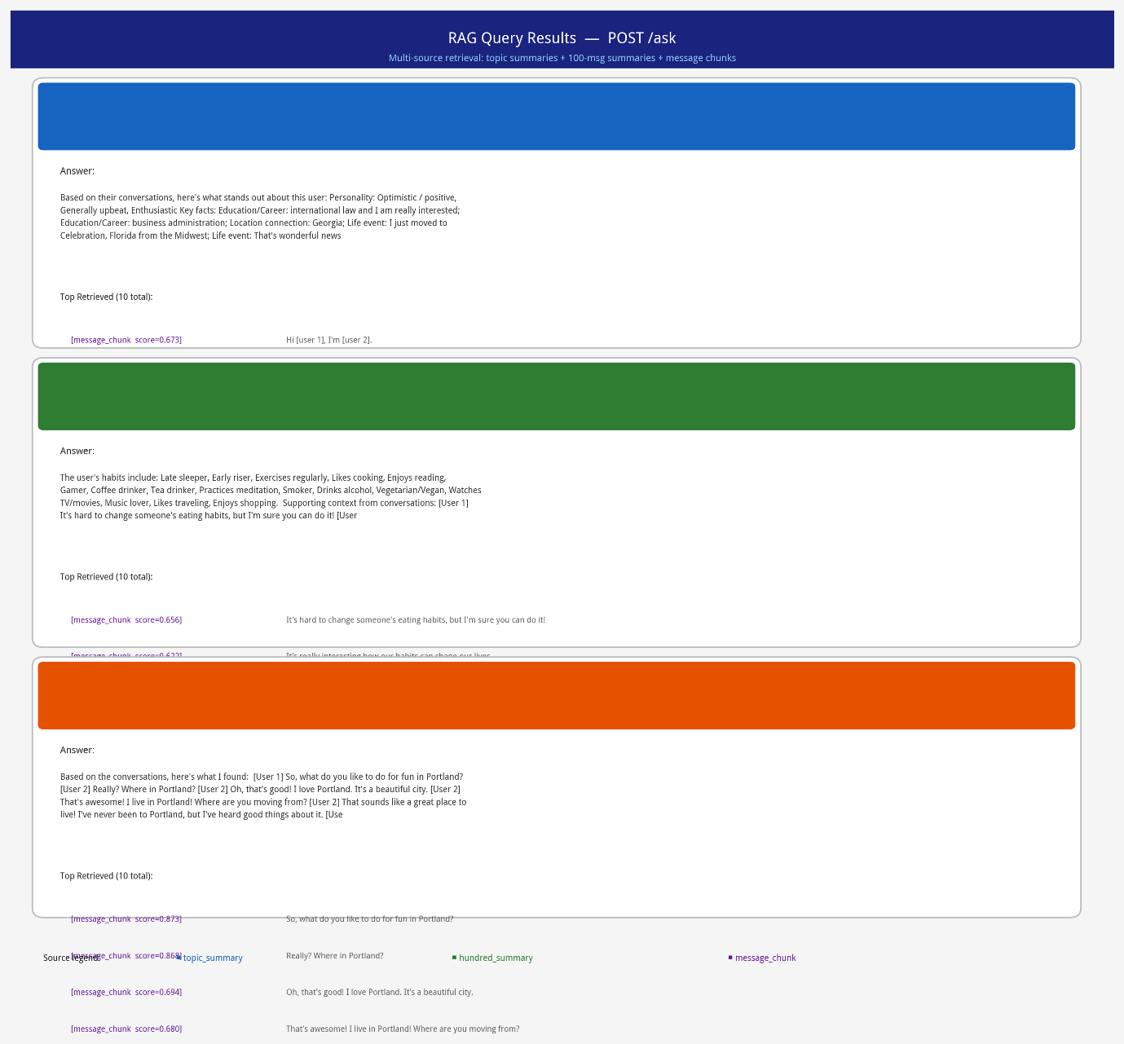
Fig4:rag_query_results

