Title: How to Implement User Reserved columns in P4312 – Purchase Order Receipt
Abstract: This document is to explain how User Reserved Columns can be implemented into F43121 – Purchase Order Receiver File through P4312 – Purchase Order Receipt
This is just example of code so actual implementation can be vary.
Caution: This document may contain information, software, products or services which are not supported by Oracle Support Services and are being provided ‘as is’ without warranty. Please refer to the following site for My Oracle Support Terms of Use: https://support.oracle.com/CSP/ui/TermsOfUse.html
Before implement any additional columns make it sure back-up all the object to be modified

Table of Contents
Introduction
User Interface
Action Plan
Example of Implementation

Introduction
Only when implementing User Reserved Columns are crucial for your daily business you may consider implementing it. Before you take any action make it sure all the information is fully understood including consequences of this change to be made.

Note: This process involves change of Data Structure and Business Function. Unless you fully understood consequences of modification, do not continue this document. And it include change of Table Structure of F43121Z – Receiver Work File, so if there is any workaround (unused columns in P4312) try to implement Work Around. In real life the usage of User Reserved Columns in F43121 will be minimum. Rather this document is to explain how it handles data from Grid to F43121

Before starts note that P4312 – Purchase Order Receipt,

- F4312BeginDoc: This BSFN will initialize cache and verify header information including Purchase Order Header
- F4312EditLine: This BSFN is to validate detail information and create cache. Actual routine is written at XT4312Z2 – F4312EditLineInternalFunctions
- F4312EditLineInternalFunctions: This function can’t be called directly from application rather this has to be called only through F4312EditLine. Same routine for F4111EditLine and F0911FSEditLine will gets called
- F4312EditDoc: This BSFN is to validate header cache with detail cache and other validation. This is important in handling G/L data
- F4312EndDoc: Commit cache to DB
- POReceiptF43121Shell: This BSFN is actual BSFN which writes data into F43121 based on data stored in F43121Z which can be simply Data Structure or data repository
- F4312ClearWorkFile: This can be subroutine when F4312EndDoc gets called or this can be called directly from P4312 – Purchase Order Receipt when user click ‘Cancel’ button to terminate cache created before close form W4312A – [Purchase Order Receipt]

This document will focus on XT4312Z1 – F4312EditLine and XT4312Z2 – F4312EditLineInternalFunctions to implement User Reserved Columns through Grid Controls

Object affected
- Change of Table F43121Z
- Change of Data Structure of DF4312Z1B and DXF43121A
- Change of BSFN XT4312Z2, XT43121Z1 and XF43121
- Change of Business View
- Change of Header Files XT43121Z1.h and XF43121.h
- Change of Event Rule of P4312

- In compiling master BSFN of XT4312Z2 which may create binary file as below,
- XT4312Z1.h
- XF43121.h
- XT43121Z1.c
- XT4312Z2.c
- But for this case XT4312Z2 is dependent on XT4312Z1.c, that is, XT4312Z2 is just internal Business Function of XT4312Z1 though it is created into a separate file

Before Start
- Back up all the objects may need to be changed
- Make clear documentation on changes made Before and After
- If there is any workaround for daily business, implement workaround rather than add additional data in User Reserved Columns

- Check business View in Grid of W4312A – [Purchase Order Receipts]. Currently V4311C – Purchase Order Detail – Receipt Entry – Joined w/F4311T. This implementation shows that it gets data from F4311 and going to insert/update F43121 – Purchase Order Receipt File. So User Reserved Columns will be implemented through Data Dictionary Item as we are not to override User Reserved Columns in F4311 – Purchase Order Detail File
- Add additional Columns in W4312A form
- In calling F4312EditLine assign GC Value to Data Structure assigned (DF4312Z1B)
- Write Cache in F43121Z through XT4312Z2
- Return to calling BSFN XT43121Z1 to proceed F4312EndDoc
- Call XF43121 - POReceiptF43121Shell to write cache into F43121
- Let P43214 - Purchase Receipts Inquiry show User Reserved Columns if needed

IMPORTANT NOTE:
Unlike other Master BSFN, the way it handles data through P4312 is very much different. Simplified steps will be,
- DF43121Z1B stored GC User Reserved Columns
- Through XT43121Z2 stores data into F43121Z (or data structure)
- Through XT43121Z1 map data from F43121Z to F43121

Data Structure of flow,
- F43121EditLine: DF43121ZB
- F43121Z
- DXF43121A

So user input value has to be handled as blow,
- F43121Z.URRF = DF43121B.URRF (lpDS->szUserReservedReference)
- DXF43121A.URRF = F43121Z.URRF
- F43121.URRF = DXF43121.URRF

Note: This document contains huge number of change in table, Data Structure and BSFN so unless this is really necessary for your daily business DO NOT implement this!!!

Back to Top

User Interface

User may enter (type) User Reserved Columns in Grid of W4321A then the information has to be delivered to F4312EditLine to create Purchase Order Receipt Cache (F43121Z). So this document will cover how User Entered Values are to be handled in P4312 application.

Note: R43121Z table can be implement in Batch Process or this file can be used only for Data Structure. For this example, we are not writing physical file so to implement this file, refer ‘How to Implement User Reserved Columns in R47071’

Possible Implementation
- Add additional members into data structure (DF4312Z1B) of F4312EditLine
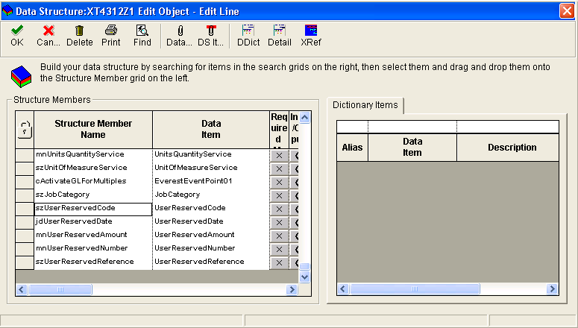

- Typedef D4312Z1B

/*****************************************
* TYPEDEF for Data Structure
* Template Name: XT4312Z1 Edit Object - Edit Line
* Template ID: DF4312Z1B
* Generated: Tue Feb 23 17:32:09 2010
*
* DO NOT EDIT THE FOLLOWING TYPEDEF
* To make modifications, use the OneWorld Data Structure
* Tool to Generate a revised version, and paste from
* the clipboard.
*
**************************************/

#ifndef DATASTRUCTURE_DF4312Z1B
#define DATASTRUCTURE_DF4312Z1B

typedef struct tagDSDF4312Z1B
{
MATH_NUMERIC mnJobNumber;
JCHAR szComputerID[16];
JCHAR cActionCode;
JCHAR cProcessEdits;
JCHAR szProgramID[11];
JCHAR cCurrencyProcessingFlag;
MATH_NUMERIC mnOrderNumber;
JCHAR szOrderType[3];
JCHAR szOrderKeyCompany[6];
JCHAR szOrderSuffix[4];
MATH_NUMERIC mnLineNumber;
…
JCHAR szJobCategory[7];
JCHAR szUserReservedCode[3];
JDEDATE jdUserReservedDate;
MATH_NUMERIC mnUserReservedAmount;
MATH_NUMERIC mnUserReservedNumber;
JCHAR szUserReservedReference[16];
} DSDF4312Z1B, *LPDSDF4312Z1B;

#define IDERRmnJobNumber_1 1L
#define IDERRszComputerID_2 2L
#define IDERRcActionCode_3 3L
#define IDERRcProcessEdits_4 4L
#define IDERRszProgramID_5 5L
#define IDERRcCurrencyProcessingFlag_6 6L
#define IDERRmnOrderNumber_7 7L
#define IDERRszOrderType_8 8L
#define IDERRszOrderKeyCompany_9 9L
#define IDERRszOrderSuffix_10 10L
#define IDERRmnLineNumber_11 11L
…
#define IDERRszJobCategory_198 198L
#define IDERRszUserReservedCode_199 199L
#define IDERRjdUserReservedDate_200 200L
#define IDERRmnUserReservedAmount_201 201L
#define IDERRmnUserReservedNumber_202 202L
#define IDERRszUserReservedReference_203 203L

#endif

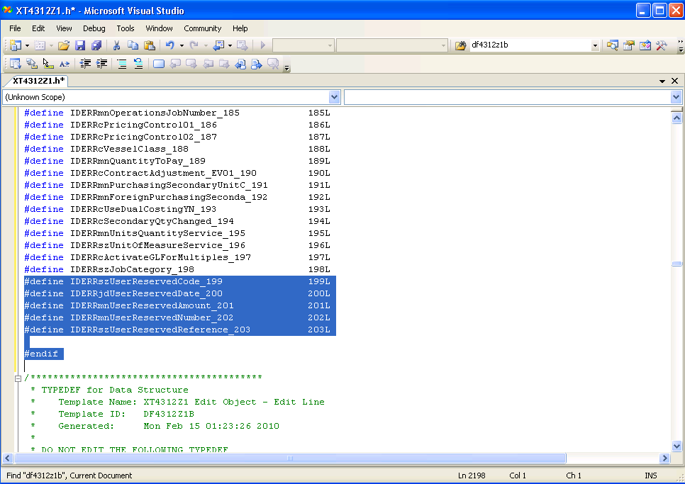
- Now XT4312Z1.h file will appears as above

- Add additional members to Data Structure DXF43121A

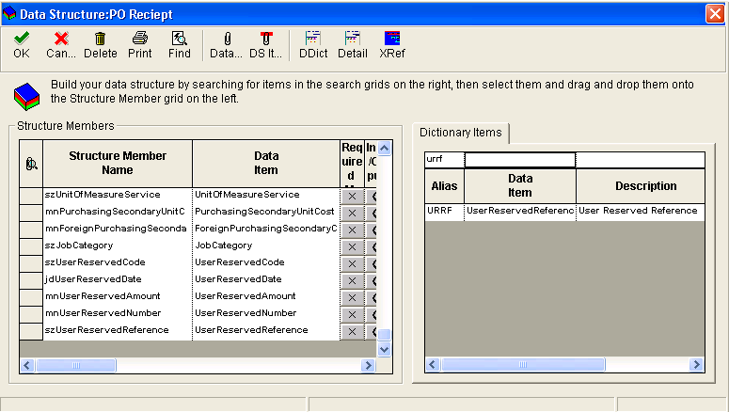

- Copy typedef and paste it into XT4312Z1.h file
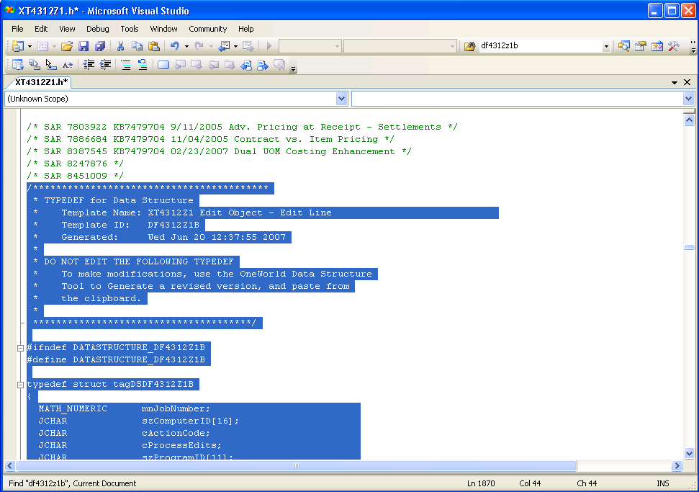
- The block of TYPEDEF is to be replaced by typedef created through steps 2

- Typedef of DXF43121A

/*****************************************
* TYPEDEF for Data Structure
* Template Name: PO Reciept
* Template ID: DXF43121A
* Generated: Tue Feb 23 23:44:36 2010
*
* DO NOT EDIT THE FOLLOWING TYPEDEF
* To make modifications, use the OneWorld Data Structure
* Tool to Generate a revised version, and paste from
* the clipboard.
*
**************************************/

#ifndef DATASTRUCTURE_DXF43121A
#define DATASTRUCTURE_DXF43121A

typedef struct tagDSDXF43121A
{
MATH_NUMERIC mnOrderNumber;
JCHAR szOrderType[3];
JCHAR szOrderKeyCompany[6];
JCHAR szOrderSuffix[4];
MATH_NUMERIC mnLineNumber;
MATH_NUMERIC mnDocumentNumber;
JCHAR szDocumentType[3];
JCHAR szKeyCompany[6];
…
JCHAR szUserReservedCode[3];
JDEDATE jdUserReservedDate;
MATH_NUMERIC mnUserReservedAmount;
MATH_NUMERIC mnUserReservedNumber;
JCHAR szUserReservedReference[16];
} DSDXF43121A, *LPDSDXF43121A;

#define IDERRmnOrderNumber_1 1L
#define IDERRszOrderType_2 2L
#define IDERRszOrderKeyCompany_3 3L
#define IDERRszOrderSuffix_4 4L
#define IDERRmnLineNumber_5 5L
…
#define IDERRszUserReservedCode_123 123L
#define IDERRjdUserReservedDate_124 124L
#define IDERRmnUserReservedAmount_125 125L
#define IDERRmnUserReservedNumber_126 126L
#define IDERRszUserReservedReference_127 127L

#endif

- Update XF43121.h
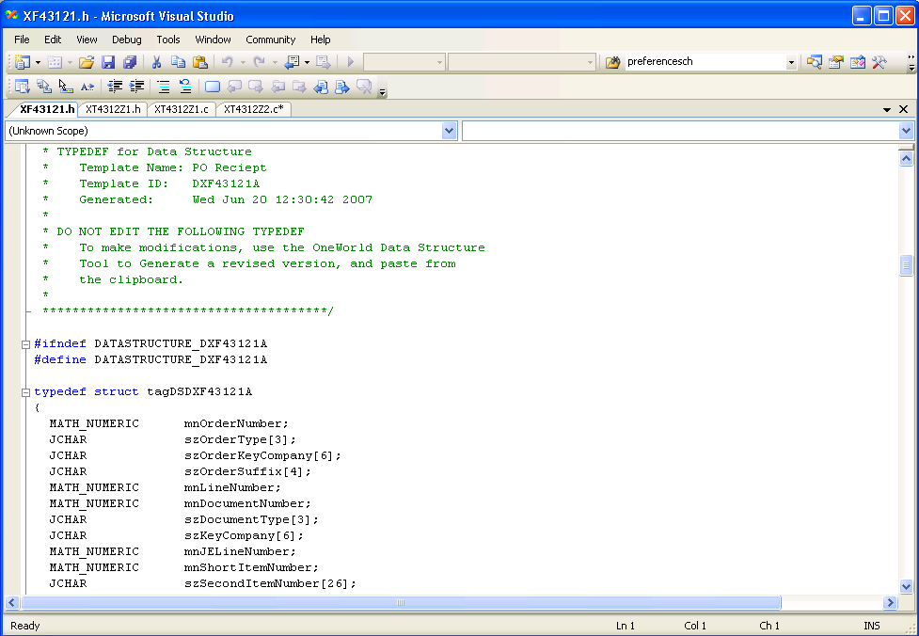
- Copy & Paste it into XF43121.h

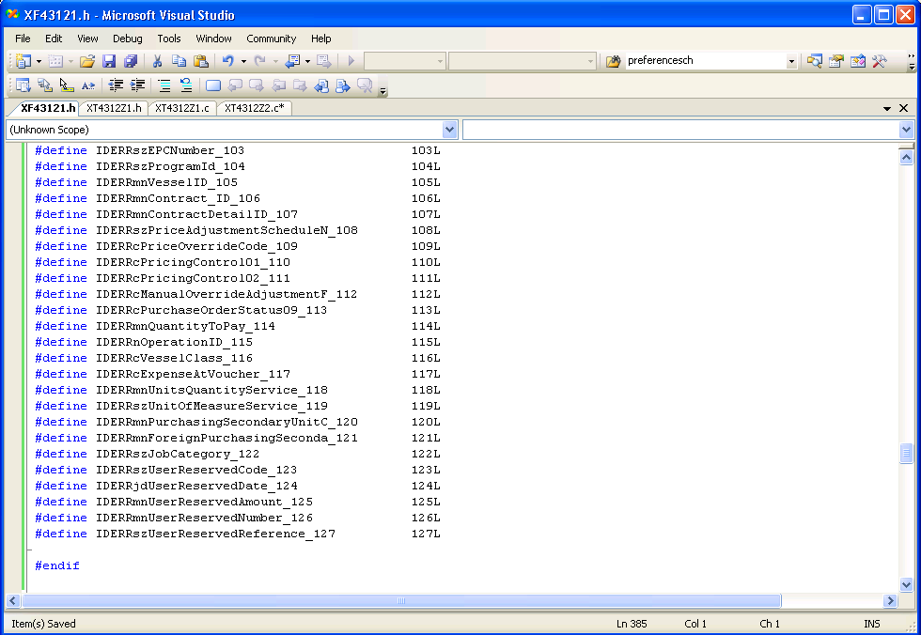

- Update XT43121Z1.c file (Note that the flow of P4312 is different from other master files)
: Below code is Internal BSFN which write cache

int Ixt4312z1_ED_WritePOReceiverRecord (LPBHVRCOM lpBhvrCom,
LPVOID lpVoid,
HUSER hUser,
LPDSDF4312Z1C lpDS,
dsInt_ED_F4311Orig *lpdsInt_ED_F4311,
dsInt_F43121ZOrig *lpdsInt_F43121Z,
dsInt_ED_MiscOrig *lpdsInt_ED_Misc,
dsInt_ED_PrOptOrig *lpdsInt_ED_PrOpt)
{
…
}

: data Structure name dsInt_F43121Orig with *lpdsInt_F43121Z (pointer)

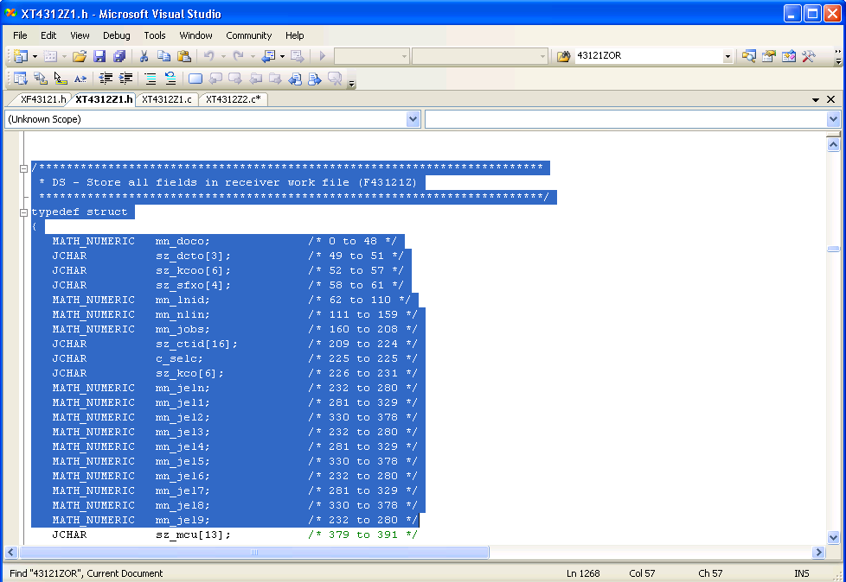
- Note that the Data Structure appears here is different from F43121Z.h file so this file is purely to store data

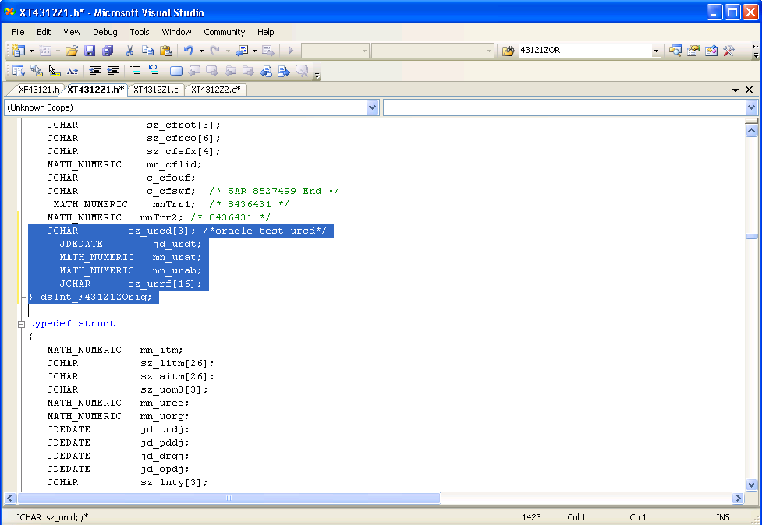

JCHAR sz_urcd[3]; /*oracle test urcd*/
JDEDATE jd_urdt;
MATH_NUMERIC mn_urat;
MATH_NUMERIC mn_urab;
JCHAR sz_urrf[16];
} dsInt_F43121ZOrig;

: Note that dsInt_F43121Orig is data structure to store F43121Z

- Modify XT43121Z2.c file to hold lpDS (Data Structure from calling BSFN F43121EditLine) to F43121Z table

*** Break In code ***
int Ixt4312z1_EL_WritePOReceiverWorkFileRecord (
LPBHVRCOM lpBhvrCom,
LPVOID lpVoid,
LPDSDF4312Z1B lpDS,
dsInt_EL_F4311Orig *lpdsInt_EL_F4311,
dsInt_EL_MiscOrig *lpdsInt_EL_Misc,
HCACHE hF43121ZCache,
LPF43121Z lpdsTable,
dsInt_EL_NewPOLineOrig *lpdsInt_EL_NewPOLine,
dsInt_EL_PrOptOrig *lpdsInt_EL_PrOpt,
HUSER hUser)
{
…

/* Oracle Test - User Reserved Columns into F43121Z */
memcpy ((void *)(&lpdsTable->pwurdt),
(const void *)(&lpDS->jdUserReservedDate), sizeof(JDEDATE));
jdeStrncpy(lpdsTable->pwurrf, lpDS->szUserReservedReference,
DIM(lpdsTable->pwurrf)-1);
/* Oracle Test End - User Reserved Columns */

…
jdeCacheResult = jdeCacheOpenCursor((HCACHE) hF43121ZCache,
&hCursor);

if (jdeCacheResult != JDECM_PASSED)
{
memset((void *) (&dsDE0022), (int)(_J('\0')), sizeof(dsDE0022));
jdeStrncpy(dsDE0022.szDescription,
(const JCHAR *) (_J("CF43121Z")),
DIM(dsDE0022.szDescription) - 1);
jdeSetGBRErrorSubText (lpBhvrCom,
lpVoid,
(ID) 0,
_J("078M"),
&dsDE0022);
}
…
}
*** Break In code ***

: Now cache CF43121Z is written based on user input value

- Go to XT43121Z1.c file to map above cache (physical value) before it calls XF43121

*** Break In code ***
int Ixt4312z1_ED_WritePOReceiverRecord (LPBHVRCOM lpBhvrCom,
LPVOID lpVoid,
HUSER hUser,
LPDSDF4312Z1C lpDS,
dsInt_ED_F4311Orig *lpdsInt_ED_F4311,
dsInt_F43121ZOrig *lpdsInt_F43121Z,
dsInt_ED_MiscOrig *lpdsInt_ED_Misc,
dsInt_ED_PrOptOrig *lpdsInt_ED_PrOpt)
{

…
/* Oracle Test - User Reserved Columns Implementation */
/*
jdeStrncpyTerminate(dsDXF43121A.szUserReservedCode,lpdsInt_F43121Z->sz_urcd,DIM(dsDXF43121A.szUserReservedCode));
MathCopy (&dsDXF43121A.mnUserReservedAmount,&lpdsInt_F43121Z->mn_urat);
MathCopy (&dsDXF43121A.mnUserReservedNumber,&lpdsInt_F43121Z->mn_urab);
*/
memcpy ((void *)(&dsDXF43121A.jdUserReservedDate),(const void *)(&lpdsInt_F43121Z->jd_urdt),
sizeof(JDEDATE));
jdeStrncpyTerminate(dsDXF43121A.szUserReservedReference,lpdsInt_F43121Z->sz_urrf,DIM(dsDXF43121A.szUserReservedReference));

/* Oracle Test End - User Reserved Columns */

…
idJDEDBReturn = jdeCallObject (_J("POReceiptF43121Shell"),
NULL, lpBhvrCom, lpVoid,
(LPVOID)&dsDXF43121A, (CALLMAP*)NULL, (int)0,
(JCHAR*)NULL, (JCHAR*)NULL, (int)0);

if (idJDEDBReturn == ER_ERROR)
{
iReturnValue = 0;
}
}
*** Break In Code ***

: Now value stored at CF43121Z is mapped to dsDXF43121A which is data structure for POReceiptF43121Shell which is actual BSFN to commit cache to F43121 – PO Receipt File

- Now write routine in XF43121 to commit cache to DB

*** Break In Code ***
JDEBFRTN(ID) JDEBFWINAPI POReceiptF43121Shell(LPBHVRCOM lpBhvrCom,
LPVOID lpVoid,
LPDSDXF43121A lpDS)
{

…
/* Oracle TEst - User Reserved Columns */

memcpy( (void *) &dsF43121.prurdt, (void *) &lpDS->jdUserReservedDate, sizeof(JDEDATE) );
jdeStrcpy((JCHAR*)dsF43121.prurrf,
(const JCHAR *)(lpDS->szUserReservedReference));

/* Oracle TEst End */

…
lpdsF43121 = (LPF43121)jdeRetrieveDataPtr(hUser, lpDS->idPointerToF43121);

if(lpdsF43121 != (LPF43121)NULL)
{
idJDBResult = JDB_InsertTable( hRequest, szTableID, (ID) 0L, (void *)(lpdsF43121) );
}
…
}

*** Break In Code ***

- Add additional column with DD items
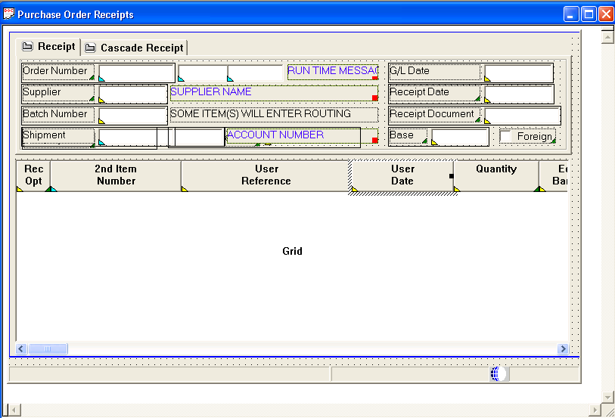

- When exit from row assign GC Value in calling F43121EditLine
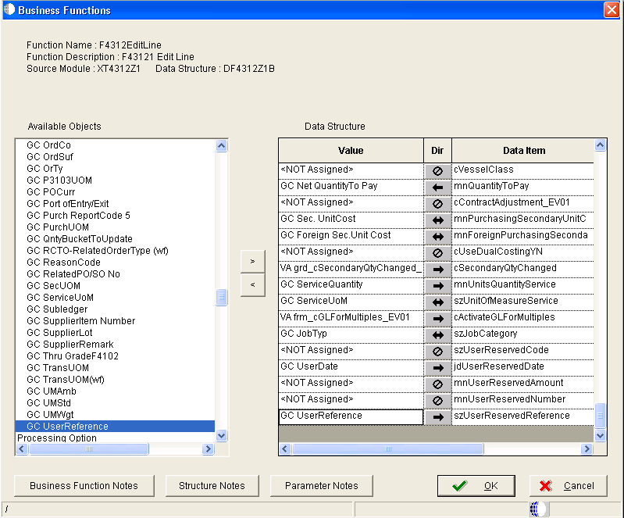

- Add additional columns into F43121Z
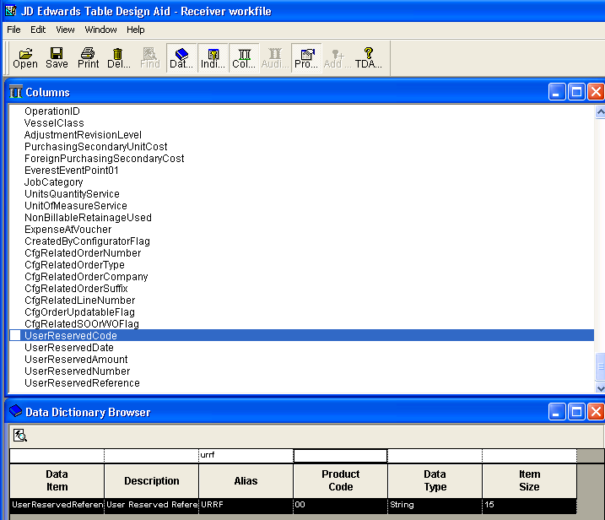
- Generate it and verify that F43121Z.h file has been updated accordingly

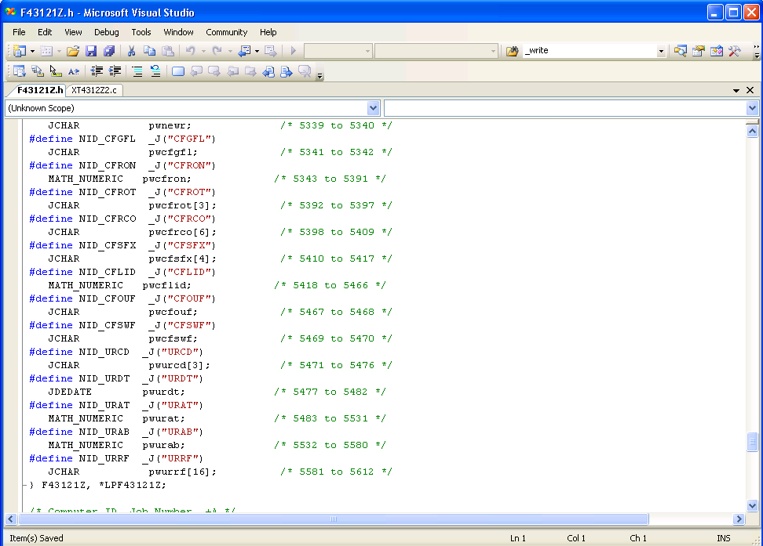

- Compile XT42121Z1, XT43121Z2 and XF43121

Note: If needed, compile it whereas you change any object as this will be easy for you to debug any syntax error

- Test it out

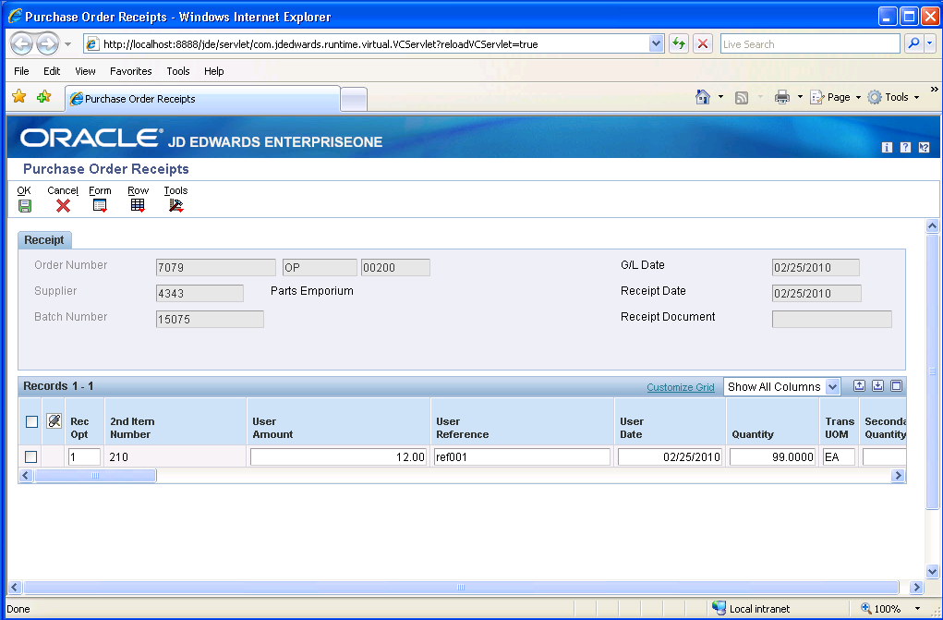

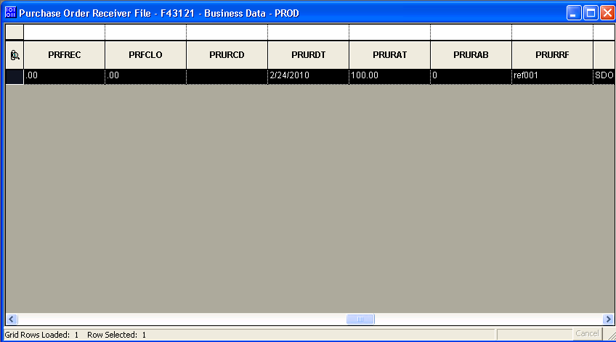

IMPORTANT NOTE:
If any of object is not handled properly, you will hit Memory Violation which crash ActiveConsole.exe or grid gets collapsed

Note: Above code is standard code so do not modify any of above codes
Note: Above code is based on Unicode
Note: This code does imply another other application other than P4312

Back to Top

E1: FDA: Object Modification Recommendations: Interactive Applications (Doc ID 626586.1)
E1: FDA: Object Modification Recommendations: Event Rules (Doc ID 626585.1)
E1: TDA: Object Modification Recommendations: Business Views (Doc ID 626582.1)
E1: BSFN: Object Modification Recommendations: Business Functions (Doc ID 626581.1)
E1: TDA: Object Modification Recommendations: Tables (Doc ID 626588.1)
E1: FDA: Object Modification Recommendations: Data Structures (Doc ID 626584.1)

Back to Top

