Title: How to Implement User Reserved columns in P4310 – Purchase Order Entry
Abstract: This document explains how User Reserved Columns can be implemented into F4311 – Purchase Order Detail File through P4310 – Purchase Order Entry
Caution: This document may contain information, software, products or services which are not supported by Oracle Support Services and are being provided ‘as is’ without warranty. Please refer to the following site for My Oracle Support Terms of Use: https://support.oracle.com/CSP/ui/TermsOfUse.html.

Table of Contents
Introduction
User Interface
Action Plan
Example of Implementation

Introduction
Before you take any action make sure all the information is fully understood including the consequences of the change to be made.

P4310 – Purchase Order Entry handles Header/Detail data as below,

- F4311InitializeCaching: This function can be called in other method of Purchase Order Creation. At the end of transaction F4311TerminateCaching has to be called
- F4311BeginDoc: Validate Header information in relation with Supplier or Order itself and store it into Header Cache F4301Z
- F4311EditLine: Validate Detail information in relation with Item or related information and write it into Detail Cache F4311Z. Actual validation and writing its of the cache is done through internal business function (BSFN) F4311EditLineInternalFunctions (XT4311Z2).
- F4311EditLineInternalFunctions (XT4311Z2.c): Handles Detail Data and create cache.If there is any change in Grid (or Purchase Order Detail) this BSFN needs adjusting accordingly
- F4311EditDoc: Most of transactions which are made up of Header and Detail relation EditDoc will compare detail with header. For example, the sum of detail has to be header
- F4311EndDoc: Last validation and including committing cache to DB
- F4311ClearWorkFiles: This function is called by F4311EndDoc to close/clear cache created during transaction if Transaction is not closed before F4311EndDoc is called. But if transaction is cancelled this function is called directly from application P4310
- F4311TerminateCaching: Since caching is initialized it has to be terminated accordingly. This BSFN corresponds with F4311InitializeCaching

Before Start
- Back up all the objects that may need to be changed
- Make clear documentation on changes made Before and After
- If there is any workaround for daily business, implement workaround rather than add additional data in User Reserved Columns

- Check business View in Grid of W4310A
- Check Data Structure or Work File whether it contains User Reserved Columns from F4301Z and F4311Z
- Check whether XT4311Z2 contains logic to handle User Reserved Columns either into Cache or into Work File

- Set proper action plan with object to be changed and object to be maintained

Back to Top

User Interface

User may enter User Reserved Columns in Grid of W4310A then the information has to be delivered to F4311EditLine to create Purchase Order Detail Cache. This document covers how User Entered Values are handled in P4310.

Action Plan
  - Verify whether existing Work File or data structure can hold User Reserved Columns for Purchase Order Detail → Check XT4311Z1.h and F4311Z2
  - Verify that exiting Business View for PO Detail file have User Reserved Columns → Go to Business View Design and check it
  - Determine whether Data Structure or Business Function has to be changed or not → Determine Data Structure which is used by F4311EditLine which has been called application P4310 in exiting Row
  - Verify that existing logic does not handle/utilize User Reserved Columns → through event rule check all the user reserved columns. During update mode BC User Reserved Columns will be handled by BSFN F4311BeginDoc
  - Verify that equivalent batch process (R4311Z1I - PO Unedited Transaction Inbound Processor) then determine whether to make use of this functionality
  - Once above items are clarified, implement F4311EditLine to hold Grid Column User Reserved Columns as all others will be taken care of master BSFN

Possible Implementation
- Purchase Order Revision form is made up of Header/Detail form so the functionality we are implementing is to be handled by Grid control which BSVW is V4311B – Purchase Order Detail Update – POE
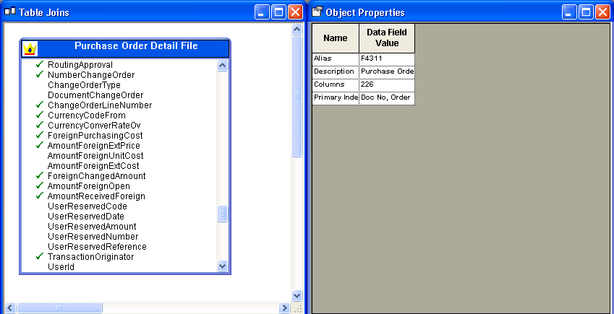
  - User Reserved Columns are not members of BSVW V4311B
  - So there has to be routine during Update Mode
  - To handle BC value select User Reserved Columns and generate BSVW again (or re-create Typedef for BSVW B4311B)
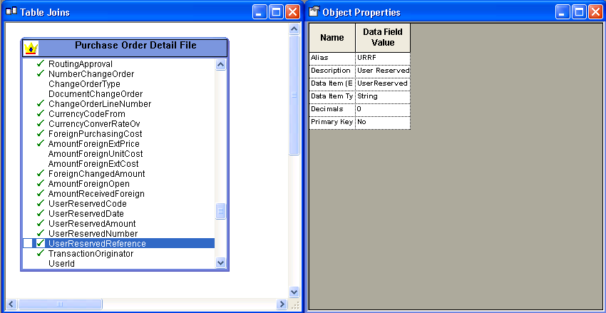

- Verify that existing Grid Control of W4311A – [Oder Detail] form does not contain User Reserved Columns
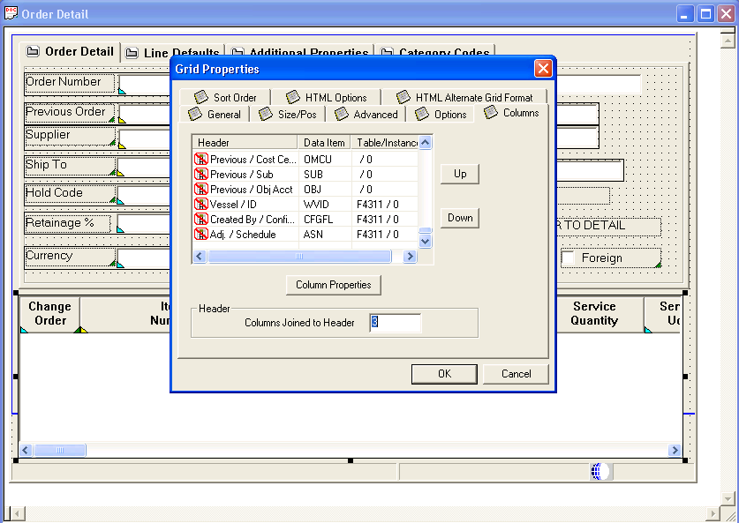
  - So additional columns are to be added to deal with user input data
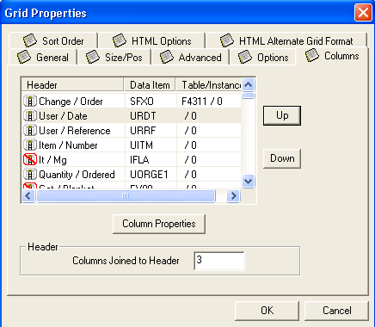
  - For testing URDT and URRF are added through Data Dictionary Item

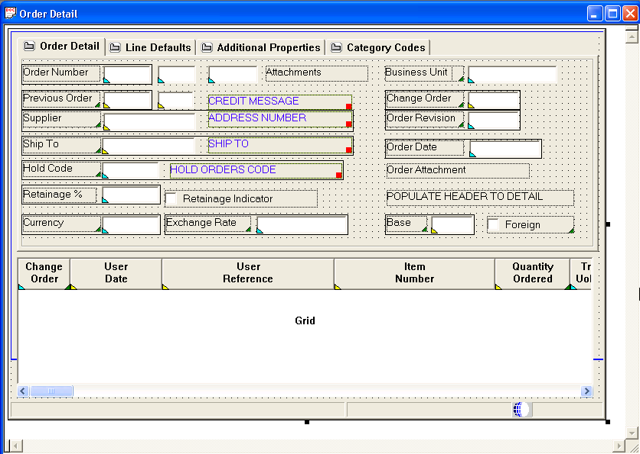

- Implemented additional GC Columns to hold GC Variable to F4311EditLine
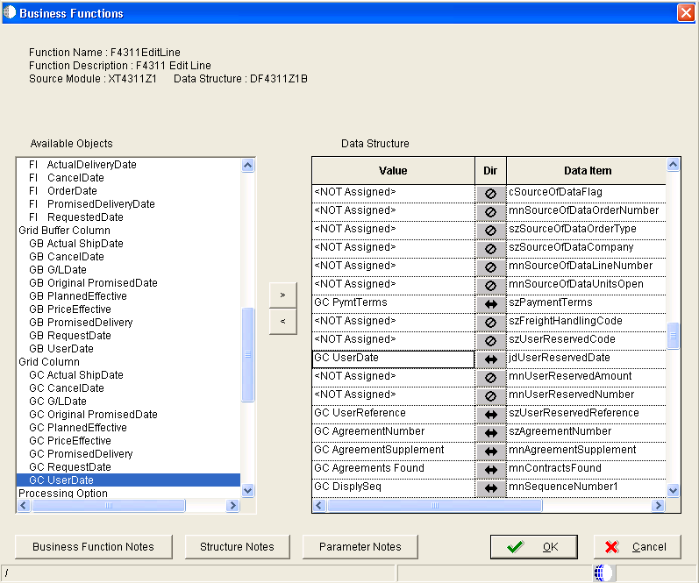
  - User Reserved Columns (of Grid Column Control) are mapped

- Verify that Data Structure DF4311Z1B has User Reserved Columns as a member of Data Structure. And work file F4311Z – Purchase Order Generator File has User Reserved Columns as columns

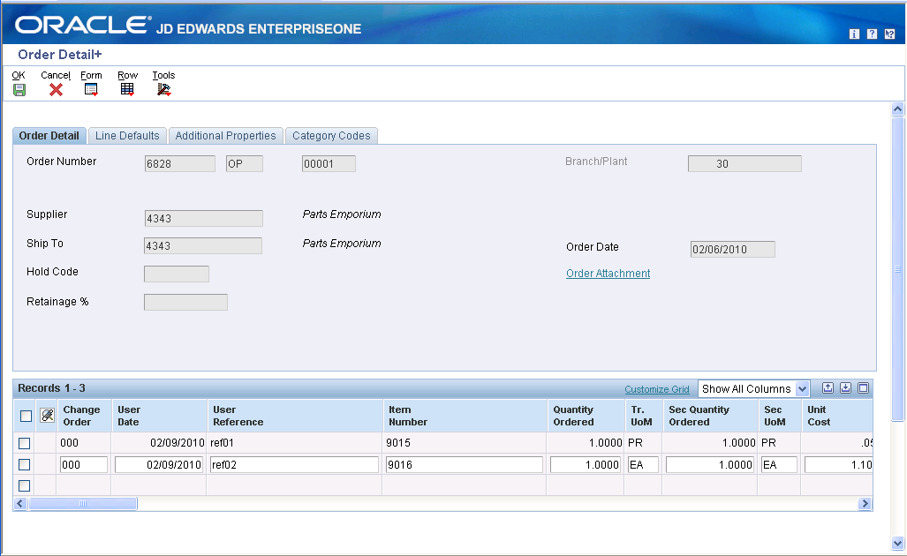

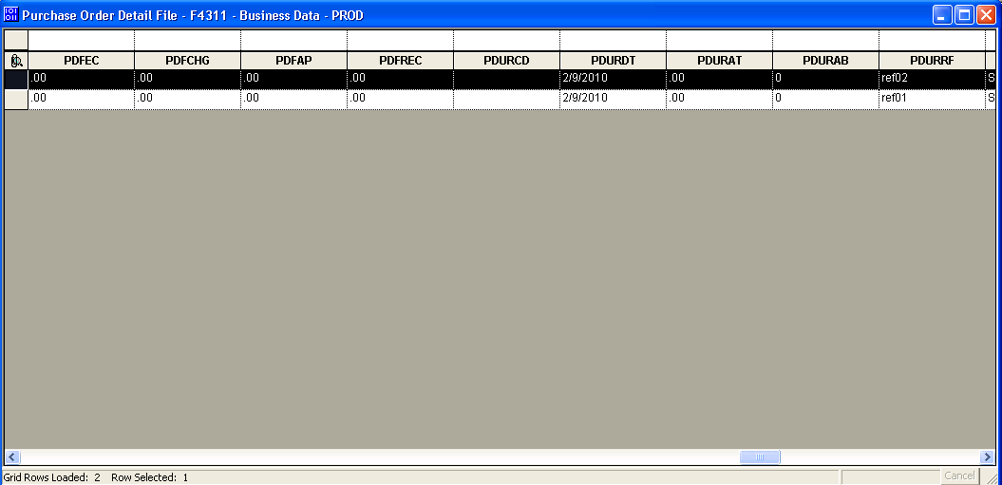
  - Data is inserted into F4311 – Sales Order Detail File

- To handle User Reserved Columns in Update Mode

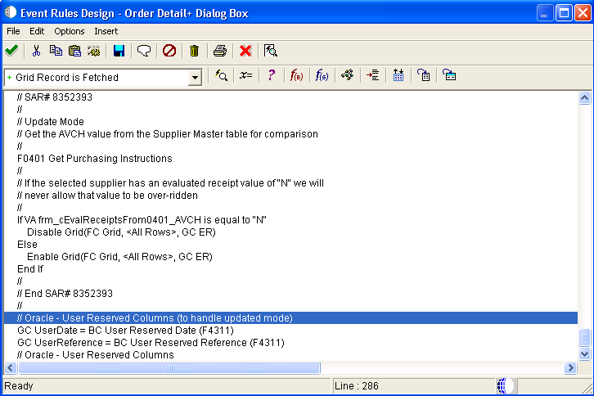

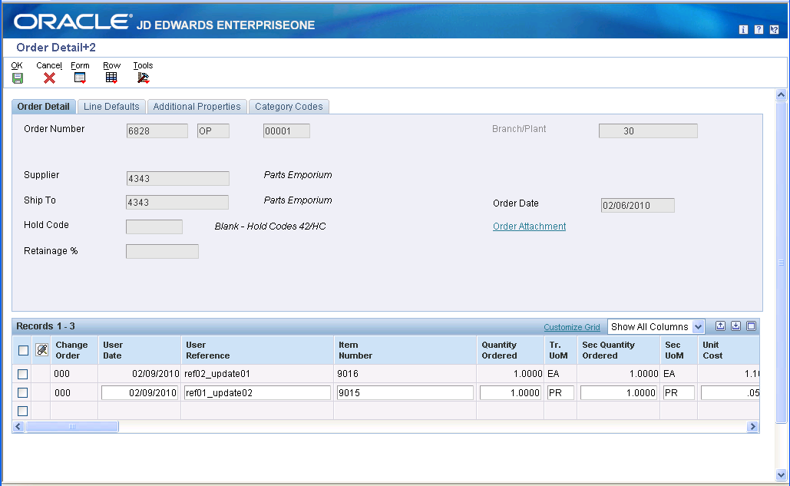

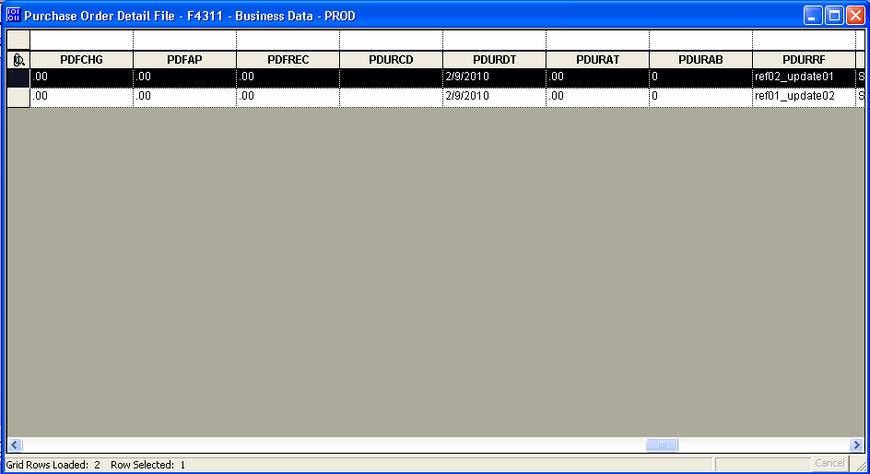
  - Data is added/updated correctly

- Code analysis

  - Data Structure in writing Work file F4311Z. Data Structure pointer *dsFetchFromF4311Z
*** Break In Code of XT4311Z2 ***
ID IXTF4311Z2_WriteToDetailWorkFile(
LPBHVRCOM lpBhvrCom,
LPVOID lpVoid,
HUSER hUser,
LPDSDF4311Z1B lpDS,
HREQUEST hRequestF4311Z,
F4311Z *dsFetchFromF4311Z,
DSD4302180G *dsPODetailCache);

*** Break In code ***

  - Return to calling BSFN
*** Break In Code of XT4311Z2 continued ***
if (IsStringBlank(lpDS->szUserReservedCode))
{
jdeStrcpy((JCHAR *)(&lpDS->szUserReservedCode),
(const JCHAR *)(lpdsF4311ZWorkFile->pwurcd));
}
if (IsJDEDATENull(&lpDS->jdUserReservedDate))
{
memcpy((void *)(&lpDS->jdUserReservedDate),
(const void *)(&lpdsF4311ZWorkFile->pwurdt),
sizeof(JDEDATE));
}

if ( (!memcmp((void *)&lpDS->mnUserReservedAmount,
(void *)&mnNullMathNumeric,
sizeof(MATH_NUMERIC))) )
{
MathCopy(&lpDS->mnUserReservedAmount,
&lpdsF4311ZWorkFile->pwurat);
}

if ( (!memcmp((void *)&lpDS->mnUserReservedNumber,
(void *)&mnNullMathNumeric,
sizeof(MATH_NUMERIC))) )
{
MathCopy(&lpDS->mnUserReservedNumber,
&lpdsF4311ZWorkFile->pwurab);
}

*** Break In Code of ***

  - Hold User-input value into Data structure dsFetchFromF4311Z
*** Break In Code of XT4311Z2 continued ***
jdeStrcpy((JCHAR *)(dsFetchFromF4311Z->pwurcd),
(const JCHAR *)(lpDS->szUserReservedCode));
memcpy((void *)(&dsFetchFromF4311Z->pwurdt),
(const void *)(&lpDS->jdUserReservedDate),
sizeof(JDEDATE));
MathCopy(&dsFetchFromF4311Z->pwurat,
&lpDS->mnUserReservedAmount);
MathCopy(&dsFetchFromF4311Z->pwurab,
&lpDS->mnUserReservedNumber);
jdeStrcpy((JCHAR *)(dsFetchFromF4311Z->pwurrf),
(const JCHAR *)(lpDS->szUserReservedReference));
*** Break In Code ***

Note: Above code is standard code so do not modify any of above codes
Note: Above code is based on Unicode
Note: This code does imply other application other than P4310

Object Affected

Business View V4311B

Interactive Application P4310

Back to Top

E1: FDA: Object Modification Recommendations: Interactive Applications (Doc ID 626586.1)
E1: FDA: Object Modification Recommendations: Event Rules (Doc ID 626585.1)
E1: TDA: Object Modification Recommendations: Business Views (Doc ID 626582.1)

Back to Top

