Title: How to Implement User Reserved Columns in P3112 – Work Order Routing
Abstract: This document explains how User Reserved Columns can be implemented into F3112 – Work Order Routing through P3112 – Work Order Routing
Caution: This document may contain information, software, products or services which are not supported by Oracle Support Services and are being provided ‘as is’ without warranty. Please refer to the following site for My Oracle Support Terms of Use: https://support.oracle.com/CSP/ui/TermsOfUse.html.

Table of Contents
Introduction
User Interface
Action Plan
Example of Implementation

Introduction
Before you take any action make sure all the information is fully understood including the consequences of the change to be made. And the relationship between Work Order Header/Detail is understood properly.

For example, work order information can be stored as below,
- F4801 – Work Order Master File [header]
- F3111 – Work Order Parts List [detail]
- F3112 – Work Order Routing [detail]
- F3114 – Rate Schedule [detail]
: This document shall explain how to populate user reserved columns in F3112 but shall not cover how to populate it in other tables listed above.

Note: The application routines in P3111 (Work Order Part List) is different from P3112. Another document is to be ready soon.

P3112 – Work Order Routing handles data as below,
Hook Up | Function | For
Post Dialog is Initialized | F3112WorkOrderRoutingsBeginDoc (B3101250, F3112 Work Order Routings Begin Doc) | This MBF initialize cache which is used along the process
Grid Record is Fetched | F3112RetrieveWorkOrderRtgRecords (B3103050, F3112 Retrieve Work Order Routing Records)  F3112WorkOrderRoutingsEditLine (B3101250, F3112 Work Order Routings Edit Line) | This is unique process in P3112. This event is hooked up in UPDATE Mode. The first BSFN gets data from table F3112 then Edit Line validates it again.  So in update mode, B3103050 has to return all values stored in F3112
Row Exit & Changed - Asynch | F3112WorkOrderRoutingsEditLine (B3101250, F3112 Work Order Routings Edit Line) | This validation/defaults routine can be called whenever it is necessary across events. To implement User Reserved columns which are to be mapped here
OK button clicked | F3112WorkOrderRoutingsEditDoc (B3101250, F3112 Work Order Routings Edit Doc) | This function is to handle additional validation (e.g., CalculateQuantityWithShrink)
Post OK button clicked | F3112WorkOrderRoutingsEndDoc (B3101250, F3112 Work Order Routings End Doc) | To commit cache to table F3112

So for this example, below functions need mapping for grid columns:
- F3112RetrieveWorkOrderRtgRecords (B3103050, F3112 Retrieve Work Order Routing Records)
- F3112WorkOrderRoutingsEditLine (B3101250, F3112 Work Order Routings Edit Line)

Before Start
- Back up all the objects that may need to be changed
- Make clear documentation on changes made Before and After
- If there is any workaround for daily business, implement workaround rather than add additional data in User Reserved Columns

- Check business View in Form of W3112E (W3112E (Work Order Routing)
- Check Data Structure or Work File whether it contains User Reserved Columns from W3112E, B3103050.h and B3101250.h

- Set proper action plan with object to be changed and object to be maintained

Back to Top

User Interface

User may update User Reserved Columns in the Form of W3112E, then this information has to be pulled from F3112 through F3112RetrieveWorkOrderRtgRecords and updated information has to be handed over to F3112WorkOrderRoutingsEditLine.

This document is to explain how we can implement this.

Action Plan
  - Verify whether existing Work File or data structure can hold User Reserved Columns for Work Order Routing Cache → Check B3101250.h Data Structure B3101250B
  - Verify that exiting Business View for Work Order Routing V3112E (Work Order Routing) contains user reserved columns: No, so you are going to add User Reserved Columns
  - Verify whether existing routine handles User Reserved Columns. So through Edit Line cache has to be stored and End Doc routine commit cache to table F3112: Yes. So you do not need to modify any in business function B3101250.
  - Implement it

Important:
  - Existing routine of B3101250.c already have routine for user reserved columns. So you do not need to change any code in business function to make it work.
  - Related internal functions.
Internal Function | For | Parameter
I3101250_LoadCacheToF3112 | Function will load the Cache to the F3112 Data Structure. | - pointer to Cache Data Structure  - pointer to Internal Data Structure  This mapping is to update cache to F3112
I3101250_LoadF3112Cache | Function will load F3112 Cache with records. | - pointer to Internal Data Structure  - pointer to Edit Cache Data Structure
I3101250_LoadCache | Function will load Edit Cache with F3112 Cache records. | - pointer to F3112 Cache Data Structure  - pointer to Edit Cache Data Structure  This mapping is from F3112 to Edit Cache

  - Refer prototype of above internal function to know the cache name
  - So when update takes place, cache information will be coming via I3101250_LoadCache (when row is fetched)
  - Update will be handled 1. I3101250_LoadF3112Cache then 2. I3101250_LoadCacheToF3112 which is validated result.

Note for cache and pointers (LPDS)
: Refer to parameters from above internal function, in case you want to know how we define it.

Possible Implementation
- V3112E (Work Order Routing). This is medium between application and database
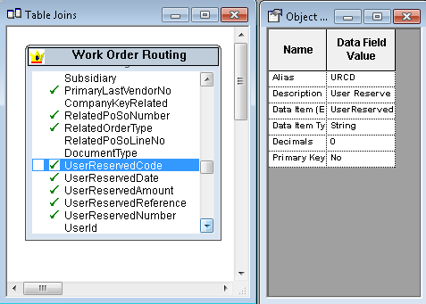
  - User Reserved Columns are not members of BSVW V3112E
  - So there has to be routine during Add/Update Mode
  - To handle BC value select User Reserved Columns and generate BSVW again (or re-create Typedef for BSVW V3112E)

- W3112E (Work Order Routing)
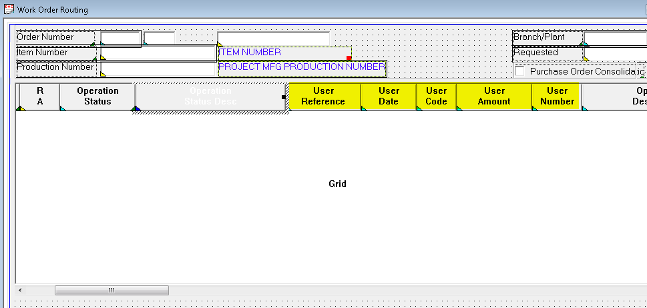
    - Based on business view colums added above, user reserved columns are shown in Grid which allows user to update value
- Verify that D3101250B (F3112EditLine) verify that above columns are available
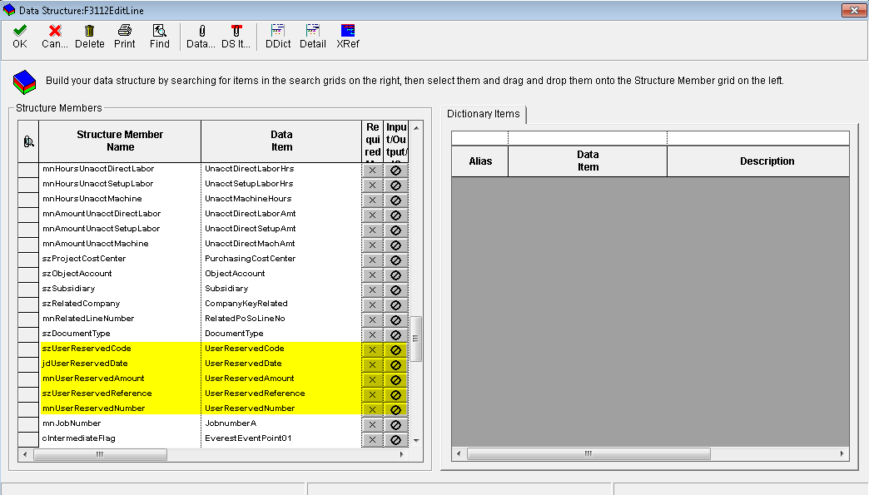
    - Meaning that you do not need to modify any data structure
- (Row Exit & Changed – Asynch) assign GC columns to business functions F3112WorkOrderRoutingsEditLine
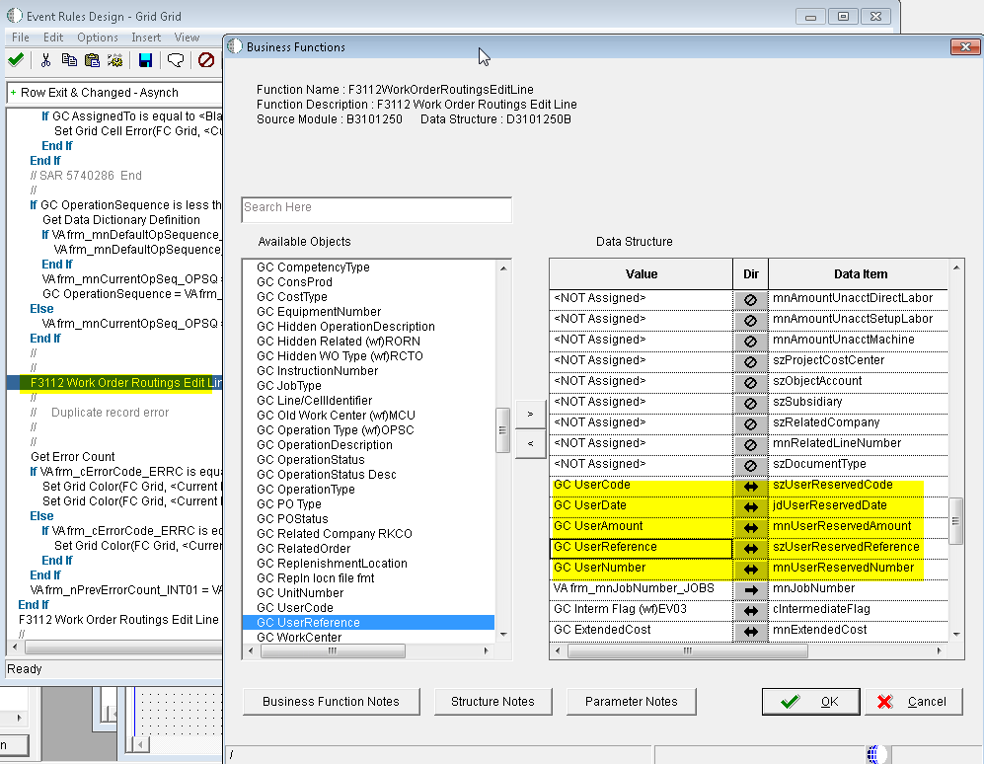
- Repeat this if there are more than one calling
- There are multiple calling of Edit Line to validate data given
- In 9.1 release, Edit Line gets called twice in same event (handle only this)

- Verify that data structure D3103050 (F3112 Retrieve Work Order Routing Records Data Structure) – verify that D3103050 contains user reserved columns
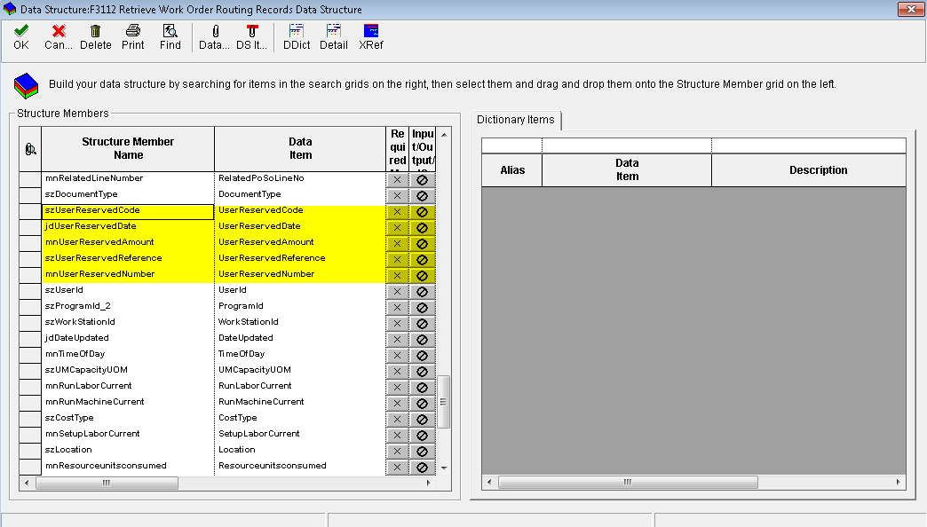
    - So you do not need to modify any data structure

- Map F3112RetrieveWorkOrderRtgRecords (B3103050 - F3112 Retrieve Work Order Routing Records) in case you need to edit it
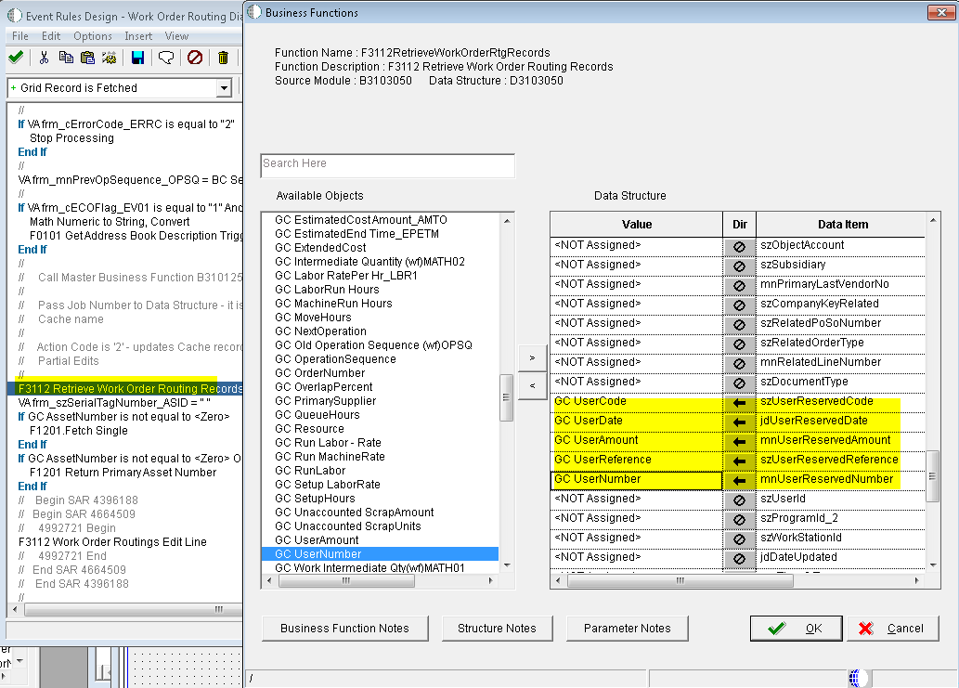
    - This business function is unique in P3112 which gets data from F3112
    - This is useful approach in updating existing data (UPDATE Mode)

- Test it
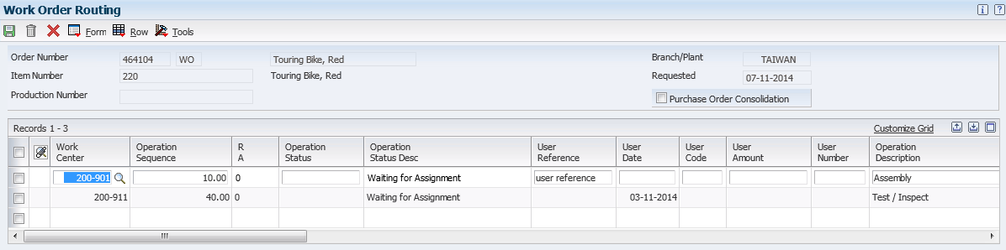
    - Data can be updated for user reserved columns

Object Affected

Business View V3112E

Interactive Application P3112 [W3112E] in Grid Record Is Fetched and Row Is Exited/Changed - Asynch

Back to Top

E1: FDA: Object Modification Recommendations: Interactive Applications (Doc ID 626586.1)
E1: FDA: Object Modification Recommendations: Event Rules (Doc ID 626585.1)
E1: TDA: Object Modification Recommendations: Business Views (Doc ID 626582.1)

Back to Top

