Title: How to Implement User Reserved Columns in P48013 – Manufacturing Work Order Processing
Abstract: This document explains how User Reserved Columns can be implemented into F4801 – Work Order Master File (or Work Order Header File) through P48013 – Manufacturing Work Order Processing
Caution: This document may contain information, software, products or services which are not supported by Oracle Support Services and are being provided ‘as is’ without warranty. Please refer to the following site for My Oracle Support Terms of Use: https://support.oracle.com/CSP/ui/TermsOfUse.html.

Table of Contents
Introduction
User Interface
Action Plan
Example of Implementation

Introduction
Before you take any action make sure all the information is fully understood including the consequences of the change to be made. And the relationship between Work Order Header/Detail is understood properly.

For example, work order information can be stored as below,
- F4801 – Work Order Master File [header]
- F3111 – Work Order Parts List [detail]
- F3112 – Work Order Routing [detail]
- F3114 – Rate Schedule [detail]
: This document shall explain how to populate user reserved columns in F4801 but shall not cover how to populate it in detail tables listed above from this document.

Note: X4801 (Work Order Entry Master Business Function) is working very much different from other routine. One of reason is that the form W48013A is a Fix/Inspect form and Edit Line routine gets called only once in clicking OK button to validate input value.

P48013 – Manufacturing Work Order Processing handles data as below,

- X4801 - F4801BeginDocument (F4801 Begin Document): This can be called per session to initialize cache and get job number which makes cache(s) unique
- X4801EditLine (F4801 Edit Line): Validate/defaults input value and call B4800210 – X4801MfgEditLineModule (X4801 Manufacturing Editing Module)
  - B4800210 – X4801MfgEditLineModule (X4801 Manufacturing Editing Module): Validate/manipulate input value handed by X4801EditLine and return updated cache to calling routine
- X4801 – F4801EndDocument: this function is to be called to commit cache created by Edit Line routine
  - B4800210 – X4801MfgEndDocModule (X4801 Manufacturing End Doc Module. . Depends on settings, this routine can create additional routine (e.g., Co/By, Part list and so on)
- X4801 – F4801ClearWorkFile (F4801 Clear Work File): This routine can be called inside End Doc routine when all the transaction is ended successfully or when caches are to be terminated by cancellation and so on this can be called.
  - B4800210 – X4801MfgTerminateModule (X4801 Manufacturing Terminate Module)

Before Start
- Back up all the objects that may need to be changed
- Make clear documentation on changes made Before and After
- If there is any workaround for daily business, implement workaround rather than add additional data in User Reserved Columns

- Check business View in Form of W48013A
- Check Data Structure or Work File whether it contains User Reserved Columns from W4801, X4801 (in X4801.h and B4800210.h)
- Check whether B4800210 contains logic to handle User Reserved

- Set proper action plan with object to be changed and object to be maintained

Back to Top

User Interface

User may enter User Reserved Columns in the Form of W48013A then this information has to be delivered to WO Header Master Business Function X4801EditLine to create WO Header Cache.

This document is to explain how we can implement this.

Action Plan
  - Verify whether existing Work File or data structure can hold User Reserved Columns for Work Order Header Cache → Check X4801.h
  - Verify that exiting Business View for Work Order Header File have user reserved Columns → Go to Business View (V4801C) Design and check it
  - Determine whether Data Structure or Business Function has to be changed or not → Determine Data Structure which is used by X4801 (X4801EditLine) and B4800210 (X4801MfgEditLineModule) which is to be called in clicking OK button in W48013A
  - Verify whether existing routine handles User Reserved Columns. So through Edit Line cache has to be stored and End Doc routine commit cache to table F4801.
  - Implement it

Important:
  - The Work Order Header Master Business Function is unique in handling cache and it makes use of multiple caches because this table needs to store multiple transactions (SALES_PROCESS, REAL_PROCESS, MFG_PROCESS, CFG_PROCESS, MPM_CFG_PROCESS, REPETITIVE_PROCESS, MPM_PROCESS, CSMS_PROCESS, WARC_PROCESS, SUPR_PROCESS, EQUIPMENT_PROCESS).
  - All the cache has to be created by X4801 (X4801EditLine) and this cache has to be manipulated/saved in B4800210 (X4801MfgEditLineModule)
  - There are 3 different major caches in this routine,
    - DSX4801INTERNAL dsInternal; - Pointer to Internal Data structure
    - DSX4801CACHE dsCache;
    - DSX4801WORKCACHE dsWorkCache; - Pointer to Work Cache datastructure
    - lpdsF4801 - Pointer to input datatstructure F4801
: So this example show how to populate lpdsF4801 through Edit Line routine which is to be utilized through End Doc routine

Note for cache and pointers (LPDS)
- Structure used in F4801EditLine
DSX4801INTERNAL dsInternal;
DSX4801CACHE dsCache;
DSX4801WORKCACHE dsWorkCache;
F4801 dsF4801;
- Structure used in F4801EndDocument
DSX4801INTERNAL dsInternal;
DSX4801CACHE dsCache;
DSX4801WORKCACHE dsWorkCache;
- Structure used in IX4801_StorePointers: Store the Cache and Input structures pointers, and output structure pointers for use in the Called Module
LPDSDX4801E lpDS, lpDS - Pointer to Output Structure
LPDSX4801INTERNAL lpdsInternal, - Pointer to internal Structure
LPDSX4801CACHE lpdsCache, - Pointer to Main Cache Structure
LPF4801 lpdsF4801 - - Pointer to input Structure
- Structure used in IX4801_StoreEndDocPointers: Store the Cache and Input structures pointers, and output structure pointers for use in the Called Module
LPDSDX4801C lpDS, - Pointer to Output Structure
LPDSX4801INTERNAL lpdsInternal, - Pointer to Internal structure
LPDSX4801CACHE lpdsCache, - Pointer to Main Cache Structure
LPF4801 lpdsF4801) - Pointer to input structure lpdsF4801
- Structure used in IX4801_StoreOutSourcePointers: Will determine which process module to call depending on the input process module flag
LPDSX4801INTERNAL lpdsInternal, - Pointer to Internal Structure
LPF4801 lpdsF4801, - Pointer to Input Structure
LPF4801 lpdsOriginalF4801) - - Pointer to lpdsOriginalF4801
- Structure used in IX4801_GetF4801Record: Retrieves the F4801 based on the Order Number
LPDSX4801INTERNAL lpdsInternal, - Pointer to Internal data structure
LPF4801 lpdsF4801, - Pointer to Input Structure
LPDSX4801WORKCACHE lpdsWorkCache, - Pointer to Work Cache structure
- Structure used in IX4801_AddF4801Record: Adds the work cache record to the F4801
LPDSX4801INTERNAL lpdsInternal, - Pointer to Internal data structure
LPF4801 lpdsF4801, - Pointer to Input data structure
LPDSX4801WORKCACHE lpdsWorkCache) - Pointer to Work Cache Data structure
- Structure used in IX4801_UpdateF4801Record: updates the work cache record to the F4801
LPDSX4801INTERNAL lpdsInternal, - Pointer to Internal data structure
LPF4801 lpdsF4801, - Pointer to F4801 Input structure
LPDSX4801WORKCACHE lpdsWorkCache) - Pointer to Work Cache Structure
- Structure used in IX4801_MFGEditing: Will call the MFG module - B4800210, to perform all Manufacturing, Repetitive and Sales editing.
  - LPDSDX4801E lpDS, - Pointer to Output datastructure
  - LPDSX4801INTERNAL lpdsInternal, - Pointer to Internal data structure
  - LPDSX4801WORKCACHE lpdsWorkCache) - Pointer to Work Cache structure
: Note Pointers defined here

Possible Implementation
- Work Order Revision form (W48013A) is written via Fix/Inspect form and data is to be handled by the business view V4801C (Manufacturing Work Order Header). Currently User Reserved Columns are not a member of data structure (or business view columns)
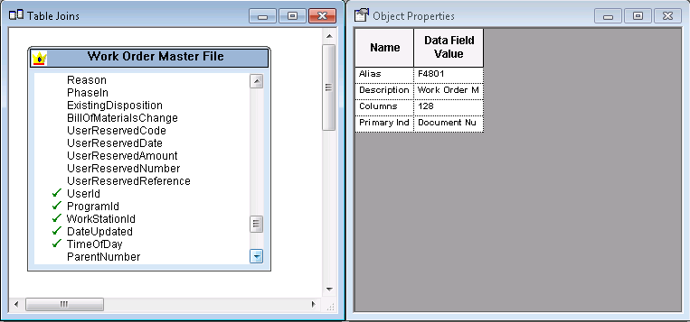
  - User Reserved Columns are not members of BSVW V4801C
  - So there has to be routine during Add/Update Mode
  - To handle BC value select User Reserved Columns and generate BSVW again (or re-create Typedef for BSVW V4801C)
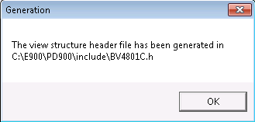

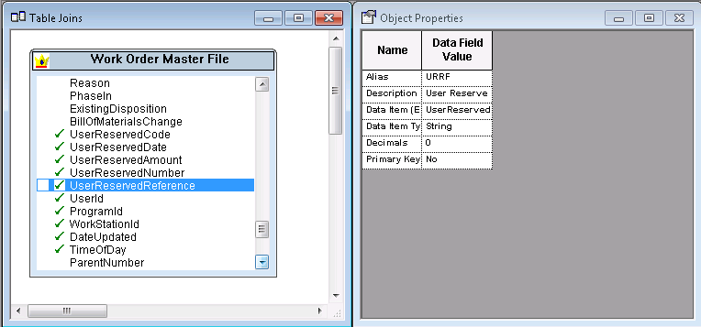
Or just implement this using Data Dictionary Columns

- Verify that existing (Fix/Inspect) Form of W48013A – [Work Order Details] does not contain User Reserved Columns
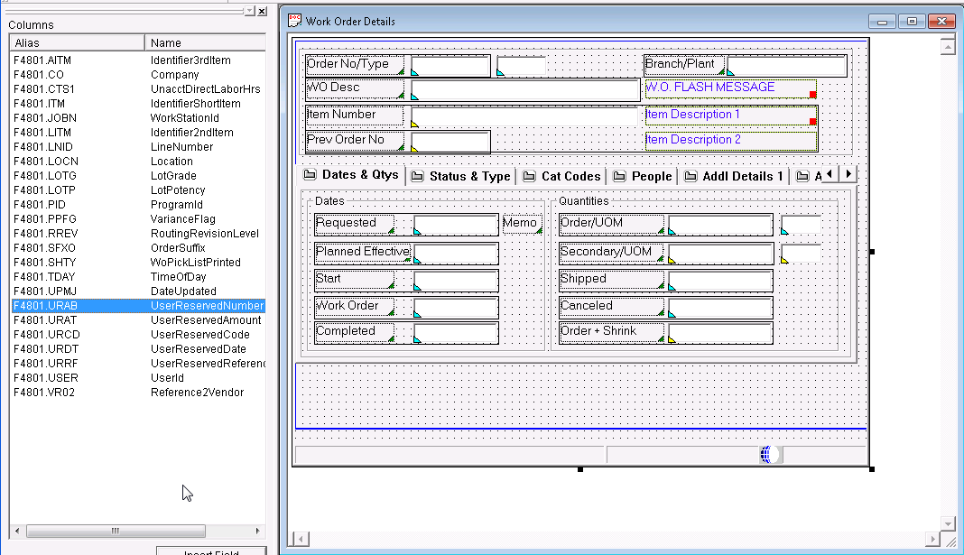
    - Now User Reserved Columns are ready to use because we have added User Reserved Columns into the associated Business View V4801C
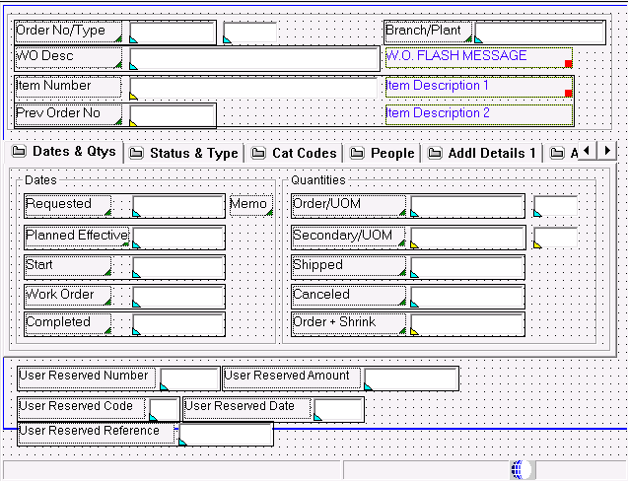
    - User Reserved Columns are added into W48013A form
- Map columns added above in calling Edit Line Routine
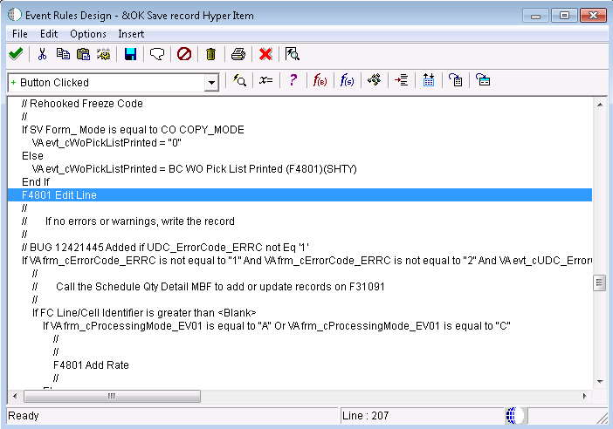

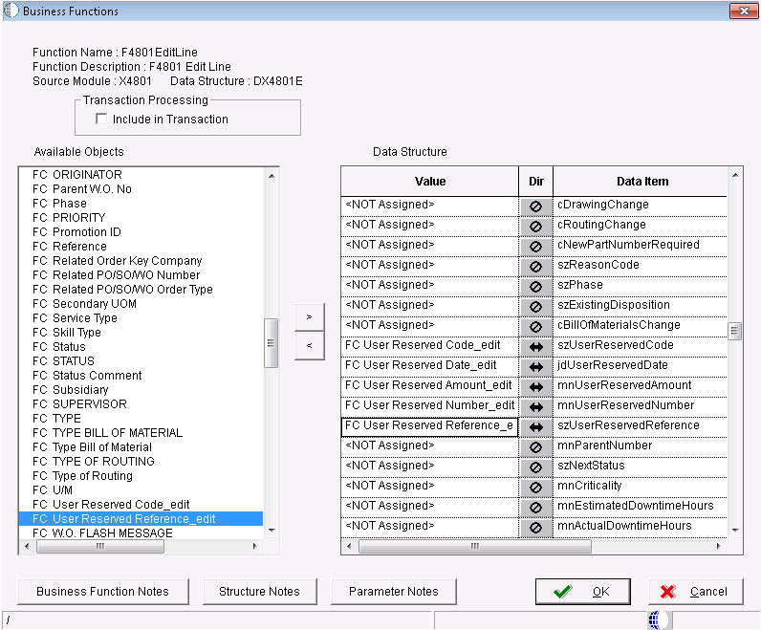
    - User Reserved columns are mapped so input value is ready to be used.
  - So now try to save this information into cache and map it to output F4801

- Map input values
: Note that whatever value assigned through F4801EditLine is stored in the main cache but this cache has to be handled by internal routine

- Open B4800210 which is internal function to handle user input data
- Go to Internal Function : IB4800210_LoadX4801InputToCache. This function copy the fields currently in the F4801 to the Cache

static void IB4800210_LoadX4801InputToCache(LPDSB4800210INTERNAL lpdsInternal,
LPDSX4801CACHE lpdsCache,
LPDSDX4801E lpdsInput)
{
*** Break In Code ***
MathCopy(&lpdsCache ->mnUserReservedAmount, &lpdsInput->mnUserReservedAmount);
MathCopy(&lpdsCache ->mnUserReservedNumber, &lpdsInput->mnUserReservedNumber);
jdeStrncpy((JCHAR *)(lpdsCache->szUserReservedCode),
(const JCHAR *)(lpdsInput->szUserReservedCode),
DIM(lpdsCache ->szUserReservedCode));
jdeStrncpy((JCHAR *)(lpdsCache->szUserReservedReference),
(const JCHAR *)(lpdsInput->szUserReservedReference),
DIM(lpdsCache ->szUserReservedReference));
memcpy((void *)(&lpdsCache->jdUserReservedDate),
(const void *)(&lpdsInput->jdUserReservedDate),
sizeof(JDEDATE));
*** Break In Code ***
}

- Go to IB4800210_LoadCacheToF4801: This function copy the fields saved in the Main Cache back to the Work Order Header table (F4801).
static void IB4800210_LoadCacheToF4801(LPF4801 lpdsF4801,
LPDSX4801CACHE lpdsCache)
{
*** Break In Code ***
jdeStrncpy((JCHAR *)(lpdsF4801->waurcd),
(const JCHAR *)(lpdsCache->szUserReservedCode),
DIM(lpdsF4801->waurcd)-1);
MathCopy(&lpdsF4801 -> waurat, &lpdsCache->mnUserReservedAmount);
MathCopy(&lpdsF4801 -> waurab, &lpdsCache->mnUserReservedNumber);
jdeStrncpy((JCHAR *)(lpdsF4801-> waurrf),
(const JCHAR *)(lpdsCache ->szUserReservedReference),
DIM(lpdsF4801 -> waurrf));
memcpy((void *)(&lpdsF4801->waurdt),
(const void *)(&lpdsCache->jdUserReservedDate),
sizeof(JDEDATE));
*** Break In Code ***
}
- Compile B4800210
- Test it

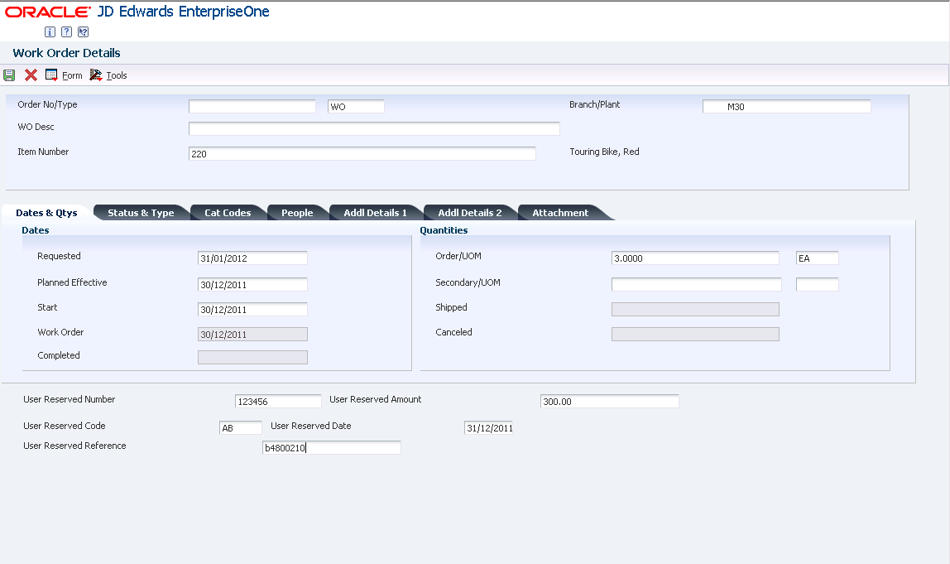

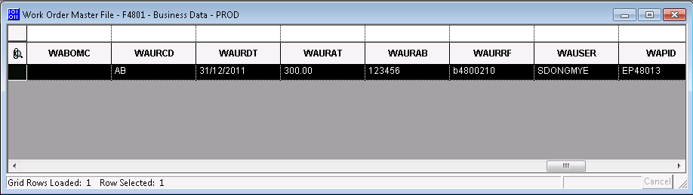

  - Data is inserted into F4801 – Work Order Header File

- Same Data can be shown in reviewing data because in calling Edit Line FC value is mapped for both Input and Output

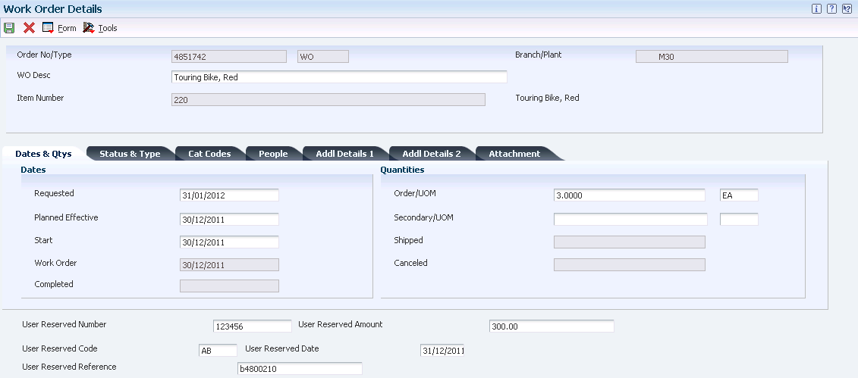

Object Affected

Business View V4801C

Interactive Application P48013 [W48013A] in clicking OK button

Business Function: B4800210.c to store value handled in X4801 and store this in returning back to X4801

Back to Top

E1: FDA: Object Modification Recommendations: Interactive Applications (Doc ID 626586.1)
E1: FDA: Object Modification Recommendations: Event Rules (Doc ID 626585.1)
E1: TDA: Object Modification Recommendations: Business Views (Doc ID 626582.1)

Back to Top

