**NAFSYA**

**WEB SITE FOR YOUR PSYCHOLOGICAL COMFORT**

**Under supervision of:**

**Prof. Ibrahiem El-Samman**

**Team Members:-**

**1-Ahmed Yahia**

**2-Aml Abd Ellatif**

**3-Sohila Ezz Alarb**

**4-Doaa Mahmoud**

**5-Samah Essam**

**6-Sara Nassert**

**ASSUIT UNIVERSITY-DEPARTMENTS:IS**

**Indexes:-**

**p.1: Informations**

**P.3:project description.**

**P.4:Project objective**

**P.7Chatbots types comparison**

**p.10:chatbots graph**

**P.11:chatbot case study**

**P.17:Project charter**

**P.20:Feasibility study**

**P.22:Project scope statement**

**P.24:responsibility matrix**

**P.27:Financial Selection Methods**

**P.30:WBS(work breakdown structure)**

**P.31:Gantt chart**

**P.33:NETWORK DAIGRAM**

**P.38:ERD**

**P.39:Actors table**

**P.39:user diagrames**

**P.42:doctor diagrames**

**P.45:admin diagrames**

**Project Description**

This web site try to connects psychiatrists with patients. Any user/patient can use the site to: reserve an appointment with a doctor, submit a consultation to be answered by a doctor, read articles posted on the website that contains helpful information regards many topics of psychology a with chat bot responsible for appointments reservation process . Also the chat bot handles the consultation submitted by the user,All these under GDPR law to save informations.

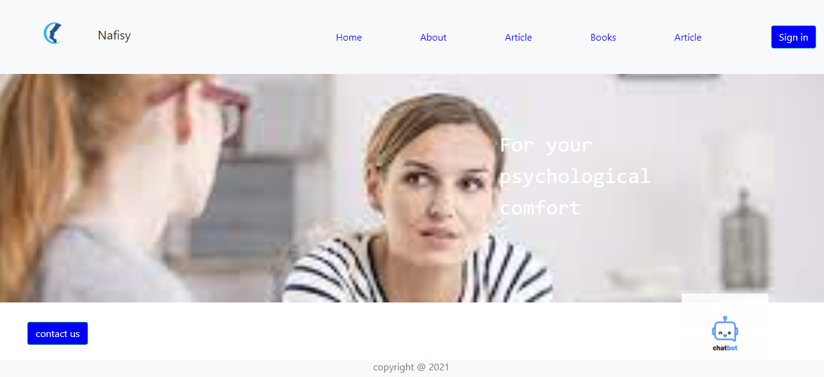

**Project objective**

We seek to make and develop a website. The project idea is based on building a website

that connects psychiatrists with patients. Any user/patient can use the site to: reserve an appointment with a doctor, submit a consultation to be answered by a doctor, read articles posted on the website that contains helpful information regards many topics of psychology and browse through a collection of e-books – freely available for download - that are chosen by experts in the field. Also the website will feature a chat bot responsible for appointments reservation process . Also the chat bot handles the consultation submitted by the user. It receive the consultation, send it to a doctor to answer it, then send the answer back to the user. The project will be developed over a period of 10 months with a cost not exceeding $100,000.

**Deliverables:**

1. Documentations: it describe the use, operation and design of the website through the use of manuals, listings, diagrams and graphic materials.

1.a.scope statement :- it describes the goals, deadlines and relationships that will shape the project from start to finish. It is a document that show scope of project.

1.b.B-business case:- it explain how you will benefit from the project and how many to pay on project

1.c. project charter :- provides a project description , and determine resources allocation and communication

1.d. feasibility study:- we conduct feasibility study to understand all aspects of a project and plan. to become aware of any problems that could occur while implementing the project.

1.e.WBS(work breakdown structure):- is a map of the project , it is important for the project manager because it can follow up the tasks more effectively and activities must be measurable and independent, with clearly defined limits.

1.f.User Interface:- in this phase make user interface simple, efficient and easier to use .

1. website : in final ,we deliver implementation of website to test and use , and can be work to solve and help people .

**Milestones**

|  |  |  |
| --- | --- | --- |
| Required | Duration | Delivery date |
| Planning $ Documentations | 3Months | 20/11/2020 |
| Design | 1Months | 20/1/2021 |
| Implementation | 4Months | 20/2/2021 |
| Delivering &Maintain | 2 Months | 20/6/2021 |

**Technical Requirements:**

1 – UI&UX

2-IBM Watson Platform

3- HTML&CSS&JS

4-PHP&MYSQL

5- Windows 10

6- System Type64 bit Operating system

7- IBM Watson framework

8-laptops

9-python(for the development of future version of the chat bot)

**Limits and exclusions:**

1- Save patients informations under GDPR low

2- From initial adequate clarification of the requirements of the client and stakeholders so that no change is required later, because this will lead to problems and increase the cost and occur delay (Inability to“stick” with the project scope).

3- The Stackholder you utilize can also put limits on project timelines. If they aren’t getting you what you requested or are backlogged, your project is at their mercy.2- Each user is responsible for the correctness of his entered data, which he will use to communicate with his psychiatrist

4- The user is responsible for clarifying his psychological problem or mental illness in a sufficiently detailed manner, which makes it easier for the psychiatrist to help him and provide the appropriate treatment

5- The site or the treating psychiatrist is not responsible for any side effects of the medical treatments provided when doctor mention it

6- The patient bears the consequences of not following the advice and instructions of the treating psychiatrist

7- The site is limited to connecting the patients with psychiatrists. We are not a provider of medical service by any mean.

**Chatbots types comparison**

|  |  |  |  |  |
| --- | --- | --- | --- | --- |
| Chat bot type | Description | Advantages | Disadvantages | Technique |
| Menu/Button based chat bot | A menu or button based chat bot is the simplest type of chat bot. | 1-On boarding  2-Surveys  3-sales support | 1-they are not so successful when it comes to scenarios with many variables  2-the slowest in terms of getting the user to their desired value  3-chatbot falls short when users want to ask more advanced questions | Pre-define rules |
| Hybrid bot | A hybrid bot is a button-based bot with an option to ask a question on natural language. Usually | Combine between sample and complex chat bots | 1. Not clear 2. Need deep knowledge in AI 3. Limited features | 1-strong AI/NLP  2-Pre-define rules |
| Support chat bots | Support chat bots are built to master a single domain,like knowledge about a company. Support chat bots need to have personality, multiturn capability | 1- Answer Wide range of FAQs  2-use in all industries - majorly in retail  3-E-commerce bot with recommendation engine capability  4- Customer service bot  5-live chat | You will want to have a short-tail and long-tail combine the 2 in solution when building this type of chat bot | 1-IBM Watson versation  2-IBM Watson discovery  3-NLP |
| skills chat bot | Skills chat bots are typically more single-turn-type bots | 1-do not require a lot of contextual awareness.  2- food ordering  3-making reservations  processing payments | 1. They should be able to follow commands quickly 2. Require higher computing power | 1-pre-defined rules |
| Assistant chat bots | work best when they know a little bit about a variety of topics. Many people envision these bots will someday become navigators of all other bots that are out there now | user does not need to turn on a device or click any buttons | Assistant chat bots need to be conversational and respond to just about anything | 1-Pre_defined rules  2-ML/AL |
| Transactional Bots | Several custom solutions for transactional bots are possible, helping users increase their  productivity as the bot interacts with external systems to perform transactions. | 1-work with external  System  2-Use in insurance company  3-Use in financial sector | 1- security threads as it work with multi able external systems  2-limited to transaction heavy types of baseness | 1- Natural Language Processing  2- Symbolic AI |
|  |  |  |  |  |

Graph for chatbots

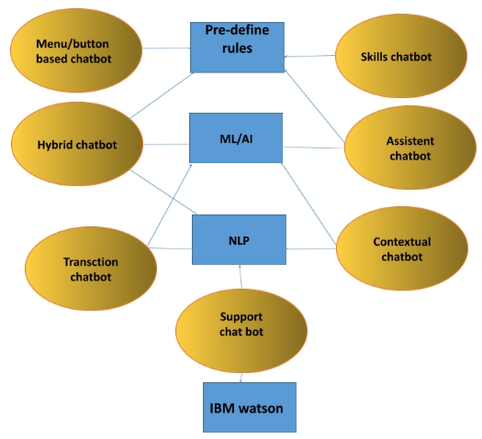

Suport chat bot

We used a Support Chatbot for appointments reservation and consultations coordination processes as it more suitble for this kind of serveces contain many features to use now and in future like:-

1- Answer Wide range of FAQs

2-use in all industries - majorly in retail

3-E-commerce bot with recommendation engine capability

4- Customer service bot

5-live chat

Chat bot Case study

*Used conversation language here is English (only for demonstration). The working final version will be in Arabic.

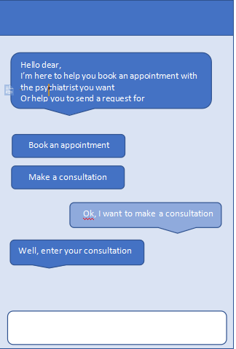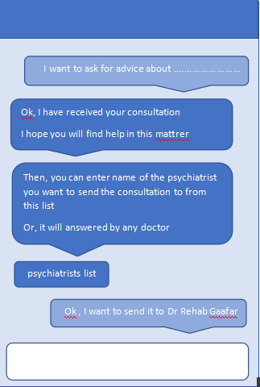

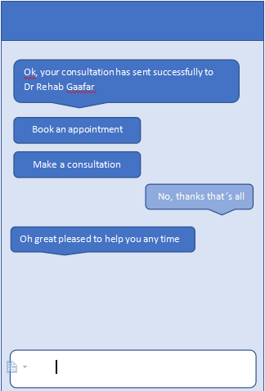

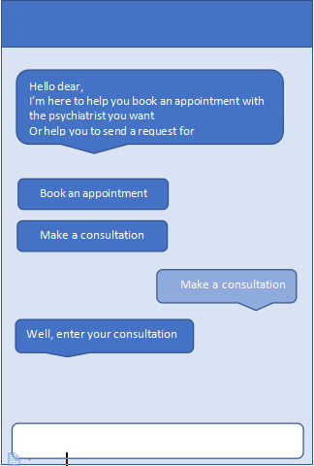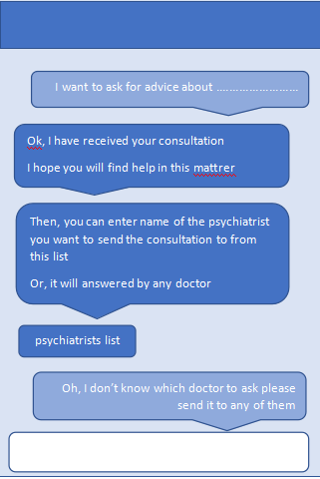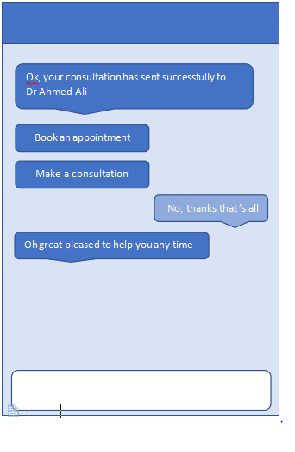

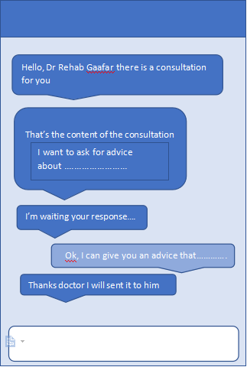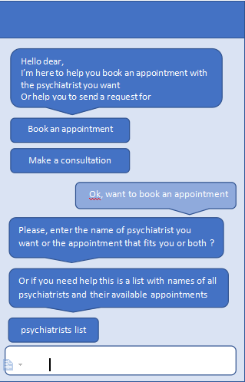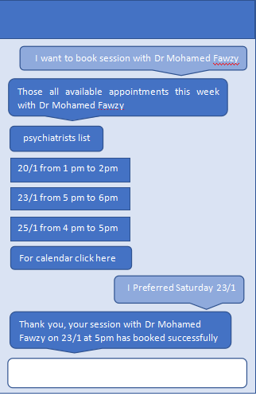

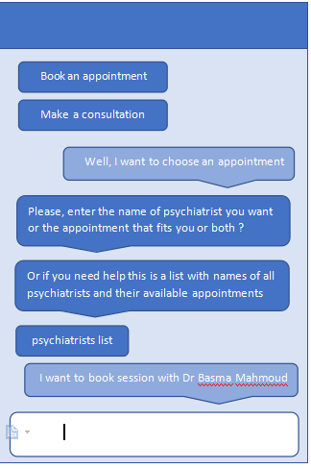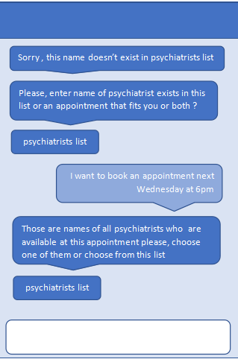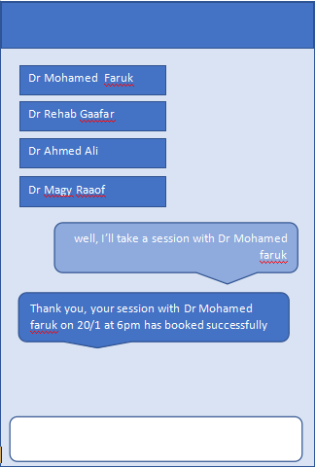

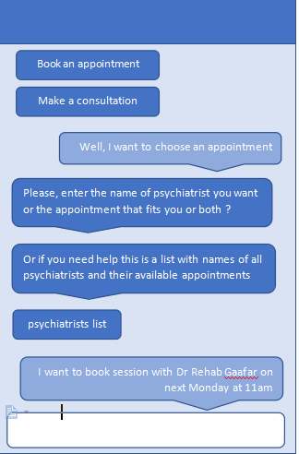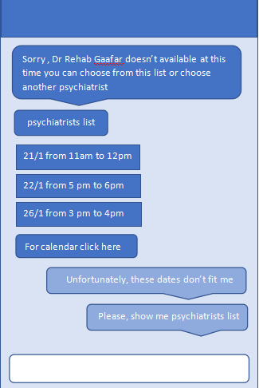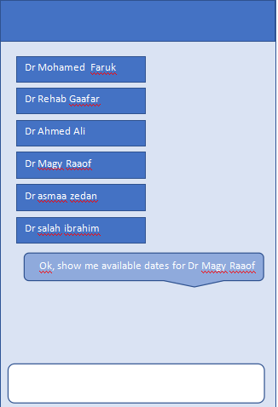

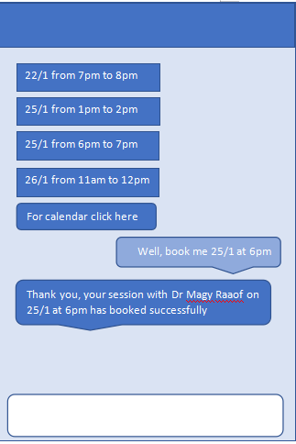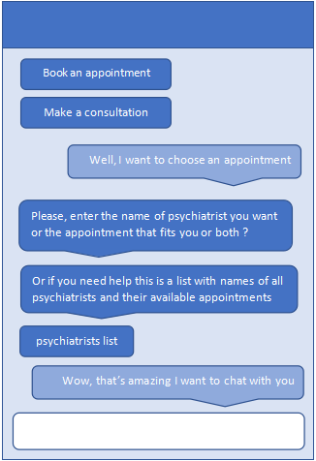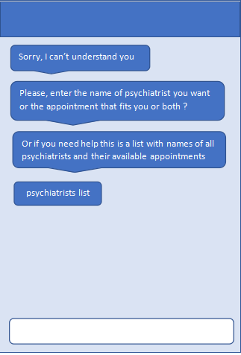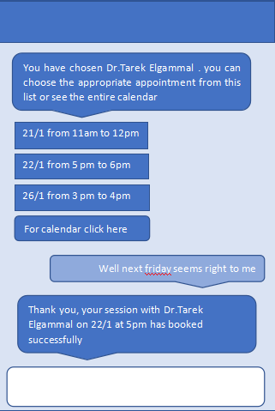

Project charter

**Project name:** Nafsya

**Project sponsor and contact information:**

Prof. Ibrahiem Elsamann - Computer science professor - Assuit university.

Email: elsemman@aun.edu.eg

**Project manager and contact information:**

Aml Abd El-latife, project manager

Email: Aml@gmail.com

**Purpose of the project:**

Helping individuals at societies that suffer from high level of negative and unhealthy beliefs regards people who get or may be in need to get psychiatric medical help.

**Business case:**

Developed countries suffer from high level of negative and unhealthy beliefs regards people who get or may be in need to get psychiatric medical help. As a consequences to all of that: high suicide rates, more severe and even more difficult to treat depressive symptoms and other psychiatric illnesses. We seek to make and develop a website. the idea is based on building a website contains on books , articles, reserve appointments, medical consultations and feature chat bot . Through our solution we help those people by providing a safe, privacy protecting and easy to access and use website that enables them to get the help they need.

**Key deliverable :**

1- Internet website provides the following to its visitors: books, scientific articles, reserving appointments and medical consultations.

2- Chat bot: responsible for appointments reservation process and consultation coordination processes.

**General statement about how the team will approach the work:**

By using Agile development model. It is more flexible allowing us to make chatbot which we make the first in future it will be able to offer connections to get medical service like doctors.

**Basic timeline:**

First three month:planning &documentations

Next months:design

Four months: implementation

Last two months: delivering&maintain

**Project resources:**

Human resources

**-** Three programmers

- Database Designer

- Graphic designer

-Chatbot developer

Hardware &software

-lab tops

- Reserved office for the project team

-Internet

-IBM Watson freamwork

-Hosting domain

**Summery budget:** Estimated budget is $100,000 at maximum.

- **Human Resource**:-

- Team salaries($40,000)

- **Software:**

-IBM Watson subscription($30,000)

- **Hardware(**laptop/internet**):** ($15,000)

-**Hosting Domain:** 15,000

**High level assumptions:**

**-** Every user know that no guarantees for their medical conditions to be fully treated.

- Operating system used by user to access must be Microsoft Windows 7 or higher.

- Secure website and hard to be hacked.

- Every specialist(Doctor) should be there in the time of heir scheduled appointments.

- Our Website is compatible with any type of browser.

**Project constraints:**

**-** Any medical specialist register in our website must be certified with college degree.

- All books we make available on our site we must own legal copyrights for it.

- Budget shouldn’t exceed $100,000

- Project must be completed within eight months.

- Have permissions to all data we use in our app.

- Ease of use.

- Every Doctor should apply the ethics and morals of the profession.

**High level risks:**

**-** Team member leaves the project

- Possible hack attacks.

- Patients expected not to read side effects of the medications prescribed by our Doctors. And they may put this back on our Doctors responsibility as they lack experience.

- Possible downs of the website and data leaks.

**Feasibility study**

Executive summary

After doing enough research and assessments we found that: developing internet website contains: books , articles, posts, reserve appointments, medical consultations and feature chatbot, all of which helping to get mental health care and guidance for our users is the best possible solution for the problem.

## Defined business problem or opportunity

## Nafsya is a start-up that seeks for strong launch for its business. Choosing a problem in the field of mental health care services and trying our best to develop good quality solution for it and making it our first project will give us a very good start at this business, trying by that helping poor people to get help .

## Audience Impacted

## It gives people a chance to talk about their problems comfortably, thus reducing depression and suicide rates , addition save time , effort and security , save and available multiple sources in one place.

## Description of the options assessed:

Option 1: make website is middle between life coaches and patient to make session and events .

Option 2: make website contains of book, articles, posts and reserve appointments also addition online session and add feature chatbot

We prefer option 2 , because more features , collect between other options , and more suitable for any types of devices as lab top , smart phone , tablet…etc.

**Assumptions used in the study:-**

Every user know that no guarantees for their medical conditions to be fully treated.

- Secure website and hard to be hacked.

- Hosting/Domain is provided by our organization.

- Team member have enough skills to develop the solution.

**- Flexible website**

-budget within 100,000$.

- deadline within more than 10 month

- Every specialist(Doctor) should be there in the time of heir scheduled appointments.

- Our Website is compatible with any type of browser and devices.

**Financial obligations:**

The budget is 100,000 $ .

- Human Resource:-

- Team salaries($40,000)

- Software:

-IBM Watson subscription($30,000)

- Hardware(laptop/internet): ($15,000)

-Hosting/Domain: 15,000

## Recommended action:

## we assume that we use windows 10 and IBM Watson Library to create the chatbot, Front-end to make interface and PHP and Mysql to build website. Only use data (for articles and books) openly available without copyrights .

## Requirements and purpose of the study

## Through the feasibility study, There are many possibilities for the success of this project because it will achieve the desired goals.

**Project scope statement**

**Product scope description**

An internet website that connects psychiatrists with patients. Any user/patient can use the site to: reserve an appointment with a doctor, read articles posted on the website that contains helpful information regards many topics of psychology and browse through a collection of books that are chosen by experts in the field.

At the project/website completion. The customer will get the following components:-

• Front-end component: a well designed and beautiful interface.

• Database that store all the data needed for the website functionalists (information about different entities like:patient/doctor/book/article….etc, and the data required for the chatbot to be function).

• Back-end component: with all the programming needed to implement the functions of the website.

• Chatbot: responsible for the appointment reservation process and make a consultations.

**Product acceptance criteria**

Each of the following components must be developed and be fully functioning to mark the project as accepted:

• User interface (Front end components).

• Database to organize the website data.

• Back-end component.

• Chatbot.

**Project deliverables**

1- Documentations (templates, reports, plans,…….etc)

• scope statement

• project charter

• feasibility study

• work breakdown structure (WBS).

• ERD diagram for the database design

• UML Diagrams

2- The actual website with its components.

3- Chatbot.

**Project exclusions**

The followings are not addressed by the project:-

• Deploying the website (another agency will be responsible for deployment)

• Developing smartphone application version of the website.

• Any additional Chatabot’s features except appointments reservations and make a consultations(for example: the Chatbot will not try to diagnose patients based on their symptoms).

**Project Constrains**

• Budget shouldn’t exceed $100,000

• Project must be completed within 10 months.

• Any medical specialist register in our website must be certified with college degree.

• All books we make available on our site we must own legal copyrights for it.

• Have permissions to all data we use in our app.

• The website must be designed with ease of use in mind.

• Every Doctor should apply the ethics and morals of the profession.

**Project assumptions**

• Every user know that no guarantees for their medical conditions to be fully treated.

• Operating system on users computers is Microsoft Windows 7 or higher.

• Secure website and hard to be hacked work on all types of browsers.

• Every specialist(Doctor) should be there in the time of heir scheduled appointments.

responsibility matrix

|  |  |  |  |  |  |  |  |
| --- | --- | --- | --- | --- | --- | --- | --- |
| Role  Tasks | DR | Ahmed | Aml | saraE | saraN | Doaa | sohila |
| identifyrequirement | I/C | A | A | A | A | A | A |
| Feasibilitystudy | I/C | R | A | I | C | R | R |
| Scopestatements | I/C | I | R | I | R | C | R |
| Charter | I/C | C/R | A | C/R | C/R | C/R | C/R |
| Budget&duration | I/C | I | I | R | R | C/R | C |
| priorityrequirements | I/C | R | R | C | I | I | A |
| identifyresources | I/C | C | C | A | R | R | I |
| processmodel | I/C | R | C | C | I | A | R |
| chatbotComparison | I/C | C | R | A | R | R | I |
| **framework Comparison** | I/C | I | A | R | I | C | R |
| gatheringinformation | I/C | I | A | R | I | C | R |
| UXdesign | I/C | C | I | A | C | A | R |
| ERD | I/C | C | A | R | I | R | C |
| sequencediagrams | I/C | A | I/R | R | R | C/R | C/R |
| architecturediagrams | I/C | A | I/C | C/R | R | C/R | C/R |
| use casewebsite | I/C | I | A | R | I | R | C/R |
| **use case chatbot** | I/C | I | C | I/R | A | I | R |
| **UI design** | I/C | I | I/R | C/R | R | R | A |
| **forent - end** | I/C |  | C | R | R | A |  |
| **Backend** | I/C | I | A | C/R |  | R | R |
| **chatbot develop** | I/C | C/R | I | I | A | I | I |
| **install IBM waston** | I/C | A | I |  | R | R |  |
| **unit test** | I/C | C/R | A | R | I/R | C | R |
| **system test** | I/C | R | R | R | A | R | R |
| **user test** | I/C | R |  | R | R | A | R |
| **security test** | I/C | R | A | R | R |  | R |
| **performance test** | I/C | R | R | R | R | R | R |
| **usability test** | I/C | R | R | R | R | R | R |
| **solve problems** | I/C | R | R | R | R | R | R |
| **improve usability** | I/C | R | R | R | R | R | R |
| **Deliver**  **Web site** | I/C | R | A | R | R | R | R |
| **Deliver**  **Chatbot** | I/C | R | A | R | R | R |  |

Financial Selection Methods

Cash –in=40,000

The required rate of return is 10%.

|  |  |  |
| --- | --- | --- |
|  |  |  |
|  |  |  |
|  |  |  |
|  |  |  |
|  |  |  |
|  |  |  |

Cash –out for 1-5year =10,000$.

Cash –out=100,000

|  |  |  |
| --- | --- | --- |
| Years | Present value | Result |
| Year=0 | 0 -100,000/1.10^0 | -100,000 |
| Year=1 | 40,000-10,000/1.10^1 | 27272,72727 |
| Year=2 | 40,000-10,000/1.10^2 | 24793,38843 |
| Year=3 | 40,000-10,000/1.10^3 | 22539,44403 |
| Year=4 | 40,000-10,000/1.10^4 | 20490,40366 |
| Year=5 | 40,000-10,000/1.10^5 | 18627,63969 |
| Year=6 | 40,000-10,000/1.10^6 | 16934,2179 |
| year=7 | 40,000-10,000/1.10  ^7 | 15394,7435 |
| year=8 | 40,000-10,000/1.10^8 | 13995.2214 |
| year=9 | 40,000-10,000/1.10^9 | 12722.9286 |
| year=10 | 40,000-10,000/1.10^10 | 11566.2987 |

Net present value= sum of present value=

-100,000 + 27272,72727 + 24793,38843 + 22539,44403 +20490,40366+18627,63969 +16934,2179+15394,7435+13995.2214+12722.9286+11566.2987= 84,337.0132

•Payback Period

=project cost /saving per year=

100,000/18627,63969=5,36

WBS(work breakdown structure)

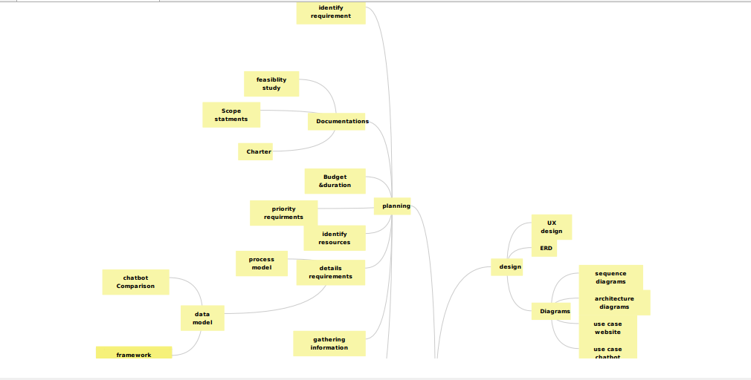

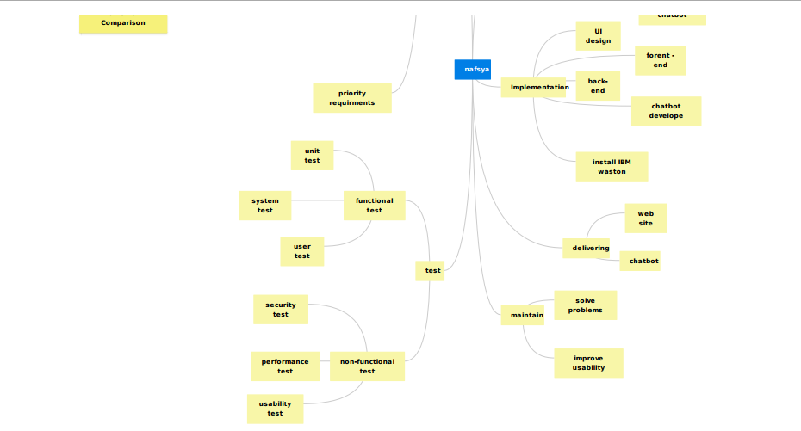

Gantt chart

|  |
| --- |
| Capture1 |
| Capture2 |
| Capture3 |

NETWORK DAIGRAM

|  |
| --- |
| Capture4 |
| Capture5 |
| Capture6 |
| Capture7 |
| Capture8 |
| Capture9CaptureCapture11 |

ERD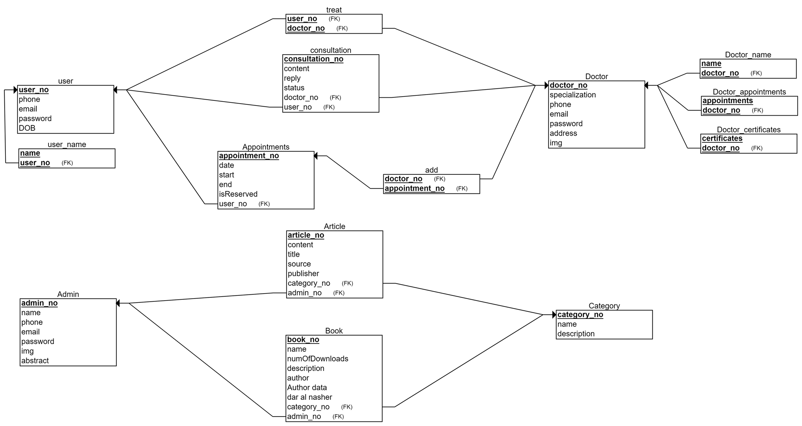

Actors table

|  |  |
| --- | --- |
| **Actor** | **Description** |
| User | Any person who visits the website to use the services it provides. |
| Doctor | Professional medical specialist registered on the website. |
| Administrator | Person responsible for the operation and maintenance of the website. |

Sequence Diagram

1-user 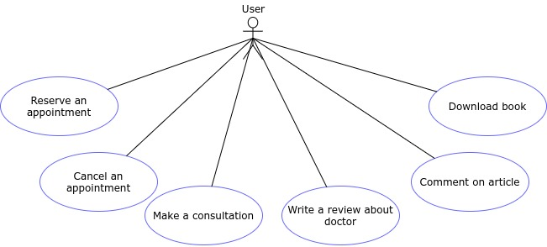

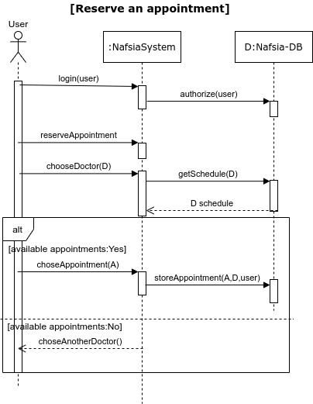

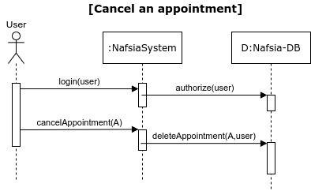

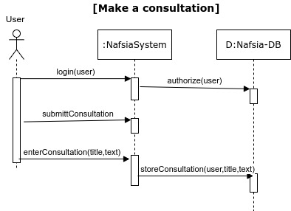

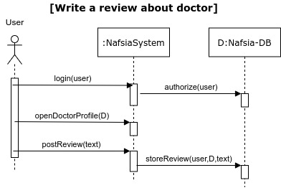

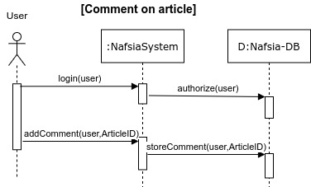

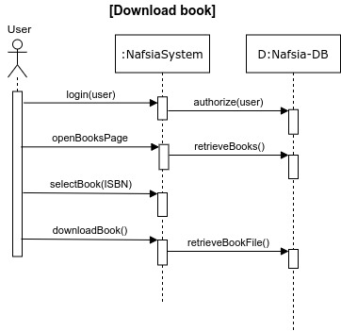

2-doctor

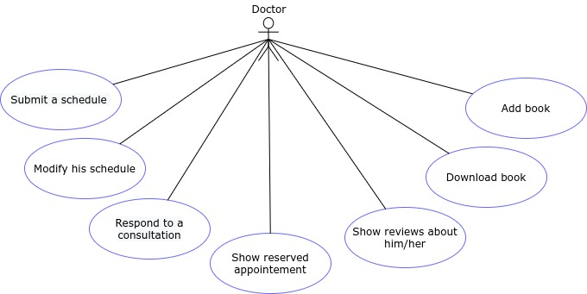

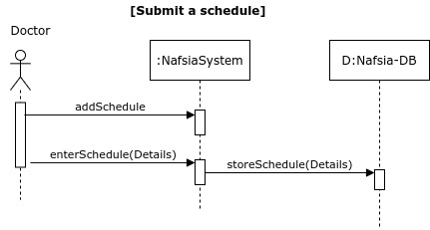

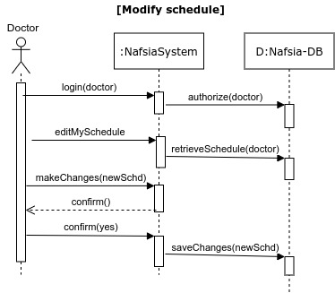

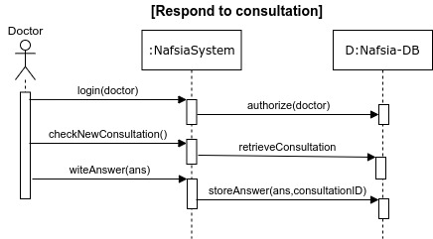

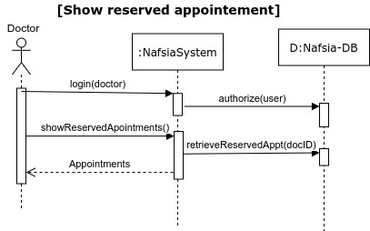

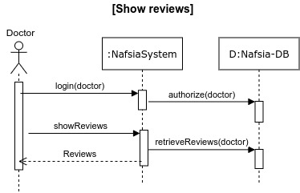

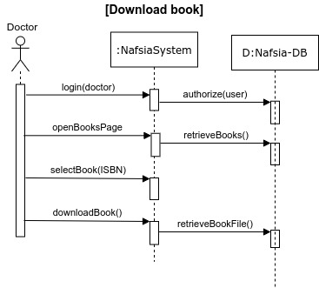

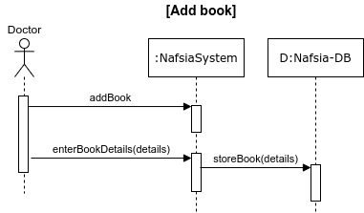

3-Admin

