**WireframeUI**

**DES_LL_WireframeUI_LoginPage**

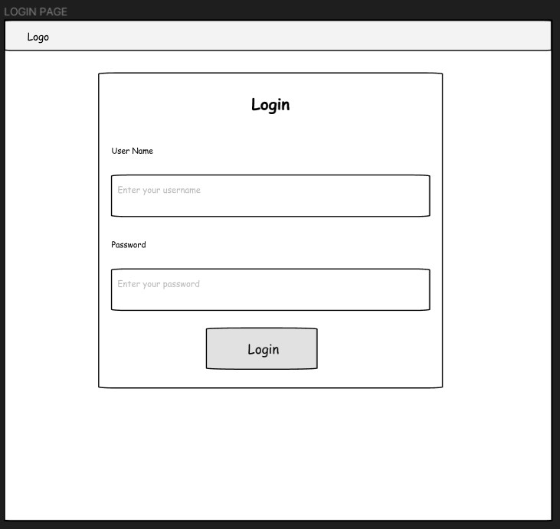

**DES_LL_WireframeUI_RegisterPage**

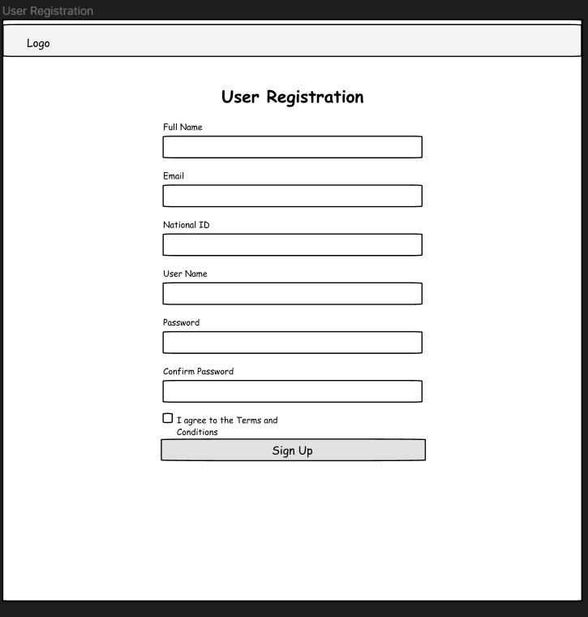

**DES_LL_WireframeUI_UserProfilePage**

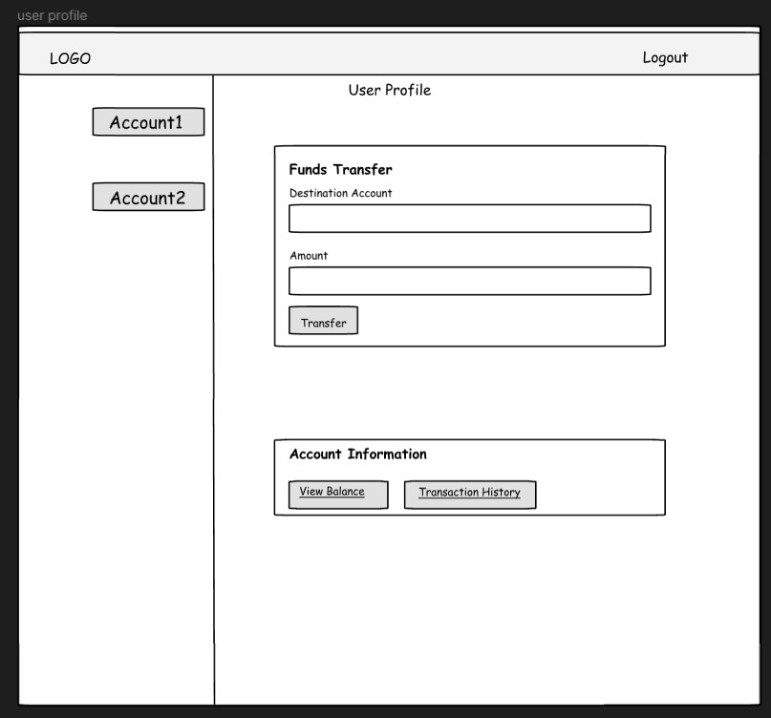

**FlowChart**

**DES_LL_FlowChart_AdminViewBalance**

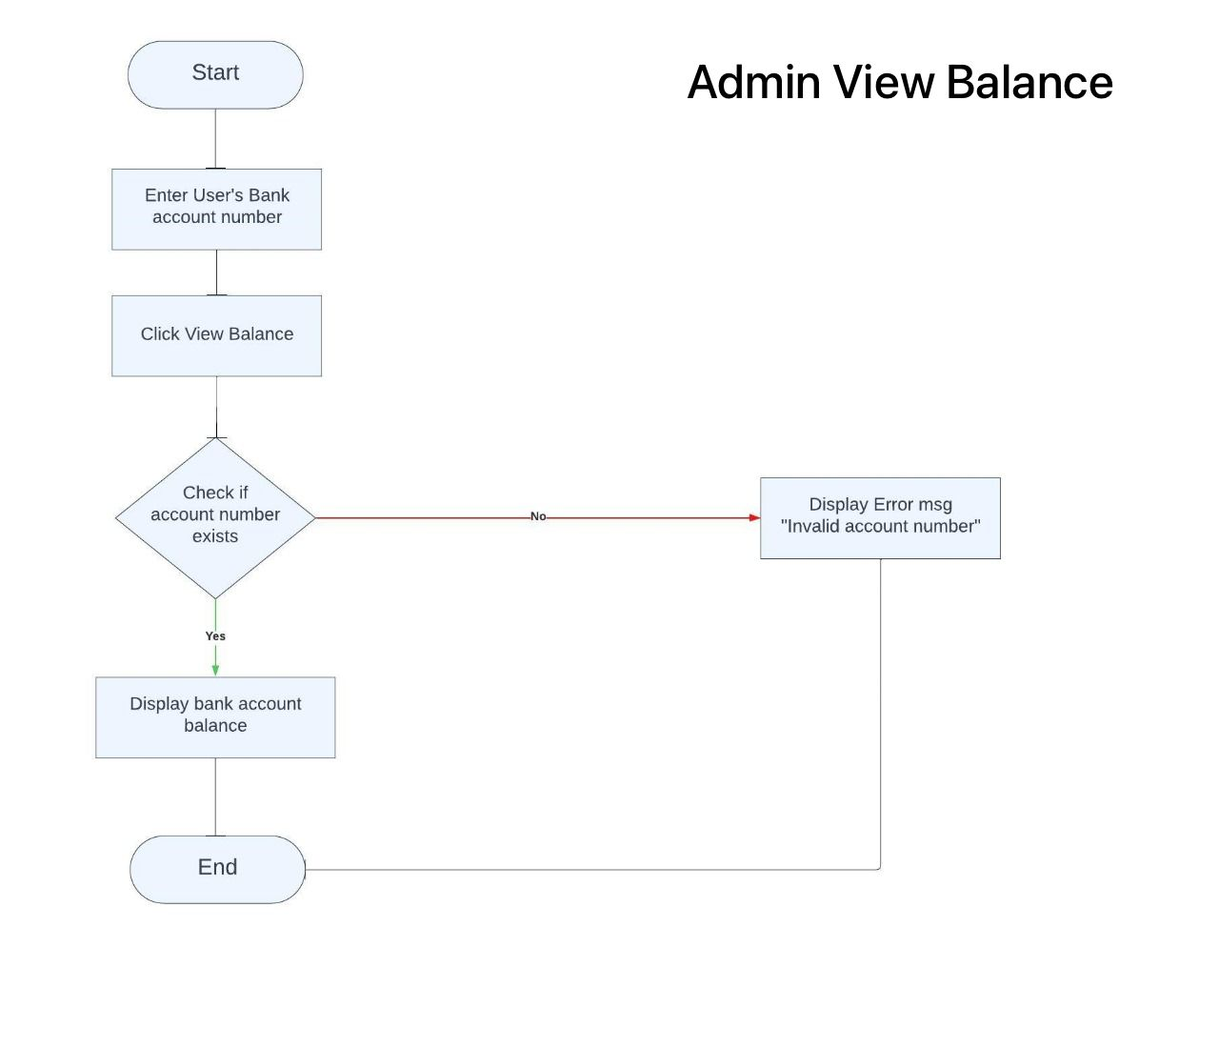

**DES_LL_FlowChart_AdminLogin**

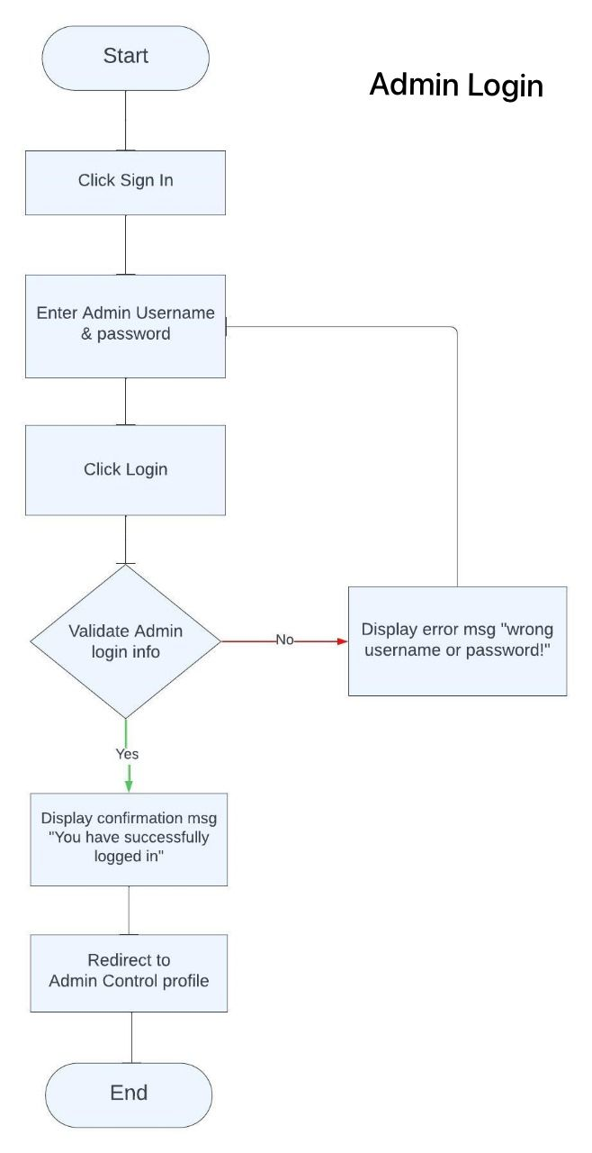

**DES_LL_FlowChart_UserRegistration**

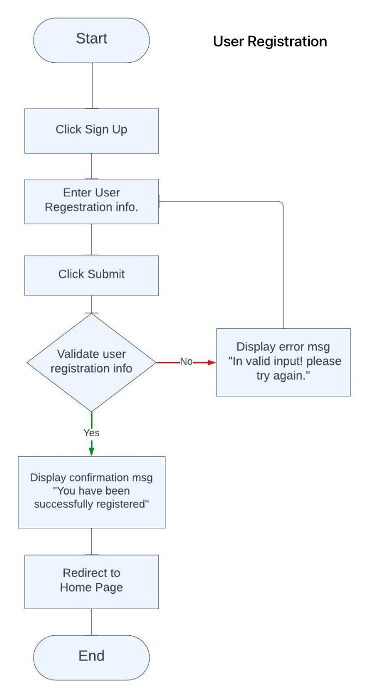

**DES_LL_FlowChart_UserLogin**

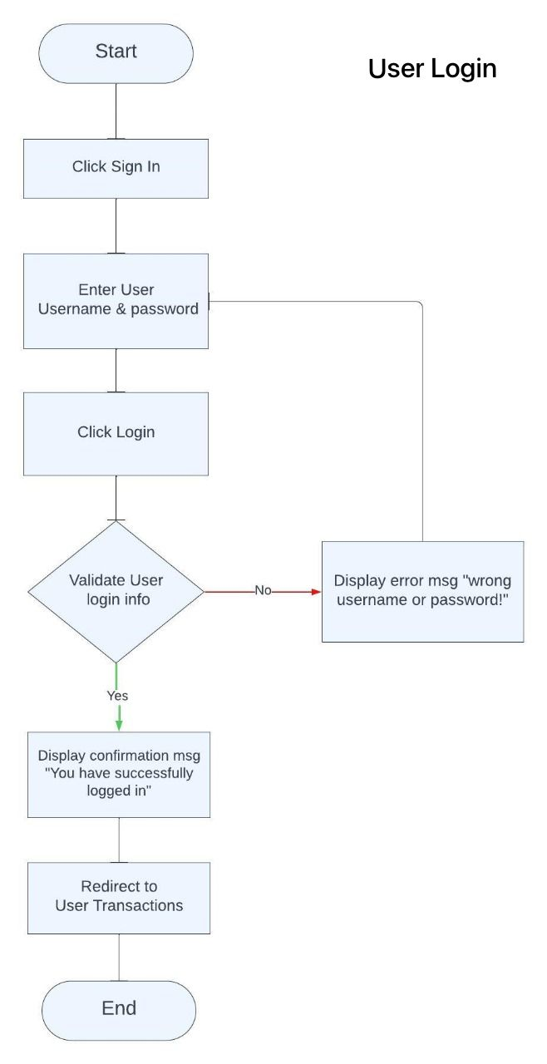

**DES_LL_FlowChart_DeleteBankAccount**

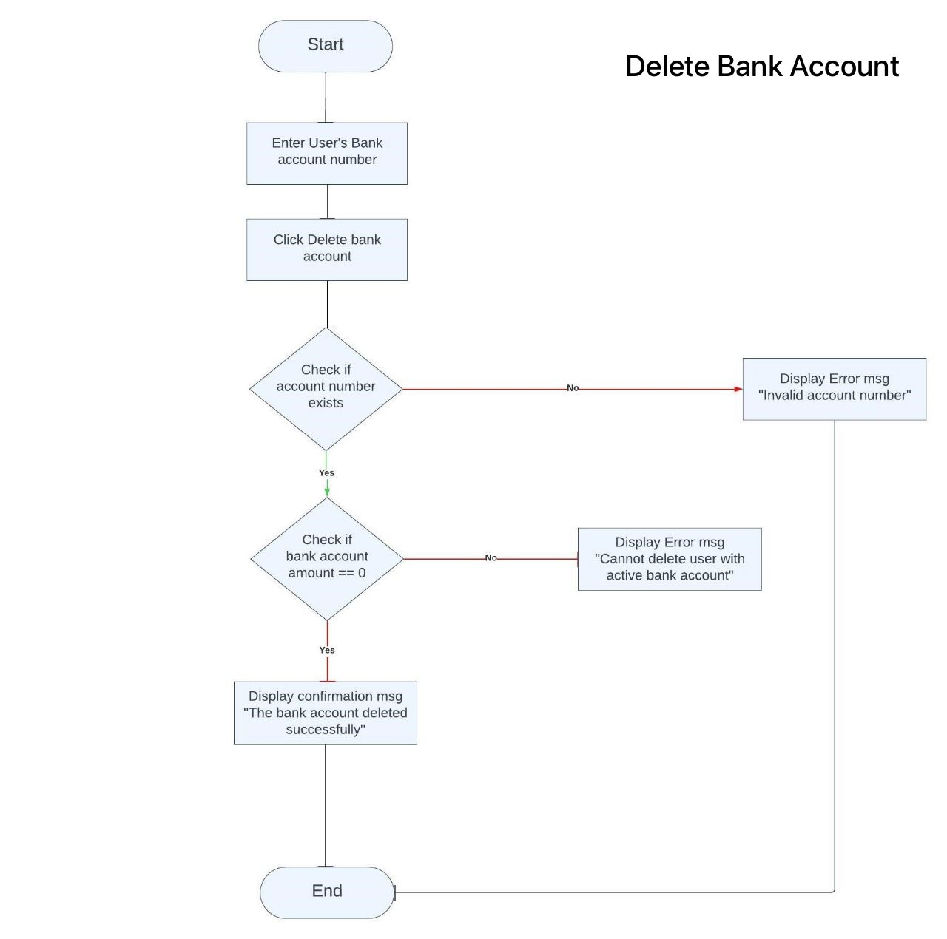

**DES_LL_FlowChart_AddBankAccount**

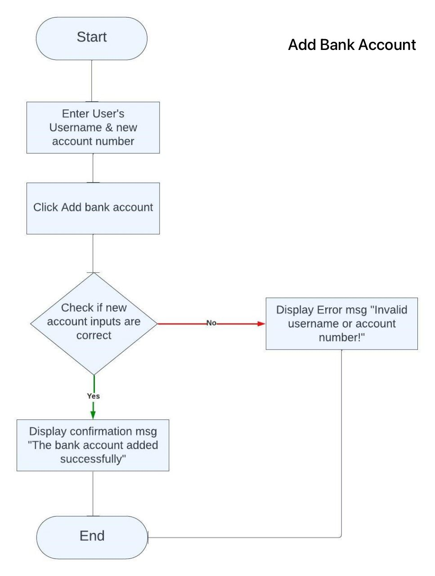

**DES_LL_FlowChart_DeleteUser**

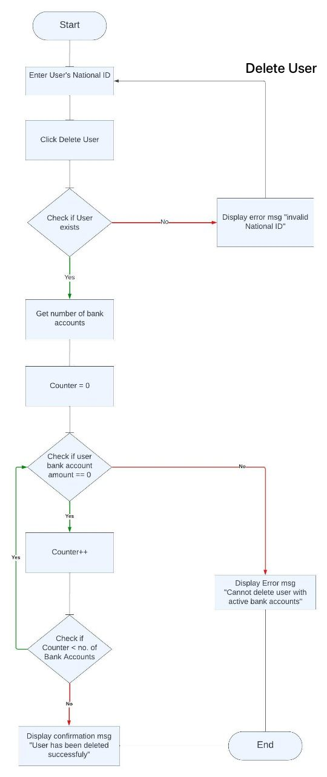

**Class Diagram**

**DES_LL_ClassDiagram**

