**Assignment4.7**

**Problem Statement:**

Blood glucose levels for obese patients have a mean of 100 with a standard deviation of15. A researcher thinks that a diet high in raw cornstarch will have a positive effect onblood glucose levels. Samples of 36 patients who have tried the raw cornstarch diet have a mean glucose level of 108. Test the hypothesis that the raw cornstarch had any effect or not.

**Answer:**

H0: μ= 100  
H1: μ > 100

significance level assume 5%

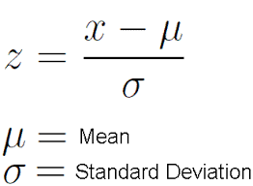

: z= (108-100) / (15/√36)=3.20

In z(3.20)= 0.9993

probability of having value less than 108 is 0.9993 and more than or equals to 108 is

1-p=(1-0.9993)=0.0007.

It is less than 0.05 so we will reject the Null hypothesis i.e. there is raw cornstarch effect.