**Assignment4.1**

**Problem Statement**:

You survey households in your area to find the average rent they are paying. Find the standard deviation from the following data:

$1550, $1700, $900, $850, $1000, $950.

Answer:

[**mean**](http://www.statisticshowto.com/mean):

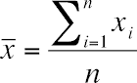

(1550 + 1700 + 900 + 850 + 1000 + 950)/6 = **1158.33**

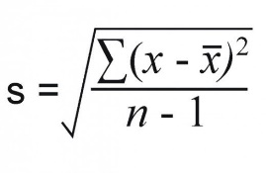

**x ( x- )2**

1550 391.672 = 153405.3889  
1700 541.672 = 293406.3889  
 900 258.332 = 66734.3889   
 850 308.332 = 95067.3889  
 1000 158.332 = 25068.3889  
 950 208.332 = 43401.3889

∑**( x- )2/n-1 =**(153405.3889 + 293406.3889 + 66734.3889 + 95067.3889 + 25068.3889 +43401.3889)/5

= 135416.66668

Square root of the number =√135416.66668 = 367.99

The [standard deviation](http://www.statisticshowto.com/probability-and-statistics/standard-deviation/) (s) is **367.99.**