**Assignment4.2**

**Problem Statement**:

Find the variance for the following set of data representing trees in California (heights in feet): 3, 21, 98, 203, 17, 9

**Answer:**

**Sample Variance**

*[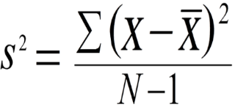](http://www.statisticshowto.com/wp-content/uploads/2009/08/usual.png)  
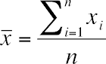*

(3 + 21 + 98 + 203 + 17 + 9)/6 = (351)/6=**58.5**

x ( x- ̅)2

3 3080.25

21 1406.25

98 1560.25

203 20880.25

17 1722.25

9 2450.25

∑**( x- )2/N-1=** (3080.25+1406.25+1560.25+20880.25+1722.25+2450.25)/5

=31099.5/5

=**6219.9**