Github

* What is Git ?
  + Distributed source control system
  + Massively scales
  + Open source
  + Very fast
  + Active community
* Repository
  + First, in Git, collections of version control files are kept together in a repository.
  + The repository also contains the history of changes, and any special configuration.
  + Generally speaking, a repository would contain all the files related to a specific project or application.
* Three states of Git
  + Working directory –
    - The working directory is the directory or folder on your computer that holds all the project or application files.
    - Files within the working directory may or may not be managed by Git; however, Git is aware of them.
    - Normally, within the working directory is a hidden folder called the ".git" folder, that contains the actual Git repository.
  + Staging area –
    - Pre-commit holding area
    - In-between is the Git staging area, often referred to as the Git index, that is a holding area for queuing up changes for the next commit.
    - Since files in the staging area haven't been committed yet, you can move the files in and out of the staging area without impacting the Git repository and its history of changes.
  + Git Repository –
    - Commit
    - History
    - The Git repository manages the Git commit history that is, all the changes that are finalized and permanently part of the Git repository.
* Master branch
  + - Branches are timelines that contain your changes.
    - In Git, branches contain commits.
    - When we start off, Git provides us with a default branch named master.
* Create repository

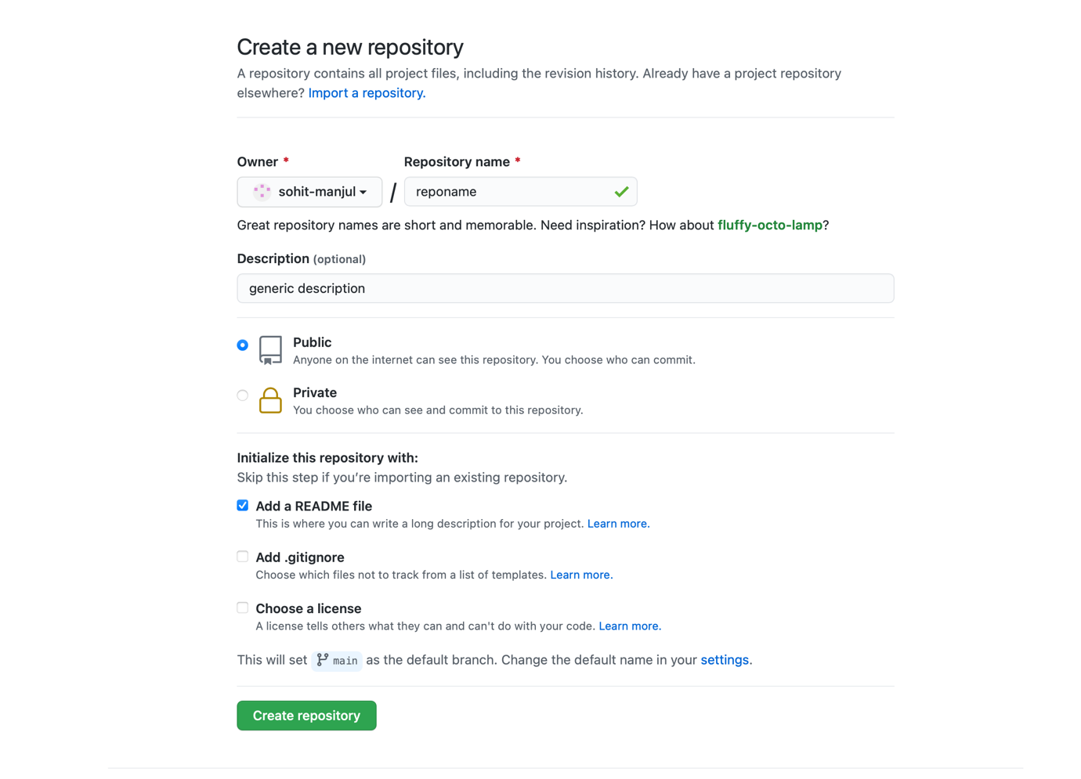

* Terminal commands
  + git version
  + git config --global user.name “user name”
  + git config --global user.email “email”
  + git config –global –list
  + git clone <https://github.com/sohit-manjul/learning-github.git>
  + git status
  + git add <newfiletoaddname>
  + git commit -m “commit message”
  + git push origin master