CUSTOMER SEGMENTATION &
3-MONTH CUSTOMER LIFETIME VALUE PREDICTION
An RFM-Based Machine Learning Approach to Revenue Forecasting and Retention Strategy

Prepared by: Sohita U
BE in Electronics & Communication Engineering
Vasavi College of Engineering
Date: Feb 25, 2026
Dataset: Online Retail Dataset — UCI Machine Learning Repository
Tools Used: Microsoft Excel · Python (pandas, scikit-learn) · Power BI

Table of Contents
1. Executive Summary 3
2. Problem Statement & Objectives 5
3. Data Sources & Methodology 6
4. Key Findings 9
5. Limitations 13
6. Recommendations 14
7. Appendix 15

1. Executive Summary
This project analysed 397,884 transaction records spanning 4,338 unique customers from the UCI Online Retail Dataset (December 1, 2010 – December 9, 2011), a UK-based online gift retailer with international sales across 37 countries. The objective was to segment customers by purchasing behaviour and build a predictive model for near-term revenue, giving leadership a data-driven basis for marketing spend, retention prioritization, and revenue forecasting.
Using RFM analysis (Recency, Frequency, Monetary) combined with K-Means clustering, customers were grouped into five actionable segments: VIP, Loyal, Potential, At Risk, and Lost. A linear regression model was then trained to predict each customer's revenue over the following 3 months, achieving an R² of 0.667 (67% of variance explained) with an RMSE of £3,493.58.

Headline Numbers
Metric | Value
Total customers analysed | 4,338
Original transaction records | 397,884
Historical revenue captured | £8,911,407.90
Model R² (3-month revenue) | 0.667
Model RMSE | £3,493.58
Highest-value segment (avg. CLV) | VIP — £1,197.02 / customer
Segment driving most total revenue | Potential (1,489 customers)
Revenue concentration | Top 26% of customers generate ~80% of revenue
Table 1. Key project metrics at a glance.

Key Insights
- Revenue is concentrated: the top 1,133 customers (26.1% of the base) generate approximately 80% of historical revenue — a classic Pareto pattern that should anchor budget allocation.
- Segment size beats segment value: the Potential segment (1,489 customers, £888.14 avg. predicted CLV) contributes more total forecast revenue than the smaller but higher-value VIP segment (533 customers, £1,197.02 avg. CLV) — making Potential the highest-leverage segment for upsell investment.
- Behavioural separation is clean: VIP customers purchase roughly 13x more frequently and 28x more recently than Lost customers, confirming the segmentation is behaviourally valid, not arbitrary.
- Retention risk is material: 1,159 customers (At Risk + Lost, 26.7% of the base) show minimal recent engagement and a combined average CLV under £410, signalling an urgent need for reactivation campaigns.

Recommended Actions
- Prioritize personalized promotions and conversion campaigns for the Potential segment — the single largest revenue lever.
- Protect the VIP segment with premium loyalty perks; they are only 12.3% of customers but the highest per-head value.
- Launch low-cost, automated win-back campaigns for At Risk and Lost customers before their value decays further.
- Operationalize the Power BI dashboard for monthly tracking of segment migration and CLV drift.

2. Problem Statement & Objectives

2.1 Business Context
The retailer's marketing and CRM teams historically treated all customers uniformly, resulting in undifferentiated spend across high- and low-value accounts, no forward-looking revenue visibility, and reactive (rather than proactive) retention efforts. This project set out to close that gap using historical transactional data.

2.2 Objectives
- Segment customers based on purchasing behaviour using Recency, Frequency, and Monetary (RFM) metrics.
- Predict each customer's revenue over the next 3 months (a forward-looking Customer Lifetime Value estimate).
- Identify which segments hold the greatest current and future value.
- Recommend segment-specific strategies to support revenue growth and retention.

2.3 Business Questions Answered
- Which customers are most valuable today, and which are trending toward churn?
- How much revenue can be expected from each customer / segment over the next quarter?
- Where should marketing budget be concentrated for the best return?
- What early-warning signals distinguish an At-Risk customer from a Lost one?

2.4 Success Criteria
A regression model explaining a meaningful share of variance in near-term revenue (targeted R² > 0.6), combined with segments that are both statistically distinct and operationally actionable (i.e., each maps to a specific, executable marketing strategy).

3. Data Sources & Methodology

3.1 Dataset Origin
Data was sourced from the Online Retail Dataset published on the UCI Machine Learning Repository, containing transactional records for a UK-registered, non-store online retailer specializing in unique all-occasion gifts, primarily sold to wholesalers.
Attribute | Detail
Raw records | 541,909 (pre-cleaning)
Cleaned records used | 397,884
Date range | Dec 1, 2010 – Dec 9, 2011
Unique customers | 4,338
Countries represented | 37 (89.0% of transactions from the UK)
Original fields | InvoiceNo, StockCode, Description, Quantity, InvoiceDate, UnitPrice, CustomerID, Country
Table 2. Raw dataset profile.

3.2 Data Cleaning (Excel)
Cleaning and initial transformation were performed in Excel prior to modelling:
- Removed rows with missing CustomerID (guest / unidentifiable transactions), as segmentation and CLV modelling require a persistent customer key.
- Removed cancelled orders and negative-quantity return rows (InvoiceNo values prefixed 'C') to avoid distorting monetary totals.
- Removed non-positive UnitPrice and Quantity records.
- Engineered a Revenue field (Quantity × UnitPrice) at the line-item level.
- Converted InvoiceDate to a proper datetime type for time-based aggregation.
- Built supporting pivot tables (Customer Segmentation tiers, revenue-by-segment, running-total Pareto ranking) used for validation and dashboarding.

3.3 RFM Feature Engineering
For every customer, three behavioural metrics were computed relative to a snapshot date:
- Recency — days since the customer's last purchase (lower = more engaged).
- Frequency — count of distinct invoices / transactions.
- Monetary — total historical spend.

3.4 Segmentation Model (Python — K-Means)
RFM features were standardized using StandardScaler (zero mean, unit variance) to prevent Monetary's larger scale from dominating the distance calculation. The optimal cluster count was selected using the Elbow Method across k = 1 to 10:
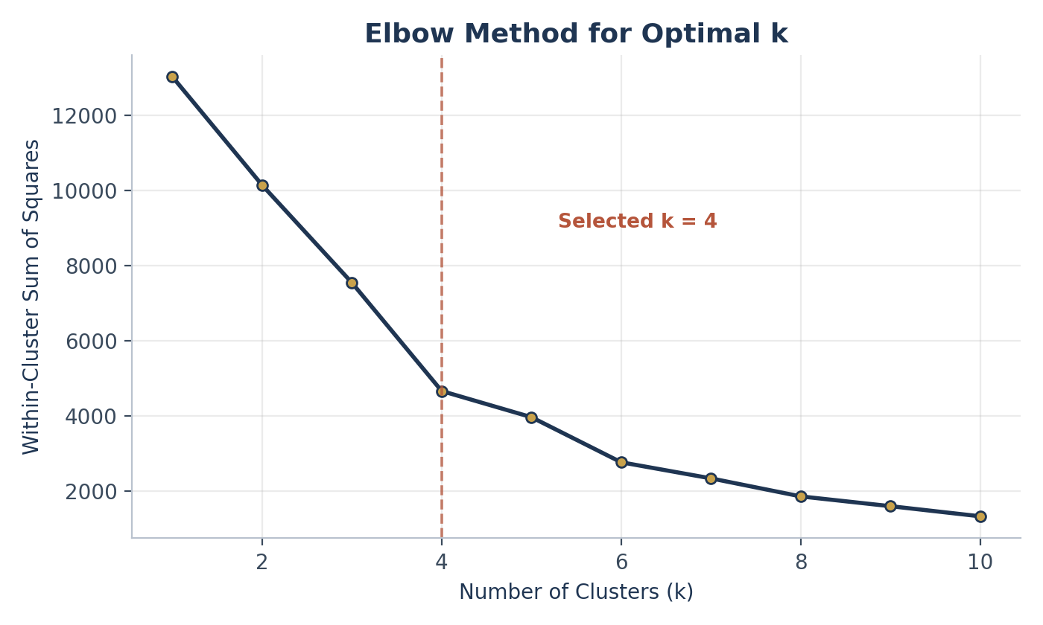
Figure 1. Elbow method — the rate of WCSS reduction flattens noticeably after k = 4, the value selected for the final model.
K-Means was fit with k = 4 (random_state = 42). The resulting numeric clusters were then mapped to business-friendly labels based on their RFM centroids, and further refined into five interpretable segments using RFM scoring (quintile-based Recency, Frequency, and Monetary scores summed into an RFM_Total):
Segment | Behaviour Pattern
VIP | Lowest recency, highest frequency & monetary — the most active, highest-spending customers
Loyal | High frequency, moderate recency — consistent repeat buyers
Potential | Medium recency, moderate frequency — engaged but not yet maximized
At Risk | High recency, low frequency — declining engagement
Lost | Very high recency, minimal activity — largely inactive
Table 3. Segment definitions used throughout the analysis.

3.5 CLV Prediction Model (Python — Linear Regression)
To forecast forward-looking value, the transaction history was split using a rolling 3-month cutoff (the final 3 months of the dataset held out as the prediction target):
- Training window: all transactions up to the cutoff date (used to compute predictor features).
- Target window: the final 3 months of transactions (summed per customer as FutureRevenue, the value the model is trained to predict).
Predictor features engineered from the training window:
- Recency, Frequency, Monetary (as of the cutoff date)
- Average Order Value (Monetary ÷ Frequency)
- Purchase Interval (mean number of days between consecutive purchases)
A Linear Regression model (scikit-learn, 80/20 train-test split, random_state = 42) was trained to predict FutureRevenue from these five features.
Model Performance
Metric | Value | Interpretation
RMSE | £3,493.58 | Average prediction error in currency terms
R² | 0.667 | ≈ 67% of variance in 3-month revenue explained
Table 4. Regression model performance on the held-out test set.
An R² of 0.667 is a strong result for behavioural retail data, where purchase timing is inherently noisy. The trained model was then applied across the full customer base to generate a Predicted_CLV value for every customer.

3.6 Tools & Technology Stack
Stage | Tool(s)
Data cleaning & pivot analysis | Microsoft Excel
Feature engineering, clustering, regression | Python (pandas, NumPy, scikit-learn, matplotlib, seaborn)
Executive dashboard & reporting | Power BI (3-page interactive dashboard)
Table 5. Tools used at each stage of the pipeline.

4. Key Findings

4.1 Customer Segment Distribution
Applying the RFM-scoring segmentation to the full customer base produced the following distribution:
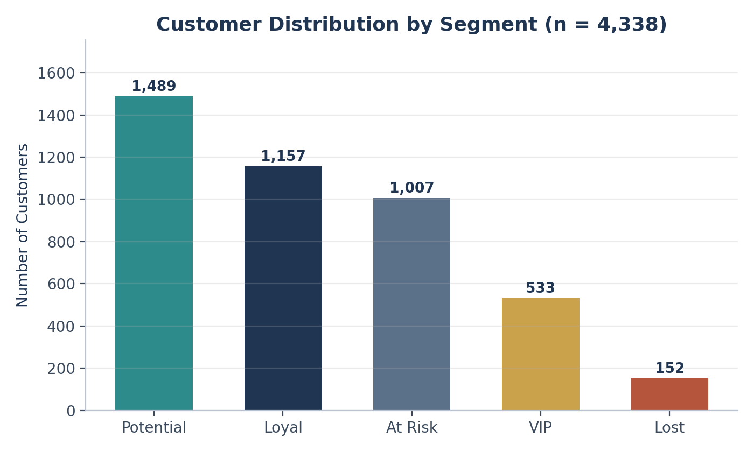
Figure 2. Customer distribution by segment (n = 4,338).
Segment | Customers | % of Base
Potential | 1,489 | 34.3%
Loyal | 1,157 | 26.7%
At Risk | 1,007 | 23.2%
VIP | 533 | 12.3%
Lost | 152 | 3.5%
Table 6. Segment sizes and share of the customer base.

4.2 Behavioral Validation (RFM Profile by Segment)
Average RFM values by segment confirm the segmentation is behaviourally sound — value and engagement decline consistently from VIP through Lost:
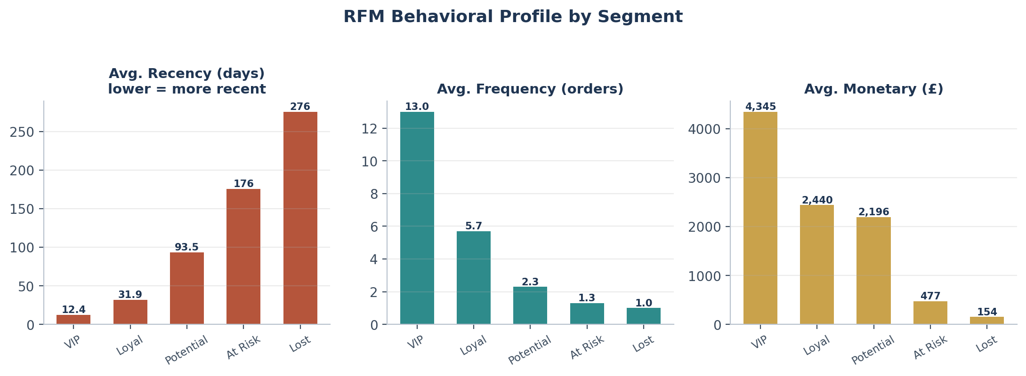
Figure 3. Average Recency, Frequency, and Monetary value by segment.
Segment | Avg. Recency (days) | Avg. Frequency (orders) | Avg. Monetary (£)
VIP | 12.4 | 13.0 | 4,344.90
Loyal | 31.9 | 5.7 | 2,439.60
Potential | 93.5 | 2.3 | 2,195.60
At Risk | 175.6 | 1.3 | 476.90
Lost | 275.6 | 1.0 | 154.00
Table 7. Segment-level RFM averages.

4.3 Predicted 3-Month CLV by Segment
Applying the regression model across all customers and averaging by segment produced the following forward-looking value estimates:
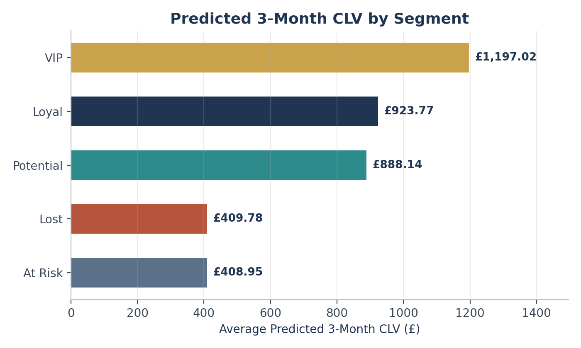
Figure 4. Average predicted 3-month CLV by segment.
Segment | Avg. Predicted CLV (£) | Suggested Action
VIP | 1,197.02 | Premium loyalty rewards & exclusive access
Loyal | 923.77 | Upsell & cross-sell campaigns
Potential | 888.14 | Engagement & personalized offers
Lost | 409.78 | Automated win-back
At Risk | 408.95 | Retention & discount campaigns
Table 8. Predicted CLV and recommended strategy by segment.

4.4 Total Revenue Contribution — Where the Money Actually Comes From
Average CLV alone is misleading without accounting for segment size. Multiplying average predicted CLV by segment population shows where total future revenue is concentrated:
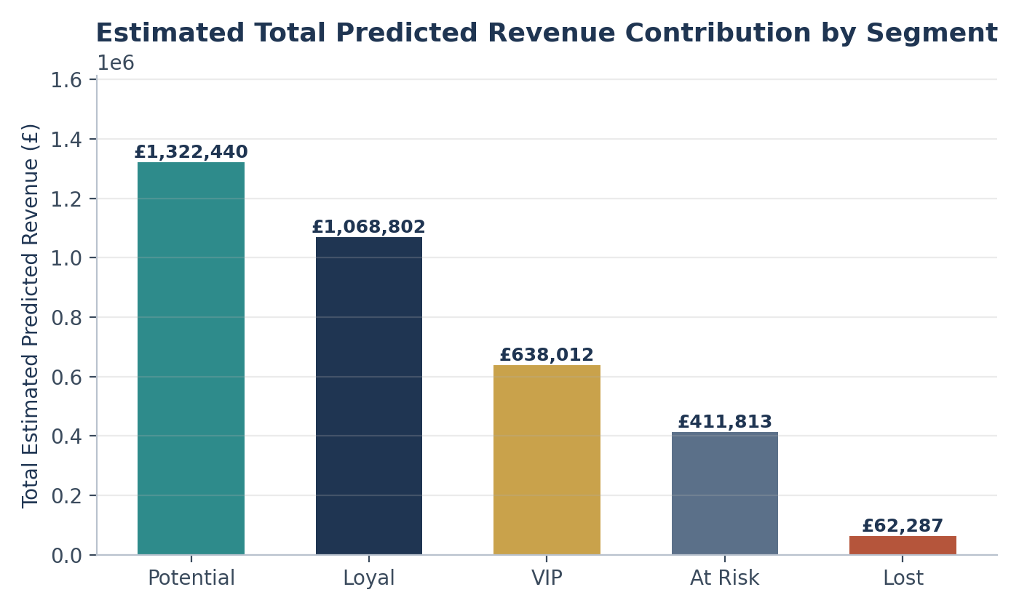
Figure 5. Estimated total predicted revenue contribution by segment (avg. CLV × segment size).
Despite VIP having the highest per-customer value, the Potential segment contributes the most total forecast revenue (an estimated £1.32M vs. VIP's £0.64M), simply because it is nearly 3x larger. This is the single most actionable insight in the analysis: upselling Potential customers likely yields a higher aggregate ROI than VIP-only retention spend.

4.5 Revenue Concentration (Pareto Analysis)
Ranking customers by historical revenue and computing a cumulative running total shows a textbook Pareto distribution:
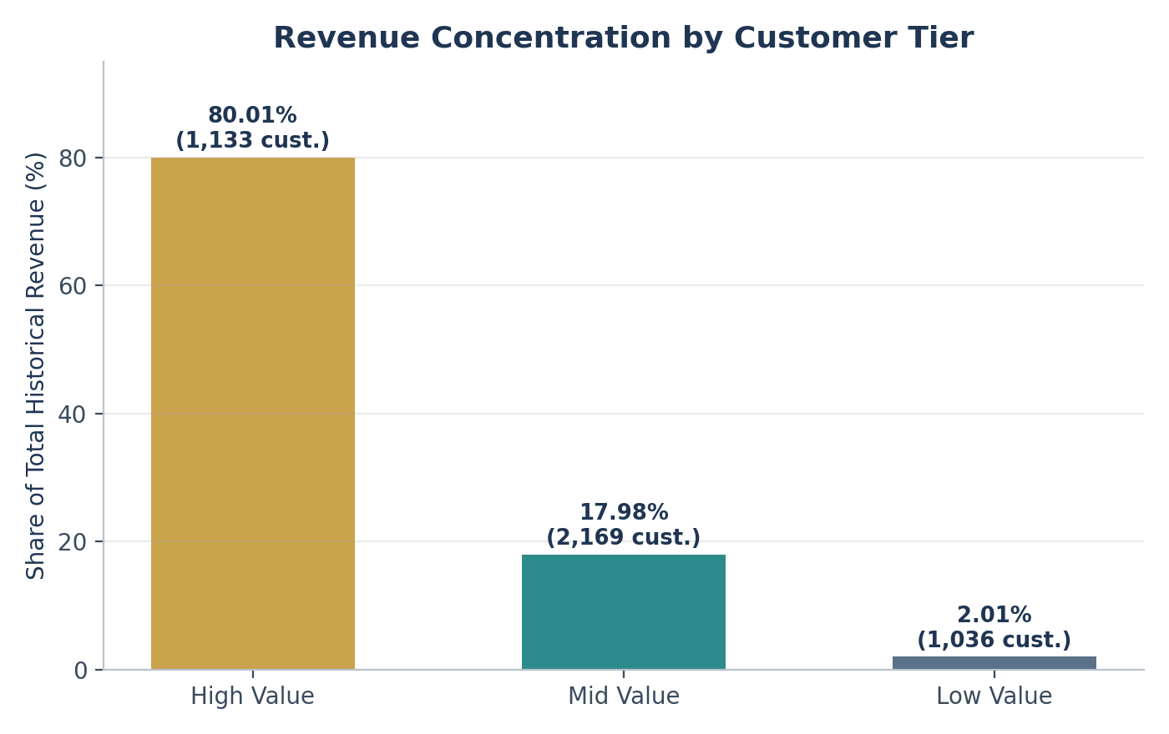
Figure 6. Share of historical revenue by customer value tier.
Tier | Customers | % of Base | Revenue Share
High Value | 1,133 | 26.1% | ~80.0%
Mid Value | 2,169 | 50.0% | ~18.0%
Low Value | 1,036 | 23.9% | ~2.0%
Table 9. Revenue concentration by customer value tier — the top ~26% of customers drive ~80% of historical revenue.

4.6 Power BI Executive Dashboard
A three-page interactive Power BI dashboard was built to operationalize these findings for non-technical stakeholders:
- Page 1 — Executive Overview: total customers, average CLV, total predicted revenue, and revenue by segment at a glance.
- Page 2 — Segmentation Analytics: customer distribution by segment, average CLV comparison, and RFM behaviour comparison for deep-dive analysis.
- Page 3 — Strategic Recommendations: revenue contribution %, segment value summary, and action mapping for direct handoff to marketing.

5. Limitations
- Prediction horizon: the model forecasts only the next 3 months of revenue; it does not estimate long-run (12-month+) lifetime value.
- No churn probability model: the analysis does not estimate the likelihood a given customer stops purchasing altogether — only expected revenue conditional on the historical pattern continuing.
- No seasonality adjustment: the dataset covers roughly one year and includes a holiday-heavy final quarter (Nov–Dec 2011); the model does not explicitly separate seasonal lift from underlying behavioural trend, which may inflate near-term predictions for some customers.
- Linear model assumptions: Linear Regression assumes a linear relationship between RFM-derived features and future revenue; it does not capture non-linear interactions (e.g., diminishing returns at very high frequency) that a tree-based model might.
- No external variables: macroeconomic conditions, marketing campaign exposure, competitor activity, and pricing changes are not included as features.
- Single-country skew: 89.0% of transactions originate in the UK, so behavioural patterns may not generalize evenly across the other 36 countries represented.
- Small-cluster instability: two of the four raw K-Means clusters contained only 8 customers each; while the business-segment relabelling smooths this, extreme-value customers (e.g., the single £77,183.60-spend outlier) can distort cluster centroids.
- Historical data only: the dataset ends December 2011; all findings describe historical behaviour and should be revalidated against current transaction data before being used for live budget decisions.

6. Recommendations

6.1 Segment-Specific Strategy
Segment | Strategic Focus | Tactics
VIP | Retain aggressively | Exclusive access, personalized loyalty programs, dedicated account support
Loyal | Upsell & cross-sell | Subscription / bundle offers, early access to new products
Potential | Convert & grow (highest ROI) | Targeted promotions, conversion campaigns, engagement automation
At Risk | Reactivate before loss | Discount reactivation campaigns, trigger-based reminders
Lost | Low-cost win-back | Automated email remarketing, minimal-spend re-engagement
Table 10. Recommended action plan by segment.

6.2 Priority Actions for Leadership
- 1. Reallocate marketing budget toward the Potential segment. It is the single largest source of total forecast revenue; even a modest lift in conversion rate here outweighs comparable spend on the smaller VIP segment.
- 2. Stand up an automated At Risk / Lost win-back flow. These 1,159 customers (26.7% of the base) are trending toward churn; low-cost, automated triggers (cart abandonment-style reminders, time-based discounts) can recover meaningful revenue before it disappears entirely.
- 3. Protect the High Value tier. With ~80% of revenue concentrated in ~26% of customers, even small attrition here has outsized financial impact — prioritize white-glove retention for this group specifically, not just the VIP RFM segment.
- 4. Operationalize the Power BI dashboard as a monthly reporting cadence. Track segment migration (customers moving between Potential → Loyal → VIP, or Loyal → At Risk) as a leading indicator, not just point-in-time snapshots.
- 5. Invest in the model roadmap. Extending the prediction window and adding a churn-classification layer (see Section 5) will materially increase the precision of budget allocation decisions.

6.3 Recommended Next Steps (Model Roadmap)
- Extend the prediction window from 3 months to 6–12 months for true lifetime value estimation.
- Add a churn-probability classification model (e.g., logistic regression or gradient boosting) to complement the revenue forecast with a likelihood-to-churn score.
- Re-fit the regression using XGBoost or a similar gradient-boosted tree model to capture non-linear feature interactions and likely improve R² beyond 0.667.
- Incorporate seasonality features (month, day-of-week, holiday flags) given the dataset's clear Q4 concentration.

7. Appendix

7.1 Data Dictionary — Cleaned Transaction Table
Field | Type | Description
InvoiceNo | Text | Unique invoice / transaction identifier
StockCode | Text | Product / item code
Description | Text | Product name
Quantity | Integer | Units purchased in the transaction line
InvoiceDate | Datetime | Date and time of the transaction
UnitPrice | Decimal | Price per unit (£)
CustomerID | Integer | Unique customer identifier
Country | Text | Customer's country
Revenue | Decimal | Engineered field: Quantity × UnitPrice
Table 11. Cleaned transaction-level data dictionary.

7.2 Data Dictionary — RFM / Segmentation Table
Field | Description
CustomerID | Unique customer identifier
Recency | Days since the customer's last purchase
Frequency | Count of distinct invoices
Monetary | Total historical spend (£)
AvgOrderValue | Monetary ÷ Frequency
PurchaseInterval | Average days between consecutive purchases
RecencyScore / FrequencyScore / MonetaryScore | Quintile scores (1–5) used to build RFM_Total
RFM_Total | Sum of the three quintile scores
Cluster | Raw K-Means cluster label (0–3)
Segment | Business-facing label: VIP / Loyal / Potential / At Risk / Lost
FutureRevenue | Actual revenue in the 3-month target window (model training target)
Predicted_CLV | Model-predicted 3-month revenue
Table 12. RFM / segmentation & modelling data dictionary.

7.3 Modelling Pipeline Summary (Python)
- Libraries: pandas, NumPy, scikit-learn (StandardScaler, KMeans, LinearRegression, train_test_split, mean_squared_error, r2_score), matplotlib, seaborn.
- Segmentation: StandardScaler → KMeans(n_clusters=4, random_state=42) on [Recency, Frequency, Monetary].
- CLV Regression: 3-month rolling cutoff split → features [Recency, Frequency, Monetary, AvgOrderValue, PurchaseInterval] → LinearRegression, 80/20 train-test split, random_state=42.
- Evaluation: RMSE = 3,493.58; R² = 0.667 on the held-out test set.
- Output: full customer table (rfm_reg) with Predicted_CLV and Segment exported for Power BI consumption.

7.4 Source Files Referenced
- Final_Clean_Data.xlsx — cleaned transactional data, RFM table, and supporting pivot analyses (Excel).
- Customer_Clustering.ipynb — full Python notebook: feature engineering, K-Means segmentation, and CLV regression model.
- clv_segmentation.pbix — three-page Power BI executive dashboard.
Full code, transformation logic, and dashboard files accompany this report as separate deliverables and are available on request.

