GRA_Net: Age and Gender Classification from Facial Images
Complete Student Project Report
Based on the supplied paper: “GRA_Net: A Deep Learning Model for Classification of Age and Gender From Facial Images” (IEEE Access, 2021).
Student Name: ______________________________
Roll Number: _______________________________
Department: Computer Science and Engineering
College: _________________________________
Guide: __________________________________

Abstract
This project implements a paper-aligned Gated Residual Attention Network (GRA_Net) for age and gender prediction from facial images. The supplied paper models age using a combination of age-category classification and exact-age digit regression, while gender is treated as binary classification. The project uses 32x32 RGB input, gated residual attention, a bottom-up/top-down soft-mask branch, and separate task-specific output models. UTKFace is used as the first practical training dataset because its standard filenames encode age and gender metadata. The project also includes data preparation, training, evaluation, command-line inference, a Streamlit demo, a Colab notebook, a report, a presentation, and viva questions.

1. Introduction
Age and gender estimation from facial images is difficult because unconstrained photographs contain variation in pose, illumination, expression, image quality, occlusion, and background. The supplied paper motivates a robust deep-learning approach and proposes GRA_Net, which combines classification and regression for age estimation and a separate gender classification task. (Paper Sec. I, p. 2.)

2. Objectives
- Implement a paper-aligned GRA_Net feature extractor with gated residual attention.
- Prepare facial images as 32x32 RGB inputs.
- Train separate gender, age-category, and age-unit models.
- Evaluate age using MAE and gender using accuracy.
- Provide single-image prediction and a Streamlit demonstration.
- Keep paper facts separate from project-specific implementation choices.

3. Paper Contributions and Motivation
The supplied paper lists six contributions: using classification and regression for age identification; a separate gender task; introducing gates for Residual Attention Networks; applying attention masks across channels; evaluating on five datasets; and reporting lower MAE and higher identification accuracy than many prior methods. (Paper Sec. III-A, p. 4.)

4. Datasets
Dataset | Paper details used in this report
FG-NET | 1002 images, 82 subjects, newborn to 69 years; class imbalance and image-quality variation are noted.
AFAD | 164,432 labeled photos; the paper states ages 15-40; Asian face age-estimation benchmark.
Wikipedia Age | 62,328 face images from 20,284 celebrities.
UTKFace | More than 20K face images; ages 0-116; age, gender and ethnicity metadata.
AdienceDB | Flickr-derived images with manually labeled gender, age and identity; evaluated by the paper.
For the runnable student pipeline, UTKFace is used first. The other datasets require dataset-specific parsers or conversion to a common manifest.

5. Age Label Decomposition
The paper decomposes an age label into two sub-labels (Figure 11). For example, 71 becomes 7 for the age-category classifier using floor(age/10), and 1 for the regression model using age modulo 10. This project follows that decomposition. The resulting predicted age is decade*10 + rounded unit digit.
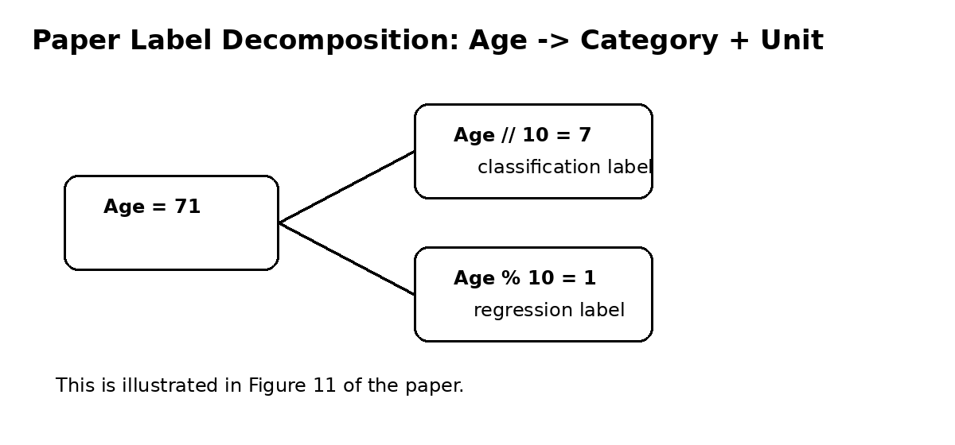

6. GRA_Net Methodology
The paper constructs the architecture from a Residual Attention Network backbone. It uses pre-activation Residual Units and ResNeXt as the basic trunk unit. Each Attention block has a Trunk branch for feature processing and a Mask branch for learning a same-sized attention mask with a bottom-up/top-down approach and skip connections. (Paper Sec. V-A-C, pp. 6-8.)
The central gated residual attention equation is: O_i,c(X) = (gamma + (1-gamma)*K_i,c(X))*F_i,c(X), where K is the soft mask, F is the trunk feature, and gamma is a trainable gate. This is Eq. (3) in the paper.
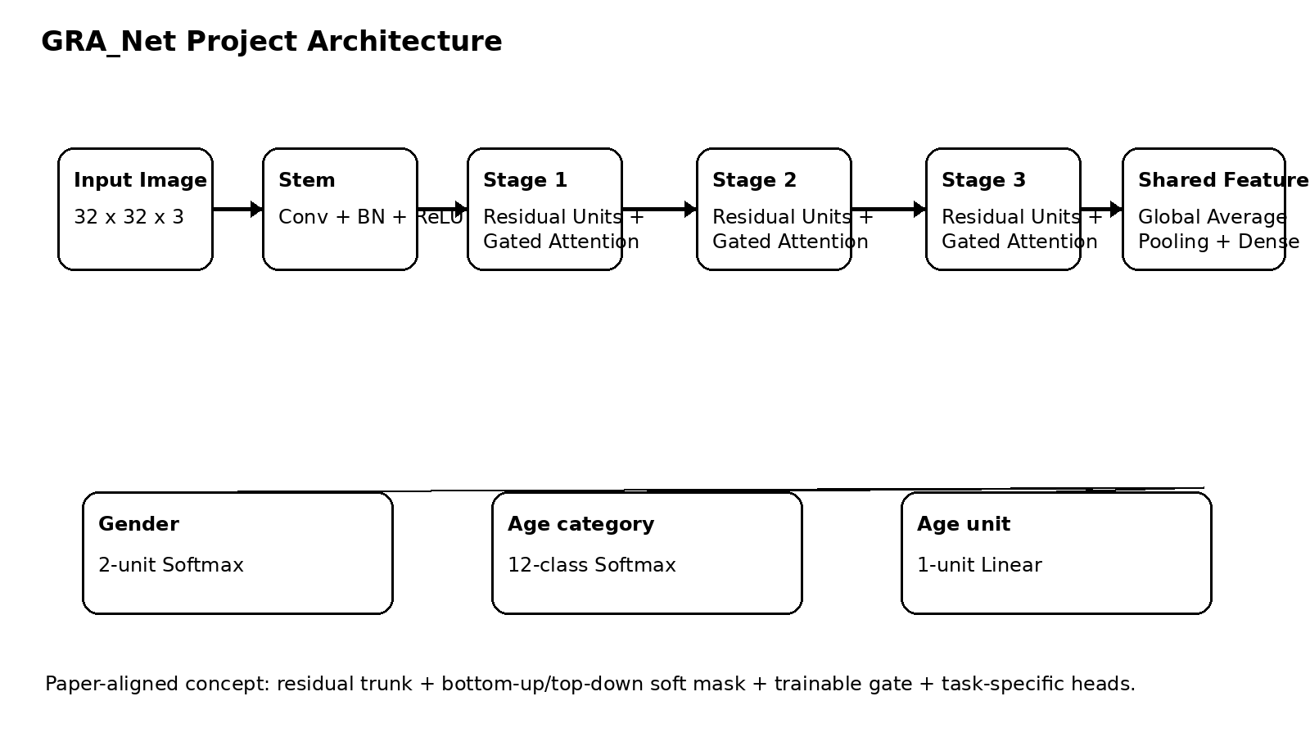

7. Soft Mask and Attention
The paper describes a bottom-up/top-down mask branch. Max pooling increases the receptive field; a symmetric interpolation-based top-down path returns to the original spatial size; skip connections preserve information across scales; two consecutive 1x1 convolutions followed by a sigmoid produce the soft mask. The paper defines three attention choices: mixed attention using sigmoid per channel and spatial position, channel attention using L2 normalization over channels, and spatial attention using channel-wise mean and standard deviation followed by sigmoid normalization.

8. Experimental Settings from the Paper
Setting | Paper statement
Input | 32x32 RGB
Gender output | 2-unit softmax: Male/Female
Gender loss | Binary cross entropy
Age classification loss | Categorical cross entropy
Optimizer | Nadam, learning rate 0.001
Model size | About 33 million trainable parameters for the reported models
Age regression output | Single Dense node, linear activation, labels 0-9
Age metric | MAE
Gender metric | Accuracy

9. Student Implementation Decisions
The paper does not specify every stage width and depth in its text. Therefore, this project uses a compact three-stage trunk that retains the named components and the gated-attention formula. This is a student implementation choice, not a claim of exact layer-by-layer reproduction. MSE is used for the age-unit regression head because the supplied paper specifies the linear output and labels but does not state the regression loss in the experimental paragraph. The Streamlit demo uses OpenCV Haar-cascade face detection as a deployment convenience; this is not claimed as the paper training preprocessing.

10. Software Architecture
Layer | Implementation
Input | 32x32x3 float image normalized to 0-1
Trunk | Pre-activation residual/ResNeXt-style units
Attention | Bottom-up/top-down soft mask + spatial/channel/mixed mode
Gate | Trainable sigmoid(gamma_logit) controlling mask contribution
Feature head | Global average pooling + dense + dropout
Gender | 2-unit softmax
Age category | 12-class decade softmax for UTKFace 0-116
Age unit | 1-unit linear regression 0-9

11. Training Pipeline
- Set random seeds.
- Parse UTKFace file names into age/gender/race.
- Create decade and unit labels.
- Split into train/validation/test sets.
- Decode and resize images to 32x32 RGB.
- Apply training augmentation.
- Train gender, age-category, and age-unit models.
- Save best weights and training-history CSV files.

12. Evaluation
The paper uses MAE for age estimation and accuracy for gender classification. The student pipeline additionally reports exact-age accuracy and the proportion of predictions within ±5 years as supplementary diagnostics. The additional metrics are project-level conveniences, not paper metrics.

13. Results
After running the code, paste values from results/results.csv into the following table. Never replace these with the paper benchmark values.
Metric | Your result
Age MAE | [FILL FROM RUN]
Gender accuracy | [FILL FROM RUN]
Exact-age accuracy | [FILL FROM RUN]
Within ±5 years | [FILL FROM RUN]

14. Paper Benchmark Reference
The paper reports age MAE values of 3.23 (FG-NET), 3.10 (AFAD), 5.45 (Wikipedia Age), 1.07 (UTKFace), and 10.57 (AdienceDB). It reports gender accuracy of 99.2% on UTKFace and 82% on AdienceDB. These are reported paper results and are included here only for comparison context; they are not this project’s results. (Paper Sec. VI-C, Table 4; Sec. VI-C-2, p. 11.)

15. Error Analysis
The paper discusses errors associated with side-view orientation, blur, occlusion, background mixing, spectacles, hats, children’s faces, and feature combinations that the model may associate with age or gender. The paper also notes that very young children are difficult for gender classification because facial differences can be subtle. These observations should be used as a discussion framework, while the student report should also describe the student model’s own error examples.

16. Streamlit Demonstration
The demo accepts a JPG/JPEG/PNG image, attempts to detect the largest face, resizes the selected face to 32x32, runs the three saved GRA_Net models, and displays estimated age, gender, and confidence. It is a demonstration layer on top of the trained weights.

17. Limitations
- Age estimation from a single face image remains sensitive to pose, blur, occlusion, lighting and atypical appearance.
- UTKFace filenames do not provide a subject-disjoint identity split, so the default split should be described as a practical random split.
- The compact three-stage configuration is a project implementation choice because the paper text does not fully specify every stage width/depth.
- The demo’s Haar-cascade detector is a deployment choice and may miss non-frontal faces.

18. Future Scope
Future work can evaluate all five paper datasets through dataset-specific adapters, improve robustness to occlusion and unusual makeup, address children’s gender-classification difficulty, improve geographic robustness, and explore improved/custom losses, consistent with directions discussed in the supplied paper conclusion.

19. Conclusion
The project turns the supplied GRA_Net paper into a runnable student workflow: dataset preparation, paper-aligned GRA components, task-specific training, evaluation, inference, and a web demo. The key academic requirement is to distinguish the paper’s documented specification and benchmark results from the student implementation configuration and experimental results.

References
A. Garain et al., “GRA_Net: A Deep Learning Model for Classification of Age and Gender From Facial Images,” IEEE Access, 2021. Primary source: supplied paper PDF. See Figures 9-11, Equations 3-6, Sections V-VII.

