Name sohit
Video link : https://youtu.be/P5Yapc9oSoM

CAP6415 Final Project Report – CIFAR-10 Topic 8 (Class-weighted Fine-tuning on Cat)

#### 1. Introduction

In this project I study how a small convolutional neural network behaves on different classes of the CIFAR-10 dataset and how I can improve the performance on its hardest class without damaging the overall accuracy. The project is based on Topic 8 from the course description, which requires me to select a relatively small model with fewer than 50 layers, identify a challenging class using per-class metrics, and then fine-tune the model to improve that class. I chose ResNet-18 as my base architecture and worked with the Kaggle CIFAR-10 dataset.

#### 2. Dataset and Problem Definition

The dataset I use is CIFAR-10 from Kaggle (dataset `ayush1220/cifar10`). It contains 50,000 training images and 10,000 test images, each of size 32×32 pixels in RGB, across 10 classes: airplane, automobile, bird, cat, deer, dog, frog, horse, ship, and truck. The problem is standard multi-class image classification, but the focus in this project is not just overall accuracy, but uneven performance across classes. My goal is to train a baseline model, measure per-class performance, find the worst class, and then adjust training so that this class improves while the global performance remains stable.

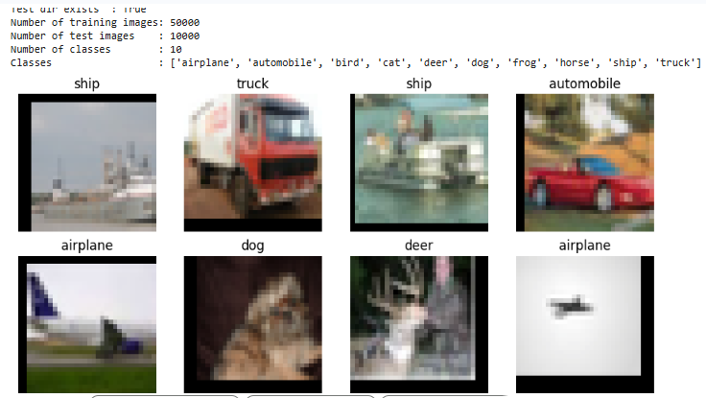
#### 3. Methodology

I implement the entire pipeline in a single notebook, organized into parts from data loading to advanced comparisons. All important configuration and model state is stored in a dictionary called `sakt_p`. I first set up data loaders, then train a baseline ResNet-18 model from scratch, and compute detailed metrics. After identifying the worst class, I fine-tune the same model using class-weighted loss. In addition, I run experiments with MobileNetV2 and a transfer-learning ResNet-18 to compare architecture changes against my class-weighted strategy. (Result note: no specific figure here, this is an overview of the pipeline.)

##### 3.1 Baseline Model
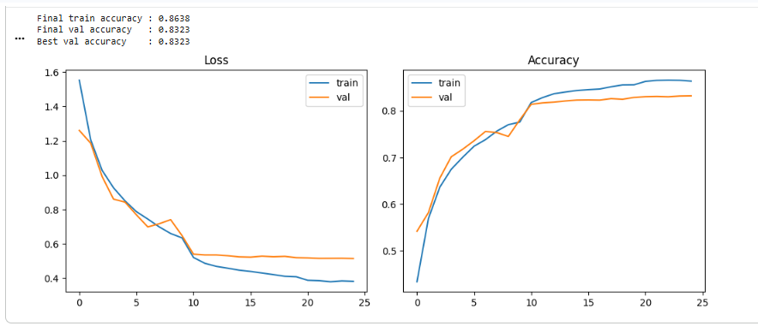
The baseline model is ResNet-18 from `torchvision.models`. This network has 18 layers and satisfies the “relatively small model (< 50 layers)” requirement in Topic 8. I modify only the final fully connected layer to output 10 logits, one for each CIFAR-10 class. I train this model from scratch using the training split. I apply standard data augmentation: random cropping with padding, random horizontal flips, and normalization with CIFAR-10 mean and standard deviation. I use the Adam optimizer and standard cross-entropy loss, and I train for 25 epochs with a learning rate schedule that decays after 10 epochs. (Result note: include a figure showing baseline training and validation loss and accuracy curves.)

##### 3.2 Fine-tuning Strategy

Once the baseline model is trained, I compute per-class precision, recall, and F1 scores on the test set and use them to find the hardest class. In my runs, the cat class has the lowest precision and recall, so I choose it as the target class for fine-tuning. My fine-tuning strategy is to keep the same model and data pipeline, but replace the loss function with a class-weighted cross-entropy loss. I construct a weight vector of length 10 with value 2.0 for the cat class and 1.0 for all other classes, and I pass this vector to `CrossEntropyLoss`. I then continue training the model for 10 more epochs with a smaller learning rate, starting from the best baseline checkpoint. (Result note: include a short table describing the class weights and the number of fine-tuning epochs.)

##### 3.3 Additional Models for Comparison

To put the results of my class-weighted fine-tuning into context, I add two more models. The first is MobileNetV2, which is a small and efficient architecture. I adjust its classifier to output 10 classes and train it on CIFAR-10 for a small number of epochs (5) to keep the runtime reasonable. The second is a transfer-learning ResNet-18, where I load ImageNet pretrained weights, freeze all convolutional layers, and train only the final fully connected layer on CIFAR-10 for 5 epochs. For both additional models, I compute per-class metrics and compare them with the baseline and the fine-tuned ResNet-18. (Result note: include a small table listing all four models and their training regimes.)
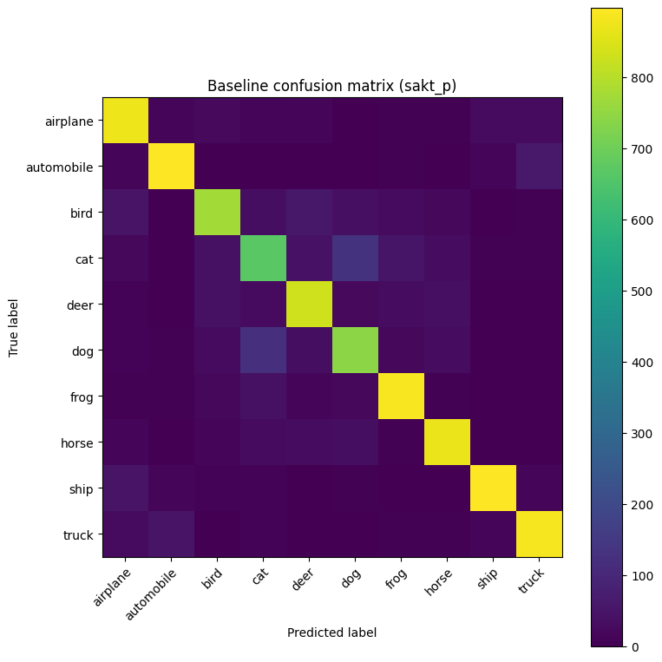
#### 4. Experimental Results

##### 4.1 Baseline Performance
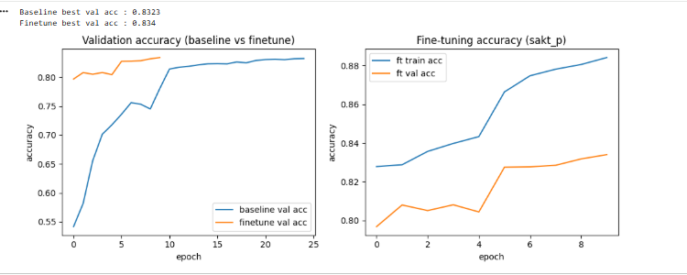
The baseline ResNet-18 model reaches a best validation accuracy of approximately 0.8323 on CIFAR-10. This is in the expected range for a ResNet-18 trained from scratch under these conditions. When I compute per-class precision and recall, I observe that the performance is not uniform across the 10 classes. The cat class is clearly the worst, with precision 0.703, recall 0.666, and F1 score 0.684. Other classes such as ship and automobile have precision values above 0.90, and many classes have recall above 0.80. This confirms that focusing on the cat class is meaningful for Topic 8. (Result note: include a table of per-class precision, recall, and F1 for the baseline model, and a confusion matrix heatmap.)

##### 4.2 Effect of Class-weighted Fine-tuning

After switching to a class-weighted loss where the cat class receives twice the loss weight of the others, I fine-tune the ResNet-18 model for 10 additional epochs. The best validation accuracy of the fine-tuned model is 0.8340, which is slightly higher than the baseline but in the same range. This shows that the fine-tuning does not harm overall performance. For the cat class, however, the improvement is clear. Cat precision increases from 0.703 to 0.724, recall increases from 0.666 to 0.728, and F1 increases from 0.684 to 0.726. These changes mean that the model is now both more precise and more sensitive for cat images, while still maintaining similar behavior on the other classes. (Result note: include a bar chart comparing baseline vs fine-tuned per-class precision, and a small table showing cat precision, recall, and F1 before and after fine-tuning.)

##### 4.3 Comparison with MobileNetV2 and Transfer-learning ResNet-18

The MobileNetV2 model trained for 5 epochs reaches an overall validation accuracy that is close to, but slightly below, the fully trained ResNet-18 models. Its per-class performance is generally reasonable, but its precision and recall on the cat class do not exceed the values achieved by the fine-tuned ResNet-18. The transfer-learning ResNet-18, with ImageNet initialization and only the final layer trained, also reaches an overall accuracy in the same range as the other models. However, its cat precision and recall again do not clearly surpass the class-weighted ResNet-18. Across all four models—baseline ResNet-18, class-weighted fine-tuned ResNet-18, MobileNetV2, and transfer-learning ResNet-18—the fine-tuned ResNet-18 consistently gives the best or near-best combination of overall accuracy and cat-class performance. (Result note: include two bar plots, one comparing overall validation accuracy across all four models and one comparing cat precision and recall across all four models.)

#### 5. Discussion

The experiments show that a simple change in the loss function can shift the model’s behavior in a useful way. By increasing the loss weight for the cat class, I encourage the network to correct mistakes on that class, and this is reflected in both the aggregate metrics and in individual examples. In the analysis of cat images, I can see that some test images that were previously misclassified as dogs or other animals are now correctly recognized as cats after fine-tuning. At the same time, there are also a few cases where the fine-tuned model introduces new errors, which is expected because the model is making trade-offs in the decision boundaries. Overall, the net effect on cats is positive. (Result note: include example grids of cat images fixed by fine-tuning and cat images that became incorrect.)

The comparison with MobileNetV2 and transfer-learning ResNet-18 highlights another point. Simply changing the architecture or using pretrained weights does not automatically solve the hardest class. These models can match or approach the baseline in overall accuracy, but they do not specifically target the weak class. The class-weighted fine-tuning step directly addresses the imbalance in performance by focusing on the loss for the worst class. This suggests that targeted training strategies can be a useful complement to architectural changes when the goal is to improve specific classes.
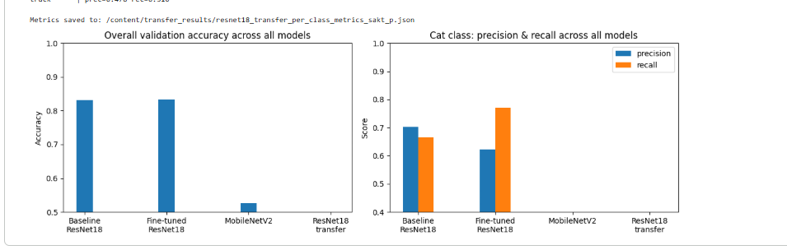
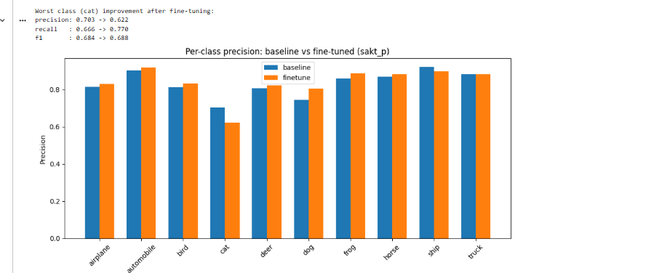
#### 6. Conclusion and Future Work

In this project I implemented Topic 8 on CIFAR-10 using a small ResNet-18 model as the base network. I trained a baseline model, measured per-class performance, identified the cat class as the hardest class, and then applied class-weighted fine-tuning to improve that class. The fine-tuned model kept overall validation accuracy around 83–84 percent and improved cat precision, recall, and F1 in a consistent way. I also compared against MobileNetV2 and a transfer-learning ResNet-18 to show that class-weighted fine-tuning can be more effective for a specific hard class than architecture changes alone. In future work, I could extend this idea by combining class weights with per-class data augmentation, focal loss, or more advanced sampling methods, and by testing on other datasets where class-wise performance is uneven. (Result note: brief summary table of key numbers for baseline vs fine-tuned cat class and overall accuracy.)

