Lost and Found Data Analysis Report – NIT Jalandhar

Introduction
This report presents a detailed analysis of Lost & Found incidents at NIT Jalandhar based on two key datasets:
1. Student Lost & Found Survey Responses
2. Lost-Mail Records (Processed Log Data)

The objective is to identify patterns in item loss, evaluate the effectiveness of recovery mechanisms, determine departmental hotspots, and assess the need for a centralized digital Lost & Found system. The analysis uses R for preprocessing and visualization, covering frequency trends, category distributions, heatmaps, and student feedback indicators.

Methodology
1. Data Sources
- Student survey responses (cleaned, standardized, NA-handled)
- Lost mail processed dataset (Month, Category, Location, Owner year group)

2. Data Preprocessing
- Converted character columns to lowercase
- Trimmed spaces and replaced missing values with “Not Applicable”
- Extracted month-based and category-based summaries
- Generated visualizations (pie charts, bar charts, heatmaps, word clouds)

3. Analytical Techniques
- Categorical frequency analysis
- Department-level and month-level trend analysis
- Word cloud analysis for feature suggestions
- Heatmap correlation between month and item category

4. Tools Used
- R Libraries: dplyr, ggplot2, tidyr, readxl, wordcloud, RColorBrewer, lubridate

Results
1. Student Survey Insights
- 60% of students reported losing an item on campus, indicating a high prevalence.
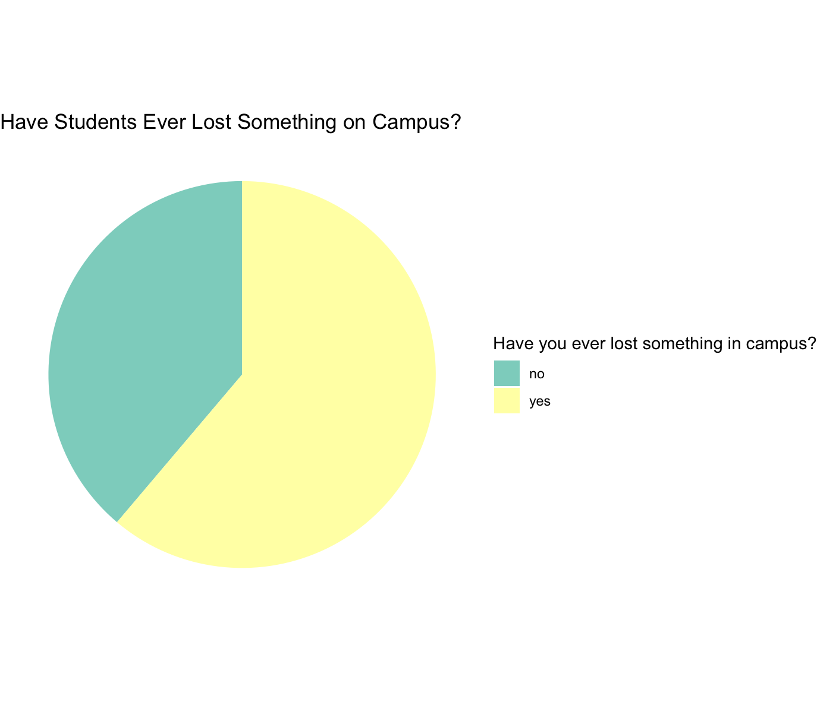
- The most common lost items include water bottles, ID cards, notebooks, pen drives, and electronics.
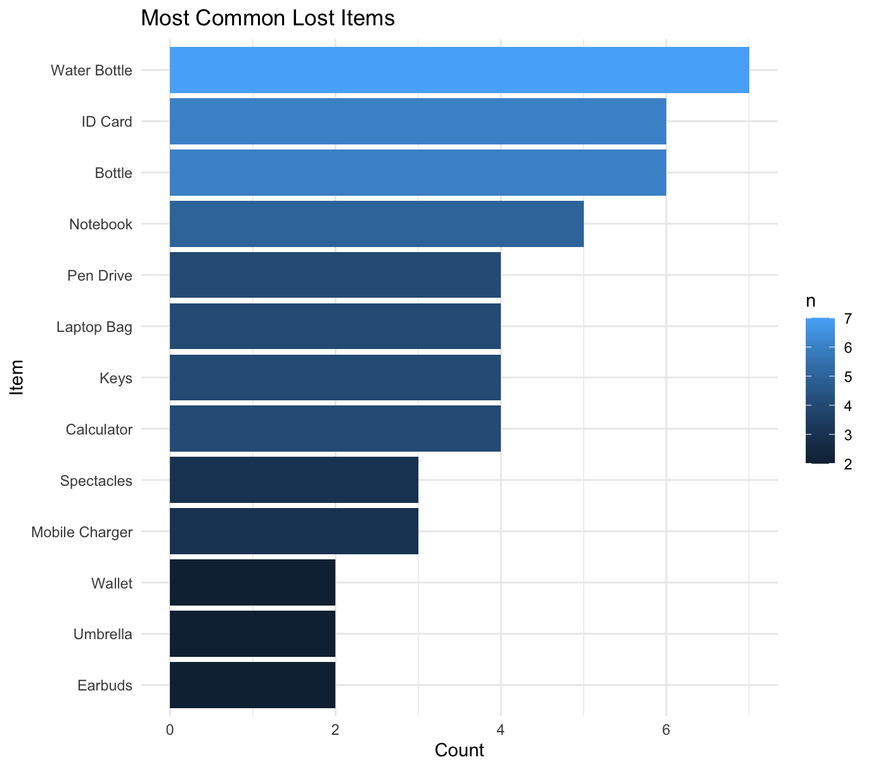
- 45% recovery rate, highlighting inefficiencies in returning lost items.
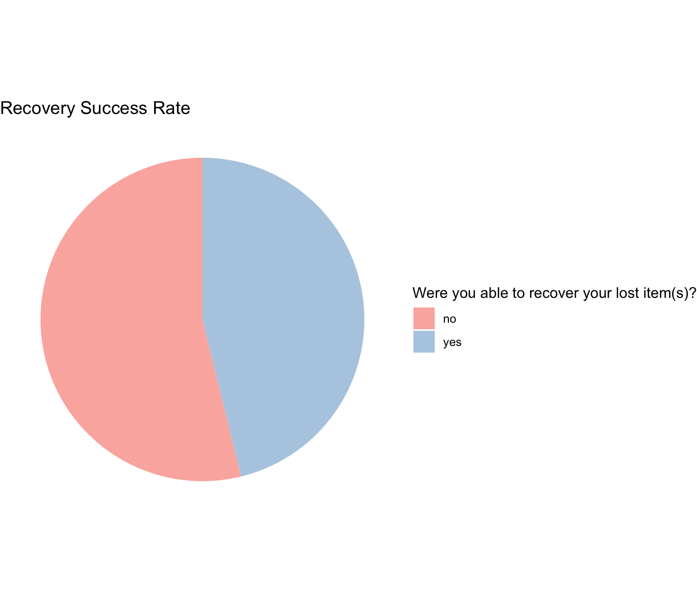

2. Department-wise Analysis
- Departments with larger class sizes (CSE, ECE, Mechanical) show higher incident counts.
- Losses correlate with high-traffic communal spaces and shared labs.
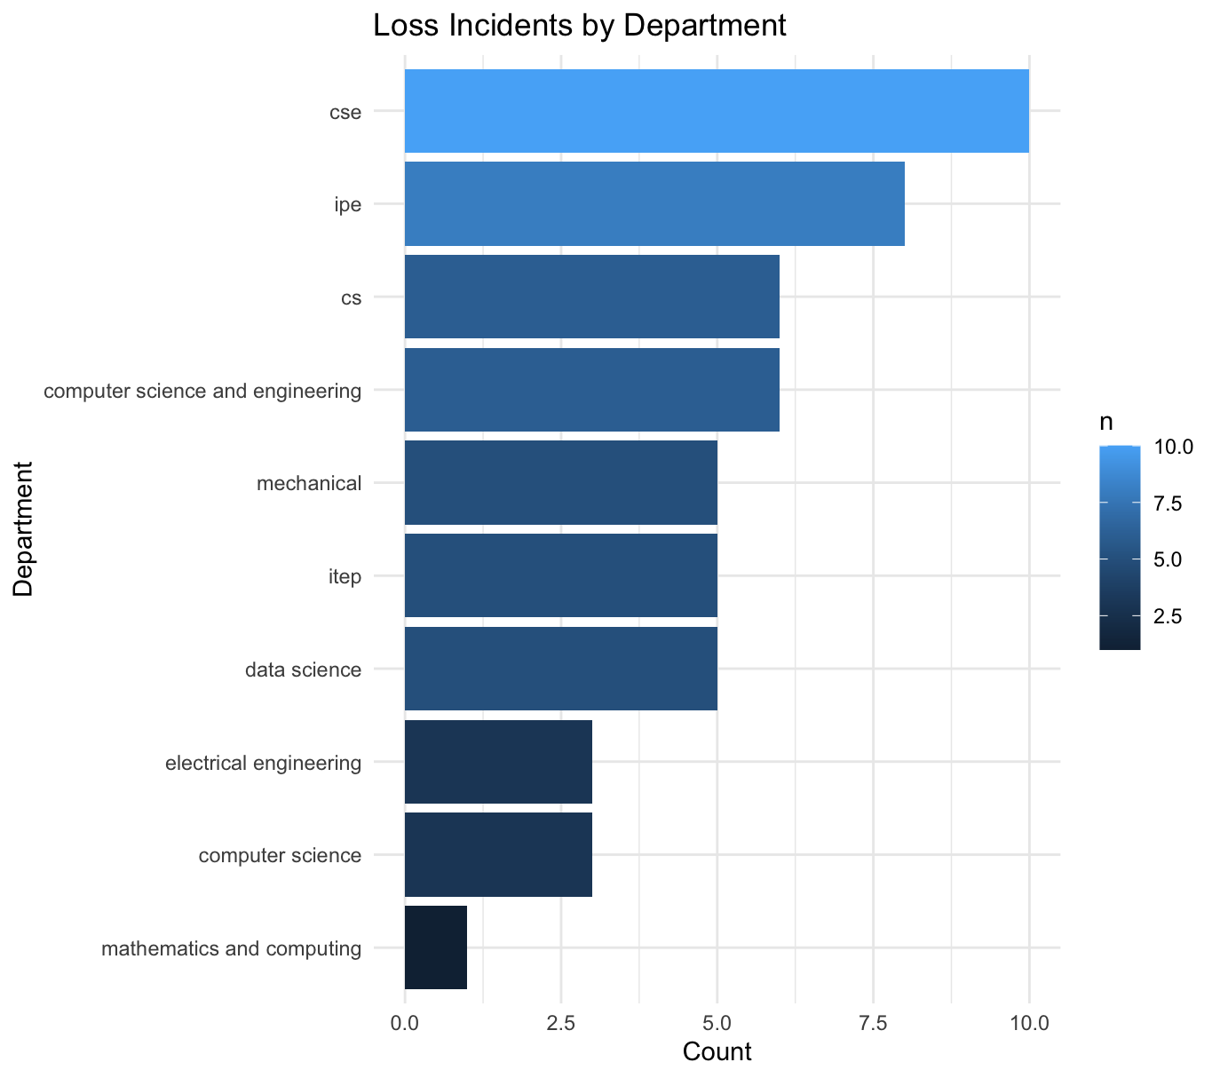
3. Monthly Trend Insights
- Peaks observed in September and October, often during semester start when student movement is highest.
- Trends suggest operational stress periods where additional staffing or drop-off points may be required.
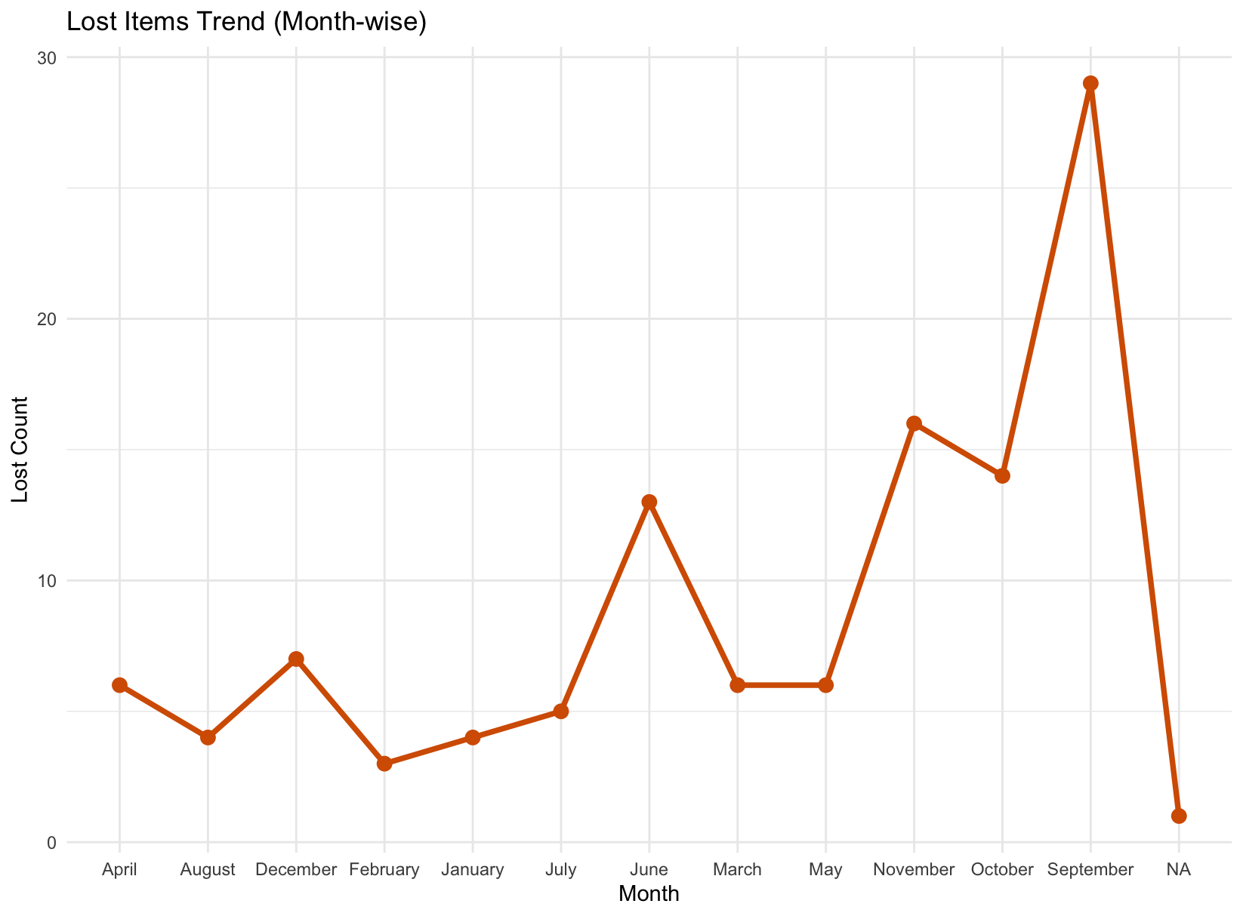
4 Lost-Mail Dataset Insights
- Categories such as electronics, documents, and personal accessories have the highest loss frequency.
- Heatmap analysis shows strong monthly-seasonal patterns (semester transitions, exam periods).
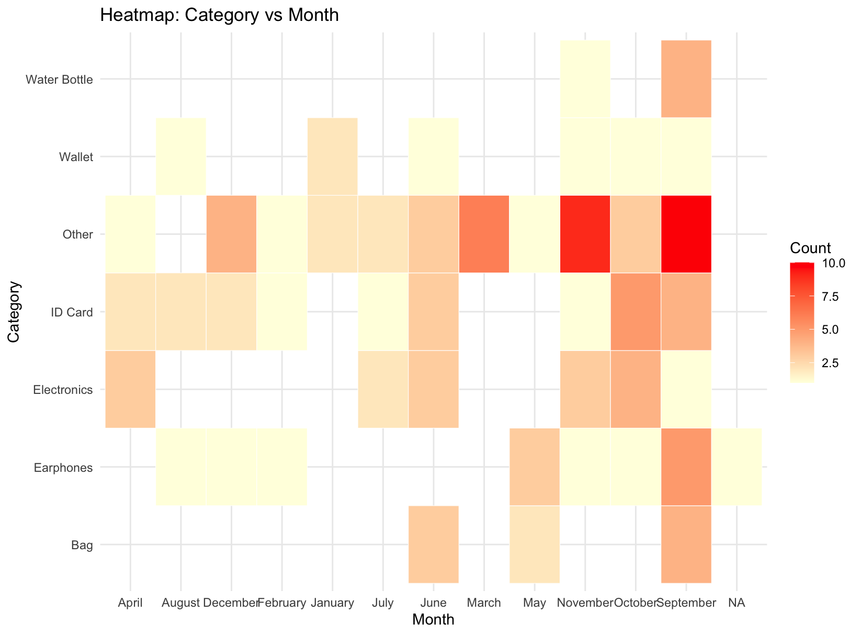
6. Support for Centralized System
- 80% of students support a centralized digital + physical Lost & Found system
- Preferred features from the word cloud:
- Online reporting portal
- Notifications for matched items
- Dedicated Lost & Found desk
- Volunteer management system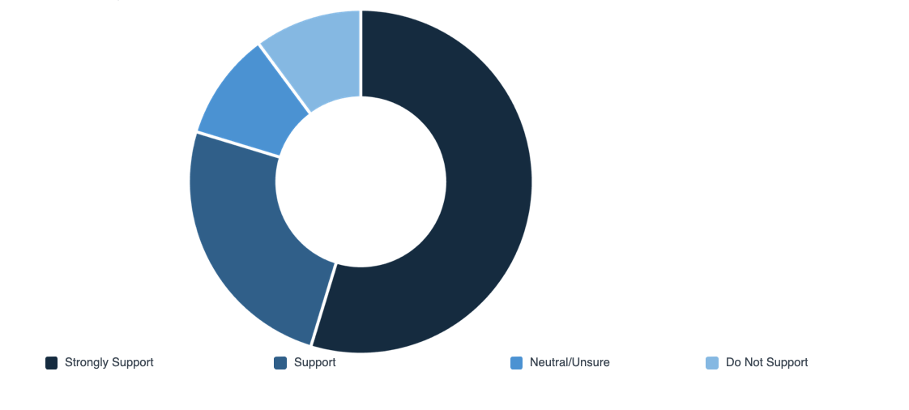

Conclusion
This study demonstrates that NIT Jalandhar faces systemic challenges in managing Lost & Found items due to fragmentation, inconsistent procedures, and lack of centralized tracking.

Key Takeaways:
1. High volume of lost items each semester
2. Low recovery efficiency (45%)
3. Strong student demand for a unified system
4. Clear evidence of departmental and seasonal hotspots

Final Recommendation:
NITJ should adopt a centralized, digitally managed Lost & Found system integrated with:
- Web/mobile reporting
- Automated notifications
- A single physical desk
- Student-volunteer-based management
- Standardized logging with timestamps and item photos

This solution will significantly improve transparency, student trust, and operational accountability across campus.

GitHub Link
The source code, raw data file and analysis scripts used to generate this report are available in the following GitHub repository

