**Entity Relationship Diagram for Q2 Database Design**

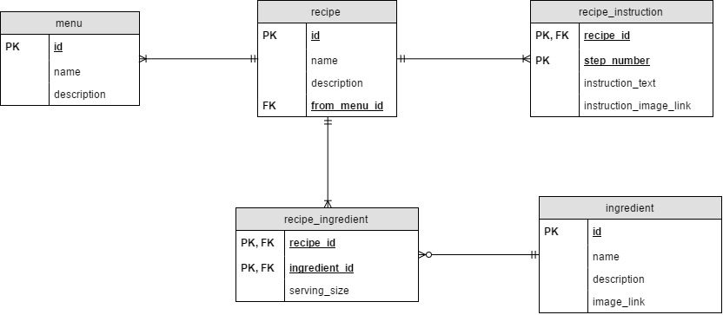

**Advantage of this design**

* Protect database against falsely entered or non-existent ingredient when user add a recipe because only ingredients available in the database can be reference
* Recipe Instruction exists on a separate table allows application that uses it to have more control on the formatting of recipe instruction, for example, able to tag each instruction step with an image
  + This also helps in natural language parsing (if necessary) since we are dealing with smaller length of text 🡪 higher text parsing accuracy

**Disadvantage of this design**

* New ingredient encountered must be added to the database first before any recipe that uses that ingredient can be added