Nick Sohm

CS357A

10/25/15

Project Proposal

1. Nick Sohm
2. Given a string and an NFA, determine if the NFA accepts or rejects the string.
3. NFA 5-tuple, string
4. Accept / Reject
5. Python
6. 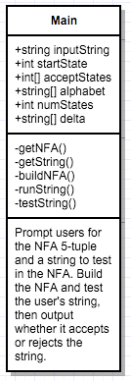
7. Run the following strings on the below NFAs:

‘00011’ – accept

‘10’ – accept

‘000’ – reject

‘1101’ – reject

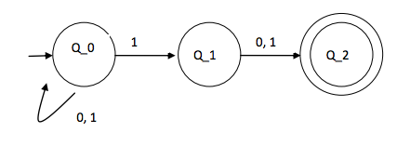

‘’ – accept

‘00’ – accept

‘00000000000’ – reject

‘0’ - reject

